*Adapting hidden Markov models to data from small GPS transmitters for tracking migratory birds*

Liam Berigan, Sarah Clements, Rachel Darling, Alex Fish, Amber Roth, Erik Blomberg, Greg Balkcom, Bobbi Carpenter, Gary Costanzo, Jeffrey Duguay, Clayton Graham, William Harvey, Michael Hook, Douglas Howell, Seth Maddox, Scott McWilliams, Shawn Meyer, Theodore Nicols, J. Bruce Pollard, Christian Roy, Colby Slezak, Josh Stiller, Mathieu Tetreault, Lisa Williams

Target: Ornithological Applications

Overview of the paper

1. The amount of GPS data collected from small birds has exploded over the last decade (Iverson et al. 2023, *Orn. Apps*).
2. This data can be used to delineate migratory tracks, which can be used for phenology, habitat, and survival analyses. Tracks can be delineated using a simple framework (e.g. a step-length threshold for migratory steps)
3. However, issues occur when we’re working with incomplete GPS tracks. In this case, the final state of the bird is unclear, which creates difficulties in determining when a bird has ceased migration.
   1. This can create difficulties for phenology and habitat studies, but especially for survival studies, where knowledge of the final state of the bird is essential to determining migratory survival
4. HMMs are a potential method for quantitatively estimating the final state of a bird when working with incomplete GPS tracks.
   1. Generally HMMs function using step length and turn angle, and rely on the high frequency of data from large mammals to fit models. However, several other studies have shown that HMMs work well with less frequent data from smaller transmitters, frequently attached to birds, if additional data streams are used in state classification.
   2. Talk about some examples- accelerometers, altitude, magnetometers, etc.
   3. These papers have a tendency to use these tools to pick out small scale behaviors, such foraging.
5. Here we’re going to demonstrate that the use of additional data streams in HMMs can also be used to delineate large scale migratory movements, and probabilistically determine whether a bird had reached the end of its migration by the time its transmitter gave out.
6. Woodcock 101
7. We demonstrate these methods through the delineation of American Woodcock migratory movements. By adding additional data streams and a correlated random walk model to interpolate missing locations, we can fit hidden Markov Models to woodcock migratory tracks and estimate woodcock movement states to a reasonable degree of accuracy, even when tracks are incomplete.

**Abstract**

Widespread collection of GPS data from migratory birds necessitates tools for the effective processing and classification of that data. Tools such as hidden Markov models provide opportunities for classifying GPS data, but are designed for regular, high frequency data which is typically not provided by migratory birds. However, the use of additional data streams to fit movement states can assist with fitting cryptic movement states and may assist with fitting movement states with sparse and irregular GPS data. Here we test an approach using a correlated random walk model and additional data streams to fit hidden Markov models to GPS data from bird migrations, specifically American Woodcock (*Scolopax minor*; hereafter woodcock). Our objectives were to determine if the use of additional data streams resulted in an improved capacity to predict migratory states, describe the migratory phenology of woodcock, and characterize long-distance movements by woodcock outside of the migratory season. We found that the inclusion of additional data streams greatly improved the performance of hidden Markov models, although the individual impact of each added data stream was low. Woodcock migratory phenology largely followed prior descriptions, although we observed low incidence of continued migration during the wintering and breeding seasons. We also observed dispersal, foray loops, and summer migrations occurring among woodcock outside of the migratory periods. Despite our progress in applying hidden Markov models to bird data, the complexities required to do so demonstrate how major new developments in the development of movement ecology tools have largely not extended to the modeling of sparse and irregular data generated by avian tracking studies. New techniques and applications are likely to be necessary to accommodate the accelerating effort to understand bird migration using GPS, Motus, and other technologies.

**Introduction**

The amount of GPS data collected from small birds has exploded over the last decade (Iverson et al. 2023b), providing opportunities to study facets of bird migration which have long eluded ornithologists. GPS data can be used to address questions of migratory phenology (Wright et al. 2021), habitat use (Moskát et al. 2019, Iverson et al. 2023a), survival (Klaassen et al. 2014), and connectivity (Combreau et al. 2011) with high resolution data and near-global coverage. Although historically GPS transmitters have been limited to larger birds, technological improvements in both archival and satellite platform transmitting terminal (SAT-PTT) GPS transmitters have allowed GPS technology to become available for a much larger group of bird species than has historically been the case (Bridge et al. 2011).

In order to answer questions about bird migration, GPS data is usually classified into migratory tracks, which delineate between pre-migration, migration, and post-migration. State classification can be done using one of several simple frameworks. One framework might be based on the known breeding and wintering ranges of a bird, where a bird is considered to have begun migration when it leaves the breeding range, and completed migration when it enters the wintering range, and visa versa (Linscott et al. 2022). Another threshold might be a step-length threshold for migratory steps, where migration begins with the first step over the threshold and ends with the last step over the threshold (Burnside et al. 2017). The range delineation method has the advantage of being robust to incomplete tracks; if a bird dies or transmitter failure occurs during the bird’s migration, the bird’s final state is still apparent. However, the range delineation method requires constrained breeding and wintering ranges that have little overlap with the migratory range (ex. Bar-tailed Godwit, *Limosa lapponica*; Battley et al. 2012). The step-threshold method relaxes the assumption that breeding and wintering ranges do not overlap with the migratory range, which allows this method to be applicable to a much wider range of birds with widespread breeding and wintering ranges (ex. Pine Siskin, *Spinus pinus*; Dawson 2020). However, the step-threshold method does not handle incomplete tracks well; if a bird dies or transmitter failure occurs during the bird’s migration, the bird’s final state is unknown (Fig. 1). Quantifying the bird’s final state in these cases is particularly important for survival and connectivity analyses, where knowing whether the bird completed migration by the end of its track is essential to the analysis, but also has relevance for phenology and habitat analyses for which migratory delineation is important.

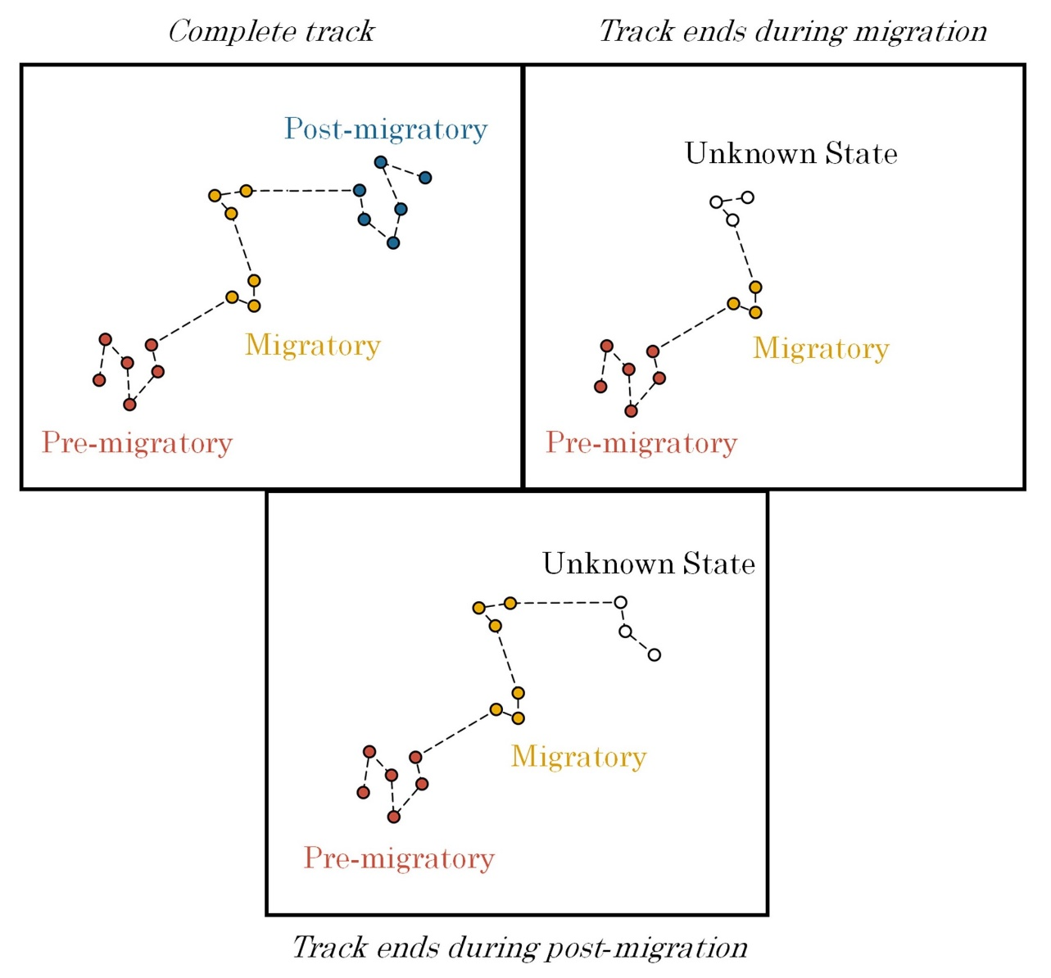

Figure 1. Complete and incomplete tracks of a theoretical migratory bird. For birds with complete tracks (encompassing the entire temporal period of migration), the pre-migratory, migratory, and post-migratory stages of the track are apparent, and can be identified using known breeding and wintering ranges or a step-length threshold to identify migratory steps. For birds with incomplete tracks, however, the final state of the bird cannot be determined using a step-length threshold. If points cannot otherwise be delineated using breeding and wintering ranges, incomplete tracks end in an uncertain state that could be either migratory or post-migratory.

Hidden Markov models are used to delineate hidden behavioral states given observed distributions of outcome variables and provide an opportunity to delineate animal movement states in a quantitatively robust way (Langrock et al. 2012, Zucchini et al. 2017). Repeated observations of step length and turn angle are typically the two parameters used to identify behavioral states using hidden Markov models, although additional data streams (such as acceleration, depth, and heading) can be used to improve the model’s predictive capabilities (Dean et al. 2013). Hidden Markov models were initially applied to GPS data from large-bodied mammal species, which can carry large transmitters that provide high frequency, regularized location data over long periods of time (Langrock et al. 2012, 2014b, a). More recent applications of hidden Markov models include tk, tk, and tk (smaller mammals and non-bird, non-mammals cite tk).

The application of hidden Markov models to bird species has been a recent innovation. Most of this work has been focused on larger bird species, particularly shorebirds, sage-grouse, prairie grouse, and seabirds, which can carry larger transmitters than most other birds and receive direct sunlight which can be used to charge a solar panel (Dean et al. 2013, Berigan 2019, Picardi et al. 2022, Mander et al. 2022). Larger battery size and the capacity for solar recharge allows these transmitters to sustain a regular frequency of multiple transmissions per day, which facilitates the fitting of hidden Markov models. Studies have shown that hidden Markov models can be used in these cases to fit smaller scale movement patterns, such as foraging, as well as larger scale movement patterns, such as migration (cite tk). However, the small size and forest dwelling habits of most birds preclude larger transmitter batteries or solar recharging, which limits the battery life and transmission frequency of GPS transmitters attached to smaller birds. The resulting GPS data collected from smaller birds is sparse and irregular and is not easily fit using traditional approaches with hidden Markov models.

The paucity of GPS data that can be collected from most small, forest-dwelling birds is demonstrated by the American Woodcock (*Scolopax minor*; hereafter woodcock). Woodcock are an early-successional habitat specialist which primarily eats earthworms and are one of the few North American members of the family Scolopacidae which does not favor coastal, wetland, or riparian habitats (cite lots of people tk). Include a sentence on range here tk. Woodcock have been in decline at least since surveys began in the 19tks, at a rate of roughly 1.tk% per year (cite tk). Presumed reasons for decline include reduction in early-successional habitat throughout the northeastern United States due to forest maturation, and potentially low migratory survival rates due to collision with anthropogenic obstacles. Woodcock are one of the 25 most common birds to find deceased as a result of bird strikes, and woodcock survival during migration is considered to be a priority research area (cite botw tk add geographic area, woodcock strategy report). Woodcock are large enough to fit SAT-PTT transmitters of 4–6 g (woodcock mass: tk–tk g; cite tk), but the species’ forest-dwelling habits preclude the use of a solar panel (cite tk, I think someone tried this). Tracking woodcock throughout their migratory cycle using these transmitters requires infrequent and irregular GPS locations, which provide obstacles for fitting hidden Markov models.

Here we suggest a modified approach that allows hidden Markov models to fit large scale movement behaviors, such as migration, using sparse and irregular GPS data. We suggest a two-stage process: 1) interpolation of data at a regular interval using a correlated random walk model, and 2) fitting a hidden Markov model using additional data streams that describe the time, location, and movement characteristics of a given GPS point. We demonstrate this approach on data collected from American Woodcock during a wide-scale study of their migratory phenology, habitat use, and survival. The addition of data streams to assist the fitting of a hidden Markov model results in substantially improved accuracy of migratory state delineation in both the fall and spring seasons. During this study, we also observed long-distance movements by woodcock which fell outside of our typical definitions of migration; we categorize these here and speculate on their prevalence in this and other species. We reflect further on potential utility of this hidden Markov model approach for other species of birds for which paucity of GPS data has to this point prohibited fitting these models.

**2 Methods**

*2.1 Collecting data via GPS transmitters*

We delineated American Woodcock movements throughout the full annual cycle using GPS-tracking data from the Eastern Woodcock Migration Research Cooperative, a collaboration of 42 agency, non-profit, and academic organizations in eastern North America (www.woodcockmigration.org). We captured woodcock at 78 sites in Quebec, Ontario, Nova Scotia, Maine, Vermont, New Jersey, New York, Rhode Island, Pennsylvania, Maryland, West Virginia, Virginia, North Carolina, South Carolina, Georgia, Alabama, Louisiana, and Florida using mist nets during morning and evening flights (Sheldon 1960), and on night roosts using spotlights and dip nets (Rieffenberger and Kletzly 1966, McAuley et al. 1993). We attached 4g, 5g, or 6.3g PinPoint GPS Argos transmitters (Lotek Wireless Inc., Newmarket, Ontario, CA) to captured woodcock. Transmitters, bands, and harness materials never exceeded 4% of a bird’s body mass, and all capture and handling were conducted with methods approved by the University of Maine Institutional Animal Care and Use Committee (Protocol # A2020-07-01).

GPS transmitters were programmed with one of several schedules, each of which collected data at a slightly different pace to optimize battery life. The most frequent schedules would record locations daily, while infrequent schedules would record locations every 3–7 days. Certain schedules were programmed to switch between frequent and infrequent modes outside of migratory time periods, and transmitters were occasionally set to go dormant for periods of 1–3 months during summer and fall to preserve battery life for a separate study objective. Each transmitter was predicted to collect a maximum of 75–150 GPS locations, depending on transmitter size and schedule, at 12–60m accuracy. Transmitters relayed GPS locations back to the ARGOS satellite network after every 3rd location, allowing recovery of data without recapture of the bird. However, transmitters occasionally failed to relay data, sometimes resulting in sporadic missing data near the end of battery life.

*2.2 Delineating spring and fall migration*

*2.2.1 Using HMMs to delineate woodcock migration*

We delineated woodcock movements within fall and spring migratory seasons, where fall generally encompassed Aug. 1st–Feb. 25th and spring encompassed Jan. 5th–Jun. 30th based on the periods of time when most birds were migrating. However, for a small subset of birds (n = 14) we had to define custom date ranges due to prolonged migratory movements (Supplementary Information A). To ensure that fall and spring migratory movements were not conflated by our models, we delineated spring migrations first, and shortened the end of the default fall migration timeframe (Aug. 1–Feb. 25) to a day before the subsequent spring migration began for that individual.

We defined woodcock migration as beginning when woodcock make their first ≥16.1 km movement in a season and ending after woodcock make their final ≥16.1 km movement in a season. We chose a 16.1 km threshold as it roughly bisects the bimodal distribution of log-transformed step lengths collected by our migratory birds (Blomberg et al. n.d.). However, tagged woodcock in our study frequently had incomplete migratory tracks, either due to waning battery life or bird mortality before the end of migration, making it unclear when their final ≥16.1 km movement occurred. We therefore used hidden Markov Models (HMMs; Ephraim and Merhav, 2002; Zucchini et al., 2017) to delineate woodcock migrations, which allowed birds with complete migratory tracks to inform the final migratory state designation of birds with incomplete migratory tracks. We made several adjustments to the HMMs to allow them to better function with infrequent locations and missing data and provided additional data streams to allow the models to better differentiate between stopovers and post-migratory locations.

Infrequent locations and missing data can complicate the process of fitting an HMM to bird movement data, as they impede the ability of the model to detect recursive movements (defined as “repeated visitations to the same particular locations in a systematic manner”; (Berger-Tal and Bar-David 2015) which could be indicative of short-distance movements during stopovers and post-migratory settlement. We accommodated infrequent locations and missing data using a correlated random walk model to interpolate daily locations at stopover, pre-migratory, and post-migratory sites using the R package crawl (Johnson and London 2018, R Core Team 2022). This allowed the HMM to detect recursive movements more accurately during stationary periods using a limited number of infrequent locations. We only used the correlated random walk model to interpolate locations between points that were <16.1 km apart (i.e., when the bird was either at a stopover or not migrating), as the correlated random walk model tended to break long migratory steps into a series of short daily movements, making the HMM less likely to identify these movements as migratory. Due to the directional consistency inherent in correlated random walks, correlated random walk models occasionally produced erroneous loops of interpolated points to explain directional changes when birds made recursive movements during non-migratory periods. These interpolated loops were often lengthy and could artificially create step lengths ≥16.1 km. To ensure that HMMs didn’t incorrectly interpret these loops as migratory movements, we removed all loops of interpolated points for which the total length of the loop was more than 10 times the distance between observed points and replaced the loops with sets of predicted locations spaced evenly along a line between the observed points.

While HMMs generally differentiate among different movement states using step lengths and turn angles, we encountered difficulties inferring the final movement state of incomplete tracks using these data streams alone. To overcome this issue, we added additional data streams that allowed models to better differentiate between stopovers and post-migratory locations. Additional data streams measured recursiveness, residence time, day of season, and location of a given point (Table 1). We measured recursive movements using the mean distance to the nearest 7 points, transformed using a natural logarithm. This measured whether the nearest 7 bird locations (meant to approximate space use over the period of a week) reflected intensive use of the same area, and presumably resource utilization, or spread-out movement throughout the area, possibly reflecting exploration. We measured residence time using the time difference between the first and last day that the bird was within a 10 km radius of a location. This reflected the difference between the amount of time that woodcock spent occupying stopover sites as opposed to their post-migratory sites. We measured day of season using an ordinal day variable, reflecting woodcocks’ tendency to migrate at similar times each year. We measured location using latitude and two binomial variables. The first binomial location variable determined whether a bird had or had not moved >16.1 km from its position at the beginning of the season and had thus departed its initial site to begin migration. The second binomial location variable reflected whether the bird was currently within the woodcock breeding range, as delineated using the eBird 2021 Status and Trends abundance maps (Fink et al. 2022).

Table 1. Covariates used to delineate movement states in hidden Markov Models (HMMs), and the type of distribution used to fit to each covariate in the HMMs. Point-specific attributes (latitude, ordinal day, distance from start, breeding range, log(distance to nearest points), residence time) are based on the woodcock’s location at the beginning of the step.

|  |  |  |
| --- | --- | --- |
| **Covariate** | **Distribution** | **Description** |
| Step length | Gamma | Length of the current step |
| Turn angle | Wrapped Cauchy | Angle between the current and previous step |
| Latitude | Normal | Latitude at the beginning of the step |
| Ordinal day | Normal | Days since the beginning of the migratory season |
| Distance from start threshold | Bernoulli | Has the bird moved >16.1 km from its location at the beginning of the migratory season? |
| Step length threshold | Bernoulli | Is the current step length ≥16.1 km? Implemented with a fixed distribution so that all steps ≥16.1 km are migratory. |
| Breeding range | Bernoulli | Does the step begin in the American Woodcock breeding range (Fink et al. 2022)? |
| Log(distance to nearest points) | Normal | Natural logarithm of the mean distance to the nearest 7 points. |
| Residence time | Normal | Number of days that the bird has spent/will spend within a 10km radius. |

*2.2.2 Model design*

We implemented fall and spring HMMs in the R package momentuHMM (McClintock and Michelot 2018) due to its accommodation of multiple data streams and customized model structures. We used separate HMMs for males and females in spring due to differential breeding movements, and together during the fall as movements were similar between sexes. We constructed a multi-state model for each HMM to delineate distinct stages of migration and identify transitions occurring between stages (Fig. 2). Models for spring migration by females and all woodcock during fall featured 4 states: pre-migration, migration, stopover, and post-migration. Birds began the season in a pre-migration state and remained as long as the bird made no movements ≥16.1 km. When the bird made its first movement ≥16.1 km it moved into a migration state, which was the only state in which movements ≥16.1 km were permitted. From the migration state, birds could enter either a stopover state or a post-migration state. The stopover state was characterized by a period of recursive movements <16.1 km, where the only possible state transition was back into the migration state. The post-migration state could only be reached from the migration state and did not allow for any further state transitions. This state indicated that the bird had completed movements ≥16.1 km for the remainder of the season. These state assignments were generally enforceable using the fixed transition framework in the momentuHMM package, but occasional errors occurred when improbable state assignments caused the framework to fail to enforce state transition rules. These errors and their fixes are detailed in Supplementary Information B.

The spring male model splits post-migration into two states, post-migration (frequent) and post-migration (infrequent), which males could enter in spring at the conclusion of migration. The inclusion of these two states fixed an artifact in the dataset caused by male-specific transmission schedules, which switched to a less-frequent transmission schedule late in the spring migratory season. Infrequent transmissions caused the correlated random walk model to infer a greater proportion of steps during the late migratory period, producing a much narrower turn angle distribution than observed earlier in the season. The inclusion of two post-migratory states with separate turn angle distributions, which birds can transition between freely, allows the model to better account for this source of variation in turn angles when delineating post-migratory movements.

To remove birds from consideration which did not make migratory movements or did not collect enough data to fit an HMM, we excluded any birds which did not have at least 1 step ≥16.1 km, or which collected fewer than 3 points in a given season. We assigned a fixed pre-migration state for the initial step of most birds captured during breeding or wintering. However, birds captured in Virginia, New Jersey, and Maryland were sometimes captured after widespread migratory initiation in the fall or spring, creating uncertainty whether a bird caught during one of these periods entered the HMM in a pre-migration or a migration state. To counteract uncertainty in the initial state for Virginia, New Jersey, and Maryland caught birds in the season of their capture, we allowed the HMM to estimate the initial state of the model instead of using a fixed pre-migration state for the initial step. The only other circumstance in which we allowed the initial state for a bird to vary from pre-migration was when the first step length was ≥16.1 km, in which case we set the first step to a known migration state. We fixed final steps to the post-migratory state for fall woodcock that were also known to initiate spring migration.

We visually inspected all HMM state assignments, which sometimes identified circumstances where birds did not fit model predictions due to extra-seasonal movements, early initiation or late termination of migration, or transmitter error. In those cases, we manually reclassified state assignments (Supplementary Information A). We also encountered issues with mortality locations, as birds which died during migration occasionally continued to transmit and caused the HMM to falsely classify dead birds as post-migratory. We have included methods used in delineating GPS mortalities and removing them from the dataset in Supplementary Information C.

*2.3 Assessment of HMM accuracy*

In all models, transition to post-migratory states was incumbent on no further steps ≥16.1 km after the transition. Because we rarely observed migratory movements beyond Jan. 15th for fall migration and Jun. 15th for spring migration, we considered the date of post-migratory transition (the date of the bird’s final ≥16.1 km movement) to be known for birds that survived and continued to transmit past the cutoff date. For birds that stopped sending data before the cutoff date, we relied on HMMs to determine whether each bird had reached its final ≥16.1 km movement of the season or was still migrating. We assessed the accuracy of our final state assignments of incomplete tracks using a leave-one-out simulation, in which we artificially removed locations from the ends of tracks for individual birds with known post-migratory transition dates, reran the HMM, and evaluated whether the model correctly determined the final movement state. We iteratively assessed 50 individuals for each seasonal simulation, testing the accuracy of final state assignment when tracks were cut off to dates from Oct. 1st–Jan 15th in fall and Mar. 15th–Jun. 15th in spring. We measured the accuracy of final state assignment based on Type I and Type II errors, where a Type I error occurred when the ending state was falsely classified as migratory, and a Type II error occurred when the ending state was falsely classified as settling or post-migratory. We conducted this assessment on the full model for each HMM and a reduced model for each season that used only step length and angle to train the HMM. Running both full and reduced models allowed us to examine how both Type I and Type II errors changed with the inclusion of additional variables in the HMM and to evaluate whether the inclusion of these variables improved the predictive capacity of the HMM.

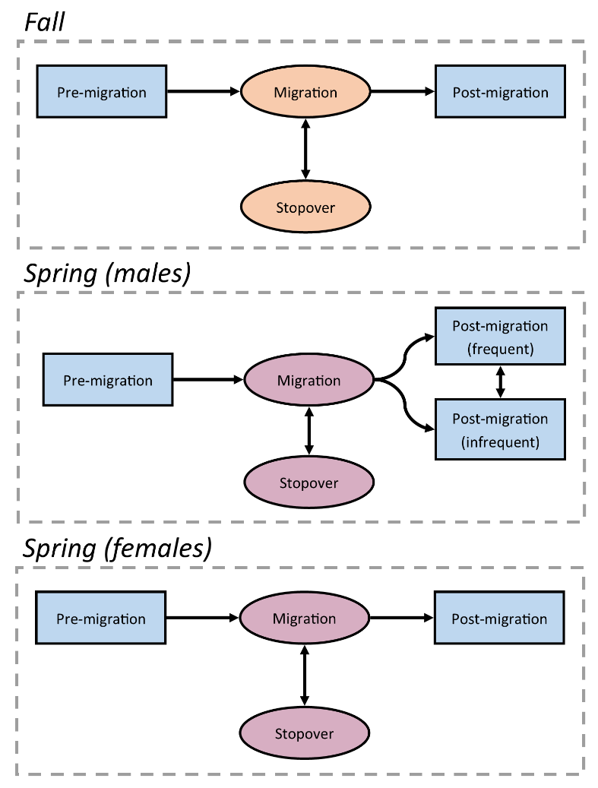

Figure 2. Movement state transition diagram for each hidden Markov Model (HMM).

*2.4 Classifying movements outside of spring and fall migration*

To examine long-distance movements, we manually classified 3 potential long-distance movement states: summer migrations, foray loops, and dispersals (Table 2). Summer migrations were southerly movements >16.1 km that were initiated after the conclusion of spring migration but prior to the period of fall migration (Aug. 1). These movements resulted in southerly displacement considerable enough to preclude further migration during the fall. Foray loops were circular or out-and-back movements that included steps ≥16.1 km, but for which the bird’s eventual displacement was <16.1 km. Dispersals were one-way movements including steps ≥ supl16.1 km that resulted in ≥16.1 km of displacement, reflecting one-way movements to a new summering or wintering site. Birds could only transition between a long-distance movement state and a non-migratory state (pre-migration, settling, or post-migration), ensuring that long-distance movements were separate from early or continued migration.

Table 2. Definitions of long-distance movement states manually delineated for American Woodcock.

|  |  |
| --- | --- |
| **Class** | **Definition** |
| Migratory (summer) | Post-breeding, southerly movements initiated before Aug 1 that preclude fall migratory movements. |
| Foray loops | Circular or out-and-back movements with steps ≥16.1 km that result in <16.1 km of net displacement between the first and last point. Foray loops can occur during any season, provided they are temporally distinct from a bird’s migratory movements. |
| Dispersals | Movements that include step lengths ≥16.1 km and result in ≥16.1 km of net displacement between the first and last point. Dispersal movements follow directions which are not typical of co-occurring seasonal migrations. |

*2.5 Calculation of full annual cycle phenology metrics*

We calculated several metrics to describe the prevalence, length, distance, and timing of each movement class. We summed the number of days between the first movement in each class and the initial location of the subsequent movement class (e.g. the start and end of migration). We also summed the total distance of all steps in each movement class for each bird. For birds undergoing fall or spring migrations, total distance excluded movements designated as stopovers, i.e. steps <16.1 km that occurred while the individual was migrating. We used medians and ranges to report dates of migratory initiation and termination, as medians are well suited to accommodating outliers that were common in the initiation and termination dates. We delineated migratory peaks by calculating the proportion of locations which fell into a migratory class during any given week, and reporting the week in which the proportion of migratory locations was greatest.

We calculated the percentage of individuals which did not migrate using the pool of all individuals tracked between the nominal start of the migratory season (Fall: Oct. 15, Spring: Feb. 15) and the date by which most birds had initiated migration (95th quantile of the departure dates for that season). Any individuals which had at least one location before, during, and after this period, but did not enter a corresponding migratory state, were designated as non-migratory for that season. We used similar time periods to determine whether a bird migrated during the season before or after its non-migratory season. We counted the frequency of summer migrations based on all birds tracked between May 1st–Sep. 1st, with dates chosen based on the first initiation date and last termination date observed in the dataset. We counted the frequency of dispersals and foray loops based on all birds with locations spanning at least 1 month, which was long enough to correctly classify movement classes. Sample sizes prevented reporting standard deviations for the duration and distance traveled of summer migrations, foray loops, and dispersal movements, so we reported ranges for these metrics.

*2.6 Distribution of methods and results*

For use in other studies, we simplified the movement state assignments to only include migratory, non-migratory, and long-distance movement designations and uploaded these designations to a Movebank repository (reference ID 351564596). The process of simplifying these designations for use in Movebank is detailed in Supplementary Information D. All code used in this study is publicly available at https://github.com/EWMRC/fac-classification.

**3 Results**

*3.1 Model evaluation*

We analyzed 522 seasonal movement tracks from 401 tagged woodcock, of which 43 (10.7%) required exceptions to the methods described above to correctly fit the seasonal HMMs. These misclassification errors, and the individual modifications to the seasonal HMMs needed to correct them, are detailed in full in Supplementary Information A. All three seasonal HMMs exhibited improved validation accuracy with the full model (included additional data streams) compared to the base model (only step length and turn angle) (Fig. 3). The full fall model had a comparable Type I error rate (0–24.2%) to the base model (0–24.2%), but the full model had a Type II error rate (0–4.3%) which was generally lower than that of the reduced model (0–28.3%). The spring male full model exhibited lower rates of Type I (0–15.6%) error than the base model (0–61.1%), and comparable rates of Type II error (Full: 0–11.4%, Base: 0–13.6%). The spring female full model exhibited greater Type I errors (0–18.8%) during some time periods than the base model (0–4.2%), but also exhibited reduced Type II error rates (2.0%–11.4%) compared with the base model (10.0–77.6%).

Individual removal of variables from the full model had low overall impact (range: -1.20–0.19%) on the Type I and Type II error rates of the seasonal models, suggesting redundancy between included variables (Fig. 4). The impact of a withheld variable often differed by season, with the removal of some variables (ex., ordinal day) leading to positive impacts on error rates in one season and negative impacts in another season. The withheld variable which led to the highest reduction in error rates was residence time, which caused a 0.20–1.20% drop in Type II error rates for all 3 seasonal models.

*3.2 Full annual cycle phenology*

Duration of fall migrations averaged 23.8 days (SD: 19.9, range: 2–83 days) with a mean distance (excluding stopovers) of 1393 km (SD: 571, range: 23–3010 km) for males, and 33.0 days (SD: 29.4, range: 1–142 days) with a distance of 1353 km (SD: 683, range: 158–2980 km) for females. Spring migrations lasted 39.2 days (SD: 24.3, range: 4–95 days) with a distance of 1554 km (SD: 644, range: 296–3337 km) for males and 49.6 days (SD: 29.3, range: 2–128 days) with a distance of 1672 km (SD: 626, range: 455–3424 km) for females. The median date of departure for fall migration was Nov. 8th (range: Sep. 24th–Dec. 11th) for males and Nov. 7th (Aug. 29th–Jan. 11th) for females. The median date of migratory termination was Dec. 1st (Nov. 1st–Jan. 28th) for males and Dec. 6th (Oct. 25th–Feb. 4th) for females. The median date of departure for males during spring migration was Mar. 1st (Jan. 6th–Apr. 14th), and the median date of migratory termination was Apr. 4th (Jan. 11th–Jun. 7th). The median date of departure for females during spring migration was Mar. 5th (Jan 19th–Apr. 26th), and the median date of migratory termination was Apr. 26th (Feb. 20th–Jul. 28th). Fall migration peaked during the week of Nov. 18th–Nov. 25th for both males and females, with 54% and 59% of male and female locations in that week being migratory, respectively. Spring migration peaked on the week of Mar. 18th–Mar. 25th for males and Mar. 25th–Apr. 1st for females, with 78% and 83% of locations in those weeks being migratory, respectively (Fig. 5).

Six of 176 birds (3%) tracked between Oct. 15th–Dec. 5th did not migrate during fall, and 6 of 193 birds (3%) tracked Feb. 15th–Mar. 29th did not migrate during spring. Of those birds that did not migrate during fall, 3 overwintered in Rhode Island, 1 in Pennsylvania, 1 in Connecticut, and 1 in Virginia. Of birds that did not migrate during spring, 2 oversummered in Virginia, and 1 each oversummered in Maryland, Florida, Georgia, and Alabama. Individuals that abstained from migration during one season did not necessarily repeat that behavior in other seasons, as non-migratory birds were observed migrating in prior or subsequent seasons when data were available (5 of 5 birds). Three of 65 birds (5%) tracked from May 1st–Sep. 1st migrated south during the summer. Summer migratory movements initiated on a mean date of Jun. 19th (May 27th–Jul. 13th) and terminated on a mean date of Jul. 28th (Jul. 8th–Aug. 22nd; Fig. 6), had a mean duration of 39 days (35–42 days) and a mean distance traveled of 756 km (523–1106 km). Three of 456 birds (0.7%) tracked for at least 1 month underwent non-migratory dispersal, with one bird making 2 dispersal movements approximately 2 months apart. Dispersals were observed during December, February, June, and July, and were restricted to the northeastern United States. Dispersal movements had a mean duration of 6 days (1–10 days) and the mean distance traveled was 129 km (30–263 km). Sixteen of 456 birds (4%) tracked for at least 1 month underwent a foray loop, which were observed in all months except for March and April (the peak of spring migration) with a mean duration of 20 days (3–95 days) and a mean distance traveled of 247 km (38–951 km).

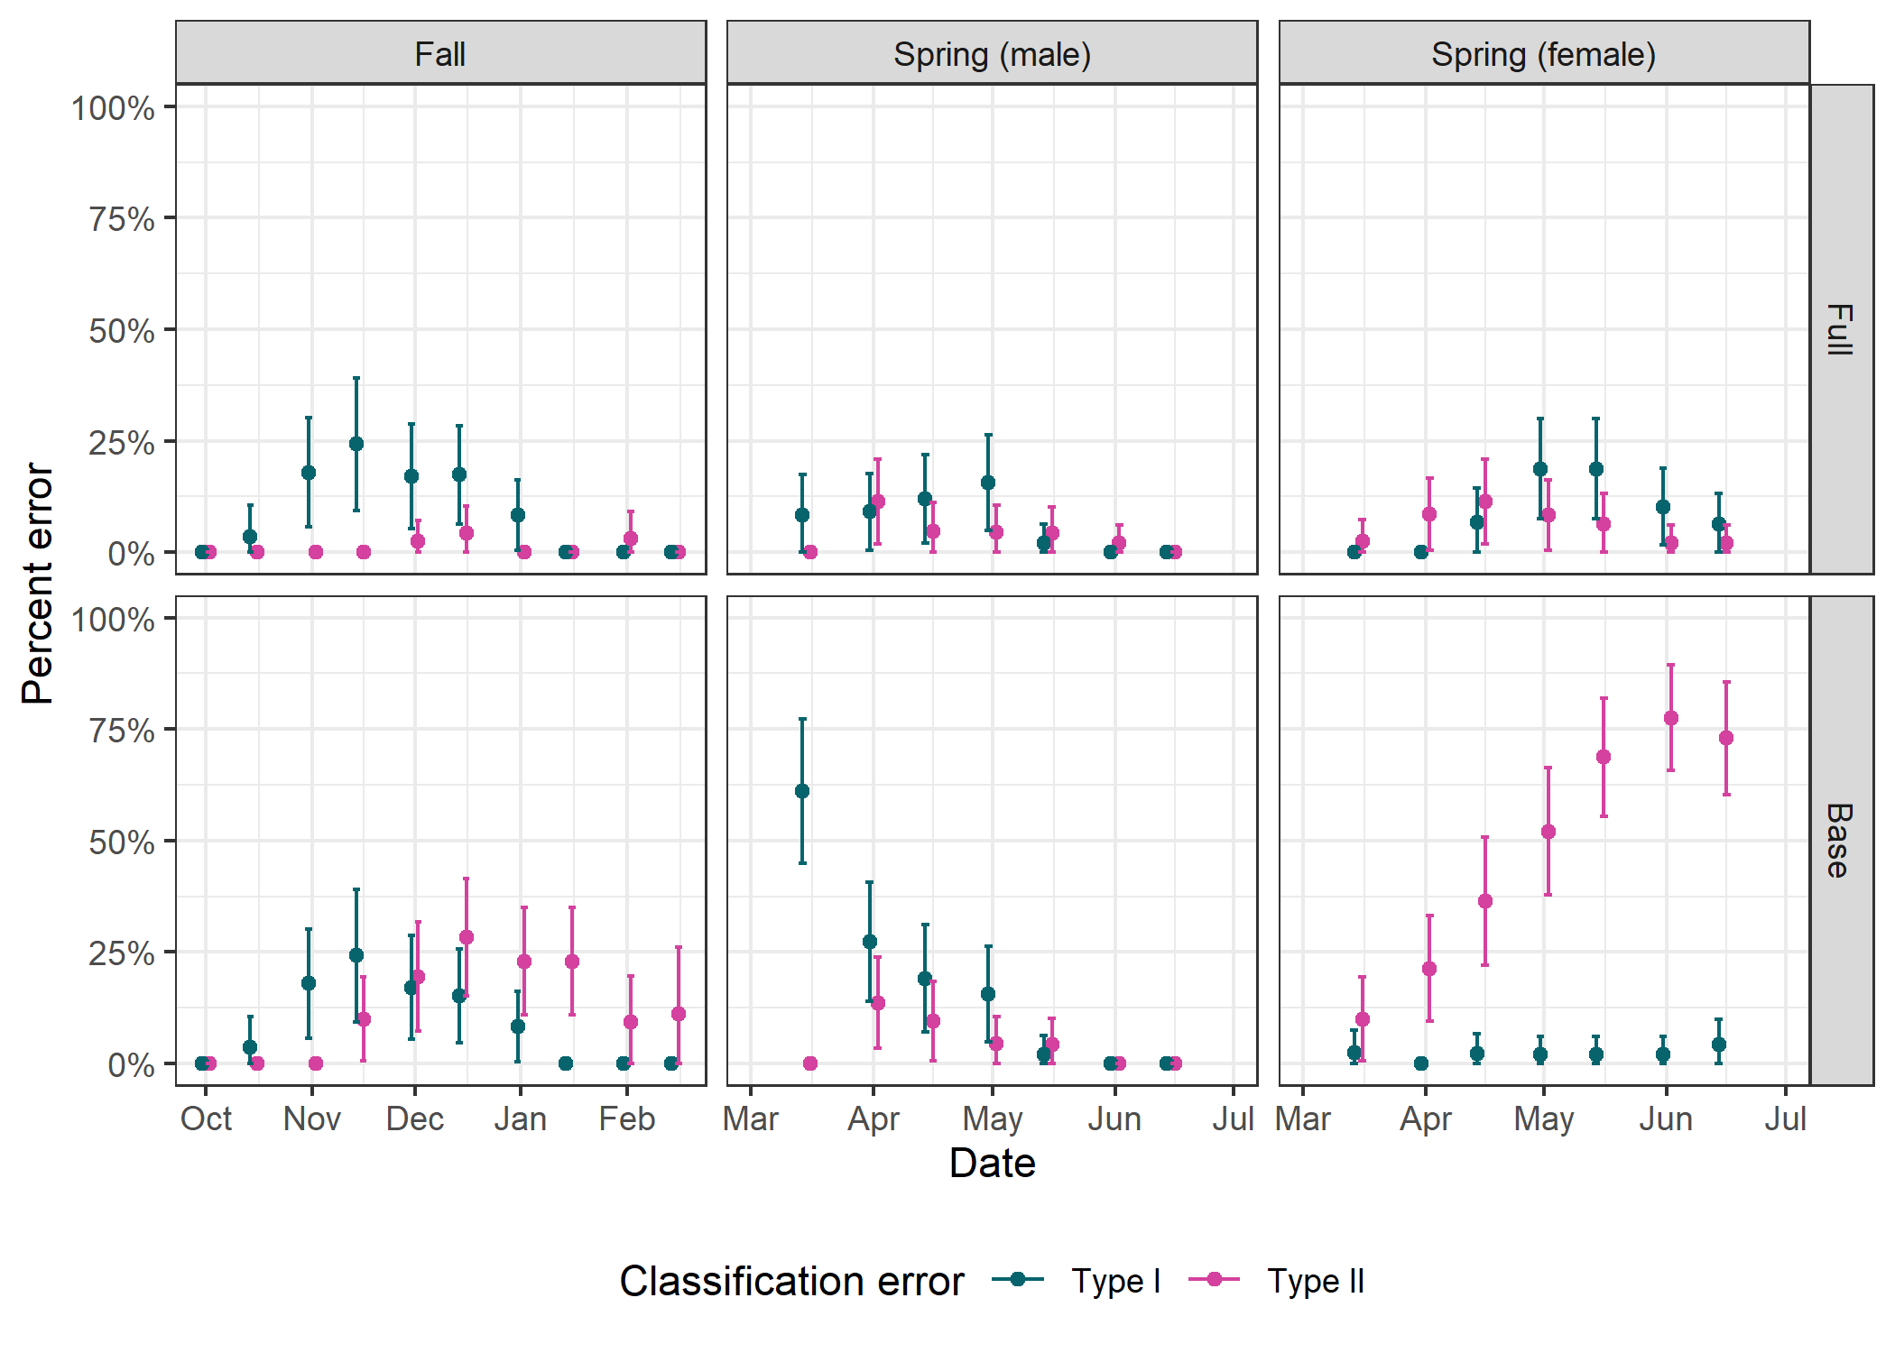

Figure 3. Error rates for movement state assignments by hidden Markov Models (HMM) for fall, spring (male), and spring (female) migrations, as measured through the model validation process. The horizontal axis reflects the cutoff date for each model that was used to simulate an incomplete track ending on that date. HMMs were grouped into full and base models, where full models included all possible data streams and base models including only step length and turn angle. Type 1 errors reflected false classification as post-migratory while the true state was migratory, whereas Type 2 errors reflected false classification as migratory while the true state was post-migratory. Bars show the 95% confidence interval of the mean.

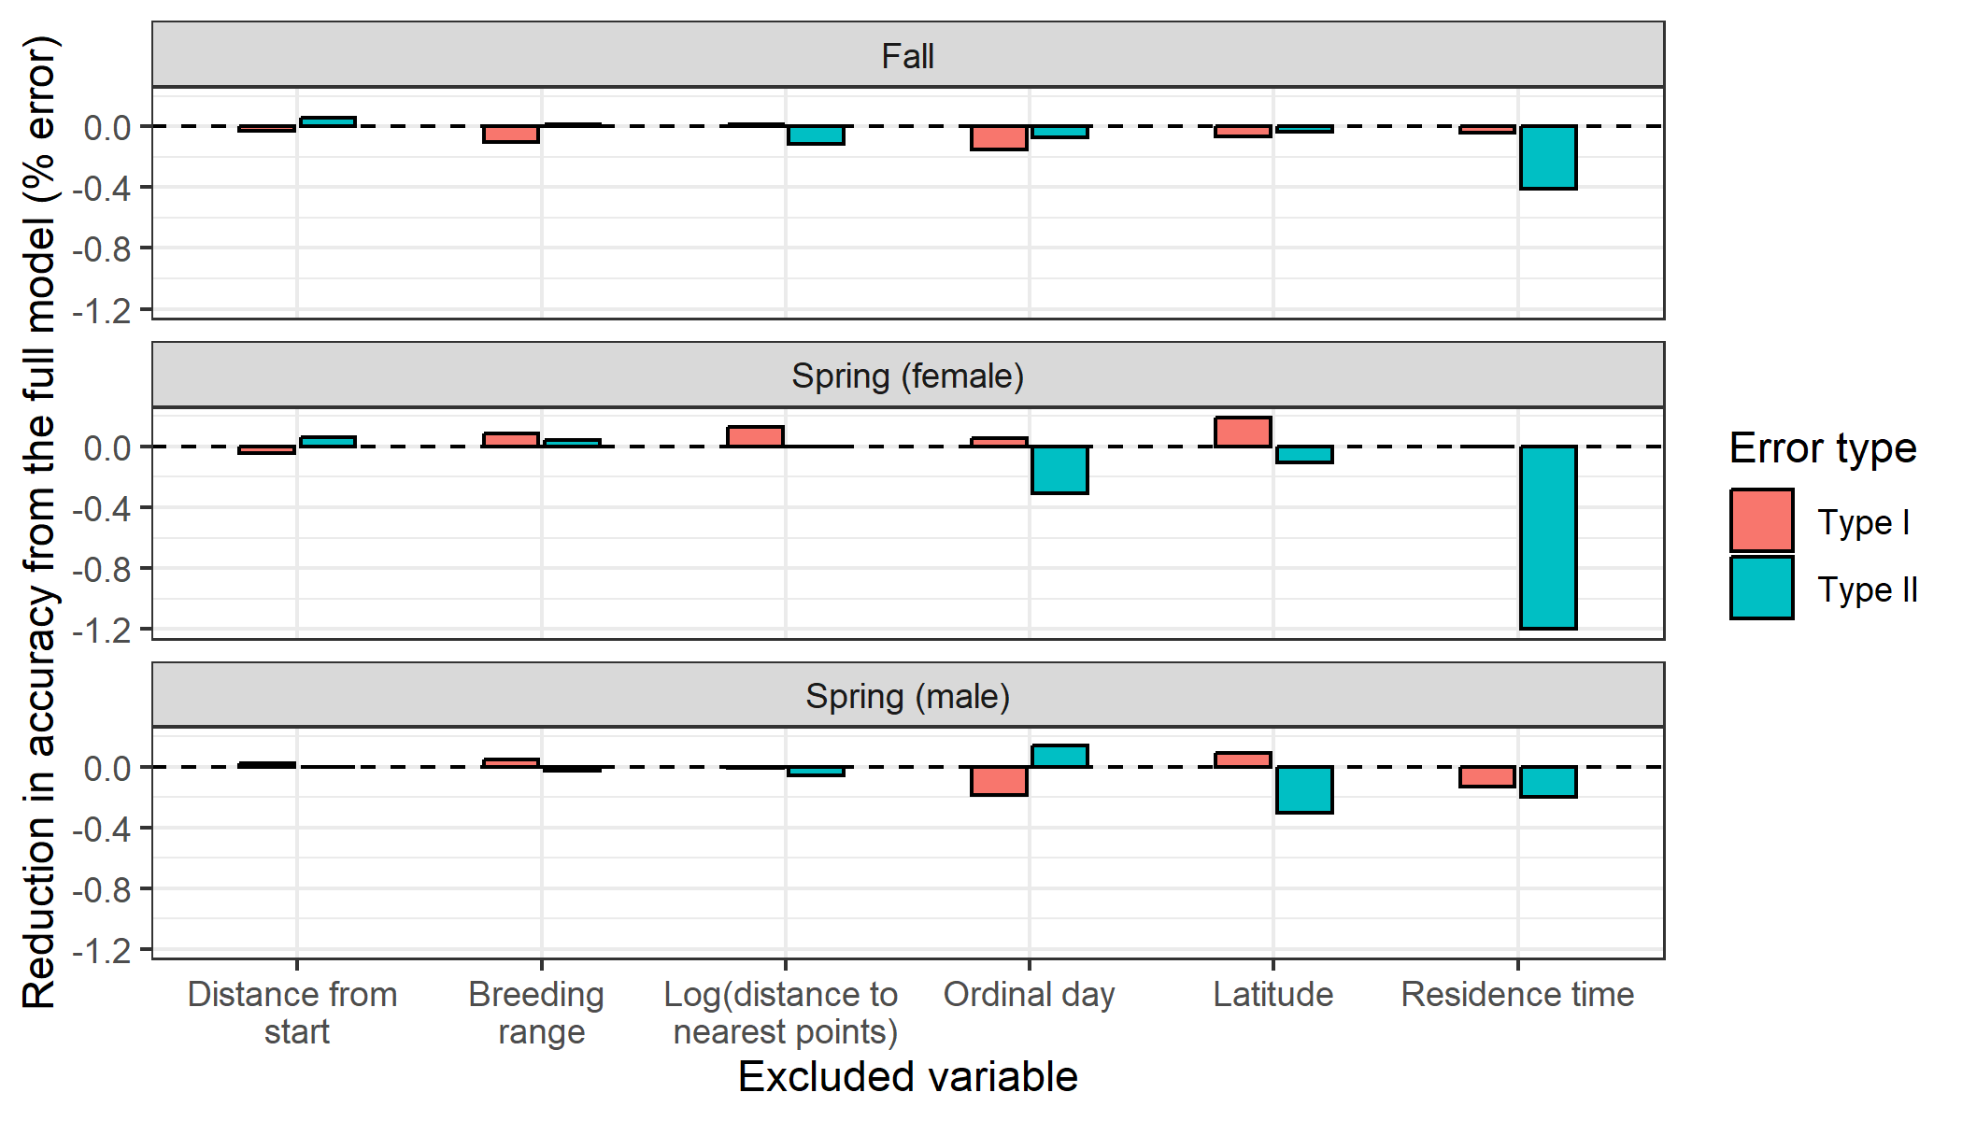

Figure 4. Reduction in accuracy from the full model due to removal of individual data streams. Error definitions. Negative values indicate reductions in accuracy, while positive values indicate that accuracy improved when the variable was excluded from the model.

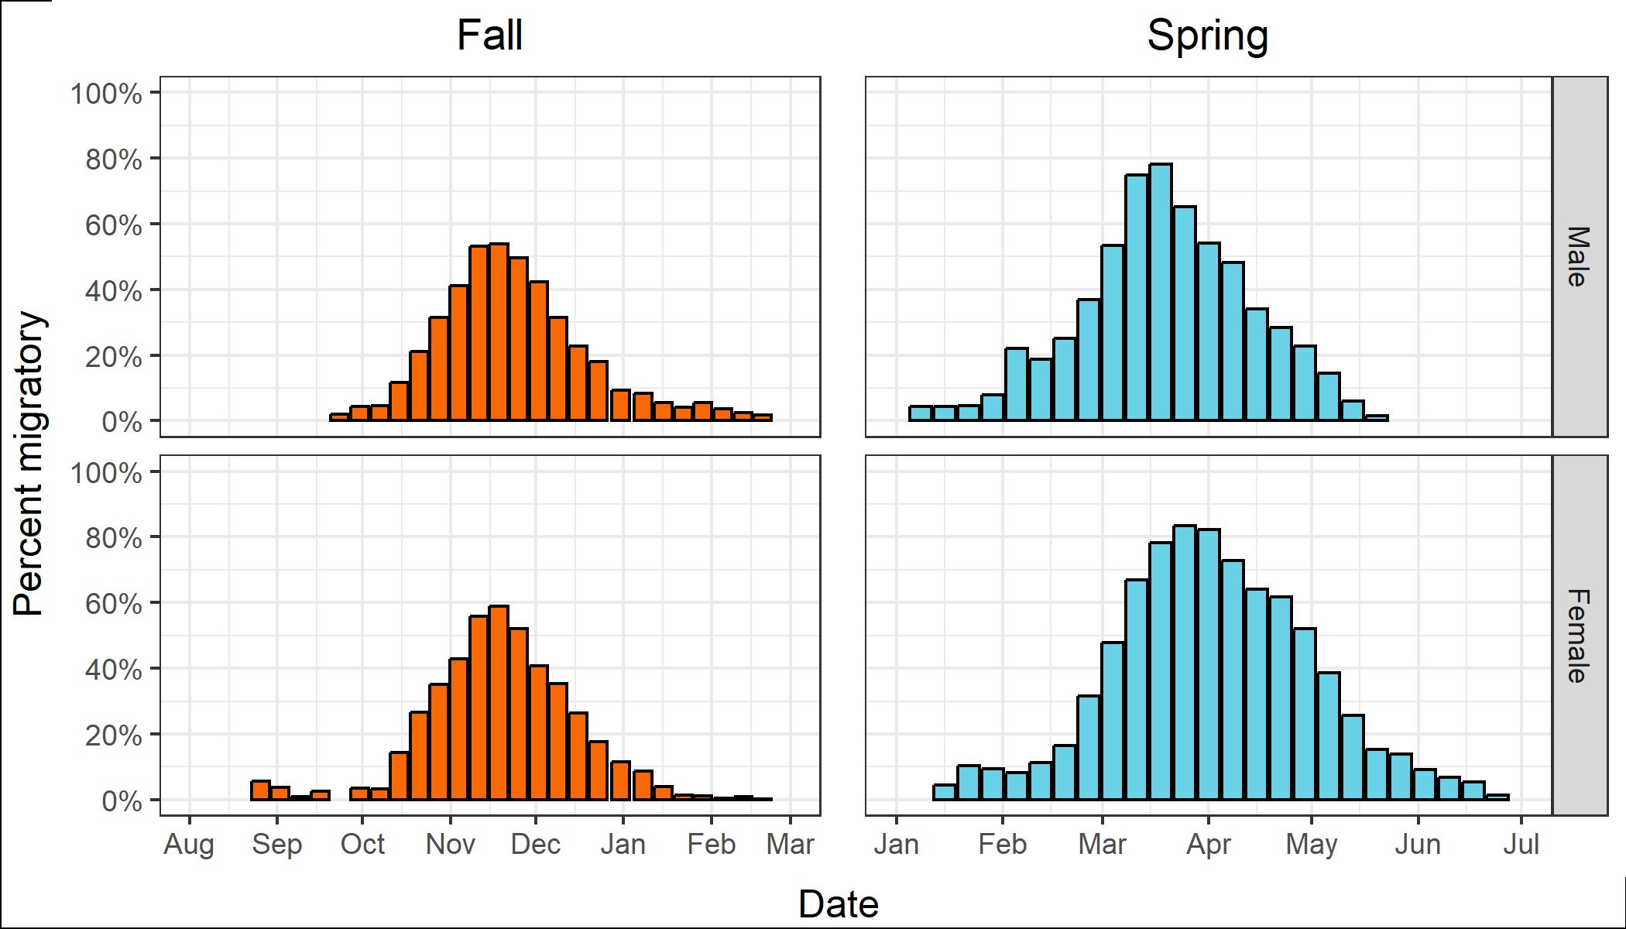

Figure 5. Peak migration dates of male and female American Woodcock throughout the fall and spring migratory seasons. Color indicates season, and the vertical axis reflects the percentage of all locations in each week that fell into fall or spring migratory movement classes.

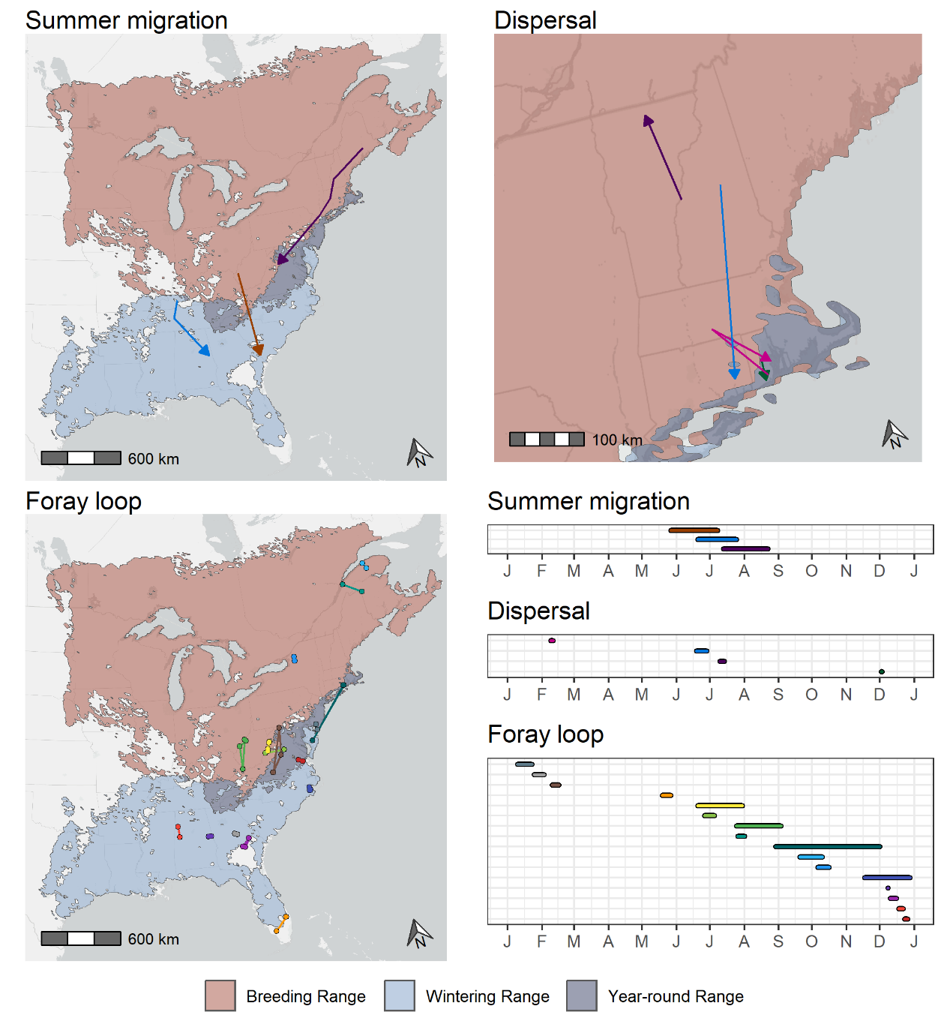

Figure 6. Spatial and temporal distribution of summer migrations, dispersals, and foray loops of American Woodcock marked with GPS transmitters in eastern North America. Maps are superimposed over the breeding, wintering, and year-round range of the American Woodcock as delineated by the eBird Status and Trends dataset (Fink et al. 2022). Timelines depict the duration of each movement by month. Each movement is matched from the map to the timeline by color.

**Discussion**

Data streams improved model

We found that the use of additional data streams, allowed hidden Markov models to better fit the migratory movements of American Woodcock. The magnitude of the improved fit differed by error type and seasonal model, with the largest improvements occurring for Type II errors in the spring female model (Type II error ranges- base model: tk–tk%, full model: tk–tk%,; Fig. 3). Despite differences in error rates between base and full models, removal of individual variables from the full model resulted in only minor differences in error rates (range: -1.20–0.19%; Fig. 4), suggesting that many of the additional data streams had some level of redundancy. Hidden Markov models work well with redundancy due to…

Redundancy in data streams is not necessarily a bad thing for hidden Markov models and may even be a good thing, based on weak learners theory (cite tk).

The use of large numbers of additional data streams to fit hidden Markov models may therefore assist in fitting sparse datasets. While additional data streams are often collected directly from transmitters (e.g. accelerometer or altitude data), we demonstrate that data streams derived from location, time, and movement characteristics can also be informative for predicting migratory states. In addition to the metrics shown here, habitat use may also be an informative predictor of migratory state, based on observed differences in migratory habitat from that used during other times of the year (cite thrush paper tk). We also note that the movement characteristic data streams observed here, log distance to nearest points and residence time, only capture the spatial point characteristics of woodcock movements. Track characteristics, such as tortuosity, are difficult to capture in sparse datasets, but further work on this may yield additional variables which might have value as data streams for detecting migratory states.

Phenology; seasonal overlap, late spring migration

As expected from past descriptions of woodcock migratory phenology (cite BOTW tk), woodcock initiate migration later in the fall than many other North American birds and initiate migration earlier in the spring. The departure of woodcock from the breeding range in the fall and return in the spring line up closely with the dates on which the ground freezes and thaws, respectively, likely due to earthworm availability (cite tk). Fall migration is generally considered to last until late December, when most birds have reached the wintering range and spring migration lasts until mid-May, at which point most females have begun nesting (cite BOTW tk). While the majority of tracked woodcock followed these patterns, we found that early initiations and late terminations are more frequent in our dataset than we anticipated. Late terminations of fall migration and early initiations of spring migration demonstrate a common pattern of continued migratory movement during wintering period for a small proportion of individuals. The reasons for this continued movement are unclear; for most bird species, migration is a costly action (cite tk), and continued migration late into the wintering season would presumably have energetic consequences. One potential explanation is tied to food availability; woodcock are earthworm specialists, and earthworm soil depth correlates with soil temperature in the winter months (cite tk). It’s possible that woodcock are prone to nomadic migratory movements as earthworm availability changes throughout the winter, especially at mid-latitudes where soil temperature is more variable. Our results suggest that most late terminations of fall migration are indeed at mid-latitudes. Females tended to continue migration far longer into the early breeding season than males did. Nesting analyses using this dataset indicate that woodcock frequently resume migration after nesting attempts, often making nesting attempts at multiple latitudes during their migration north, explaining why female woodcock are still making migratory movements in June after nesting has started (Slezak et al. tk).

Both the continued migration of birds throughout the wintering season and alternation between nesting and migration in the spring suggest that woodcock physiology may not undergo the same drastic changes that other birds do in advance of migration. Certain species of birds, and especially Scolopacids, are known to prepare for migration through increases in hormone levels, reabsorption of organs, and changes in muscle mass which prime them for migration but leave them ill-suited for reproduction or foraging (cite tk). Woodcock have a comparatively large body size to migratory distance ratio compared to other North American migrants, which might allow them to more easily bear the energetic costs of migration without extensive modifications that would preclude reproduction. Further study of woodcock physiology during the migratory season may shed some light on how woodcock adapt to rapid switches between reproductive efforts and migration.

A small proportion of birds initiate fall migration prior to October 15th (males: tk, females: tk) and continue migrating after Jan. 1st (males: tk, females: tk), with females having a higher incidence of early migration and males having a higher incidence of late migration (Fig. tk). A higher proportion of birds initiate spring migration prior to Feb. 15th (males: tk, females: tk), and females in particular are likely to terminate migration after May 15th (males: tk, females: tk). Overlap between the periods of fall and spring occurred for a small number of birds between tk date and tk date (tk% birds continuing fall migration after tk date, tk% birds initiating spring migration before tk date).

LDMs; ecological precedent

Outside of migration, we observed long-distance movements by woodcock, including dispersal movements, foray loops, and summer migrations. These types of extra-seasonal movements have been noted occasionally among species such as tk (cite tk) and tk (cite tk). We posit that extra seasonal movements are likely even more common than have been observed so far, but due to the difficulty associated with tracking small birds during small scale movements these movements are difficult to identify. The ecological reasons for these movements are unclear. Dispersal movements were largely limited to the northeastern United States and may be the result of changing environmental conditions near the northernmost extent of the year-round range (Fig. 6). Three of the 4 movements ended near coastal areas of Connecticut and Rhode Island where milder conditions frequently allow woodcock to persist throughout the winter. Foray loops were much more geographically widespread, occurring throughout the wintering and breeding range. The reasons for foray loops are much less clear, and may range from avoiding negative environmental conditions in the winter (see movements from Rhode Island to Maryland and back) to foraging and exploratory behaviors, which are more frequently associated with foray loops (cite tk, this might be a good memory paper thing). Summer migration is an infrequently noted phenomenon among bird species, although it has been noted among other Scolopacid species in the past (cite tk). Radar studies have also noted that some level of migration continues throughout the summer season, even outside of traditional migratory periods (cite tk). It is possible that summer migrations are an infrequent behavior among other common bird species, but the lack of prevalence of tracking devices has so far made these movements hard to observe so far.

Movement ecology tools are rarely designed to work with migratory bird data

The field of movement ecology has become increasingly focused on innovations in transmitters that can record locations at a nearly constant frequency, allowing tracking of certain animals to a minute-by-minute resolution (cite tk). While the resulting methods for approximating continuous trajectories and instantaneous habitat selection decisions has considerable merit for the field (cite tk), methodological advances have largely overlooked the increasing prevalence of small transmitters that can fit on a much larger portion of the world’s animals but collect much more sparse and irregular data. The satellite GPS transmitters used in this manuscript are an excellent example, as are the increasing prevalence of Motus transmitters in bird migration studies (cite tk). While this study demonstrates that hidden Markov models can be retrofitted for use with sparse and irregular data, new methods will eventually be required for the abundance of new transmitter data collected by migratory bird studies. Innovations in animal movement models are an excellent example of a possible frontier for innovation in bird movement modeling. Traditional correlated random walk models, as demonstrated in this manuscript, can encounter difficulties with infrequent locations and data gaps that are common in migratory bird data (cite tk). Spatial point process models may provide a hopeful alternative to correlated random walk models that are better suited to migratory bird data, due to their tolerance of long, rapid migratory movements and irregular data (cite Camila tk). Beyond advances in modeling techniques, proper modeling of migratory bird movements may require bespoke models which are specifically designed to accommodate rapid alternation between stopover states with short, recursive steps and migratory states with long, directional steps. With further innovation, we can take the myriad successes of the advancement of the field of movement ecology and better apply those tools to the much larger network of animals which can be tracked using small transmitters.

**References**

Battley, P. F., N. Warnock, T. L. Tibbitts, R. E. Gill, T. Piersma, C. J. Hassell, D. C. Douglas, D. M. Mulcahy, B. D. Gartrell, R. Schuckard, D. S. Melville, and A. C. Riegen (2012). Contrasting extreme long-distance migration patterns in bar-tailed godwits Limosa lapponica. Journal of Avian Biology 43:21–32.

Berger-Tal, O., and S. Bar-David (2015). Recursive movement patterns: review and synthesis across species. Ecosphere 6:art149.

Berigan, L. A. (2019). Dispersal, reproductive success, and habitat use by translocated lesser prairie-chickens.

Blomberg, E. J., A. C. Fish, L. A. Berigan, A. M. Roth, R. Rau, S. J. Clements, G. Balkcom, B. Carpenter, G. Costanzo, J. Duguay, C. L. Graham, et al. (no date). The American Woodcock Singing Ground Survey largely conforms to the phenology of male woodcock migration. The Journal of Wildlife Management n/a:e22488.

Bridge, E. S., K. Thorup, M. S. Bowlin, P. B. Chilson, R. H. Diehl, R. W. Fléron, P. Hartl, R. Kays, J. F. Kelly, and W. D. Robinson (2011). Technology on the move: recent and forthcoming innovations for tracking migratory birds. BioScience 61:689–698.

Burnside, R. J., N. J. Collar, and P. M. Dolman (2017). Comparative migration strategies of wild and captive‐bred Asian Houbara *Chlamydotis macqueenii*. Ibis 159:374–389.

Combreau, O., S. Riou, J. Judas, M. Lawrence, and F. Launay (2011). Migratory pathways and connectivity in Asian houbara bustards: evidence from 15 years of satellite tracking. PloS one 6:e20570.

Dawson, W. R. (2020). Pine Siskin (Spinus pinus), version 1.0. In Birds of the World (A. F. Poole, Editor). Cornell Lab of Ornithology, Ithaca, NY, USA.

Dean, B., R. Freeman, H. Kirk, K. Leonard, R. A. Phillips, C. M. Perrins, and T. Guilford (2013). Behavioural mapping of a pelagic seabird: combining multiple sensors and a hidden Markov model reveals the distribution of at-sea behaviour. Journal of The Royal Society Interface 10:20120570.

Ephraim, Y., and N. Merhav (2002). Hidden markov processes. IEEE Transactions on information theory 48:1518–1569.

Fink, D., T. Auer, A. Johnston, M. Strimas-Mackey, S. Ligocki, O. Robinson, W. Hochachka, L. Jaromczyk, A. Rodewald, C. Wood, I. Davies, and A. Spencer (2022). eBird Status and Trends.

Iverson, A. R., D. L. Humple, R. L. Cormier, and J. Hull (2023a). Land cover and NDVI are important predictors in habitat selection along migration for the Golden-crowned Sparrow, a temperate-zone migrating songbird. Movement Ecology 11:2.

Iverson, A. R., J. L. Schaefer, S. M. Skalos, and C. E. Hawkins (2023b). Global positioning system (GPS) and platform transmitter terminal (PTT) tags reveal fine-scale migratory movements of small birds: A review highlights further opportunities for hypothesis-driven research. Ornithological Applications 125:duad014.

Johnson, D. S., and J. M. London (2018). crawl: an R package for fitting continuous-time correlated random walk models to animal movement data. [Online.] Available at https://doi.org/10.5281/zenodo.596464.

Klaassen, R. H. G., M. Hake, R. Strandberg, B. J. Koks, C. Trierweiler, K. Exo, F. Bairlein, and T. Alerstam (2014). When and where does mortality occur in migratory birds? Direct evidence from long‐term satellite tracking of raptors. Journal of Animal Ecology 83:176–184.

Langrock, R., J. G. C. Hopcraft, P. G. Blackwell, V. Goodall, R. King, M. Niu, T. A. Patterson, M. W. Pedersen, A. Skarin, and R. S. Schick (2014a). Modelling group dynamic animal movement. Methods in Ecology and Evolution 5:190–199.

Langrock, R., R. King, J. Matthiopoulos, L. Thomas, D. Fortin, and J. M. Morales (2012). Flexible and practical modeling of animal telemetry data: hidden Markov models and extensions. Ecology 93:2336–2342.

Langrock, R., T. A. Marques, R. W. Baird, and L. Thomas (2014b). Modeling the diving behavior of whales: a latent-variable approach with feedback and semi-Markovian components. Journal of Agricultural, Biological, and Environmental Statistics 19:82–100.

Linscott, J. A., J. G. Navedo, S. J. Clements, J. P. Loghry, J. Ruiz, B. M. Ballard, M. D. Weegman, and N. R. Senner (2022). Compensation for wind drift prevails for a shorebird on a long-distance, transoceanic flight. Movement Ecology 10:11.

Mander, L., I. Nicholson, R. M. W. Green, S. G. Dodd, R. M. Forster, and N. H. K. Burton (2022). Individual, sexual and temporal variation in the winter home range sizes of GPS-tagged Eurasian Curlews *Numenius arquata*. Bird Study 69:39–52.

McAuley, D. G., J. R. Longcore, and G. F. Sepik (1993). Techniques for Research into Woodcocks: Experiences and Recommendations. Proceedings of the eighth American woodcock symposium. U.S. Fish and Wildlife Service, p. 5.

McClintock, B. T., and T. Michelot (2018). momentuHMM: R package for generalized hidden Markov models of animal movement. Methods in Ecology and Evolution 9:1518–1530.

Moskát, C., M. Bán, A. Fülöp, J. Bereczki, and M. E. Hauber (2019). Bimodal habitat use in brood parasitic Common Cuckoos (Cuculus canorus) revealed by GPS telemetry. The Auk: Ornithological Advances 136:uky019.

Picardi, S., P. Coates, J. Kolar, S. O’Neil, S. Mathews, and D. Dahlgren (2022). Behavioural state‐dependent habitat selection and implications for animal translocations. Journal of Applied Ecology 59:624–635.

R Core Team (2022). R: A Language and Environment for Statistical Computing. R Foundation for Statistical Computing, Vienna, Austria.

Rieffenberger, J. C., and R. C. Kletzly (1966). Woodcock night-lighting techniques and equipment. WH Goudy, compiler. Woodcock research and management:33–35.

Sheldon, W. G. (1960). A method of mist netting woodcocks in summer. Bird-banding 31:130–135.

Wright, J. R., J. A. Johnson, E. Bayne, L. L. Powell, C. R. Foss, J. C. Kennedy, and P. P. Marra (2021). Migratory connectivity and annual cycle phenology of Rusty Blackbirds (Euphagus carolinus) revealed through archival GPS tags. Avian Conservation & Ecology 16.

Zucchini, W., I. L. MacDonald, and R. Langrock (2017). Hidden Markov models for time series: an introduction using R. CRC press.