*Enhancing hidden Markov models using additional data streams can better track a migratory bird with incomplete or missing GPS data*

Liam Berigan1*, Rachel Darling1, Sarah Clements1, Alex Fish1, Amber Roth1,2, Greg Balkcom3, Bobbi Carpenter4, Gary Costanzo5, Jeffrey Duguay6, Kayleigh Filkins7, Clayton Graham8, William Harvey9, Michael Hook10, Douglas Howell11, Seth Maddox12, Scott McWilliams13, Shawn Meyer14, Theodore Nichols15, J. Bruce Pollard16, Christian Roy17, David Sausville18, Colby Slezak13, Josh Stiller19, Jacob Straub7, Mathieu Tetreault17, Dawn Washington20, Lisa Williams21, Erik Blomberg1.

1 Department of Wildlife, Fisheries, and Conservation Biology, University of Maine, Orono, Maine, USA.

2 School of Forest Resources, University of Maine, Orono, Maine, USA.

3 Georgia Department of Natural Resources, Wildlife Resources Division, Fort Valley, Georgia, USA.

4 Fish and Wildlife Research Institute, Florida Fish and Wildlife Conservation Commission, Gainesville, Florida, USA.

5 Virginia Department of Wildlife Resources, Charles City, Virginia, USA.

6 Louisiana Department of Wildlife and Fisheries, Baton Rouge, Louisiana, USA.

7 Department of Environmental Science and Ecology, State University of New York-Brockport, Brockport, New York, USA.

8 Department of Natural Resources Science, University of Rhode Island, Kingston, Rhode Island, USA.

9 Wildlife and Heritage Service, Maryland Department of Natural Resources, Cambridge, Maryland, USA.

10 South Carolina Department of Natural Resources, Columbia, South Carolina, USA.

11 North Carolina Wildlife Resources Division, Wildlife Management Division, Edenton, North Carolina, USA.

12 Wildlife and Freshwater Fisheries Division, Alabama Department of Conservation and Natural Resources, Montgomery, Alabama, USA.

13 Department of Natural Resources Science, University of Rhode Island, Kingston, Rhode Island, USA.

14 Environment and Climate Change Canada, Ottawa, Ontario, Canada.

15 New Jersey Division of Fish and Wildlife, Woodbine, New Jersey, USA.

16 Environment and Climate Change Canada, Sackville, New Brunswick, Canada.

17 Environment and Climate Change Canada, Gatineau, Quebec, Canada.

18 Vermont Fish and Wildlife Department, Essex Junction, Vermont, USA.

19 New York State Department of Environmental Conservation, Division of Fish and Wildlife, Albany, New York, USA.

20 U.S. Fish and Wildlife Service, Davis, West Virginia, USA.

21 Pennsylvania Game Commission, Harrisburg, Pennsylvania, USA.

*Corresponding author: liamaberigan@gmail.com

# Abstract

*Background*: Recent technological advances resulting in the widespread collection of tracking data from birds necessitates tools for the effective processing and classification of that data. Tools such as hidden Markov models (HMMs) provide opportunities to classify movement states from high-resolution Global Positioning System (GPS) data collected at frequent, regular intervals. However, small-bodied migratory birds often cannot carry tags that can collect GPS data frequently which limits the applicability of HMMs.

*Methods*: We applied HMMs supplemented with additional data streams (composed of spatial and temporal variables derived from the movement track; e.g., latitude, ordinal day) to fit infrequent and irregular GPS data from American Woodcock (*Scolopax minor*; hereinafter woodcock). Our objectives were to determine if additional data streams improved an HMM’s capacity to predict migratory states and characterize woodcock migratory distance, duration, phenology, and the presence of long-distance movements outside of fall and spring migration.

*Results*: We found that each additional data stream only marginally improved model performance, but collectively data streams decreased model error rates by a median value of 5.93%. Migratory characteristics measured using a full model which included all data streams were similar to a base model which only included step length and turn angle for all birds during fall and for males during spring. However, the full model was 2.12 times more likely to identify a migratory endpoint than the base model for females during spring. The mean duration and distance of migration was also underestimated by 7 days and 278 kilometers for the base model as opposed to the full model for females during spring. Long-distance movements outside of fall and spring migration, such as directional movements and foray loops, were less frequently identified with the base model (3 directional movements, 15 foray loops) as opposed to the full model (4 directional movements, 18 foray loops).

*Conclusions*: Adding additional data streams to HMMs increases the classification accuracy of migratory movements for birds tracked using sparse and irregular GPS data. This technique may be particularly beneficial for classifying the migratory movements of bird species with overlapping seasonal distributions and prolonged stopovers.

*Keywords*: American Woodcock, *Scolopax minor*, hidden Markov model, migration, long-distance movements

# Background

The amount of tracking data collected from birds has substantially increased in the 21st century [1], providing opportunities to address facets of bird migration that have long eluded ornithologists, such as migration phenology [2], migratory habitat use [3,4], survival [5], and connectivity [6]. In particular, GPS tracking devices can provide data at a high temporal resolution with near global spatial coverage. GPS transmitters have traditionally required large batteries or solar panels which limit their use to larger birds. However, recent innovations in these technologies have allowed GPS technology to become available for smaller-bodied birds, facilitating migration studies for a wide range of bird species [7,8].

To answer questions about bird migration, GPS data are often classified into movement states that delineate ecological periods such as pre-migration, migration, and post-migration, under one of several frameworks (summarized in [9]). The spatial threshold method (Fig. 1A; [10–15]) is based on the known breeding and wintering ranges, where a bird is considered to have begun fall migration when it leaves the breeding range, completed migration when it enters the wintering range, and vice versa in the spring. The spatial threshold method has the advantage of being robust to incomplete tracks; if a bird dies or transmitter failure occurs during the bird’s migration, the bird’s final state is still apparent. However, the spatial threshold method assumes constrained breeding and wintering ranges that have no overlap with the migratory range (ex. Bar-tailed Godwit, *Limosa lapponica*; [16]). In contrast, the absolute displacement method [17–19] defines the start of migration by the first movement longer than a defined distance threshold, and migration ends with the last movement longer than the distance threshold (Fig. 1B). The absolute displacement method does not rely on the assumption that breeding and wintering ranges do not overlap with the migratory range, making this method applicable to birds with overlapping seasonal ranges (ex. Pine Siskin, *Spinus pinus*; [20]). However, the absolute displacement method is sensitive to incomplete tracks: if a bird dies or its transmitter fails during migration, it is impossible to determine whether the bird made its final migratory step (Fig. 2). Quantifying the terminal migration state is particularly important for survival and connectivity analyses, as well as phenology and habitat analyses for which accurate delineation of migration status is important.

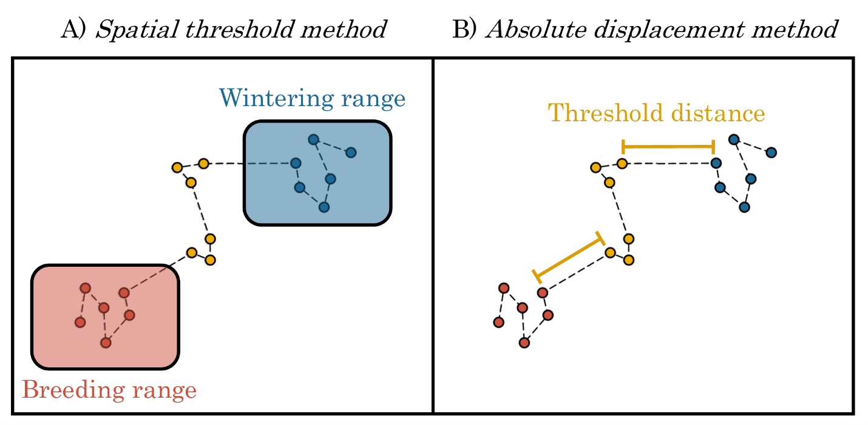

Figure 1. Spatial threshold [10–15] and absolute displacement [17–19] methods of delineating migratory tracks. Using the spatial threshold method (Panel A), migratory locations can be defined as all locations outside the breeding and the wintering range. Using the absolute displacement method (Panel B), migratory locations can be categorized as all locations occurring after the first migratory step (determined using a threshold step length) and prior to the final migratory step.

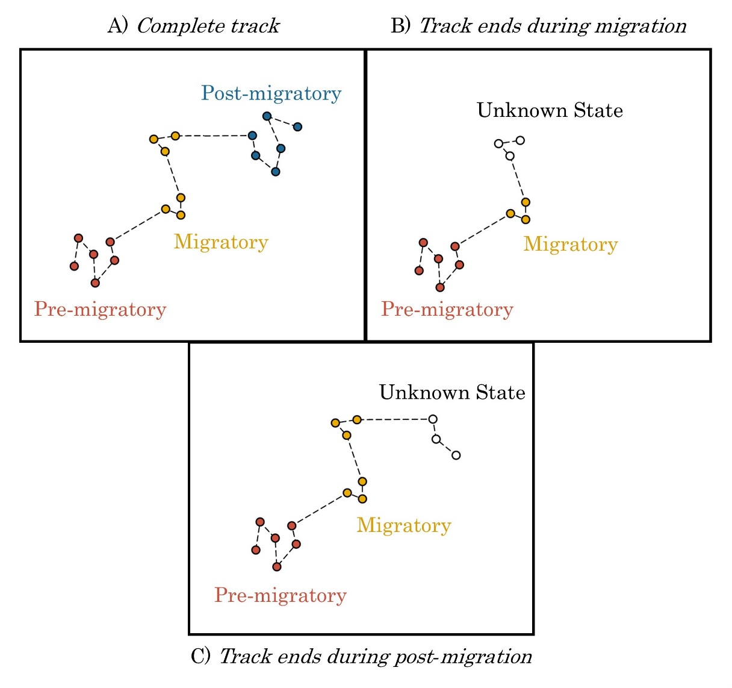

Figure 2. Complete and incomplete tracks of a theoretical migratory bird. For birds with complete tracks (Panel A; encompassing the entire temporal period of migration), the pre-migratory, migratory, and post-migratory stages of the track are apparent, and can be identified using the spatial threshold or step-length threshold methods. For birds with incomplete tracks (Panels B and C) the final state of the bird cannot be determined using a step-length threshold. If points cannot otherwise be delineated using breeding and wintering ranges, incomplete tracks end in an uncertain state that could be either migratory or post-migratory.

Hidden Markov models (HMMs) use observed distributions of outcome variables to assign movement states to animal tracking data and could potentially overcome limitations of the spatial threshold and absolute displacement methods, particularly for the final movement state of incomplete movement tracks [21,22]. Step length and turn angle are the two most common data streams used by hidden Markov models in movement analyses, although additional data streams (e.g., acceleration, depth/altitude, and immersion in water) can be used to improve the model’s predictive capabilities [23]. HMMs have delineated foraging, dispersal, and migratory behaviors for a variety of bird taxa including shorebirds, sage-grouse, prairie grouse, and seabirds [23–28]. These taxa can carry large transmitters (often with solar panels) that provide high frequency, regular location data over long periods of time, which assists with fitting HMMs. However, frequent and regular GPS data collection is difficult for bird species with small body sizes and forest-dwelling or nocturnal habits (i.e., no direct sunlight for solar panels). These data limitations complicate using traditional HMM approaches for many taxa.

We illustrate the fitting of HMMs to low-frequency GPS data using American woodcock (*Scolopax minor*; hereinafter woodcock). Woodcock are widely distributed throughout eastern North America, typically breeding in the northern United States and southern Canada and wintering in the southern United States. They are frequently among the latest migrants to leave the breeding range as frost encroaches in the fall and the earliest to arrive as snow melts in the spring [29]. Woodcock are particularly flexible in their migratory and reproductive timing; females regularly nest in the migratory and wintering ranges and have been observed migrating between nesting attempts [30]. Woodcock can carry small GPS transmitters with limited battery life (woodcock mass: 116–279 g, maximum transmitter mass (< 4 % of body mass): 4–6 g; [31]).

Here we present a modified approach combining the absolute displacement method and HMMs to classify large-scale movement behaviors, such as migration, using sparse and irregular GPS data. We used a three-stage process: 1) interpolation of data at a regular interval using a correlated random walk model [32], 2) delineating known movement states using the absolute displacement method, and 3) estimating unknown movement states using an HMM with additional data streams that describe the time, location, and movement characteristics of each GPS point. Our objective was to determine whether use of additional data streams facilitated estimation of terminal movement states from incomplete GPS tracks and improved our ability to quantify woodcock migratory distance, duration, phenology, and long-distance movements outside of fall and spring migration.

# Methods

## Collecting data via GPS transmitters

We used GPS-tracking data from 2017–2022 collected by the Eastern Woodcock Migration Research Cooperative, a collaboration of 43 agency, non-profit, and academic organizations in eastern North America [24,33,34]. We captured woodcock at 78 sites throughout Quebec, Ontario, Nova Scotia, Maine, Vermont, New Jersey, New York, Rhode Island, Pennsylvania, Maryland, West Virginia, Virginia, North Carolina, South Carolina, Georgia, Alabama, Louisiana, and Florida. We used mist nets to capture woodcock during morning and evening flights [35] and used spotlights and dip nets on night roosts [36,37]. We attached 4g, 5g, or 6.3g PinPoint GPS Argos transmitters (Lotek Wireless Inc., Newmarket, Ontario, CA) to captured woodcock. GPS transmitters were programmed with one of several schedules designed to collect data at different frequencies according to specific project objectives. The most frequent schedules recorded locations daily, while infrequent schedules recorded locations every 2–3 days during migratory time periods and every 3–7 days outside of migration. Certain schedules were programmed to switch between frequent and infrequent modes, and transmitters were occasionally set to go dormant for periods of 1–3 months during summer and fall to preserve battery life for separate study objectives. Transmitters were predicted to collect a maximum of 75–150 GPS locations, depending on transmitter size and schedule, at 12–60m accuracy. Transmitters relayed GPS locations to the ARGOS satellite network after every 3rd location; however, transmitters occasionally failed to relay data, resulting in GPS locations not being recorded at scheduled times.

## Delineating spring and fall migration

### Track interpolation and application of the absolute displacement method

We delineated woodcock movements during periods of fall (Aug. 1st–Feb. 25th) and spring (Jan. 5th–Jun. 30th) migration, based on initial observations of the timing of northerly and southerly movements. However, for a small subset of birds (n = 14; 3%) we extended these date ranges due to migratory movements that occurred outside these periods (Supplementary material: S1). Woodcock have flexible migratory timing in the fall [34], which occasionally caused the last fall migrants to settle after the first day of spring migration (Jan. 5th). To ensure that fall and spring migratory movements were delineated separately, we modeled spring migrations first for each woodcock, and removed any spring migratory movements from consideration in the prior fall season.

We interpolated daily locations within each track prior to fitting HMMs, as infrequent and missing locations can impede the ability of the HMMs to detect recursive movements (defined as repeated visitations to the same locations in a systematic manner, *sensu* [38]) which could be indicative of stopovers and post-migratory settlement. We used a correlated random walk model implemented in the R package crawl [39,40], which interpolated locations based on prior and subsequent location, speed, and direction, resulting in fewer time gaps in movement tracks. We predicted that interpolated locations would improve the capacity of the HMM to detect recursive movements more accurately during stationary periods: however, during initial model fitting, we observed that correlated random walk locations often prevented the HMM from recognizing migratory movements. To address this tendency, we removed interpolated points when the distance between observed points was ≥16.1 km (i.e., when the bird was actively migrating). Due to the directional consistency inherent in correlated random walks, models occasionally produced erroneous loops of interpolated points when birds made recursive movements during non-migratory periods. These interpolated loops were often lengthy and could artificially create step lengths ≥16.1 km. To ensure that HMMs did not incorrectly assign these loops as migratory movements, we removed all loops of interpolated points for which the total length of the loop exceeded 10 times the distance between observed points and replaced the loops with predicted locations spaced evenly between the observed points.

Following point interpolation, we applied the threshold method [19] to define migration for each season on an individual basis, beginning after the first movement ≥16.1 km and ending after the final ≥16.1 km movement. We chose a 16.1 km threshold as it roughly bisects the bimodal distribution of log-transformed step lengths in the dataset [24]. We then used HMMs to refine movement state classifications and assign ending states to incomplete migration tracks.

### Use of additional data streams to inform HMMs

We derived several additional data streams based on the spatial and temporal characteristics of the movement track to assist HMMs in differentiating between stopovers and post-migratory locations (Table 1). Log mean distance to the nearest 7 points measured whether the nearest 7 bird locations indicated intensive use of the same area, and presumably resource utilization, or spread-out movement throughout the area, possibly indicating exploration. Residence time measured the time difference between the first and last day that the bird was located within a 10 km radius of a focal location and was expected to be shorter for woodcock occupying stopover sites as opposed to their post-migratory sites. Ordinal day captured woodcocks’ annual phenology of migration. Latitude measured latitudinal differences in the breeding, migratory, and wintering ranges of woodcock. Distance from start measured whether a bird had moved ≥16.1 km from its position at the beginning of the season, indicating it had departed its initial site to begin migration. Breeding range indicated whether the bird was currently within the woodcock breeding range, as delineated using the eBird 2021 Status and Trends abundance maps [41].

We created two versions of each seasonal HMM, described as base and full models, with different suites of data streams used to inform each. The base model included only step length, turn angle, and step length threshold data streams, while the full model included the data streams used in the base model and all 6 additional data streams (Table 1). We estimated error rates, migratory characteristics, and long-distance movements separately for each base and full model (described further below) to allow us to infer how additional data streams changed the model’s predictive capacity and ability to make inferences into migratory ecology.

Table 1. Data streams used to delineate movement states in hidden Markov models (HMMs), and the type of distribution fit to each data stream in the HMMs. Data streams are categorized by their appearance in the base and full models, with the base model using only the 3 core data streams and the full model using all 9 data streams. Point-specific attributes (latitude, ordinal day, distance from start, breeding range, log(distance to nearest points), residence time) are based on the woodcock’s location at the beginning of the step.

|  |  |  |
| --- | --- | --- |
| **Data stream** | **Distribution** | **Description** |
| *Base & Full Model* |  |  |
| Step length | Gamma | Length of the current step |
| Turn angle | Wrapped Cauchy [42] | Angle between the current and previous step |
| Step length threshold | Bernoulli | Binomial indicating if the current step length is ≥16.1 km. Implemented with a fixed distribution so that all steps ≥16.1 km are migratory. |
| *Full model* |  |  |
| Log(distance to nearest points) | Normal | Natural logarithm of the mean distance to the nearest 7 points. |
| Residence time | Normal | Number of days that the bird has spent/will spend within a 10km radius. |
| Ordinal day | Normal | Days since the beginning of the migratory season (Fall: Aug. 1st, Spring: Jan. 1st). |
| Latitude | Normal | Latitude at the beginning of the step |
| Distance from start threshold | Bernoulli | Binomial indicating if the bird moved >16.1 km from its location at the beginning of the migratory season |
| Breeding range | Bernoulli | Binomial indicating if the step begins in the American Woodcock breeding range (Fink et al. 2022). |

### Seasonal HMM design

We implemented HMMs in the R package momentuHMM [43]. We conducted separate HMMs for fall and spring migration, and further subset spring migration by sex due to different breeding motivations during spring migration [24,30] which we assumed *a priori* would result in fundamentally different movement characteristics. We manually designed a multi-state model and transition diagram for each HMM to fit our data to the presumed structure of a multi-stopover migration (Fig. 3). Models for spring migration by females, and all woodcock during fall, featured 4 states: pre-migration, migration, stopover, and post-migration. Birds began the season in a pre-migration state and transitioned to migration following the first movement ≥16.1 km, as migration was the only state in which movements ≥16.1 km were permitted. From the migration state, we set transition probabilities so that birds could either remain in migration (if the subsequent movement was ≥16.1 km) or enter a stopover or post-migration state (if <16.1 km). We defined stopovers as periods of <16.1 km movements in which subsequent migratory movements were expected, and therefore the only transitions we permitted were to remain in a stopover state (<16.1 km movements) or resume migration (≥16.1 km). Once a bird transitioned from the migration to the post-migration state, we did not allow it to make any more state transitions for the rest of the season. We enforced these state assignments using the fixed transition framework in the momentuHMM package, but occasional errors occurred when improbable state assignments caused the framework to fail to enforce state transition rules. These errors and their fixes are detailed in Supplementary material: S2.

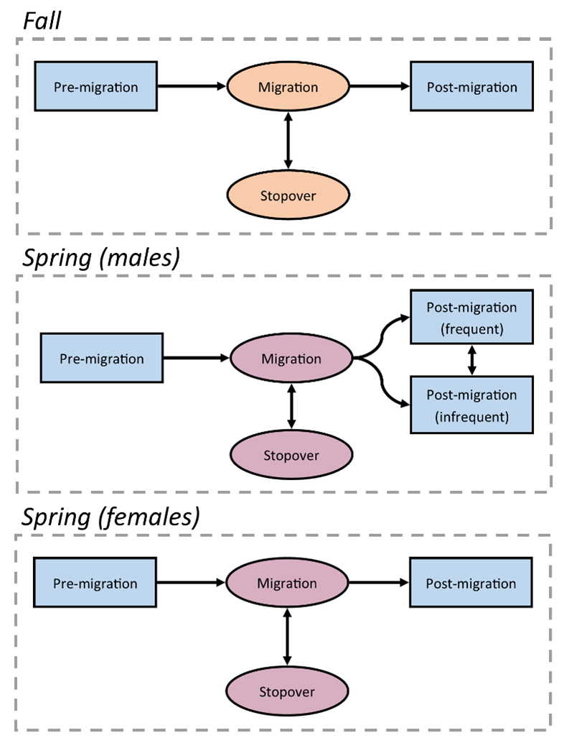

Figure 3. Movement state transition diagram for each hidden Markov model (HMM). Blue boxes represent pre- and post-migratory states, while yellow and red circles represent states during fall and spring migrations, respectively. Arrows indicate directional transitions between states that we permitted within the HMM framework. The spring male model includes two post-migration states to compensate for less frequent GPS locations collected from males in late spring.

While most models had a single post-migration state, we included two in the spring male model: post-migration (frequent) and post-migration (infrequent). The inclusion of these two states fixed an artifact in the dataset caused by male-specific transmission schedules switching to less-frequent transmission late in the spring migratory season. Infrequent locations caused the correlated random walk model to infer a greater proportion of steps during the late migratory period, producing a much narrower turn angle distribution than observed earlier in the season. By including two post-migratory states with separate turn angle distributions, which birds could transition between freely, we allowed the model to better account for this source of variation in turn angles when delineating post-migratory movements.

We excluded any birds that did not have at least 1 step ≥16.1 km, or which collected fewer than 3 points, from migratory delineation in the respective season. We assigned a fixed pre-migration state for the initial step of most birds captured during breeding or wintering, and a fixed migration state if the first step was ≥16.1 km. Because birds captured in Virginia, New Jersey, and Maryland were sometimes captured during migration, we allowed the HMM to estimate the initial state of the model for birds captured in these locations. We fixed final steps to the post-migratory state for any fall woodcock that were also known to initiate a subsequent spring migration.

We visually inspected HMM state assignments for all individuals, which sometimes identified circumstances where birds did not fit model predictions due to extra-seasonal movements (6% of tracks), early initiation or late termination of migration (3%) or transmitter error (1%). There were also additional issues with initial state designations that were encountered only by the base model (3% of tracks). In these cases, we manually reclassified state assignments (Supplementary material: S1). Woodcock that died during migration occasionally continued to transmit and caused the HMM to falsely classify dead birds as post-migratory. We have included methods used in delineating bird mortalities and removing them from the dataset in Supplementary material: S3.

## Model assessment

### HMM error rates and variable importance

We assessed the accuracy of HMM state assignments using a leave-one-out validation based on individuals with known terminal states. For individuals with transmitters that functioned past the end of each migration period, we truncated the movement track by removing one week of points, simulating a scenario where data transmission was lost prior to the end of migration. We then refitted the HMM to the truncated data, and evaluated whether the model correctly assigned the known final movement state. We repeated this process by iteratively truncating an additional week of data from each track to evaluate the capacity of models to correctly assign latent states throughout the core period of migration (fall: Oct. 1st–Jan 15th, spring: Mar. 15th–Jun. 15th; dates outside of this range were excluded due to low sample size). We repeated the validation process for 50 individuals, with replacement, for each model set. We measured the accuracy of final state assignment based on Type I and Type II errors, where a Type I error occurred when a known post-migratory state was falsely classified as migratory, and a Type II error occurred when a known migratory state was falsely classified as post-migratory.

To determine which additional data streams had the greatest impact on model error rates, we repeated the leave-one-out validation but omitted one of the additional data streams from the full model (Table 1) and measured how Type I and Type II error changed compared to the full and base models. We inferred data stream importance based on the relative change in Type I and II errors following removal (e.g., removal of residence time caused reduction in Type II accuracy, demonstrating that this data stream improved model inference).

### Migratory characteristics

We calculated several migration metrics that described the duration, distance, and timing of each movement state. Duration was the sum of the number of days between the first movement in each state and the initial location of the subsequent movement state (e.g. the start and end of migration). Distance was the sum of the total step distance in each movement state. For birds undergoing fall or spring migration, total distance excluded movements designated as stopovers, i.e. steps <16.1 km, and only reflected the summed distance of migratory steps. Timing was the ordinal date of the transition point between movement states. We used medians and ranges to report the population-level timing of migratory initiation and termination, as medians are well suited to accommodating outliers that were common in the initiation and termination dates. We compared all migration metrics between full and base models to evaluate improvements in inference resulting from the more complex full model.

### Long-distance movements and non-migratory individuals

Woodcock occasionally underwent long-distance movements outside of the spring and fall migratory periods. To determine if the full and base models affected our ability to detect these long-distance movements, we manually classified 3 potential movement states: foray loops, directional movements, and summer migrations (Table 2). Foray loops and directional movements were both presumably exploratory movements, where directional movements resulted in displacement ≥16.1 km from the original site while foray loops did not. We counted the frequency of directional movements and foray loops for all birds with locations spanning at least 1 month, which was long enough to correctly classify movement classes. Summer migrations were movements of similar distance and direction to fall migration, but occurred prior to Aug. 1, well before the normal onset of fall migration. We counted the frequency of summer migrations based on all birds tracked between May 1st–Sep. 1st.

Not all woodcock migrate; some individuals may stay in the same area year-round [31]. To determine if the use of the full and base models impacted our detection of non-migratory individuals, we calculated the percentage of individuals that did not migrate using the pool of all individuals tracked between the start of the core migratory season (Fall: Oct. 15, Spring: Feb. 15) and the date by which most birds had initiated migration (95th quantile of the departure dates for that season). Any individuals with at least one location before, during, and after this period, which did not enter a corresponding migratory state, were designated as non-migratory for that season. We used the same time periods to determine whether a bird migrated during the season before or after its non-migratory season.

Table 2. Definitions of long-distance movement states manually delineated for American Woodcock.

|  |  |
| --- | --- |
| **Class** | **Definition** |
| Summer migration | Post-breeding, southerly movements initiated before Aug. 1 that preclude fall migratory movements. |
| Foray loops | Circular or out-and-back movements with steps ≥16.1 km that result in <16.1 km displacement between the first and last point. Foray loops can occur during any season, provided they are temporally distinct from a bird’s migratory movements. |
| Directional movements | Movements that include step lengths ≥16.1 km and result in ≥16.1 km displacement between the first and last point. These movements follow directions which are not typical of co-occurring seasonal migrations. |

# Results

## HMM error rates

We analyzed 522 seasonal movement tracks from 401 tagged woodcock, of which 45 tracks (9%) in the full model and 56 tracks (11%) in the base model required modifications to the methods described above to correctly fit the seasonal HMMs (detailed in Supplementary material: S1). The full model improved classification accuracy for all three seasonal HMMs compared to the base model (Fig. 4). Type I error rates were similar for full (median 6.0%, range 0–24.2%) and base models (median 6.0%, range 0–24.2%) during fall migration, but Type II error rates were lower for the full model (median 0%, range 0–4.3%) compared to the base model (median 10.6%, range 0–28.3%). The spring male full model exhibited lower rates of Type I (median 8.3%, range 0–15.6%) error than the base model (median 15.6%, range 0–61.1%), and comparable rates of Type II error (full: median 4.3%, range 0–11.4%; base: median 4.3%, range 0–13.6%). The spring female full model exhibited greater Type I errors (median 6.8%, range 0–18.8%) during some time periods than the base model (median 2.1%, range 0–4.2%), but also exhibited reduced Type II error rates (median 6.3%, range 2.0%–11.4%) compared with the base model (median 52.1%, range 10.0–77.6%).

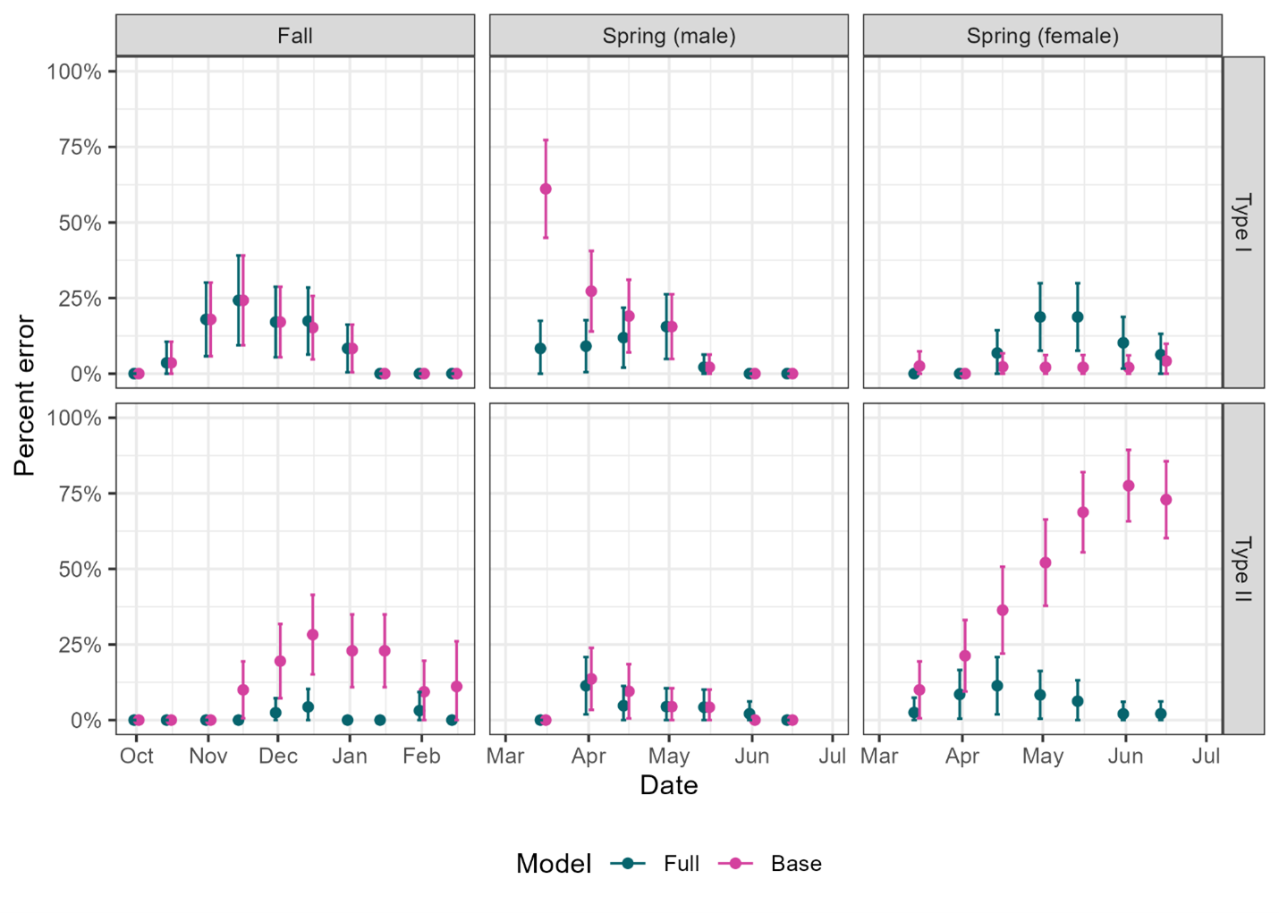

Figure 4. Error rates for movement state assignments by hidden Markov models (HMMs) for fall, spring (male), and spring (female) migrations, as measured through a leave-one-out model validation process. The horizontal axis reflects the cutoff date for each model that was used to simulate an incomplete track ending on that date. HMMs were grouped into full and base models, where full models included all possible data streams and base models including only step length and turn angle. Type 1 errors reflected false classification as post-migratory while the true state was migratory, whereas Type 2 errors reflected false classification as migratory while the true state was post-migratory. Bars show the 95% confidence interval of the mean.

## Variable importance

Individual removal of variables from the full model had low overall impact (median -0.31%, range -17.17–2.70%) on Type I and Type II error rates of the seasonal models (Fig. 5). The importance of a withheld variable often differed by season, with the removal of some variables (e.g., ordinal day) leading to reduced error in one season and increased error in another. Residence time produced the greatest reduction in error rates, with a 2.81–17.17% drop in Type II error rates for all 3 seasonal models. The full model caused a 0.71–42.55% reduction in Type II error rates for those 3 models, suggesting that these variables have a more appreciable impact on error rates when used in aggregate.

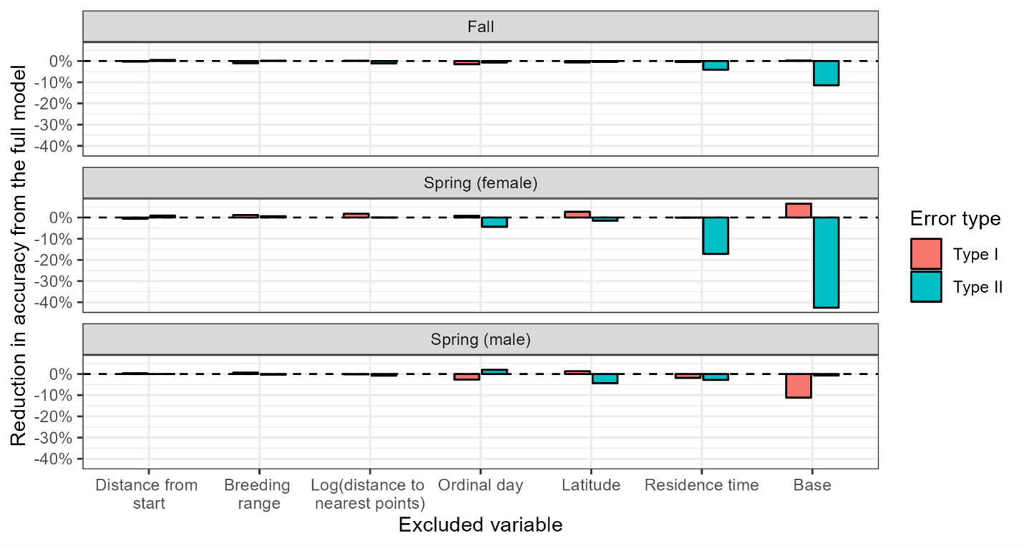

Figure 5. Reduction in accuracy from the full model due to removal of individual data streams, as well as the base model which included none of these 6 data streams. Type I errors occurred when the ending state was falsely classified as migratory, and Type II errors occurred when the ending state was falsely classified as post-migratory. Negative values indicate reductions in accuracy, while positive values indicate that accuracy improved when the variable was excluded from the model.

## Migratory characteristics

Among all seasons, the measured characteristics of woodcock migratory movements, such as distance, duration, phenology, and the percentage of individuals completing migration (i.e., arriving at a migratory endpoint), changed least between the fall full and base models (Table 3). The full fall model was 1.01 times more likely to identify a migratory endpoint than the base model, and there was no difference in mean migratory duration or median migratory initiation date. The base model underestimated mean migratory distance by 13 km compared to the full model and underestimated the median termination date by a single day. The full spring male model was 1.15 times more likely to identify a migratory endpoint than the base model. There was no difference in mean migratory duration between the two models, although the base model underestimated mean migratory distance by 45 km compared to the full. The spring male base model estimated that the median migratory initiation and termination dates were two days earlier than the full model. The spring female model exhibited more drastic differences between the base and full models, with the full model 2.12 times more likely to identify a migratory endpoint than the base model. The mean duration and distance of spring female migration was underestimated by 7 days and 278 km for the base model as compared to the full model, while the median initiation date of the base model was 4 days earlier and the median termination date was 12 days earlier than that of the full model.

Table 3. Migratory characteristics of American Woodcock based on full and base models for each seasonal hidden Markov model, in addition to detection rates for long-distance movements outside of spring and fall migration.

|  |  |  |  |
| --- | --- | --- | --- |
| **Season** | **Metric** | **Full model** | **Base model** |
| Fall migration | Percent completed migration1 | 56% | 55% |
|  | Duration2 | 32 days (± 26, 1–134 days) | 32 days (± 26, 1–134 days) |
|  | Distance3 | 1353 km (± 647, 20–3210 km) | 1344 km (± 645, 20–3210 km) |
|  | Initiation date4 | Nov. 7th (Aug. 29th–Jan. 11th) | Nov. 7th (Aug. 29th–Jan. 11th) |
|  | Termination date5 | Dec. 6th (Oct. 28th–Feb. 4th) | Dec. 5th (Oct. 28th–Feb. 4th) |
| Spring migration (male) | Percent completed migration1 | 75% | 86% |
|  | Duration2 | 39 days (± 24, 4–95 days) | 39 days (± 25, 4–95 days) |
|  | Distance3 | 1554 km (± 644, 296–3337 km) | 1509 km (± 649, 262–3337 km) |
|  | Initiation date4 | Feb. 29th (Jan. 6th–Apr. 14th) | Feb. 27th (Jan. 6th–Apr. 17th) |
|  | Termination date5 | Apr. 6th (Jan. 20th–Jun. 7th) | Apr. 4th (Jan. 20th–Jun. 7th) |
| Spring migration (female) | Percent completed migration1 | 55% | 26% |
|  | Duration2 | 49 days (± 29, 2–128 days) | 42 days (± 28, 2–101 days) |
|  | Distance3 | 1671 km (± 626, 455–3424 km) | 1393 km (± 698, 248–3424 km) |
|  | Initiation date4 | Mar. 5th (Jan 14th–Apr. 26th) | Mar. 1st (Jan 14th–Apr. 23rd) |
|  | Termination date5 | Apr. 25th (Mar. 10th–Jun. 28th) | Apr. 13th (Mar. 2nd–May. 25th) |
| Long-distance movements | Directional movements6 | 3 detected (0.7%; 2 M, 1 F) | 2 detected (0.4%; 2 M, 1 F) |
|  | Foray loops7 | 18 detected (4%; 8 M, 10 F) | 15 detected (3%; 7 M, 8 F) |
|  | Summer migrations8 | 3 detected (5%; 2 M, 1 F) | 3 detected (5%; 2 M, 1 F) |

1 Percent of birds which completed their migration prior to the end of their track.

2 Mean duration of migration, with standard deviation and range.

3 Mean distance of migration, with standard deviation and range.

4 Median and range of migratory initiation dates.

5 Median and range of migratory termination dates.

6 Number of individuals which underwent a directional movement among all birds tracked for at least one month (n = 456), including the percentage of birds which underwent a directional movement and the number of directional movements associated with males and females. Note that one bird underwent two directional movements, bringing the total number of directional movements detected to 4 for the full model and 3 for the base model.

7 Number of individuals which underwent a foray loop among all birds tracked for at least one month (n = 456), including the percentage of birds which underwent a foray loop and the number of foray loops associated with males and females.

8 Number of individuals which underwent a summer migration among all birds tracked throughout May 1st–Sep. 1st (n = 65), including the percentage of birds which underwent a summer migration and the number of summer migrations associated with males and females.

## Long-distance movements and non-migratory individuals

Long distance movements outside of spring and fall migration were less frequently detected using the base model than the full model, with the full model detecting 3 more foray loops and 1 more directional movement than the base model (Table 3). Using the long-distance movements detected by the full model, we found that directional movements had a mean duration of 6 days (1–10 days) and the mean distance traveled was 129 km (30–263 km). Foray loops had a mean duration of 20 days (2–95 days) and a mean total distance traveled of 221 km (34–951 km). The number of summer migrations detected was not impacted by use of the full or base model, with 3 of 65 birds (5%; 2 males, 1 female) tracked throughout May 1st–Sep. 1st migrating south during the summer. These summer migratory movements initiated around May 27th, Jun. 20th, and Jul. 13th and terminated around Jul. 8th, Jul. 25th, and Aug. 22nd (Fig. 6). Summer migrations had a mean duration of 39 days (35–42 days) and a mean distance traveled of 756 km (523–1106 km).

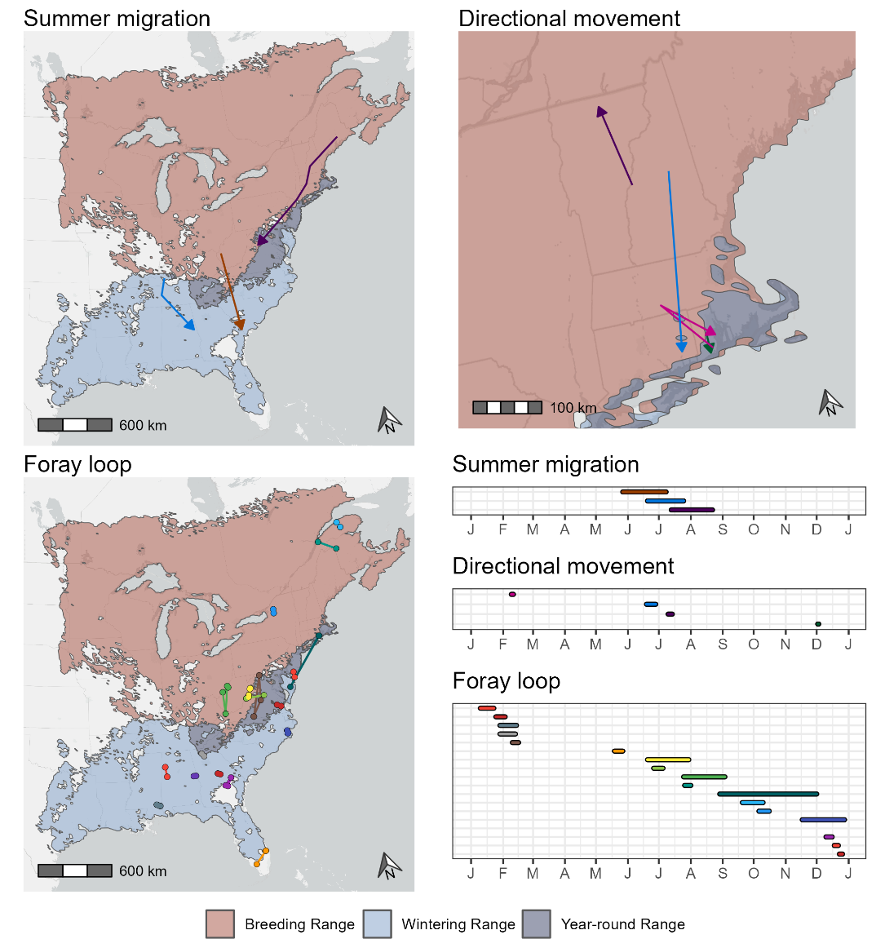

Figure 6. Spatial and temporal distribution of summer migrations, directional movements, and foray loops of American Woodcock marked with GPS transmitters in eastern North America. Maps are superimposed over the breeding, wintering, and year-round range of the American Woodcock as delineated by the eBird Status and Trends dataset [41]. Timelines depict the duration of each movement by month, and each movement is matched from the map to the timeline by color. These long-distance movements are derived from the full model, which includes all possible data streams for informing delineations of woodcock migratory movements.

Non-migrants were detected by the full and base models, with some differences in detection rates. The full model detected 6 non-migrants in the fall (3% of individuals tracked between Oct. 15th–Dec. 5th; 3 males, 3 females) and spring (3% of individuals tracked between Feb. 15th–Mar. 29th; 1 male, 5 females). The base model detected one fewer non-migrant in fall (3% of individuals tracked between Oct. 15th–Dec. 8th; 2 males, 3 females) and the same number of non-migrants in spring (3% of individuals tracked between Feb. 15th–Mar. 28th; 1 male, 5 females). The fall non-migrants detected using the full model overwintered in Rhode Island (3), Pennsylvania (1), Connecticut (1), and Virginia (1), while the spring non-migrants summered in Virginia (2), Maryland (1), Florida (1), Georgia (1), and Alabama (1). Individuals that abstained from migration during one season were observed migrating in prior or subsequent seasons when data were available (5 of 5 birds detected in the full model).

# Discussion

Combining the absolute displacement method with a set of hidden Markov models allowed us to overcome limitations associated with sparse location data and estimate the migratory state of American Woodcock. We found that the use of additional data streams allowed HMMs to fit the migratory movements of woodcock with lower error rates for several seasonal models. The most substantial improvement was among Type II errors for spring females (full: median 6.3%, range 2.0%–11.4%; base: median 52.1%, range 10.0–77.6%), although spring males also had some improvements in Type I error rates early in the season (full: median 8.3%, range 0–15.6%; base: median 15.6%, range 0–61.1%). These differences were mirrored by our migratory characteristics results, which found that spring females had the most substantial differences between the full and base models, with less pronounced differences for spring males and few differences for fall birds (Table 3). Individual variable results suggest that the improved error rates and classification of migratory characteristics seems to be due to several added data streams working in aggregate, with each individual variable having a reduced influence when used in isolation (Fig. 5). The three most important of these variables, ordinal day, latitude, and residence time, demonstrate how spatial and temporal variables can assist in delineating migratory and post-migratory states even for a species that has considerable overlap in seasonal ranges and migratory/non-migratory periods [34,44].

Our results demonstrate that certain seasons, in particular spring female migration, are more difficult to accurately characterize using only step length and turn angle. The difficulties encountered with spring females are likely due to female woodcocks’ tendency to nest during spring migration, with continued migration following nest failure [30]. Under this reproductive system, movement patterns of female woodcock during stopover may be very similar to those post-migration, which may lead to difficulties in discriminating among movement states based only on step length and turn angle. The addition of data streams, especially residence time, ordinal day, and latitude, increased the accuracy of the spring female model (Fig. 5), likely distinguishing among early, southerly nesting attempts that are prone to failure and resumption of migration and later nesting attempts which are less likely to have a subsequent migratory movement. While woodcock have an uncommon breeding system [30], this technique for refining HMMs may be useful for any migratory bird with lengthy stopovers and spatial overlap in their seasonal ranges. For example, Sora (*Porzana carolina*) use the Chesapeake Bay in Virginia, Maryland, and Delaware, USA, as both a breeding and a staging area during spring migration, and an HMM technique like ours could be used to differentiate between breeding and staging states based on movement characteristics [45]. This technique may be widely applicable to shorebirds and waterbirds, for which extended stopover and staging behaviors are common [46,47], as well as facultative migrants (e.g. American Robin, *Turdus migratorius*) which encounter substantial overlap in their migratory, breeding, and wintering ranges [48].

We found that the increased classification accuracy of the full model allowed us to identify more long-distance movements outside of fall and spring migration. These movements were relatively uncommon (directional movements: 0.7% of individuals in the full model; foray loops: 4%; summer migrations: 5%), and motivations may range from avoiding negative environmental conditions in the winter (e.g., movements from Rhode Island to Maryland and back) to foraging and exploratory behaviors. Directional movements and foray loops have been observed among a variety of songbird, grouse, and shorebirds, most frequently occurring after the breeding season [49–51]. During our study we observed directional movements and foray loops throughout the year, including directional movements during summer and winter and foray loops during every season except for the peak of spring migration. Cooper and Marra [50] suggest that the prevalence of long-distance movements is underestimated due to the difficulty of tracking small birds at fine spatial scales, and this may be exacerbated due to the prevalence of single-season movement studies [52]. Directional movements can in some cases allow population exchange and gene flow among subpopulations (i.e., dispersal), and identifying these movements is important for understanding avian life history and population dynamics [53,54]. Robust frameworks for differentiating these movements from fall and spring migrations, such as we present here, could improve our ability to document these movements in future studies.

Onboard data collected by the transmitter, such as acceleration, altitude, or depth, have traditionally been used as data streams to inform animal movement HMMs [23], but these data are frequently unavailable for small transmitters. Our results demonstrate that external data streams, such as spatial and temporal variables derived from the movement track, can have a similar benefit for predicting migratory states. Extensions of HMMs which incorporate feedback when calculating transition probabilities, such as an increased likelihood of switching from a foraging state to a transit state after spending time feeding, may also be well suited to explaining the temporal patterns that distinguish migratory stopover behavior from post-migratory resource utilization [55].

# Conclusion

Using additional data streams to model HMMs can resolve many of the issues which are inherent in using movement models with sparse and infrequent tracking data, improving our ability to classify the migratory movements of birds with overlapping seasonal distributions and prolonged stopovers. Our study joins a cohort of recent work demonstrating how adding external data streams, such as weather or seasonal abundance data, can allow movement models to make inferences into avian migratory ecology despite small amounts of tracking data [56–58]. As most bird species are too small to carry a device collecting frequent tracking data [8], these inferential techniques will be essential to facilitate the expansion of movement modeling to encompass a wider range of avifauna. Based on our work, we would encourage caution in using HMMs or similar models for migratory state inference without quantifying error; our leave-one-out validation process found that Type II errors were substantial in the base model, which could have been overlooked if this HMM had been employed without a validation technique (see [59] for the importance of validation in HMMs). This might lead to biased migratory state estimates, with implications for any downstream analyses that those states are used in. With proper validation, however, HMMs can be a compelling tool for assigning migratory classifications regardless of incomplete data.

# Abbreviations

HMM: Hidden Markov Model

GPS: Global Positioning System

USA: United States of America

USDA: United States Department of Agriculture

USFWS: United States Fish and Wildlife Service

USGS: United States Geological Survey

# Acknowledgements

We would like to thank the 43 collaborating organizations which have provided funding and logistic support since this project began in 2017, a full list of whom is available at woodcockmigration.org. Special thanks to C. Baranski, A. Bourgeois, R. Brown, L. Clark, T. Cooper, S. Heerkens, R. Masse, D. McAuley, G. Norman, T. Pitman, K. Sullivan, and H. Wallbridge for their significant contributions. J. Zydlewski, P. Rahimzadeh-Bajgiran, S. Morano, R. Tyl, and M. Lewis provided comments which substantially improved this manuscript.

# Authors’ contributions

EJ, AR, and LB initially conceived of this paper, and LB conducted the analysis and wrote the initial draft manuscript. EJ and AR provided substantive feedback on subsequent drafts. EJ, AR, AF, RD, SC, and LB contributed to the collection and maintenance of the Eastern Woodcock Migration Research Cooperative dataset. GB, BC, GC, JD, KF, CG, WH, MH, DH, S Maddox, S McWilliams, S Meyer, TN, JP, CR, DS, CS, J Stiller, J Straub, MT, DW, and LW provided funding and/or logistic support for the acquisition and deployment of GPS transmitters on woodcock. All authors read and approved the final manuscript.

# Funding

Funding and logistic support was provided, in part, by the Alabama Department of Conservation and Natural Resources, American Woodcock Society, Association des Savaginiers du Saguenay-Lac-St-Jean, Canaan Valley National Wildlife Refuge, Cape May National Wildlife Refuge, Silvio O. Conte National Wildlife Refuge, Club des Becassiers du Quebec, Eastern Bird Banding Association, Environment and Climate Change Canada, Florida Fish and Wildlife Conservation Commission, Friends of the 500th, Georgia Department of Natural Resources, Louisiana Department of Wildlife and Fisheries, Maine Department of Inland Fisheries and Wildlife, Maryland Department of Natural Resources, Moosehorn National Wildlife Refuge, New Jersey Division of Fish and Wildlife, New York Department of Environmental Conservation, North Carolina Wildlife Resources Commission, Old Hemlock Foundation, Pennsylvania Game Commission, Penobscot Valley Chapter—Maine Audubon, Rhode Island Department of Environmental Management, Ruffed Grouse Society and American Woodcock Society, South Carolina Department of Natural Resources, The Nature Conservancy—New Jersey, The Nature Conservancy—Vermont, USFWS Webless Migratory Game Bird Program, USGS Patuxent Wildlife Research Center, University of Maine, University of Maine Canadian-American Center, University of Rhode Island, Vermont Fish and Wildlife Department, Virginia Department of Wildlife Resources, West Virginia Highlands Conservancy, Wildlife Management Institute, and the Woodcock Conservation Society. This project was supported by the USDA National Institute of Food and Agriculture, McIntire-Stennis project number ME0-21422 and ME0-42018 through the Maine Agricultural and Forest Experiment Station.

# Availability of data and materials

To make our classifications available for use in future research, we uploaded all woodcock GPS locations and their movement state assignments to a Movebank repository (reference ID 351564596) from which data is accessible upon reasonable request. The process of refining these designations for use in Movebank is detailed in Supplementary material: S4. All code used in this study is publicly available at https://github.com/EWMRC/fac-classification.

# Declarations

## Ethics approval and consent to participate

To ensure the welfare of all tagged birds, the combined weight of all transmitters, bands, and harness materials never exceeded 4% of a bird’s body mass. All capture and handling were conducted with methods approved by the University of Maine Institutional Animal Care and Use Committee (Protocol # A2017-05-02 and A2020-07-01).

## Consent for publication

Not applicable.

## Competing interests

The authors declare that they have no competing interests.

# References

1. Iverson AR, Schaefer JL, Skalos SM, Hawkins CE. Global positioning system (GPS) and platform transmitter terminal (PTT) tags reveal fine-scale migratory movements of small birds: A review highlights further opportunities for hypothesis-driven research. Ornithological Applications. 2023;125:duad014.

2. Wright JR, Johnson JA, Bayne E, Powell LL, Foss CR, Kennedy JC, et al. Migratory connectivity and annual cycle phenology of Rusty Blackbirds (*Euphagus carolinus*) revealed through archival GPS tags. Avian Conservation & Ecology. 2021;16:20.

3. Moskát C, Bán M, Fülöp A, Bereczki J, Hauber ME. Bimodal habitat use in brood parasitic Common Cuckoos (*Cuculus canorus*) revealed by GPS telemetry. The Auk: Ornithological Advances. 2019;136:uky019.

4. Iverson AR, Humple DL, Cormier RL, Hull J. Land cover and NDVI are important predictors in habitat selection along migration for the Golden-crowned Sparrow, a temperate-zone migrating songbird. Movement Ecology. 2023;11:2.

5. Klaassen RHG, Hake M, Strandberg R, Koks BJ, Trierweiler C, Exo K, et al. When and where does mortality occur in migratory birds? Direct evidence from long‐term satellite tracking of raptors. Journal of Animal Ecology. 2014;83:176–84.

6. Combreau O, Riou S, Judas J, Lawrence M, Launay F. Migratory pathways and connectivity in Asian houbara bustards: evidence from 15 years of satellite tracking. PloS ONE. 2011;6:e20570.

7. Flack A, Aikens EO, Kölzsch A, Nourani E, Snell KRS, Fiedler W, et al. New frontiers in bird migration research. Current Biology. 2022;32:R1187–99.

8. Bridge ES, Thorup K, Bowlin MS, Chilson PB, Diehl RH, Fléron RW, et al. Technology on the move: recent and forthcoming innovations for tracking migratory birds. BioScience. 2011;61:689–98.

9. Soriano-Redondo A, Acácio M, Franco AMA, Herlander Martins B, Moreira F, Rogerson K, et al. Testing alternative methods for estimation of bird migration phenology from GPS tracking data. Ibis. 2020;162:581–8.

10. López-López P, Limiñana R, Mellone U, Urios V. From the Mediterranean Sea to Madagascar: Are there ecological barriers for the long-distance migrant Eleonora’s falcon? Landscape Ecol. 2010;25:803–13.

11. Hewson CM, Thorup K, Pearce-Higgins JW, Atkinson PW. Population decline is linked to migration route in the Common Cuckoo. Nature Communications. 2016;7:12296.

12. Gutierrez Illan J, Wang G, Cunningham FL, King DT. Seasonal effects of wind conditions on migration patterns of soaring American white pelican. PLoS One. 2017;12:e0186948.

13. King DT, Wang G, Yang Z, Fischer JW. Advances and environmental conditions of spring migration phenology of American White Pelicans. Scientific Reports. 2017;7:40339.

14. Monti F, Grémillet D, Sforzi A, Sammuri G, Dominici JM, Triay Bagur R, et al. Migration and wintering strategies in vulnerable Mediterranean Osprey populations. Ibis. 2018;160:554–67.

15. Linscott JA, Navedo JG, Clements SJ, Loghry JP, Ruiz J, Ballard BM, et al. Compensation for wind drift prevails for a shorebird on a long-distance, transoceanic flight. Movement Ecology. 2022;10:11.

16. Battley PF, Warnock N, Tibbitts TL, Gill RE, Piersma T, Hassell CJ, et al. Contrasting extreme long-distance migration patterns in bar-tailed godwits Limosa lapponica. Journal of Avian Biology. 2012;43:21–32.

17. Oppel S, Dobrev V, Arkumarev V, Saravia V, Bounas A, Kret E, et al. High juvenile mortality during migration in a declining population of a long‐distance migratory raptor. Ibis. 2015;157:545–57.

18. Flack A, Fiedler W, Blas J, Pokrovsky I, Kaatz M, Mitropolsky M, et al. Costs of migratory decisions: A comparison across eight white stork populations. Science Advances. 2016;2:e1500931.

19. Burnside RJ, Collar NJ, Dolman PM. Comparative migration strategies of wild and captive‐bred Asian Houbara *Chlamydotis macqueenii*. Ibis. 2017;159:374–89.

20. Dawson WR. Pine Siskin (*Spinus pinus*), version 1.0. In: Poole AF, editor. Birds of the World. Ithaca, NY, USA: Cornell Lab of Ornithology; 2020. Available from: https://doi.org/10.2173/bow.pinsis.01

21. Langrock R, King R, Matthiopoulos J, Thomas L, Fortin D, Morales JM. Flexible and practical modeling of animal telemetry data: hidden Markov models and extensions. Ecology. 2012;93:2336–42.

22. Zucchini W, MacDonald IL, Langrock R. Hidden Markov models for time series: an introduction using R. CRC Press; 2017.

23. Dean B, Freeman R, Kirk H, Leonard K, Phillips RA, Perrins CM, et al. Behavioural mapping of a pelagic seabird: combining multiple sensors and a hidden Markov model reveals the distribution of at-sea behaviour. Journal of The Royal Society Interface. 2013;10:20120570.

24. Blomberg EJ, Fish AC, Berigan LA, Roth AM, Rau R, Clements SJ, et al. The American Woodcock Singing Ground Survey largely conforms to the phenology of male woodcock migration. The Journal of Wildlife Management. 2023;87:e22488.

25. Berigan LA, Aulicky CSH, Teige EC, Sullins DS, Fricke KA, Reitz JH, et al. Lesser prairie-chicken dispersal after translocation: Implications for restoration and population connectivity. Ecology and Evolution. 2024;14:e10871.

26. Picardi S, Coates P, Kolar J, O’Neil S, Mathews S, Dahlgren D. Behavioural state‐dependent habitat selection and implications for animal translocations. Journal of Applied Ecology. 2022;59:624–35.

27. Mander L, Nicholson I, Green RMW, Dodd SG, Forster RM, Burton NHK. Individual, sexual and temporal variation in the winter home range sizes of GPS-tagged Eurasian Curlews *Numenius arquata*. Bird Study. 2022;69:39–52.

28. Zhang J, Rayner M, Vickers S, Landers T, Sagar R, Stewart J, et al. GPS telemetry for small seabirds: using hidden Markov models to infer foraging behaviour of Common Diving Petrels (*Pelecanoides urinatrix urinatrix*). Emu - Austral Ornithology. 2019;119:126–37.

29. Moore JD, Andersen DE, Cooper T, Duguay JP, Oldenburger SL, Stewart CA, et al. Migration phenology and patterns of American woodcock in central North America derived using satellite telemetry. Wildlife Biology. 2021;2021:wlb.00816.

30. Slezak CR, Blomberg EJ, Berigan LA, Darling R, Fish AC, Clements SJ, et al. Unconventional life-history in a migratory shorebird: desegregating reproduction and migration. Proceedings of the Royal Society B. 2024;291:20240021.

31. McAuley DG, Keppie DM, Whiting Jr. RM. American Woodcock (Scolopax minor), version 1.0. In: Poole AF, editor. Birds of the World. Ithaca, NY, USA: Cornell Lab of Ornithology; 2020. Available from: https://doi.org/10.2173/bow.amewoo.01

32. Kareiva PM, Shigesada N. Analyzing insect movement as a correlated random walk. Oecologia. 1983;56:234–8.

33. Clements SJ, Berigan LA, Fish AC, Darling RL, Roth AM, Balkcom G, et al. Satellite tracking of American Woodcock reveals a gradient of migration strategies. Ornithology. 2024;141:ukae008.

34. Fish AC, Roth AM, Balkcom G, Berigan L, Brunette K, Clements S, et al. American woodcock migration phenology in eastern North America: implications for hunting season timing. The Journal of Wildlife Management. 2024;88:e22565.

35. Sheldon WG. A method of mist netting woodcocks in summer. Bird-banding. 1960;31:130–5.

36. Rieffenberger JC, Kletzly RC. Woodcock night-lighting techniques and equipment. WH Goudy, compiler. Woodcock research and management. 1966;33–5.

37. McAuley DG, Longcore JR, Sepik GF. Techniques for research into woodcocks: experiences and recommendations. Proceedings of the eighth American woodcock symposium. U.S. Fish and Wildlife Service; 1993. p. 5.

38. Berger-Tal O, Bar-David S. Recursive movement patterns: review and synthesis across species. Ecosphere. 2015;6:art149.

39. Johnson DS, London JM. crawl: an R package for fitting continuous-time correlated random walk models to animal movement data. 2018. Available from: https://doi.org/10.5281/zenodo.596464

40. R Core Team. R: A language and environment for statistical computing. Vienna, Austria: R Foundation for Statistical Computing; 2024. Available from: https://www.R-project.org/

41. Fink D, Auer T, Johnston A, Strimas-Mackey M, Ligocki S, Robinson O, et al. eBird Status and Trends. Ithaca, New York: Cornell Lab of Ornithology; 2022. Available from: https://doi.org/10.2173/ebirdst.2021

42. Kent JT, Tyler DE. Maximum likelihood estimation for the wrapped Cauchy distribution. Journal of Applied Statistics. 1988;15:247–54.

43. McClintock BT, Michelot T. momentuHMM: R package for generalized hidden Markov models of animal movement. Methods in Ecology and Evolution. 2018;9:1518–30.

44. Berigan LA. Full annual cycle analysis of American Woodcock (*Scolopax minor*) distribution, habitat use, and migration ecology [Dissertation]. Orono, Maine: University of Maine; 2024.

45. Duerr AE, Watts BD. Waterbirds of the Chesapeake Bay: Status, ecological requirements, and threats. Williamsburg, Virginia: Center for Conservation Biology, College of William and Mary/Virginia Commonwealth University; 2012.

46. Colwell MA. Shorebird ecology, conservation, and management. Berkeley, California: University of California Press; 2010.

47. Stafford JD, Janke AK, Anteau MJ, Pearse AT, Fox AD, Elmberg J, et al. Spring migration of waterfowl in the northern hemisphere: a conservation perspective. Wildfowl. 2014; Special Issue 4:70–85.

48. Vanderhoff N, Pyle P, Patten MA, Sallabanks R, James FC. American Robin (*Turdus migratorius*), version 1.0. In: Rodewald PG, editor. Birds of the World. Ithaca, NY, USA: Cornell Lab of Ornithology; 2020. Available from: https://doi.org/10.2173/bow.pinsis.01

49. Earl JE, Fuhlendorf SD, Haukos D, Tanner AM, Elmore D, Carleton SA. Characteristics of lesser prairie-chicken (*Tympanuchus pallidicinctus*) long-distance movements across their distribution. Ecosphere. 2016;7:e01441.

50. Cooper NW, Marra PP. Hidden long-distance movements by a migratory bird. Current Biology. 2020;30:4056-4062.

51. Hoepfner SA. High-frequency GPS transmitters allow understanding of breeding shorebird movements and nest survival without human disturbance [Thesis]. Ames, Iowa: Iowa State University; 2023.

52. Marra PP, Cohen EB, Loss SR, Rutter JE, Tonra CM. A call for full annual cycle research in animal ecology. Biology letters. 2015;11:20150552.

53. Bohonak AJ. Dispersal, gene flow, and population structure. The Quarterly Review of Biology. 1999;74:21–45.

54. Morales JM, Moorcroft PR, Matthiopoulos J, Frair JL, Kie JG, Powell RA, et al. Building the bridge between animal movement and population dynamics. Philosophical Transactions of the Royal Society B: Biological Sciences. 2010;365:2289–301.

55. Zucchini W, Raubenheimer D, MacDonald IL. Modeling time series of animal behavior by means of a latent‐state model with feedback. Biometrics. 2008;64:807–15.

56. Nicol S, Cros M, Peyrard N, Sabbadin R, Trépos R, Fuller RA, et al. FlywayNet: A hidden semi‐Markov model for inferring the structure of migratory bird networks from count data. Methods in Ecology and Evolution. 2023;14:265–79.

57. Fuentes M, Van Doren BM, Fink D, Sheldon D. BirdFlow: Learning seasonal bird movements from eBird data. Methods in Ecology and Evolution. 2023;14:923–38.

58. Nussbaumer R, Gravey M, Briedis M, Liechti F, Sheldon D. Reconstructing bird trajectories from pressure and wind data using a highly optimized hidden Markov model. Methods in Ecology and Evolution. 2023;14:1118–29.

59. Saldanha S, Cox SL, Militão T, González-Solís J. Animal behaviour on the move: the use of auxiliary information and semi-supervision to improve behavioural inferences from Hidden Markov Models applied to GPS tracking datasets. Movement Ecology. 2023;11:41.