*Adapting hidden Markov models to data from small GPS transmitters*

Liam Berigan, Sarah Clements, Rachel Darling, Alex Fish, Amber Roth, Erik Blomberg, Greg Balkcom, Bobbi Carpenter, Gary Costanzo, Jeffrey Duguay, Clayton Graham, William Harvey, Michael Hook, Douglas Howell, Seth Maddox, Scott McWilliams, Shawn Meyer, Theodore Nicols, J. Bruce Pollard, Christian Roy, Colby Slezak, Josh Stiller, Mathieu Tetreault, Lisa Williams

Target: Movement Ecology

Overview of the paper

1. Tracking devices are getting smaller, and data is getting coarser, but movement models are still designed to require lots of data.
2. We demonstrate how the creative application of additional data streams and correlated random walk models can allow movement models to fit coarse and irregular data gathered by small GPS transmitters.
3. We demonstrate these methods through the delineation of American Woodcock migratory movements. By adding additional data streams and a correlated random walk model to interpolate missing locations, we can fit hidden Markov Models to woodcock migratory tracks and estimate woodcock movement states to a reasonable degree of accuracy, even when tracks are incomplete.

**2 Methods**

*2.1 Collecting data via GPS transmitters*

We delineated American Woodcock movements throughout the full annual cycle using GPS-tracking data from the Eastern Woodcock Migration Research Cooperative, a collaboration of 42 federal, state, provincial, non-profit, and university partners throughout the United States and Canada (www.woodcockmigration.org). We captured woodcock at 78 sites in Quebec, Ontario, Nova Scotia, Maine, Vermont, New Jersey, New York, Rhode Island, Pennsylvania, Maryland, West Virginia, Virginia, North Carolina, South Carolina, Georgia, Alabama, Louisiana, and Florida using mist nets during morning and evening flights [1], and on night roosts using spotlights and dip nets [2,3]. We attached 4g, 5g, and 6.3g PinPoint GPS Argos transmitters (Lotek Wireless Inc., Newmarket, Ontario, CA) to captured woodcock. Transmitters, bands, and attachment materials never exceeded 4% of a bird’s body weight, and all capture and handling were conducted with methods approved by the University of Maine Institutional Animal Care and Use Committee (Protocol # A2020-07-01).

GPS transmitters were programmed with one of several schedules, each of which collected data at a slightly different pace to optimize battery life. Transmitters with a frequent schedule collected locations daily, and typically lasted throughout the duration of a single migration. Transmitters with an infrequent schedule collected locations every 3–5 days, with the aim of collecting data from several migrations. Hybrid schedules combined characteristics of frequent and infrequent schedules, collecting locations every 3–7 days outside of the migratory season, and collecting data every 1–2 days during the migratory season. Gap schedules used a similar timing to hybrid schedules, but additionally included a period of 1–3 months in which the transmitter did not collect locations to extend battery life over the course of multiple seasons. Each transmitter was predicted to collect 75–150 GPS locations, depending on transmitter size and schedule, at 12–60m accuracy. Transmitters relayed GPS locations back to the ARGOS satellite network after every 3rd location, allowing recovery of data without recapture of the bird. However, transmissions back to satellites are energetically demanding and transmitters occasionally fail to relay data as their battery life wanes, creating issues with sporadic missing data near the end of migration.

*2.2 Delineating spring and fall migration*

*2.2.1 Using HMMs to delineate woodcock migration*

For woodcock with a full migratory track, we define woodcock migration as beginning when woodcock make their first ≥30.2 km movement in a season and ending after woodcock make their final ≥30.2 km movement in a season (Fall: Aug. 1st–Feb. 25th, Spring: Jan. 5th–Jun. 30th). The 30.2 km threshold was chosen as it roughly divides the bimodal distribution of step lengths. However, tagged woodcock in our study frequently had incomplete migratory tracks, either due to waning battery life or bird mortality before the end of the season, making it unclear when their final ≥30.2 km movement occurred. We therefore used hidden Markov Models (HMMs, [4,5]) to delineate woodcock migrations, which allowed birds with complete migratory tracks to inform the final migratory state designation of birds with incomplete migratory tracks. We made several adjustments to these HMMs to allow them to better function with infrequent locations and missing data and provided additional data streams to allow the models to better differentiate between stopovers and post-migratory locations.

Infrequent locations and missing data can complicate the process of fitting an HMM to bird movement data, as they impede the ability of the model to detect recursive movement which could be indicative of post-migratory settlement. We accommodated for infrequent locations and missing data using a correlated random walk model to interpolate daily locations at stopover, pre-migratory, and post-migratory sites using the R package crawl [6,7]. This allowed the HMM to detect recursive movements more accurately during stationary periods using small numbers of infrequent locations. We only used the correlated random walk model to interpolate locations between points that were <30.2 km apart (i.e. when the bird was either at a stopover or not migrating), as the correlated random walk model tended to break long, single night migratory flights into a series of short movements over multiple days, making the HMM less likely to identify these movements as migratory. Due to the directional consistency inherent in correlated random walks, our models occasionally produced erroneous loops of interpolated points to explain directional changes when birds made recursive movements during non-migratory periods. These interpolated loops were often lengthy and could artificially create step lengths ≥30.2 km. To ensure that HMMs didn’t incorrectly interpret these loops as migratory movements, we removed all loops of interpolated points for which the total length of the loop was more than 10 times the distance between observed points. We replaced these loops with sets of predicted locations spaced evenly along a line between the observed points.

While HMMs generally differentiate between different movement states using step lengths and turn angles, we encountered difficulties inferring the final movement state of incomplete tracks using these data streams alone. To overcome this issue, we added additional data streams that would allow the models to better differentiate between stopovers and post-migratory locations. Additional data streams measured recursiveness, residence time, day of season, and location of a given point (Table 1). We measured recursive movements using the mean distance to the nearest 7 points, transformed using a natural logarithm. This measured whether bird locations over the period of a week reflected intensive use of the same area (presumably resource utilization) or spread-out movement throughout the area (reflecting exploration). We measured residence time using the time difference between the first and last day that the bird was within a 10km radius of the point. This reflected the difference between the amount of time that woodcock spent occupying stopover sites as opposed to their post-migratory sites. We measured day of season using an ordinal day variable, reflecting woodcocks’ tendency to migrate at similar times each year. We measured location using latitude and two binomial variables. The first binomial location variable determined whether a bird had or had not moved >16.1 km from its position at the beginning of the season and had thus departed its initial site to begin migration. The 16.1 km threshold was determined based on a visual inspection of the radius of pre-migratory home ranges. The second binomial location variable reflected whether the bird was currently within the woodcock breeding range, as delineated using the eBird 2021 Status and Trends abundance maps [8].

Table 1. Covariates used to delineate movement states in hidden Markov Models (HMMs), and the type of distribution used to fit to each covariate in the HMMs. Point-specific attributes (latitude, ordinal day, distance from start, breeding range, log(distance to nearest points), residence time) are based on the woodcock’s location at the beginning of the step.

|  |  |  |
| --- | --- | --- |
| **Covariate** | **Distribution** | **Description** |
| Step length | Gamma | Length of the current step |
| Turn angle | Wrapped Cauchy | Angle between the current and previous step |
| Latitude | Normal | Latitude at the beginning of the step |
| Ordinal day | Normal | Days since the beginning of the migratory season |
| Distance from start threshold | Bernoulli | Has the bird moved >16.1 km from its location at the beginning of the migratory season? |
| Step length threshold | Bernoulli | Is the current step length ≥30.2km? Implemented with a fixed distribution so that all steps ≥30.2km are migratory. |
| Breeding range | Bernoulli | Does the step begin in the American Woodcock breeding range [8]? |
| Log(distance to nearest points) | Normal | Natural logarithm of the mean distance to the nearest 7 points. |
| Residence time | Normal | Number of days that the bird has spent/will spend within a 10km radius. |

*2.2.2 Model design*

We implemented HMMs in the R package momentuHMM [9] due to its accommodation of multiple data streams and customized model structures. We designed separate models for the fall (Aug. 1st–Feb. 25th) and spring (Jan. 5th–Jun. 30th) migratory seasons. We used separate HMMs for males and females in spring due to differential breeding movements, and together during the fall as movements were similar between sexes. We constructed a multi-state model for each HMM to distinguish between pre-migratory, migratory, and post-migratory movements (Fig. 1). Spring females and fall birds had 4 states in their model: pre-migration, migration, stopover, and post-migration. Pre-migration was the initial state that birds entered at the beginning of the season and continued as long as the bird made no movements ≥30.2km. When the bird made its first movement ≥30.2km it moved into a migration state, which was the only state in which movements ≥30.2km were permitted. From the migration state, birds could enter either a stopover state or a post-migration state. The stopover state was characterized by a lengthy period of recursive movements of <30.2 km, where the only possible state transition was back into the migration state. The post-migration state could only be reached from the migration state and did not allow for any further state transitions. This state characterized when birds had completed movements ≥30.2km for the rest of the season.

The spring male model used one additional state, settling, to reflect an additional movement state that males entered in spring at the conclusion of migration. The settling state was likely due to male breeding behavior causing differential step lengths immediately after migration that faded as breeding displays concluded near the end of the spring. Birds were able to transition freely between the settling and post-migratory states, but birds were not able to reenter migration after entering either of these states.

To remove birds from consideration which did not make migratory movements or did not collect enough data to fit an HMM, we excluded any birds which did not have at least 1 step length ≥30.2 km or which collected less than 3 points from HMM delineation for that season. We assigned a fixed pre-migration state for the initial step of most tagged birds, which were captured during either the breeding or the wintering season. However, birds captured in Virginia, New Jersey, and Maryland were sometimes captured after widespread migratory initiation in the fall or spring, leaving us uncertain whether a bird caught during these periods entered the HMM in a pre-migration or a migration state. To counteract uncertainty in the initial state for Virginia, New Jersey, and Maryland caught birds in the season of their capture, we allowed the HMM to estimate the initial state of the model instead of using a fixed pre-migration state for the initial step. The only other circumstance in which we allowed the initial state for a bird to vary from pre-migration was when the first step length was ≥30.2 km, in which case we set the first step to a known migration state. We also included known post-migratory states for the final steps of fall birds that had a successive delineated spring migration.

During our study, we observed an overlap in a small proportion of birds between the dates on which the final fall migrants settled into their wintering ranges and when the first spring migrants began their spring migrations. We addressed this by using an individual-specific date range for each bird when designating their fall migrations. We delineated the spring migrations before the fall migrations. If a given bird had a fall migration in the season immediately preceding a delineated spring migration, we shortened the end of the default fall migration timeframe (Aug. 1–Feb. 25) to a day before spring migration was set to start for that bird. By doing this, we were able to delineate fall migration using custom timeframes for each bird to overcome the fact that there is no universal cutoff date between spring and fall migration.

Because of the extent of behavioral variation that we observed in the data, there were several occasions in which we needed to make individual exceptions to the rules to allow a bird’s HMM to fit correctly. Our analysis was also stymied by mortality issues, as birds which died during migration occasionally continued to transmit from the mortality location, causing the HMM to think that they were still alive and had ceased migrating. We have detailed these individual bug fixes and exceptions, as well as methods used in delineating GPS mortalities and removing them from the dataset, in Supplementary Information.

*2.3 Assessment of HMM accuracy*

In all models, transition to post-migratory states was incumbent on no further steps ≥30.2 km occurring after the transition. As we had a high degree of certainty that no further ≥30.2 km steps would occur after certain dates (Jan. 15th in fall, Jun. 15th in spring) we considered the date of post-migratory transition (the date of the bird’s final ≥30.2 km movement) to be known for birds that survived and continued to transmit past the cutoff date. For birds which stopped sending data before the cutoff date, we relied on HMMs to determine whether that bird had reached its final ≥30.2 km movement of the season or was still migrating. We assessed the accuracy of our final state assignments of incomplete tracks using a leave-one-out simulation, in which we artificially removed the ends of tracks from individual birds with known post-migratory transition dates to see if the model would still correctly determine the movement state that the bird was in at the end of its artificially constrained track. We iterated through 50 individuals for the simulation, testing the accuracy of final state assignment when tracks were cut off to dates from Oct. 1st–Jan 15th in fall and Mar. 15th–Jun. 15th in spring. We measured the accuracy of final state assignment using two metrics modified from statistical hypothesis testing, Type I and Type II error. In our case, Type I errors occurred when an ending state was falsely classified as migratory, when the bird had in fact stopped migrating. Type II errors occurred when an ending state was falsely classified as settling or post-migratory, when the bird was in fact still migrating. We conducted this assessment on the full model for each HMM and a reduced model for each season which used only step length and angle to train the HMM. Running both full and reduced models allowed us to examine how both Type I and Type II errors changed with the inclusion of additional variables in the HMM and allowed us to evaluate whether the inclusion of these variables improved the predictive capacity of the HMM.

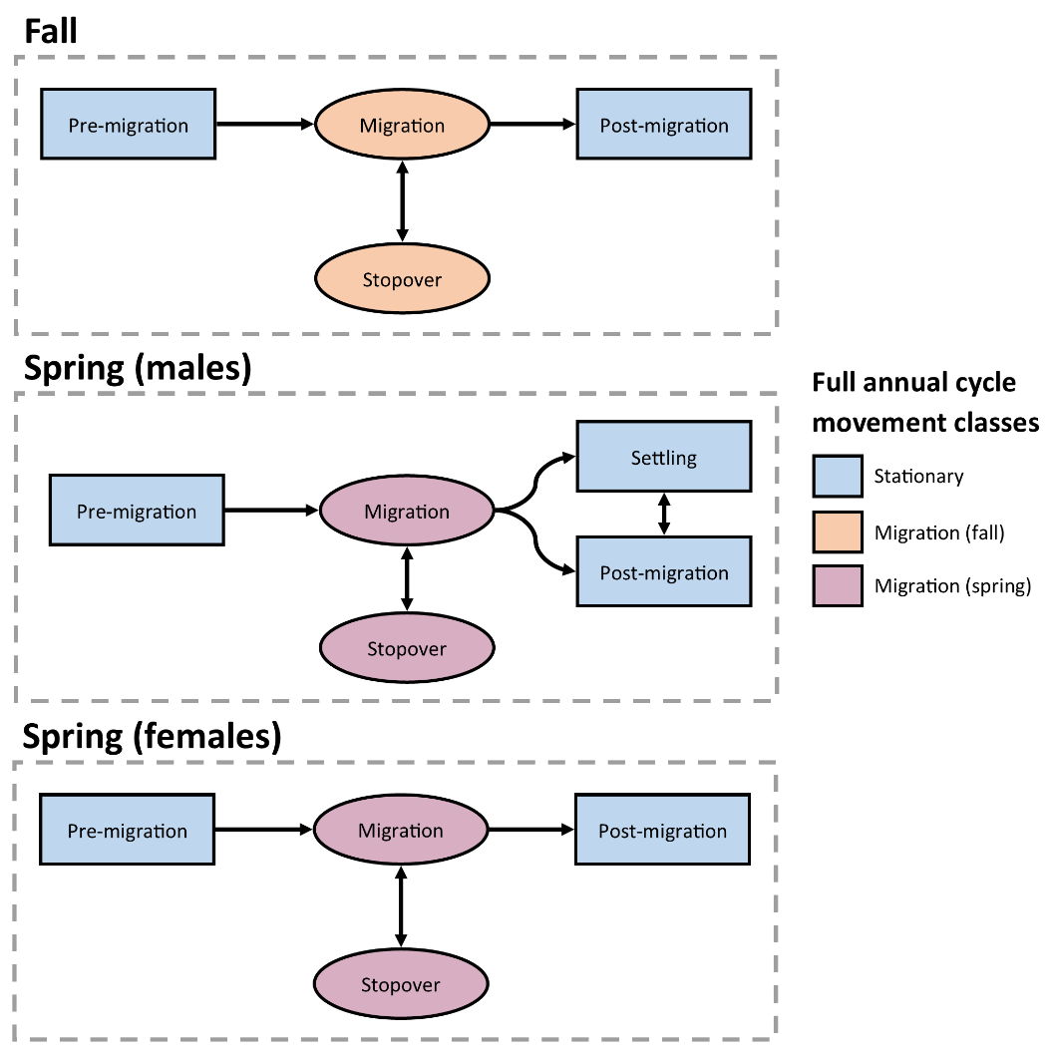

Figure 1. Movement state transition diagram for each hidden Markov Model (HMM). After HMM designation, these movement states were simplified to full annual cycle movement classes (indicated by color and shape) to better describe behaviors throughout the full annual cycle.

*2.4 Classifying movements outside of spring and fall migration*

In addition to the timing of fall and spring migration, we were also interested in movements before or after migration had concluded. To examine these movements, we first matched the classifications from the fall and spring HMMs with the locations from each woodcocks’ full trajectory, which included locations in the summer which were not considered in either HMM (Fig. 1). Before we matched the classifications, we simplified the classification states to 3 classes: stationary, migration (fall), and migration (spring). We then manually classified movements from each bird which fell outside the migratory period. We added 3 additional movement classes in this manual delineation: summer migrations, foray loops, and dispersal movements (Table 2). Summer migrations initiated after the conclusion of breeding activity but prior to the first date of consideration for fall migration (Aug. 1). These movements resulted in southerly displacement which was considerable enough to preclude further migration in the fall. Foray loops were recursive movements which included step lengths ≥30.2 km but for which the resulting displacement was <30.2 km, reflecting exploratory movements which would eventually return to the original breeding or wintering site. Dispersal movements were one-way movements which included step lengths ≥30.2 km and resulted in ≥30.2 km of displacement, reflecting one-way movements to a new breeding or wintering site. All 3 additional movement classes were further constrained to begin and end as stationary. For example, a bird could make a dispersal movement after its migration had concluded, but it could not transition directly from migration into a dispersal event, as this would be classified as a continued migration.

Table 2. Definitions of all full annual cycle movement classes delineated for American Woodcock.

|  |  |
| --- | --- |
| **Class** | **Definition** |
| Stationary | Recursive movements with steps <30.2km that are associated with non-migratory behavior. |
| Migratory (fall/spring) | Directional movements along a latitudinal gradient that bring the bird from the breeding to the wintering range, or visa-versa. Steps can be >, =, or < 30.2 km. Fall migratory movements initiate between Aug 1 and Feb 1, while spring migratory movements initiate between Jan 1 and June 1. |
| Migratory (summer) | Post-breeding, southerly movements that initiate before Aug 1 and would preclude further migratory movements in the fall. |
| Foray loops | Movements that include step lengths ≥30.2 km but result in <30.2 km of net displacement between the first and last point. Foray loops can occur in any season, provided they are temporally distinct from a bird’s migratory movements. |
| Dispersal events | Movements that include step lengths ≥30.2 km and result in ≥30.2 km of net displacement between the first and last point. Dispersal movements are temporally distinct from a bird’s migratory movements and occur outside of peak migratory periods. If dispersal movements result in northerly or southerly displacement, it will be in the opposite direction of most migrants at that time. |

*2.5 Calculation of full annual cycle phenology metrics*

We calculated several metrics to describe the prevalence, length, distance, and timing of each full annual cycle movement class. We reported the number of days between the first movement in each class (e.g. the start of migration) and the initial location of the subsequent movement class. We reported total distance as the sum of all step lengths in that movement class for each bird. For birds undergoing fall or spring migrations, total distance excludes any movements which were designated as stopovers by the HMM. We used medians and ranges to report dates of migratory initiation and termination, as medians are well suited to dealing with outliers which were common in the initiation and termination dates. We delineated migratory peaks by calculating the proportion of locations which fall into a migratory class in any given week, and reporting the week in which the proportion of migratory locations was highest.

We calculated the percentage of individuals which did not migrate using the pool of all individuals tracked between the nominal start of the migratory season (Fall: Oct. 15, Spring: Feb. 15) and the date by which most birds had initiated migration (95th quantile of the departure dates for that season). Any individuals which had at least one location before, during, and after this period, but did not enter a corresponding migratory state, were designated as non-migratory for that season. We used similar time periods for determining whether a bird had migrated in the season before or after its non-migratory season. We measured the frequency of summer migrations based on all birds tracked from May 1st–Sep. 1st, with dates chosen based on the first initiation date and last termination date observed in the dataset. We measured the frequency of dispersal movements and foray loops based on all birds which had locations spanning at least 1 month, to ensure that the bird had been active long enough to correctly designate its movement class. We did not report standard deviations for the duration and distance traveled of summer migrations, foray loops, and dispersal movements, as our sample sizes were too small to do so reliably. In these cases, we reported ranges instead.

**3 Results**

*3.1 Model evaluation*

We created HMM classifications for 522 individual seasonal tracks from 401 tagged woodcock. Of the 522 classified tracks, 36 needed individual exceptions to the methods described above to correctly fit the seasonal HMMs. These fixes can be broadly categorized as misclassification errors due to the presence of foray loops (13 misclassification errors), dispersal movements (3), and summer migrations (2), as well as errors caused by continued migration after the end of the HMM’s consideration period (13) and transmissions beginning after the start of migration (3). We additionally edited the known state classification for 2 birds, one of which was captured on nest late in spring migration, and the other which was recaught at a suspected post-migratory site several months after its transmitter had prematurely died. These misclassification errors, and the individual modifications to the seasonal HMMs which were made to correct them, are detailed in full in Supplementary Information C.

All three seasonal HMMs exhibited some measure of improved validation accuracy with the full model compared to the reduced model, although some seasonal HMMs showed more pronounced improvements than others (Fig. 2). The full fall model had a comparable Type I error rate (0–28.6%) to the reduced model (0–28.2%), but the full model had a Type II error rate (0–4.0%) which was generally lower than that of the reduced model (0–26.1%). The spring male full model exhibited lower rates of Type I (0–13.0%) and Type II (0–8.9%) error during most time periods than the reduced model (Type I: 0–55.6%, Type II: 0–19.6%). The spring female full model exhibited higher Type I errors (0–20.8%) during some time periods than the reduced model (2.0–17.9%), but the full model also experienced substantially reduced Type II error rates (2.0%–16.7%) than the reduced model (7.7–70.0%).

*3.2 Full annual cycle phenology*

Fall migrations lasted an average of 22.1 days (SD 19.0, range 2–83 days) and had a mean migration distance (excluding stopovers) of 1383 km (SD 564, range 44–2970 km). for males and lasted 30.9 days (SD 27.7, range 1–142 days) and were 1346 km (SD 680, range 158–2980 km) long for females. Spring migrations lasted 38.2 days (SD 23.4, range 4–94 days) and were 1552 km (SD 646, range 296–3337 km) long for males and lasted 46.9 days (SD 29.3, range 2–128 days) and were 1654 km (SD 625, range 455–3407 km) long for females. The median date of departure for fall migration was Nov. 9th (range: Sep. 24th–Dec. 10th) for males and Nov. 7th (Aug. 29th–Jan. 11th) for females. The median date of migratory termination was Nov. 28th (Nov. 1st–Dec. 30th) for males and Dec. 6th (Oct. 25th–Feb. 4th) for females. The median date of departure for males during spring migration was Mar. 1st (Jan. 6th–Apr. 14th), and the median date of migratory termination was Apr. 4th (Jan. 11th–Jun. 4th). The median date of departure for females during spring migration was Mar. 6th (Jan 19th–Apr. 26th), and the median date of migratory termination was Apr. 21st (Feb. 20th–Jul. 28th). Fall migration peaked on the week of Nov. 18th–Nov. 25th for both males and females, with 53% and 57% of male and female locations in that week being migratory, respectively. Spring migration peaked on the week of Mar. 18th–Mar. 25th for males and Apr. 1st–Apr. 8th for females, with 78% and 82% of locations in those weeks being migratory, respectively (Fig. 3).

Eight of 174 birds (5%) tracked from Oct. 15th–Dec. 6th did not migrate in fall, and 7 of 194 birds (4%) tracked from Feb. 15th–Mar. 29th did not migrate in spring. Of those birds which did not migrate in fall, 5 overwintered in Rhode Island, 2 in Pennsylvania, and 1 in Virginia. Of birds which did not migrate in spring, 2 overwintered in Virginia, and 1 each overwintered in Maryland, Florida, North Carolina, Georgia, and Alabama. Individuals which abstained from migration during one season did not necessarily repeat that behavior, as non-migratory birds were frequently observed migrating in prior or subsequent seasons when data was available (5 of 5 birds). 3 of 65 birds (5%) tracked from May 1st–Sep. 1st undertook a southerly migration during the summer. These summer migratory movements initiated on a mean date of Jun. 19th (May 27th–Jul. 13th) and terminated on a mean date of Jul. 28th (Jul. 8th–Aug. 22nd; Fig. 4). These movements had a mean length of 39 days (35–42 days) and the mean distance traveled was 756 km (523–1106 km). Three of 456 birds (0.7%) tracked for at least 1 month underwent a dispersal movement, with one bird undergoing 2 dispersal movements that were approximately 2 months apart. Dispersal movements were observed in December, February, June, and July, and were restricted to the northeastern United States. Dispersal movements had a mean length of 6 days (1–10 days) and the mean distance traveled was 129 km (30–263 km). 13 of 456 birds (3%) tracked for at least 1 month underwent a foray loop. Foray loops were observed in all months except for March and April during the peak of spring migration. They had a mean length of 20 days (3–95 days) and the mean distance traveled was 288 km (31–951 km).

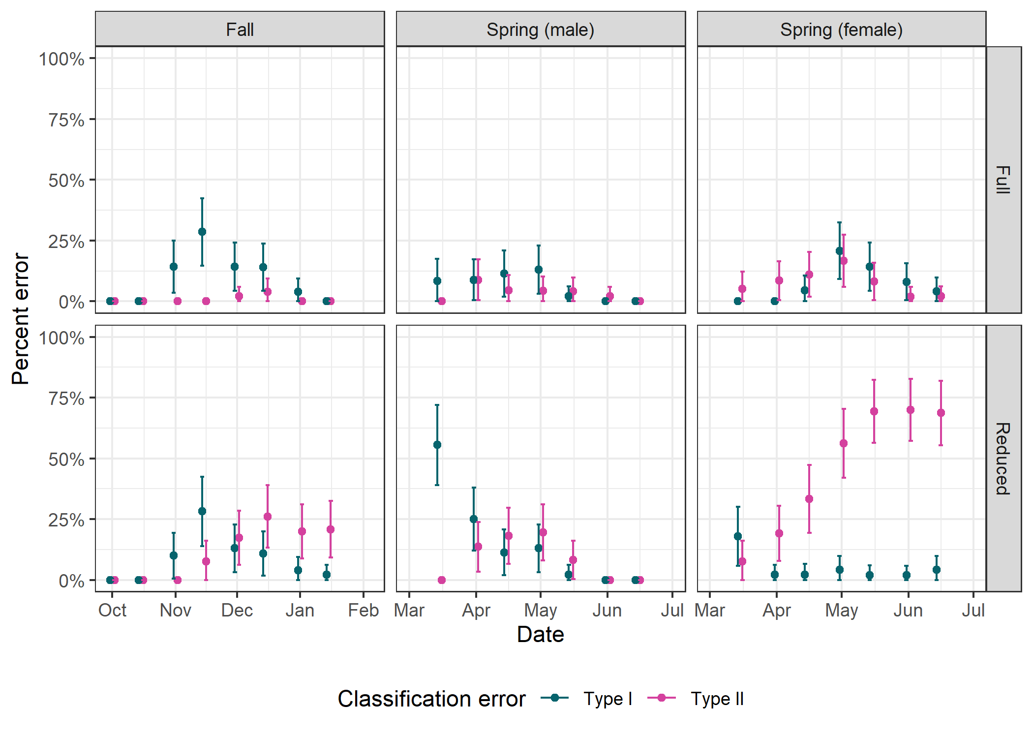

Figure 2. Error rates for the fall, spring (male), and spring (female) hidden Markov Models (HMM), as measured through the model validation process. The horizontal axis reflects the cutoff date for each model, used to simulate how an incomplete track ending on that date might be classified incorrectly. HMMs are grouped into full and reduced models, with full models including all possible covariates and reduced models including only step length and turn angle, to demonstrate how classification accuracy changes with the addition of more covariates. Type 1 errors reflect false classification as post-migratory while the true state is migratory. Type 2 errors reflect false classification as migratory while the true state is post-migratory. Bars show the 95% confidence interval of the mean.

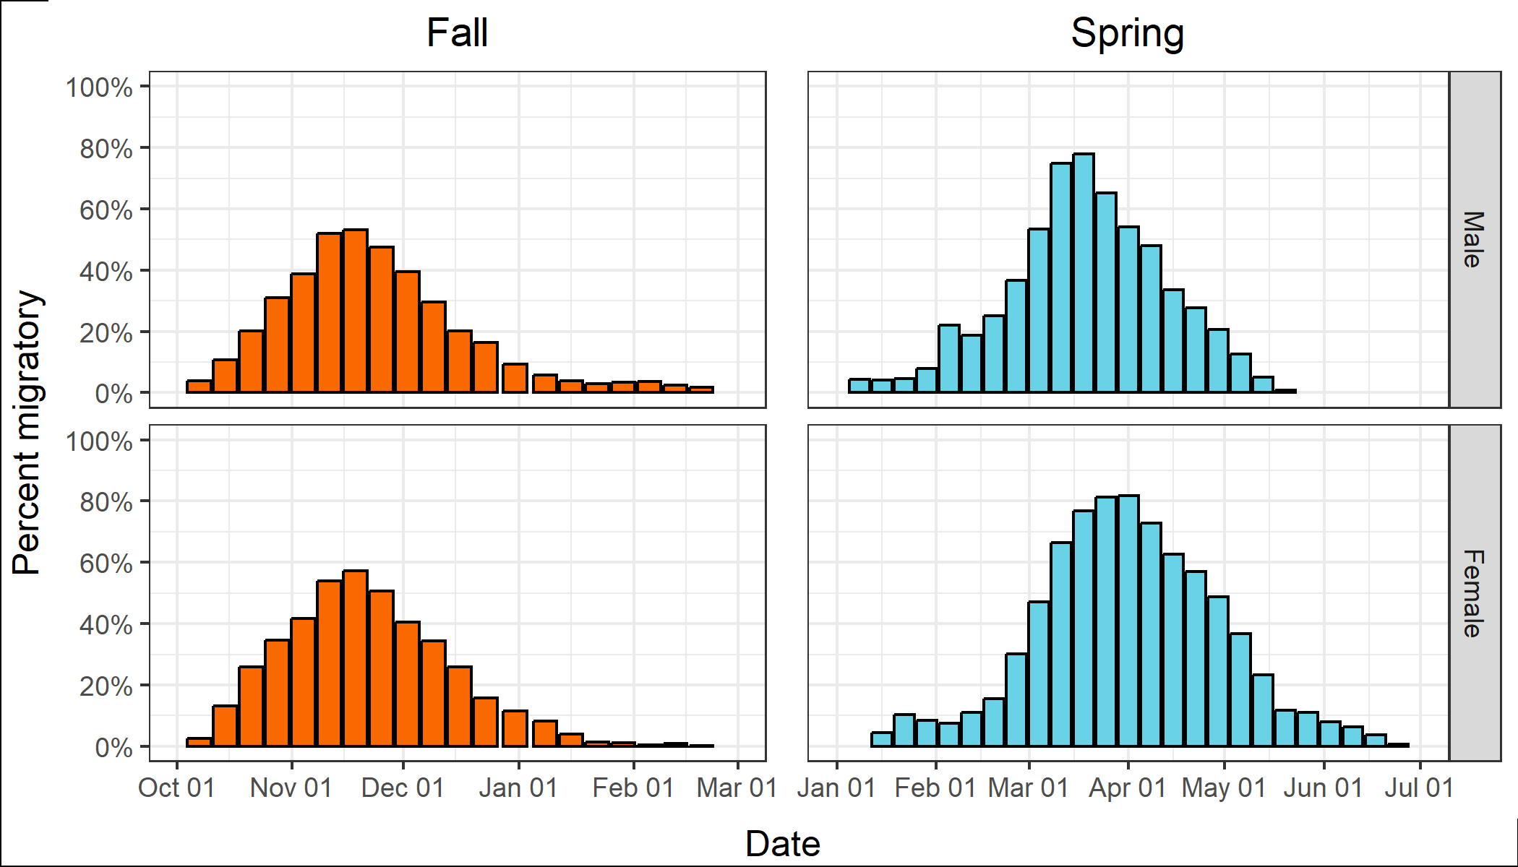

Figure 3. Migratory intensity of male and female American Woodcock throughout the fall and spring migratory seasons. Color indicates season, and the vertical axis reflects the percentage of all locations in each week that fall into the migratory (fall) or migratory (spring) movement classes.

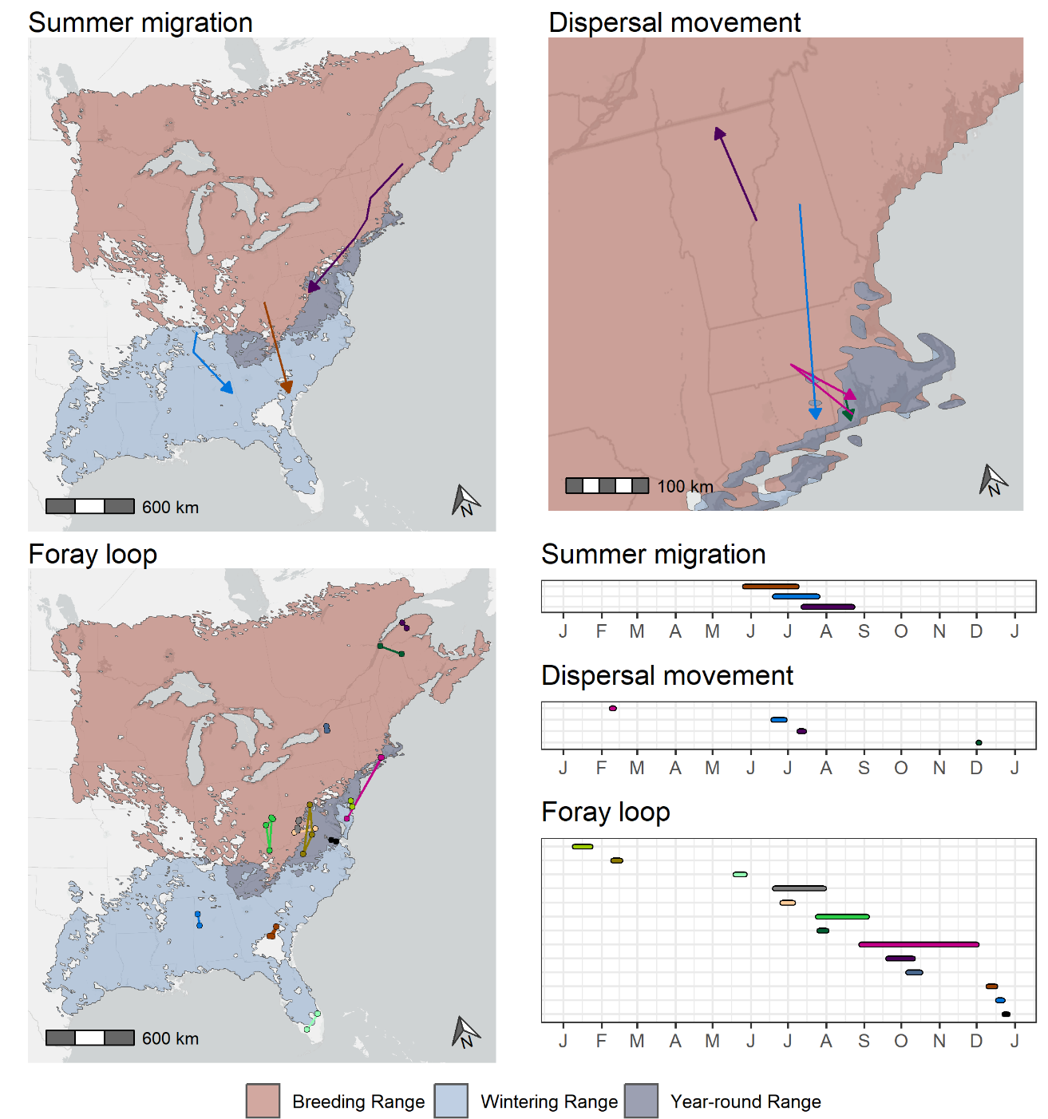

Figure 4. Spatial and temporal distribution of all identified summer migrations, dispersal movements, and foray loops of American Woodcock throughout the full annual cycle. Maps are superimposed over the breeding, wintering, and year-round range of the American Woodcock as delineated by the eBird Status and Trends dataset [8]. Timelines show the duration of each movement and are mapped against month on the horizontal axis. Each movement is matched from the map to the timeline by color.

**References**

1. Sheldon WG. A method of mist netting woodcocks in summer. Bird-banding. 1960;31:130–5.

2. Rieffenberger JC, Kletzly RC. Woodcock night-lighting techniques and equipment. WH Goudy, compiler Woodcock research and management. 1966;33–5.

3. McAuley DG, Longcore JR, Sepik GF. Techniques for Research into Woodcocks: Experiences and Recommendations. Proceedings of the eighth American woodcock symposium. U.S. Fish and Wildlife Service; 1993. p. 5.

4. Ephraim Y, Merhav N. Hidden markov processes. IEEE Transactions on information theory. 2002;48:1518–69.

5. Zucchini W, MacDonald IL, Langrock R. Hidden Markov models for time series: an introduction using R. CRC press; 2017.

6. Johnson DS, London JM. crawl: an R package for fitting continuous-time correlated random walk models to animal movement data [Internet]. 2018. Available from: https://doi.org/10.5281/zenodo.596464

7. R Core Team. R: A Language and Environment for Statistical Computing [Internet]. Vienna, Austria: R Foundation for Statistical Computing; 2022. Available from: https://www.R-project.org/

8. Fink D, Auer T, Johnston A, Strimas-Mackey M, Ligocki S, Robinson O, et al. eBird Status and Trends. Ithaca, New York: Cornell Lab of Ornithology; 2022.

9. McClintock BT, Michelot T. momentuHMM: R package for generalized hidden Markov models of animal movement. Methods in Ecology and Evolution. 2018;9:1518–30.