*Adapting hidden Markov models to data from small GPS transmitters for tracking migratory birds*

Liam Berigan, Sarah Clements, Rachel Darling, Alex Fish, Amber Roth, Erik Blomberg, Greg Balkcom, Bobbi Carpenter, Gary Costanzo, Jeffrey Duguay, Clayton Graham, William Harvey, Michael Hook, Douglas Howell, Seth Maddox, Scott McWilliams, Shawn Meyer, Theodore Nicols, J. Bruce Pollard, Christian Roy, Colby Slezak, Josh Stiller, Mathieu Tetreault, Lisa Williams

Target: Ornithological Applications

**Abstract**

Widespread collection of GPS data from migratory birds necessitates tools for the effective processing and classification of that data. Tools such as hidden Markov models provide opportunities for classifying GPS data, but are designed for regular, high frequency data which is typically not provided by migratory birds. However, the use of additional data streams to fit movement states can assist with fitting cryptic movement states and may assist with fitting movement states with sparse and irregular GPS data. Here we test an approach using a correlated random walk model and additional data streams to fit hidden Markov models to GPS data from bird migrations, specifically American Woodcock (*Scolopax minor*; hereafter woodcock). Our objectives were to determine if the use of additional data streams resulted in an improved capacity to predict migratory states, describe the migratory phenology of woodcock, and characterize long-distance movements by woodcock outside of the migratory season. We found that the inclusion of additional data streams greatly improved the performance of hidden Markov models, although the individual impact of each added data stream was low. Woodcock migratory phenology largely followed prior descriptions, although we observed low incidence of continued migration during the wintering and breeding seasons. We also observed dispersal, foray loops, and summer migrations occurring among woodcock outside of the migratory periods. Despite our progress in applying hidden Markov models to bird data, the complexities required to do so demonstrate how major new developments in the development of movement ecology tools have largely not extended to the modeling of sparse and irregular data generated by avian tracking studies. New techniques and applications are likely to be necessary to accommodate the accelerating effort to understand bird migration using GPS, Motus, and other technologies.

**Introduction**

The amount of GPS data collected from small birds has exploded over the last decade (Iverson et al. 2023b), providing opportunities to study facets of bird migration which have long eluded ornithologists. GPS data can be used to address questions of migratory phenology (Wright et al. 2021), habitat use (Moskát et al. 2019, Iverson et al. 2023a), survival (Klaassen et al. 2014), and connectivity (Combreau et al. 2011) with high resolution data and near-global coverage. Although historically GPS transmitters have been limited to larger birds, technological improvements in both archival and satellite platform transmitting terminal (SAT-PTT) GPS transmitters have allowed GPS technology to become available for a much larger group of bird species than has historically been the case (Bridge et al. 2011).

In order to answer questions about bird migration, GPS data is usually classified into migratory tracks, which delineate between pre-migration, migration, and post-migration. State classification can be done using one of several simple frameworks. One framework might be based on the known breeding and wintering ranges of a bird, where a bird is considered to have begun migration when it leaves the breeding range, and completed migration when it enters the wintering range, and visa versa (Linscott et al. 2022). Another threshold might be a step-length or distance threshold for migratory steps, where migration begins with the first step longer than the distance threshold and ends with the last step longer than the distance threshold (Burnside et al. 2017). The range delineation method has the advantage of being robust to incomplete tracks; if a bird dies or transmitter failure occurs during the bird’s migration, the bird’s final state is still apparent. However, the range delineation method requires constrained breeding and wintering ranges that have little overlap with the migratory range (ex. Bar-tailed Godwit, *Limosa lapponica*; Battley et al. 2012). The step-threshold method relaxes the assumption that breeding and wintering ranges do not overlap with the migratory range, which allows this method to be applicable to a much wider range of birds with widespread breeding and wintering ranges (ex. Pine Siskin, *Spinus pinus*; Dawson 2020). However, the step-threshold method does not handle incomplete tracks well; if a bird dies or transmitter failure occurs during the temporal period of migration, the bird’s final state is unknown (Fig. 1). Quantifying the bird’s final state in these cases is particularly important for survival and connectivity analyses, where knowing whether the bird completed migration by the end of its track is essential to the analysis, but also has relevance for phenology and habitat analyses for which migratory delineation is important.

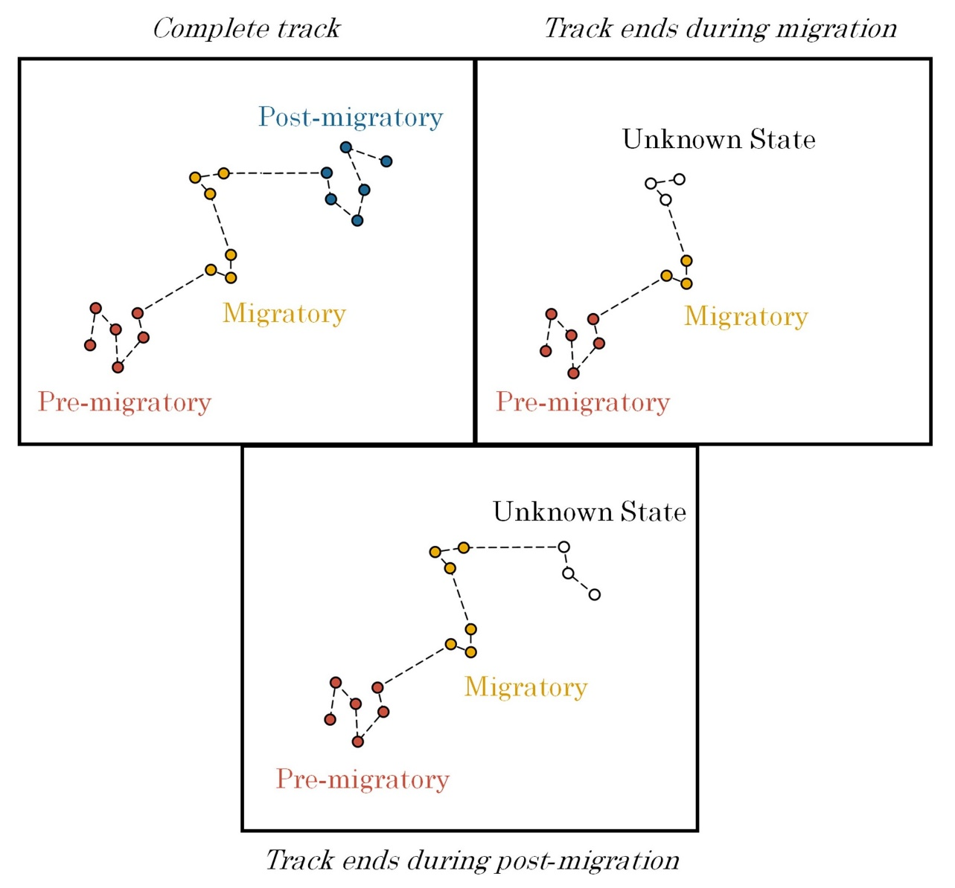

Figure 1. Complete and incomplete tracks of a theoretical migratory bird. For birds with complete tracks (encompassing the entire temporal period of migration), the pre-migratory, migratory, and post-migratory stages of the track are apparent, and can be identified using known breeding and wintering ranges or a step-length threshold to identify migratory steps. For birds with incomplete tracks, however, the final state of the bird cannot be determined using a step-length threshold. If points cannot otherwise be delineated using breeding and wintering ranges, incomplete tracks end in an uncertain state that could be either migratory or post-migratory.

Hidden Markov models are a frequently employed tool for the estimation of movement states, and could potentially be used to estimate the final movement state of incomplete movement tracks (Langrock et al. 2012, Zucchini et al. 2017). Hidden Markov models are used to delineate hidden behavioral states given observed distributions of outcome variables, allowing the assignment of animal movement states in a quantitatively robust manner. Step length and turn angle are typically the two parameters used to identify behavioral states in movement datasets, although additional data streams (such as acceleration, depth/altitude, and immersion in water) can be used to improve the model’s predictive capabilities (Dean et al. 2013). Hidden Markov models were initially applied to GPS data from large-bodied mammal species, which can carry large transmitters that provide high frequency, regularized location data over long periods of time (Langrock et al. 2012, 2014b, a). More recent applications of hidden Markov models include small mammals, fish, reptiles, and birds (Bagniewska et al. 2013, McKellar et al. 2015, Heerah et al. 2017, Hromada et al. 2023).

The application of hidden Markov models to birds has mostly focused on larger species, particularly shorebirds, sage-grouse, prairie grouse, and seabirds, which can carry larger transmitters than most other birds and receive direct sunlight which can be used to charge a solar panel (Dean et al. 2013, Berigan 2019, Picardi et al. 2022, Mander et al. 2022). Larger battery size and the capacity for solar recharge allows these transmitters to sustain a regular frequency of multiple transmissions per day, which facilitates the fitting of hidden Markov models. Studies have shown that hidden Markov models can be used in these cases to fit smaller scale movement patterns, such as foraging, as well as larger scale movement patterns, such as dispersal or migration (Berigan 2019, Zhang et al. 2019, Blomberg et al. 2023). However, the small size and forest dwelling habits of most birds preclude larger transmitter batteries or solar recharging, which limits the battery life and transmission frequency of GPS transmitters attached to smaller birds. The resulting GPS data collected from smaller birds is sparse and irregular and is not easily fit using traditional approaches with hidden Markov models.

The paucity of GPS data that can be collected from most small, forest-dwelling birds is demonstrated by the American Woodcock (*Scolopax minor*; hereafter woodcock). Woodcock are an early-successional habitat specialist which primarily eats earthworms and are one of the few North American members of the family Scolopacidae which does not favor coastal, wetland, or riparian habitats (McAuley et al. 2020). Woodcock typically breed throughout the northern United States and southern Canada, and winter throughout the southern United States. They are frequently among the earliest migrants to arrive in the breeding range as snow melts in the spring and the latest to leave as frost encroaches in the fall (Moore et al. 2021). Woodcock have been in decline at least since surveys began in 1968, at a rate of roughly 1.8% per year in central North America and 1.9% in eastern North America (Kelley et al. 2008). Presumed reasons for decline include reduction in early-successional habitat throughout the northeastern United States due to forest maturation, and potentially low migratory survival rates due to collision with anthropogenic obstacles. Woodcock are among the 25 most common birds to find deceased as a result of bird strikes in major U.S. cities, and woodcock survival during migration is considered to be a priority research area (Kelley et al. 2008, McAuley et al. 2020). Woodcock are large enough to fit SAT-PTT transmitters of 4–6 g (woodcock mass: 116–279 g; McAuley et al. 2020), but the species’ forest-dwelling habits preclude the use of a solar panel (Arizaga et al. 2015). Tracking woodcock throughout their migratory cycle using SAT-PTT transmitters produces infrequent and irregular GPS locations, which provide obstacles for fitting hidden Markov models.

Here we suggest a modified approach that allows hidden Markov models to fit large scale movement behaviors, such as migration, using sparse and irregular GPS data. We suggest a two-stage process: 1) interpolation of data at a regular interval using a correlated random walk model, and 2) fitting a hidden Markov model using additional data streams that describe the time, location, and movement characteristics of a given GPS point. We demonstrate this approach on data collected from American Woodcock during a wide-scale study of their migratory phenology, habitat use, and survival. Our objectives were to 1) determine whether the use of additional data streams would allow us to infer the final movement state of an incomplete track more accurately, 2) describe the migratory phenology of woodcock, and 3) estimate the prevalence of long-distance movements and non-migratory behaviors among tagged individuals. These joint objectives, examining both model design and the life history of American Woodcock, demonstrate the potential of a hidden Markov model approach for dealing with sparse and irregular GPS data and the ecological insights that can be gained from the application of those models to data from migratory birds.

**2 Methods**

*2.1 Collecting data via GPS transmitters*

We delineated American Woodcock movements throughout the full annual cycle using GPS-tracking data from the Eastern Woodcock Migration Research Cooperative, a collaboration of 42 agency, non-profit, and academic organizations in eastern North America (www.woodcockmigration.org). We captured woodcock at 78 sites in Quebec, Ontario, Nova Scotia, Maine, Vermont, New Jersey, New York, Rhode Island, Pennsylvania, Maryland, West Virginia, Virginia, North Carolina, South Carolina, Georgia, Alabama, Louisiana, and Florida using mist nets during morning and evening flights (Sheldon 1960), and on night roosts using spotlights and dip nets (Rieffenberger and Kletzly 1966, McAuley et al. 1993). We attached 4g, 5g, or 6.3g PinPoint GPS Argos transmitters (Lotek Wireless Inc., Newmarket, Ontario, CA) to captured woodcock. Transmitters, bands, and harness materials never exceeded 4% of a bird’s body mass, and all capture and handling were conducted with methods approved by the University of Maine Institutional Animal Care and Use Committee (Protocol # A2020-07-01).

GPS transmitters were programmed with one of several schedules, each of which collected data at a slightly different pace to optimize battery life. The most frequent schedules would record locations daily, while infrequent schedules would record locations every 3–7 days. Certain schedules were programmed to switch between frequent and infrequent modes outside of migratory time periods, and transmitters were occasionally set to go dormant for periods of 1–3 months during summer and fall to preserve battery life for a separate study objective. Each transmitter was predicted to collect a maximum of 75–150 GPS locations, depending on transmitter size and schedule, at 12–60m accuracy. Transmitters relayed GPS locations back to the ARGOS satellite network after every 3rd location, allowing recovery of data without recapture of the bird. However, transmitters occasionally failed to relay data, sometimes resulting in sporadic missing data near the end of battery life.

*2.2 Delineating spring and fall migration*

*2.2.1 Using HMMs to delineate woodcock migration*

We delineated woodcock movements within fall and spring migratory seasons, where fall generally encompassed Aug. 1st–Feb. 25th and spring encompassed Jan. 5th–Jun. 30th based on the periods of time when most birds were migrating. However, for a small subset of birds (n = 14) we had to define custom date ranges due to prolonged migratory movements (Supplementary Information A). To ensure that fall and spring migratory movements were not conflated by our models, we delineated spring migrations first, and shortened the end of the default fall migration timeframe (Aug. 1–Feb. 25) to a day before the subsequent spring migration began for that individual.

We defined woodcock migration as beginning when woodcock make their first ≥16.1 km movement in a season and ending after woodcock make their final ≥16.1 km movement in a season. We chose a 16.1 km threshold as it roughly bisects the bimodal distribution of log-transformed step lengths collected by our migratory birds (Blomberg et al. 2023). However, tagged woodcock in our study frequently had incomplete migratory tracks, either due to waning battery life or bird mortality before the end of migration, making it unclear when their final ≥16.1 km movement occurred. We therefore used hidden Markov Models (HMMs; Ephraim and Merhav, 2002; Zucchini et al., 2017) to delineate woodcock migrations, which allowed birds with complete migratory tracks to inform the final migratory state designation of birds with incomplete migratory tracks. We made several adjustments to the HMMs to allow them to better function with infrequent locations and missing data and provided additional data streams to allow the models to better differentiate between stopovers and post-migratory locations.

Infrequent locations and missing data can impede the ability of the model to detect recursive movements (defined as “repeated visitations to the same particular locations in a systematic manner”; Berger-Tal and Bar-David 2015) which could be indicative of short-distance movements during stopovers and post-migratory settlement. We filled in data gaps using a correlated random walk model to interpolate daily locations at stopover, pre-migratory, and post-migratory sites using the R package crawl (Johnson and London 2018, R Core Team 2022). This allowed the HMM to detect recursive movements more accurately during stationary periods using a limited number of infrequent locations. We only used the correlated random walk model to interpolate locations between points that were <16.1 km apart (i.e., when the bird was either at a stopover or not migrating), as the correlated random walk model tended to break long migratory steps into a series of short daily movements, making the HMM less likely to identify these movements as migratory. Due to the directional consistency inherent in correlated random walks, correlated random walk models occasionally produced erroneous loops of interpolated points to explain directional changes when birds made recursive movements during non-migratory periods. These interpolated loops were often lengthy and could artificially create step lengths ≥16.1 km. To ensure that HMMs didn’t incorrectly interpret these loops as migratory movements, we removed all loops of interpolated points for which the total length of the loop was more than 10 times the distance between observed points and replaced the loops with sets of predicted locations spaced evenly along a line between the observed points.

While HMMs generally differentiate among different movement states using step lengths and turn angles, we encountered difficulties inferring the final movement state of incomplete tracks using these data streams alone. To overcome this issue, we added additional data streams that allowed models to better differentiate between stopovers and post-migratory locations. Additional data streams measured recursiveness, residence time, day of season, and location of a given point (Table 1). We measured recursive movements using the mean distance to the nearest 7 points, transformed using a natural logarithm. This measured whether the nearest 7 bird locations (meant to approximate space use over the period of a week) reflected intensive use of the same area, and presumably resource utilization, or spread-out movement throughout the area, possibly reflecting exploration. We measured residence time using the time difference between the first and last day that the bird was within a 10 km radius of a location. This reflected the difference between the amount of time that woodcock spent occupying stopover sites as opposed to their post-migratory sites. We measured day of season using an ordinal day variable, reflecting woodcocks’ tendency to migrate at similar times each year. We measured location using latitude and two binomial variables. The first binomial location variable determined whether a bird had or had not moved ≥16.1 km from its position at the beginning of the season and had thus departed its initial site to begin migration. The second binomial location variable reflected whether the bird was currently within the woodcock breeding range, as delineated using the eBird 2021 Status and Trends abundance maps (Fink et al. 2022).

Table 1. Covariates used to delineate movement states in hidden Markov Models (HMMs), and the type of distribution used to fit to each covariate in the HMMs. Point-specific attributes (latitude, ordinal day, distance from start, breeding range, log(distance to nearest points), residence time) are based on the woodcock’s location at the beginning of the step.

|  |  |  |
| --- | --- | --- |
| **Covariate** | **Distribution** | **Description** |
| Step length | Gamma | Length of the current step |
| Turn angle | Wrapped Cauchy | Angle between the current and previous step |
| Latitude | Normal | Latitude at the beginning of the step |
| Ordinal day | Normal | Days since the beginning of the migratory season |
| Distance from start threshold | Bernoulli | Has the bird moved >16.1 km from its location at the beginning of the migratory season? |
| Step length threshold | Bernoulli | Is the current step length ≥16.1 km? Implemented with a fixed distribution so that all steps ≥16.1 km are migratory. |
| Breeding range | Bernoulli | Does the step begin in the American Woodcock breeding range (Fink et al. 2022)? |
| Log(distance to nearest points) | Normal | Natural logarithm of the mean distance to the nearest 7 points. |
| Residence time | Normal | Number of days that the bird has spent/will spend within a 10km radius. |

*2.2.2 Model design*

We implemented fall and spring HMMs in the R package momentuHMM (McClintock and Michelot 2018) due to its accommodation of multiple data streams and customized model structures. We used separate HMMs for males and females in spring due to differential breeding movements, and together during the fall as movements were similar between sexes. We constructed a multi-state model for each HMM to delineate distinct stages of migration and identify transitions occurring between stages (Fig. 2). Models for spring migration by females and all woodcock during fall featured 4 states: pre-migration, migration, stopover, and post-migration. Birds began the season in a pre-migration state and remained as long as the bird made no movements ≥16.1 km. When the bird made its first movement ≥16.1 km it moved into a migration state, which was the only state in which movements ≥16.1 km were permitted. From the migration state, birds could enter either a stopover state or a post-migration state. The stopover state was characterized by a period of recursive movements <16.1 km, where the only possible state transition was back into the migration state. The post-migration state could only be reached from the migration state and did not allow for any further state transitions. This state indicated that the bird had completed movements ≥16.1 km for the remainder of the season. These state assignments were generally enforceable using the fixed transition framework in the momentuHMM package, but occasional errors occurred when improbable state assignments caused the framework to fail to enforce state transition rules. These errors and their fixes are detailed in Supplementary Information B.

The spring male model splits post-migration into two states, post-migration (frequent) and post-migration (infrequent), which males could enter in spring at the conclusion of migration. The inclusion of these two states fixed an artifact in the dataset caused by male-specific transmission schedules, which switched to a less-frequent transmission schedule late in the spring migratory season. Infrequent transmissions caused the correlated random walk model to infer a greater proportion of steps during the late migratory period, producing a much narrower turn angle distribution than observed earlier in the season. The inclusion of two post-migratory states with separate turn angle distributions, which birds can transition between freely, allows the model to better account for this source of variation in turn angles when delineating post-migratory movements.

To remove birds from consideration which did not make migratory movements or did not collect enough data to fit an HMM, we excluded any birds which did not have at least 1 step ≥16.1 km, or which collected fewer than 3 points in a given season. We assigned a fixed pre-migration state for the initial step of most birds captured during breeding or wintering. However, birds captured in Virginia, New Jersey, and Maryland were sometimes captured after widespread migratory initiation in the fall or spring, creating uncertainty whether a bird caught during one of these periods entered the HMM in a pre-migration or a migration state. To counteract uncertainty in the initial state for Virginia, New Jersey, and Maryland caught birds in the season of their capture, we allowed the HMM to estimate the initial state of the model instead of using a fixed pre-migration state for the initial step. The only other circumstance in which we allowed the initial state for a bird to vary from pre-migration was when the first step length was ≥16.1 km, in which case we set the first step to a known migration state. We fixed final steps to the post-migratory state for fall woodcock that were also known to initiate spring migration.

We visually inspected all HMM state assignments, which sometimes identified circumstances where birds did not fit model predictions due to extra-seasonal movements, early initiation or late termination of migration, or transmitter error. In those cases, we manually reclassified state assignments (Supplementary Information A). We also encountered issues with mortality locations, as birds which died during migration occasionally continued to transmit and caused the HMM to falsely classify dead birds as post-migratory. We have included methods used in delineating GPS mortalities and removing them from the dataset in Supplementary Information C.

*2.3 Assessment of HMM accuracy*

In all models, transition to post-migratory states was incumbent on no further steps ≥16.1 km after the transition. Because we rarely observed migratory movements beyond Jan. 15th for fall migration and Jun. 15th for spring migration, we considered the date of post-migratory transition (the date of the bird’s final ≥16.1 km movement) to be known for birds that survived and continued to transmit past the cutoff date. For birds that stopped sending data before the cutoff date, we relied on HMMs to determine whether each bird had reached its final ≥16.1 km movement of the season or was still migrating. We assessed the accuracy of our final state assignments of incomplete tracks using a leave-one-out simulation, in which we artificially removed locations from the ends of tracks for individual birds with known post-migratory transition dates, reran the HMM, and evaluated whether the model correctly determined the final movement state. We iteratively assessed 50 individuals for each seasonal simulation, testing the accuracy of final state assignment when tracks were cut off to dates from Oct. 1st–Jan 15th in fall and Mar. 15th–Jun. 15th in spring. We measured the accuracy of final state assignment based on Type I and Type II errors, where a Type I error occurred when the ending state was falsely classified as migratory, and a Type II error occurred when the ending state was falsely classified as settling or post-migratory. We conducted this assessment on the full model for each HMM and a base model for each season that used only step length, turn angle, and a ≥16.1 km step length threshold parameter to train the HMM. Running both full and base models allowed us to examine how both Type I and Type II errors changed with the inclusion of additional variables in the HMM and to evaluate whether the inclusion of these variables improved the predictive capacity of the HMM.

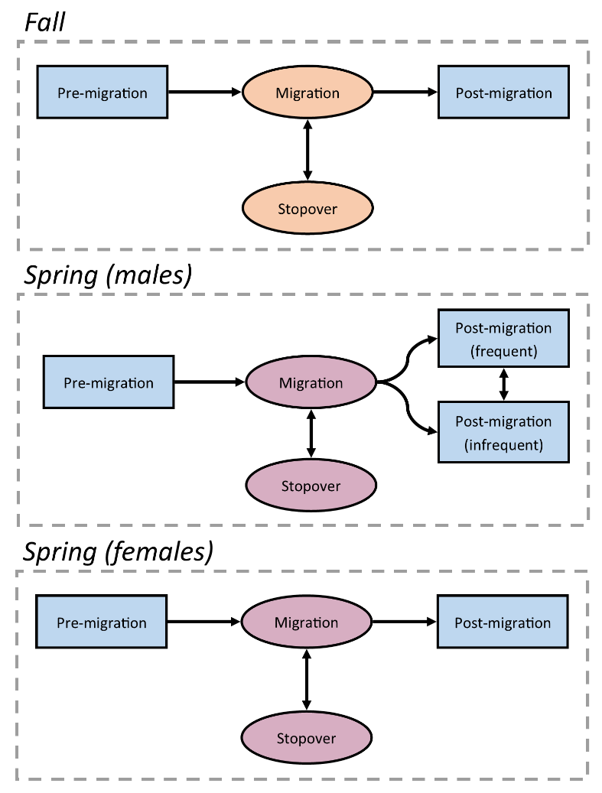

Figure 2. Movement state transition diagram for each hidden Markov Model (HMM).

*2.4 Classifying movements outside of spring and fall migration*

To examine long-distance movements, we manually classified 3 potential long-distance movement states: summer migrations, foray loops, and dispersals (Table 2). Summer migrations were southerly movements ≥16.1 km that were initiated after the conclusion of spring migration but prior to the period of fall migration (Aug. 1). These movements resulted in southerly displacement considerable enough to preclude further migration during the fall. Foray loops were circular or out-and-back movements that included steps ≥16.1 km, but for which the bird’s eventual displacement was <16.1 km. Dispersals were one-way movements including steps ≥16.1 km that resulted in ≥16.1 km of displacement, reflecting one-way movements to a new summering or wintering site. Birds could only transition between a long-distance movement state and a non-migratory state (pre-migration, settling, or post-migration), ensuring that long-distance movements were separate from early or continued migration.

Table 2. Definitions of long-distance movement states manually delineated for American Woodcock.

|  |  |
| --- | --- |
| **Class** | **Definition** |
| Migratory (summer) | Post-breeding, southerly movements initiated before Aug 1 that preclude fall migratory movements. |
| Foray loops | Circular or out-and-back movements with steps ≥16.1 km that result in <16.1 km of net displacement between the first and last point. Foray loops can occur during any season, provided they are temporally distinct from a bird’s migratory movements. |
| Dispersals | Movements that include step lengths ≥16.1 km and result in ≥16.1 km of net displacement between the first and last point. Dispersal movements follow directions which are not typical of co-occurring seasonal migrations. |

*2.5 Calculation of full annual cycle phenology metrics*

We calculated several metrics to describe the prevalence, length, distance, and timing of each movement state. We summed the number of days between the first movement in each state and the initial location of the subsequent movement state (e.g. the start and end of migration). We also summed the total distance of all steps in each movement state for each bird. For birds undergoing fall or spring migrations, total distance excluded movements designated as stopovers, i.e. steps <16.1 km that occurred while the individual was migrating. We used medians and ranges to report dates of migratory initiation and termination, as medians are well suited to accommodating outliers that were common in the initiation and termination dates. We delineated migratory peaks by calculating the proportion of locations which fell into a migratory state during any given week, and reporting the week in which the proportion of migratory locations was greatest.

We calculated the percentage of individuals which did not migrate using the pool of all individuals tracked between the nominal start of the migratory season (Fall: Oct. 15, Spring: Feb. 15) and the date by which most birds had initiated migration (95th quantile of the departure dates for that season). Any individuals which had at least one location before, during, and after this period, but did not enter a corresponding migratory state, were designated as non-migratory for that season. We used similar time periods to determine whether a bird migrated during the season before or after its non-migratory season. We counted the frequency of summer migrations based on all birds tracked between May 1st–Sep. 1st, with dates chosen based on the first initiation date and last termination date observed in the dataset. We counted the frequency of dispersals and foray loops based on all birds with locations spanning at least 1 month, which was long enough to correctly classify movement classes. Sample sizes prevented reporting standard deviations for the duration and distance traveled of summer migrations, foray loops, and dispersal movements, so we reported ranges for these metrics.

*2.6 Distribution of methods and results*

For use in other studies, we simplified the movement state assignments to only include migratory, non-migratory, and long-distance movement designations and uploaded these designations to a Movebank repository (reference ID 351564596). The process of simplifying these designations for use in Movebank is detailed in Supplementary Information D. All code used in this study is publicly available at https://github.com/EWMRC/fac-classification.

**3 Results**

*3.1 Model evaluation*

We analyzed 522 seasonal movement tracks from 401 tagged woodcock, of which 43 (10.7%) required exceptions to the methods described above to correctly fit the seasonal HMMs. These misclassification errors, and the individual modifications to the seasonal HMMs needed to correct them, are detailed in full in Supplementary Information A. All three seasonal HMMs exhibited improved validation accuracy with the full model (which included additional data streams) compared to the base model (only step length, turn angle, and ≥16.1 km step length threshold; Fig. 3). The full fall model had a comparable Type I error rate (0–24.2%) to the base model (0–24.2%), but the full model had a Type II error rate (0–4.3%) which was generally lower than that of the base model (0–28.3%). The spring male full model exhibited lower rates of Type I (0–15.6%) error than the base model (0–61.1%), and comparable rates of Type II error (full: 0–11.4%, base: 0–13.6%). The spring female full model exhibited greater Type I errors (0–18.8%) during some time periods than the base model (0–4.2%), but also exhibited reduced Type II error rates (2.0%–11.4%) compared with the base model (10.0–77.6%). Adding additional parameters caused the HMM to take substantially longer to fit the spring male (base: 60 sec, full: 470 sec), spring female (base: 170 sec, full: 2293 sec), and fall models (base: 183 sec, full: 4061 sec; tested on an Intel i7-8700 processor).

Individual removal of variables from the full model had low overall impact (range: -1.20–0.19%) on the Type I and Type II error rates of the seasonal models, suggesting redundancy between included variables (Fig. 4). The impact of a withheld variable often differed by season, with the removal of some variables (ex., ordinal day) leading to positive impacts on error rates in one season and negative impacts in another season. The withheld variable which led to the highest reduction in error rates was residence time, which caused a 0.20–1.20% drop in Type II error rates for all 3 seasonal models.

*3.2 Full annual cycle phenology*

Duration of fall migrations averaged 23.8 days (SD: 19.9, range: 2–83 days) with a mean distance (excluding stopovers) of 1393 km (SD: 571, range: 23–3010 km) for males, and 33.0 days (SD: 29.4, range: 1–142 days) with a distance of 1353 km (SD: 683, range: 158–2980 km) for females. Spring migrations lasted 39.2 days (SD: 24.3, range: 4–95 days) with a distance of 1554 km (SD: 644, range: 296–3337 km) for males and 49.6 days (SD: 29.3, range: 2–128 days) with a distance of 1672 km (SD: 626, range: 455–3424 km) for females. The median date of departure for fall migration was Nov. 8th (range: Sep. 24th–Dec. 11th) for males and Nov. 7th (Aug. 29th–Jan. 11th) for females. The median date of migratory termination was Dec. 1st (Nov. 1st–Jan. 28th) for males and Dec. 6th (Oct. 25th–Feb. 4th) for females. The median date of departure for males during spring migration was Mar. 1st (Jan. 6th–Apr. 14th), and the median date of migratory termination was Apr. 4th (Jan. 11th–Jun. 7th). The median date of departure for females during spring migration was Mar. 5th (Jan 19th–Apr. 26th), and the median date of migratory termination was Apr. 26th (Feb. 20th–Jul. 28th). Fall migration peaked during the week of Nov. 18th–Nov. 25th for both males and females, with 54% and 59% of male and female locations in that week being migratory, respectively. Spring migration peaked on the week of Mar. 18th–Mar. 25th for males and Mar. 25th–Apr. 1st for females, with 78% and 83% of locations in those weeks being migratory, respectively (Fig. 5).

Six of 176 birds (3%) tracked between Oct. 15th–Dec. 5th did not migrate during fall, and 6 of 193 birds (3%) tracked Feb. 15th–Mar. 29th did not migrate during spring. Of those birds that did not migrate during fall, 3 overwintered in Rhode Island, 1 in Pennsylvania, 1 in Connecticut, and 1 in Virginia. Of birds that did not migrate during spring, 2 oversummered in Virginia, and 1 each oversummered in Maryland, Florida, Georgia, and Alabama. Individuals that abstained from migration during one season did not necessarily repeat that behavior in other seasons, as non-migratory birds were observed migrating in prior or subsequent seasons when data were available (5 of 5 birds). Three of 65 birds (5%) tracked from May 1st–Sep. 1st migrated south during the summer. Summer migratory movements initiated on a mean date of Jun. 19th (May 27th–Jul. 13th) and terminated on a mean date of Jul. 28th (Jul. 8th–Aug. 22nd; Fig. 6), had a mean duration of 39 days (35–42 days) and a mean distance traveled of 756 km (523–1106 km). Three of 456 birds (0.7%) tracked for at least 1 month underwent non-migratory dispersal, with one bird making 2 dispersal movements approximately 2 months apart. Dispersals were observed during December, February, June, and July, and were restricted to the northeastern United States. Dispersal movements had a mean duration of 6 days (1–10 days) and the mean distance traveled was 129 km (30–263 km). Sixteen of 456 birds (4%) tracked for at least 1 month underwent a foray loop, which were observed in all months except for March and April (the peak of spring migration) with a mean duration of 20 days (3–95 days) and a mean distance traveled of 247 km (38–951 km).

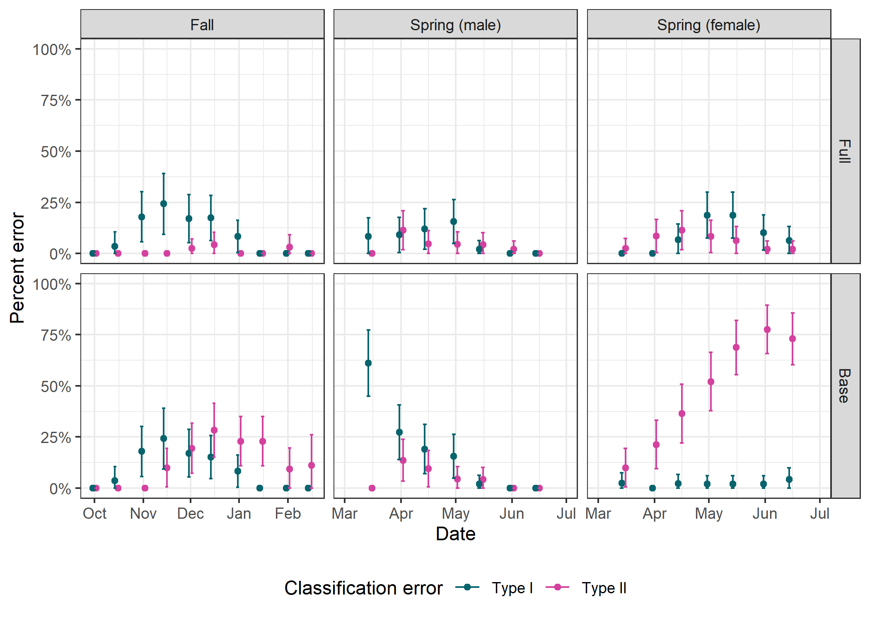

Figure 3. Error rates for movement state assignments by hidden Markov Models (HMM) for fall, spring (male), and spring (female) migrations, as measured through the model validation process. The horizontal axis reflects the cutoff date for each model that was used to simulate an incomplete track ending on that date. HMMs were grouped into full and base models, where full models included all possible data streams and base models including only step length and turn angle. Type 1 errors reflected false classification as post-migratory while the true state was migratory, whereas Type 2 errors reflected false classification as migratory while the true state was post-migratory. Bars show the 95% confidence interval of the mean.

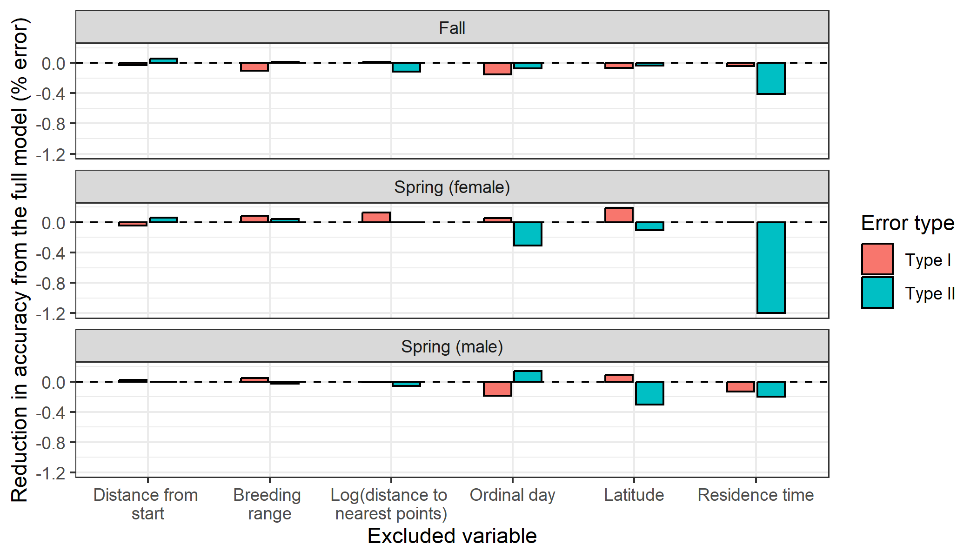

Figure 4. Reduction in accuracy from the full model due to removal of individual data streams. Type I errors occurred when the ending state was falsely classified as migratory, and Type II errors occurred when the ending state was falsely classified as settling or post-migratory. Negative values indicate reductions in accuracy, while positive values indicate that accuracy improved when the variable was excluded from the model.

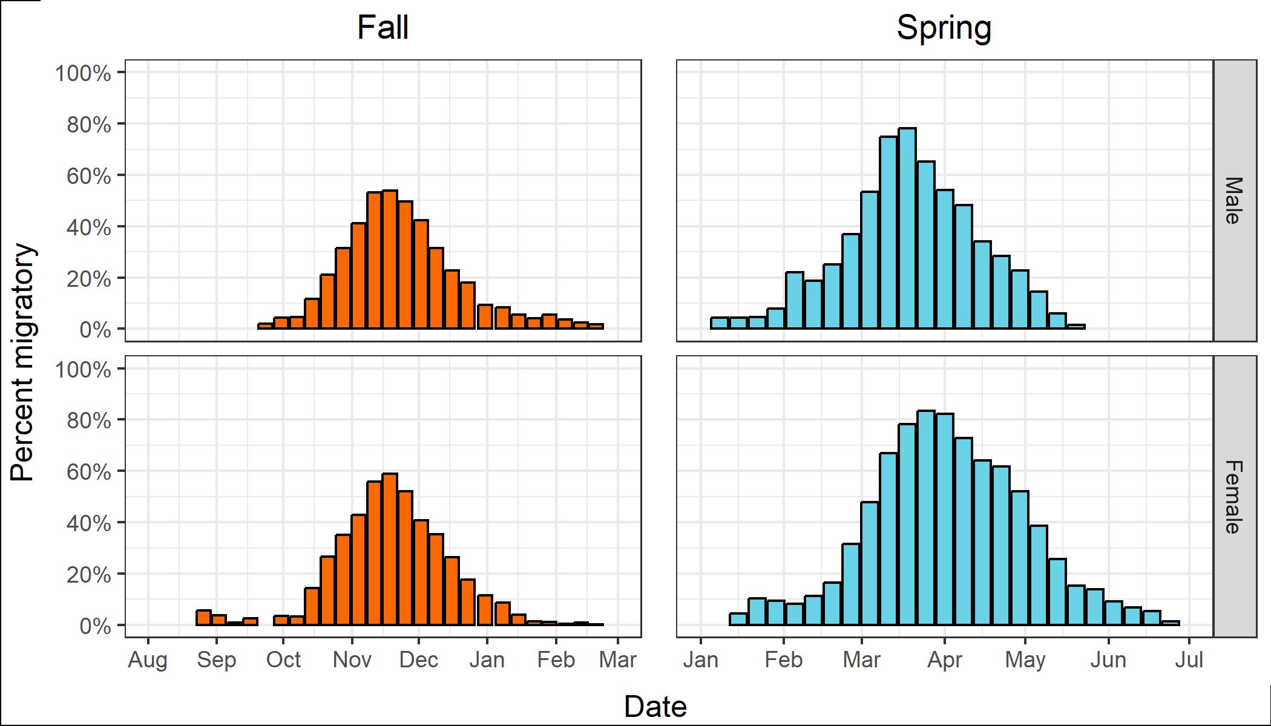

Figure 5. Peak migration dates of male and female American Woodcock throughout the fall and spring migratory seasons. Color indicates season, and the vertical axis reflects the percentage of all locations in each week that fell into fall or spring migratory movement classes.

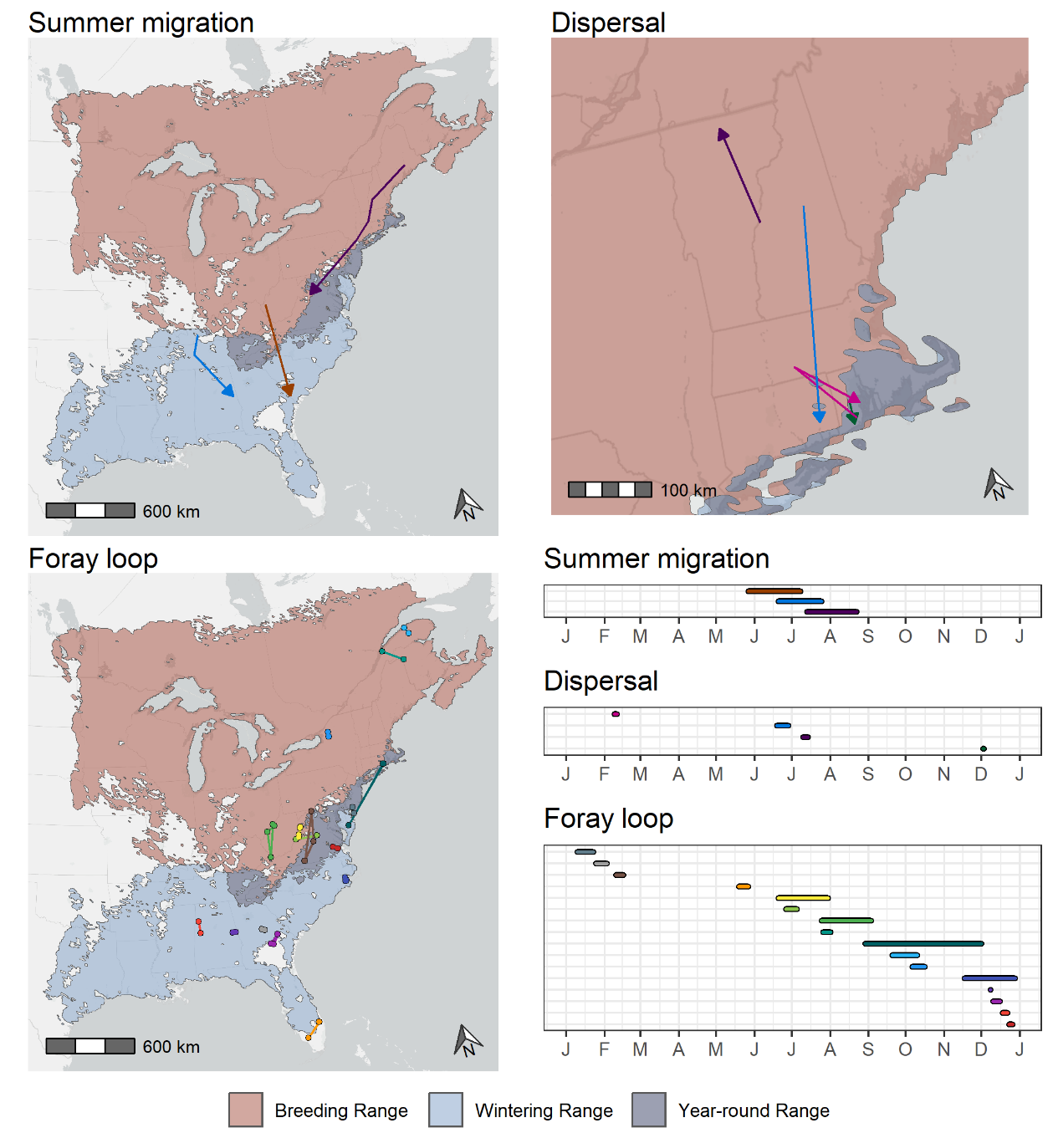

Figure 6. Spatial and temporal distribution of summer migrations, dispersals, and foray loops of American Woodcock marked with GPS transmitters in eastern North America. Maps are superimposed over the breeding, wintering, and year-round range of the American Woodcock as delineated by the eBird Status and Trends dataset (Fink et al. 2022). Timelines depict the duration of each movement by month. Each movement is matched from the map to the timeline by color.

**Discussion**

We found that the use of additional data streams allowed hidden Markov models to better fit the migratory movements of American Woodcock. The magnitude of the improved fit differed by error type and seasonal model, with the largest improvements occurring for Type II errors in the spring female model (Type II error ranges— base model: 10.0–77.6%, full model: 2.0%–11.4%%; Fig. 3). Despite differences in error rates between base and full models, removal of individual variables from the full model resulted in only minor differences in error rates (range: -1.20–0.19%; Fig. 4), suggesting that many of the additional data streams had some level of redundancy. Hidden Markov models are well suited to estimation using multiple data streams due to the extensible nature of their likelihoods (Zucchini et al. 2017), which allow state estimation to be informed by as many parameters as are available. By adding data streams we were able to increase the amount of data available to estimate the underlying behavioral state, at the cost of having to estimate additional parameters. The redundancy observed indicates that there may be some fall-off to the benefits of additional data streams, beyond which improved temporal resolution would likely be required to improve model fit. Increasing the number of parameters used in the model does substantially increase runtime (by a factor of 7.9x–22.1x), although the full model is still easily achievable on a modest desktop computer. Runtime can be further optimized through the informed choice of initial parameter values, and the use of the simplest model structure possible that fits the data. For high throughput applications, such as testing variable redundancy in HMM applications, high performance computing clusters may be advisable for running large numbers of HMMs in parallel.

While the use of additional data streams to inform animal movement HMMs has traditionally focused on data collected directly by the transmitter, such as acceleration, altitude, and depth (Dean et al. 2013), we demonstrate that data streams derived from location, time, and movement characteristics can also be informative for predicting migratory states. In addition to the metrics shown here, habitat use may also be an informative predictor of migratory state, based on observed differences in migratory habitat from that used during other times of the year (Stanley et al. 2021). We also note that the data streams describing movement characteristics (log distance to nearest points and residence time) only capture the spatial point characteristics of woodcock movements. Track characteristics, such as tortuosity, are difficult to capture in sparse datasets, but further study may yield additional variables which might have value as data streams for detecting migratory states. Extensions of HMMs which incorporate feedback when calculating transition probabilities, such as an increased likelihood of switching from a foraging state to a transit state after spending time feeding, may also be well suited to explaining the temporal patterns that largely distinguish migratory stopover behavior from post-migratory resource utilization (Zucchini et al. 2008).

As expected from past descriptions of woodcock migratory phenology (McAuley et al. 2020), we found that woodcock generally migrate from early November to early December in the fall (median initiation and termination dates; males: Nov. 8th–Dec. 1st, females: Nov. 7th–Dec. 6th) and from early March to early/late April in spring (males: Mar. 1st–Apr. 4th, females: Mar. 5th–Apr. 26th). Among woodcock which did not follow these patterns, we found regular occurrences of early migratory initiation and late termination during periods of the year when woodcock are typically considered to be non-migratory. Late terminations of fall migration and early initiations of spring migration demonstrate a common pattern of continued migratory movement during wintering period for a small proportion of individuals (<10% of locations after Jan. 1st are migratory; Fig. 5). The reasons for continued movement during the winter are unclear; for most bird species, migration is physiologically and energetically costly (Dingle 2014), and woodcock would be therefore incentivized to minimize the duration of their migrations. One potential explanation is tied to food availability; woodcock are earthworm specialists, and earthworm soil depth correlates closely with soil temperature and moisture (Potvin and Lilleskov 2017, McAuley et al. 2020). Woodcock may undertake nomadic migratory movements as earthworm availability changes throughout the winter, fleeing areas where cold temperatures and dry weather result in local scarcity of earthworms. This driver would also explain woodcocks’ unusually early spring migration and presence along the snowmelt line at high latitudes, as melting snow saturates the soil and forces earthworms towards the surface in search of oxygen (Lee 1985; see exploitation of this resource by grizzly bears, *Ursus arctos horribilis*: Mattson et al. 2002). Although both sexes migrated in early spring, females tended to continue migrating far longer into the early breeding season than males did. Nesting analyses using this dataset indicate that woodcock frequently resume migration after nesting attempts, often making nesting attempts at multiple latitudes during their migration north, explaining why female woodcock continue migratory movements as late as June, after nesting has started (Slezak et al. In review).

Outside of migration, we observed long-distance movements by woodcock, including dispersal movements, foray loops, and summer migrations. Dispersal movements were largely limited to the northeastern United States and may be the result of changing environmental conditions near the northernmost extent of the year-round range (Fig. 6). Three of the 4 movements ended near coastal areas of Connecticut and Rhode Island where milder conditions frequently allow woodcock to persist throughout the winter. Foray loops were much more geographically widespread, occurring throughout the wintering and breeding range. The motivations for foray loops may range from avoiding negative environmental conditions in the winter (e.g. movements from Rhode Island to Maryland and back) to foraging and exploratory behaviors. Dispersal movements and foray loops have been observed among a variety of songbird, grouse, and shorebird species and are most frequently observed immediately after breeding has concluded (Earl et al. 2016, Cooper and Marra 2020, Hoepfner 2023). Dispersal movements and foray loops observed during our study occurred in a much greater portion of the year than has been observed in most bird species to date, including dispersal movements in summer and winter and foray loops in every season except for the peak of spring migration. Cooper and Marra (2020) suggest that the prevalence of dispersals and foray loops is underestimated due to the difficulty of tracking small birds at fine spatial scales- we similarly posit that the prevalence of dispersals and foray loops throughout the full year is likely underestimated due to the prevalence of single-season movement studies (Marra et al. 2015).

Summer migrations are also not unprecedented among tracked bird species. Departure from the breeding grounds early in the season, typically after a failed breeding attempt, is a regularly observed phenomenon among many Scolopacids (O’Brien et al. 2006). Scolopacids generally have high plasticity in their migratory phenology, characterized by partial migration to the breeding grounds and variable dates of initiation and termination for the post-breeding migration (Colwell 2010). Our results demonstrate that the American Woodcock seems to have similar plasticity in its migratory schedule to related Scolopacids. This is notable considering the differences in ecology and migratory phenology between woodcock and their closest relatives. Woodcock are similarly invertebrate specialists but have a very different resource utilization strategy, maximizing their time in the breeding grounds and only leaving in late fall, when soil temperatures and snowfall interfere with foraging (Wishart 1977). This is in contrast to most shorebirds, which migrate as soon as breeding concludes and well in advance of prey depletion in the breeding grounds (Schneider and Harrington 1981). Why some woodcock would retain the trait of immediately migrating south after breeding failure is unclear, although the low observed frequency of this strategy (5% of birds observed from May 1st–Sep. 1st) may indicate that it is ecologically disadvantageous in most circumstances.

Advancements in the field of movement ecology have been driven largely by innovations in the individual tracking of animals using transmitters, particularly high-frequency transmitters that can collect multiple locations per day, if not per hour (Mills et al. 2006, Joo et al. 2020). Methods that have been designed to accommodate high frequency data, such as approximations of continuous trajectories and step selection functions, have considerable merit for the field (Thurfjell et al. 2014, Calabrese et al. 2016). However, methodological advances have largely overlooked the increasing prevalence of small transmitters that can fit on a much larger portion of the world’s animals but collect more sparse and irregular data. The satellite GPS transmitters used in this manuscript, as well as non-GPS trackers such as Motus transmitters and geolocators (Rakhimberdiev et al. 2015, Taylor et al. 2017), are examples of small transmitters that are immensely useful for tracking small animals but collect sparse and irregular location data. While this study demonstrates that hidden Markov models can be retrofitted for use with imperfect data, new methods will eventually be required for the abundance of new transmitter data collected by migratory bird studies. Recent innovations in point process modeling provide examples of tools that might better allow for the modeling of movement data from small animals. The traditionally used technique for interpolating movement trajectories, correlated random walk models, can encounter difficulties with infrequent locations and data gaps that are common in migratory bird data, as demonstrated in this manuscript. Non-mechanistic movement models are better able to compensate for rapid behavioral shifts and, due to their non-parametric nature, may better deal with irregular time intervals in which step lengths and turn angles are not consistent (Rieber 2023). Beyond advances in modeling techniques, proper modeling of migratory bird movements may require bespoke models which are specifically designed to accommodate rapid alternation between stopover states with short, recursive steps and migratory states with long, directional steps. With further innovation, we can take the myriad successes of the advancement of the field of movement ecology and better apply those tools to the much larger network of animals which can be tracked using small transmitters.

**References**

Arizaga, J., A. Crespo, I. Telletxea, R. Ibáñez, F. Díez, J. F. Tobar, M. Minondo, Z. Ibarrola, J. J. Fuente, and J. A. Pérez (2015). Solar/Argos PTTs contradict ring-recovery analyses: Woodcocks wintering in Spain are found to breed further east than previously stated. Journal of Ornithology 156:515–523.

Bagniewska, J. M., T. Hart, L. A. Harrington, and D. W. Macdonald (2013). Hidden Markov analysis describes dive patterns in semiaquatic animals. Behavioral Ecology 24:659–667.

Battley, P. F., N. Warnock, T. L. Tibbitts, R. E. Gill, T. Piersma, C. J. Hassell, D. C. Douglas, D. M. Mulcahy, B. D. Gartrell, R. Schuckard, D. S. Melville, and A. C. Riegen (2012). Contrasting extreme long-distance migration patterns in bar-tailed godwits Limosa lapponica. Journal of Avian Biology 43:21–32.

Berger-Tal, O., and S. Bar-David (2015). Recursive movement patterns: review and synthesis across species. Ecosphere 6:art149.

Berigan, L. A. (2019). Dispersal, reproductive success, and habitat use by translocated lesser prairie-chickens.

Blomberg, E. J., A. C. Fish, L. A. Berigan, A. M. Roth, R. Rau, S. J. Clements, G. Balkcom, B. Carpenter, G. Costanzo, J. Duguay, C. L. Graham, et al. (2023). The American Woodcock Singing Ground Survey largely conforms to the phenology of male woodcock migration. The Journal of Wildlife Management 87:e22488.

Bridge, E. S., K. Thorup, M. S. Bowlin, P. B. Chilson, R. H. Diehl, R. W. Fléron, P. Hartl, R. Kays, J. F. Kelly, and W. D. Robinson (2011). Technology on the move: recent and forthcoming innovations for tracking migratory birds. BioScience 61:689–698.

Burnside, R. J., N. J. Collar, and P. M. Dolman (2017). Comparative migration strategies of wild and captive‐bred Asian Houbara *Chlamydotis macqueenii*. Ibis 159:374–389.

Calabrese, J. M., C. H. Fleming, and E. Gurarie (2016). ctmm: An R package for analyzing animal relocation data as a continuous-time stochastic process. Methods in Ecology and Evolution 7:1124–1132.

Colwell, M. A. (2010). Shorebird ecology, conservation, and management. Univ of California Press.

Combreau, O., S. Riou, J. Judas, M. Lawrence, and F. Launay (2011). Migratory pathways and connectivity in Asian houbara bustards: evidence from 15 years of satellite tracking. PloS one 6:e20570.

Cooper, N. W., and P. P. Marra (2020). Hidden long-distance movements by a migratory bird. Current Biology 30:4056-4062.e3.

Dawson, W. R. (2020). Pine Siskin (Spinus pinus), version 1.0. In Birds of the World (A. F. Poole, Editor). Cornell Lab of Ornithology, Ithaca, NY, USA.

Dean, B., R. Freeman, H. Kirk, K. Leonard, R. A. Phillips, C. M. Perrins, and T. Guilford (2013). Behavioural mapping of a pelagic seabird: combining multiple sensors and a hidden Markov model reveals the distribution of at-sea behaviour. Journal of The Royal Society Interface 10:20120570.

Dingle, H. (2014). Migration: the biology of life on the move. Oxford University Press, USA.

Earl, J. E., S. D. Fuhlendorf, D. Haukos, A. M. Tanner, D. Elmore, and S. A. Carleton (2016). Characteristics of lesser prairie-chicken (Tympanuchus pallidicinctus) long-distance movements across their distribution. Ecosphere 7:e01441.

Ephraim, Y., and N. Merhav (2002). Hidden markov processes. IEEE Transactions on information theory 48:1518–1569.

Fink, D., T. Auer, A. Johnston, M. Strimas-Mackey, S. Ligocki, O. Robinson, W. Hochachka, L. Jaromczyk, A. Rodewald, C. Wood, I. Davies, and A. Spencer (2022). eBird Status and Trends.

Heerah, K., M. Woillez, R. Fablet, F. Garren, S. Martin, and H. De Pontual (2017). Coupling spectral analysis and hidden Markov models for the segmentation of behavioural patterns. Movement Ecology 5:20.

Hoepfner, S. A. (2023). High-Frequency GPS Transmitters Allow Understanding of Breeding Shorebird Movements and Nest Survival Without Human Disturbance. [Online.] Available at https://www.proquest.com/docview/2858557102/abstract/F71320D7248F4BB4PQ/1.

Hromada, S. J., T. C. Esque, A. G. Vandergast, K. K. Drake, F. Chen, B. Gottsacker, J. Swart, and K. E. Nussear (2023). Linear and landscape disturbances alter Mojave desert tortoise movement behavior. Frontiers in Ecology and Evolution 11.

Iverson, A. R., D. L. Humple, R. L. Cormier, and J. Hull (2023a). Land cover and NDVI are important predictors in habitat selection along migration for the Golden-crowned Sparrow, a temperate-zone migrating songbird. Movement Ecology 11:2.

Iverson, A. R., J. L. Schaefer, S. M. Skalos, and C. E. Hawkins (2023b). Global positioning system (GPS) and platform transmitter terminal (PTT) tags reveal fine-scale migratory movements of small birds: A review highlights further opportunities for hypothesis-driven research. Ornithological Applications 125:duad014.

Johnson, D. S., and J. M. London (2018). crawl: an R package for fitting continuous-time correlated random walk models to animal movement data. [Online.] Available at https://doi.org/10.5281/zenodo.596464.

Joo, R., S. Picardi, M. E. Boone, T. A. Clay, S. C. Patrick, V. S. Romero-Romero, and M. Basille (2020). A decade of movement ecology. [Online.] Available at http://arxiv.org/abs/2006.00110.

Kelley, J. R., S. Williamson, and T. R. Cooper (2008). American Woodcock Conservation Plan: a summary of and recommendations for woodcock conservation in North America. US Fish & Wildlife Publications 430.

Klaassen, R. H. G., M. Hake, R. Strandberg, B. J. Koks, C. Trierweiler, K. Exo, F. Bairlein, and T. Alerstam (2014). When and where does mortality occur in migratory birds? Direct evidence from long‐term satellite tracking of raptors. Journal of Animal Ecology 83:176–184.

Langrock, R., J. G. C. Hopcraft, P. G. Blackwell, V. Goodall, R. King, M. Niu, T. A. Patterson, M. W. Pedersen, A. Skarin, and R. S. Schick (2014a). Modelling group dynamic animal movement. Methods in Ecology and Evolution 5:190–199.

Langrock, R., R. King, J. Matthiopoulos, L. Thomas, D. Fortin, and J. M. Morales (2012). Flexible and practical modeling of animal telemetry data: hidden Markov models and extensions. Ecology 93:2336–2342.

Langrock, R., T. A. Marques, R. W. Baird, and L. Thomas (2014b). Modeling the diving behavior of whales: a latent-variable approach with feedback and semi-Markovian components. Journal of Agricultural, Biological, and Environmental Statistics 19:82–100.

Lee, K. E. (1985). Earthworms: their ecology and relationships with soils and land use. Academic Press Inc.

Linscott, J. A., J. G. Navedo, S. J. Clements, J. P. Loghry, J. Ruiz, B. M. Ballard, M. D. Weegman, and N. R. Senner (2022). Compensation for wind drift prevails for a shorebird on a long-distance, transoceanic flight. Movement Ecology 10:11.

Mander, L., I. Nicholson, R. M. W. Green, S. G. Dodd, R. M. Forster, and N. H. K. Burton (2022). Individual, sexual and temporal variation in the winter home range sizes of GPS-tagged Eurasian Curlews *Numenius arquata*. Bird Study 69:39–52.

Marra, P. P., E. B. Cohen, S. R. Loss, J. E. Rutter, and C. M. Tonra (2015). A call for full annual cycle research in animal ecology. Biology letters 11:20150552.

Mattson, D. J., M. G. French, and S. P. French (2002). Consumption of earthworms by Yellowstone grizzly bears. Ursus:105–110.

McAuley, D. G., D. M. Keppie, and R. M. Whiting Jr. (2020). American Woodcock (Scolopax minor), version 1.0. In Birds of the World (A. F. Poole, Editor). Cornell Lab of Ornithology, Ithaca, NY, USA.

McAuley, D. G., J. R. Longcore, and G. F. Sepik (1993). Techniques for Research into Woodcocks: Experiences and Recommendations. Proceedings of the eighth American woodcock symposium. U.S. Fish and Wildlife Service, p. 5.

McClintock, B. T., and T. Michelot (2018). momentuHMM: R package for generalized hidden Markov models of animal movement. Methods in Ecology and Evolution 9:1518–1530.

McKellar, A. E., R. Langrock, J. R. Walters, and D. C. Kesler (2015). Using mixed hidden Markov models to examine behavioral states in a cooperatively breeding bird. Behavioral Ecology 26:148–157.

Mills, K. J., B. R. Patterson, and D. L. Murray (2006). Effects of variable sampling frequencies on GPS transmitter efficiency and estimated wolf home range size and movement distance. Wildlife Society Bulletin 34:1463–1469.

Moore, J. D., D. E. Andersen, T. Cooper, J. P. Duguay, S. L. Oldenburger, C. A. Stewart, and D. G. Krementz (2021). Migration phenology and patterns of American woodcock in central North America derived using satellite telemetry. Wildlife Biology 2021.

Moskát, C., M. Bán, A. Fülöp, J. Bereczki, and M. E. Hauber (2019). Bimodal habitat use in brood parasitic Common Cuckoos (Cuculus canorus) revealed by GPS telemetry. The Auk: Ornithological Advances 136:uky019.

O’Brien, M., R. Crossley, and K. Karlson (2006). The shorebird guide. Houghton Mifflin Harcourt.

Picardi, S., P. Coates, J. Kolar, S. O’Neil, S. Mathews, and D. Dahlgren (2022). Behavioural state‐dependent habitat selection and implications for animal translocations. Journal of Applied Ecology 59:624–635.

Potvin, L. R., and E. A. Lilleskov (2017). Introduced earthworm species exhibited unique patterns of seasonal activity and vertical distribution, and Lumbricus terrestris burrows remained usable for at least 7 years in hardwood and pine stands. Biology and Fertility of Soils 53:187–198.

R Core Team (2022). R: A Language and Environment for Statistical Computing. R Foundation for Statistical Computing, Vienna, Austria.

Rakhimberdiev, E., D. W. Winkler, E. Bridge, N. E. Seavy, D. Sheldon, T. Piersma, and A. Saveliev (2015). A hidden Markov model for reconstructing animal paths from solar geolocation loggers using templates for light intensity. Movement Ecology 3:25.

Rieber, C. (2023). Treed Gaussian processes for animal movement modeling.

Rieffenberger, J. C., and R. C. Kletzly (1966). Woodcock night-lighting techniques and equipment. WH Goudy, compiler. Woodcock research and management:33–35.

Schneider, D. C., and B. A. Harrington (1981). Timing of Shorebird Migration in Relation to Prey Depletion. The Auk 98:801–811.

Sheldon, W. G. (1960). A method of mist netting woodcocks in summer. Bird-banding 31:130–135.

Slezak, C. R., E. J. Blomberg, L. A. Berigan, R. Darling, A. C. Fish, S. J. Clements, A. M. Roth, R. D. Rau, G. Balkcom, B. Carpenter, G. Costanzo, et al. (In review). Consider a rare phenotype: itinerant breeding in a peculiar shorebird and its ecological correlates. Science.

Stanley, C. Q., M. R. Dudash, T. B. Ryder, W. G. Shriver, K. Serno, S. Adalsteinsson, and P. P. Marra (2021). Seasonal variation in habitat selection for a Neotropical migratory songbird using high-resolution GPS tracking. Ecosphere 12:e03421.

Taylor, P. D., T. L. Crewe, S. A. Mackenzie, D. Lepage, Y. Aubry, Z. Crysler, G. Finney, C. M. Francis, C. G. Guglielmo, and D. J. Hamilton (2017). The Motus Wildlife Tracking System: a collaborative research network to enhance the understanding of wildlife movement. ACE 12.

Thurfjell, H., S. Ciuti, and M. S. Boyce (2014). Applications of step-selection functions in ecology and conservation. Movement ecology 2:1–12.

Wishart, R. A. (1977). Some features of breeding and migration of woodcock in southwestern Quebec. Bird-Banding 48:337–340.

Wright, J. R., J. A. Johnson, E. Bayne, L. L. Powell, C. R. Foss, J. C. Kennedy, and P. P. Marra (2021). Migratory connectivity and annual cycle phenology of Rusty Blackbirds (Euphagus carolinus) revealed through archival GPS tags. Avian Conservation & Ecology 16.

Zhang, J., M. Rayner, S. Vickers, T. Landers, R. Sagar, J. Stewart, and B. Dunphy (2019). GPS telemetry for small seabirds: using hidden Markov models to infer foraging behaviour of Common Diving Petrels (Pelecanoides urinatrix urinatrix). Emu - Austral Ornithology 119:126–137.

Zucchini, W., I. L. MacDonald, and R. Langrock (2017). Hidden Markov models for time series: an introduction using R. CRC press.

Zucchini, W., D. Raubenheimer, and I. L. MacDonald (2008). Modeling time series of animal behavior by means of a latent‐state model with feedback. Biometrics 64:807–815.