**1 Introduction**

**2 Methods**

*2.1 Data collection and preprocessing*

We collected satellite GPS data with altitude readings from 2017–2023 using 4–7 g PinPoint GPS transmitters (Lotek Wireless Inc., Newmarket, Ontario, CA) as a part of a larger collaborative effort by the Eastern Woodcock Migration Research Cooperative (Blomberg et al. 2023, Clements et al. 2024, Fish et al. 2024). Transmitters were deployed by 42 collaborators across the eastern portion of the woodcock’s range and were programmed to collect locations primarily during fall and spring migration. In addition to recording diurnal altitudes, transmitters would record nocturnal altitudes at either 0000 or 0100 hours Eastern Time at varying schedules during the migratory season. We subset these readings to only include high quality altitude fixes, and excluded any locations in which the bird’s migratory or non-migratory state was unknown (Chp. 2).

*2.2 Transformation of altitude measurements*

Altitude readings were initiated measured in height above the WGS84 ellipsoid model, which is easily calculable using GPS satellites but does not reliably translate to height above ground level. We transformed these readings in ArcPro (version number tk)

(cite tk)

*2.3 Modeling altitude distributions*

*2.4 Comparison to other metrics*

**3 Results**

We collected 12 558 GPS locations with altitude recordings, of which 428 could potentially be flight locations based on time of day and migratory classification. The model predicted that tk of these locations were most likely recorded when the bird was in flight (fall: tk locations, spring: tk; adult: tk, juvenile tk). Woodcock have an estimated median flight altitude of 262m and a mean flight altitude of 364m (Table 1). Woodcock fly at mean altitudes of 312m in fall and 428m in spring, with no overlap in the 50% credible intervals of those seasons (Fig. 1). Adult woodcock fly at mean altitudes of 400m, while juveniles fly at altitudes of 344m, with some overlap in the 50% credible intervals of those age classes (Fig. 2). Almost half of woodcock flight locations were at altitudes <244m, posing potential risks for collisions with low-rise buildings, wind turbines, and communications towers (Fig. 3).

|  |  |  |  |
| --- | --- | --- | --- |
| Metric | Estimate | 50% Credible Interval | 95% Credible Interval |
| **Median Flight Altitude** | **262m** | **239–285m** | **195–332m** |
| *Fall* | 225m | 196–252m | 148–312m |
| *Spring* | 319m | 282–355m | 216–427m |
| *Adult* | 294m | 254–333m | 185–408m |
| *Juvenile* | 260m | 231–288m | 182–345m |
| **Mean Flight Altitude** | **364m** | **341–386m** | **300–432m** |
| *Fall* | 312m | 284–338m | 239–398m |
| *Spring* | 428m | 392–463m | 326–539m |
| *Adult* | 400m | 360–437m | 301–516m |
| *Juvenile* | 344m | 316–370m | 270–430m |
| **% of observations below NEXRAD detection altitude** | **33%** | **29–36%** | **23–43%** |
| *Fall* | 37% | 32–42% | 23–51% |
| *Spring* | 26% | 21–31% | 14–41% |
| *Adult* | 29% | 23–34% | 15–45% |
| *Juvenile* | 31% | 26–36% | 18–45% |
| **% of observations below height of low-rise buildings (47m)** | **10%** | **8–13%** | **4–19%** |
| *Fall* | 12% | 8–16% | 4–25% |
| *Spring* | 8% | 5–10% | 2–18% |
| *Adult* | 9% | 5–12% | 2–22% |
| *Juvenile* | 9% | 5–12% | 2–19% |
| **% of observations within sweep of terrestrial wind turbines (32–164m)** | **27%** | **25–29%** | **21–32%** |
| *Fall* | 30% | 28–33% | 22–36% |
| *Spring* | 23% | 22–36% | 14–30% |
| *Adult* | 24% | 21–27% | 15–31% |
| *Juvenile* | 27% | 25–30% | 18–34% |
| **% of observations below height of large communication towers (244m)** | **47%** | **44–51%** | **37–57%** |
| *Fall* | 53% | 49–58% | 39–65% |
| *Spring* | 40% | 35–45% | 26–54% |
| *Adult* | 43% | 38–48% | 28–58% |
| *Juvenile* | 47% | 43–52% | 34–60% |

Table 1. Caption tk

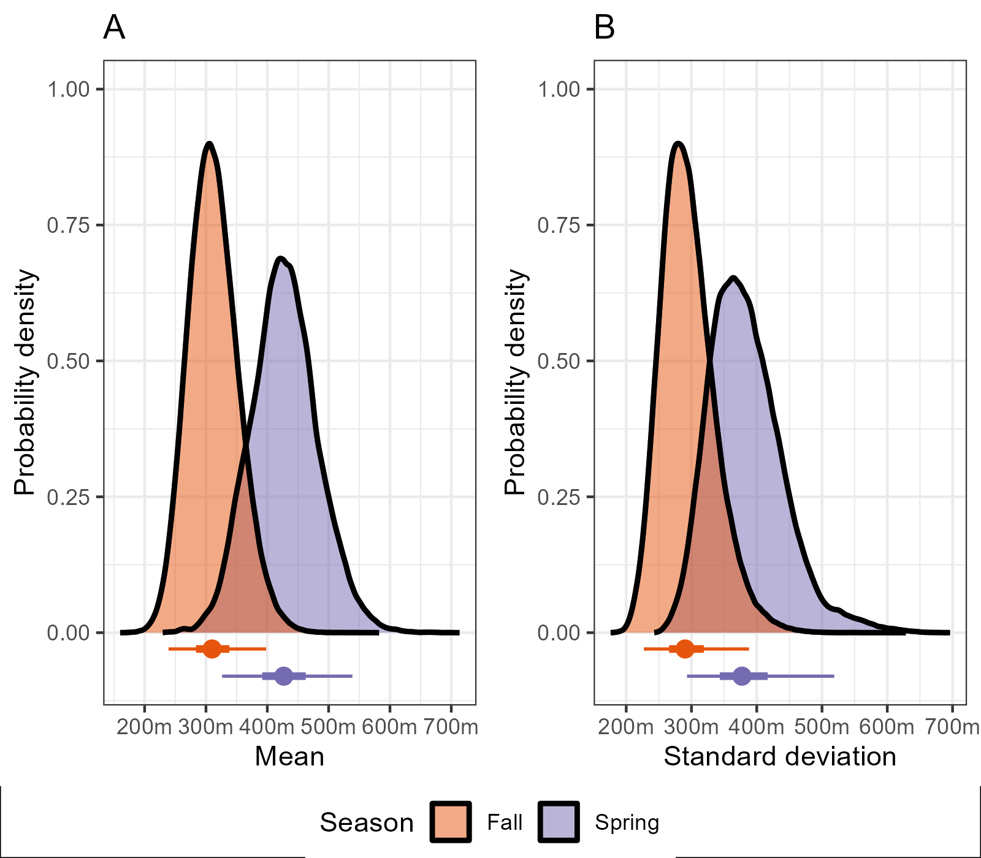

Figure 1. Points represent medians, thick lines represent 50% credible intervals, thin lines represent 95% credible intervals.

Figure 2. Points represent medians, thick lines represent 50% credible intervals, thin lines represent 95% credible intervals.

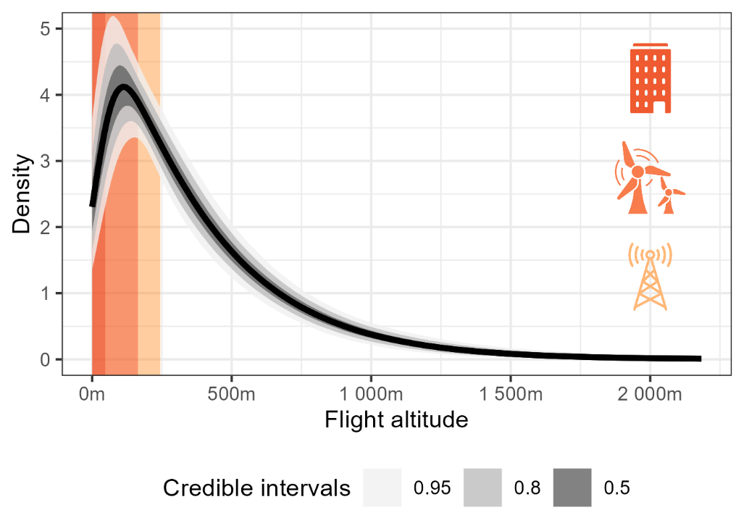

Figure 3. Distribution of woodcock flight altitudes compared to the heights of low-rise buildings (red), terrestrial wind turbines (orange), and communications towers (yellow).

**4 Discussion**