*Low migratory flight altitudes explain increased collision risk for American Woodcock*

Target: Ornithological Applications

**Abstract**

Understanding bird migration at low altitudes is critical to evaluating risk of collision with obstacles; however, quantifying flight at low altitudes is often complicated by difficulty measuring low altitude flight using weather radar, and the tendency of some species to fly at lower altitudes than others. Studies using transmitters and dataloggers can quantify use of low altitudes by nocturnal migrants, allowing species-level inference into potential collision risk based on use of risky altitudes. The American Woodcock (*Scolopax minor*) has long been considered a low altitude migrant due to its frequent collisions with buildings, and mortality during migration may be contributing to population declines. We investigated migratory flight altitudes using satellite transmitters deployed on woodcock in 2020–2024 and examined how flight altitudes compare to the heights of common airspace obstacles. Transmitters recorded nocturnal GPS locations with altitude readings at 0000–0100 hours Eastern Time during fall and spring migrations. We implemented a model using Bayesian Markov Chain Monte Carlo to identify whether locations were recorded on the ground or during flight and describe the distribution of flight altitudes. We found that woodcock fly at mean altitudes of 364m (95% credible interval: 300–432m), flying higher during spring (428m, 95% CRI: 326–539m) than fall (312m, 95% CRI: 239–398m). Mean flight altitudes were slightly higher for adults (400m, 95% CRI: 301–516m) than juveniles (344m, 95% CRI: 270–430m). Woodcock flight altitudes were frequently lower than could be observed using weather radar (33% of observations), and 47% of observations fell within the altitude range of at least one airspace obstacle. Our results suggest that woodcock fly at altitudes lower than reported for most nocturnal migrants, which likely contributes to their vulnerability to obstacle collisions. Further study on low altitude flights, especially among species known for disproportionate collisions with obstacles, may allow us to better understand the circumstances that result in obstacle collisions and can inform mitigation strategies to reduce bird mortality.

**1 Introduction**

Avian migratory flights can be studied using a wide range of techniques, including GPS and satellite telemetry, altimeters, imaging, and radar (Thaxter et al. 2016). These tools can be used to describe the altitudinal distributions of nocturnal avian migrants and examine how those altitudes shift in response to wind, weather, and artificial light during migration (Bauer et al. 2019). Research has focused on how these factors influence the risk of bird collision with obstacles (Lao et al. 2020), although there are still knowledge gaps regarding low altitude flights which put birds within range of airspace obstacles (<200m above ground level, hereafter AGL). Obstacles present at these altitudes include buildings (365–988 million bird collisions per year, Loss et al. 2014), wind turbines (234 thousand bird collisions per year, Loss et al. 2013), and communication towers (4–5 million bird collisions per year, Gehring et al. 2011). Flights at obstacle height can be difficult to study due to blind spots in weather radar at low altitudes (Rogers et al. 2020), although some radar studies have had success in quantifying their prevalence. Cohen et al. (2022) estimated that 35% of birds migrating along the Great Lakes shorelines passed through the rotor sweep of a wind turbine at some point during their migratory flight, and White et al. (2020) found that migrating bird densities remained highest below 400m, even during peak migratory periods. Despite the utility of these studies, radar is generally limited to making inferences about overall patterns in bird migration and cannot provide insights into susceptibility to obstacle collisions at a species level. Species level insight is particularly important as not all birds are equally susceptible to obstacle collisions; Nichols et al. (2018) has identified 13 species and 7 genera as “supercolliders”, or birds which are found more often after obstacle collisions than expected given their population size. Gathering species-level data regarding use of low altitudes, at which building collisions occur, is therefore important for understanding and mitigating these collisions.

Gaining species-level insight into bird flight altitudes requires the use of bird-borne telemetry equipment, usually either altimeters or satellite GPS transmitters (Thaxter et al. 2016). Transmitters come with their own set of drawbacks; they are frequently expensive to deploy, collect far less data than other techniques, and are usually limited to birds above a specific size. However, telemetry equipment can be used to make inferences about species-specific flight altitudes, including both high and low altitudes, and in the case of GPS transmitters, can often do so with a very high level of precision. Several studies have described low altitude flights using GPS transmitters, including Bowlin et al. (2015), which found that of 13 tracked Swainson’s Thrush (*Catharus ustulatus*) migratory flights, one bird spent over an hour flying at altitudes <100m before rising to altitudes of 300–500m. A second thrush spent the entirety of its ~2 hour migratory flight at an altitude of ~40 m. Galtbalt et al. (2021) found that Whimbrel (*Numenius phaeopus*) and Far Eastern Curlew (*Numenius madagascariensis*) have overwater median flight altitudes of 132m and 156m above sea level, respectively, although those altitudes increase by 382m and 586m when flying over land. Further transmitter studies focusing specifically on birds with high susceptibility of collision to airspace obstacles may allow us to better understand the prevalence of low altitude flights among these species, and how those flights influence collision risk.

The American Woodcock (*Scolopax minor*, hereinafter woodcock) has long been thought to migrate at low altitudes. Even before tracking data were available, Mendall and Aldous (1943) estimated that woodcock migrate at altitudes 12–15m based on the high rate of woodcock collisions with power, telephone, and telegraph lines. Woodcock are among the most frequently found species due to building collisions in major US cities such as Minneapolis (Loss et al. 2019) and Chicago (Van Doren et al. 2021), and mass building collision events occurred when woodcock were caught in snowstorms during their early spring migration (Loss et al. 2020). Woodcock morphology is believed to play a role in their susceptibility to building collisions; the species is comparatively rotund with shorter wings than many other nocturnal migrants, which may make woodcock less maneuverable during migratory flight (Loss et al. 2020). The comparative positioning of woodcock eyes further back on the head than most other birds provides greater peripheral vision but also substantially reduces their binocular vision, which may impede their ability to avoid airspace obstacles (Cobb 1959, Martin 1994). Woodcock have declined at a rate of 0.8% per year since surveys began in the 1960s, and migratory mortality has been identified as a potential causal factor (Cooper and Rau 2012, Loss et al. 2020). No studies to date have quantified woodcock flight altitudes, or examined how those altitudes might impact their vulnerability to collision with airspace obstacles.

Here we investigate the propensity for the American Woodcock to fly at low altitudes during migratory flights and examine how flight altitudes compare to the altitudinal distributions of common airspace obstacles. We also quantify the proportion of woodcock flight locations which fall below a threshold detectable by weather radar to provide some context for comparing our estimates to other studies. We hypothesized that woodcock flight altitudes would fall below mean estimates for nocturnal migrants (418–459m AGL; Horton et al. 2016) and would frequently fall within altitudinal ranges corresponding with obstacles such as buildings, air turbines, and communication towers, based on high rates of collisions for this species (Mendall and Aldous 1943, Loss et al. 2020). We also hypothesized that woodcock flight altitudes will be lower in fall than spring, in accordance with general trends in nocturnal migrants (Horton et al. 2016), and that flight altitudes will be similar among age and sex classes due to minimal differences in morphological characteristics among these classes (McAuley et al. 2020, Agostini et al. 2023). Our analysis sheds light on the vulnerability of woodcock and other nocturnal migrants to airspace collisions during their migratory flights, and the necessity for further study of low altitude movements of birds in general.

**2 Methods**

*2.1 Data collection and preprocessing*

We collected woodcock locations with altitude readings from 2020–2024 using GPS transmitters as a part of a larger collaborative effort by the Eastern Woodcock Migration Research Cooperative (Blomberg et al. 2023, Clements et al. 2024, Fish et al. 2024). We captured woodcock across the eastern portion of their range using spotlighting and mist nets (McAuley et al. 1993) and attached 4–7 g PinPoint transmitters with altimeters (Lotek Wireless Inc., Newmarket, Ontario, CA) using a rump-mounted leg loop harness (Fish et al. 2024). We aged and sexed birds upon capture, where juveniles were birds undertaking their first fall and spring migrations, after which they were considered adults. All capture and handling was conducted in accordance with protocols approved by the University of Maine Institutional Animal Care and Use Committee (Protocols A2017_05_02 and A2020_07_01) as well as permits from the USGS Bird Banding Laboratory and Canadian Bird Banding Office.

We programmed transmitters to collect locations every 1-3 days during migration, with locations alternating between diurnal (1300–1500 hours Eastern Time) and nocturnal (0000–0100 hours) locations. We subset these readings to include only locations in which birds had a known migratory or non-migratory state (Chp. 2). We used ArcGIS Pro 3.2.1 (ESRI 2024) to calculate the difference between the recorded altitude and orthometric elevation for each location (ESRI 2023), providing a measurement of height above ground level for each point. To ensure computational tractability, we divided all observed altitudes by the maximum altitude in the dataset (2183m), allowing estimated flight altitudes to scale between 0 and 1. As woodcock are nocturnal migrants, we assumed all diurnal and non-migratory points were known ground locations, while the flight status of nocturnal migratory points was unknown.

*2.2 Modeling altitude distributions*

Our model of woodcock flight altitudes included both potential flight locations and known ground locations, with each class of data informing a different aspect of the model. Known ground locations were assumed to always have a true altitude of 0m, making their recorded altitudes $A_{r}$ solely attributable to measurement error $E$ ( $A_{r}$ = $E$; importance of accommodating for measurement error is reviewed in Poessel et al. 2018, Péron et al. 2020). As such, we used known ground locations to estimate the error terms of the model. Potential flight locations had either a true altitude of 0m, in which case $A_{r}$ = $E$, or a flight altitude $A_{f}$, in which case $A_{r}$ = $A_{f}$ + $E$. Thus, potential flight locations could be used to estimate a latent flight state which we represented as binomial variable $I$, with $I$ =0 indicating a ground location and $I$ =1 indicating a flight location. We derived $A_{f}$ from locations where $I$ =1,

Equation 1

$$A_{r}= I*A_{f}+ E$$

$$E \sim Normal(μ_{bias}, σ_{error})$$

$$A_{f} \sim Gamma(α,β)$$

with $I$ fixed to 0 for all known ground locations and as an estimable parameter for all potential flight locations. When $I$ was not known, we provided an informed prior of *p = 0.33,* which we based on pre-existing knowledge of the ratio of stopovers to migratory flights during a typical woodcock migration (Fish et al. 2024). Measurement bias in the data, $μ_{bias}$, was given an uninformative normal prior with mean 0 and standard deviation 1, while the standard deviation of the measurement error, $σ_{error}$, was given a half-normal prior with standard deviation 1. We modelled the distribution of $A_{f}$ using a gamma distribution with shape parameter $α$ and rate parameter $β$. We gave $α$ and $β$ semi-informative priors to restrict their possible values to those that might sensibly describe a distribution scaled between 0 and 1 (McElreath 2018). After simulating possible distributions, we chose to give $α$ a half-normal prior with standard derivation 5 and $β$ a half-normal prior with standard derivation 10.

Season and age models both received a similar formulation to the base model, with the only difference being the use of group-specific (*g*) $α$ and $β$ parameters

Equation 2

$$A_{f,g} \sim Gamma(α_{g},β_{g})$$

where the $α_{g}$ and $β_{g}$ parameters were dependent on the season or age class associated with any given altitude observation. This model structure allowed the distribution of flight altitudes to be estimated for each season and age class separately, but with shared inference of error terms $μ_{bias}$ and $σ_{error}$.

We implemented these models using Bayesian Markov Chain Monte Carlo in program JAGS (Plummer 2003) running 4 chains at 200,000 iterations with 10,000 iterations burn-in and no sample thinning. We checked all models for convergence using trace plots and ensured that R-hat values were <1.1. A model with sex as the grouping variable did not converge, so we did not consider its results further. We ran models using the transformed height above ground level estimates for $A_{r}$, and back-transformed all parameter estimates into meters AGL for evaluation. We derived the posteriors of parameters describing flight altitude distributions by simulating a gamma distribution for each posterior value of $α$ and $β$, and sampling the mean, median, and standard deviation of each simulated distribution. We estimated the number of flight locations from the base, season, and age models by summing estimated $I$ values. We summarized posteriors for all parameters using median values and highest density credible intervals following the guidelines outlined in Makowski et al. (2019). We also calculate the probability of superiority, or the likelihood of one group having a higher parameter value than another group, for age and sex models following Ruscio (2008).

*2.3 Comparison of flight altitudes to other metrics*

We evaluated how often woodcock flight altitudes occurred in the altitude range typically detected by ground-based radar and how they coincided with height intervals associated with common airspace obstacles that pose collision risk. We compared woodcock flight altitudes to the minimum altitude (120m) detected by Horton et al. (2016) using the Next Generation Weather Radar (NEXRAD) system, a weather radar system in the United States frequently used to study bird migration (DeMott et al. 2022, Horton et al. 2023). We quantified the proportion of woodcock flight locations (represented by the posterior of $Gamma(α,β)$) which fell below a 120m threshold, which we used to represent the proportion of locations would not be detectable by weather radar. As low-rise buildings (defined as residential buildings 4–11 stories and non-residential buildings ≤11 stories) result in the majority of window collision mortalities in the United States (Loss et al. 2014), we also quantified the proportion of locations at an altitude below that of an 11-story low-rise building (47m). We also estimated the proportion of woodcock flight locations which fell within the rotor sweep of the average land-based wind turbine installed in 2022 (32–164m; Wiser et al. 2023). Finally, we measured the proportion of woodcock flight locations which fell below the height of a 305m communication tower, as these towers are responsible for 5–70x as many collisions as shorter towers (Gehring et al. 2011).

**3 Results**

We collected 12,558 GPS locations with altitude recordings, of which 428 could potentially be flight locations based on time of day and migratory classification. The base model predicted that 144 of these locations were most likely recorded when the bird was in flight (95% CRI: 131–161). The season model identified 78 flight locations in the fall (95% CRI: 67–90) and 65 in the spring (95% CRI: 58–74), while the age model identified 58 flight locations among adults (95% CRI: 51–67) and 80 locations among juveniles (95% CRI: 71–93). Woodcock estimated median flight altitude was 262m, and mean flight altitude was 363m (Table 1). Woodcock flew at mean altitudes of 310m in fall and 427m in spring, with 96% probability that mean flight altitudes are higher in fall than spring (Fig. 1). Adult woodcock flew at mean altitudes of 397m while juveniles flew at altitudes of 343m, with 79% probability that mean flight altitudes are higher for adults than juveniles (Fig. 2).

Over half of woodcock flight locations were at altitudes <305m, posing potential risks for collisions with low-rise buildings, wind turbines, and communications towers (Table 2, Fig. 3). Woodcock were more likely to fly within range of obstacles in fall, with 5% more locations occurring at low-rise building altitude, 8% more at wind turbine altitude, and 14% more at communication tower altitude. 33% of woodcock locations were below the minimum flight altitude reported in Horton et al. (2016) and likely would not have been detectable using NEXRAD weather radar.

Table 1. Characteristics of American Woodcock (*Scolopax minor*) altitudes above ground level during migratory flights, measured using a base model (bold) as well as season and age models. Estimates indicate the median value of the posterior distribution, while credible intervals reflect highest density intervals.

|  |  |  |  |
| --- | --- | --- | --- |
| Metric | Estimate | 50% Credible Interval | 95% Credible Interval |
| **Median Flight Altitude** | **262m** | **240–286m** | **194–331m** |
| *Fall* | 224m | 193–249m | 145–308m |
| *Spring* | 320m | 283–356m | 215–426m |
| *Adult* | 294m | 256–334m | 181–403m |
| *Juvenile* | 260m | 229–287m | 179–342m |
| **Mean Flight Altitude** | **363m** | **339–385m** | **299–430m** |
| *Fall* | 310m | 279–334m | 235–393m |
| *Spring* | 427m | 392–463m | 324–536m |
| *Adult* | 397m | 355–431m | 295–509m |
| *Juvenile* | 343m | 313–367m | 266–425m |

Table 2. Proportion of American Woodcock (*Scolopax minor*) migratory flight altitudes within height intervals related to weather radar and airspace obstacles. Metrics are measured using a base model (bold) as well as season and age models. Estimates indicate the median value of the posterior distribution, while credible intervals reflect highest density intervals.

|  |  |  |  |
| --- | --- | --- | --- |
| Metric | Estimate | 50% Credible Interval | 95% Credible Interval |
| **Below NEXRAD detection altitude (120m)1** | **32%** | **29–36%** | **22–43%** |
| *Fall* | 37% | 32–42% | 23–51% |
| *Spring* | 26% | 21–30% | 13–40% |
| *Adult* | 28% | 22–33% | 14–45% |
| *Juvenile* | 31% | 26–36% | 18–45% |
| **Below height of low-rise buildings (47m)2** | **10%** | **7–12%** | **4–18%** |
| *Fall* | 12% | 7–15% | 3–23% |
| *Spring* | 7% | 3–8% | 1–16% |
| *Adult* | 8% | 4–10% | 1–20% |
| *Juvenile* | 8% | 4–10% | 2–18% |
| **Within sweep of land-based wind turbines (32–164m)3** | **27%** | **26–29%** | **22–32%** |
| *Fall* | 31% | 29–33% | 23–37% |
| *Spring* | 23% | 20–26% | 15–30% |
| *Adult* | 25% | 23–28% | 16–32% |
| *Juvenile* | 28% | 26–31% | 19–35% |
| **Below height of large communication towers (305m)4** | **56%** | **53–59%** | **47–65%** |
| *Fall* | 62% | 58–66% | 50–73% |
| *Spring* | 48% | 44–53% | 35–62% |
| *Adult* | 51% | 46–56% | 38–66% |
| *Juvenile* | 57% | 53–61% | 45–68% |

1 Minimum NEXRAD detection height is based on the lowest altitude detected by Horton et al. (2016).

2 Height of low-rise buildings is determined based on that of an 11-story building, based on Loss et al. (2014).

3 Sweep of wind turbines is based on the average land-based turbine constructed in 2022 (Wiser et al. 2023).

4 Height of large communication towers based on Gehring et al. (2011).

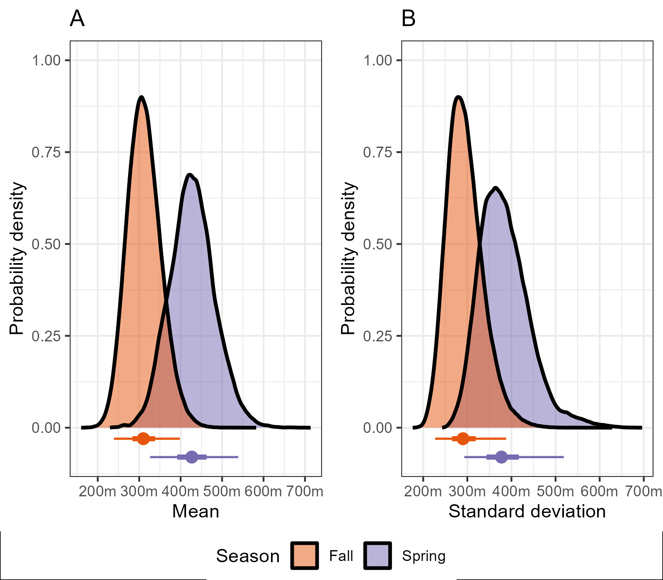

Figure 1. Means and standard deviations of American Woodcock (*Scolopax minor*) flight altitudes above ground level during fall and spring migration. Density plots represent posterior distributions of parameters, while point intervals represent the medians (points), 50% highest density credible intervals (thick lines), and 95% highest density credible intervals (thin lines) of the posteriors.

Figure 2. Means and standard deviations of American Woodcock (*Scolopax minor*) flight altitudes above ground level for adult and juvenile individuals. Density plots represent posterior distributions of parameters, while point intervals represent the medians (points), 50% highest density credible intervals (thick lines), and 95% highest density credible intervals (thin lines) of the posteriors.

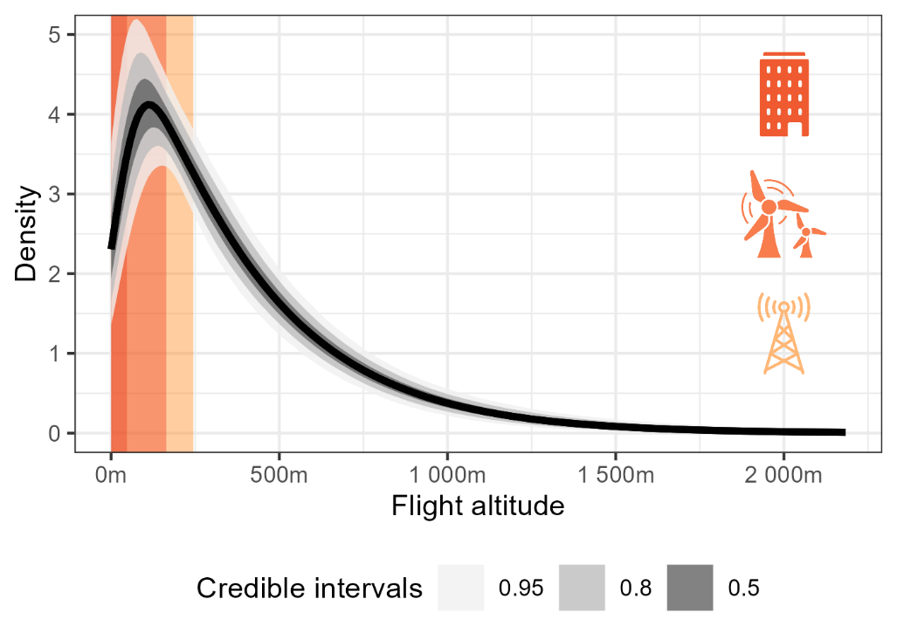

Figure 3. Distribution of woodcock flight altitudes above ground level compared to the heights of low-rise buildings (red; 47m), land-based wind turbines (orange; 32–164m), and large communications towers (yellow; 244m). The dark line represents the median flight altitude distribution calculated using the base model, while ribbons represent 50%, 80%, and 95% highest density credible intervals for the distribution.

**4 Discussion**

We found that mean woodcock flight altitudes fell below those typical of most migrating birds during fall (woodcock: 310m; all birds: 418–491m) and spring (woodcock: 427m; all birds: 438–559m; Horton et al. 2016). This result may be due, in part, to the greater representation of lower altitude flight locations in our data, as 33% of woodcock flight locations fell below the minimum altitude normally observed via weather radar (120m; Horton et al. 2016). However, given preexisting information about woodcock’s high susceptibility to collisions with anthropogenic structures (Mendall and Aldous 1943, Loss et al. 2020) we believe that some portion of this effect is due to a biological difference between the flight altitudes of woodcock and other nocturnal migrants. Woodcock use of lower altitudes than other birds may be related to morphology, as they have a greater wing loading than 79% of species sampled by Poole (1938), and their wing loading appears to be considerably higher than other birds of comparable size. Birds with a higher wing loading than woodcock were generally non-migratory gamebirds or ducks, and the most similar species in terms of wing loading and mass is the non-migratory Rock Pigeon (*Columba livia*). As high wing loading is speculated to be associated with migratory inefficiency (Bowlin et al. 2015), woodcock may be inefficient fliers and choose lower altitudes as a result (Galtbalt et al. 2021).

As anticipated, we found little support for an age difference in woodcock flight altitudes but considerable support for a seasonal difference, with woodcock flight altitudes being higher during spring (mean: 427m, 95% CRI: 324–536m) than fall (mean: 310m, 95% CRI: 235–393m). This matches seasonal variation in flight altitudes observed via radar (Horton et al. 2016), presumably due to migrants utilizing southerly jet streams present at higher altitudes in the spring (La Sorte et al. 2014). As a result of these seasonal differences, woodcock are more likely to fly at altitudes like to intersect airspace obstacles during fall, with 5% more locations occurring at low-rise building altitude, 8% more at wind turbine altitude, and 14% more at communication tower altitude. Woodcock collisions with buildings are generally observed during the spring rather than fall (Loss et al. 2019), which is interesting given that flight altitudes are generally higher during spring. This may be due to the short migratory durations of woodcock in the fall (Fish et al. 2024) or a mismatch between the data collection windows for bird collision studies and the fall migratory periods of woodcock (Loss et al. 2020).

Despite a mean flight altitude of 364m, we found that more than half of woodcock flight altitudes occurred below 305m. The occurrence of so many flight locations within the range of anthropogenic obstacles during peak times for migratory flight (12–1am Eastern Time) suggests that woodcock are not solely vulnerable to collision with these obstacles during takeoff and landing, but throughout their migratory flights. While all three types of structures examined here are responsible for substantial migratory bird mortality, collisions with these structures are likely caused by different mechanisms. Low-rise buildings, for example, are responsible for more collisions than any other structure examined in this study (est. 339 million per annum, Loss et al. 2014) despite having the lowest height (47m). The exceptional rate of mortality associated with low rise buildings is likely the joint function of their prevalence (est. 15.1 million low rise buildings in the United States, Loss et al. 2014) and a higher rate of mortality associated with birds undergoing stopovers, which can be lengthy and expose birds to mortality risk through the diurnal hours in addition to nocturnal migratory flights (Cusa et al. 2015). In comparison, communication towers kill fewer birds (4–5 million per annum) and are less prevalent on the landscape (>26 thousand in the United States) but are more likely to result in collisions during migratory flights, especially if guy lines are present (Gehring et al. 2011). Understanding these differing risk profiles is an important facet of interpreting the relative risk of low altitude flights and drawing connections between low altitude flights and increased rates of bird collisions.

It is unclear whether woodcock are the only species with such substantial use of low flight altitudes. Woodcock appear to fly at altitudes lower than most other nocturnal migrants, but many other bird species have disproportionate representation among bird collision victims, including White-throated Sparrows (*Zonotrichia albicollis*), Tennessee Warblers (*Leiothlypis peregrina*) and Mourning Doves (*Zenaida macroura*, Nichols et al. 2018). These species may benefit from further study on whether their increased vulnerability is also due to low migratory flight altitudes or other factors. Future work might also focus on individual variability in flight altitudes, which suggests that individual migratory strategies (e.g. short migratory flights) might increase the prevalence of low altitude flights (Bowlin et al. 2015). Further research on species- and individual-specific variation in flight altitudes may allow us to better understand how use of low altitudes impacts bird collision risk and devise strategies for its mitigation.

**References**

Agostini, N., M. Gustin, M. Cento, J. Von Hardenberg, and G. Chiatante (2023). Differential Flight Strategies of Western Marsh Harrier Circus aeruginosus in Relation to Sex and Age Class during Spring Migration in the Central Mediterranean. Acta Ornithologica 58:41–53.

Bauer, S., J. Shamoun-Baranes, C. Nilsson, A. Farnsworth, J. F. Kelly, D. R. Reynolds, A. M. Dokter, J. F. Krauel, L. B. Petterson, K. G. Horton, and J. W. Chapman (2019). The grand challenges of migration ecology that radar aeroecology can help answer. Ecography 42:861–875.

Blomberg, E. J., A. C. Fish, L. A. Berigan, A. M. Roth, R. Rau, S. J. Clements, G. Balkcom, B. Carpenter, G. Costanzo, J. Duguay, C. L. Graham, et al. (2023). The American Woodcock Singing Ground Survey largely conforms to the phenology of male woodcock migration. The Journal of Wildlife Management 87:e22488.

Bowlin, M. S., D. A. Enstrom, B. J. Murphy, E. Plaza, P. Jurich, and J. Cochran (2015). Unexplained altitude changes in a migrating thrush: long-flight altitude data from radio-telemetry. The Auk: Ornithological Advances 132:808–816.

Clements, S. J., L. A. Berigan, A. C. Fish, R. L. Darling, A. M. Roth, G. Balkcom, B. Carpenter, G. Costanzo, J. Duguay, and K. Filkins (2024). Satellite tracking of American Woodcock reveals a gradient of migration strategies. Ornithology:ukae008.

Cobb, S. (1959). On the angle of the cerebral axis in the American woodcock. The Auk 76:55–59.

Cohen, E. B., J. J. Buler, K. G. Horton, S. R. Loss, S. A. Cabrera-Cruz, J. A. Smolinsky, and P. P. Marra (2022). Using weather radar to help minimize wind energy impacts on nocturnally migrating birds. Conservation Letters 15:e12887.

Cooper, T. R., and R. D. Rau (2012). American Woodcock: Population Status, 2012. U.S. Fish and Wildlife Service.

Cusa, M., D. A. Jackson, and M. Mesure (2015). Window collisions by migratory bird species: urban geographical patterns and habitat associations. Urban Ecosystems 18:1427–1446.

DeMott, W. G., A. N. Stillman, J. B. Kolb, and C. S. Elphick (2022). NEXRAD highlights the effects of wind and date at a Tree Swallow (Tachycineta bicolor) roost during fall migration. The Wilson Journal of Ornithology 134:623–632.

ESRI (2023). Terrain. [Online.] Available at https://www.arcgis.com/home/item.html?id=58a541efc59545e6b7137f961d7de883.

ESRI (2024). ArcGIS Pro. Redlands, CA, USA.

Fish, A. C., A. M. Roth, G. Balkcom, L. Berigan, K. Brunette, S. Clements, G. Costanzo, C. L. Graham, W. F. Harvey, M. Hook, D. L. Howell, et al. (2024). American woodcock migration phenology in eastern North America: implications for hunting season timing. The Journal of Wildlife Management e22565.

Galtbalt, B., A. Lilleyman, J. T. Coleman, C. Cheng, Z. Ma, D. I. Rogers, B. K. Woodworth, R. A. Fuller, S. T. Garnett, and M. Klaassen (2021). Far eastern curlew and whimbrel prefer flying low - wind support and good visibility appear only secondary factors in determining migratory flight altitude. Movement Ecology 9:32.

Gehring, J., P. Kerlinger, and A. M. Manville (2011). The role of tower height and guy wires on avian collisions with communication towers. The Journal of Wildlife Management 75:848–855.

Horton, K. G., J. J. Buler, S. J. Anderson, C. S. Burt, A. C. Collins, A. M. Dokter, F. Guo, D. Sheldon, M. A. Tomaszewska, and G. M. Henebry (2023). Artificial light at night is a top predictor of bird migration stopover density. Nature Communications 14:7446.

Horton, K. G., B. M. Van Doren, P. M. Stepanian, A. Farnsworth, and J. F. Kelly (2016). Where in the air? Aerial habitat use of nocturnally migrating birds. Biology Letters 12:20160591.

La Sorte, F. A., D. Fink, W. M. Hochachka, A. Farnsworth, A. D. Rodewald, K. V. Rosenberg, B. L. Sullivan, D. W. Winkler, C. Wood, and S. Kelling (2014). The role of atmospheric conditions in the seasonal dynamics of North American migration flyways. Journal of Biogeography 41:1685–1696.

Lao, S., B. A. Robertson, A. W. Anderson, R. B. Blair, J. W. Eckles, R. J. Turner, and S. R. Loss (2020). The influence of artificial light at night and polarized light on bird-building collisions. Biological Conservation 241:108358.

Loss, S. R., S. Lao, A. W. Anderson, R. B. Blair, J. W. Eckles, and R. J. Turner (2020). Inclement weather and American woodcock building collisions during spring migration. Wildlife Biology 2020.

Loss, S. R., S. Lao, J. W. Eckles, A. W. Anderson, R. B. Blair, and R. J. Turner (2019). Factors influencing bird-building collisions in the downtown area of a major North American city. PLOS ONE 14:e0224164.

Loss, S. R., T. Will, S. S. Loss, and P. P. Marra (2014). Bird–building collisions in the United States: Estimates of annual mortality and species vulnerability. The Condor 116:8–23.

Loss, S. R., T. Will, and P. P. Marra (2013). Estimates of bird collision mortality at wind facilities in the contiguous United States. Biological Conservation 168:201–209.

Makowski, D., M. Ben-Shachar, and D. Lüdecke (2019). bayestestR: Describing Effects and their Uncertainty, Existence and Significance within the Bayesian Framework. Journal of Open Source Software 4:1541.

Martin, G. R. (1994). Visual fields in woodcocks Scolopax rusticola (Scolopacidae; Charadriiformes). Journal of Comparative Physiology A 174.

McAuley, D. G., D. M. Keppie, and R. M. Whiting Jr. (2020). American Woodcock (Scolopax minor), version 1.0. In Birds of the World (A. F. Poole, Editor). Cornell Lab of Ornithology, Ithaca, NY, USA.

McAuley, D. G., J. R. Longcore, and G. F. Sepik (1993). Techniques for Research into Woodcocks: Experiences and Recommendations. Proceedings of the eighth American woodcock symposium. U.S. Fish and Wildlife Service, p. 5.

McElreath, R. (2018). Statistical rethinking: A Bayesian course with examples in R and Stan. Chapman and Hall/CRC.

Mendall, H. L., and C. M. Aldous (1943). The ecology and management of American woodcock. Maine Cooperative Wildlife Research Unit.

Nichols, K. S., T. Homayoun, J. Eckles, and R. B. Blair (2018). Bird-building collision risk: An assessment of the collision risk of birds with buildings by phylogeny and behavior using two citizen-science datasets. PLOS ONE 13:e0201558.

Péron, G., J. M. Calabrese, O. Duriez, C. H. Fleming, R. García-Jiménez, A. Johnston, S. A. Lambertucci, K. Safi, and E. L. C. Shepard (2020). The challenges of estimating the distribution of flight heights from telemetry or altimetry data. Animal Biotelemetry 8:5.

Plummer, M. (2003). JAGS: A program for analysis of Bayesian graphical models using Gibbs sampling. Proceedings of the 3rd international workshop on distributed statistical computing. Vienna, Austria, pp. 1–10.

Poessel, S. A., A. E. Duerr, J. C. Hall, M. A. Braham, and T. E. Katzner (2018). Improving estimation of flight altitude in wildlife telemetry studies. Journal of Applied Ecology 55:2064–2070.

Poole, E. L. (1938). Weights and Wing Areas in North American Birds. The Auk 55:511–517.

Rogers, R. M., J. J. Buler, C. E. Wainwright, and H. A. Campbell (2020). Opportunities and challenges in using weather radar for detecting and monitoring flying animals in the Southern Hemisphere. Austral Ecology 45:127–136.

Ruscio, J. (2008). A probability-based measure of effect size: robustness to base rates and other factors. Psychological methods 13:19.

Thaxter, C. B., V. H. Ross-Smith, and A. Cook (2016). How High Do Birds Fly?: A Review of Current Datasets and an Appraisal of Current Methodologies for Collecting Flight Height Data; Lterature Review. British Trust for Ornithology.

Van Doren, B. M., D. E. Willard, M. Hennen, K. G. Horton, E. F. Stuber, D. Sheldon, A. H. Sivakumar, J. Wang, A. Farnsworth, and B. M. Winger (2021). Drivers of fatal bird collisions in an urban center. Proceedings of the National Academy of Sciences 118:e2101666118.

White, J. D., K. W. Heist, and M. T. Wells (2020). Great Lakes Avian Radar Technical Report Lake Erie Lakeshore: Macomb and Wayne County, MI, Fall 2018. U.S. Fish and Wildlife Service.

Wiser, R., M. Bolinger, B. Hoen, D. Millstein, J. Rand, G. Barbose, N. Darghouth, W. Gorman, S. Jeong, and E. O’Shaughnessy (2023). Land-based wind market report: 2023 edition. Lawrence Berkeley National Laboratory (LBNL), Berkeley, CA, United States.