*Under the radar and into the window: flight altitudes and collision risk for American Woodcock*

Target: Ornithological Applications

**Abstract**

While bird migration altitudes are increasingly well described, low altitudes (<200m above ground level) have received less focus, in large part due to the difficulty in studying these altitudes with conventional weather radar. Studies using transmitters and dataloggers have been able to detect use of low altitudes by nocturnal migrants, however, and certain species may be more prone to fly at low altitudes than others. The American Woodcock (*Scolopax minor*) has long been thought to be a low altitude flier due to its frequent collisions with buildings, and mortality during migration may be contributing to its decline. We investigated the tendency of woodcock to fly at low altitudes during their migratory flights and examine how those flight altitudes compare to the altitudinal distributions of common airspace obstacles, using satellite transmitters deployed on woodcock in 2020–2024. These transmitters recorded nocturnal GPS locations with altitude readings at 12–1 am Eastern Time during fall and spring migrations. We used a model (implemented using Bayesian Markov Chain Monte Carlo) to identify whether each of these locations was recorded on the ground or during a migratory flight and describe the distribution of migratory flight altitudes. We found that woodcock fly at mean altitudes of 364m (95% credible interval: 300–432m), flying higher during spring (mean: 428m, 95% CRI: 326–539m) than fall (mean: 312m, 95% CRI: 239–398m), and with similar flight altitudes between adults (mean: 400m, 95% CRI: 301–516m) and juveniles (mean: 344m, 95% CRI: 270–430m). Woodcock mean flight altitudes were frequently lower than could be observed using weather radar (33% of observations), and 47% of observations fell within the altitude range of at least one airspace obstacle. Our results suggest that woodcock fly at altitudes lower than most nocturnal migrants, while likely contributes to their vulnerability to obstacle collisions. Further study on low altitude flights, especially among species known for disproportionate collisions with obstacles, may allow us to better understand the circumstances that result in obstacle collisions and implement mitigation strategies to reduce bird mortality.

**1 Introduction**

The study of avian migratory flights has made substantial progress in the 21st century, in large part due to advances in radar ornithology and the widespread availability of weather radar data (Bridge et al. 2011). These studies have allowed us to describe the altitudinal distributions of nocturnal avian migrants, and examine how those altitudes shift in response to wind, weather, and artificial light during migration (Bauer et al. 2019). These studies have primarily focused on altitudes >200m above ground level (a.g.l.), at which birds spend most of their migratory flights. However, altitudes <200m are particularly relevant to avian mortality during migration, as it is at these altitudes at which most obstacles which could cause collisions occur. Major sources of mortality which occur in this height range include buildings (365–988 million bird collisions per year, Loss et al. 2014), wind turbines (234 thousand bird collisions per year, Loss et al. 2013), and communication towers (4–5 million bird collisions per year, Gehring et al. 2011). Identifying the frequency of avian flight locations which fall within the altitudinal range of these obstacles is an important aspect of measuring avian vulnerability to these obstacles and directing conservation efforts appropriately.

Most weather radar systems, such as NEXRAD in the United States, do not characterize migratory flight altitudes in the <200m band effectively due to ground-level obstacles and the curvature of the Earth, which causes the lowest observable altitude to increase proportionally with distance from the weather radar station (Rogers et al. 2020). Horton et al. (2016), which characterized mean flight altitudes for nocturnal migrants as 418–459m a.g.l. throughout the United States, did not observe flight altitudes below 120m likely due to this restriction. Several studies using bird-mounted transmitters and dataloggers, however, have been better able to characterize the low altitude flights of nocturnal migrants. Bowlin et al. (2015) found that, of 13 tracked Swainson’s Thrush (*Catharus ustulatus*) migratory flights, one bird spent over an hour flying at altitudes <100m before rising to altitudes of 300–500m, and another spent the entirety of its short (~2 hour) migratory flight at an altitude of ~40 m. Although Norevik et al. (2021) did not transform their calculations of height above mean sea level to height above ground level, their observations of European Nightjar (*Caprimulgus europaeus*) flight altitudes suggest that nightjars spend an appreciable portion of their migratory flights <200m above the ground, especially in fall. There is likely to be considerable inter-species variation in flight altitudes due to morphological and physiological adaptations of species affecting their ability to achieve higher altitudes during their migratory flights (Butler 2016), which could cause increased susceptibility to collision with airspace obstacles for lower flying species.

The American Woodcock (*Scolopax minor*, hereafter woodcock) is a species that has long been thought to migrate at low altitudes. Even before tracking data was available, Mendall and Aldous (1943) estimated that woodcock migrate at altitudes 12–15m based on the high rate of woodcock collisions with power lines, telephone, and telegraph wires. Woodcock are among the most frequently found birds after building collisions in major cities such as Minneapolis (Loss et al. 2019) and Chicago (Van Doren et al. 2021), and there are records of mass building collision events occurring when woodcock are caught in snowstorms during their early spring migration (Loss et al. 2020). Woodcock morphology is believed to play a role in their susceptibility to building collisions; the species is comparatively rotund and has shorter wings than many other nocturnal migrants, which may make the species less maneuverable during migratory flight (Loss et al. 2020). The comparative positioning of woodcock eyes further back on the head than most other species, presumably to assist in avoiding predation and facilitate their non-visual method of foraging for earthworms, also substantially reduces their binocular vision, which likely impedes their ability to avoid airspace obstacles (Cobb 1959, Martin 1994). Woodcock have been declining at a rate of 0.8% per year since surveys began in the 1960s, and migratory mortality has been identified as a potential factor in the species’ decline (Cooper and Rau 2012, Loss et al. 2020).

Here we investigate the propensity for the American Woodcock to fly at low altitudes during their migratory flights and examine how those flight altitudes compare to the altitudinal distributions of common airspace obstacles. We hypothesize that woodcock flight altitudes will fall below mean estimates for nocturnal migrants (418–459m a.g.l.; Horton et al. 2016), and would frequently fall within lower altitudinal ranges corresponding with obstacles such as buildings, air turbines, and communication towers, based on high rates of collisions for this species (Mendall and Aldous 1943, Loss et al. 2020). We also hypothesize that woodcock flight altitudes will be lower in fall than spring, in accordance with general trends in nocturnal migrants (Horton et al. 2016), and that flight altitudes will be similar among age and sex classes due to similar morphological characteristics among these classes (McAuley et al. 2020, Agostini et al. 2023). Our analysis sheds light on the vulnerability of woodcock and other nocturnal migrants to airspace collisions during their migratory flights, and the necessity for further study of low altitude movements.

**2 Methods**

*2.1 Data collection and preprocessing*

We collected satellite GPS data with altitude readings from 2020–2024 using GPS transmitters as a part of a larger collaborative effort by the Eastern Woodcock Migration Research Cooperative (Blomberg et al. 2023, Clements et al. 2024, Fish et al. 2024). We captured woodcock across the eastern portion of their range using spotlighting and mist nets (McAuley et al. 1993) and attached 4–7 g PinPoint transmitters (Lotek Wireless Inc., Newmarket, Ontario, CA) using a rump-mounted leg loop harness. We aged and sexed birds upon capture and considered tagged birds to be juveniles for the duration of their first fall and spring migrations, after which we deemed those individuals to be adults. All capture and handling was conducted in accordance with permits from the University of Maine Institutional Animal Care and Use Committee (Protocols A2017_05_02 and A2020_07_01) as well as the USGS Bird Banding Laboratory and Canadian Bird Banding Office.

We programmed transmitters to collect locations primarily during fall and spring migration. In addition to recording diurnal altitudes, transmitters would record nocturnal altitudes at either 0000 or 0100 hours Eastern Time at varying schedules during the migratory season. We subset these readings to only include high quality altitude fixes, and excluded any locations in which the bird’s migratory or non-migratory state was unknown (Chp. 2). We used ArcGIS Pro 3.2.1 to extract the difference between the recorded altitude and orthometric elevation for each location, providing a measurement of height above ground level for each point (ESRI 2023, 2024). We normalized height above ground level measurements to between -1 and 1 based on the maximum observed altitude in the dataset (2183m). We then identified locations that were collected at night during each woodcock’s individually-delineated migration (Chp. 2). Locations which met these requirements were designated as possible flight locations, while other locations were designated as definitive non-flight locations for further analysis.

*2.2 Modeling altitude distributions*

Our model of woodcock flight altitudes included both possible flight locations and definitive non-flight locations, with each class of data informing a different aspect of the model. Definitive non-flight locations were assumed to always have a true altitude of 0m, making their recorded altitudes $A_{r}$ solely attributable to measurement error $E$ ( $A_{r}$ = $E$; importance of accommodating for measurement error is reviewed in Poessel et al. 2018, Péron et al. 2020). As such, definitive non-flight locations could be used to estimate the error terms of the model. Possible flight locations had either a true altitude of 0m, in which case $A_{r}$ = $E$, or some flight altitude $A_{f}$, in which case $A_{r}$ = $A_{f}$ + $E$. Thus, possible flight locations could be used to jointly estimate their own non-flight/flight state (represented as binomial variable $I$, with 0 indicating a ground location and 1 indicating a flight location) and the distribution from which $A_{f}$ was drawn. This model, termed the base model, was structured as follows

Equation 1

$$A_{r}= I*A_{f}+ E$$

$$E \sim Normal(μ_{bias}, σ_{error})$$

$$A_{f} \sim Gamma(α,β)$$

with $I$ set to a known value of 0 for all definitive non-flight locations and used as an estimable parameter for all possible flight locations. When $I$ was not known, we provided an informed prior of *p = 0.33* based on pre-existing knowledge of the ratio of stopovers to migratory flights during a typical woodcock migration (Fish et al. 2024). The measurement bias in the data, $μ_{bias}$, was given an uninformative normal prior with mean 0 and standard deviation 1, while the standard deviation of the measurement error, $σ_{error}$, was given a half-normal prior with standard deviation 1. The distribution of $A_{f}$ was modeled using a gamma distribution with shape parameter $α$ and rate parameter $β$. We gave $α$ and $β$ semi-informative priors to restrict their possible values to those that might sensibly describe a distribution scaled between 0 and 1 (McElreath 2018). After simulating possible distributions, we chose to give $α$ a half-normal prior with standard derivation 5 and $β$ a half-normal prior with standard derivation 10.

Season and age models both received a similar formulation to the base model, with the only difference being the use of group-specific (*g*) $α$ and $β$ parameters

Equation 2

$$A_{f,g} \sim Gamma(α_{g},β_{g})$$

where the $α_{g}$ and $β_{g}$ parameters were dependent on the season or age class associated with any given altitude observation. This model structure allowed the distribution of flight altitudes to be estimated for each season and age class separately, but with shared inference of error terms $μ_{bias}$ and $σ_{error}$.

We implemented these models using Bayesian Markov Chain Monte Carlo in program JAGS (Plummer 2003) running 4 chains at 200 000 iterations with 10 000 iterations burn-in and no sample thinning. We checked all models for convergence using trace plots and ensured that R-hat values were <1.1. We also tested a model with sex used as the group variable, but the model did not converge and so the results are not included below. We ran these models using the transformed height above ground level estimates for $A_{r}$, and back-transformed all parameter estimates into meters a.g.l. afterwards for evaluation. We described the posteriors of flight altitude distributions by simulating a gamma distribution for each posterior value of $α$ and $β$, and sampling the mean and standard deviation of each simulated distribution. We designated locations with a posterior probability density of >0.5 for $I$ = 1 as likely flight locations for the purpose of calculating sample sizes.

*2.3 Comparison of flight altitudes to other metrics*

We measured how often woodcock flight altitudes occurred in height intervals associated with NEXRAD minimum detectable altitudes and several airspace obstacles. We estimated the minimum detectable flight altitude of NEXRAD based on the minimum altitude recorded in Horton et al. (2016; 120m), and estimated the proportion of woodcock flight locations (represented by the posterior of $Gamma(α,β)$) which fell below this threshold. As low-rise buildings (defined as residential buildings 4–11 stories and non-residential buildings ≤11 stories) result in the majority of window collision mortalities in the United States (est. 339 million per annum; Loss et al. 2014), we estimated the proportion of locations which were at an altitude below that of an 11-story low-rise building (47m). We also estimated the proportion of woodcock flight locations which fell within the rotor sweep of the average land-based wind turbine installed in 2022 (32–164m; Wiser et al. 2023). Finally, we measured the proportion of woodcock flight locations which fell below the height of a 244m communication tower, as these towers are responsible for 5–70x as many collisions as shorter towers (Gehring et al. 2011).

**3 Results**

We collected 12 558 GPS locations with altitude recordings, of which 428 could potentially be flight locations based on time of day and migratory classification. The model predicted that tk of these locations were most likely recorded when the bird was in flight (fall: tk locations, spring: tk; adult: tk, juvenile tk). Woodcock have an estimated median flight altitude of 262m and a mean flight altitude of 364m (Table 1). Woodcock fly at mean altitudes of 312m in fall and 428m in spring, with no overlap in the 50% credible intervals of those seasons (Fig. 1). Adult woodcock fly at mean altitudes of 400m, while juveniles fly at altitudes of 344m, with some overlap in the 50% credible intervals of those age classes (Fig. 2). Almost half of woodcock flight locations were at altitudes <244m, posing potential risks for collisions with low-rise buildings, wind turbines, and communications towers (Fig. 3).

Table 1. Characteristics of American Woodcock (*Scolopax minor*) altitudes above ground level during migratory flights, measured using a base model (bold) as well as season and age models. Estimates indicate the mean value of the posterior distribution.

|  |  |  |  |
| --- | --- | --- | --- |
| Metric | Estimate | 50% Credible Interval | 95% Credible Interval |
| **Median Flight Altitude** | **262m** | **239–285m** | **195–332m** |
| *Fall* | 225m | 196–252m | 148–312m |
| *Spring* | 319m | 282–355m | 216–427m |
| *Adult* | 294m | 254–333m | 185–408m |
| *Juvenile* | 260m | 231–288m | 182–345m |
| **Mean Flight Altitude** | **364m** | **341–386m** | **300–432m** |
| *Fall* | 312m | 284–338m | 239–398m |
| *Spring* | 428m | 392–463m | 326–539m |
| *Adult* | 400m | 360–437m | 301–516m |
| *Juvenile* | 344m | 316–370m | 270–430m |
| **% of observations below NEXRAD detection altitude (120m)1** | **33%** | **29–36%** | **23–43%** |
| *Fall* | 37% | 32–42% | 23–51% |
| *Spring* | 26% | 21–31% | 14–41% |
| *Adult* | 29% | 23–34% | 15–45% |
| *Juvenile* | 31% | 26–36% | 18–45% |
| **% of observations below height of low-rise buildings (47m)2** | **10%** | **8–13%** | **4–19%** |
| *Fall* | 12% | 8–16% | 4–25% |
| *Spring* | 8% | 5–10% | 2–18% |
| *Adult* | 9% | 5–12% | 2–22% |
| *Juvenile* | 9% | 5–12% | 2–19% |
| **% of observations within sweep of land-based wind turbines (32–164m)3** | **27%** | **25–29%** | **21–32%** |
| *Fall* | 30% | 28–33% | 22–36% |
| *Spring* | 23% | 22–36% | 14–30% |
| *Adult* | 24% | 21–27% | 15–31% |
| *Juvenile* | 27% | 25–30% | 18–34% |
| **% of observations below height of large communication towers (244m)4** | **47%** | **44–51%** | **37–57%** |
| *Fall* | 53% | 49–58% | 39–65% |
| *Spring* | 40% | 35–45% | 26–54% |
| *Adult* | 43% | 38–48% | 28–58% |
| *Juvenile* | 47% | 43–52% | 34–60% |

1 Minimum NEXRAD detection height is based on the lowest altitude detected by Horton et al. (2016).

2 Height of low-rise buildings is determined based on that of an 11-story building, based on Loss et al. (2014).

3 Sweep of wind turbines is based on the average land-based turbine constructed in 2022 (Wiser et al. 2023).

4 Height of large communication towers based on Gehring et al. (2011).

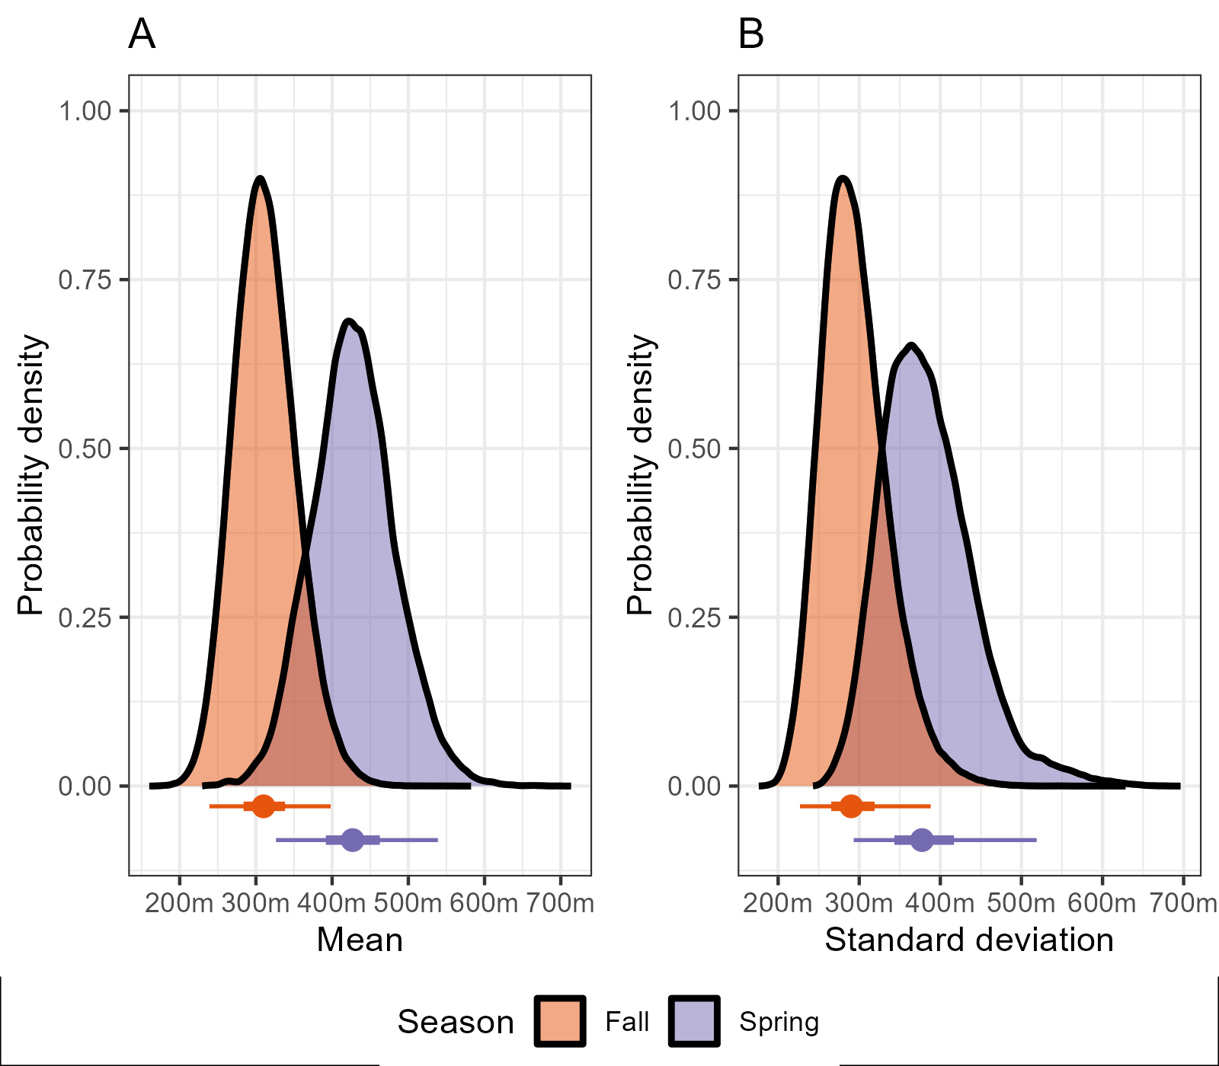

Figure 1. Means and standard deviations of American Woodcock (*Scolopax minor*) flight altitudes above ground level during fall and spring migration. Density plots represent posterior distributions of parameters, while point intervals represent the medians (points), 50% credible intervals (thick lines), and 95% credible intervals (thin lines) of the posteriors.

Figure 2. Means and standard deviations of American Woodcock (*Scolopax minor*) flight altitudes above ground level for adult and juvenile individuals. Density plots represent posterior distributions of parameters, while point intervals represent the medians (points), 50% credible intervals (thick lines), and 95% credible intervals (thin lines) of the posteriors.

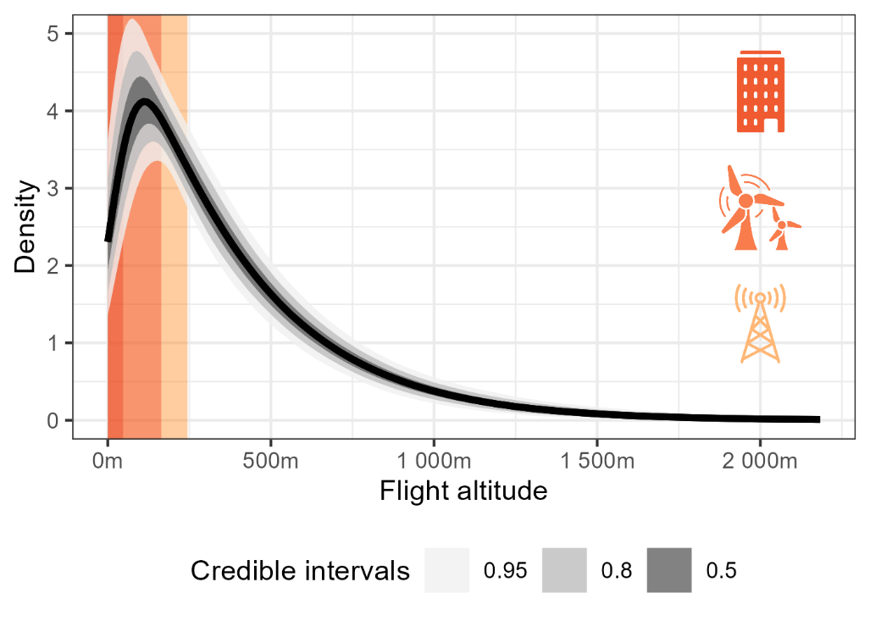

Figure 3. Distribution of woodcock flight altitudes above ground level compared to the heights of low-rise buildings (red; 47m), land-based wind turbines (orange; 32–164m), and large communications towers (yellow; 244m). The dark line represents the median flight altitude distribution calculated using the base model, while ribbons represent 50%, 80%, and 95% credible intervals for the distribution.

**4 Discussion**

We found that mean woodcock flight altitudes fell below those that birds generally occupy during fall (woodcock: 312m; all birds: 418–491m) and spring (woodcock: 428m; all birds: 438–559m; Horton et al. 2016). This result may be due in part to the increased representation of lower altitude flight locations in our data, as 33% of woodcock flight locations fell below the minimum altitude observed via radar in Horton et al. (2016; 120m). However, given preexisting information about woodcock’s high susceptibility to collisions with anthropogenic structures (Mendall and Aldous 1943, Loss et al. 2020) we believe that some portion of this effect is due to a biological difference between the flight altitudes of woodcock and other nocturnal migrants. Woodcock’s use of lower altitudes than other birds may be related to their morphology. Woodcock, like Ruffed Grouse (*Bonasa umbellus*; Marden 1994) are short-burst fliers, which facilitates rapid takeoff to evade predators. This is also likely the reason woodcock have shorter, rounder wings than other related Scolopacids, in a manner which is more reminiscent of grouse species (McAuley et al. 2020). However, the muscle configuration which facilitates short-burst flight generally is not well suited to long, continuous flights (Askew and Marsh 2002), and it may be more difficult for woodcock to climb to altitudes which provide optimal tailwinds in the same manner as other nocturnal migrants. Energetic costs for flight also increase with altitude, which may provide incentives for inefficient fliers to maintain low altitudes (Galtbalt et al. 2021).

As anticipated, we found little support for an age difference in woodcock flight altitudes but considerable support for a seasonal difference, with woodcock flight altitudes being higher in spring (mean: 428m, 95% CRI: 326–539m) than fall (mean: 312m, 95% CRI: 239–398m). This matches seasonal variation in flight altitudes observed via radar (Horton et al. 2016), which is presumably due to interactions between the Earth’s atmospheric boundary layer and the predominantly southerly winds observed in the northern hemisphere. Woodcock, like other migrants, appear to select higher altitudes in the spring, when birds traveling north can receive a favorable tailwind higher in the boundary layer, and lower altitudes in fall, when lower wind speeds closer to the ground make it easier for woodcock to fly against the wind. This produced an increase in woodcock flight locations at airspace obstacle height in fall, with a 4% increase in locations occurring at low-rise building altitude, 7% increase in locations at wind turbine altitude, and 13% increase in locations at communication tower altitude. Notably, woodcock’s lower flight altitudes have not resulted in an observed increase in building collisions during the fall, with more collisions generally observed during the spring (Loss et al. 2019). This may be due to the short migratory durations of woodcock in the fall (Fish et al. 2024) or a mismatch between the data collection windows for bird collision studies and the fall migratory periods of woodcock (Loss et al. 2020).

We found that, despite a mean flight altitude of 364m, 47% of woodcock flight locations fell within the altitudinal range of at least one airspace obstacle. Woodcock locations appear to be largely gamma distributed, with roughly half of locations occurring between 0–250m, and the other half ranging between 250–2200m. The occurrence of so many flight locations within the range of anthropogenic obstacles during peak times for migratory flight (12–1am Eastern Time) suggests that woodcock are not solely vulnerable to collision with these obstacles during takeoff and landing, but throughout their migratory flights. It is unclear whether woodcock are the only species with such substantial vulnerability. Woodcock appear to fly at altitudes lower than most other nocturnal migrants, but many other bird species have been classified as having a disproportionate representation among bird collision victims, including White-throated Sparrows (*Zonotrichia albicollis*), Tennessee Warblers (*Leiothlypis peregrina*) and Mourning Doves (*Zenaida macroura*, Nichols et al. 2018). These species may benefit from further study on whether their increased vulnerability is also due to low flight altitudes or other factors.

The circumstances that lead to bird collisions with obstacles can be varied, and include weather conditions, artificial light, and the placement of obstacles adjacent to favorable stopover habitat (Richardson 1998, Van Doren et al. 2021). Frequently these risk factors operate by causing birds to fly lower altitudes and become susceptible to collisions with airspace obstacles. However, airspace <200m a.g.l. remains comparatively understudied compared to higher altitudes, in large part due to restrictions in the capabilities of weather radar below this altitude. The continued use of transmitters or dataloggers to track bird altitudes can provide a potential mechanism for improving study of low altitude flights and determining individual- and species-level differences in use of low altitude space (Bowlin et al. 2015). The use of portable radar technologies may also provide opportunities to better quantify low altitude space use in local areas, and particularly in response to stimuli such as artificial light and weather conditions (Nilsson et al. 2018). Further study may allow us to better understand the circumstances that result in obstacle collisions and implement mitigation strategies to reduce bird mortality.

**References**

Agostini, N., M. Gustin, M. Cento, J. Von Hardenberg, and G. Chiatante (2023). Differential flight strategies of Western Marsh Harrier *Circus aeruginosus* in relation to sex and age class during spring migration in the central Mediterranean. Acta Ornithologica 58:41–53.

Askew, G. N., and R. L. Marsh (2002). Muscle designed for maximum short-term power output: quail flight muscle. Journal of Experimental Biology 205:2153–2160.

Bauer, S., J. Shamoun-Baranes, C. Nilsson, A. Farnsworth, J. F. Kelly, D. R. Reynolds, A. M. Dokter, J. F. Krauel, L. B. Petterson, K. G. Horton, and J. W. Chapman (2019). The grand challenges of migration ecology that radar aeroecology can help answer. Ecography 42:861–875.

Blomberg, E. J., A. C. Fish, L. A. Berigan, A. M. Roth, R. Rau, S. J. Clements, G. Balkcom, B. Carpenter, G. Costanzo, J. Duguay, C. L. Graham, et al. (2023). The American Woodcock Singing Ground Survey largely conforms to the phenology of male woodcock migration. The Journal of Wildlife Management 87:e22488.

Bowlin, M. S., D. A. Enstrom, B. J. Murphy, E. Plaza, P. Jurich, and J. Cochran (2015). Unexplained altitude changes in a migrating thrush: long-flight altitude data from radio-telemetry. The Auk: Ornithological Advances 132:808–816.

Bridge, E. S., K. Thorup, M. S. Bowlin, P. B. Chilson, R. H. Diehl, R. W. Fléron, P. Hartl, R. Kays, J. F. Kelly, W. D. Robinson, and M. Wikelski (2011). Technology on the Move: Recent and Forthcoming Innovations for Tracking Migratory Birds. BioScience 61:689–698.

Butler, P. J. (2016). The physiological basis of bird flight. Philosophical Transactions of the Royal Society B: Biological Sciences 371:20150384.

Clements, S. J., L. A. Berigan, A. C. Fish, R. L. Darling, A. M. Roth, G. Balkcom, B. Carpenter, G. Costanzo, J. Duguay, and K. Filkins (2024). Satellite tracking of American Woodcock reveals a gradient of migration strategies. Ornithology:ukae008.

Cobb, S. (1959). On the angle of the cerebral axis in the American woodcock. The Auk 76:55–59.

Cooper, T. R., and R. D. Rau (2012). American Woodcock: Population Status, 2012. U.S. Fish and Wildlife Service. Laurel, MD.

ESRI (2023). Terrain. [Online.] Available at https://www.arcgis.com/home/item.html?id=58a541efc59545e6b7137f961d7de883.

ESRI (2024). ArcGIS Pro version 3.2.1. Redlands, CA.

Fish, A. C., A. M. Roth, G. Balkcom, L. Berigan, K. Brunette, S. Clements, G. Costanzo, C. L. Graham, W. F. Harvey, M. Hook, D. L. Howell, et al. (2024). American woodcock migration phenology in eastern North America: implications for hunting season timing. The Journal of Wildlife Management e22565.

Galtbalt, B., A. Lilleyman, J. T. Coleman, C. Cheng, Z. Ma, D. I. Rogers, B. K. Woodworth, R. A. Fuller, S. T. Garnett, and M. Klaassen (2021). Far eastern curlew and whimbrel prefer flying low - wind support and good visibility appear only secondary factors in determining migratory flight altitude. Movement Ecology 9:32.

Gehring, J., P. Kerlinger, and A. M. Manville (2011). The role of tower height and guy wires on avian collisions with communication towers. The Journal of Wildlife Management 75:848–855.

Horton, K. G., B. M. Van Doren, P. M. Stepanian, A. Farnsworth, and J. F. Kelly (2016). Where in the air? Aerial habitat use of nocturnally migrating birds. Biology Letters 12:20160591.

Loss, S. R., S. Lao, A. W. Anderson, R. B. Blair, J. W. Eckles, and R. J. Turner (2020). Inclement weather and American woodcock building collisions during spring migration. Wildlife Biology 2020.

Loss, S. R., S. Lao, J. W. Eckles, A. W. Anderson, R. B. Blair, and R. J. Turner (2019). Factors influencing bird-building collisions in the downtown area of a major North American city. PLOS ONE 14:e0224164.

Loss, S. R., T. Will, S. S. Loss, and P. P. Marra (2014). Bird–building collisions in the United States: Estimates of annual mortality and species vulnerability. The Condor 116:8–23.

Loss, S. R., T. Will, and P. P. Marra (2013). Estimates of bird collision mortality at wind facilities in the contiguous United States. Biological Conservation 168:201–209.

Marden, J. H. (1994). From damselflies to pterosaurs: how burst and sustainable flight performance scale with size. American Journal of Physiology-Regulatory, Integrative and Comparative Physiology 266:R1077–R1084.

Martin, G. R. (1994). Visual fields in woodcocks Scolopax rusticola (Scolopacidae; Charadriiformes). Journal of Comparative Physiology A 174.

McAuley, D. G., D. M. Keppie, and R. M. Whiting Jr. (2020). American Woodcock (Scolopax minor), version 1.0. In Birds of the World (A. F. Poole, Editor). Cornell Lab of Ornithology, Ithaca, NY, USA.

McAuley, D. G., J. R. Longcore, and G. F. Sepik (1993). Techniques for Research into Woodcocks: Experiences and Recommendations. Proceedings of the eighth American woodcock symposium. U.S. Fish and Wildlife Service, p. 5.

McElreath, R. (2018). Statistical rethinking: A Bayesian course with examples in R and Stan. Chapman and Hall/CRC.

Mendall, H. L., and C. M. Aldous (1943). The ecology and management of American woodcock. Maine Cooperative Wildlife Research Unit. Orono, ME.

Nichols, K. S., T. Homayoun, J. Eckles, and R. B. Blair (2018). Bird-building collision risk: An assessment of the collision risk of birds with buildings by phylogeny and behavior using two citizen-science datasets. PLOS ONE 13:e0201558.

Nilsson, C., A. M. Dokter, B. Schmid, M. Scacco, L. Verlinden, J. Bäckman, G. Haase, G. Dell’Omo, J. W. Chapman, H. Leijnse, and F. Liechti (2018). Field validation of radar systems for monitoring bird migration. Journal of Applied Ecology 55:2552–2564.

Norevik, G., S. Åkesson, A. Andersson, J. Bäckman, and A. Hedenström (2021). Flight altitude dynamics of migrating European nightjars across regions and seasons. Journal of Experimental Biology 224:jeb242836.

Péron, G., J. M. Calabrese, O. Duriez, C. H. Fleming, R. García-Jiménez, A. Johnston, S. A. Lambertucci, K. Safi, and E. L. C. Shepard (2020). The challenges of estimating the distribution of flight heights from telemetry or altimetry data. Animal Biotelemetry 8:5.

Plummer, M. (2003). JAGS: A program for analysis of Bayesian graphical models using Gibbs sampling. Proceedings of the 3rd international workshop on distributed statistical computing. Vienna, Austria, pp. 1–10.

Poessel, S. A., A. E. Duerr, J. C. Hall, M. A. Braham, and T. E. Katzner (2018). Improving estimation of flight altitude in wildlife telemetry studies. Journal of Applied Ecology 55:2064–2070.

Richardson, W. J. (1998). Bird migration and wind turbines: migration timing, flight behavior, and collision risk. Proceedings of the National Avian-wind Power Planning Meeting III, San Diego, California.

Rogers, R. M., J. J. Buler, C. E. Wainwright, and H. A. Campbell (2020). Opportunities and challenges in using weather radar for detecting and monitoring flying animals in the Southern Hemisphere. Austral Ecology 45:127–136.

Van Doren, B. M., D. E. Willard, M. Hennen, K. G. Horton, E. F. Stuber, D. Sheldon, A. H. Sivakumar, J. Wang, A. Farnsworth, and B. M. Winger (2021). Drivers of fatal bird collisions in an urban center. Proceedings of the National Academy of Sciences 118:e2101666118.

Wiser, R., M. Bolinger, B. Hoen, D. Millstein, J. Rand, G. Barbose, N. Darghouth, W. Gorman, S. Jeong, and E. O’Shaughnessy (2023). Land-based wind market report: 2023 edition. Lawrence Berkeley National Laboratory (LBNL), Berkeley, CA.