*Under the radar and into the window: distribution of flight altitudes for American Woodcock*

**1 Introduction**

Estimates of birds killed by collisions with comm towers (Longcore et al. 2013) and wind turbines (Loss et al. 2013)

Estimates of flight altitudes for all birds from NEXRAD (Horton et al. 2016)

Originally believed to migrate at altitudes of 12–15m due to their frequent collision with anthropogenic structures (Mendall and Aldous 1943)

**2 Methods**

*2.1 Data collection and preprocessing*

* Data collection
* Data formatting
* Adults vs. juveniles

*2.2 Transformation of altitude measurements*

* Altitude above ellipsoid to altitude above ground level using a model in ArcGIS
  + Specify the tools used

*2.3 Modeling altitude distributions*

* Model structure
  + Normalized flight altitude distribution to (-1, 1) based on the maximum observed flight altitude
* Running the model subsets

*2.4 Comparison to other metrics*

* Minimum NEXRAD detection height
* Potential airspace obstacles:
  + Low-rise buildings
  + Terrestrial wind turbines
  + Large communication towers

**3 Results**

Structure:

* Distribution of woodcock flight altitudes
  + OG
  + Season
  + Age
* Woodcock flight altitudes (OG and by season) in relation to:
  + NEXRAD weather radar
  + Low-rise buildings
  + Wind turbines
  + Communication towers

~~Stats~~

~~OG~~

* ~~Estimated median flight altitude is 262m (50% CI: 239–285m, 95% CI: 195–332m)~~
* ~~Estimated mean flight altitude is 364m (50% CI: 341–386m, 95% CI: 300–432m)~~
* ~~An estimated 33% of locations (50% CI: 29–36m, 95% CI: 23–43%) fall below the minimum flight altitude reported in (Horton et al. 2016), suggesting that they are lower than would be detected via NEXRAD weather radar~~
* ~~An estimated 10% of locations (50% CI: 8–13%, 95% CI: 4–19%) are at an altitude where they might collide with a building (0–47m)~~
* ~~An estimated 47% of locations (50% CI: 44–51%, 95% CI: 37–57%) are at an altitude where they might collide with a communications tower (0–244m)~~
* ~~An estimated 27% of locations (50% CI: 25–29%, 95% CI: 21–32%) are at an altitude where they might collide with a wind turbine (32–164m)~~

~~Season~~

* ~~Estimated median flight altitude is 225m (50% CI: 196–252m, 95% CI: 148–312m) in fall and 319m (50% CI: 282–355m, 95% CI: 216–427m) in spring~~
* ~~Estimated mean flight altitude is 312m (50% CI: 284–338m, 95% CI: 239–398m) in fall and 428m (50% CI: 392–463m, 95% CI: 326–539m) in spring~~
* ~~An estimated 37% of locations (50% CI: 32–42%, 95% CI: 23–51%) in fall and 26% (50% CI: 21–31%, 95% CI: 14–41%) in spring fall below the minimum flight altitude reported in (Horton et al. 2016), suggesting that they are lower than would be detected via NEXRAD weather radar~~
* ~~An estimated 12% of locations (50% CI: 8–16%, 95% CI: 4–25%) in fall and 8% (50% CI: 5–10%, 95% CI: 2–18%) in spring are at an altitude where they might collide with a building (0–47m)~~
* ~~An estimated 53% of locations (50% CI: 49–58%, 95% CI: 39–65%) in fall and 40% (50% CI: 35–45%, 95% CI: 26–54%) in spring are at an altitude where they might collide with a communications tower (0–244m)~~
* ~~An estimated 30% of locations (50% CI: 28–33%, 95% CI: 22–36%) in fall and 23% (50% CI: 22–36%, 95% CI: 14–30%) in spring are at an altitude where they might collide with a wind turbine (32–164m)~~

~~Age~~

* ~~Estimated median flight altitude is 294m (50% CI: 254–333m, 95% CI: 185–408m) for adults and 260m (50% CI: 231–288m, 95% CI: 182–345m) for juveniles~~
* ~~Estimated mean flight altitude is 400m (50% CI: 360–437m, 95% CI: 301–516m) for adults and 344m (50% CI: 316–370m, 95% CI: 270–430m) for juveniles~~
* ~~An estimated 29% of locations (50% CI: 23–34%, 95% CI: 15–45%) for adults and 31% (50% CI: 26–36%, 95% CI: 18–45%) for juveniles fall below the minimum flight altitude reported in (Horton et al. 2016), suggesting that they are lower than would be detected via NEXRAD weather radar~~
* ~~An estimated 9% of locations (50% CI: 5–12%, 95% CI: 2–22%) for adults and 9% (50% CI: 5–12%, 95% CI: 2–19%) for juveniles are at an altitude where they might collide with a building (0–47m)~~
* ~~An estimated 43% of locations (50% CI: 38–48%, 95% CI: 28–58%) for adults and 47% (50% CI: 43–52%, 95% CI: 34–60%) for juveniles are at an altitude where they might collide with a communications tower (0–244m)~~
* ~~An estimated 24% of locations (50% CI: 21–27%, 95% CI: 15–31%) for adults and 27% (50% CI: 25–30%, 95% CI: 18–34%) for juveniles are at an altitude where they might collide with a wind turbine (32–164m)~~

**Etc**

~~Sex only works for 300k, and age doesn’t work at that # of iterations~~

~~Compare flight heights to the rotor sweep of newly installed turbines (average wind turbine installed in 2022):~~

~~“The average rotor diameter of newly installed turbines was 131.6 meters, a 3% increase over 2021 and 173% over 1998−1999, while the average hub height was 98.1 meters, up 4% from 2021 and 73% since 1998−1999” (U.S. Department of Energy 2023)~~

~~This would put the average rotor sweep at 32.2 to 163.8m. What proportion of woodcock locations fall within that sweep?~~

~~“Tall study towers were similar in structure and lighting to approximately 1,500 towers in the United States that are >244 m AGL in height.” (Gehring et al. 2011)~~

~~Max height of a low rise building, at which most mortality occurs according to (Loss et al. 2014), is 154 feet or 47 meters~~

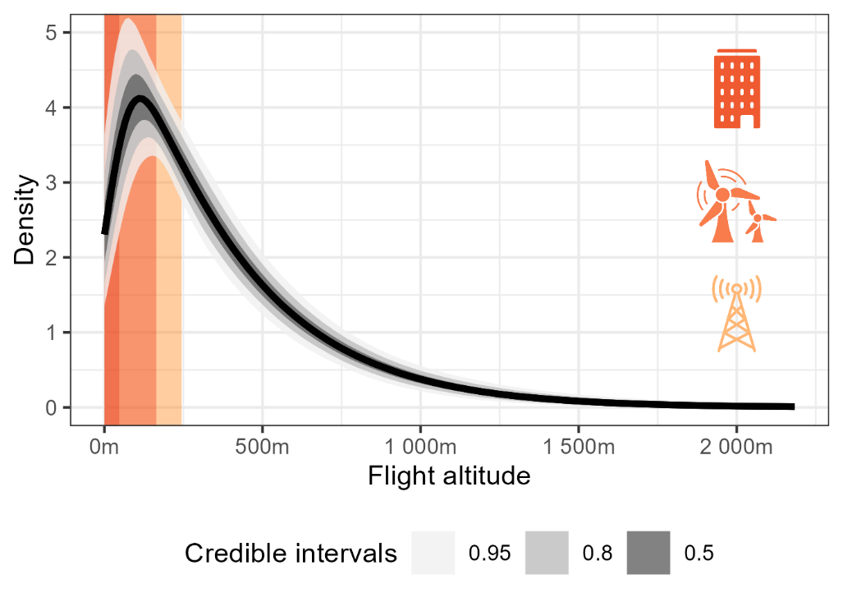

Figure 1. 95%, 80%, and 50% credible intervals

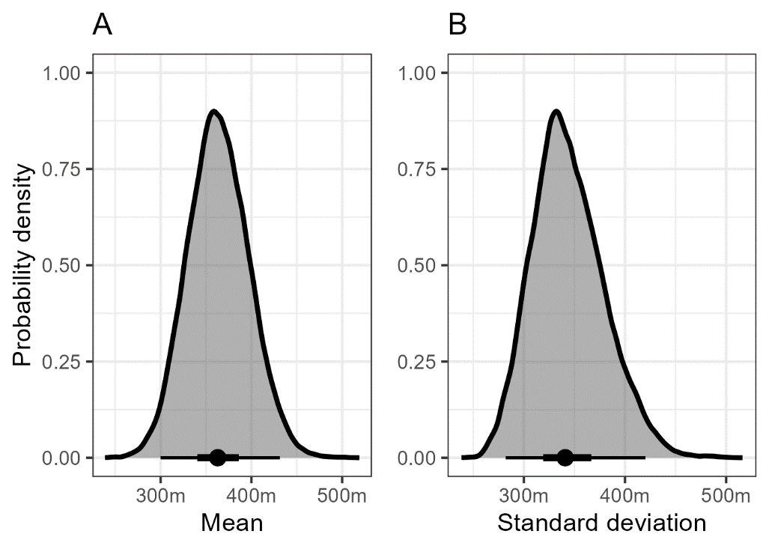

Figure 2. Points represent medians, thick lines represent 50% credible intervals, thin lines represent 95% credible intervals.

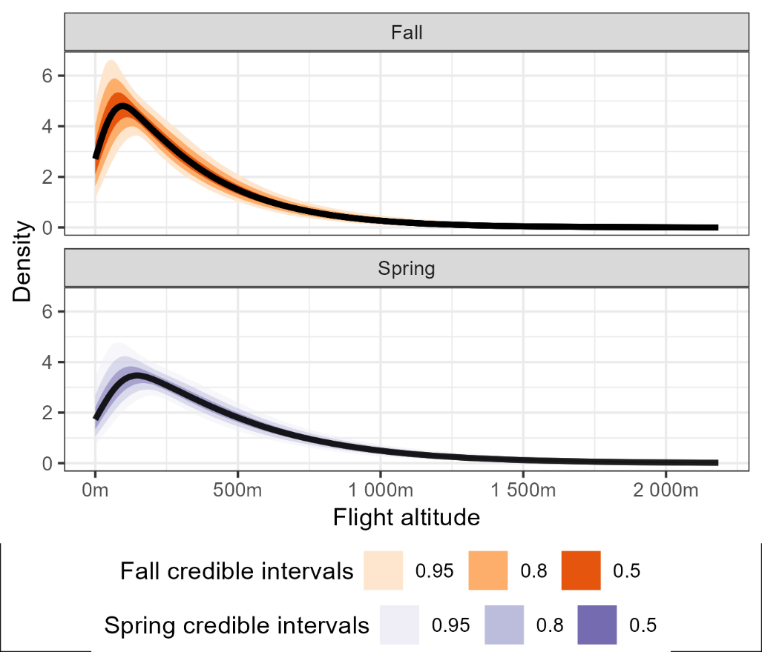

Figure 3

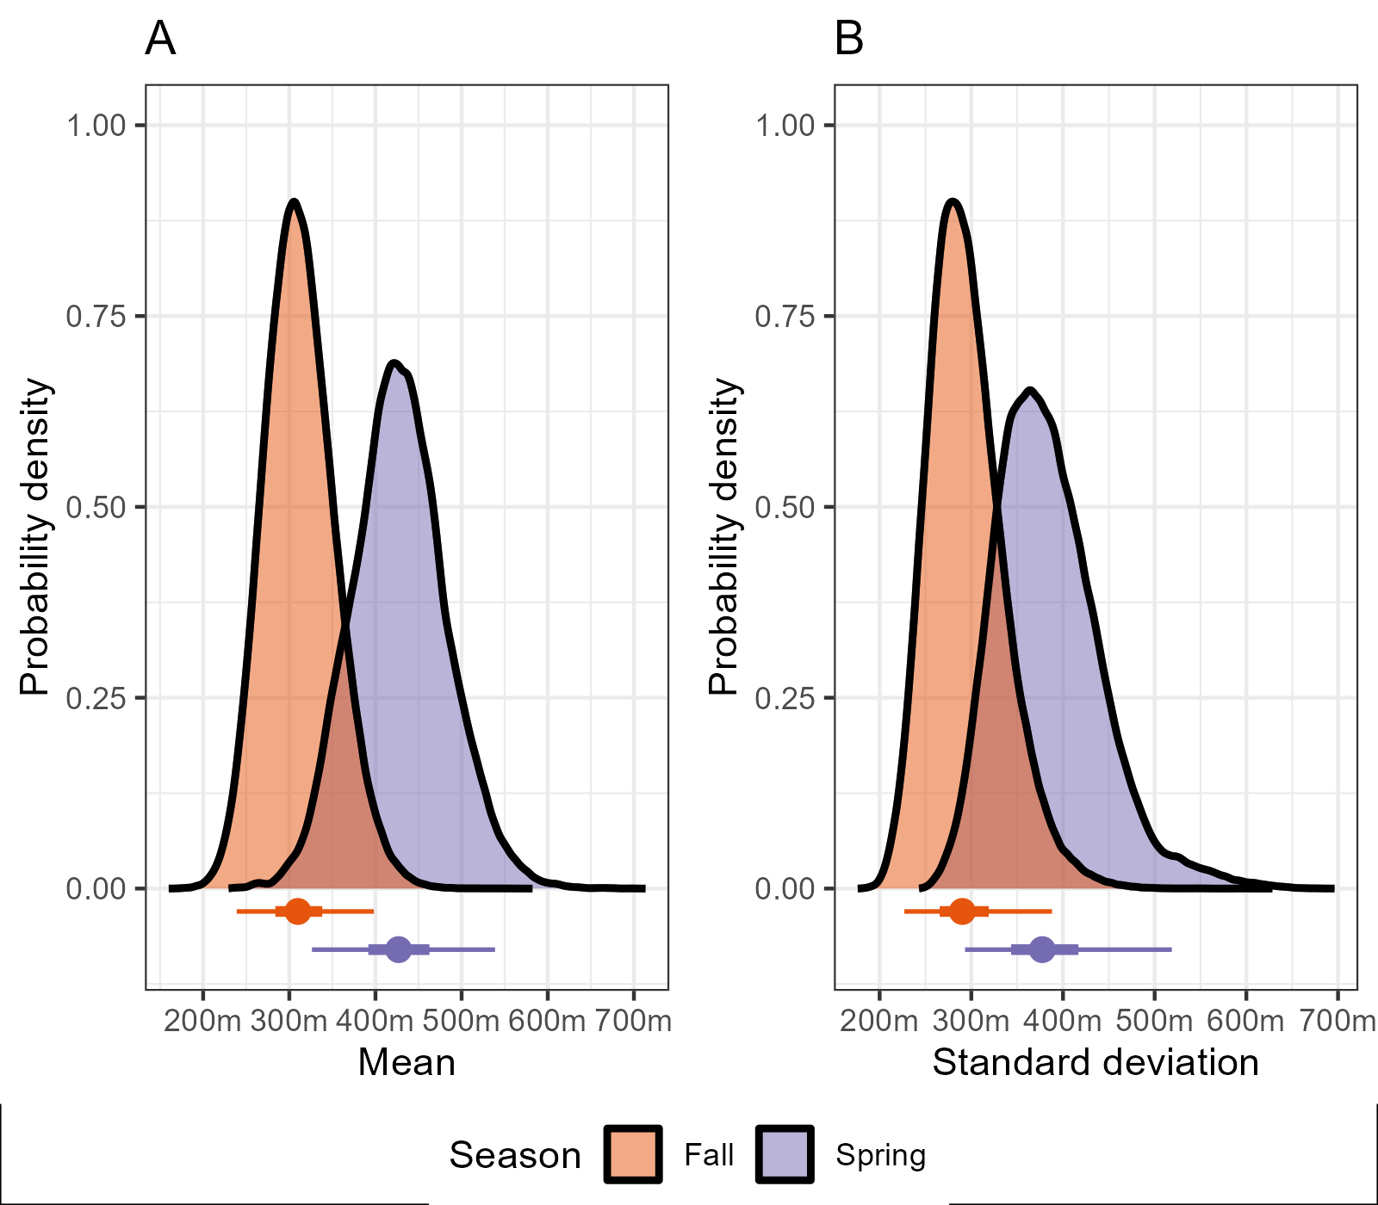

Figure 4

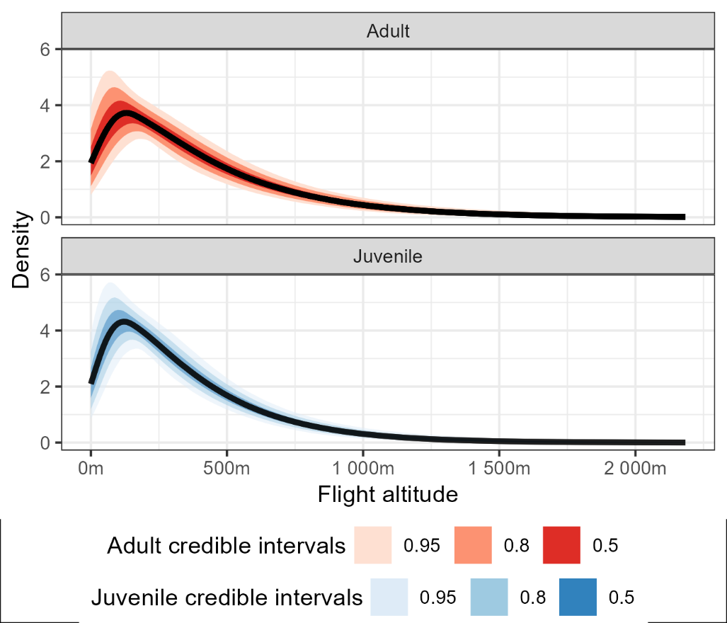

Figure 5.

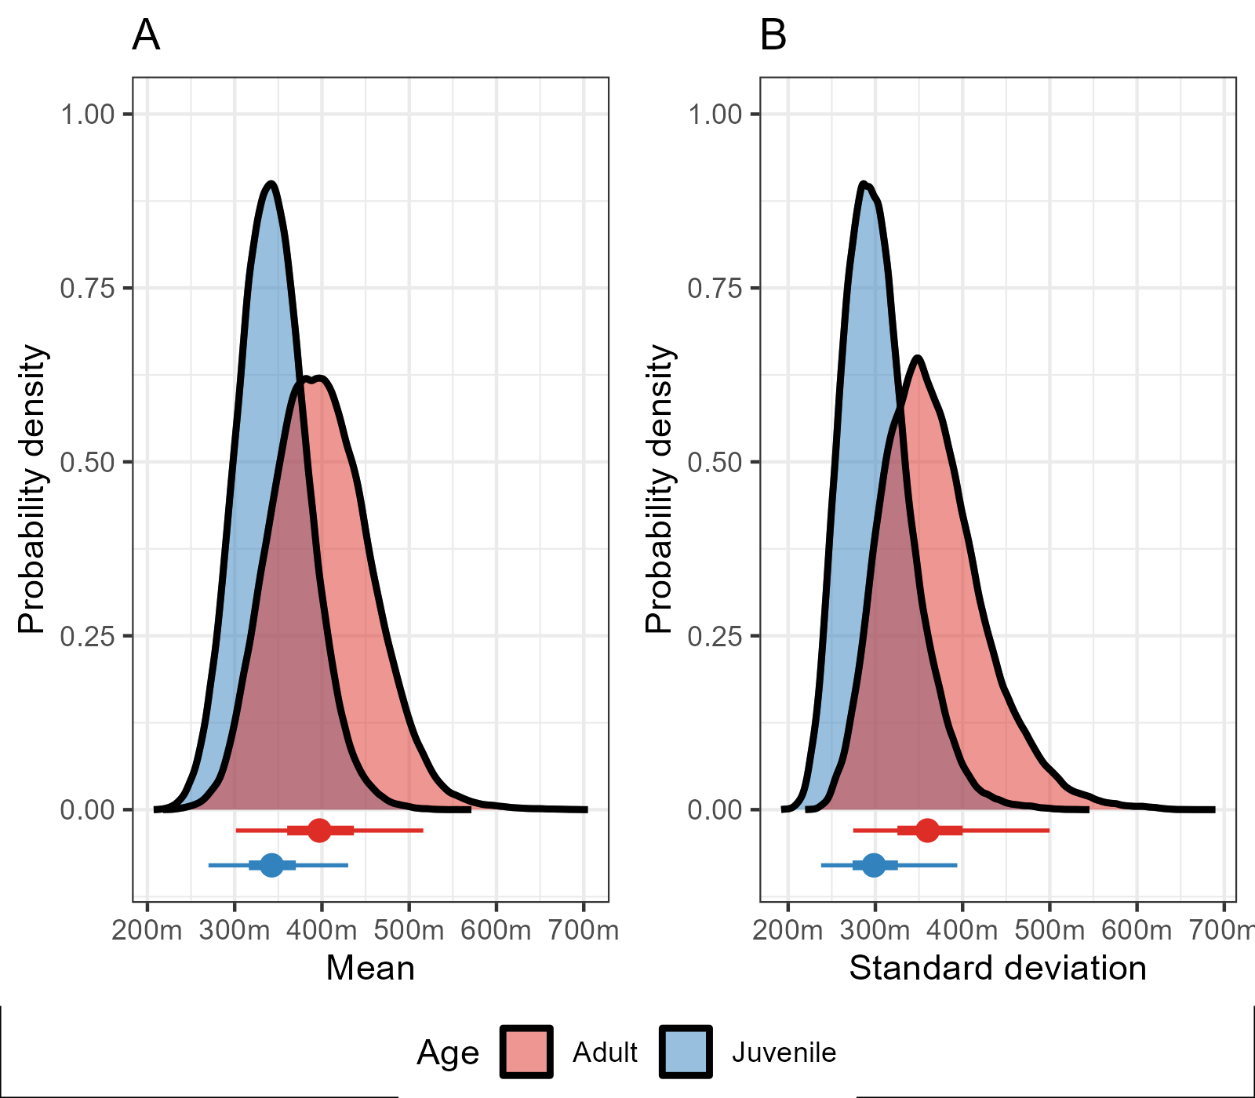

Figure 6.