LA Berigan, 3/20/23

We classified mortality locations using a two-step process, with the first step using an automated process and the second step using a manual classification. During the initial step, we used a hidden Markov model (applied using the R package momentuHMM) to identify GPS locations in which the bird carrying the transmitter was likely deceased. We taught the HMM to recognize mortality locations by incorporating a training dataset of 413 known mortality locations in the HMM’s fitting process. These known locations were collected during a test scenario, in which we placed 10 transmitters on the ground in a variety of vegetative covers and programmed them to take 1 location per minute for ~40 minutes. We gave the hidden Markov model the following state-space structure:

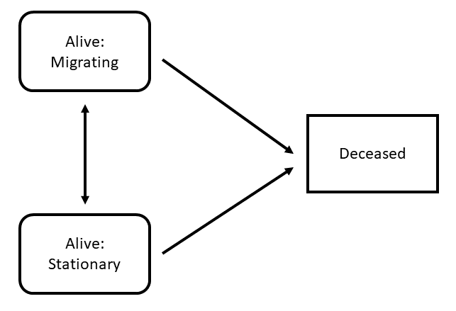

Woodcock were allowed to enter the model during any of the 3 states and could transition freely between either of the 2 living states. However, once they entered the deceased state they had to remain in that state until the end of the track. The HMM distinguished between these states using 3 data streams, including step length, turn angle, and mean distance to the nearest 15 points. The HMM was able to identify 127 birds that had potential mortality events at the conclusion of their migratory tracks. These 127 birds were then further examined using manual classification to determine their veracity.

During manual classification, we used a Shiny application to visually inspect the potential mortality to see if it met two criteria. The first criteria was whether the bird had >= 15 locations in a mortality state. This was used to determine whether the bird had enough mortality locations to identify whether the transmitter was truly stationary. The second criteria was the distance from the centroid of the mortality locations within which 50% of all mortality locations fell. This threshold was landcover type specific (10.85 m in forest, 5.33 m in grass or open cover) and was chosen based on testing of the known mortality dataset. Most birds were clearly delineated via these criteria, but in certain cases birds met one of the criteria and nearly, but did not quite, meet the second. In those circumstances, the reviewer’s judgement was used to determine whether the bird was most likely alive or deceased, with time of residence and “boxing” of GPS locations playing a role in those decisions. Occasionally the presumed date of mortality was adjusted manually based on the date on which the bird first started displaying mortality-like behavior. We found 20 birds that exhibited evidence of mortality at some point during their track. We uploaded mortality classifications for each location as a binary attribute to Movebank’s mortality status field, with 0s for living locations and 1s for mortality locations.