# 无线网络及安全

# 实验报告

**实验名称： assignment2**

**学生姓名： 牛熠玮**

**学生学号： 71118420**

**Email ID: nyw(213183189@seu.edu.cn)**

**Answer:**

**1. Network configuration**

a. A screenshot of the output from the command ip address on the router,web, files and desktop machines, respectively.

router:

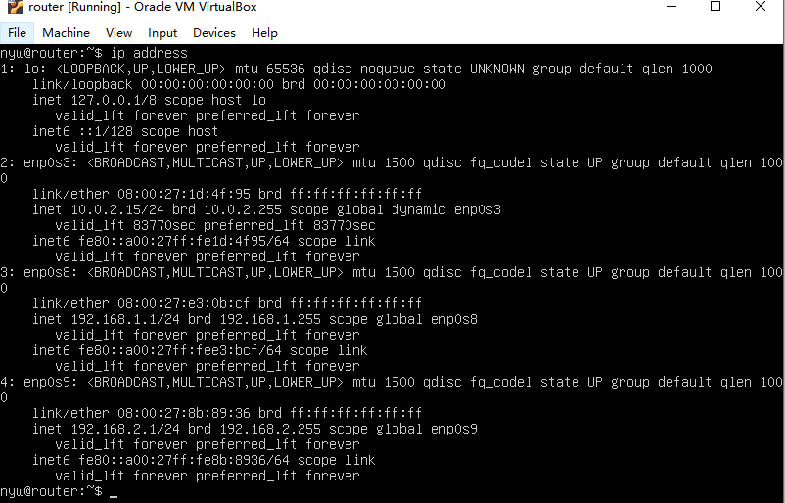

web:

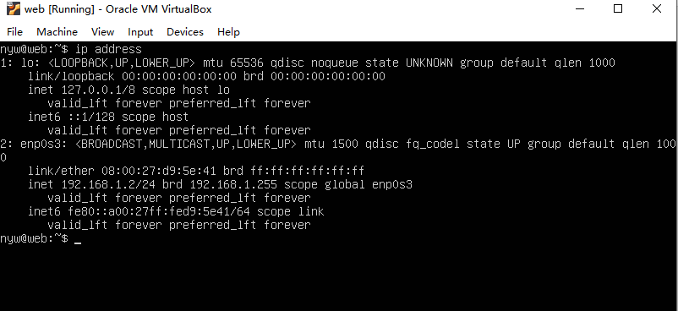

files:

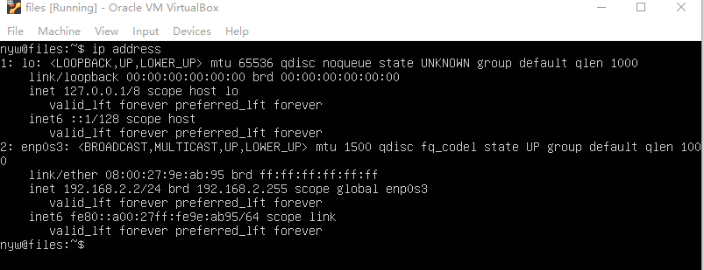

desktop:

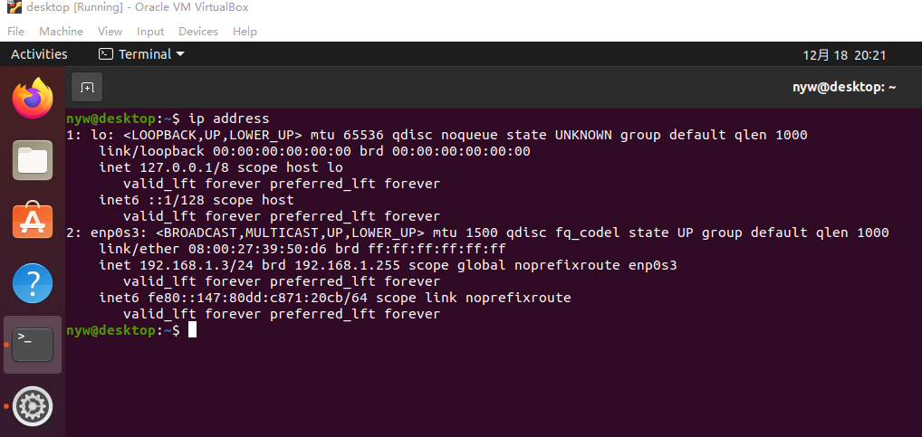

**2. Routing configuration**

a. A screenshot of the output from the command cat /etc/iptables/rules.v4 on the router machine.

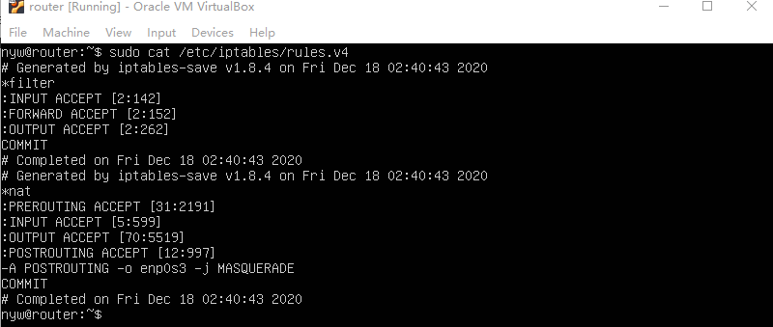

b. A screenshot of the output from the command ping 192.168.1.2 on the files machine and ping 192.168.2.2 on the web machine, respectively.

ping 192.168.1.2 on the files:

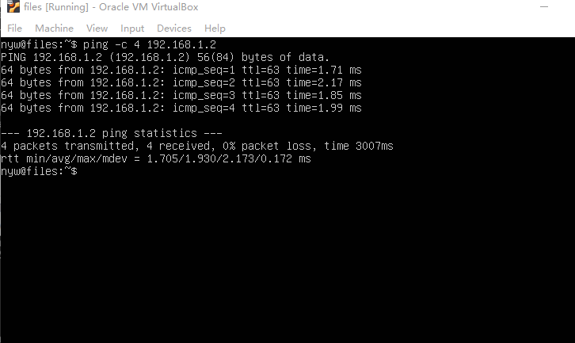

ping 192.168.2.2 on the web:

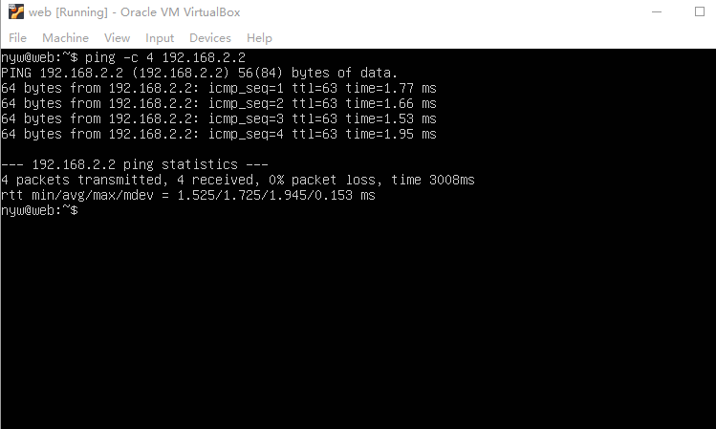

**3. DNS service configuration**

a. Content of the file /etc/bind/named.conf.local and all forward and

reverse zone files.

/etc/bind/named.conf.local

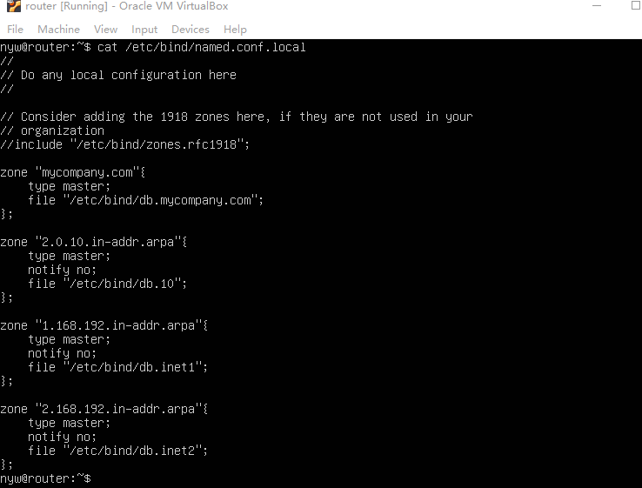

forward zone file /etc/bind/db.mycompany.com

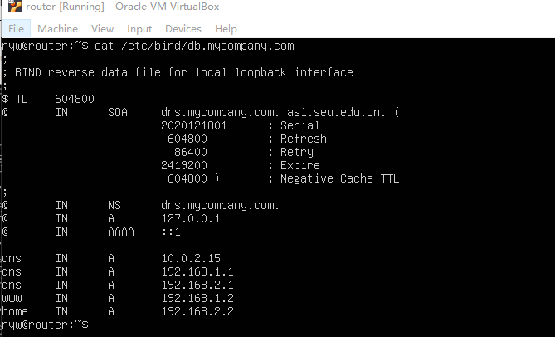

reverse zone files:

/etc/bind/db.10

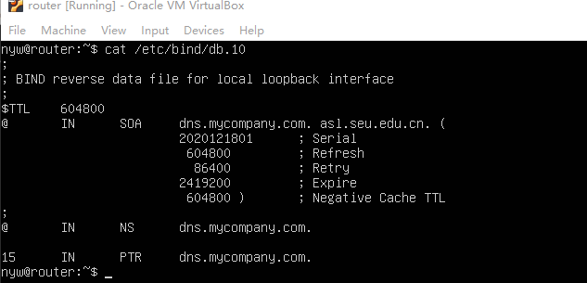

/etc/bind/db.inet1

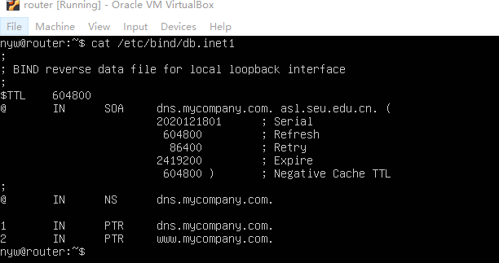

/etc/bind/db.inet2

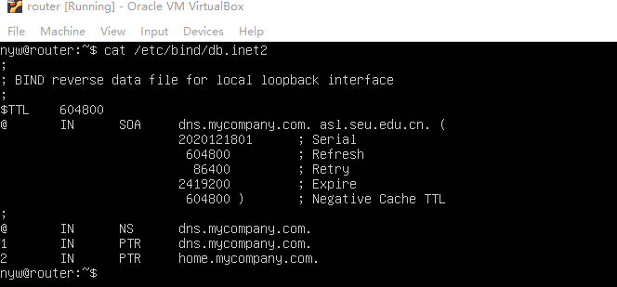

b. A screenshot of the output from the command dig home.mycompany.com on the web machine and dig www.mycompany.com on the files machine, respectively.

dig home.mycompany.com on the web

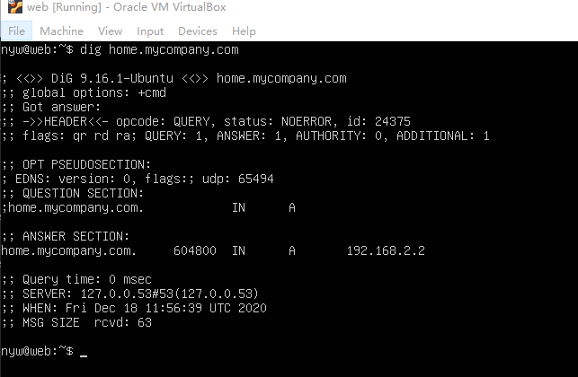

dig www.mycompany.com on the files

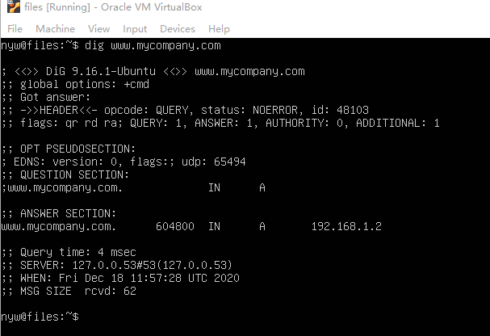

c. A screenshot of the output from the command dig -x 192.168.2.2 @dns.mycompany.com on the web machine.

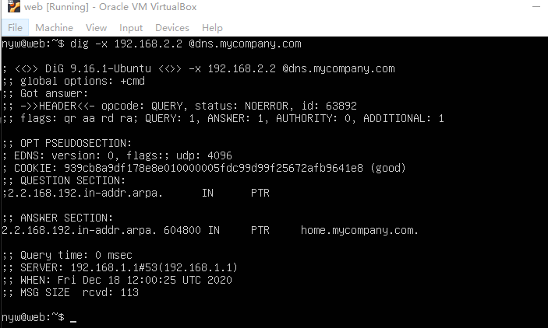

**4. File system configuration**

a. A screenshot of the output from the command zpool status on the web and files machines, respectively.

zpool status on the web

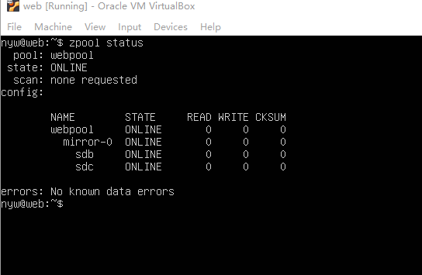

zpool status on files

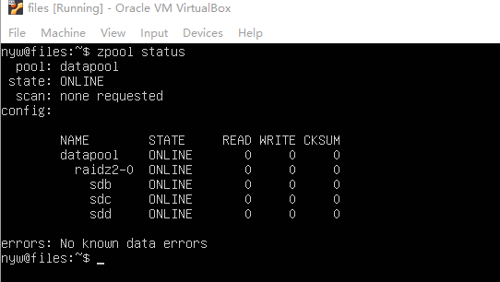

b. A screenshot of the output from the command zfs list on the web and

files machines, respectively.

zfs list on the web

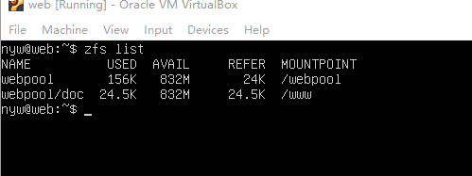

zfs list on the files

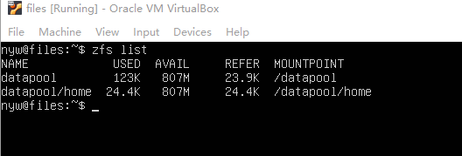

c. A screenshot of the output from the command showmount -e home.mycompany.com on the desktop machine.

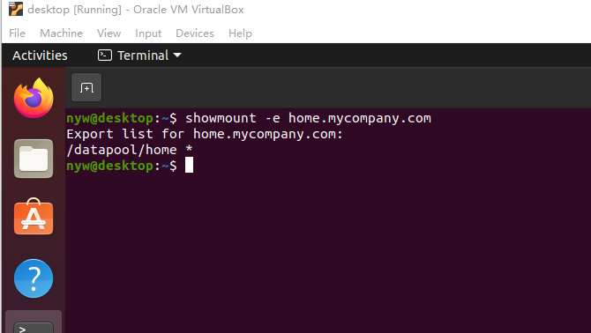

d. A screenshot of the output from the command cat /etc/fstab on the desktop machines.

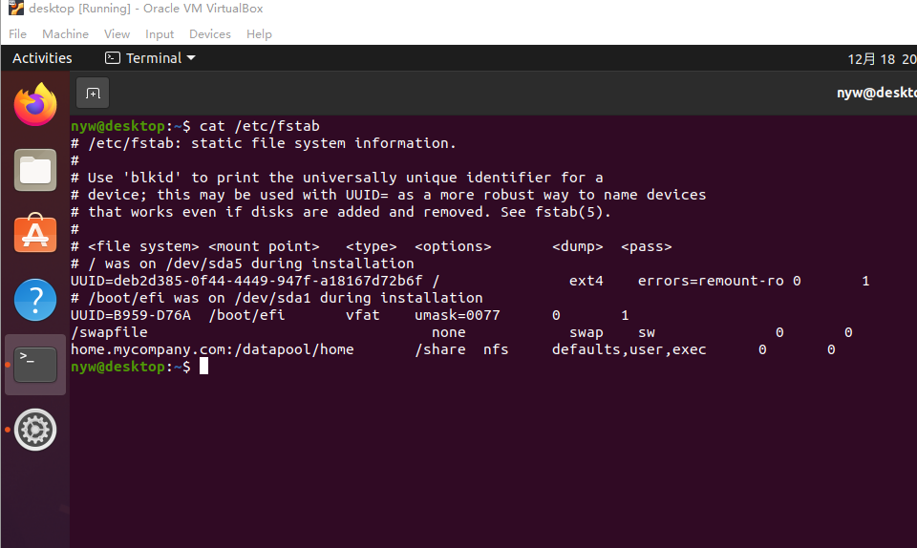

**5. Web service configuration**

a. A screenshot of the output from the command cat /etc/apache2/sites-available/000-default.conf on the web machines.

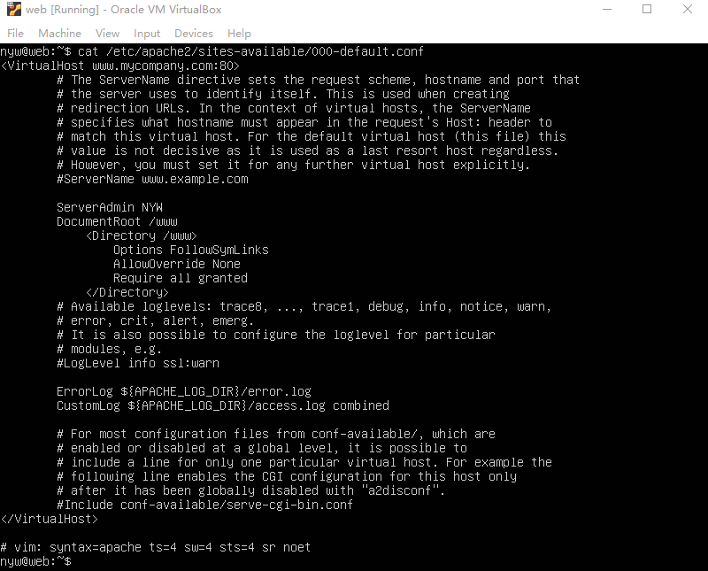

b. A screenshot of your assignment web page on Firefox pointing to www.mycompany.com on the desktop machine.

