**Assignment 2.**

**Modelling life cycle.**

Content:

Components 1

LED type and characteristics 1

Driver/PCB board 2

Life Cycle phases of the solar LED street light. 2

Geographic boundaries and disposal scenario. 4

Delimitations and approach to data gathering. 4

References: 5

# Components

AsimaSun, the stand alone solar driven street light system is completely based on the plug and play principle [6. It consists of the following parts: PV panel, lightning fixture with 16 LEDs, an aluminium pole, a rechargeable battery, a PCB board with control system (dimmers and controller) and the copper cables [5]. The luminaire´s weight is assumed to be around 8,4 kg [6]. And the entire system - weight is assumed to be around 110 kg [5].

## LED type and characteristics

The street lamp is equipped with 16 LEDS module type- XPGBWT-B1-CACE-A0KE5, manufactured by Cree Inc. (figure 1). Footprint (size) of each LED- 3.5 mm. It is stated in the manufacturers data sheet that this type of LEDs has operational life min 100.000 hours at a max 25° C, L80 B10 [2].

The measure of life-time of a LED is related to the luminous flux depreciation at a given ambient temperature. L70, L80 or L90 indicates how many lumens (in percentage related to the initial lumens) remains after end-of-life. The L-value may be explained B- and C-values [3]. “The failure factor for By expresses only the gradual light output degradation as a percentage “y” of a number of LED modules of the same type that at their rated life designates the percentage (fraction) of failures. The value B10 means that minimum 90 % of the LED modules will meet the declared L-value and only 10% will have a lower flux level”[2],[3].

Other LED Components: LED array, aluminium parts, remote phosphor cover, LED board connectors, lens, packaging [1], [7]. 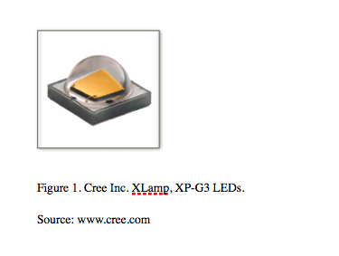

PV- modul.

The lamp has installed the 62Wp panel with 12 peaces of mono crystalline solar cells (5,16 Wp each) with antireflection coating that converts the light into energy. The conversion rate of mono-crystalline solar panels are much higher than their poly-crystalline. The panel has 15 years product warranty.

## Driver/PCB board

The luminaries drivers expected life time depends on the design itself, the used components and the temperature of these components. The drivers are usually marked with a reference temperature point, which should not be exceeded, Tc. Often the maximum ambient temperature (Ta) of the luminaire relates to the maximum value on the Tc-point. At this Ta the lifetime of 50.000h with an estimated failure rate of 10% during this time [3].

//The NiMh- based battery

nickel-metal hydride batteries consume a more significant amount of inputs from nature, and consequentially emits more outputs to air, water, soil, and waste. The inputs and outputs from NiMH batteries are nearly 100%. The inputs from LiIo batteries are less than 20%. The output from LiIo batteries to air is 50%, to soil it is 38%, to water it is 32% and to waste it is 100%. Overall, the emissions to air, water, and land are more significant from NiMH batteries, but the waste emission is larger for LiIo batteries. [batteries pdf]//

## Life Cycle phases of the solar LED street light.

The Model for LCA of a stand-alone solar driven street light system AsimaSun was created based on several previous research [1],[5],[7],[8] ) on solar driven street lamps. We added two scenarios for the product life time and product disposal.

Generally the Life- Cycle phases of the product or a system are simplified down to five main phases (as in figure 2): “primary resource acquisition, raw material processing, manufacturing and assembly, use, and the end-of-life phase” [1], including transportation between phases. It is important to note that the end-of-life phase can vary due to the time horisont of street lamp working life (up till 15 years). Since we dont know how the lamp can be processed for disposal in the future there will be two possible disposal scenarios considered: landfilling and recycling.

At the same time, two usage scenarios will be studied through this project according to the functional unit. As it was mentioned in the previous chapter, the standart LED's average lifetime with sufficient light output is 50,000 h of lighting. AsimaSun LEDs type are estimated up to 100,000 working hours, which is equivalent to 12 years operation (24 hours a day). Most solar panels turn on and turn off automatically by sensing outdoor light using a light source. Solar streetlights are designed to work throughout the night. Many can stay lit for more than one night if the sun is not available for a couple of days [4].

In Figure 2 there are both scenarios of lamp life time included. The life time of 100,00 will be used as base case scenario [9] and compared to the live of 50,000 h.

There are transport input during each stage of product life. We assume also that the major transport impacts are under customer distribution phase and disposal phase, as it might require international freight. More general data for transport units can be adopted from Tähkämö et,al [9], as a default scenarios for the product environmental profile (PEP): the global transport is estimated to be 19,000 km by ship and 1,000 km by lorry, the intercontinental transport 3,500 km by lorry, and local transport 1,000 km by lorry.

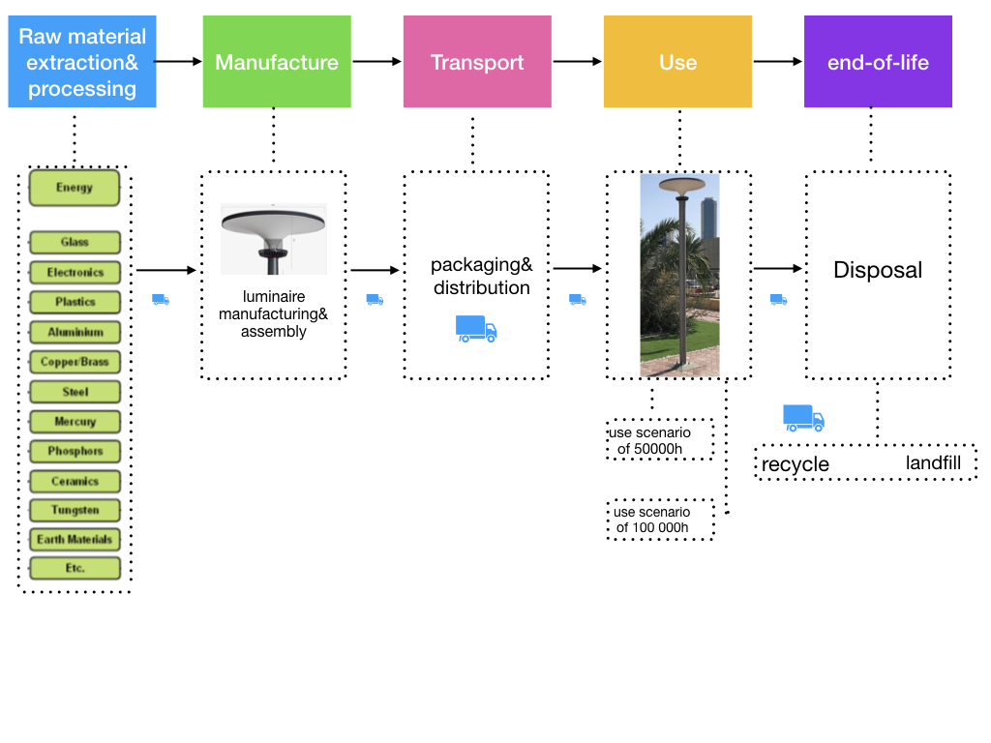Figure 2. Life Cycle phases of the AsimaSun street light.

## Geographic boundaries and disposal scenario.

Suncil Aps distributes their solar street light systems in Europe, USA and UAE. We assume that the product in question - AsimaSun lamp is assembled in Europe in one of the companies production facilities and installed in Denmark. As Denmark has has one of the lowest landfilling rates in Europe and it has been stable around 5-6% for the past ten years [10], we assume that the landfill scenario for the waste treatment will take only 5%, the rest should be recycled, remanufactured and reused.

## Delimitations and approach to data gathering.

There are two plans for data acquisition for the present project. Plan A is to contact directly the manufacture and request more detailed components and product data sheets, production locations and transport information, as well as the masses and percentages of materials. Since there has already been made separate Life cycle analises of LEDs, aluminium poles, rechargeable NiMh batteries, PV solar panels and etc., so in other case: Plan B is to use general data derived from previous LCA research and databases (such as for ex. Ecoinvent 3) and to make general product assumptions.

The system boundaries exclude travel impacts for LED replacements, the lighting, heating and maintenance of production facilities, transport of the employees, water for cleaning PV modul, as it was stated in previous research that those inputs represents less then 2% of the total weight of the product environmental foot print [9],[11],[8].

## References:

[1] Life-Cycle Assessment of Energy and Environmental Impacts of LED Lighting Products. February 2012. US Department of Energy. Navigant Consulting Inc.

[2] Product family data sheet. XLamp® XP-G3 LEDs, retrieved from www.cree.com

[3]. <https://glamox.com/gmo/led-and-lifetime>

[4] <http://www.excellentsolars.com/products/solar-street-lighting-system/>

[5] S. Tannous et al. "Comparative cradle-to-grave life cycle assessment of traditional grid- connected and solar stand-alone street light systems: A case study for rural areas in Lebanon”.

Journal of Cleaner Production 186 (2018). https://doi.org/10.1016/j.jclepro.2018.03.155

[6] Asima Sun data sheet. retrieved from www.[suncil.com](http://suncil.com).

[7] Life Cycle Assessment of Ultra-Efficient Lamps. May 2009. Navigant consulting Europe Ltd.

[8] Sabina Abdul Hadi, Muna R. Al Kaabi, Meshayel O. Al Ali, Hassan A. Arafat: Comparative Life Cycle Assessment (LCA) of streetlight technologies for minor roads in United Arab Emirates. Energy for Sustainable Development 17 (2013) 438–450 <http://dx.doi.org/10.1016/j.esd.2013.05.001>

[9] Leena Tåhkåmå, Manuel Bazzana, Pierre Ravel, Francis Grannec, Christophe Martinsons, Georges Zissis: Life cycle assessment of light-emitting diode downlight luminaire—a case study. Int J Life Cycle Assess (2013) 18:1009–1018. Published online: 9 January 2013. DOI 10.1007/s11367-012-0542-4

[10] <https://dakofa.com/element/landfilling-in-denmark/>

[11] Hendrickson, C. T. (2010). Reducing environmental burdens of solid-state lighting through end- of-life design. *Environmental Research Letters.* available online at: <https://iopscience.iop.org/article/10.1088/1748-9326/5/1/014016/meta>.

[12] [M. A. Parvez Mahmud](https://www.mdpi.com/search?authors=M.%20%20A.%20Parvez%20Mahmud&orcid=),[Nazmul Huda](https://www.mdpi.com/search?authors=Nazmul%20Huda&orcid=0000-0002-2349-7019), [Shahjadi Hisan Farjana](https://www.mdpi.com/search?authors=Shahjadi%20%20Hisan%20Farjana&orcid=) and[Candace Lang](https://www.mdpi.com/search?authors=Candace%20Lang&orcid=0000-0003-1064-630X). Comparative Life Cycle Environmental Impact Analysis of Lithium-Ion (LiIo) and Nickel-Metal Hydride (NiMH) Batteries. Batteries 2019, 5(1), 22. <https://doi.org/10.3390/batteries5010022>

[13] Del Borghi, A., Binaghi, L., Del Borghi, M., Gallo, M., 2007. The application of the environmental product declaration to waste disposal in a sanitary landfill four case studies, LCA cases studies. International Journal of Life Cycle Assess-ment 12 (1), 40e49. Available online at https://www.researchgate.net/publication/237403293_The_Application_of_the_Environmental_Product_Declaration_of_Waste_Disposal_in_a_Sanitary_Landfill_4_Case_Studies

.