23-09-2019
Life cycle assessment of a solar-driven LED street light system.

E. W. Storm stud.n. 163627;62202 Life Cycle Assessement, Instructor: GitteMellemgård

;

Table of content:
Introduction 2
Problem statement 3
Product description and Functional unit 3
Prospective delimitations 5
Product specifications: 5
Methodology and scope 7
Analyses 7
Discussion 7
Conclusion 7
List of references: 7

Introduction

The major gaol of this project is to perform a Life cycle assessment of the solar energy street lamp designed by Morten Lyhne and produced by Danish company Suncil ApS. The company founded in 2017 provides smart city streetlight solar solutions on the territory of EU, USA and UAE. Suncil is striving to work towards UN 17 sustainable goals as a part of their corporate strategy [6].
The product in question is- Asima Sun (fig.1), solar street LED light. The outdoor lightning has an integrated intelligent technology, works without cabling and can be remotely controlled via mobile app. All components of Asima Sun are manufactures in Europe and assembled in the company´s production facilities. The solar panel is placed on the top and is tilted 5° to keep the surface free from water (fig.2). The 16 LEDs are made in 2 half circles to provide symmetrical and asymmetrical light control. The control unit is mounted in the lower part of the pole. It is pre-programmed in order to provide energy all night long based on the amount of power generated during the day [5].
The product´s rechargeable battery- is nickel-metal hydride. It does not include Cadmium, Mercury or Lead. The company states that their NiMh- based battery is an “environmentally friendly solution” [6]. However, this might be critical and an important point to consider as the recent LCA comparative studies [4] on NiMh batteries show the significant emission to air, water, soil and waste.

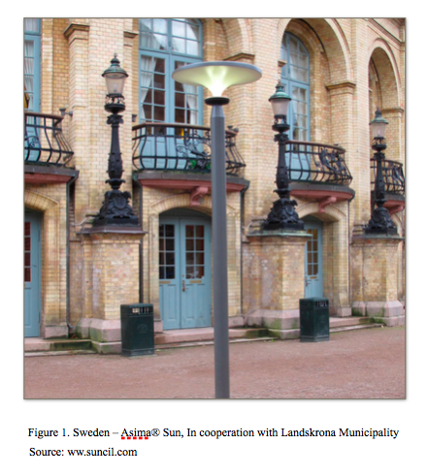
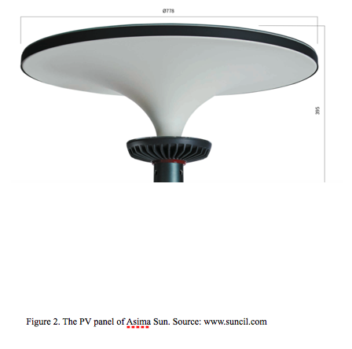

Problem statement

The goal of the present work is to create the environmental profile of the chosen product by means of Life-cycle analysis methodology. We are to make an overview over the environmental impacts and potential effects from the product over the whole life cycle. There will be used a so called- from- cradle- to- grave principle approach, with the curtain limitations and delimitations related to country specific aspects and data derived from previous research in field. This topic will be discussed later in Limitations part of this paper.
LCA methodology provides a basis for assessing potential improvements in the environmental performance of a product system [1,2]. Today small and middle-size companies widely use LCA as a decision-making tool in process selection, design and optimization in order to identify clean technologies or choose among alternative products and processes. The obtained data is actively employed by manufactures in marketing of their products [2]. The findings from the present work could be used for commercial purposes for Suncil´s marketing communication and to serve as a basis for customers to make environmentally friendly decisions.

Product description and Functional unit

Asima Suns is equipped with a rechargeable nickel-metal hybride battery with the range of operating temperature -30° C to 77° C with a typical life cycle 4000. There 2 sizes batteries used for Asima Sun: 12V-130Wh and 12V-260Wh depending on location and environment. The system control unit maximises the energy available from the solar panel and uses it to charge the battery. During the daytime the controller handles charge up to 60W. In the night time controller lighting the LED with up to 24W.
The controller registers the dark hours from the night before, and uses this to calculate the allowed light level/intensity. The street lamp can work whole night most days of the year. The only thing that changes is the light intensity. Solar (PV) panel 62 Wp with 12 monocrystaline solar cells (5,16Wp each) is placed on top of the poll. It has antireflection coating, the structured glass surface reduces reflection, resists wind and snow weather conditions.
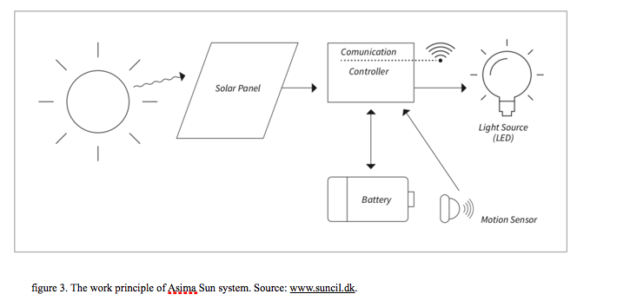
Functional unit- is a measure of the performance of the functional outputs of the product system. [7,14]. The functional unit defines the service that needs to be delivered by the product and helps to compare the overall environmental performance of different product systems in terms of impacts per unit of delivered service [8]. As an example, the main function of a solar PV panel is to produce electricity. The functional unit can be 1 kWh of electricity produced by the panel. Even though in present case the solar panel is an integral part of the street lamp, the main function of the street lightning system- is to generate light. So, the functional unit must be defined within this framework.
Lighting technology varies widely in many aspects such as lumen efficacy, color rendering index, wattage, lifetime etc. The lamps can provide the same amount of light (lumens), but some use less electricity and require less frequent component changes [8,9]. Lux (or illuminance) is a measure of lumens per square meter. Asima Sun luminous flux (lumens) - 1550-4400 lm.
As it is suggested in previous research on LED street-lightning systems, two functional units will be used: a lumen-hour and a kilometer of lit road [12,13]. LED's average lifetime with sufficient light output is 50,000 h [10,11] of lighting, which is equivalent to- 5.7 years if the light is operated for 24 hours in a day, 7.6 years if the lights are on 18 hours per day and 11.4 years for 12 hours a day [11]. Lumen-hour comprises of the average rated luminous flux of the luminaire expressed in lumens and the life of the luminaire in hours [12]. But since this measure does not address the actual illumination of the road, the function of the road lighting, a kilometer of lit road is suggested to choose as another functional unit [13]. The life cycle cost calculations of road lighting are typically calculated per kilometer of lit road (The European standards EN 13201:2-4).

Prospective delimitations

The product packaging and transportation will not be considered during the present studies as previous research determined the environmental impacts of manufacturing were mainly due to the driver, LED array and aluminium parts. The installation, transport and end of life had nearly no effect on the total life cycle impacts, except for the end of life in hazardous waste [13]. The same aspect is also relevant for the solar PV modul, where the major impacts were determined during the production phase [15].
Recyclable materials and wastes will be not included in report as the primary producer does not receive any credit for the provision of any recyclable materials. The treatment of wastes is completely allocated to waste producer [16].

Product specifications:

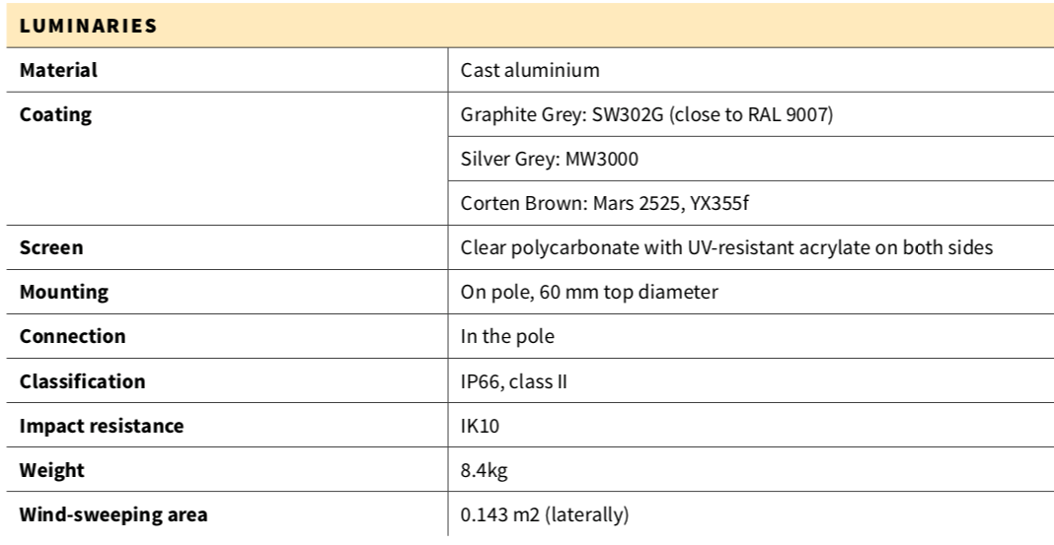

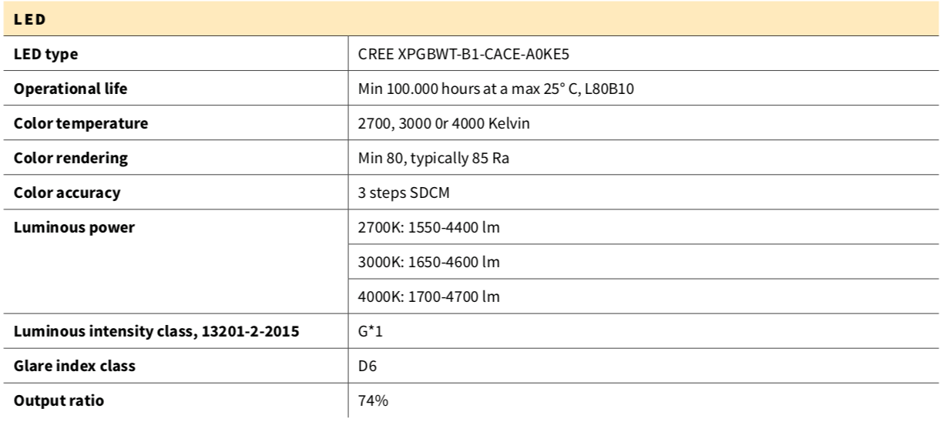

The battery specifications:
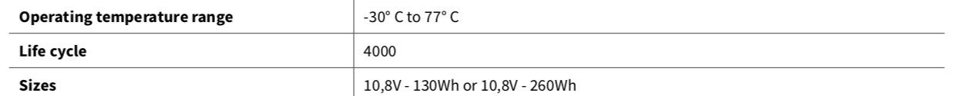

List of references:

[1]Azapagic, A., Clift, R., 1999b. The application of life cycle assessment to process
optimisation. Computers and Chemical Engineering 23, 1509e1526.
[2] Carla Pieragostini, Miguel C. Mussati, Pío Aguirre: On process optimization considering LCA methodology INGAR Instituto de Desarrollo y Diseño (CONICET e UTN), S3002GJC Santa Fe, Argentina. doi:10.1016/j.jenvman.2011.10.014
[3] Del Borghi, A., Binaghi, L., Del Borghi, M., Gallo, M., 2007. The application of the environmental product declaration to waste disposal in a sanitary landfill e four case studies, LCA cases studies. International Journal of Life Cycle Assess-ment 12 (1), 40e49.
[4] M. A. Parvez Mahmud,Nazmul Huda, Shahjadi Hisan Farjana andCandace Lang. Comparative Life Cycle Environmental Impact Analysis of Lithium-Ion (LiIo) and Nickel-Metal Hydride (NiMH) Batteries. Batteries 2019, 5(1), 22. https://doi.org/10.3390/batteries5010022
[5] http://www.lyhnedesign.com/adelie-sun/
[6] www.suncil.com

[7]ISO 14040 standard 2006. Environmental management - Life cycle assessment - Principles and framework. retrieved on 22.09.2019. from https://www.iso.org/standard/37456.html

[8] https://app.sustainableminds.com/learning-center/conducting-sm-lca/functional-unit

[9] Sabina Abdul Hadi, Muna R. Al Kaabi, Meshayel O. Al Ali, Hassan A. Arafat:
Comparative Life Cycle Assessment (LCA) of streetlight technologies for minor roads in United Arab Emirates. “Energy for Sustainable Development” 17 (2013) 438–450 dx.doi.org/10.1016/j.esd.2013.05.001

[10] https://www.electronicsweekly.com/blogs/led-luminaries/led-life-expectancy-2009-02/
[11] www.phillips.com. What does a life of 50,000 hours mean in the case of - LEDs? retrieved on 23.09.2019 from https://www.lighting.philips.com/main/support/support/faqs/life-and-light-output/a-life-of-50000-hours

[12] Leena Ta€hka€mo€, Liisa Halonen: Life cycle assessment of road lighting luminaires e Comparison of light-emitting diode and high-pressure sodium technologies. Journal of Cleaner Production 93 (2015) 234-242. http://dx.doi.org/10.1016/j.jclepro.2015.01.025

[13] Leena Tåhkåmå: Life cycle assessment of light-emitting diode downlight luminaire—a case study. Int J Life Cycle Assess (2013) 18:1009–1018. Published online: 9 January 2013. DOI 10.1007/s11367-012-0542-4.

[14] The Product, Functional Unit and Reference Flows in LCA. Danish Ministry og the Environment. Environmental News No. 70 2004. Retrieved on 23.09.2019 from https://www2.mst.dk/Udgiv/Publications/2004/87-7614-233-7/pdf/87-7614-234-5.PDF

[15]. (V. Fthenakis, H.C. Kim, Photovoltaics: life-cycle analyses, Sol. Energy 85 (2011) 1609–1628.)
[16] Ecoinvent. Allocation, Cut-off by Classification. Available online: http://www.ecoinvent.org/
database/ecoinvent-version-3/system-models/allocation-cut-off-by-classification/

