Sorter User Interface, Report #1

**Goals:**

The initial goals for setting up the user interface are to be able to use 4 inputs (Reset, interrupt, Button1, Button2) to move to between 4 simple states that are represented by different LED outputs (Yellow, Red, Green Blue).

**What we have done so far:**

We have decided on the basic inputs and outputs and how they connect to the user and the LEDs. (See images below)

Worked on getting everyone setup on interfacing with the TM4C.

Gathered all the components we need to prototype the user interface. Put together non-functioning code.

**Problems we have had:**

Getting everyone setup up to work with the TM4C has been difficult (software to download, compiler errors, etc.).

Limiting the number of inputs to not take up too many pins on the TM4C.

Not knowing what inputs and states we need to implement from other sections of the sorter project.

**Actions going forward:**

Need to get everybody able to complete the steps necessary to operate the TM4C so we can focus on the fun stuff for the project.

Communicate with the other teams so that we can collaborate more effectively to define the desired inputs, outputs and functionality.

Figure out why the code that we have so far is not operating the way that we would like. Learn how to use the debugger. What is the difference between the device port and the debugger port?

Get all the components connected correctly on the breadboard.

**Simple State Diagram**

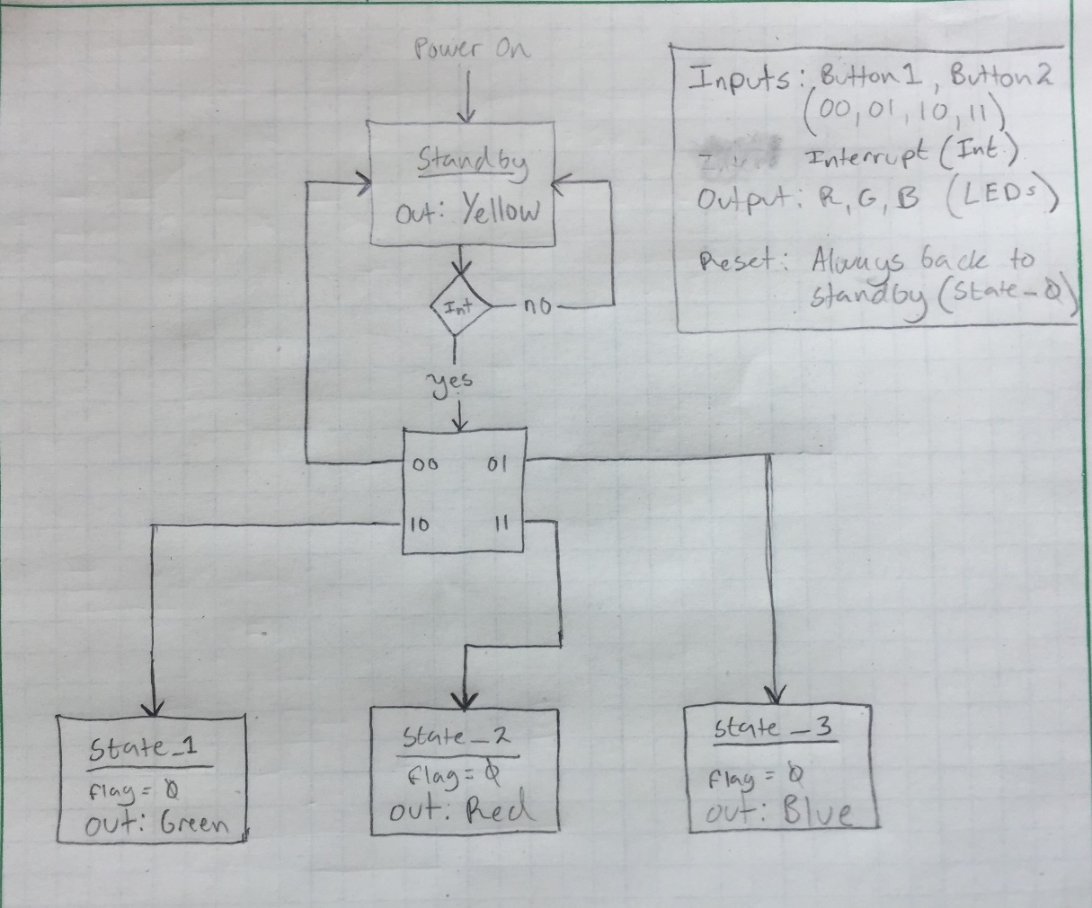

**Input Diagram**

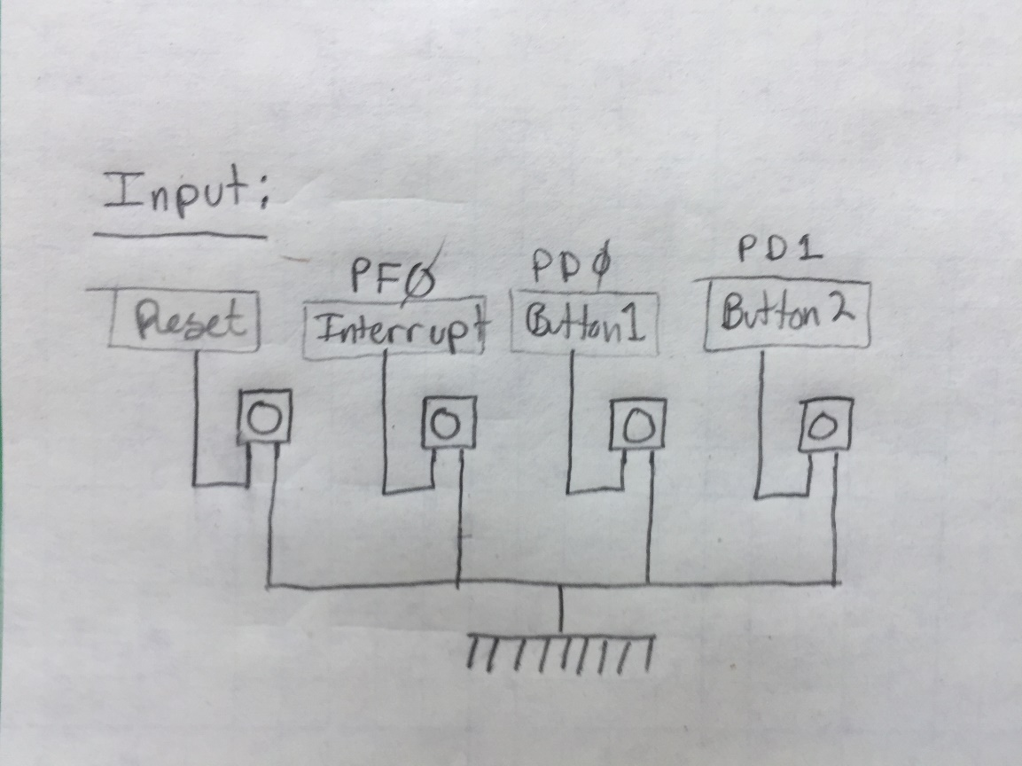

**Output Diagram**

