Stefan Bostain  
Stacy Carlson  
Dan Watt



Stefan placed a story in the Icebox.

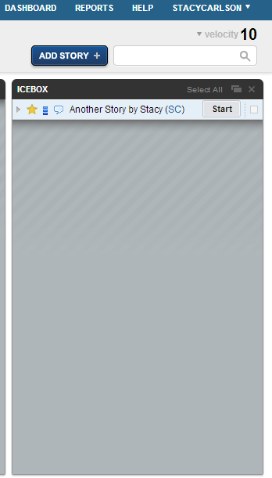

Stacy placed a story in the Icebox.

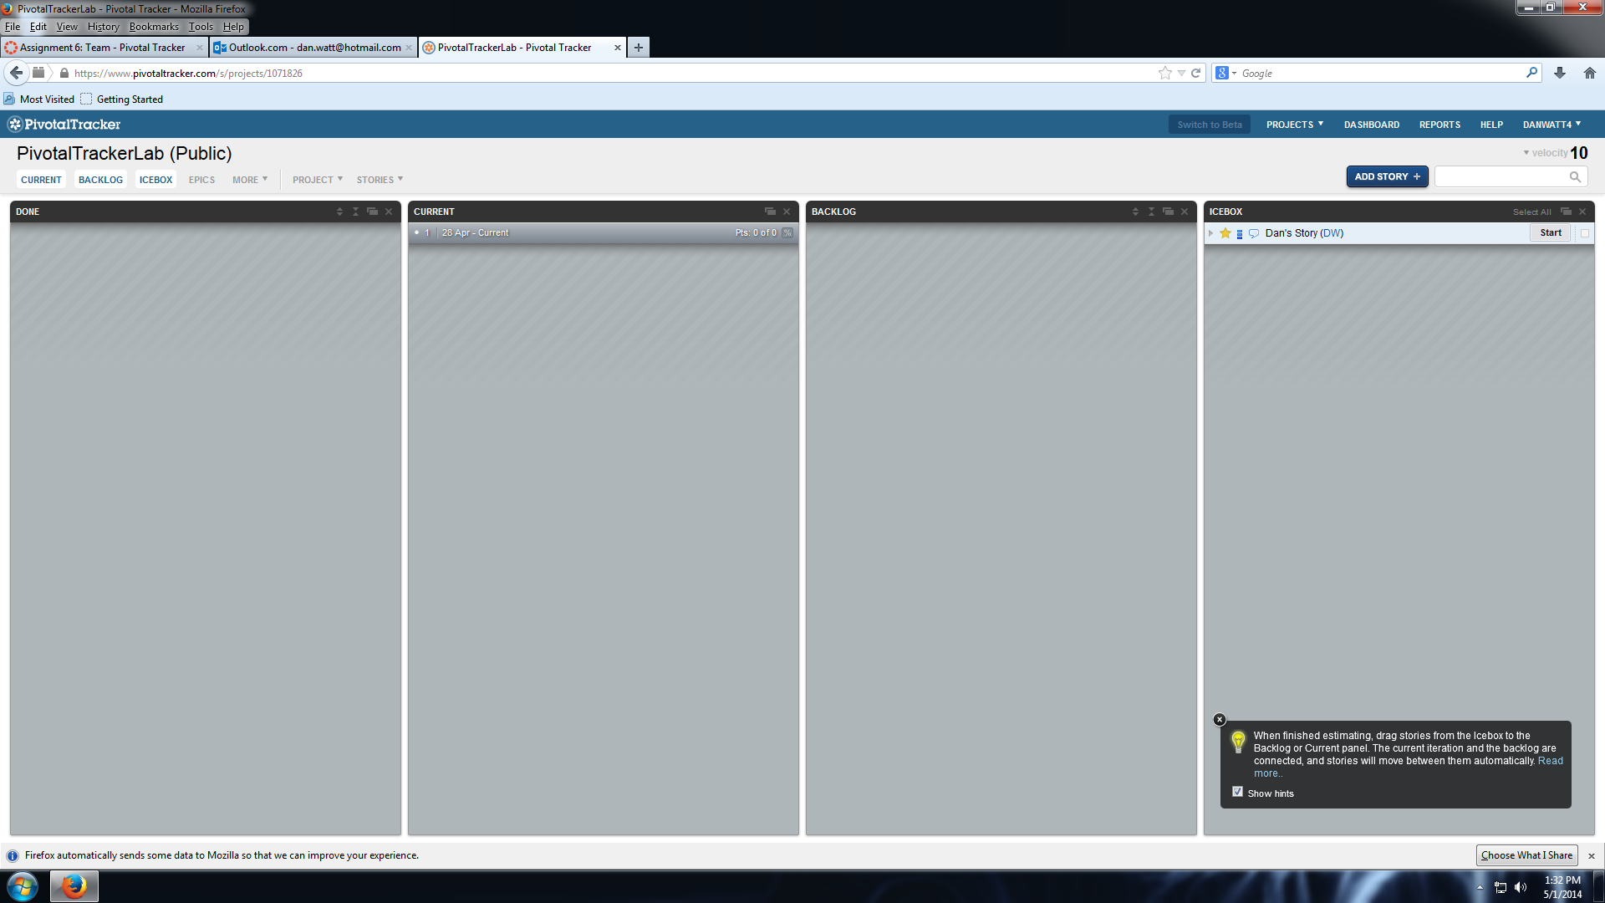

Dan placed a story in the icebox.



Stefan moved a story to the backlog.

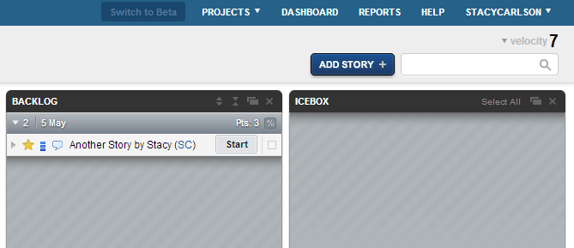

Stacy moved a story to the backlog.

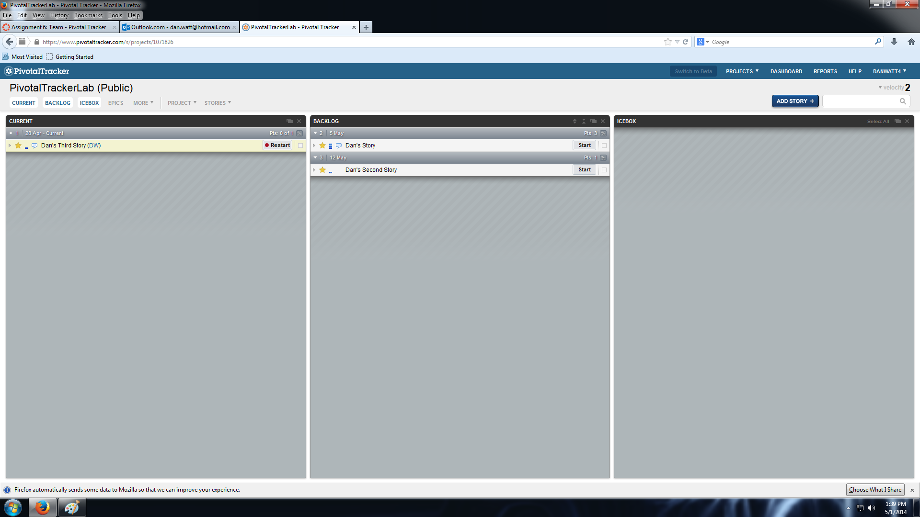Dan moved a story to the backlog.



Stefan completed a story.

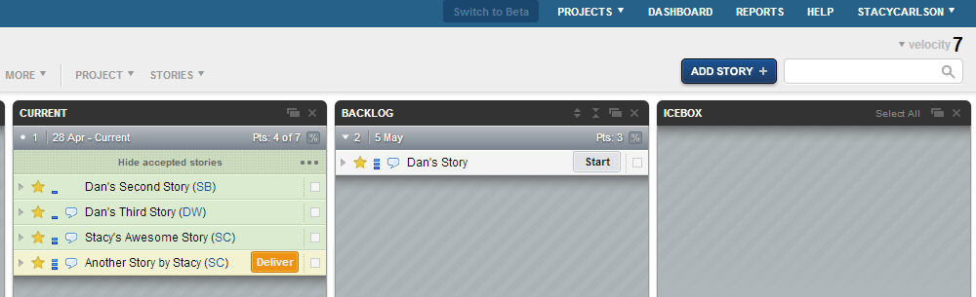

Stacy completed a story.

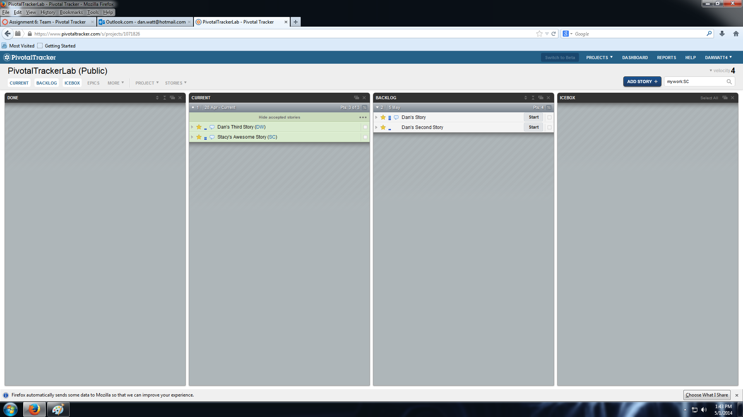

Dan completed a story.

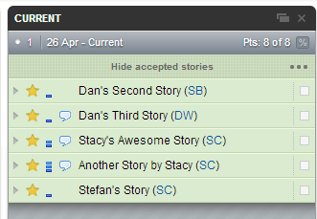

All stories are accepted.