Hangover
Time Limit: 1000MS |  | Memory Limit: 10000K
Total Submissions: 68411 |  | Accepted: 32278
Description
How far can you make a stack of cards overhang a table? If you have one card, you can create a maximum overhang of half a card length. (We're assuming that the cards must be perpendicular to the table.) With two cards you can make the top card overhang the bottom one by half a card length, and the bottom one overhang the table by a third of a card length, for a total maximum overhang of 1/2 + 1/3 = 5/6 card lengths. In general you can make n cards overhang by 1/2 + 1/3 + 1/4 + ... + 1/(n + 1) card lengths, where the top card overhangs the second by 1/2, the second overhangs tha third by 1/3, the third overhangs the fourth by 1/4, etc., and the bottom card overhangs the table by 1/(n + 1). This is illustrated in the figure below.

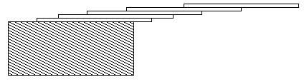

Input
The input consists of one or more test cases, followed by a line containing the number 0.00 that signals the end of the input. Each test case is a single line containing a positive floating-point number c whose value is at least 0.01 and at most 5.20; c will contain exactly three digits.
Output
For each test case, output the minimum number of cards necessary to achieve an overhang of at least c card lengths. Use the exact output format shown in the examples.
Sample Input
1.00
3.71
0.04
5.19
0.00
Sample Output
3 card(s)
61 card(s)
1 card(s)
273 card(s)
Source
Mid-Central USA 2001

