Is the tube in the stomach
Nasogastric aspirate pH bench prototype
EXSU 620 Surgical Innovation • Project 04 • Team 4
Sophia Lee • Seoyoung Park • Muhammad Bey Ali • Saada Hussein • Kayla Giampa
McGill University • 11 November 2026
Design and verification dossier

Abstract
We developed a bench prototype that measures nasogastric aspirate simulant pH, applies the course decision rule and saves an audit record. The revised browser service can queue phone messages for all four completed outcomes, including technical failures.
Three added prototype–meter comparisons differed by +0.082, +0.105 and +0.231 pH, meeting the selected ±0.30 agreement criterion. Reference uncertainty, repeatability and accuracy near the decision thresholds remain unverified.
Two historical phone receipts have separate consent and confirmation records. The revised notification path passed targeted software checks. Phone receipt for each outcome under the revised service remains to be verified.
Comparator uncertainty, physical fault coverage, complete alarm-pattern verification and seven-day measurement stability remain open.
All measurements concern educational bench liquids. Course verdict wording is reproduced to document the prototype and does not authorize a clinical feeding decision.

Technical memorandum

What the prototype does and what the evidence means
We designed the prototype to measure pH, check the quality of each reading, and save the results in one system. The operator enters initials and a sample name, places the probe in the liquid and selects NEW SAMPLE. The Pico takes 20 scheduled readings. At approximately 21 seconds, it publishes either a completed result or a technical reason for withholding the verdict. The result is then held until the operator stops the test or starts another sample.
Green, amber and red represent the course’s pH categories. Cyan represents a measurement problem. Laptop speakers provide sound because the separate amplifier overheated during development. The physical button stops the test, silences laptop audio when its event reaches the service, and commands the ring off. The browser’s ACKNOWLEDGE control mutes sound but does not itself send a stop command to the Pico.
The archived final logs show timed acquisition, advisory and critical results, stopped samples and a confirmed phone message. Added snapshots include a valid normal result. The videos show normal/critical colours, critical tones and physical STOP/OFF with audio cessation. A supplied image shows the disconnected technical display. Software tests exercise boundaries, age and defined faults; they do not establish true reference pH or detection of every damaged electrode.
The prototype agreed with the comparison meter within ±0.30 pH at three tested points. Earlier checks against nominal buffer labels exceeded this criterion. The reference changed between these comparisons; the new results do not demonstrate that the earlier discrepancy was corrected. Reference uncertainty, repeatability and accuracy near the decision thresholds remain unverified.
The critical alarm is remembered by the laptop separately from the current result. The ring follows the current sample and can turn off after stopping while critical history remains. This is a declared difference from a continuously latched red indication. Laptop or service failure also removes audio and does not restore alarm history automatically on restart.
The optional phone message reports the completed sample outcome or the reason the system withheld a verdict. The operator checks the matching sample ID on the phone and records receipt separately.
Report section | Section locator
D1 Requirements | D1
D2 Design and D3 interfaces | D2–D3
D4 Diagrams and D5 operation | D4–D5
D6 Plan and D7 results | D6–D7
D8 Risks and D9 dossier | D8–D9
Evidence claim matching and sources | Appendix A and Sources

D1 Clinical need and requirements

Need statement and intended scope
A way to reduce uncertainty during nasogastric tube placement checks in patients requiring enteral feeding in order to support timely, appropriate feeding decisions.
The course project asks for a numerical pH measurement, explicit decision categories, refusal when the measurement cannot be trusted, and a retrievable record. Our prototype explores this workflow using bench liquids. No patient samples, tube-location ground truth or clinical outcomes are included. The intended benefit of reduced uncertainty has therefore not been measured in clinical practice. [C1]
Clinical requirement | Course meaning
CR1 | The pH of a nasogastric aspirate shall be measured and displayed to one decimal place, with a clear indication of when the reading has settled.
CR2 | The device shall state a verdict against the accepted rule: at or below pH 5.5 gastric, 5.6 to 6.0 escalate, above 6.0 do not feed.
CR3 | The device shall refuse to give a verdict when its calibration is older than the configured interval, or when the electrode is drifting or unresponsive.
CR4 | Every test shall be recorded with the value, the verdict, the operator and the calibration state, and shall be retrievable for audit.

The following eight engineering requirements retain the draft’s numerical targets and identify the latest implemented settings. These requirements reflect our final design, including changes we made during development. Not all of them were established before testing began. Requirements are assessed separately from whether an individual run completed. [E01-E04]
ID and trace | Requirement and acceptance criterion
ER1 • CR1 | Estimate pH over the proposed nominal range 4.00-10.01 and display one decimal. Every independent reference check must be within ±0.30 pH, with reference identity, temperature and uncertainty documented. A display or a two-point fit alone does not pass accuracy.
ER2 • CR1 CR3 | Acquire readings at seconds 1-20 after accepted sample start, each within 250 ms of schedule. Publish no verdict before 21.000 s and one outcome by 21.250 s on the device clock. A valid outcome also requires a ten-reading pH range ≤0.35 maintained for a ten-second dwell.

The evaluated nominal range is broader than the 4-7 calibration interval. Values above pH 7 are extrapolated. ER1 is a target to be verified, not an established continuous operating range. ER2 measures software acquisition and publication timing; it does not guarantee electrode equilibrium within 20 seconds.

D1 Decision and alarm requirements
ID and trace | Requirement and acceptance criterion
ER3 • CR2 | Apply categories to the unrounded final filtered estimate. pH ≤5.5 is NORMAL; 5.5 < pH ≤6.0 is ADVISORY; pH >6.0 is CRITICAL. Values immediately below, at and above both boundaries must classify correctly. Invalid measurements must not produce a verdict.
ER4 • CR3 | Before a verdict, reject incomplete or late captures, implausible input and the defined drift or response-check failure. Any raw value <500 or >60000, estimated pH outside 0-14, drift >0.40 pH, missing timed reading or failed known-buffer response check must produce a technical result with no verdict at the decision point.
ER5 • CR3 CR4 | Limit calibration use to 604800 seconds from recorded completion. A restart or new sample must not renew the interval. Missing clock, invalid coefficients, future completion time and the expiry boundary must withhold a new verdict. Physical accuracy throughout that interval requires separate verification.
ER6 • CR2 CR3 | Provide the specified normal, advisory, critical and technical indications; retain critical history until acknowledged and a valid normal returns. Normal is green and silent, advisory amber with three tones, critical red with ten, and technical cyan with one. The physical button must stop acquisition, mute sound through the host and command OFF. Current indication and retained critical history must be distinguishable.

The signal limits in ER4 are provisional software settings. They are neither measured fault boundaries nor electrical protection. The evidence PDF refers to an older upper limit of 45000; the latest code uses 60000. A valid high-pH signal exceeded the older limit, demonstrating why a signal gate cannot itself identify the cause of a fault. [E01, E03, E08]
The drift rule compares the mean of readings 1-3 with readings 18-20. A difference exactly equal to 0.40 pH passes; a greater absolute difference fails in routine mode. This is a net-change test. It can respond to a jump and may miss changes that return to their initial level.
Stuck assessment is limited to a dedicated known-buffer response check. A three-reading moving average must remain within ±0.10 pH of the previous measured baseline throughout seconds 3-20 for at least 15 seconds to fail. The actual observation interval is approximately 17 seconds. Routine NEW SAMPLE measurements do not assess stuck behaviour. [E03]
ER6 uses a deliberate deviation from continuously latched red indication: the ring shows the current sample and physical STOP turns it off, while the host retains critical history. Approval of this latch deviation is not documented. The separately reported instructor approval for laptop audio does not establish approval of latch behaviour. Selected functions are demonstrated; remaining physical pattern coverage is stated in D7. [E19-E21]

D1 Audit and notification requirements
ID and trace | Requirement and acceptance criterion
ER7 • CR3 CR4 | Attribute each accepted NEW SAMPLE to a distinct sample ID, operator, label and calibration context. Reset its timer and acquisition history. After link loss or more than five seconds without a valid heartbeat, withhold the host’s current verdict. Reconnection must require a new sample. Corresponding JSONL and SQLite events must agree, and interruptions and label corrections must remain retrievable.
ER8 • CR2 CR4 | With prior consent, queue one message per eligible completed Normal, Advisory, Critical or Technical sample. Include the sample ID and outcome, with the reason for technical refusal. Match the provider message ID to an independently observed phone receipt. Idle, measuring and manually stopped cases shall produce no result message.

Acceptance rationale
The team chose a seven-day calibration policy to reduce repeated calibration work. It is not a manufacturer-validated lifetime established by this project. A stored timestamp permits age checking, while a longitudinal reference study is needed to justify the duration physically. No new sample, browser action or reboot should be described as recalibration.
The latest stability condition is a maximum-minus-minimum range of 0.35 pH across ten unfiltered readings, followed by a ten-second qualifying dwell. The evidence notes describe ±0.35 around a mean for 20 seconds; that is a different algorithm and is not used here. The calibration script’s separate 0.95 pH capture-spread limit is also not an accuracy tolerance. [E01, E03, E04]
Classification uses full internal precision before the packet is rounded. Consequently, the final recorded value 6.029 is critical even though the browser displays 6.0. This avoids silently rounding a value down across the decision boundary, but the display still needs to explain such cases to users. [E06]
Clinical requirement | Engineering requirements | Main evidence
CR1 | ER1 ER2 | Calibration record, reference checks, timed captures and display code.  Partial. Three paired checks met the numerical tolerance. Independent reference documentation and full range remain open.
CR2 | ER3 ER6 ER8 | Boundary tests, final results, alarm records and phone receipts.  Partial. Tested rules pass. Reconcile one-decimal boundaries and latched red behaviour with the card. Revised phone receipt remains open.
CR3 | ER2 ER4 ER5 ER6 ER7 | Defined virtual faults, calibration-age tests, stop and interruption records.  Partial. Selected refusals pass. Routine stuck detection and physical fault coverage remain open.
CR4 | ER5 ER7 ER8 | Calibration identity, paired stores, sample attribution and consent records.  Supported for reviewed runs. Current stores reconcile. Crash recovery and revised notification receipts remain open.

D2 System architecture
The sensing chain consists of a glass pH electrode, BNC connection and pH meter V1.1 conditioning board. The board converts the electrode response into an analogue signal read at GP26 on the Pico 2 W through the Grove shield. The Pico also controls the 16-pixel ring on GP15 and reads an active-low button on GP14. [E03, E17]
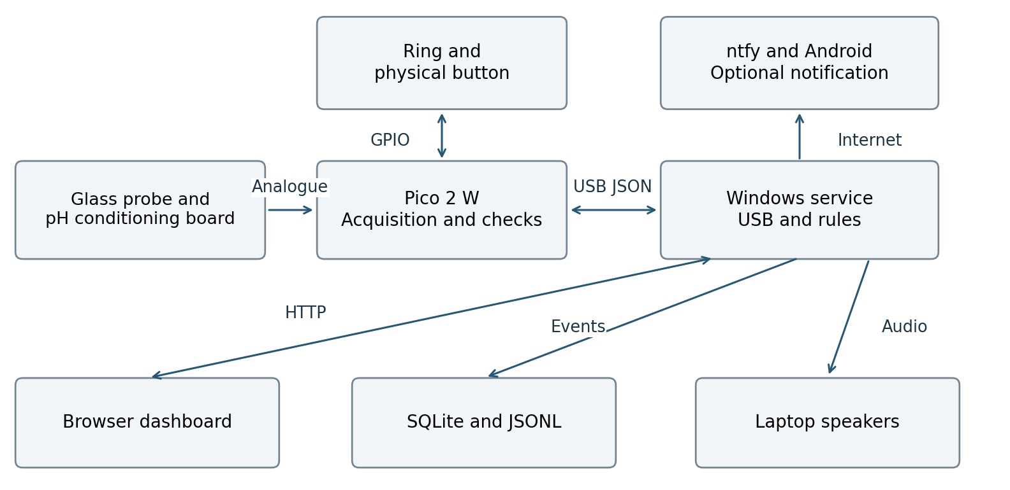
Figure 1. Implemented functional architecture. The Pico performs measurement checks. The Windows service owns serial communication, audit writes and audio. The browser is an interface to that service. Remote notification is a separate internet-dependent path. [E03, E13]
The Pico uses MicroPython rather than the CircuitPython runtime suggested in the project card. It transmits newline-delimited JSON over USB. Its wireless capability is not used for measurement transport. The service exposes a local HTTP interface at 127.0.0.1:8765 and supplies a browser display with a trace, result, calibration details and recent events.
USB provides both power and communication in the documented arrangement. Laptop audio replaces the separate PAM8302 amplifier and speaker following overheating during assembly. The team reports instructor approval for laptop audio; written approval is not present in the supplied evidence. The failed amplifier is not counted as a working subsystem. [E01, E02]
The architecture is dependent on a functioning laptop and service. Local logging and display do not require internet, but phone messages do. The prototype has no demonstrated independent audible warning when the laptop loses power or the service stops.

D2 Calibration and measurement processing
The calibration script asks for nominal pH 4.00 and 7.00 liquids. It waits 60 seconds after each operator confirmation and then acquires 30 readings at one-second intervals. It rejects raw readings at or beyond 100 and 65435, separation of 500 counts or less, reversed order, or a capture spread greater than 0.95 estimated pH. It saves both complete captures, their means, operator initials, an identifier and provisional reference status. [E04]
The conversion is:
pH estimate = 4.00 + 3.00 × (raw − R4) / (R7 − R4)
R4 and R7 are the saved mean raw readings. The final archive bench-59daedbc contains stored means 31220.868 and 38102.332. Recomputed means differ by only about 0.0013 counts. Its estimated-pH spreads are 0.06278 and 0.04883, both below the configured 0.95 capture criterion. This describes within-capture variation, not independent accuracy. [E05]
Stage | Latest implementation
Start | NEW_SAMPLE clears the preceding capture, filter, stability and result; duplicate delivery of the same ID does not restart it.
Acquire | One raw reading in each scheduled second 1-20, with a 250 ms acquisition tolerance.
Filter | Three-reading moving average of converted pH values.
Settle | Latest ten unfiltered values have range ≤0.35 pH for a ten-second dwell.
Evaluate | At 21 s, check calibration, completeness, signal range, pH validity, mode-specific response or drift, and settling.
Hold | Freeze a valid completed result; continue status and button handling without new ADC acquisition.

The routine result is the filtered value at second 20, equivalent to the mean of converted readings 18-20. The program classifies this internal value before rounding. A successful known-buffer response check instead returns PROBE_RESPONSE_DETECTED, which is not a feeding verdict.
The calibration archive has no completion timestamp. Later runtime records show a registered completion of 2026-11-10 14:35 UTC for the same calibration ID. This is an operator-entered time, registered at 19:35 UTC; it is not an independently timestamped capture. The calibration archive is therefore not represented as the final timestamped on-device file. [E05, E08 lines 113-114]

D2 Alarms and operator interaction
The browser starts in Ready. During measurement it withholds the main pH and verdict while counting down. A completed result is held; a failed capture displays its technical reason. Raw information, calibration metadata, history and response-check controls are available under More info. [E13]
State | Current ring | Programmed laptop pattern
NORMAL | Green | Silent.
ADVISORY | Amber | Three 800 Hz tones, 150 ms each.
CRITICAL | Red | Ten 1200 Hz tones, 150 ms each.
TECHNICAL | Cyan | One 1500 Hz tone, 100 ms.
Measuring | Dim white | Muted.
Physically stopped | OFF | Muted.
Host reconnecting | No confirmed host control of ring | Muted in the latest browser service.

Tone sequences program 150 ms gaps and non-normal reminders every 120 seconds when unmuted. The video contains ten recorded bursts near 1200 Hz with the red critical display, supporting that selected pattern. A second clip shows audio cessation during physical ACK/STOP. Sound pressure and exact output latency remain unmeasured; programmed pulse durations are not calibrated acoustic results. [E01, E13, E19, E21]
An on-screen acknowledgement mutes audio for 120 seconds. The physical button generates an ACK event and stops the Pico sample. The Pico repeatedly sends OFF to the ring after stopping. The host removes the current measurement from its main result while retaining the last measurement in the audit. Starting again requires NEW SAMPLE.
The host’s critical latch is a separate memory. It remains until an acknowledgement has occurred and a valid normal reading returns. The current browser panel and ring may nevertheless show a newer advisory sample, or turn off after stopping. This was introduced to avoid displaying an old critical category as the current sample’s result. It also means the ring is not a continuously latched critical indicator. [E03, E13]
After communication loss, the service clears the current sample gate, withholds the host verdict and mutes sound. The added image directly shows “Pico not connected”, a blank pH, paused timer and “Connection lost - reconnect USB”. [E22] It cannot prove the ring’s physical state if the Pico remains powered independently. Closing the browser tab does not stop the service. Restarting the service creates a new session and does not reconstruct critical latch or consent state from historical storage.

D2 Audit model and design alternatives
Each saved event contains received_utc, run_id, operator, sample label, kind and payload. Measurement payloads include sample_id, device elapsed time, pH, raw ADC, calibration ID, validity, state and quality-check information. Device time and host reception time are different clocks and are not interchangeable latency measurements. [E13]
SQLite stores events in one table. A separate JSONL file retains each service run. The service writes and flushes JSONL before inserting and committing SQLite. These writes are not one transaction across both stores. The current snapshots reconcile, but an interrupted write can leave them inconsistent. There is no demonstrated automatic reconciliation or durable replay of the in-memory alarm and recipient state.
The browser shows recent events rather than a complete persistent audit browser. Historical data remain accessible in SQLite and JSONL. An earlier label correction is preserved in a separate sidecar file without altering the original records; it is not an implemented label-editing API. [E12, E13, E15]
Choice | Rationale and remaining trade-off
MicroPython | Retained the working Thonny environment and machine ADC interface. The runtime substitution is declared.
Browser and local REST service | Replaced the earlier Tkinter interface and supports the course’s browser/service architecture. The backend uses Python’s standard HTTP server, rather than FastAPI or Flask.
Laptop audio | Avoided reusing the failed amplifier. It introduces dependence on Windows, the service and laptop speakers.
ntfy Android messages | Provides a demonstrable phone path. It substitutes for the suggested WhatsApp options; specific approval of this substitution is not documented.
Held completed results | Prevents later probe movement from changing a completed sample. A new measurement must be explicitly requested.
Dedicated response challenge | Avoids misclassifying similar unknown samples as a stuck probe. It depends on the operator actually transferring between known buffers.

The revised service offers notifications for completed Normal, Advisory, Critical and Technical results. Technical messages identify why a verdict was withheld. Consent is logged before queueing. The public ntfy topic is accessible to subscribers, so messages contain bench sample information only. [E23]

D3 Component and interface chart
Module | Components and role
Sensing | Glass probe, BNC lead and pH meter V1.1 board condition the liquid response.
Control | Pico 2 W, Grove shield and MicroPython perform timed acquisition and quality gating.
Local interaction | Sixteen-pixel ring and momentary button provide visual status and physical stop.
Mechanical | Printed case, lid, probe holder and sample-cup position organize the assembly.
Host | Windows laptop, Python service, browser, SQLite and JSONL provide interface, audio and audit.
Remote | ntfy service and an opted-in Android phone provide optional notification.

Interface and direction | Signal and range or constraint
USB → Pico and shield | Nominal 5 V power plus serial communication. Team meter observations were approximately 5.1 V.
Shield supply → sensor + and ring V+ | Nominal 5 V supply; common ground. Actual harness continuity is not established solely by code.
Sensor A → GP26 through A0 | Nominal ADC domain 0-3.3 V; read_u16 returns 0-65535 counts. Software gate 500-60000 inclusive. Direct wiring has no documented overvoltage protection. [E16]
GP15 → ring DIN | Pixel data at nominal 3.3 V GPIO levels; sixteen RGB pixels. Ring supply is 5 V; level compatibility has not been physically qualified. [E16]
Button → GP14 and GND | Active-low 3.3 V input with internal pull-up; pressed to GND; 30 ms debounce. [E16]
Pico ↔ laptop | Newline-delimited JSON measurements and commands; host opens the port at 115200.
Browser ↔ service | Local HTTP JSON at port 8765; POST requests use a per-process request token.
Service → storage | Append JSONL and commit SQLite event records.
Service → ntfy → phone | Internet-dependent HTTPS messaging; delivery confirmation is a separate operator action.

The added video directly shows the assembled blue enclosure, lid-mounted ring and button, probe support, laptop and liquid handling. It strengthens the earlier assembly report and open-bench photograph. It does not authenticate a CAD revision, print material, fastener specification, mechanical tolerance or ingress rating. Earlier STL files are not assumed to be the final manufactured revision. [E01, E17, E19]
We excluded the damaged PAM8302 amplifier and speaker from the final working system. We also did not assess the enclosure’s water resistance or mechanical performance.

D4 Wiring and control diagrams
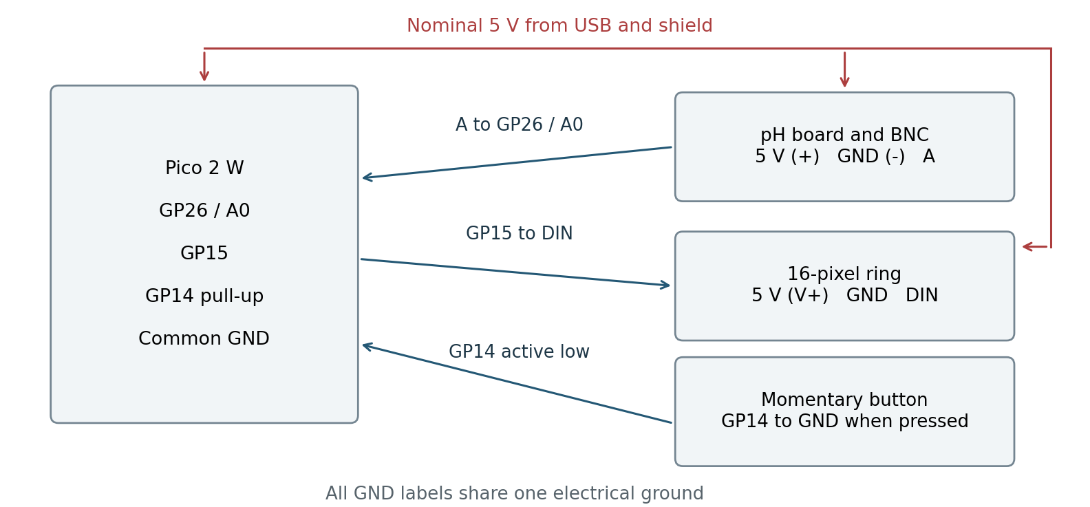
Figure 2. Functional wiring for the documented signal assignments. Grounds are common. The sensor-to-ADC link is shown as documented direct wiring, not as an electrically protected input. Wire colour is not used to infer a pin assignment. [E03, E17]
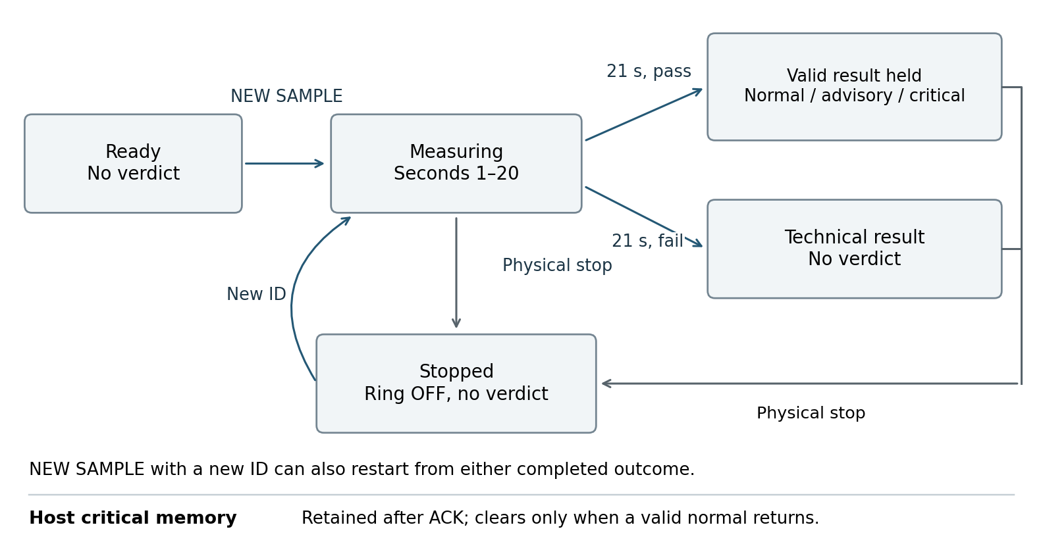
Figure 3. Pico sample lifecycle and the separate host critical memory. A completed valid result is held. A technical result withholds a verdict. Physical stop commands OFF; it does not erase the host’s critical history. This explains why our alarm system differs from the course. [E03, E13]

D4 Sample to notification sequence
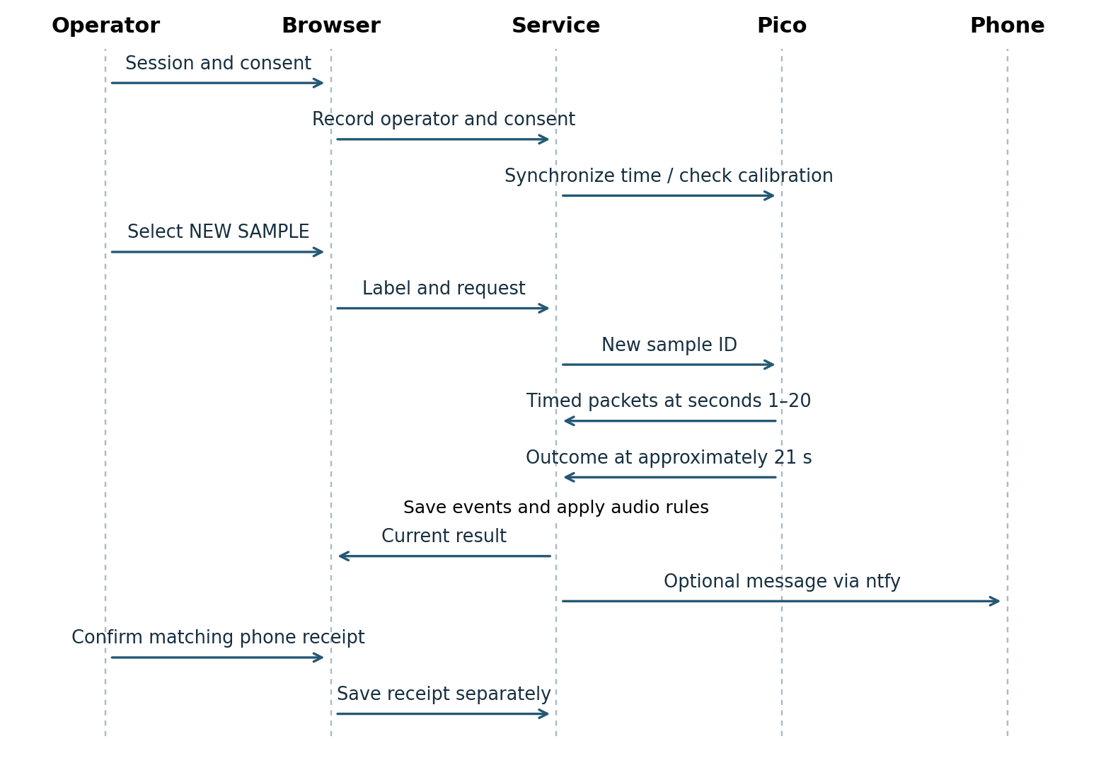
Figure 4. Routine measurement and notification sequence. The decision time starts when the Pico accepts the sample. The notification branch applies to all four completed outcomes in the revised service. [E03, E13, E23]
The service synchronizes laptop UTC with the Pico. If calibration completion has not been registered, the operator supplies the actual completion time once; that control does not perform a calibration. Each NEW SAMPLE creates a fresh identifier. Repeated requests with the same identifier do not restart the Pico timer.
With consent active, the revised service queues one submission per sample ID for an eligible result at or after 21 seconds. Measuring, idle and manually stopped samples do not send. USB loss clears the active sample and has no phone alert. All four outcomes use ntfy priority 4. The phone worker records provider acceptance or failure. The operator records receipt separately. [E23]
Communication interruption clears the host’s current sample gate. Reconnection does not convert buffered or held data into a valid new measurement. The operator must request another sample. This behaviour does not establish recovery from every power, storage or process failure; the service’s in-memory state is not reconstructed after a fresh process start.

D5 Implementation and deployment
Item | Reviewed implementation
Pico firmware | Attached main.py; identical to button_stop_update/main.py; reports sample_response_v10.
Calibration | Attached calibrate_bench_weekly.py and bench-59daedbc.json with all 60 raw readings.
Backend and rules | browser_monitor/service.py, monitor_rules.py and phone_notifications.py.
Browser | browser_monitor/index.html, dashboard.js and styles.css; custom Canvas trace.
Dependency and launch | browser_monitor/requirements.txt specifies pyserial; start_browser_monitor.cmd starts the service on Windows.
Evidence | Original archives/PDF; added meter snapshots, two videos, connection-loss image, source hashes, claim map and trial index.
Printed assembly | Enclosure, fitted ring/button and support visible in the video; manufacturing revision and mechanical performance remain unverified.

Our repository is https://github.com/EXSU-620-TEAM-4-NG-TUBE/ng-tube-prototype. The reviewed versions are sample_response_v10 on the Pico and browser_service_v2_all_results on the host. A matching repository commit has not been verified. Before submission, align the README with COM7 (or the actual connected port), these versions, the final wiring and printed-part revision. [E02, E03, E13, E23]

Deployment procedure
1. Use the team’s electrically checked bench assembly. Save the supplied MicroPython firmware on the Pico as main.py. Keep the failed amplifier isolated.
2. Run the calibration script in Thonny when recalibration is required. Retain the complete calibration record and use the same sensor, wiring and acquisition configuration for subsequent measurements.
3. Close Thonny before opening the serial monitor. In the Windows Python environment, install browser_monitor/requirements.txt and start start_browser_monitor.cmd. Keep the service window open.
4. Enter operator initials and a session label. Confirm the actual port and loaded calibration ID. Register a missing completion timestamp using the actual calibration time, rather than resetting an old calibration to the current time.
5. Rinse, immerse and keep the probe still. Enter a sample label and select NEW SAMPLE. Observe the outcome after the 21-second acquisition workflow and retain its sample ID.
6. Use on-screen ACK for audio muting or the physical button to stop. After reconnection or stopping, select NEW SAMPLE for another measurement.
7. Restart the Python service after updating both notification files and confirm version browser_service_v2_all_results at /api/health. Record consent and check one matching phone receipt for each completed outcome.
The latest firmware does not consume calibration_pending.json or enforce the older one-use ten-minute session. The calibration script still writes that legacy file; current authorization depends on a usable saved calibration and clock. [E03, E04]

D6 Verification plan
The verification plan separates acceptance criteria from observed outcomes in D7. Some criteria were established during development rather than prospectively. Software injections assess defined logic; physical observations assess the demonstrated assembly. Repeated held packets are not independent trials.
ER | Method and reviewed sample set | Acceptance and reviewer
ER1 | Recompute 30 readings per calibration buffer; retain nominal-label checks and three added paired meter comparisons from one supplied snapshot run. | Each paired difference must be within ±0.30 pH. Document comparator identity, calibration status, uncertainty and liquid temperature. Measurement reviewer; sign-off pending.
ER2 | Reconstruct five v10 captures and 100 scheduled readings; execute virtual clock/ADC timing and missing/late-reading cases. | No early verdict; 21.000-21.250 s outcome; complete timed capture and defined stability gate. Firmware and verification reviewers.
ER3 | Execute ten current-source boundary/classification cases and eight invalid/gating cases; compare five v10 outcomes. | Every supplied valid input has the correct unrounded category; invalid or gated input has no verdict. Firmware reviewer.
ER4 | Run virtual drift, stuck, signal and incomplete-capture cases; inspect four earlier physical response challenges and retained refusals. | Defined injected failure gives technical/no verdict. Document routine versus challenge scope and physical versus virtual input. Verification reviewer.
ER5 | Inject missing time, future time, restart age and expiry boundary; inspect registered completion and current archive. | No age renewal; no new verdict for invalid age. A separate fixed-calibration seven-day reference study is required. Firmware and measurement reviewers.
ER6 | Review five v10 stops, historical v9 normal clearing/v3-v8 active stops; inspect both videos for colours, tones and physical stop/mute. | Required colours, tone sequences, physical STOP/mute/OFF and separate critical history must behave as specified. Record physical observations and any untested pattern. Hardware/interface reviewers; sign-off pending.
ER7 | Compare three paired stores; inspect interruption records, connection-loss image and five service unit tests. | Corresponding stored fields agree; no interrupted sample becomes a new valid sample; records and corrections remain retrievable. Service reviewer.
ER8 | Software: verify every defined technical reason maps to the correct message. Phone: run normal, advisory, critical and one representative technical result on the revised service, matching sample IDs to consent and receipt. | Four matching phone receipts establish category delivery only. Verify no duplicates, pre-result or stopped-sample messages. Claim receipt of every technical subtype only when each has its own matched receipt. Team notification reviewer; sign-off pending.

Team ownership recorded in the notes is firmware by Sophia, Seoyoung, Saada and Bey; dashboard by Sophia; physical design by Bey and Saada; verification and documentation by the full team. These roles identify review responsibility without fabricating a completed sign-off. [E01]

D7 Evidence inventory and reconciliation
The original archives contain 139 JSONL copies and 123 distinct byte streams after hash deduplication. Copies and held records are not additional trials. Added evidence comprises three user-transcribed meter comparisons, two videos, one connection-loss image and a retrospective alarm-record index. These additions do not change the original JSONL counts or store reconciliations. [E15, E18-E22]
Dataset | JSONL files | Events | Interpretation
Separate bench_logs.zip | 80 | 9301 | Earlier bench development and trials.
Project button_stop_update logs | 33 | 4734 | Multiple stop, fixed-window, weekly and response revisions.
Project browser_monitor logs | 10 | 3928 | Browser integration, including v8, v9 and v10.
Preserved historical logs | 11 | 1526 | Copies of earlier development evidence.
Preserved latest_update logs | 5 | 1150 | Selected historical copies and named evidence exports.

Counts above are per location and include duplicate copies between locations. They are not summed to estimate experiment count. The browser set contains 40 NEW_SAMPLE_REQUEST events, 24 FIXED_WINDOW_RESULT events and 3,238 READING records. Its sample index has 41 run/sample associations, including an inherited association without a new request in that run.

Paired storage result
All three databases returned “ok” from SQLite integrity_check. Event comparison normalized payload JSON and matched every stored field, including time, operator, label, kind and payload, while preserving duplicate counts.
Store pair | JSONL | SQLite | Matching events | Difference
Browser | 3928 | 3928 | 3928 | None.
Stop monitor | 4734 | 4734 | 4734 | None.
Earlier bench archive | 9301 | 9300 | 9300 | One JSONL-only RUN_START.

The unmatched event belongs to run 6ad22b889efb4111​9ec7a7f0856189fc, 2026-11-03 01:21:07.387719 UTC, label “nominal pH 7”. It is a session-start record, not a missing measurement. Its cause is not established; snapshot timing and interrupted persistence are possibilities, not findings.
This gives us more confidence that the current data records are consistent, although we still found one discrepancy in an older dataset. Snapshot equality does not prove atomic writes, disk-failure recovery or restart replay. [E15]

D7 Final calibration model and residuals
Calibration bench-59daedbc is identified by the five final v10 samples. It contains 30 raw readings per nominal buffer, operator SL and reference_integrity marked UNRESOLVED. Figure 5 uses these final capture data. [E05-E07]
Quantity | Nominal pH 4.00 | Nominal pH 7.00
Capture count | 30 | 30
Recomputed raw mean | 31220.8667 | 38102.3333
Stored raw mean | 31220.868 | 38102.332
Raw minimum to maximum | 31159-31303 | 38041-38153
Estimated pH range within capture | 0.06278 | 0.04883

The raw separation is 6881.4667 counts using recomputed means, giving approximately 0.000435954 pH per count. The tiny mean differences are consistent with numeric rounding and do not affect the displayed result.
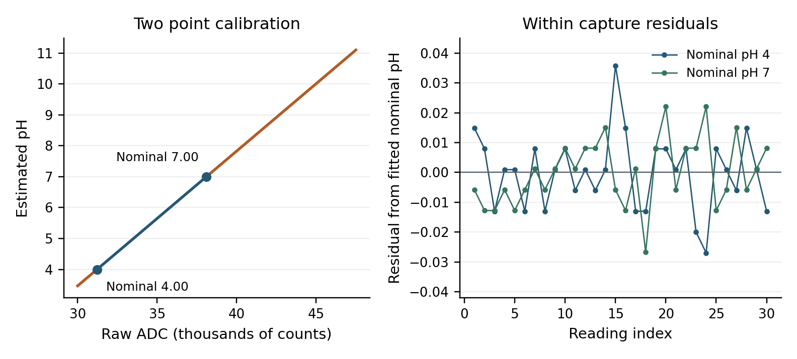
Figure 5. Final two-point model and individual capture residuals about the fitted nominal levels. Blue denotes the fitted 4-7 interval; orange denotes extrapolation. Residuals use recomputed means. All points are from the supplied calibration archive. [E05]
The final captures pass the configured 0.95 spread screen and would also pass a 0.20 screen. This measures within-capture scatter, not independent accuracy: fitting a line through two means reproduces those means by construction. Thirty adjacent observations are not thirty independently prepared standards.
Reference lot, certified uncertainty and actual liquid temperature are not documented in the final record. Earlier notes describe buffer labels and expiry. The added digital-meter readings permit three paired comparisons, but do not establish the meter as traceable ground truth. No R-squared, zero fitting residual or successful save operation is presented as independent validation. [E18]

D7 Reference checks and accuracy
Independent accuracy requires a reference that was not used to determine the measured result. The following checks retain their actual revision and calibration context. Nominal labels are not independently established true values. [E08, E09, E11]
Evidence and nominal liquid | Observations | Estimate | Deviation
Historical T28 return to 7.00 | 30 within one immersion | 7.021 mean | +0.021
Historical T28 held-out 10.01 | 30 within one immersion | 10.360 mean | +0.350
v9 PH4-labelled samples | Two completed samples | 4.224; 4.175 | +0.224; +0.175
v9 PH7-labelled sample | One completed sample | 6.985 | −0.015
v9 PH10.01 and PH10.01 A | Two completed samples | 10.564; 10.550 | +0.554; +0.540
v10 PH10-labelled sample | One completed sample | 10.585 | +0.575 if nominal 10.01

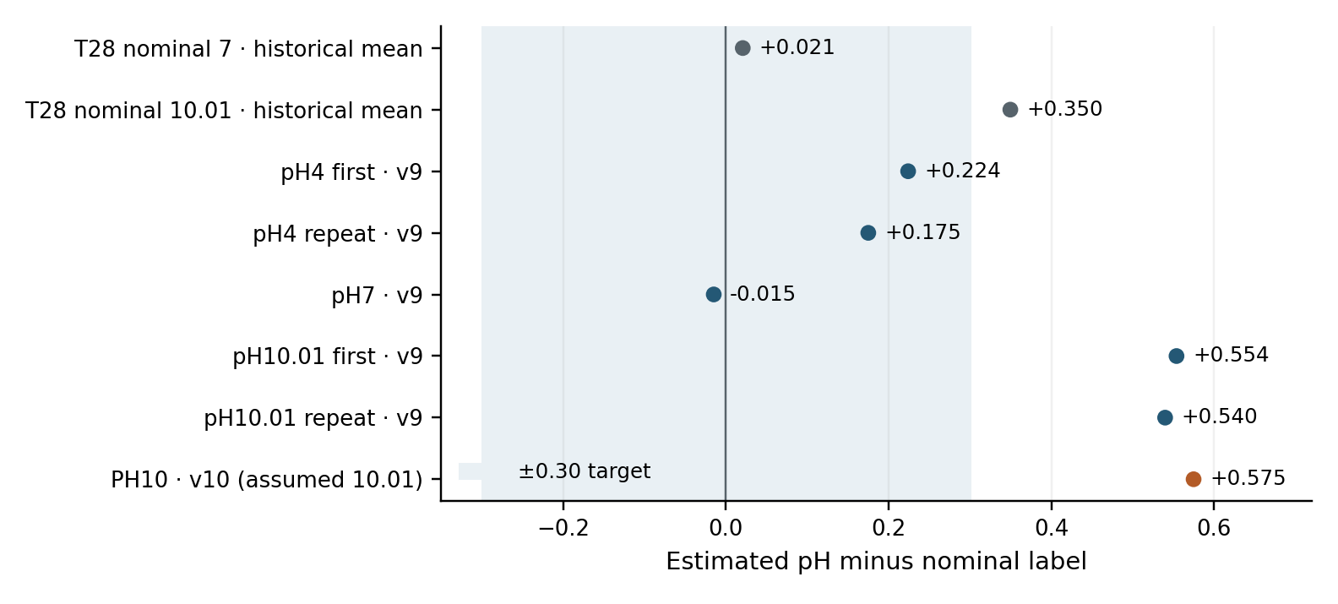
Figure 6. Selected deviations from nominal labels against the ±0.30 target. Different revisions and calibrations are shown separately and are not pooled into an accuracy statistic. The final PH10 comparison assumes the liquid was the nominal 10.01 buffer. [E07-E09, E11]
For historical T28, the independently recomputed 90-120 s windows contain 30 observations each. The pH 10.01 range is 10.280-10.410; the return-to-7 range is 6.972-7.112. The high-pH point was not used to fit that calibration. [E11 lines 116-145 and 381-410]
Several historical differences from nominal buffer labels exceed ±0.30. The new high-pH comparison instead uses the meter’s observed 10.41 and the prototype’s 10.641, a difference of +0.231. This changes the comparison reference; it does not prove that the earlier discrepancy was corrected or identify whether the buffer, meter or prototype caused it. Both sets are retained separately.

D7 Added digital meter comparisons
The team supplied three digital-meter readings paired with device snapshots from run 20fda0d966d2425e​a3a0105a0911b8c1. All identify calibration bench-59daedbc and firmware sample_response_v10. E18 preserves selected fields as a user-supplied transcription; an original JSONL export for this run was not provided. These checks are separate from the nominal-label comparisons. [E18]
Sample ID prefix | Meter pH | Prototype pH | Difference | ±0.30 check
5b75e456 | 3.94 | 4.022 | +0.082 | PASS
0e142cf6 | 6.91 | 7.015 | +0.105 | PASS
235f4850 | 10.41 | 10.641 | +0.231 | PASS

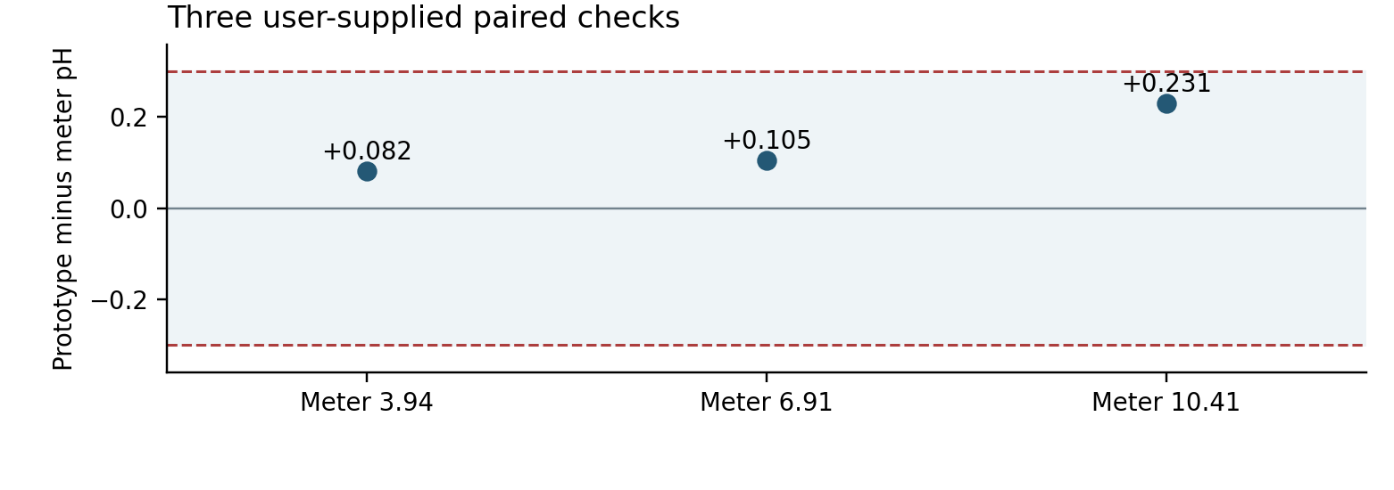
Figure 7. Three paired prototype-meter differences against the ±0.30 numerical target. No uncertainty bars are shown because comparator uncertainty was not supplied. The plot establishes selected agreement, not reference-traceable accuracy over a continuous range. [E18]
The first value is the completed current result: VALID, NORMAL, sample_complete and result_held true. The other snapshots were taken after stopping; their current pH and verdict are null by design. Their retained last_measurement entries contain the valid completed results 7.015 and 10.641. Those saved values, rather than the null current fields, are used above. Packet values have three decimal places and are not represented as full internal precision.
All three absolute differences meet ±0.30. Maximum absolute difference is 0.231 pH and mean absolute difference is 0.139 pH for these three pairs only. All differences are positive, suggesting a possible systematic offset to investigate; three observations do not establish bias. There is one observation at each level, not a repeatability study. No intermediate or near-threshold accuracy is established.
The prototype agreed with the comparison meter within ±0.30 pH at three tested points. Meter model, calibration status, uncertainty and liquid temperature were not recorded in the supplied comparison data. Reference uncertainty, repeatability and accuracy near the decision thresholds remain unverified. The calibration_valid flag indicates software eligibility, not physical accuracy.

D7 Final workflow timing and held results
Five completed routine samples in two browser runs identify firmware sample_response_v10 and calibration bench-59daedbc. The table contains one decision per sample, rather than counting repeated held packets as repeated tests. [E06, E07]
Sample ID prefix | Final pH | Category | Device time s | Range pH | Net change pH
3609e8b9 | 7.006 | Critical | 21.004 | 0.056 | +0.014
9472776b | 6.029 | Critical | 21.008 | 0.042 | +0.007
d66e2bff | 5.950 | Advisory | 21.008 | 0.042 | +0.030
f4ce4d6e | 5.908 | Advisory | 21.009 | 0.049 | −0.014
d9127ee4 | 10.585 | Critical | 21.007 | 0.105 | +0.012

All 100 scheduled readings are present. Recorded acquisition lateness ranges from 0 to 10 ms, below the configured 250 ms tolerance. Every final capture reports complete_timed_capture true. Recomputing the mean of converted raw readings 18-20 reproduces all five final pH values within packet rounding. No pre-21-second verdict occurs in these reviewed captures. [E15]
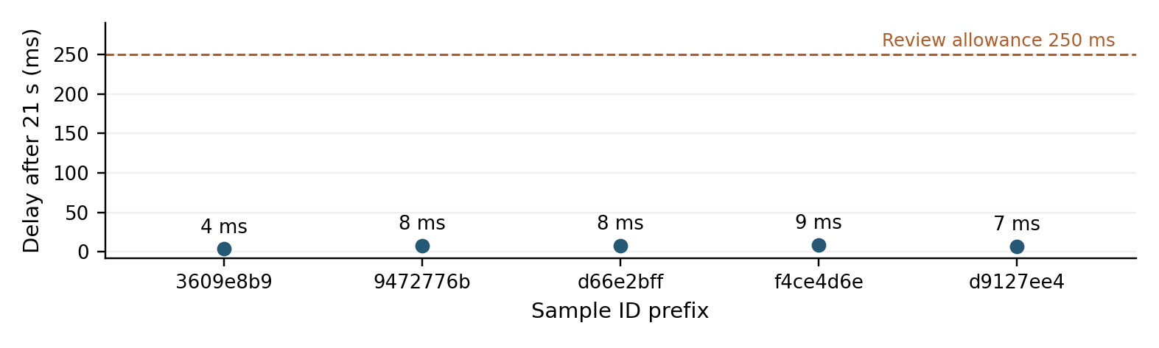
Figure 8. Device publication delay beyond 21 seconds for the five completed v10 samples. The observed delay is 4-9 ms; the review acceptance allowance is 250 ms. This is software publication timing, not physical electrode response or sound latency.
Host request-to-result-event intervals are 21.051-21.090 seconds. Those intervals include serial command and event handling; the physical start of immersion is not synchronized to them. ER2 passes for these reviewed timing cases and the virtual incomplete/late-capture tests.
Each sample has a physical stop event after completion. Subsequent records command OFF and withhold the current verdict. The final PH10 run contains 285 OFF heartbeats after its one stop, not 285 separate stop trials. A 60-second virtual run changes input after completion and confirms the held result and absence of further ADC acquisition. A separate run verifies that NEW SAMPLE resumes acquisition. Active-acquisition stopping passes virtually. Earlier physical v3/v8 stops are indexed separately; a final-v10 physical active-acquisition stop is not identified. [E20]
These five fully archived v10 captures contain no normal result. The added E18 snapshot supplies a distinct valid v10 NORMAL result of 4.022, and the video shows a green 4.0 display. Neither addition is represented as a sixth fully reconstructed 20-reading capture. [E18, E19]

D7 Fault rejection and response checks
The latest code contains explicit fault logic; the PDF’s “need to make the code” note is superseded for the defined cases. Its claim that all drifting conditions are detected is not supported. Drift is assessed in routine mode; known-buffer response mode permits the expected pH change and uses the separate response and settling checks. [E01, E03]
Test input or condition | Current software evidence
Routine net change >0.40 pH | DRIFT_FAILURE and no verdict; equality and both directions are exercised.
Confirmed buffer change with unchanged filtered signal | STUCK_FAILURE and no verdict; inclusive ±0.10 boundary is exercised.
Similar consecutive unknown samples | No stuck inference; the same pH may be legitimate.
Early meaningful response in challenge mode | PROBE_RESPONSE_DETECTED; not a feeding verdict.
Late response or excessive range | UNABLE_TO_SETTLE and no verdict.
Raw outside 500-60000 | SIGNAL_OUT_OF_RANGE at decision; inclusivity checked at both limits.
Missing or late timed reading | MISSING_TIMED_READINGS and no verdict.

Four v9 known-buffer challenges are identifiable: two 4→7 challenges and one 10.01→4 challenge report response detected; a 7→10 challenge is rejected by the older signal range. Thus three have valid response outcomes and one is refused. These are tests of response under stated transfers, not three trials with a genuinely stuck electrode. [E08, E09]
The labels “PH4 STUCK TEST” in two routine v9 trials do not establish a stuck challenge: their requests have known_buffer_changed false, and the saved results explicitly say NOT_ASSESSED_ROU​TINE_SAMPLE. This prevents a misleading test name from being counted as demonstrated fault detection. [E08]
The PDF’s small before/after differences, such as approximately 4.20 to 4.16, do not exceed the configured 0.40 drift threshold. They cannot demonstrate rejection of a deliberately drifting input. A correctly responding physical probe also cannot establish the sensitivity of the stuck detector.
Defined fault rejection is demonstrated under demo conditions for the virtual inputs and selected buffer challenges. Routine unknown-sample stuck detection is not implemented. Physical fault sensitivity and specificity are not estimable: no independent labelled set of genuine faulty and healthy electrodes, with TP, FN, FP and TN counts, is supplied. Passing the software tests does not tell us how reliably the prototype would detect faults in a real physical sensor.

D7 Calibration age and software verification
The weekly gate is calculated from saved calibration completion and synchronized laptop UTC. It returns no valid age when time is missing, completion lies in the future, coefficients fail validation or seven days have elapsed. Restarting on day three leaves four days; it does not create a fresh week. The saved calibration timestamp cannot be registered again to renew an existing record. [E03]
Runtime E08 records registration for bench-59daedbc and the five v10 results carry the same completion epoch. The calibration archive’s null timestamp shows why archive identity and operational state must both be retained. The timestamp’s factual accuracy still depends on the operator and laptop clock.
No fixed-calibration seven-day physical comparison is identified. Logs collected on several dates under different calibration IDs do not constitute that study. ER5 calibration-age gating is demonstrated under demo conditions through the selected software cases. Physical accuracy throughout seven days remains unverified.

Software verification by version
Ten supplied check scripts passed on copies of the reviewed code. The earlier browser-service suite contained five tests. After the all-results notification update, seven tests passed across test_service and test_notification_messages for browser_service_v2_all_results. This later count includes the existing tests and is not seven additional tests. Simulated serial inputs and mocked delivery were used; no phone messages were sent by these checks. [E14, E23]
Check | Scope
check_firmware_loop | Actual firmware control loop, publication, held result, new sample and repeated OFF after stop.
check_fixed21 | Decision block, six drift readings, missing/late capture and calibration precedence.
check_weekly | Expiry equality, missing clock, future timestamp and restart age.
check_signal_limits | Actual current ADC constants and inclusive boundaries.
check_stuck and check_drift | Defined thresholds, duration, known-change scope and selected exceptions.
check_logic and check_countdown | Stop idempotence, latch, duplicate prevention and countdown; includes older desktop control helpers.
check_simple_monitor and check_phone_notifications | Earlier desktop loop and mocked message acceptance/failure; supplementary, not final-browser hardware evidence.

The old check_deadline script targets an earlier 20-second implementation and was excluded. check_fixed21 supplies its own older ADC maximum, so it is used for decision/timing evidence, not proof of the final signal limit. Separate current-source classification checks passed ten numerical cases and eight invalid/gating cases. All results are software-only evidence.

D7 Alarm notification and interruption evidence
Five v10 physical ACK/STOP actions are independently recoverable from E06/E07. They are followed by 387 stopped/OFF heartbeats with no current verdict. ACK-to-STOP device event intervals are 1-2 ms; these are software intervals, not physical press-to-light or press-to-sound latency. The videos add direct physical observations, including audio cessation during ACK, in the following section. [E20, E21]
Retrospective review also identifies a complete earlier browser sequence: valid critical 7.059, physical ACK/STOP, retained critical history, then a routine valid normal 4.224 and cleared history. This is v9 evidence, not a final-v10 repetition. The routine request has known_buffer_changed false despite its “STUCK TEST” label. [E08 lines 407, 418-421, 644, 669-672]
Earlier v3 physical stops at 12.272 and 8.667 seconds remain stopped past their original 20-second deadlines, without a new current verdict. A v8 stop at 4.501 seconds has only about seven seconds of follow-up. These demonstrate historical active-stop behaviour; current firmware is supported separately by virtual tests. Final-v10 history also remains latched through ACK, OFF and later advisory results. [E20]
The chosen design keeps current indication separate from critical history. A physical stop turns the ring off; the host latch remains until acknowledged and a valid normal returns. Fresh service startup does not restore it. The disconnected-state image shows no current pH, a paused timer and an explicit reconnect message. It does not record recovery or detection latency. Reconnection is muted; an older USB-loss chirp is not final-browser behaviour. [E22]

Phone and interruption evidence
Historical browser logs contain 13 consent events, 24 queued/accepted messages and two manual receipt confirmations. Revised software tests cover category eligibility, technical reason text, consent, timing and duplicate suppression. Live acceptance requires normal, advisory, critical and one representative technical receipt with matching sample IDs. That verifies category delivery, not every technical subtype; each subtype needs its own receipt if that stronger claim is made. [E07, E09, E19, E23]
Final PH10 delivery milestone | UTC on 10 November 2026
Recipient consent | 20:50:00.546578
Sample request | 20:50:32.362650
Fixed-window result received | 20:50:53.413479
Matching phone receipt manually confirmed | 20:51:18.441864

The final confirmation links sample d9127ee4… to message t0p7nGtG1Z0p; the second links v9 sample 997b090e… to 6JNqJDP32EwX. Both are MANUAL_PHONE_OBSERVATION. The 25.03-second result-to-confirmation interval includes human action and is not arrival latency. [E07 line 95; E09 line 301]
The logs retain 47 link errors, 19 interruptions and 72 parse errors; repeated events are not independent failures. Current store equality supports snapshot consistency, while process replay and interrupted-write recovery remain incomplete. [E15]

D7 Physical and connection demonstrations
The 127.17-second E19 clip, 25.46-second E21 ACK clip and E22 connection-loss image add direct demonstration evidence. Timecodes locate observations; device clocks, firmware versions and run identities are not authenticated by the footage.
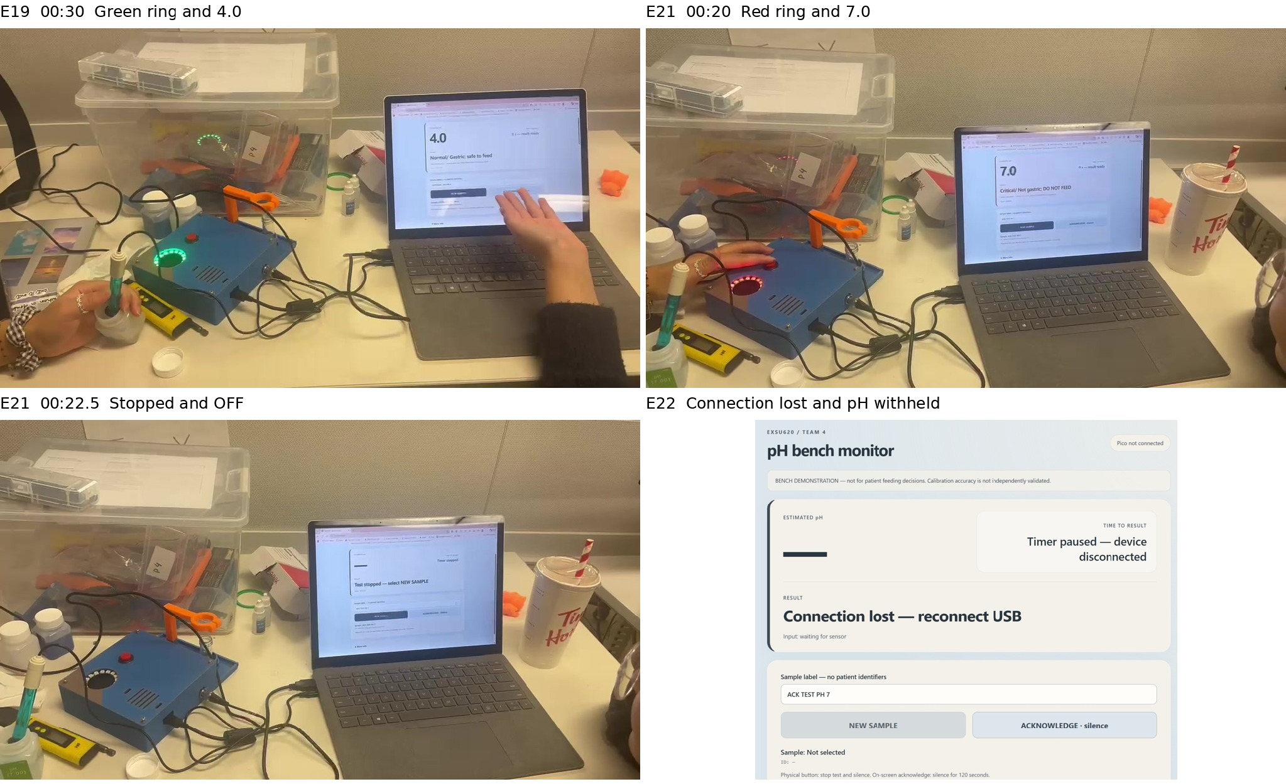
Figure 9. Original-content evidence views show green/4.0, red/7.0, stopped/OFF after physical ACK, and a disconnected host with pH withheld. Labels and margins are added outside the source images. [E19, E21, E22]
Evidence location | Direct observation
E19 00:25-00:47 | Green ring and normal 4.0 display.
E19 01:34.65-01:37.20 | Ten recorded bursts near 1200 Hz with red/7.0 critical indication.
E19 00:48-00:55 and 02:00-02:05 | Two physical button actions followed by OFF/stopped screens.
E21 about 00:20-00:23 | Red/7.0, button operation, audio cessation, ring OFF and stopped/no-result screen.
E22 static image | “Pico not connected”; blank pH; paused timer; “Connection lost - reconnect USB”.

E21 contains five near-1200 Hz bursts at approximately 20.29-21.55 seconds, then no further detected critical bursts. Their cessation during the ACK sequence is consistent with cancelling the programmed ten-tone pattern. Physical stop/mute is demonstrated under these demo conditions. Hidden button contact and unsynchronized clocks prevent a press-to-output latency estimate; sound pressure is also unmeasured.
E22 demonstrates the host’s visible disconnected technical state, not the unplug transition or successful recovery. Advisory/technical physical patterns, final-version active-acquisition stopping and restart recovery retain their stated evidence limits. The selected STOP/OFF design remains unchanged.

D7 Requirement dispositions
“Demonstrated under demo conditions” refers to the specific reviewed functions in each row. The accompanying limits identify criteria that these demonstrations do not establish; the status is not an unqualified full-requirement pass.
Requirement | Demonstration disposition | Evidence supported scope and remaining uncertainty
ER1 Accuracy and range | Incomplete against full criterion | Three meter comparisons meet ±0.30: +0.082, +0.105, +0.231. Reference calibration/uncertainty, temperature, repeatability and continuous-range accuracy remain unresolved. Historical nominal-label differences retained.
ER2 Timing and settling | PASS for reviewed cases | Five v10 outcomes at 21.004-21.009 s; 100 scheduled readings and selected software withholding cases pass. Universal electrode response time is not established.
ER3 Classification | PASS for tested inputs | Boundary tests, invalid-input tests and recorded outcomes support correct classification before rounding. Physical measurement accuracy near the thresholds remains an ER1 issue.
ER4 Fault rejection | Software cases pass. Physical coverage incomplete. | Defined virtual faults and selected buffer challenges support refusal/response logic. Genuine physical fault coverage and routine unknown-sample stuck detection are not established.
ER5 Weekly calibration | Expiry logic tested. Seven-day stability unverified. | Selected age-gating software cases pass. Seven-day physical accuracy with unchanged coefficients is not demonstrated.
ER6 Indication and stop | Selected patterns demonstrated. Continuous red latch differs from card. | Videos directly support green/red indications, critical tones and physical ACK stopping/muting with ring OFF. Logs support critical-history retention.
ER7 Identity audit recovery | PASS for reviewed current cases | Current JSONL/SQLite pairs match, sample identities and corrections are retained, and interruption handling supports withholding the current verdict. The image confirms the disconnected display. Broader storage-failure and process-restart recovery remain unverified.
ER8 Consent and notification | Software checks pass. Revised live receipt pending. | Revised software checks cover category eligibility and reason-specific messages. Two historical matched receipts establish earlier delivery. Obtain four revised category receipts; separately retain each technical subtype receipt if claiming all subtypes were received.

The current STOP/OFF design is retained. Current indication follows the current sample; critical history is retained separately on the host. This remains a declared difference from continuously latched red indication.

Remaining validation work
ER1 needs documented comparator calibration/uncertainty, temperature and repeated independent checks across the claimed range and decision boundaries. ER4 needs a labelled physical fault set. ER5 needs an actual fixed-calibration seven-day study. ER6 needs the unfilmed physical patterns and quantified timing for any latency claim. ER7 needs controlled storage/process interruptions and documented restart recovery. These are remaining activities, not invented test results.

D8 Failure modes and mitigation
The following scores are qualitative post-mitigation judgments for the implemented bench design, not measured probabilities. Higher scores indicate greater severity S, occurrence O or difficulty of detection D; RPN = S × O × D. FM07 detection is revised to 2 and its RPN to 20. FM03, FM06 and FM11 retain the team-selected scores. Low detection scores in these rows are assumptions, not demonstrated detection performance. [E01]
ID and failure | S O D | RPN | Implemented mitigation and remaining evidence
FM01 Electrode damage or disconnection | 5 1 2 | 10 | Signal gate, technical refusal and dedicated response challenge. Cannot identify every disconnection or physical fault.
FM02 USB or communication failure | 4 1 1 | 4 | Image shows blank pH, paused timer and connection-loss message. Host gate/unit tests support withholding. Recovery timing and independent audio absent.
FM03 Liquid exposure | 4 2 1 | 8 | Assembled enclosure and external liquid handling visible in video. No ingress or spill test is supplied.
FM04 Unstable placement or damage | 3 2 1 | 6 | Printed support and secured assembly are reported. No quantified force, drop or repeatability test.
FM05 Invalid or expired calibration | 5 2 1 | 10 | Loaded coefficients and recorded-age gate. Selected software cases pass; reference accuracy and weekly stability remain open.
FM06 Undetected drift | 5 1 1 | 5 | First/last mean comparison and settling gate. Defined cases pass; not all physical drift patterns are covered.
FM07 Stuck or unresponsive probe | 5 2 2 | 20 | Known-buffer challenge with measured baseline. Routine unknown-sample stuck detection is not established. D = 2 reflects the dedicated check, not automatic detection in routine samples.
FM08 Category switching near boundaries | 3 3 1 | 9 | Unrounded classification and frozen completed result. Repeat samples can still fall on opposite sides; physical threshold accuracy is unresolved.

Scoring anchors for this review: S1 negligible effect, S2 minor disruption, S3 repeat test or workflow delay, S4 lost function or misleading information, S5 potentially consequential incorrect decision. O1 considered unlikely, O2 occasional, O3 plausible recurring, O4 frequent, O5 very frequent; these are judgments without measured rates. D1 readily apparent or expected to be detected, D2 usually detectable with a defined check, D3 detection depends on operator action, D4 difficult to detect, D5 no reliable detection. These anchors clarify interpretation; they do not retroactively validate the retained scores.
Temporary connections, high ADC readings and reference disagreement were encountered during development. Some causes were suspected, but the evidence does not isolate every fault mechanism. The direct sensor-to-ADC path has no documented overvoltage protection. Rejecting a reading after conversion is not electrical protection. No claim that the completed system is safe under every disconnected-probe or wiring condition follows from stable buffer readings.

D8 Use and environment risks
ID and failure | S O D | RPN | Implemented mitigation and remaining evidence
FM09 Premature settling | 5 1 1 | 5 | Range/dwell gate and 21 s outcome. Defined cases pass; no independent universal stabilization time.
FM10 Incorrect or incomplete audit | 3 1 1 | 3 | Unique IDs and dual stores. Two current pairs match; one older session-start mismatch and non-atomic writes remain.
FM11 Insufficient sample volume | 4 3 1 | 12 | Instructions require tip immersion. No quantified minimum volume or automatic volume detector is verified.
FM12 Probe movement | 4 2 1 | 8 | Holder, still measurement and quality checks. Controlled movement tolerance is not measured.
FM13 Inadequate rinsing and carry-over | 4 3 3 | 36 | Rinsing and clean liquid handling are required. No controlled rinse versus no-rinse dataset is reconstructed.
FM14 ACK fails to stop as intended | 2 1 1 | 2 | Both videos show button/OFF; dedicated ACK clip shows critical audio cessation. Five v10 stops retained. Exact latency and outage behaviour unverified.
FM15 Browser or notification failure | 4 2 1 | 8 | Host state checks, audit and receipt confirmation. Dependence on service, internet and subscribed phone remains.
FM16 Power interruption or restart | 5 2 1 | 10 | Time resynchronization and fresh-sample gate. Host critical history, consent and pending deliveries are not restored from storage.

FM13 has the highest retained RPN, but this is not a validated ranking of clinical risk. FM03, FM06 and FM11 retain D = 1 by team decision despite incomplete evidence: no ingress test, only selected drift patterns covered, and no verified automatic volume detection. These detectability assumptions require review before any broader use. Routine unknown-sample stuck detection is not established; FM07 therefore uses D = 2 for the dedicated response-check approach.
The prototype requires a stable surface, adequate immersion, a functioning laptop and a deliberate new-sample action. Probe transfer and rinsing are operator-dependent. The evidence does not demonstrate a minimum 3-5 mL volume, liquid-ingress resistance, cleaning compatibility, sterilization, electrical certification or nurse usability.
The words “safe to feed” and “not gastric” are course demonstration labels. A pH-only bench classification cannot establish actual tube location. A final interface intended for clinical evaluation would require review of wording, alarm presentation and measurement uncertainty. No such evaluation is claimed here.

D9 Dossier traceability and team contribution
Deliverable | Evidence in this dossier | Remaining submission issue
D1 • 10 marks | Eight ERs, CR mapping and explicit criteria. | Team acceptance and sign-off.
D2 • 5 marks | Architecture, processing, alarms, audit and alternatives. | Confirm approval of substitutions and alarm deviation.
D3 • 10 marks | Modules, signals, directions and constraints. | Final as-built manufacturing record.
D4 • 5 marks | Block, wiring, state and sequence diagrams, 11-12. | Compare with final physical harness.
D5 • 35 marks | Reviewed implementation and operation; supplied source archive. | Align README versions/port, repository and final printed-part files; live demonstration is separate.
D6 • 5 marks | Methods, actual counts, criteria and review responsibility. | Named reviewer approval is not yet recorded.
D7 • 10 marks | Calibration, errors, timing, faults, notifications and dispositions. | Physical accuracy, longitudinal stability, fault coverage and live phone receipt for each revised outcome remain open.
D8 • 10 marks | Team risk scores, corrected RPN and qualified mitigations. | Review optimistic detection scores and test unverified mitigations.
D9 • 10 marks | Consolidated PDF, memorandum and evidence companion. | Final group review and submission.

The notes attribute firmware work to Sophia, Seoyoung, Saada and Bey; dashboard work to Sophia; and physical design to Bey and Saada. Verification and documentation involve all five members, including Kayla. These are the supplied team roles and are not presented as independently measured individual contributions. [E01]
The bench prototype demonstrated measurement, selected alarm and stop behaviours, and audit retrieval. The revised service adds reason-specific phone messages for completed technical results and extends notification eligibility to normal and advisory results. Four-outcome phone verification remains open.
The prototype agreed with the comparison meter within ±0.30 pH at three tested points. Videos support selected LED and stop functions; the connection-loss image shows the browser withholding pH. Reference uncertainty, repeatability and near-threshold accuracy remain unverified. The weekly interval and physical fault-detection limits are summarized in the requirement dispositions.
Report preparation used ChatGPT Codex to organize evidence, recompute results, repeat virtual software tests, prepare diagrams and draft text. No new physical measurements were made during that process. Team review and responsibility for the final interpretation and submission remain necessary.

Appendix A Matching the evidence notes

Claims V01 through V08
The evidence PDF is a working collection of observations, proposed tests and older implementation descriptions. The matches below identify support without turning a reported “worked” into a numerical pass. Exact filenames, hashes, sample IDs and line locations are in claim_evidence_map.csv and source_manifest.csv.
PDF claim | Matching file evidence | Conclusion for this report
V01 Power and startup | E01 page 1 reports pH4 meter values 1.72-1.75 V and pH7 1.95 V. Final E06/E07 contain complete unsaturated timed captures. | Meter values remain team-reported. Final captures do not prove every startup is stable or isolate ADC noise from analogue change.
V02 Calibration record | E04 script; E05 complete 30+30 captures, SL, provisional status and calibration ID. | Final record structure and arithmetic verified. Its spreads are 0.06278/0.04883, rather than the older figures quoted in the PDF. Null archive timestamp is qualified using runtime evidence.
V03 Buffer repeatability | E08 has two completed PH4-labelled samples; E09 has PH7 and two PH10.01 samples. E11 preserves historical return-to-7 data. | Selected repeat immersions are supported. Revisions and calibrations are kept separate; no broad repeatability claim or success percentage.
V04 Independent accuracy | E18 three paired meter comparisons; E07/E09 nominal PH10 checks; E11 held-out window. | Three meter-agreement checks pass, errors +0.082/+0.105/+0.231. Comparator agreement demonstrated under demo conditions; reference uncertainty persists and historical nominal differences retained.
V05 New sample and settling | E06 requests/results at lines 14/39, 97/122, 148/173 and 224/249; E03 start_sample; E14 loop regression. | Distinct IDs and timer/capture reset supported. Final algorithm is range/dwell with a 21 s decision, not the PDF’s 20 s mean-band description.
V06 Boundaries | E03 decide; E14 current-source classification cases; E06 result at 6.029 is critical. | Logic supported for tested inputs. No independent physical boundary accuracy.
V07 Light and audio | E19 video: green/4.0, red/7.0 and ten near-1200 Hz bursts. E13 patterns; E01 observations. | Normal/critical functions directly observed. Advisory/technical physical patterns, calibrated sound level and physical latency remain unverified.
V08 Physical ACK and latch | E19 button/OFF; E21 dedicated physical ACK/audio clip; E20 five v10 stops and historical clearing/active stops. | Stop/mute/OFF demonstrated under demo conditions. Ring follows current sample; host retains history. Exact output latency and restart replay unverified; versions kept separate.

Original raw data have not been relabelled or edited. Where the evidence notes disagree with current source behaviour, the current implementation is described explicitly and the older statement is retained in this match record.

Appendix A Remaining claim matches

Claims V09 through V15
PDF claim | Matching file evidence | Conclusion for this report
V09 Expiry and restart | E03 age logic; E08 registration lines 113-114; E14 weekly checks. | Selected seven-day software cases supported. Older consumed-token behaviour is obsolete; physical weekly stability remains untested.
V10 Sensor faults | E03 drift_summary, stuck_summary and decision block; E14 virtual faults; E08/E09 known-buffer requests. | Defined software detection implemented. Routine trials named “STUCK TEST” were not challenge mode. No evidence supports detecting all physical drift/stuck conditions.
V11 USB and laptop loss | E22 disconnected-state image; browser interruption/link-error records; E13 source; five E14 service tests. | Blank pH, paused timer and reconnect message directly shown. Fresh-sample gate supported in software; detection time, successful recovery and restart replay not established by image.
V12 Audit records | E15 full field comparison of three store pairs; E12 label correction. | Current browser and stop stores match. One older session-start is JSONL-only. Corrections are a retained sidecar, not an editing API.
V13 Timing drift carry-over | E06/E07 timed captures; E20 ACK/STOP software intervals; E19 video; E11 historical return. | Acquisition timing demonstrated. Video and 1-2 ms event intervals are not physical alarm latency. Full end-session drift and controlled carry-over remain unverified.
V14 Mechanical assembly | E19 enclosed prototype, fitted ring/button and support; E17 earlier photo; E01 assembly notes. | Assembled use directly visible. Final CAD identity, force tolerance and liquid-ingress performance remain unverified.
V15 Browser and notification | E13 browser assets; E07/E09 consent and receipts; E19 visible phone messages; E14 tests. | Selected receipts and browser use supported. Video messages not joined to archived receipt pairs; no extra matched delivery or latency count.

Corrections applied to the draft
The final calibration plot now uses bench-59daedbc rather than substituting a historical calibration because the final archive was previously missing. Current-store event equality is now established, with the historical discrepancy retained. The old 45000 ADC maximum, one-use authorization and 20-second mean-band description have been replaced by the actual latest rules.
The statements “detects all drifting conditions” and “weekly calibration is verified” are narrowed to defined software behaviour and age gating. Four reported transitions without linked ground-truth timing are not treated as proof of universal electrode settling. Critical history, current category, ring indication and muting are documented separately. Both videos and the connection-loss image strengthen selected demonstrations. Dispositions use “Demonstrated under demo conditions”, with the demonstrated scope and remaining uncertainty beside each result. Three meter checks meet the numerical target; reference provenance remains open.
The retained label-correction file says cal95_pH4 test 1 was actually nominal pH7 and test 2 nominal pH4. It also warns that transfer timing is unconfirmed. That correction is included in the companion rather than silently rewriting the original trace. [E12]

Sources and reproducibility
Source IDs refer to the evidence package and project files. E16 is the official board datasheet, used for electrical interface constraints. Preserve repository-relative source paths and hashes in the companion manifest. A file listed here is not evidence that it has been uploaded; verify availability in the final repository.
ID | Source and role
C1 | EXSU620_Project0​4_NGpH_Card.pdf and updated course handbook; requirements, D1-D9 and grading.
E01 | EXSU620 midterm_digital prototype (2).pdf; 17-page team evidence and decision notes.
E02 | output/final_report/report_content.md and output/midterm_evidence/report_draft.md; supplied drafts, checked against raw data.
E03 | Attached main.py and identical button_stop_update/main.py; current v10 implementation.
E04 E05 | Attached calibrate_bench_weekly.py and bench-59daedbc.json; final calibration procedure and captures.
E06 | browser_monitor/bench_logs/f938dda46ad0448f​a5716778f8c7e2d6.jsonl; four v10 results and stops.
E07 | browser_monitor/bench_logs/5646b799eca54f1b​93d25eafff738e7e.jsonl; v10 PH10, stop, consent and receipt.
E08 E09 | Browser runs b6744ffff6cd4e06​a51f3b01eb4a4199 and dc68b79b79c84d1b​a807cb82729ceba9; v9 checks and receipt.
E10 | Browser run b25cf7effd82488b​b293fd6208c46634; earlier outcomes and refusals.
E11 | bench_logs/f93b67133c1045aa​9210c638fde8c07c.jsonl and historical bench-18f0c71b archive; T28 check.
E12 | output/midterm_evidence/latest_update/sample_label_cor​rection_cal95.json and run 4132c507502f4b62​8a8417ee473d1f9f.
E13 | browser_monitor source, browser assets, requirements and README; current host implementation.
E14 | Re-executed supplied checks, five service unit tests and derived current-source classification results.
E15 | Independent event reconciliation, final-capture reconstruction and file inventory; derived from both archives.
E16 | Raspberry Pi Pico 2 W Datasheet, sections 3.2-3.3; https://datasheets.raspberrypi.com/picow/pico-2-w-datasheet.pdf, accessed 10 November 2026.
E17 | output/midterm_evidence/latest_update/assembly_overview.png; earlier open bench photograph.
E18 | ER1_User_Supplie​d_Comparisons.json; selected-field transcription of three added snapshots and stated meter readings, not an original JSONL export.
E19 | Added video evidence of interface lights sound ACK.mp4; unchanged video, timecoded observations and documented audio-spectrum analysis.
E20 | Retrospective stop/history index; original v10, v9 and historical v3/v8 records, with versions and line numbers retained.
E21 | evidence for ack turning off the alarm.mp4; unchanged 25.46-second physical ACK/audio clip and documented review.
E22 | evidence for connection lost.jpeg; unchanged disconnected-state screenshot and visible-field review.
E23 | Workspace browser_monitor/service.py, phone_notifications.py, README.md, test_service.py and test_notification_messages.py. Reviewed service version browser_service_v2_all_results. Targeted notification checks passed with simulated serial inputs and mocked delivery.

Submission checklist: include every source named in the claim map; use repository-relative paths; record the final commit and source hashes; identify firmware sample_response_v10 and host browser_service_v2_all_results; update the port and launch instructions; include final manufactured-part files; and obtain named team review of the requirement dispositions. Verify these items against the uploaded repository rather than assuming local files are present remotely.
We analysed existing experiments, videos and the connection-loss image without performing new physical experiments. Final group review should confirm source availability, reference provenance and the documented design deviations before submission.
Weakest assumption: agreement at three bench points represents accuracy near the course decision thresholds.

