**Space Shooter App**

This is my little pygame application where you can chat with friends use ai assistance during chat, play space shooter game and compete with each other, See game statistics and more!

**Interface**

* **Login/Register Section**

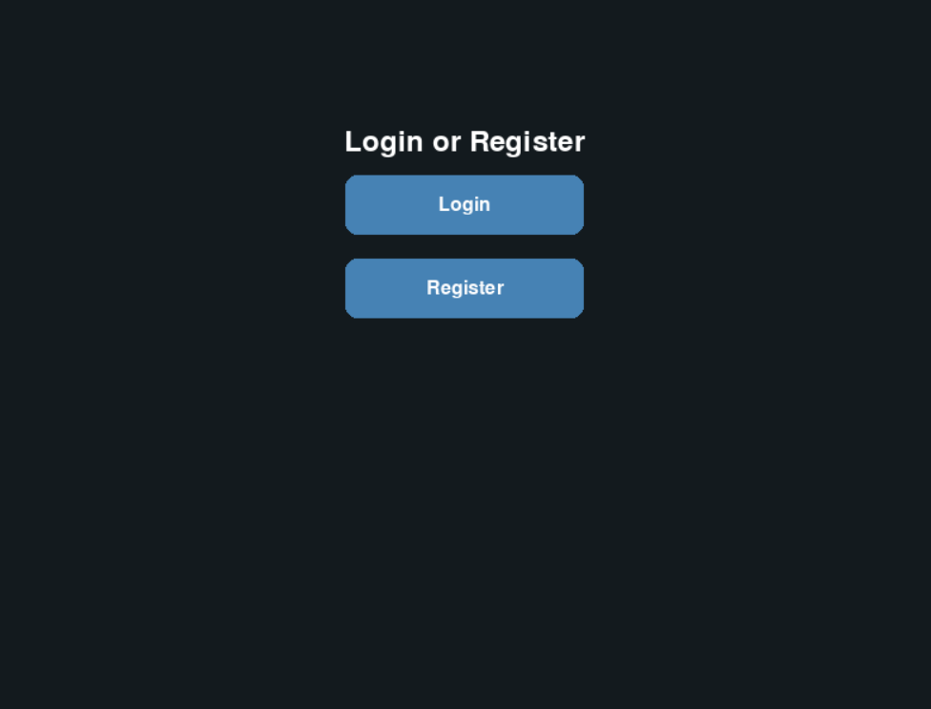

* ***Get information form Data Base:***
* If register succsesful get new account
* If login succesful get information from database and push to our account
* **Profile Section**

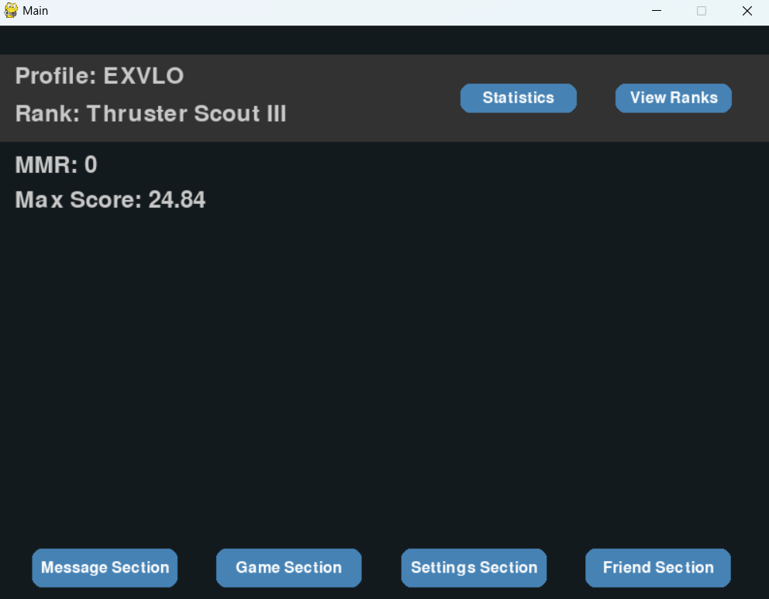

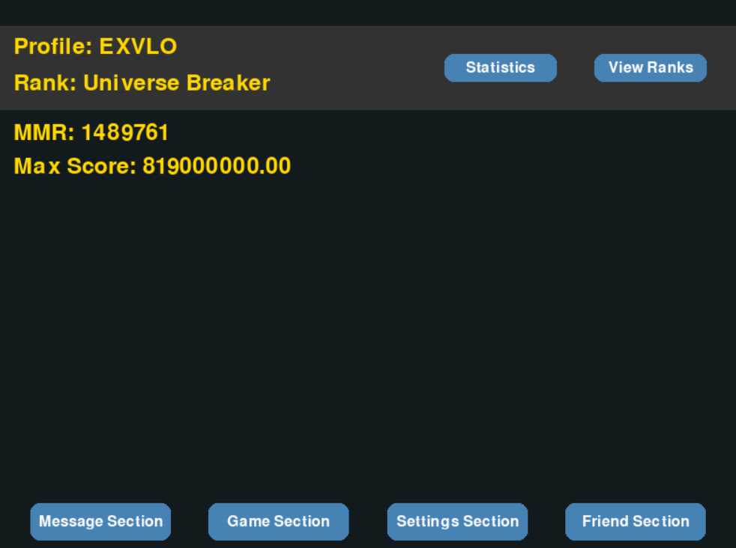

* ***Profile UI:***
* Displays Name, Rank Name, MMR and Max Score.
* Color of your Profile is based on your Rank
* Rank Colors:

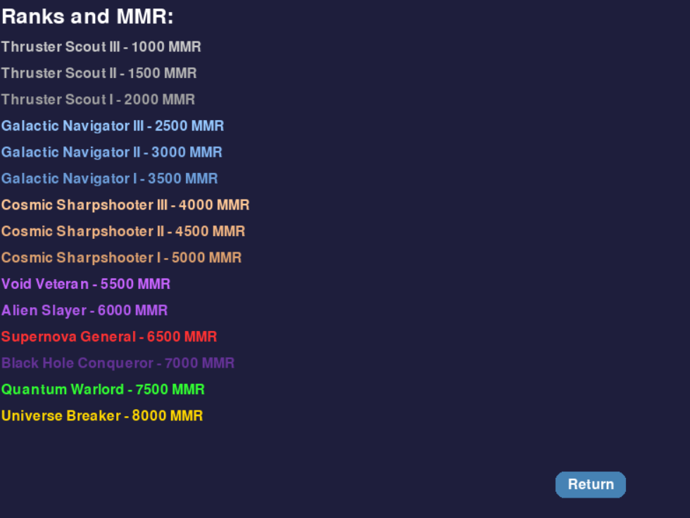

* This is Rank Names, also with colors
* Score is based on your game
* MMR is based on your Score (First Project Plan), but if I have time I will make MMR Based on **All Players Avarage Value (Improved Version)**
* Rank is based on your mmr, now Rank is based on your score, but if Improved version is excecuted, rank will be more accurate
* **Friends Section**

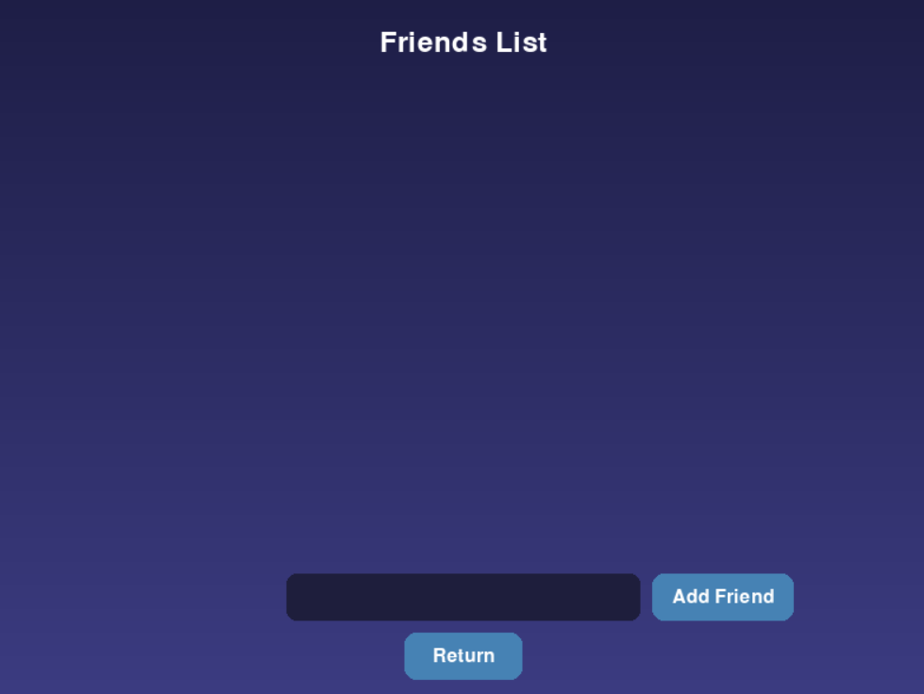

* ***FunctionsI:***
* Displays your Friends names
* Can Add Friend/Remove Friend
* Friends functionality may be improved

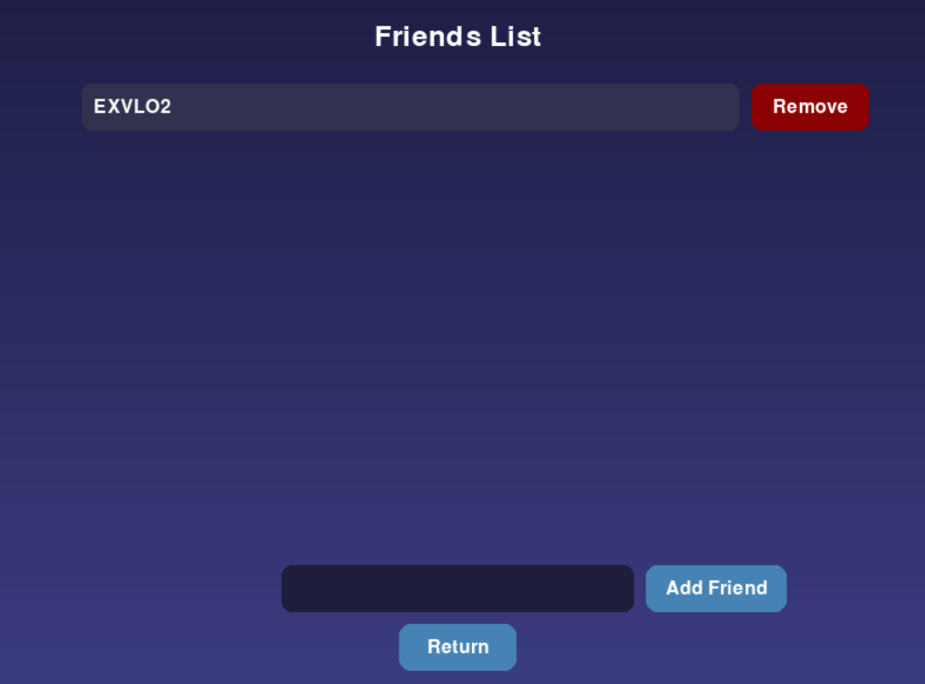

* DataBase Is Not Saving Friends for each account, if you close the program you should ReEnter The Friends
* Pernament Friends DataBase may be Added for improved project
* For improvement We can display their Rank Colors in your account
* **Settings Section**

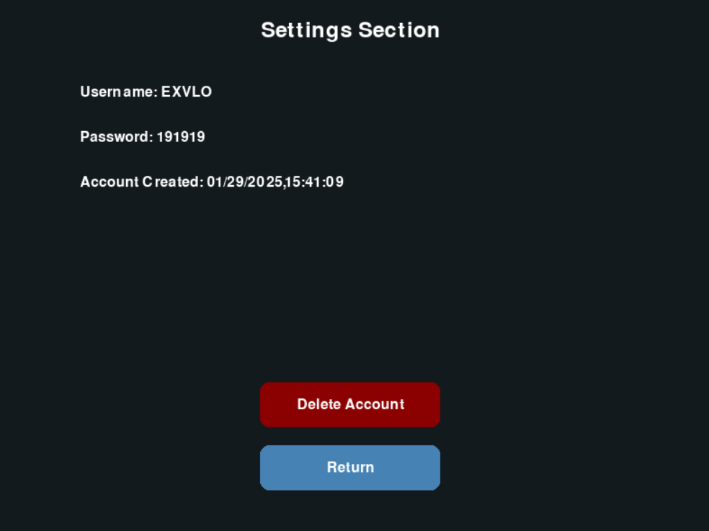

* Settings Display your Account Data as shown in picture
* If we Delete an account new one with same name can be created / Account will be deleted in Database too
* Improvements we can add your max_rank_date (when you got your highest score) and many other little details to be more detailed
* **Game Section**

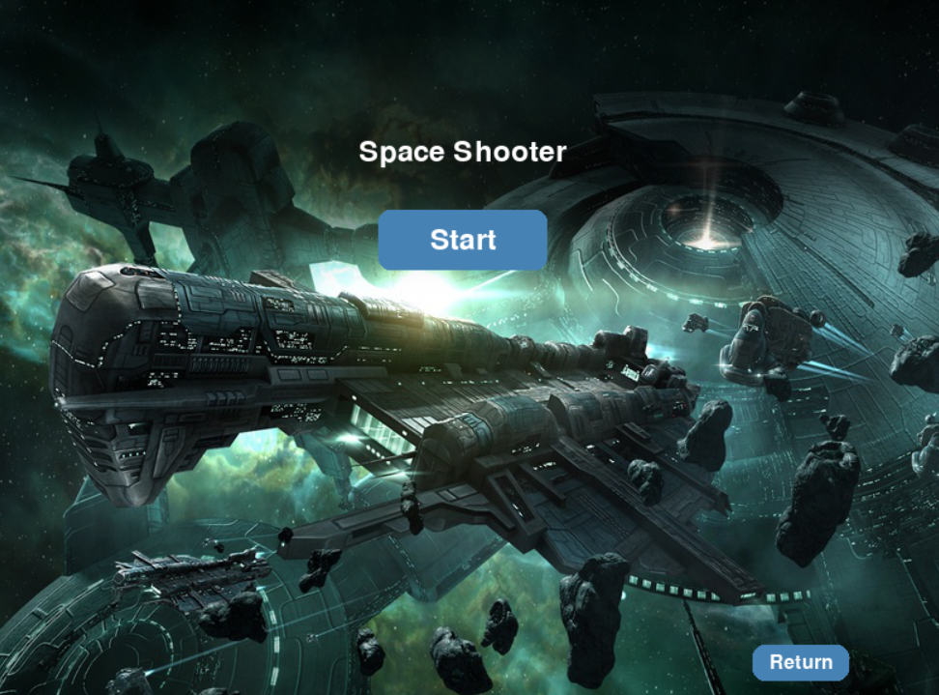

* Game Has lots of potential to improve
* We Can Add Skins settings to Change skins (Wallpaper, Rocket, Lazer, Ufos)
* Other Skins have been added but not functionality
* **Chat Section**

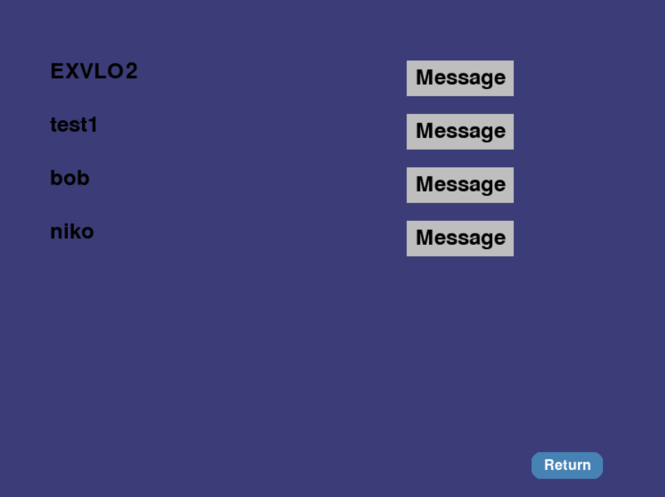

* If other user is connected we can chat with other user
* Displayes messages

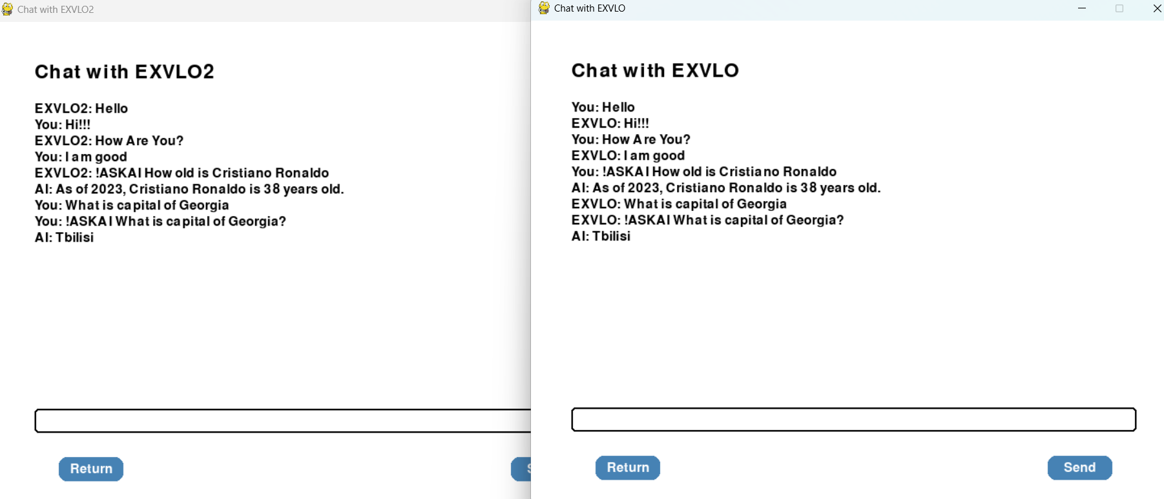

* **!ASKAI** Function is command that you can use in any client chat, whenever you have a question you can write this command and then question, AI will answer and both you and your friend will see the answer
* **Statistics Section**



* Statistics Section will show and plot stats of every player on matplotlib (Work In progress), Currently not done,
* ***Bellow is first idea and Plan for my game***

**Profile**

Friend List

* *Message*
* *AI assistance in messages*

Add Friend

* *Search By Username*
* *Remove Friend*

Stats

* *Game Personal Statistics*
* *Universal Statistics*
* *Graphs of Statistics and Distribution*
* *Ranking*

Game

* *Space Shooting Game*

Settings

* *Delete Account*