Part 1

When it comes to food and cuisine people seem to have a problem of choosing what to eat depending on their mood, dietary needs, or desire. Due to the numerous foods from different parts of the world, it becomes a challenge to decide on what to eat. An expert system that can recommend cuisines according to the preferences of the user could be a useful tool to lead people to a satisfying meal. The aim of the current work is to design an expert system that gives recommendations on cuisines and particular dishes depending on the user’s preferences. The system takes a straightforward rule-based approach to recommending dishes from a variety of cuisines based on the user’s cravings, such as spicy, sweet, savoury, or comforting.  
  
The data for this system was gathered by looking at the most famous dishes in various countries and categorising them based on the taste that is spicy, sweet, salty, and others. The knowledge was then sorted into the types of cuisine and the dishes that represent the flavours that were mentioned. The study showed that there are some dishes which are closely linked to a particular flavour or comfort factor. For instance, Indian and Mexican meals are known to be spicy, while French and Turkish meals are known to have sweet dishes. This categorisation made it possible to develop the rules that define the correspondence between the user’s preferences and the relevant cooking and food.  
  
The knowledge of the system is based on the rule-based system where each rule defines the relations between the user’s input and the list of cuisines and dishes available. For example:

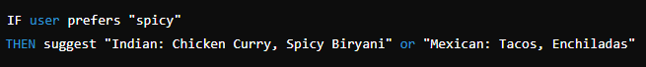The knowledge is stored in a dictionary called cuisine_map, which is the knowledge base that contains the links between the flavour profiles and cuisines/dishes.  
  
Frames (Alternative Representation):  
On the other hand, the system could be developed based on the frames approach, where each frame corresponds to a certain cuisine and contains attributes that describe flavour, dishes, and cooking techniques. For example:

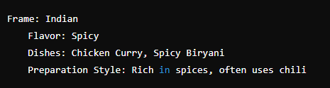

The coded system is in Python as Python is relatively easy to code as well as very effective in handling the I/O operations. As for the rule-based approach it could be easily coded in Python due to its native support of both data and control structures.  
  
System Structure:  
The system is composed of three main components: A cuisine map, an inference engine and a user interface.  
  
Knowledge Base (cuisine_map):  
The knowledge base contains the mapping of user inputs (like "spicy" or "comfort food") to relevant cuisines and dishes. The knowledge base consists of the mapping of user preferences, such as “spicy” or “comfort food”, to certain cuisines and dishes:

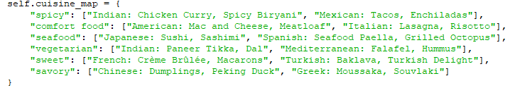

Inference Engine:  
This component of the system translates the user’s input into a format that the knowledge base can easily recognize and compare. It uses a simple matching algorithm to determine the relevant cuisines and dishes: How it selects the cuisines and dishes that will be recommended, it is quite straightforward:



User Interface:

The system uses a command-line interface which requires the user to make a series of selections to arrive at his or her desired outcome. It shows potential inputs, gathers user’s choices, and provides the final recommendations.

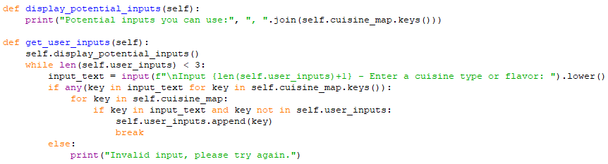

Testing and Refinements:

The system was tested by inputting different user interactions with the system. These included options such as ‘spicy’, ‘comfort food’, and ‘vegetarian’ to make sure the system offered a variety of recommendations that were related to the input.  
  
Some adjustments were made to the rules based on the tests, for instance, when two or more flavours intersect, for instance, when a user desires something spicy and crunchy. The system was also improved to check if the cuisine entered by the user matches any of the available ones; if not, then the system should ask the user if they want to modify their input.

Part 2

Knowledge representation is important in the field of Artificial Intelligence (AI) since it enables the machines to interpret the data provided to them. This aspect plays a significant role in determining the efficiency of an AI system as to how knowledge is represented. There are various methods of knowledge representation in AI and each has its own advantages and disadvantages. When choosing a method, it is crucial to take into account factors such as the nature of the knowledge, if the system will make decisions, the kind of problems it will solve, and the particular field of application.

A frequently used approach is a logical representation. This means that knowledge is represented in a formal way, for example using the logic statements such as, ‘if this, then that’. For example, if we have the premises that state “All birds have wings” and “A penguin is a bird,” then the system can come up with the conclusion that “A penguin has wings.” Logical representation is useful in situations that require accurate and rigorous thinking like in mathematics or when analysing legal matters. Nevertheless, it may not be very effective when the information provided is not fully certain or when there is a lack of information.

Another method is semantic networks where knowledge is represented as a graph of interrelated concepts. Each idea is a node and the links between the nodes are the relations. For instance, in a semantic network, “a bird” is linked with “can fly” and “has feathers”. This type is quite understandable and is applicable for purposes of understanding language or data classification. The only disadvantage is that it might become challenging to manage as the network increases in size.

Frames are also used to represent knowledge and they are very helpful when it comes to explaining the typical circumstances or items. A frame is a structure that includes certain characteristics of something in it. For example, if the frame was a “restaurant” frame, then the information it may contain could be the menu, location and time of operations. Frames are helpful when there is a requirement to present a large amount of information, for example, in diagnostic systems for experts. However, they can be rather limiting if one requires more options for expressing knowledge.

Ontologies are a more formal approach to modelling knowledge since they define concepts and relationships between these concepts. It is more structured as compared to semantic networks and is capable of handling complicated data, which is beneficial in disciplines such as biology where precise definitions are crucial. However, the process of developing and sustaining an ontology is quite a challenging task.

When deciding on the format of knowledge storage in an AI system, it is necessary to take into account the characteristics of the system. Semantic networks and frames are more effective than logical representations for situations that involve relationships. Ontologies on the other hand are good for detailed and well organized knowledge but it takes a long time to develop them. It is crucial to know these options to develop a suitable AI system for various tasks and domains.

Reference

* Mwewa, M. (2023) What is logical representation in ai?, Kinnu. Available at: https://kinnu.xyz/kinnuverse/technology/artificial-intelligence/logical-representation/ (Accessed: 11 August 2024).
* Gillis, A.S. (2024) What is a semantic network?: Definition from TechTarget, Content Management. Available at: https://www.techtarget.com/searchcontentmanagement/definition/semantic-network-knowledge-graph#:~:text=A%20semantic%20network%20is%20a,and%20call%20attention%20to%20relationships. (Accessed: 11 August 2024).
* (No date) Lark. Available at: https://www.larksuite.com/en_us/topics/ai-glossary/frame-in-ai (Accessed: 11 August 2024).
* GeeksforGeeks (2024) Introduction to ontologies, GeeksforGeeks. Available at: https://www.geeksforgeeks.org/introduction-to-ontologies/ (Accessed: 11 August 2024).