Comp301 – Programming Languages
Spring 2026
Project 1- MYLet
Submission Report

Question 1
The main parts of a language was defined as
- Syntax (Structure)
- Semantics (Meaning)
- Implementation
To answer the first question part a, we can say that:
- Syntax
  - Lexical Syntax
  - Concrete Syntax
  - Abstract Syntax
- Semantics (Behaviour Specification)
- Implementation/Interpreter

The syntax is defined in lang.rkt:
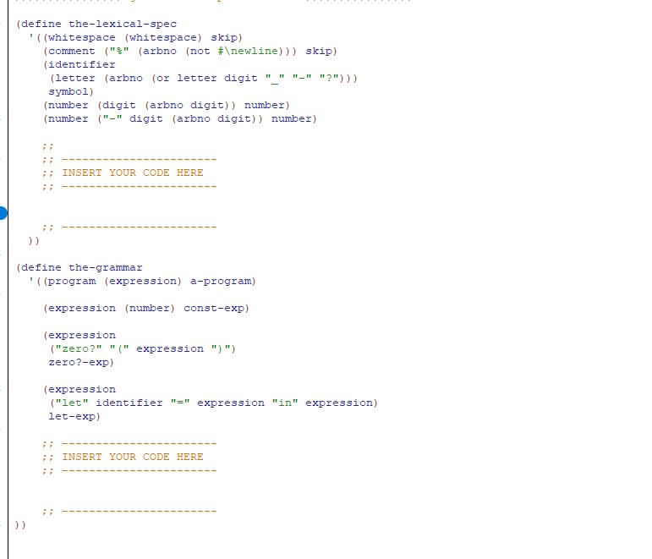
As the names suggest, define the-lexical-spec part defines our lexical specification, or lexical syntax.
define the-grammar part defines our concrete syntax (how we write the code) and abstract syntax (how the computer sees it), labeling the invariants as abstract representations, like zero? -exp, let-exp etc. accordingly.
The Semantics, namely what our expressions mean, what do each expression evaluates to is defined in interp.rkt. Specifically, at:
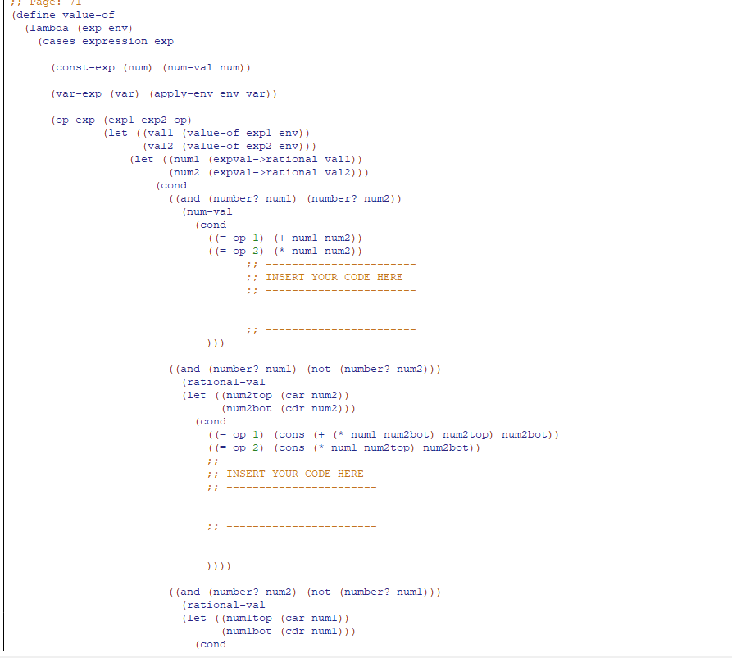
The Implementation / interpreter is how do the whole machinery works, the collection of environments.rkt, data-structures.rkt, parser machinery, lang.rkt and interp.rkt refers to implementation.

Question 2

Part A
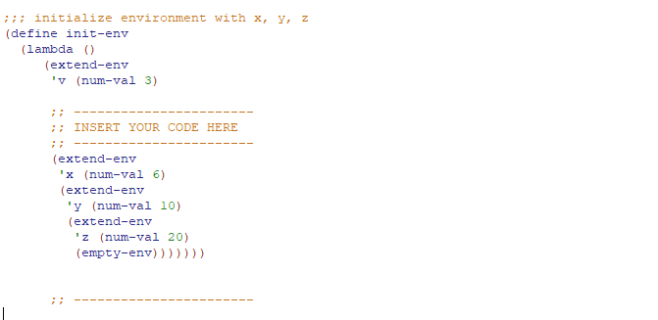

Part B
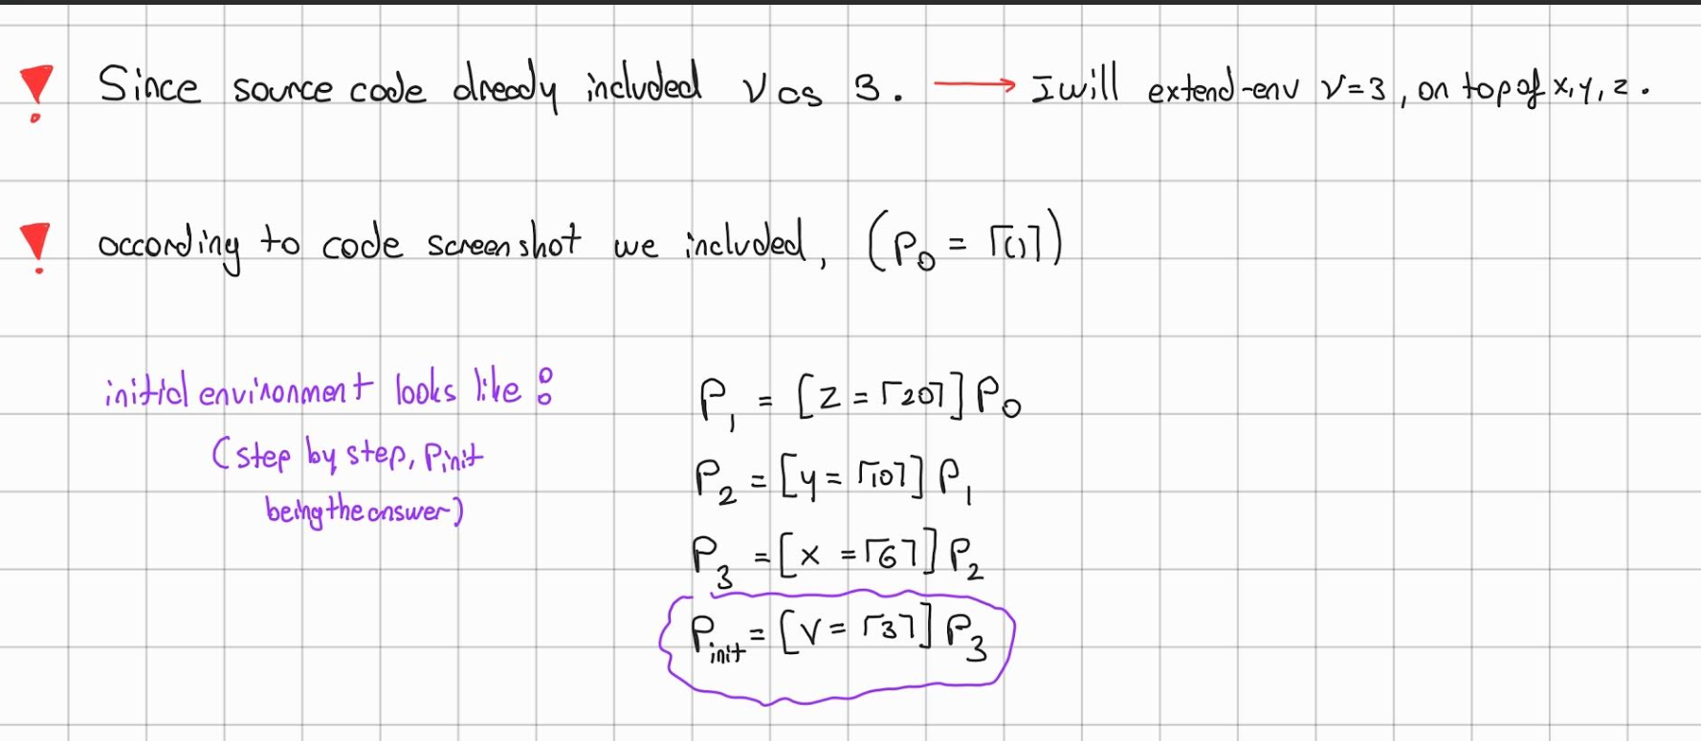

Part C
We have seen 2 ways of representing environments. One is data structure type and the other is procedural representation.
We call a representation procedural when the object is represented as a procedure, and operations on it are performed by calling that procedure.

We call a representation “data structure representation” when we represent our objects with a concrete data structure, lists, pairs etc. Here, the in our code, the giveaway is:
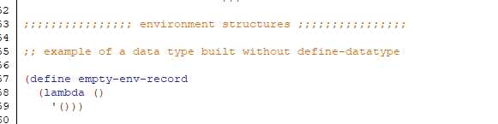
According to that:
Our environments are for sure data structure representation.

Question 3
The expressed values are set of values that our expressions can evaluate to
The denoted values are the set of values that our variables can take, assigned to.
In MYLet
ExpVal = number + bool + list
DenVal = number + bool + list

Question 4

List-exp
We are asked to implement list-exp, which returns an empty list.
///DELETE THOSE BEFORE UPLOADING
My own question: I see we do not do define-datatype list list? but rather use scheme lists, is that normal? Or expected. See the logic below. Or do I do define-datatype list list? Also, the handout says list-exp takes an input (lst), but grammar suggests otherwise, and coding wise no input makes more sense, what do I do? See: 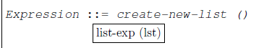
///DELETE THOSE BEFORE UPLOADING

Firstly, we define our grammar:
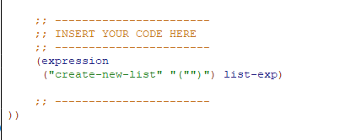
Then, we define our constructors and extractors at data-structures.rkt:
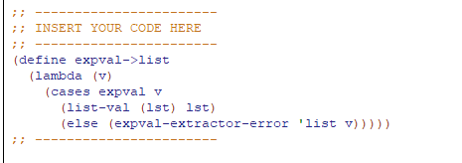
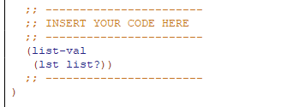
Lastly, we have to implement how value-of evaluates list-exp, inside interp.rkt, after “(cases expression exp” in (define value-of :
Since list-exp takes no input, returns an empty list, we do (:
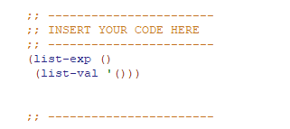

Cons-exp

First defining the grammar:
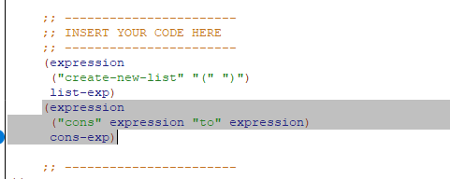
Cons-exp does not change expVal, so we do not really change anything in constructors or extractors.
Modifying Value-of:
