* All photos to be the same size and shape & all text to be aligned

**Examples of FAKE NEWS from Europe**

**Click image below to read story**

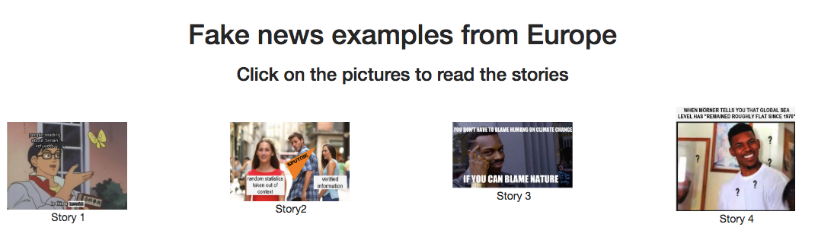

^captions possibly different? Maybe change the caption to ‘Migration’, ‘Migration’, ’Climate Change’, ‘Climate Change’

Story 1. “2% of Syrian refugees are terrorists”

FAKE

The above article claimed that 2% of Syrian refugees were terrorists. This was published by various European media outlets after it was originally reported by the Daily Mail.

TRUE

The 2% was taken out of context. This was pulled from a quote by the Lebanese Minister of Education when he said “You may have let’s say two per cent [of refugees] that could be radicals”.

Story 2. “Disgusting. In the immigrant capital of Sweden, a charming lady was beaten up roughly for refusing sex”

FAKE

This article features a 19-year-old Swedish girl who was harassed in a club in the city of Malmo. The man who sexually harassed her threw a bottle at her head when she was leaving the club. The article states that “More than 40% of Malmo residents are immigrants”.

TRUE

In this article there is a combination of false and true statements. It is true that there was a girl at a party where a man harassed her and then beat her for refusing sex. It is false that this man was an immigrant in Sweden. Sputniks statement that 40% of Malmo residents are immigrants is dangerously misleading.

Story 3. “Climate Change - the REAL inconvenient truth: Scientist claims global warming is NATURAL”

FAKE

The source of this news is reported to be a respected scientist, who claimed that the rise in temperatures would have been the same without industrial activities. This story carried by Expresso was a common story told in 2017. This story was carried by various media outlets after first being published by Expresso.

TRUE

The Guardian reported that the Expresso’s source was without scientific support. The Guardian approached the scientist about her claims, but she did not wish to respond. The Guardian then reached out to an other scientist who said “None of the writers [of the fake news] bothered to ask a single other genuine climate scientist for their view on the paper, I asked five. They variously summarised the research as “junk science” and seriously flawed”.

Story 4. “The Sea Level Scam: the rise and rise of a global scare story”

FAKE

Nils Axel Mörner, a retired professor of geology from Stockholm University, made a number of extraordinarily inaccurate and misleading claims about the impacts of climate change on the world's oceans. Not only did Mörner assert that global sea level has "remained roughly flat" since 1970, but he also suggested that the tidal gauge on the low-lying Pacific island of Tuvalu "clearly shows there has been no rise" over the past 25 years

TRUE

These statements by Mörner were not new and have been debunked many times over by genuine experts on sea levels. But the editor of The Spectator, Fraser Nelson offered George Monbiot a page in the 10 December issue of the magazine to respond to Mörner. While this could have repaired some of the damage to the magazine's reputation, Nelson nullified Monbiot's essay by publishing on the opposite page an article by Christopher Booker, the veteran columnist for The Sunday Telegraph, which repeated some of Mörner's inaccurate and misleading assertions. These actions by Booker and Nelson have highlighted yet again how the self-regulation of newspapers and the oversight of the Press Complaints Commission (PCC) have failed to promote the public interest when it comes to the science of climate change

Steps for debunking fake news

What are the fake news?

'Fake news' – fabricated news stories with the deliberate aim of fooling readers – has become an increasingly visible global phenomenon. Viral 'fake news' received more engagement from Facebook users than real news in the final three months of the US presidential election campaign last year. A growing number of EU citizens (46 % on average in 2016) follow news on social media. Six out of ten news items shared on social media have not been read by the user who shares them. And recent US research has shown that most young, digital-savvy school and college students have difficulties identifying fake news. What can you do to spot and counter fake, lies and disinformation?

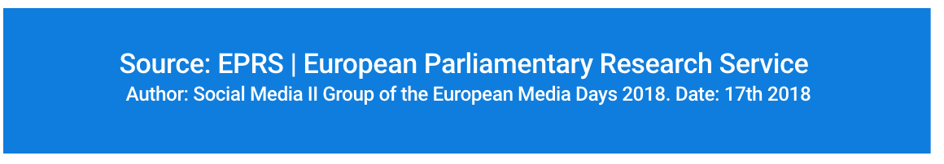

^ check the date, missing the month 17th October 2018

POSSIBLY PUT THIS AT THE TOP underneath the video as it sets out the objective of the website

What concerns European people?

The graphic below lists the 10 most important issues citizens currently believe the EU are facing. Stories on these topics will therefore likely surface throughout the media in the lead up to the European Elections next May. Democracy is one of the core values in the EU. However, for a democracy to flourish, people need to know that they can trust the news they read. Fake news is therefore a growing threat to our democracy and European values. This website will provide you with tools to spot and debunk fake news stories. We want you to stay informed without being misinformed.

**What are the main issues the EU is currently facing? (do you need this headline as the graphic list is described above^)**

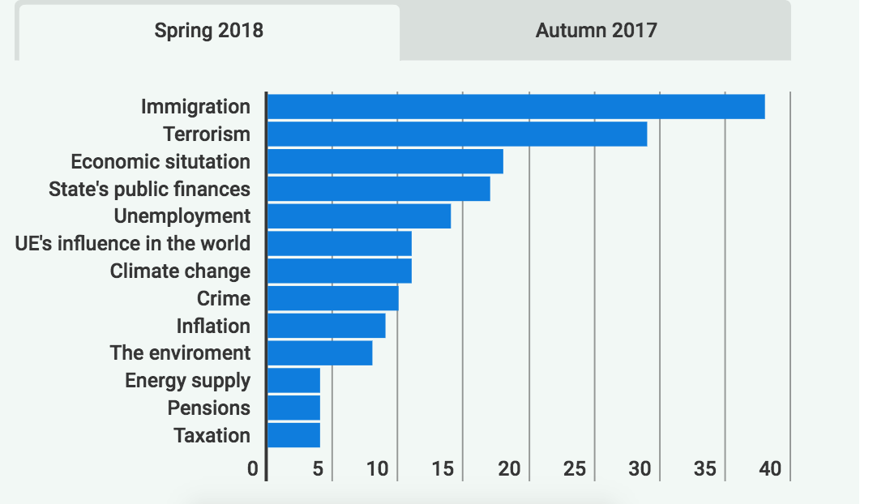

^ CORRECTION: UE’s influence in the world = EU

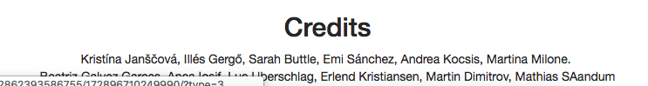

^SAandum TYPO on name