## CSCI 140 PA 1 Submission

## Due Date:3/3/2025 Late (date and time):_________________

## Name: Ean Zheng

Exercise 1 – zyBook 1.13 zyLab training: Basics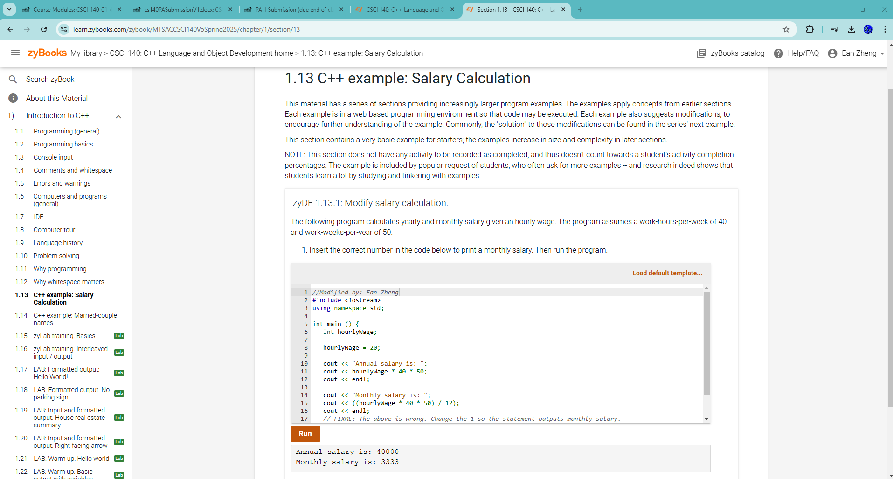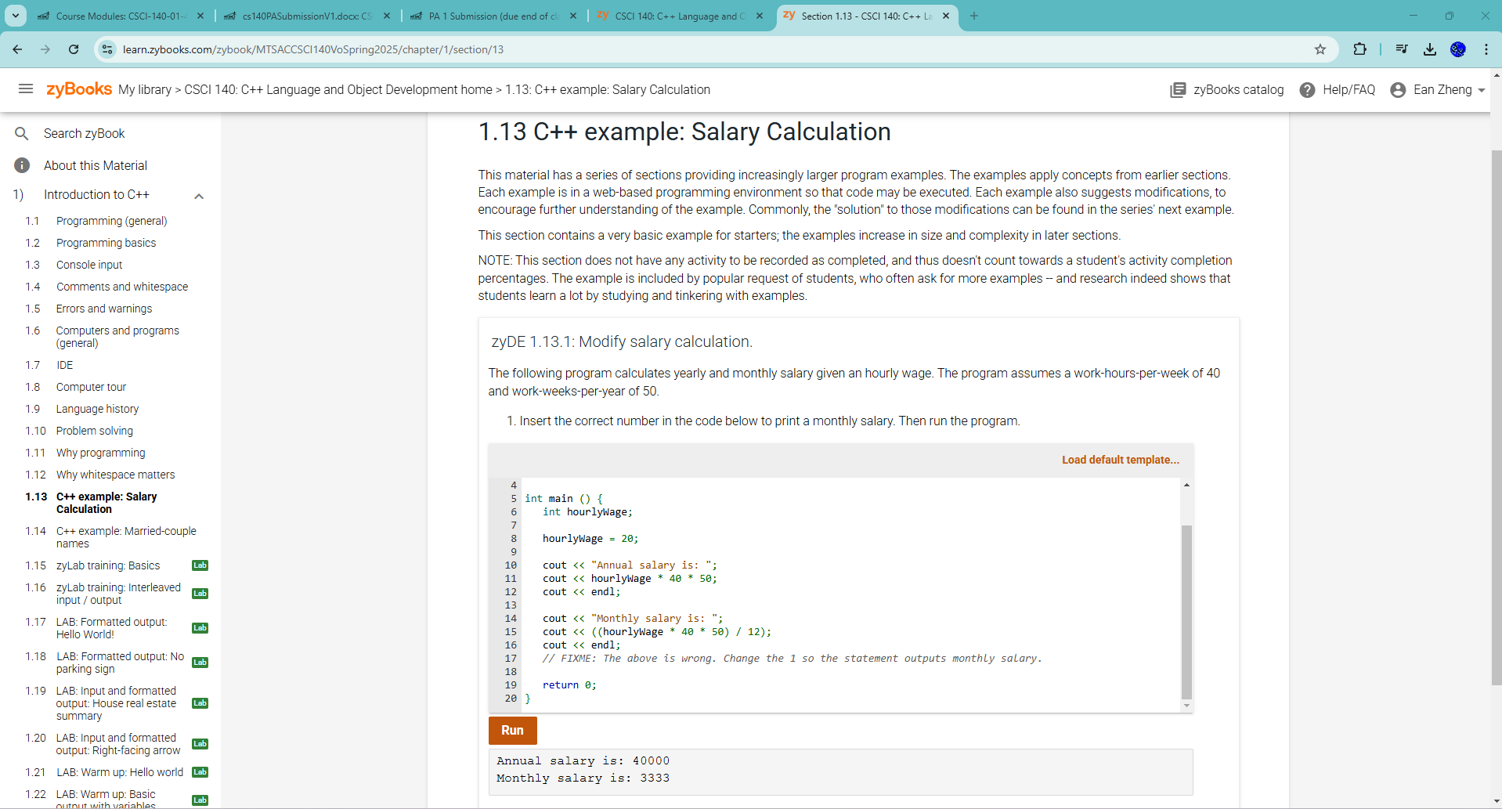

Exercise 1 – zyBook 1.15 zyLab training: Basics 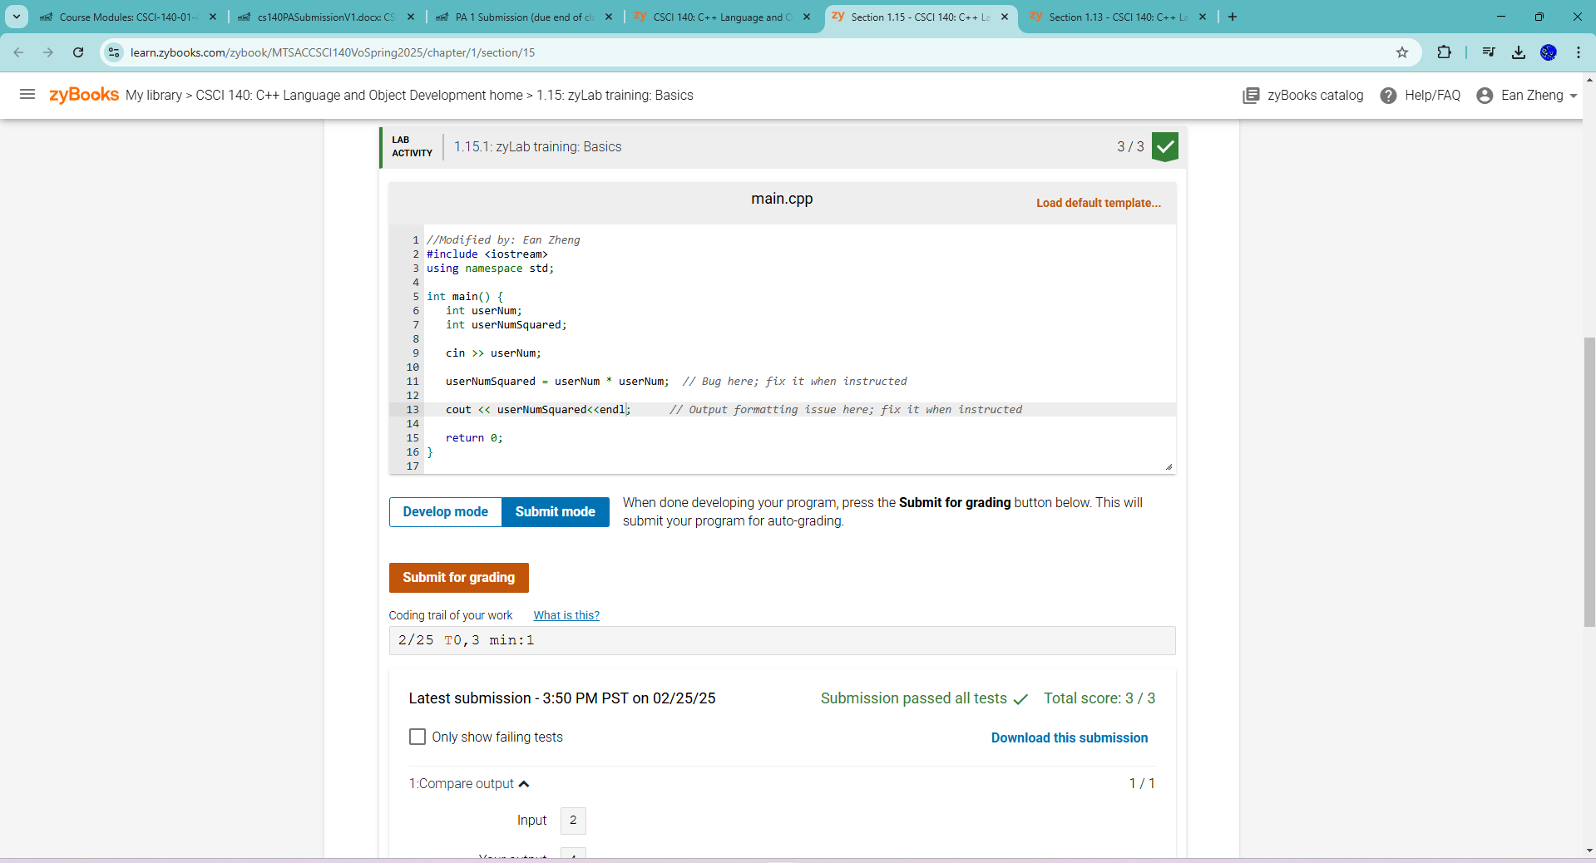 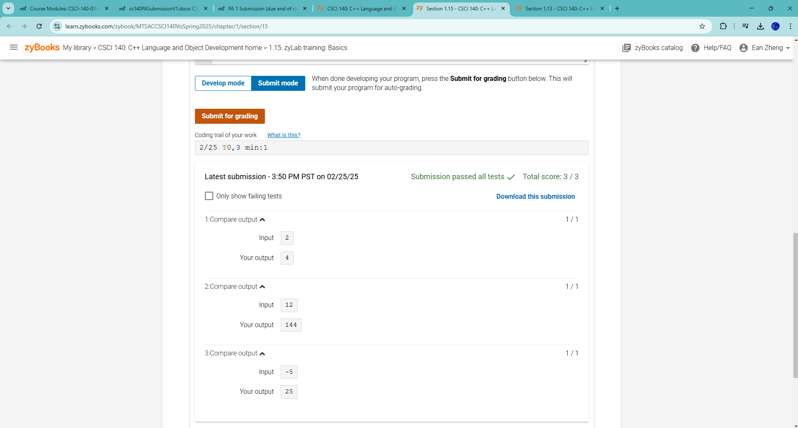  
Exercise 2 – zyBook 1.21 LAB*: Program: ASCII art  
Exercise 3 – zyBook 1.24 zyLab training: One large program  
Exercise 4 – zyBook 2.27 LAB: Driving costs  
Exercise 5 – zyBook 2.29 LAB: Using math functions  
Exercise 6 – zyBook 2.36 LAB*: Program: Painting a wall  
Exercise 7 – Writing Your First Program from Scratch  
Step 1: Develop a design that leads to an algorithm that will read in a number that  
represents the number of total seconds. The output will be the equivalent number of  
hours, number of minutes, and leftover seconds. For examples, an input of 10000  
seconds would be equivalent to 2 hours, 46 minutes, and 40 seconds. Provide  
pseudocode for this step.  
Step 2: Use your own IDE such as MS Visual Studio to develop your program. Call this  
program timeConversion.cpp. Translate pseudocode to C+ code. Compile the program.  
If you get compile errors, try to fix them, and recompile until your program is free of  
syntax errors.  
Step 3: Run the program with 10000 seconds. Is your output what you expect from the  
input you gave? If not, try to find and correct the logic error and run the program again.  
Continue this process until you have a program that produces the correct result. Try  
another value, 601 seconds, and confirm it produces the correct result as well.

Question 1: Explain why source code is much more important than executable code for  
a SW developer.  
Question 2: How do you know for sure that your program is working correctly?  
Extra Credit (2 points): Develop a design that leads to an algorithm and a program that  
will read in a positive integer that represents a potential value of 1 less than power of 2.  
The output will be “yes” for a 1 less than power of 2 and “no” when it is not. Some  
examples of yes: 0, 7, 4095. Some examples of no: 5, 10, 5000. You must start with  
pseudocode and provide pseudocode for this exercise in addition to the program and its  
output. Note: do not use bit shift operators and you may need selection, repetition, and  
possibly a function for this exercise