## CSCI 140 PA 2 Submission

## Due Date:3/10/2025 Late (date and time):_________________

## Name: Ean Zheng

Exercise 1 – zyBook 3.24 LAB: Interstate highway numbers

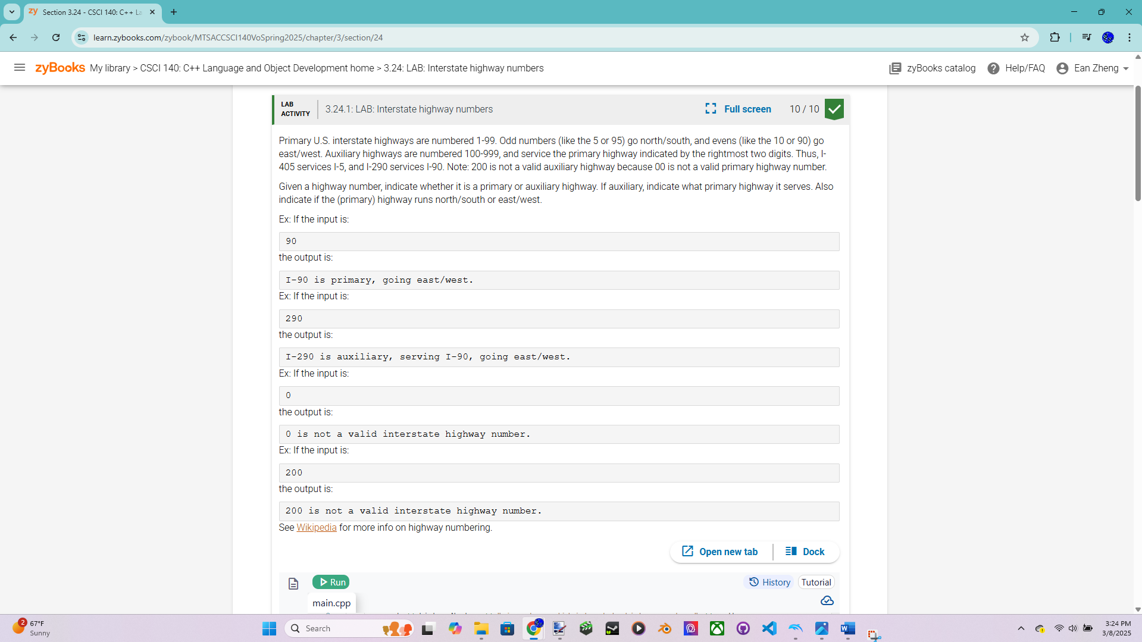

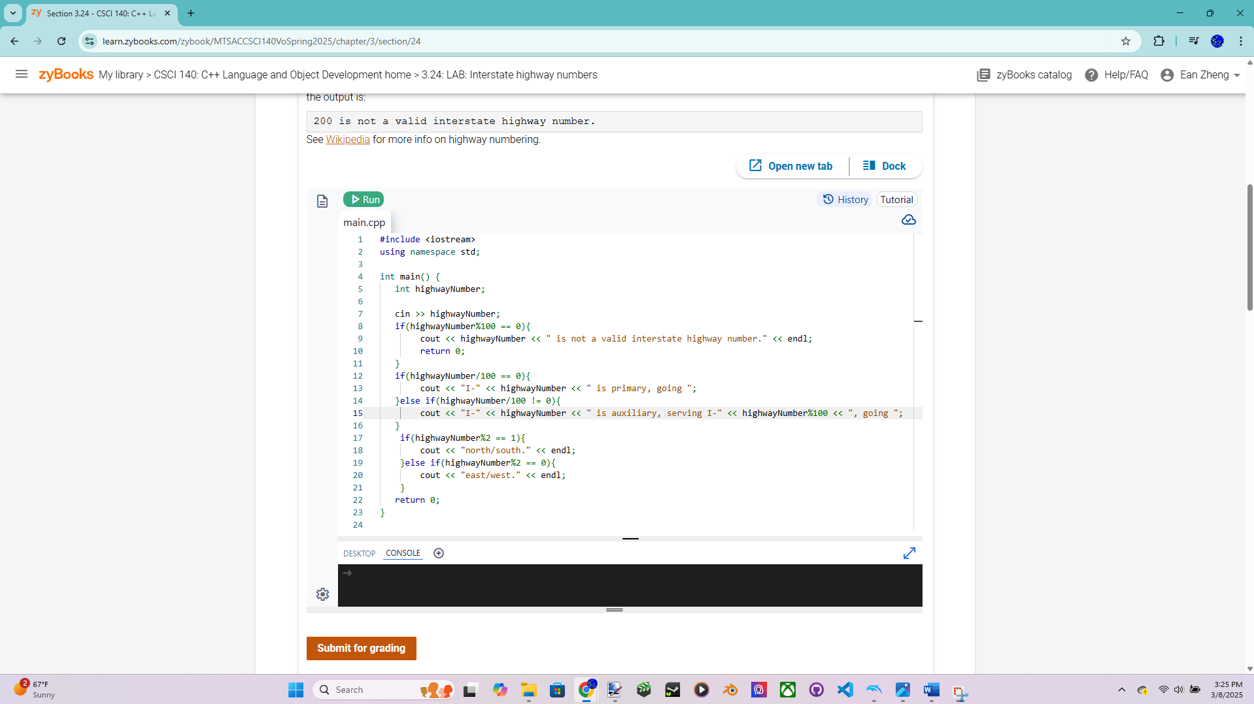

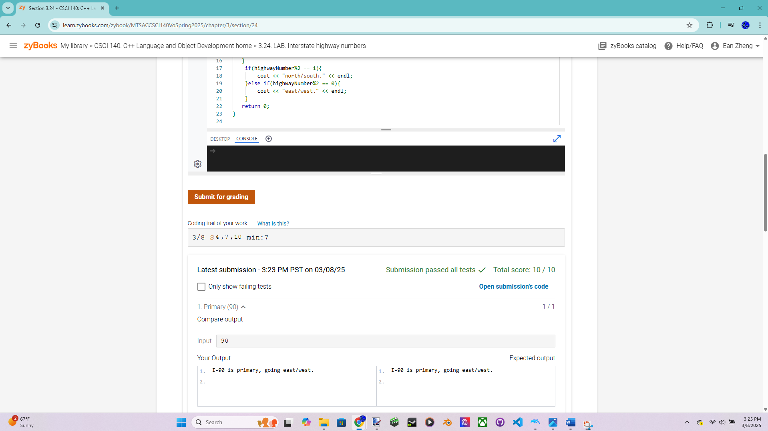

Exercise 2 – zyBook 3.26 LAB: Exact change

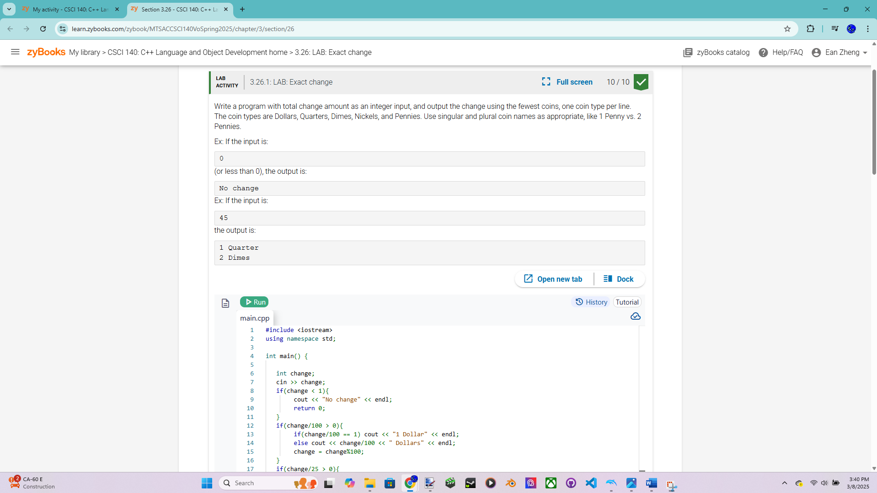

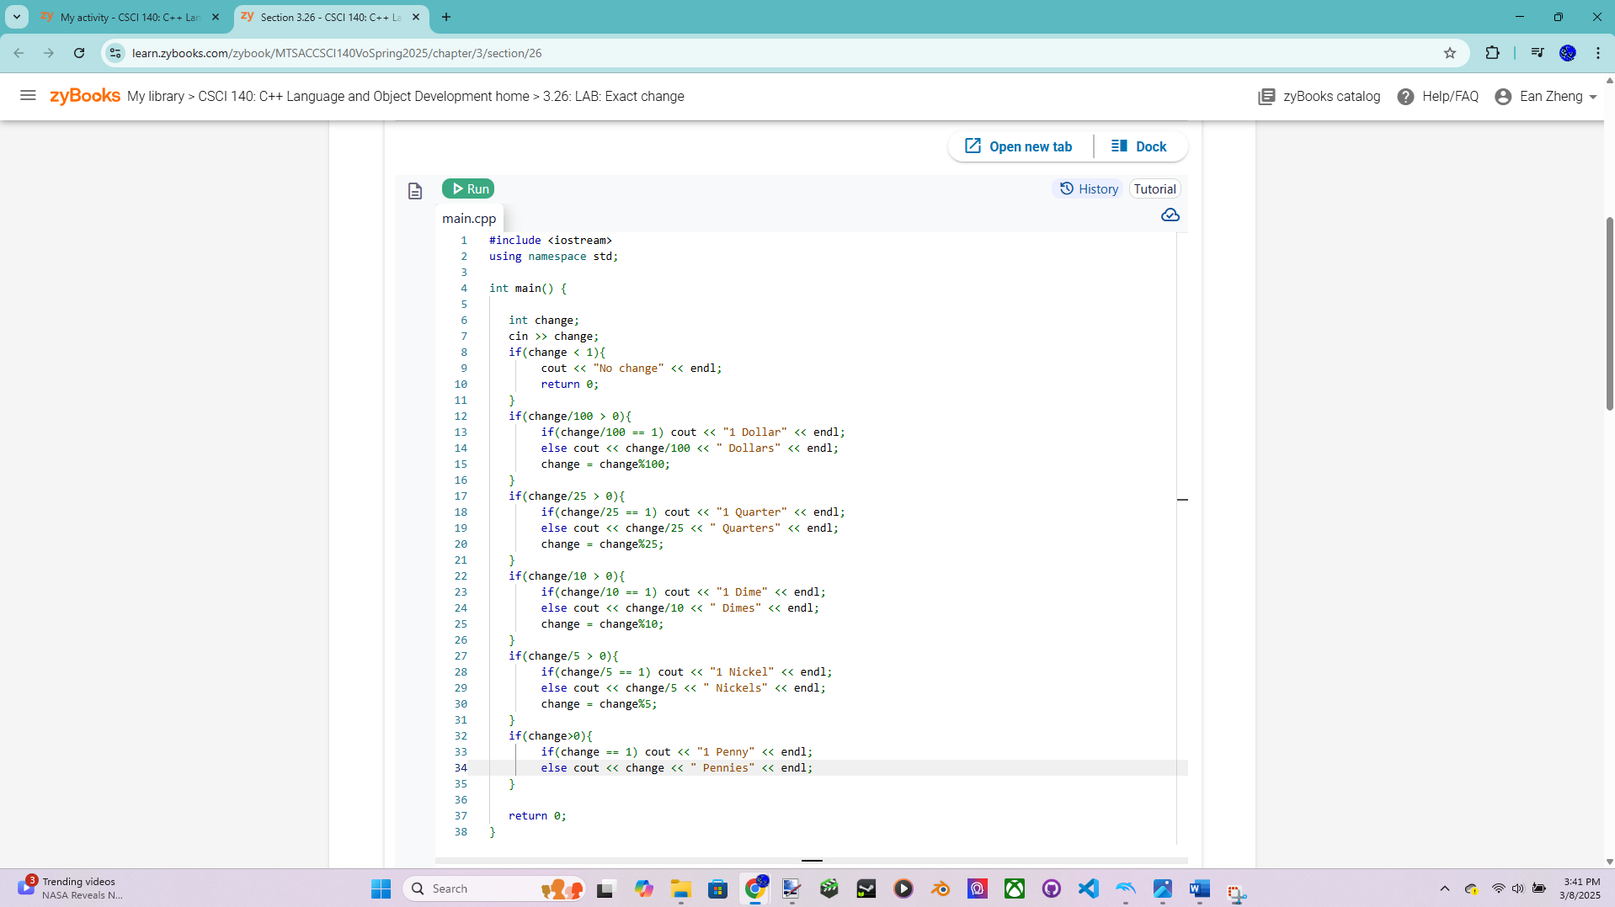

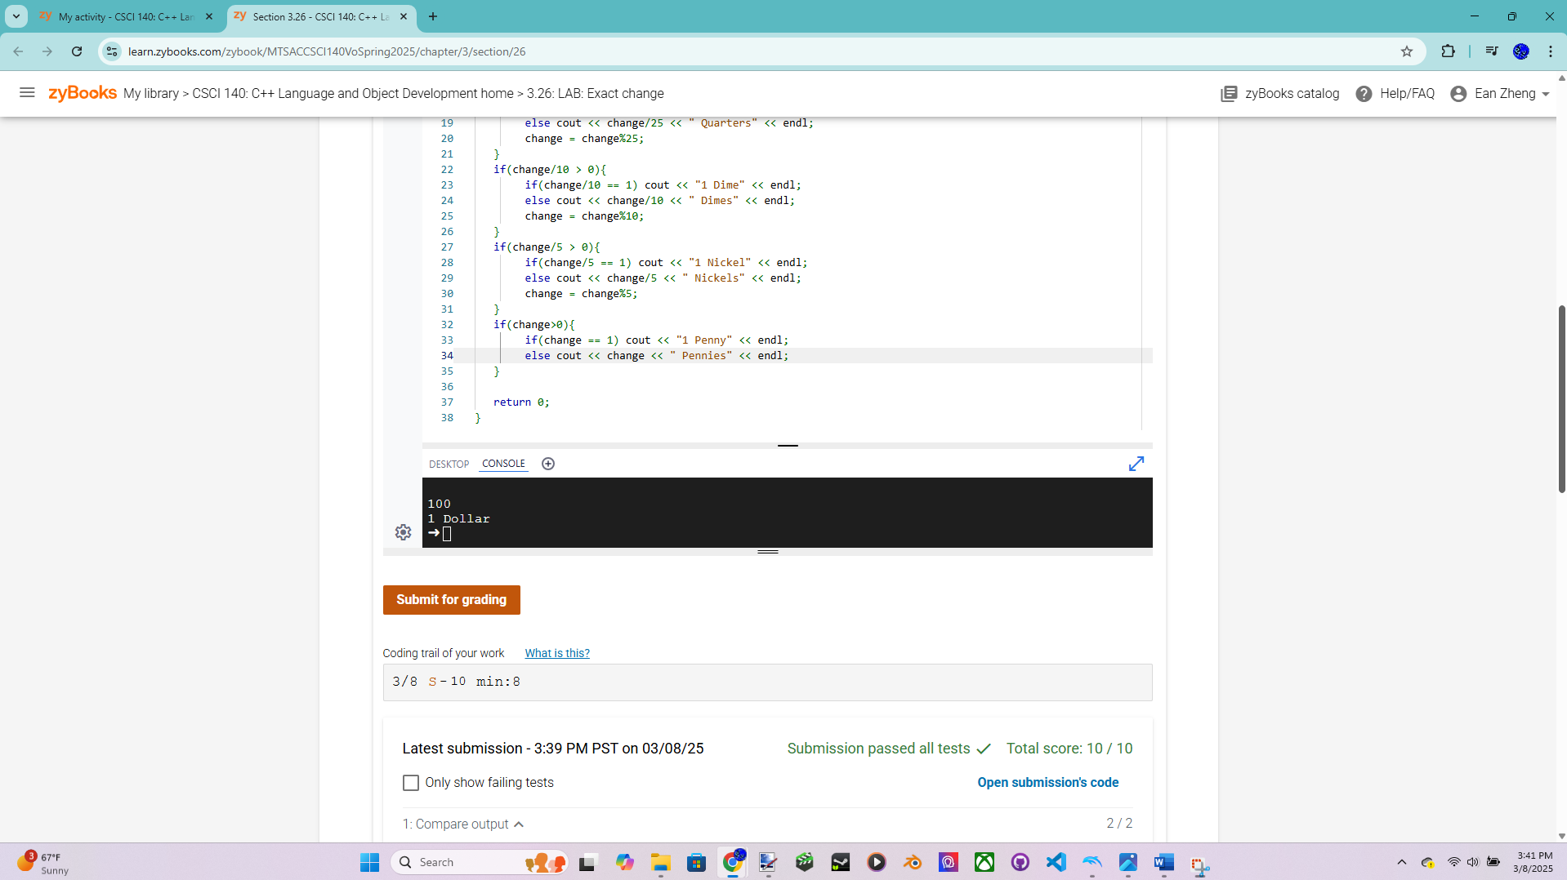

Exercise 3 – zyBook 3.31 LAB*: Program: Text message expander

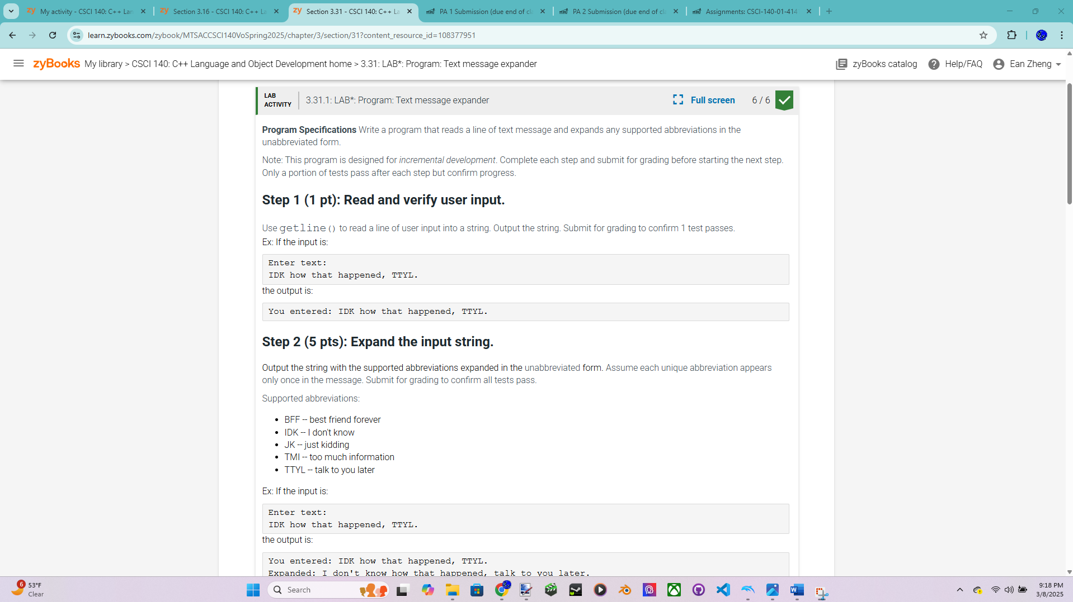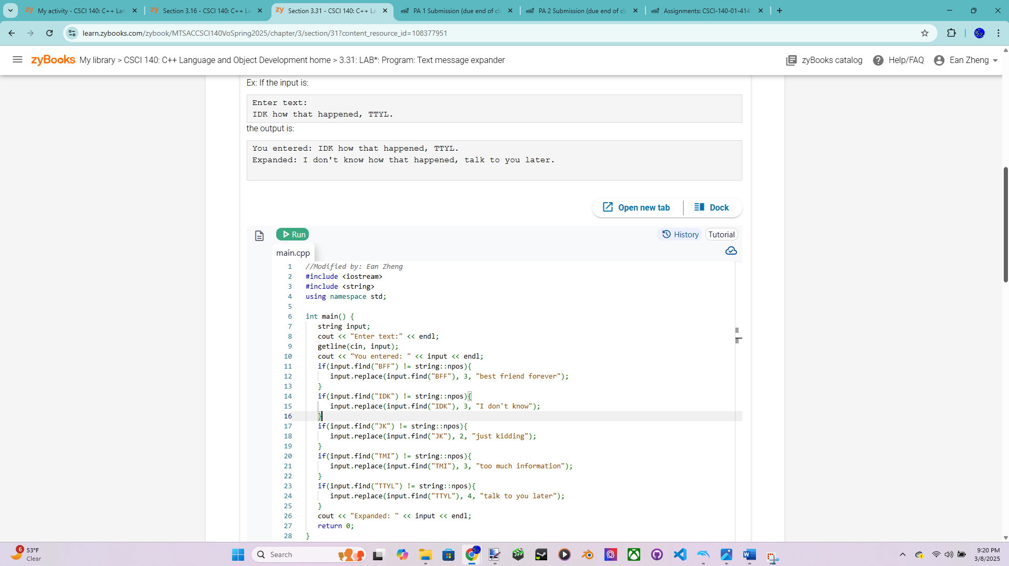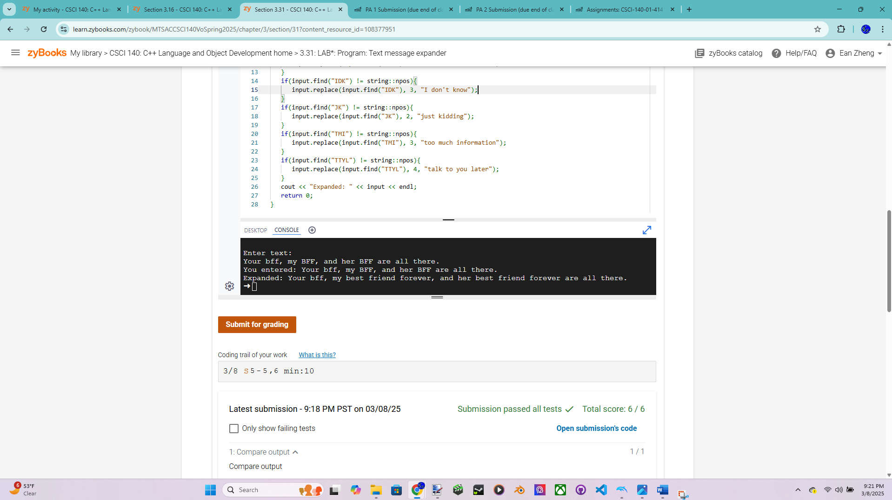

Exercise 4 – Simple Vending Machine Version 1 – more points for this exercise  
Pseudocode below if applicable:

Source code below:

Input/output below:

Question 1: What is the main difference between an expression and a condition? Can  
you use an expression when a condition is required in C++ (e.g., use a + b as a  
condition)? Why or why not?  
Question 2: It is easy to convert a switch statement to a nested if statement and it can be  
quite difficult to convert a nested if statement to a switch statement. Provide an example  
or situation to show that it can be quite difficult to convert a nested if statement to a  
switch statement.  
Extra Credit (2 points): Text message expander V2; copy your working code from  
exercise 3 to your IDE and modify it so it would expand all abbreviations. For example:  
Input: IDK how that happened, TTYL. IDK and TTYL.  
Output: I don't know how that happened, talk to you later. I don't know  
and talk to you later.  
Fill out and turn in the PA submission file with this lab (save as PDF format).