## CSCI 140 PA 4 Submission

## Due Date:3/24/2025 Late (date and time):_________________

## Name(s):Ean Zheng

Exercise 1 – 5.25 LAB: Middle item; can use an array or a vector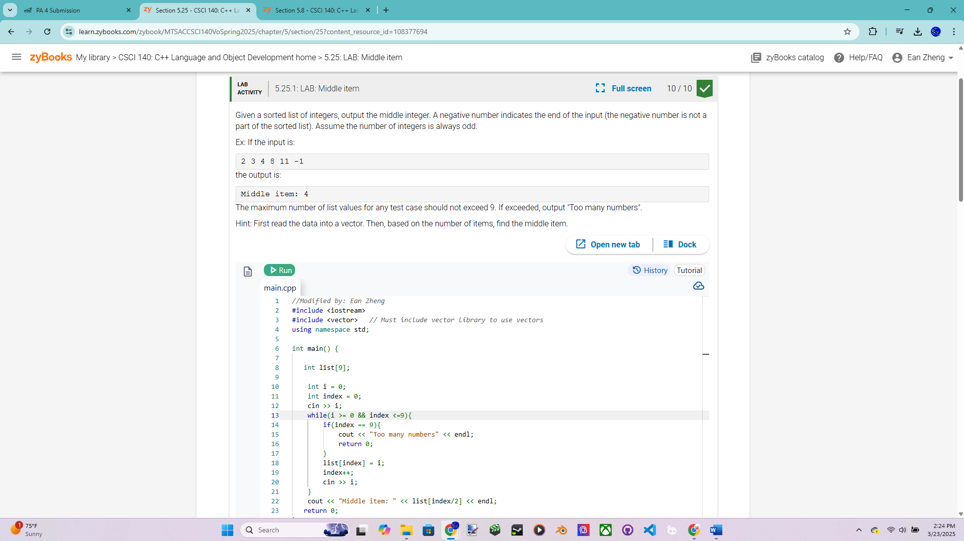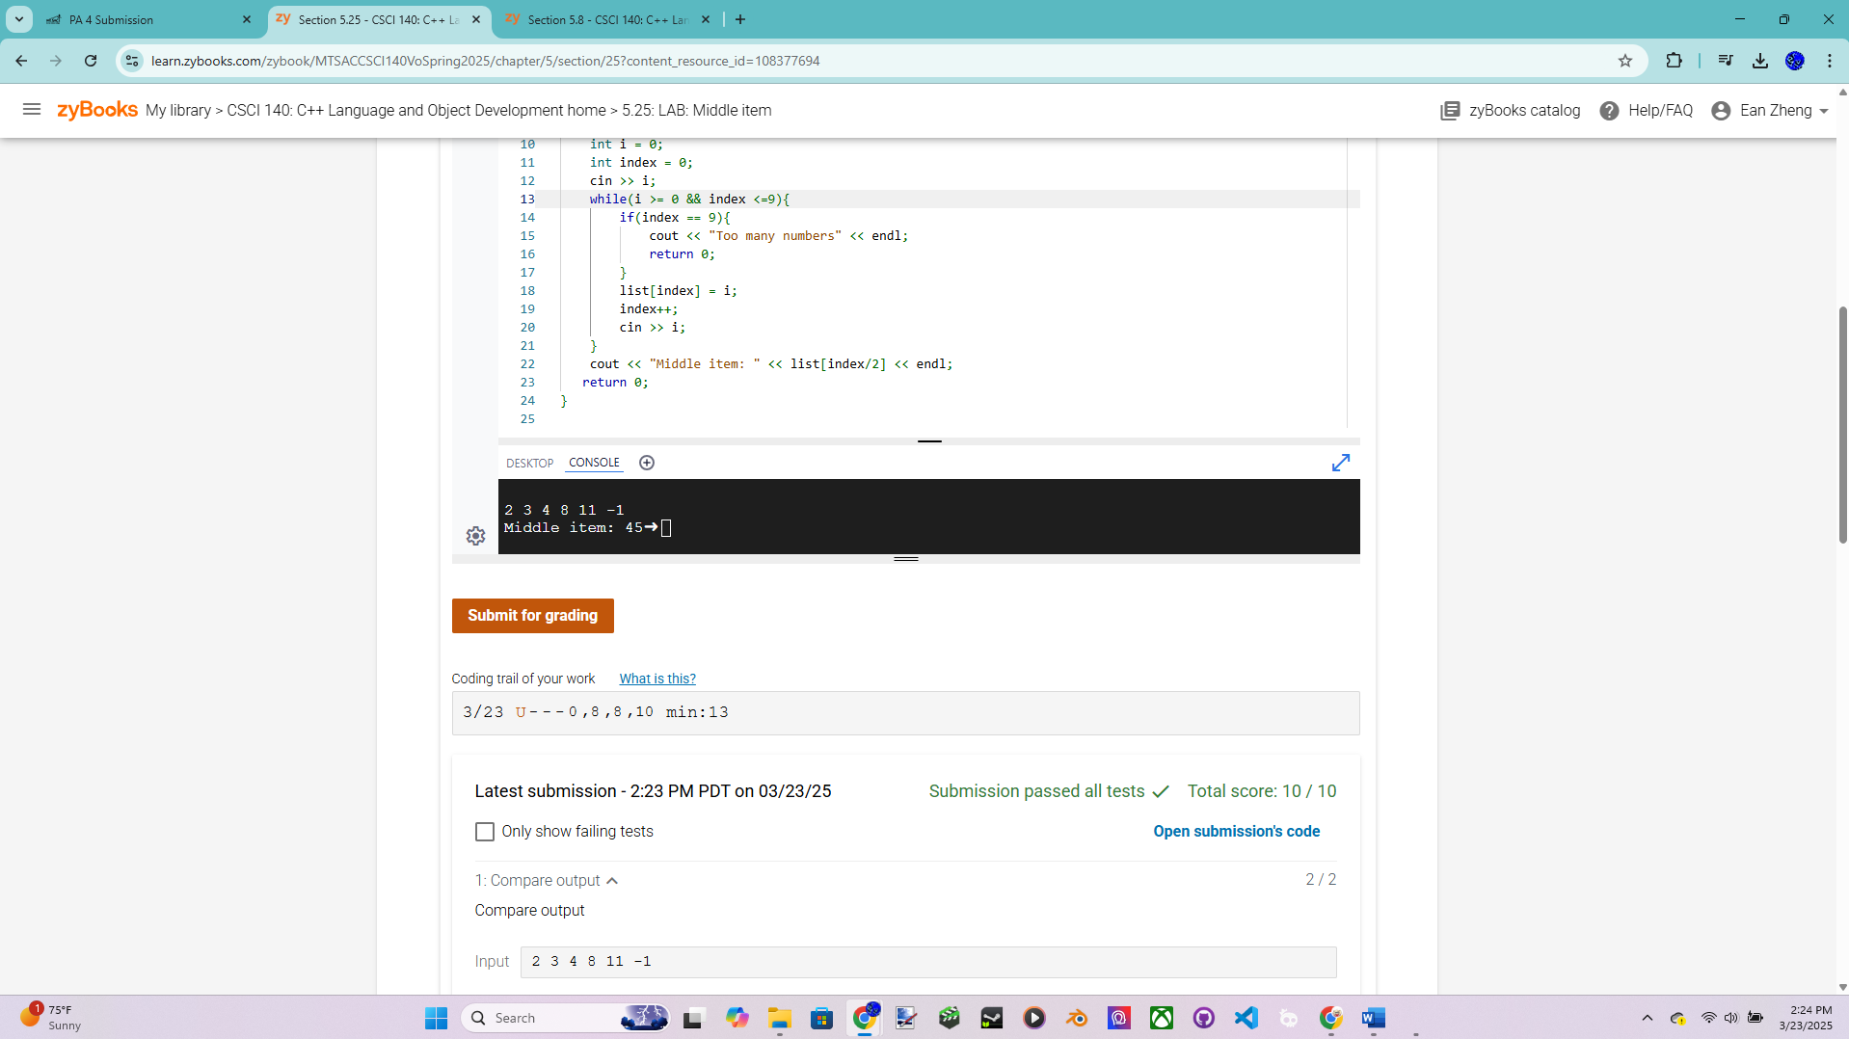

Exercise 2 – 5.29 LAB: Word frequencies

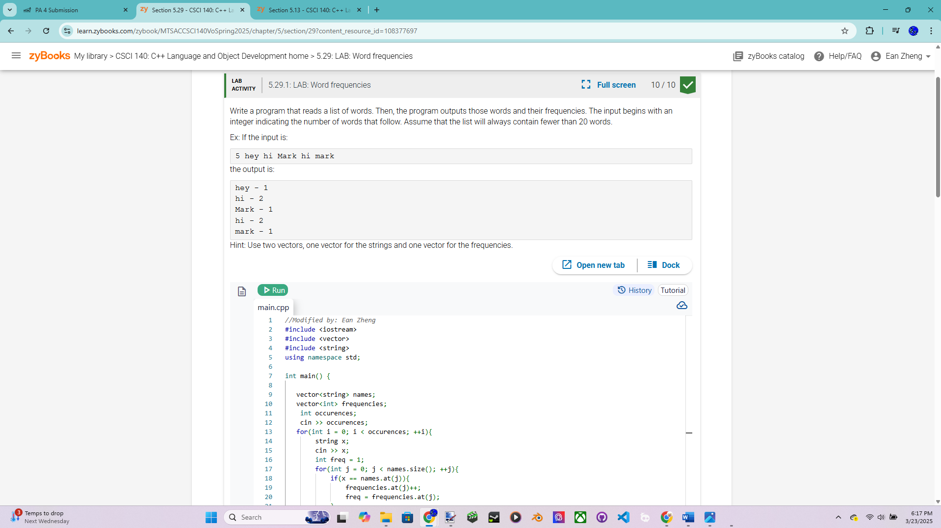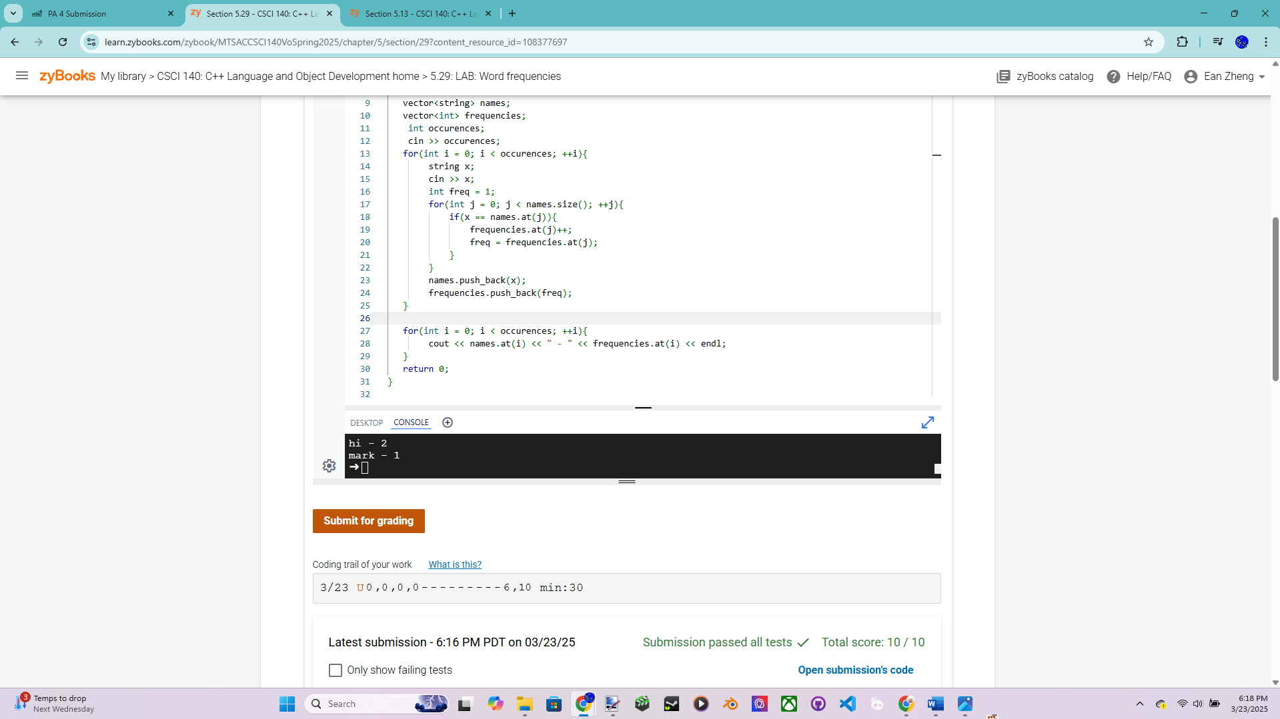

Exercise 3 – 5.35 LAB: Warm up: People's weights (Arrays)

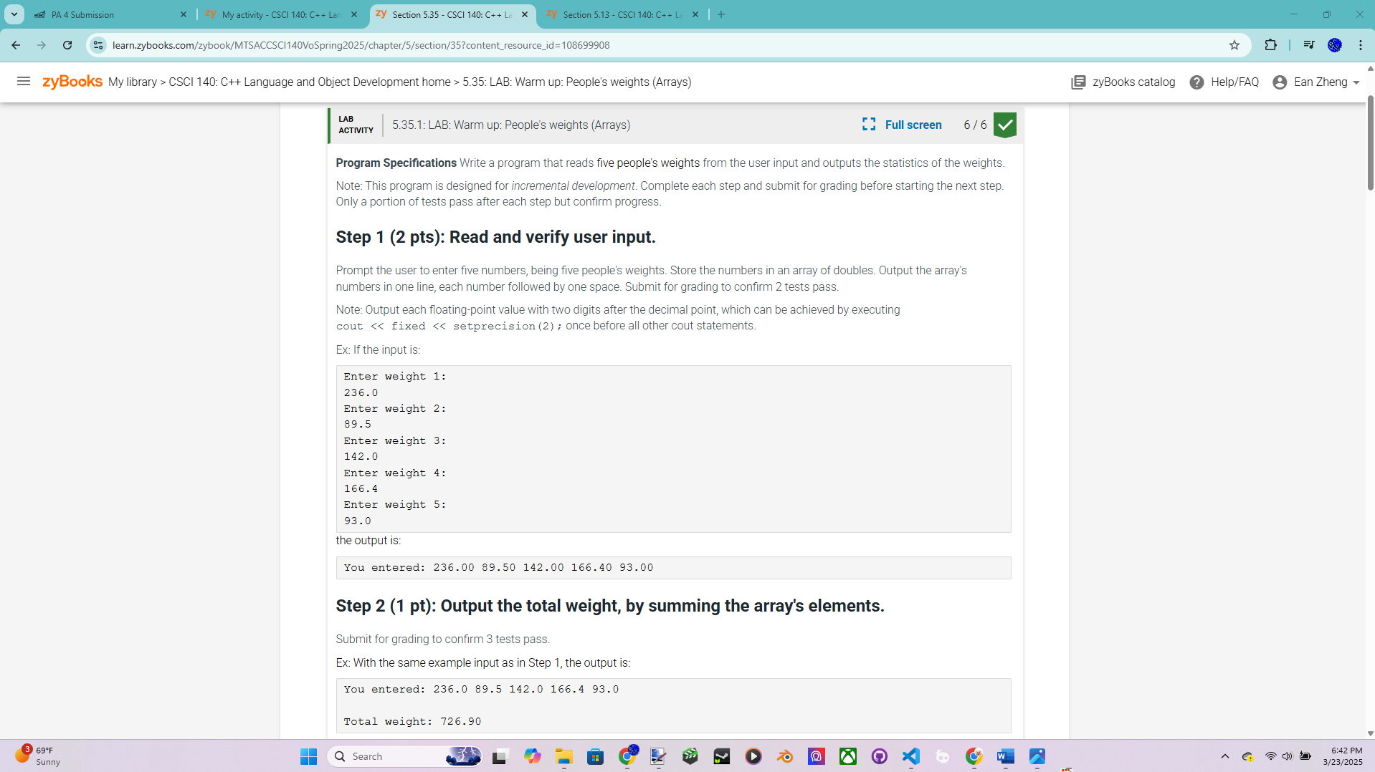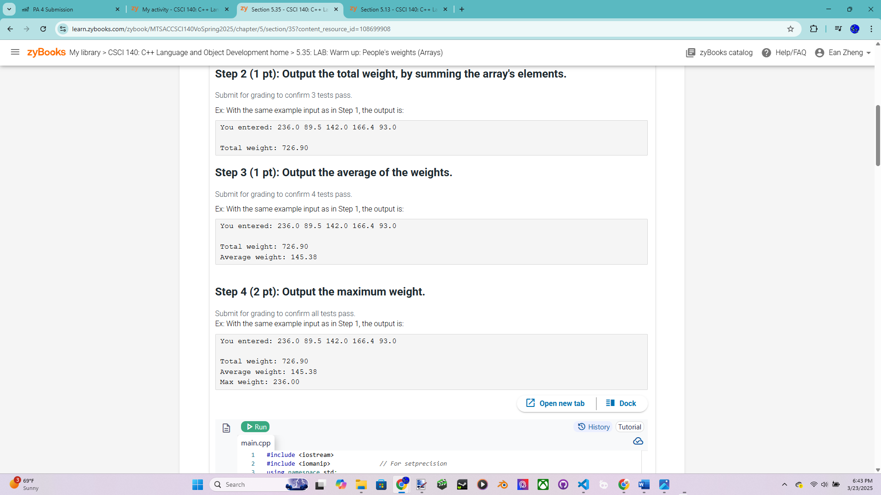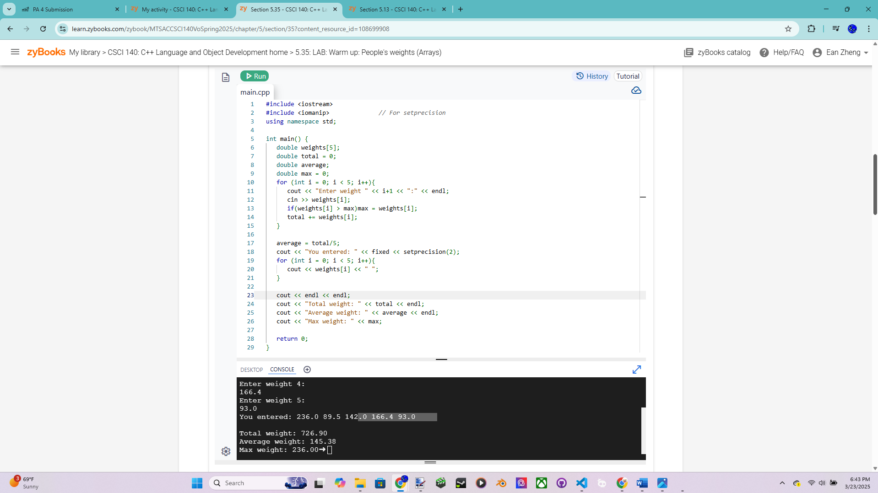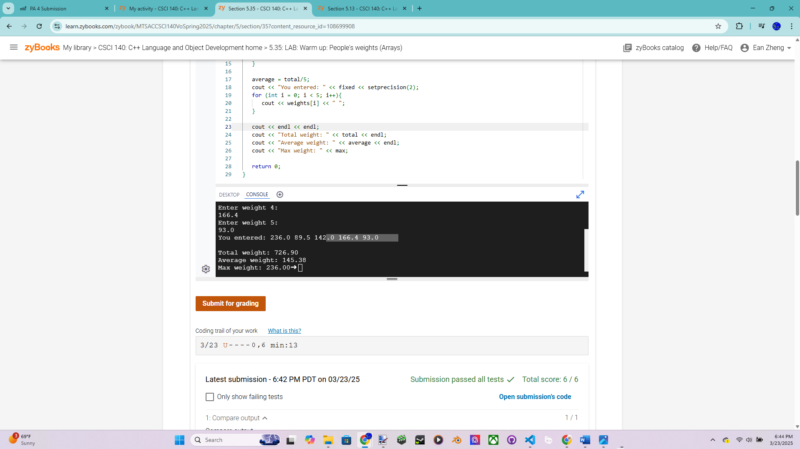

Exercise 4 – Large Integers – more points for this exercise  
If you need to work with very large integers such as applications in data encryption and  
decryption, you may not be able to use data type int or even the new long long int. A  
string or an array of integers can be used to store a large integer, but it is easier to  
perform basic arithmetic operations with an array or vector of integers. There are many  
ways you can store the digits in an array or vector: {1, 2, 3, 4, 0 ... 0}, {4, 3, 2, 1, 0 ...  
0}, or {0 ... 0, 1, 2, 3, 4,}. For this exercise, the integer 1234 MUST be stored in an int  
array a or int vector a by setting a[0] to 4, a[1] to 3, a[2] to 2, and a[3] to 1 and the  
number of digits (4) can be stored in a separate variable (the second way). Unused digits  
will be initialized to 0 and you might need a variable such as numDigits or  
lastIndex to keep track of the number of actual digits.

Source code below:

/* Program: Large Integers Program for Exercise 4, PA Submission 4

Author: Ean Zheng

Class: CSCI 140

Date: 3/23/2025

Description:

I certify that the code below is my own work.

Exception(s): N/A

*/

#include <cstring>

#include <iostream>

using namespace std;

int main()

{

cout << "Author: Ean Zheng" << endl;

int array[25];

char cstring[26];

cout << "Enter a large integer up to 25 digits ---> ";

cin >> cstring;

if(strlen(cstring)>25){

cout << "Error: too many digits";

return 0;

}

for (int i = 0; i < strlen(cstring); i++){

array[i] = cstring[strlen(cstring)-1-i]-48;

}

for (int i = strlen(cstring); i < 25; i++){

array[i] = 0;

}

cout << "Digits: ";

for (int i = 0; i < 25; i++){

cout << array[i] << " ";

}

cout << endl << "Number of digits: " << strlen(cstring);

return 0;

}

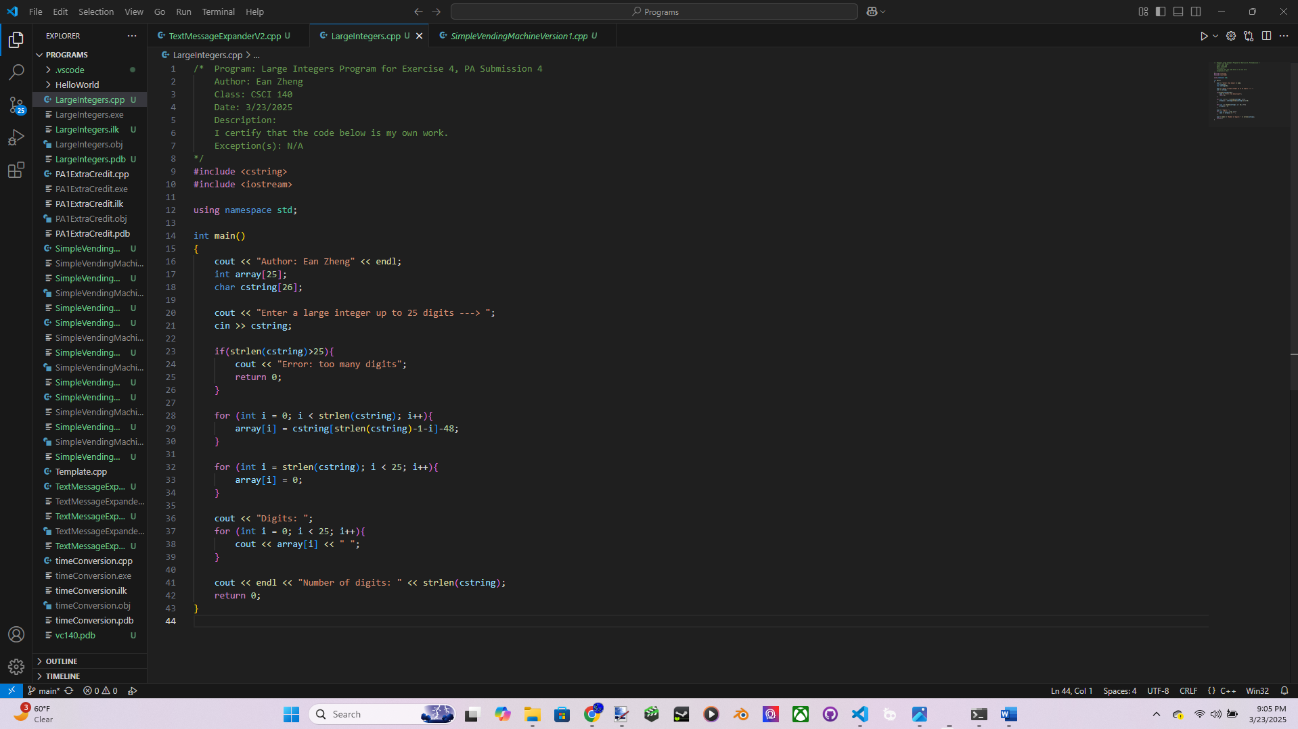

Input/output below:

Author: Ean Zheng

Enter a large integer up to 25 digits ---> 0

Digits: 0 0 0 0 0 0 0 0 0 0 0 0 0 0 0 0 0 0 0 0 0 0 0 0 0

Number of digits: 1

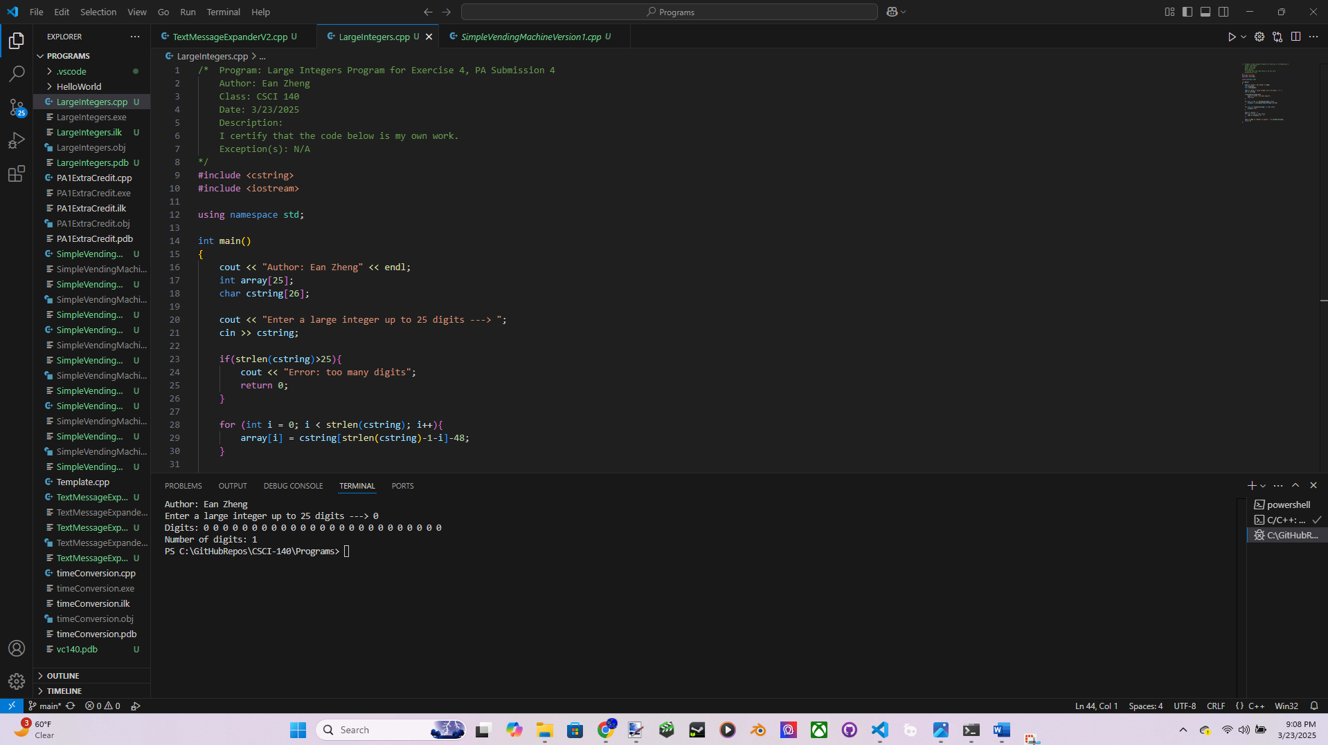

Author: Ean Zheng

Enter a large integer up to 25 digits ---> 1234

Digits: 4 3 2 1 0 0 0 0 0 0 0 0 0 0 0 0 0 0 0 0 0 0 0 0 0

Number of digits: 4

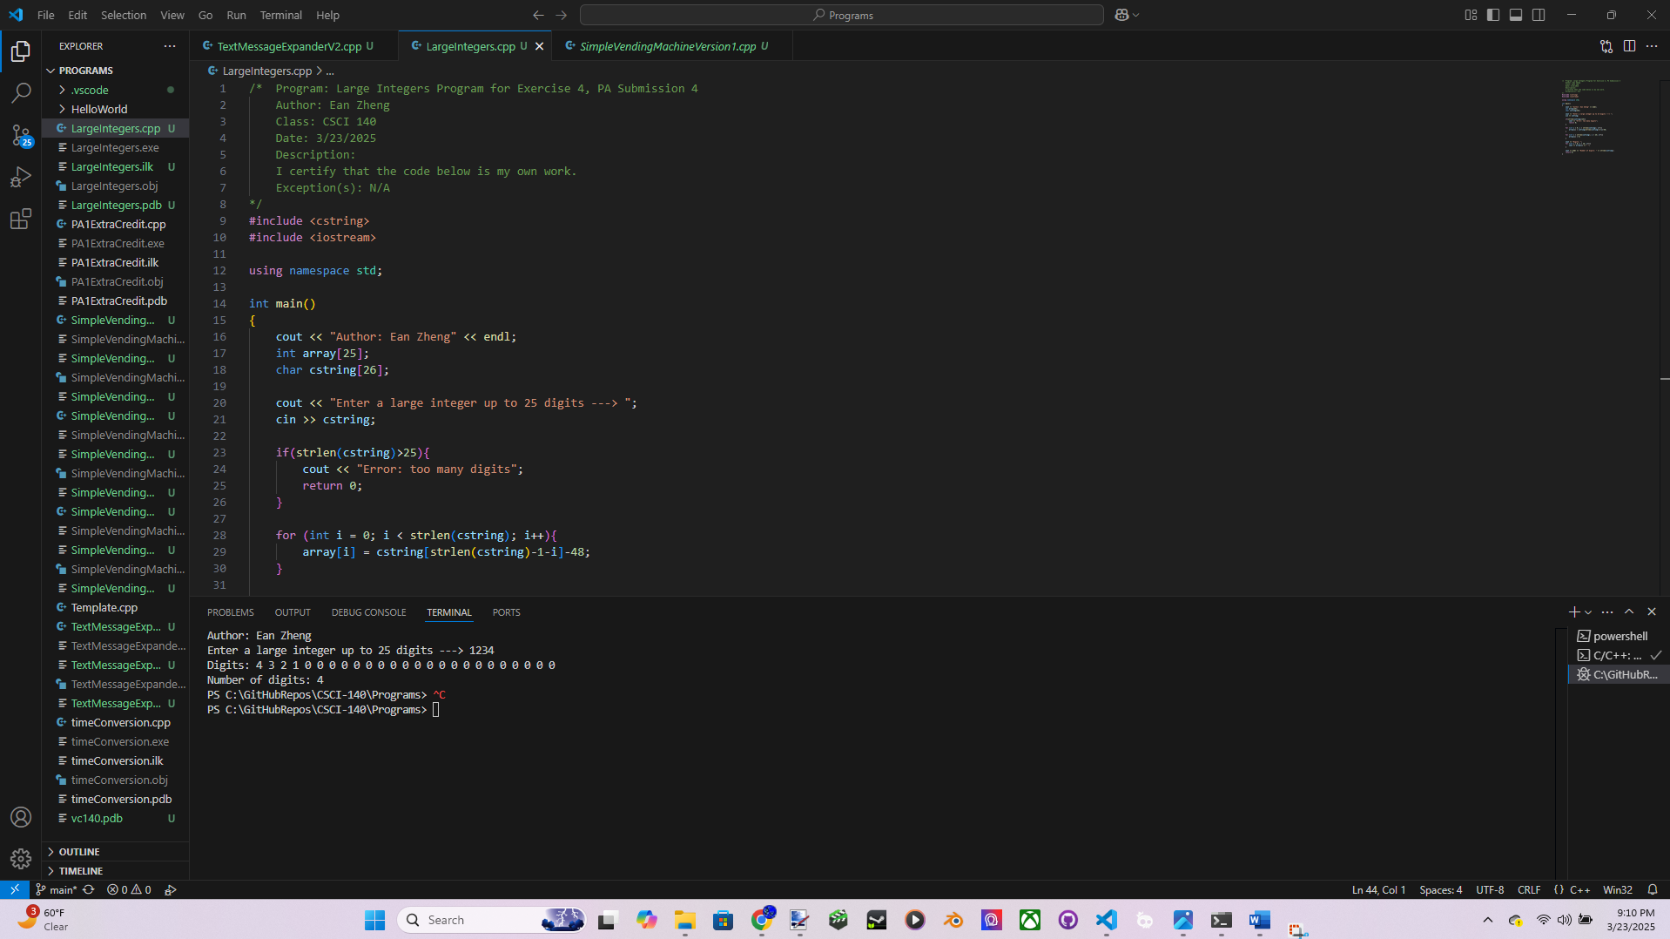

Author: Ean Zheng

Enter a large integer up to 25 digits ---> 5432109876543210987654321

Digits: 1 2 3 4 5 6 7 8 9 0 1 2 3 4 5 6 7 8 9 0 1 2 3 4 5

Number of digits: 25

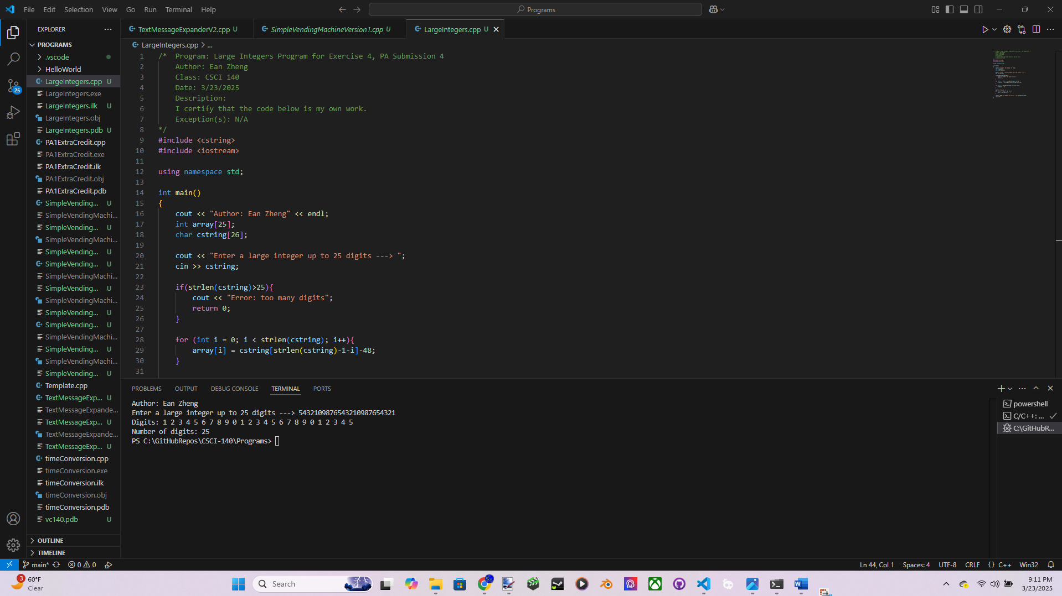

Author: Ean Zheng

Enter a large integer up to 25 digits ---> 12345678901234567890123456789

Error: too many digits

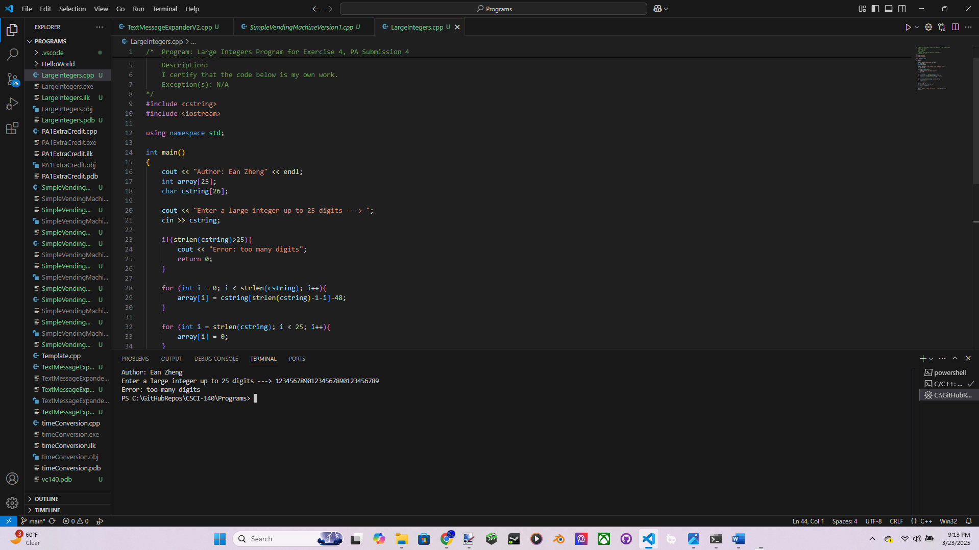

Question 1: Although C++ vectors can be more productive (getting things done quicker), list some good reasons for learning and using arrays instead of C++ vectors.

Arrays are more compact and use less space, and their set size are desirable for some cases. They also don’t require additional stl headers, reducing compile time. Fixed size arrays can also be directly embedded, improving memory locality and reducing the amount of heap allocations that are needed.

Question 2: Given two int arrays with the same size, arrX and arrY, you simply cannot  
copy array arrY to array arrX with “arrX = arrY;”? Explain why not. How would  
you go about copying arrY to arrX?

You can’t copy one same-size array to another with a simple assignment because they have multiple values/instances. Simple assignment only works on two simple and exact instances, and don’t work for multiple at once. I would copy arrY to arrX with a for loop that indexes and accesses the values of the two arrays, and assigns them each one by one until the number of iterations reaches the arrays’ sizes.

Extra Credit (2 points): Start with 5.30 (LAB: Contains the character) in zyBook first  
and then modify it so that it does not display the trailing comma. You can copy the  
source code from zyBook to your development environment and then modify it. Make  
sure to provide the source code and sample input/output.  
Ex: If the input is:  
4  
hello zoo sleep drizzle  
z  
then the output is:  
zoo,drizzle

Source Code:

//Modified by: Ean Zheng

#include <iostream>

#include <vector>

using namespace std;

int main() {

vector<string> list;

int size;

cin >> size;

for (int i = 0; i < size; ++i) {

string s;

cin >> s;

list.push_back(s);

}

char specialChar;

bool first = true;

cin >> specialChar;

for (int i = 0; i < size; ++i) {

if(list.at(i).find(specialChar) != string::npos){

if(!first)

cout << ",";

else

first = false;

cout << list.at(i);

}

}

cout << endl;

return 0;

}

Input/Output:

4

hello zoo sleep drizzle

z

zoo,drizzle

