## CSCI 140 PA 8 Submission

## Due Date: 4/28/2025

## Name(s): Ean Zheng

Exercise 1 – 8.19 LAB: Mad Lib (Pointers)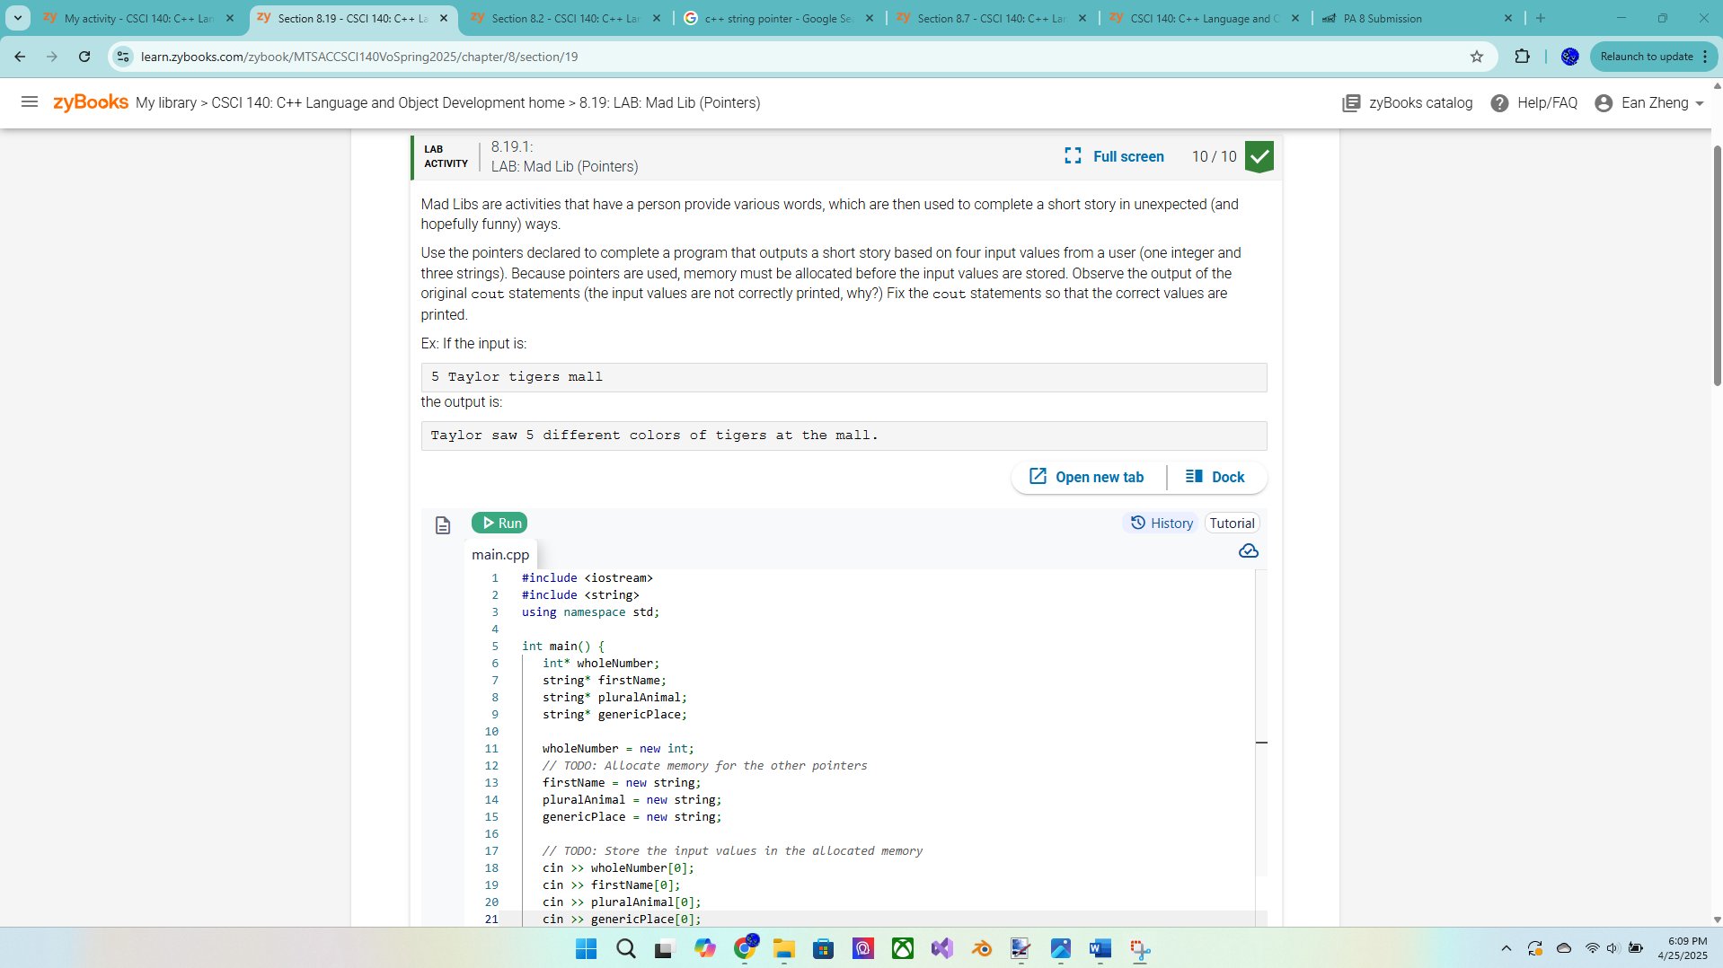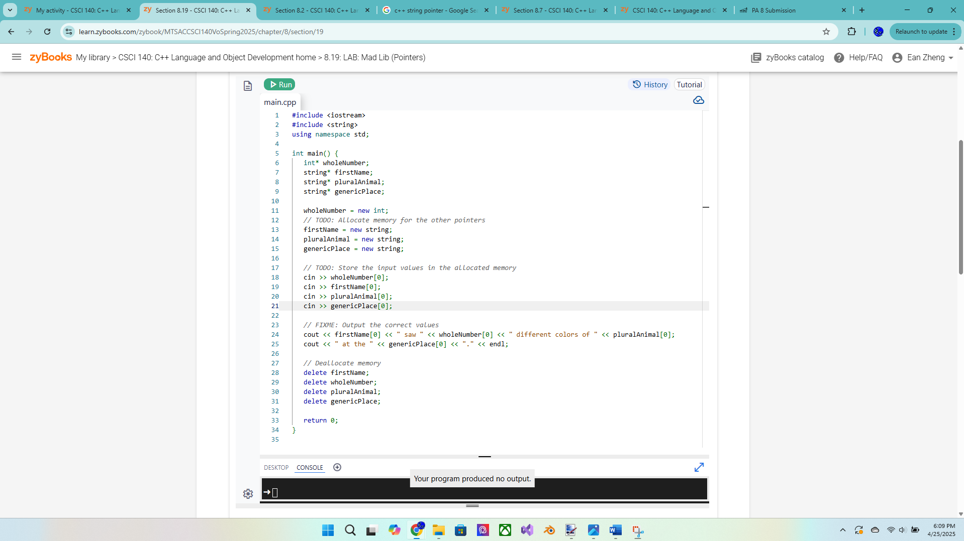

Exercise 2 – 8.20 LAB: Update GPA

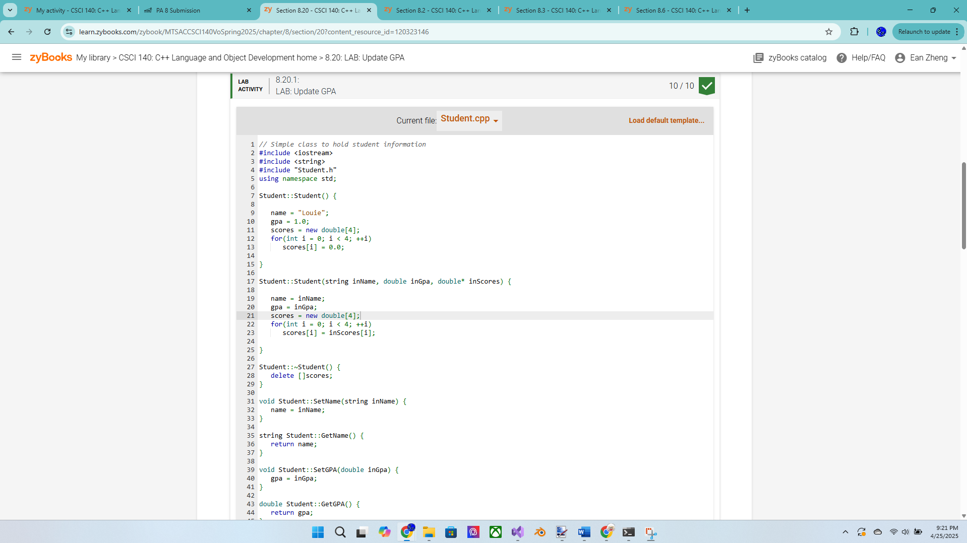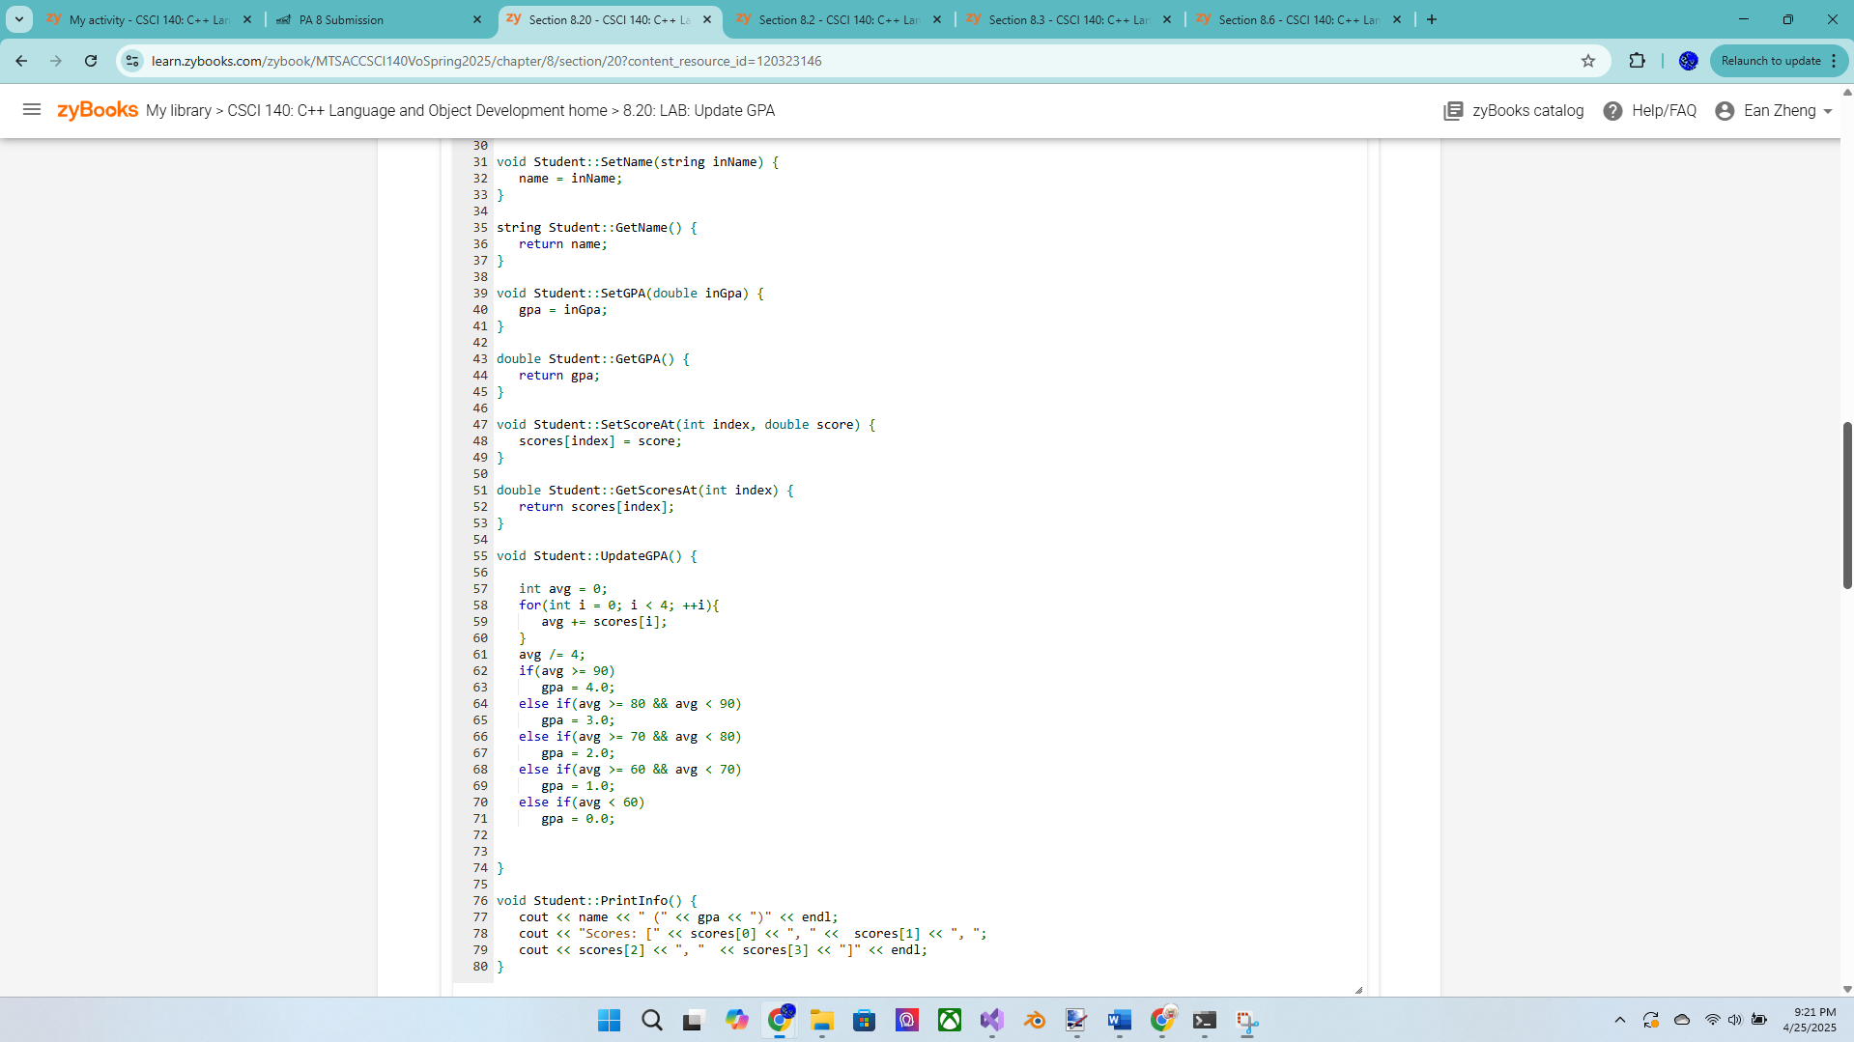

Exercise 3 – Dynamic Array  
Write a program that will process monthly sales using a dynamically allocated array. The  
program will call a function inputValues (prototype below) to input the size of the array  
from the user as well as the monthly sales into the dynamic array. It will call a function  
sumValues (prototype below) to compute and return the total sales (the sum of all the  
sales). The program will display both the total sales and the average monthly sales with 2  
digits after the decimal point. It also calls the same function to compute and return the  
total sales of all the months except the first month (hint: call the function a bit differently  
and you can also use another pointer for this call). It will then display both the new total  
sales and the new average monthly sales with 2 digits after the decimal point. Make sure  
to return allocated array when you are done.  
// function prototype  
double sumValues(double *pArr, int n);  
int inputValues(double *pArr);  
Sample output:  
Please enter the number of monthly sales --> 4<Enter>  
Please input the sales for month 1 --> 1290.89<Enter>  
Please input the sales for month 2 --> 905.95<Enter>

Please input the sales for month 3 --> 1567.98<Enter>  
Please input the sales for month 4 --> 994.83<Enter>  
Total sales (all months): $4759.65  
Average monthly sales (all months): $1189.91  
Total sales (without first month): $3468.76  
Average monthly sales (without first month): $1156.25  
Returning dynamic memory ...  
Done.

Exercise 4 – MyInteger class – more points for this exercise  
You will work with MyInteger class (like an int, but it will be an object that holds an int  
value using a pointer) by obtaining the two files, MyInteger.h and testMyInteger.cpp,  
from Canvas. Create the file MyInteger.cpp by implementing the member functions for  
the class. Confirm that the class is working correctly (i.e., correct output, copy object  
correctly, no memory leak, will not crash, etc.).  
Question 1: Discuss one advantage and one disadvantage when working with dynamic  
memory.  
Question 2: What is a friend function? Do we have to use friend functions? Explain  
why or why not.  
Extra Credit (2 points): 8.25 LAB: Playlist (output linked list)