## CSCI 140 PA _____ Submission

## Due Date:____________ Late (date and time):_________________

## Name(s):____________________ & _______________________

Exercise 1 – provide zyBook lab such as **zyBook 1.15 LAB: Formatted output: Hello World!** as applicable   
 -- check if completely done in zyBook __X__ ; otherwise, discuss issues below  
Include a screenshot of current status/score

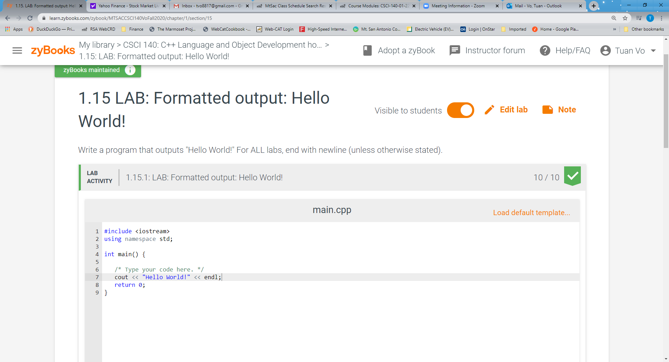

Exercise 2 – provide more zyBook lab as applicable   
 -- check if completely done in zyBook ____ ; otherwise, discuss issues below  
Output seems correct but failed one test case (an example when it is not done and failed some test cases)  
Include a screenshot of current status/score

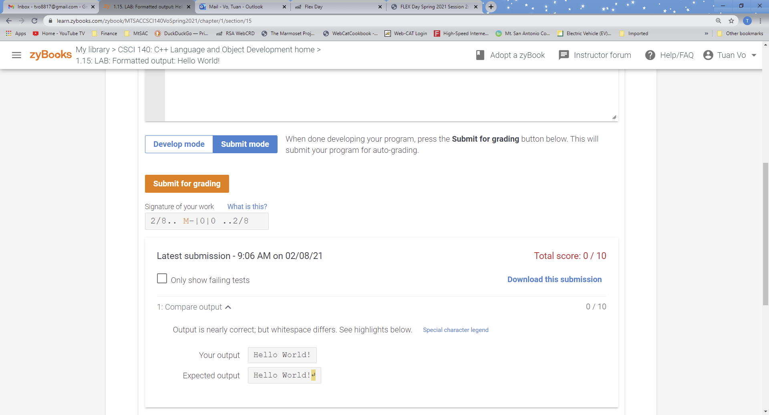

*Add more exercises as needed*

Exercise n -- use for a non-zyBook exercise; need to submit source code and I/O  
 -- check if completely done ____ ; otherwise, discuss issues below

Pseudocode below if applicable:

Source code below:

Input/output below:

Answer for Question 1

Answer for Question 2

Extra Credit – provide if applicable