Server Room Server Remodeling Proposal
Mat Covert, Jeremy Jordan, Daniel Powell, Connor Klingenburg

Objective: Remodel the IP’s and how routing is handled to ensure IP overlap is unlikely by using different IP ranges between the management network (MGMT) storage, and VMs/Capstones.

Table of Contents
Current configuration 2
IP ranges 2
VLANS 2
Routing 3
Proposed Solution 4
IP Ranges 4
VLANS 4
Routing 5
Argument 6
Steps/Testing 6

Current configuration
As of right now (May 2022) the current configuration is as follows for how IPs and VLANs are used in the server room.

IP ranges
- Network 10.0.0.0/16
- MGMT: 10.0.10.0/24
- Storage: 192.168.10.0/24
- VMs/Capstones: 10.0.<4th octet of blade IPs>.0/24
  - Chassis A
    - Blades IPs: 10.0.0.101-116
    - VM IPs: 10.0.<101-116>.0/24
  - Chassis B1
    - Blades IPs: 10.0.10.101-116
    - VM IPs: 10.0.<101-116>.0/24
  - Chassis B2
    - Blades IPs: 10.0.10.121-136
    - VM IPs: 10.0.<121-136>.0/24
  - Chassis C1
    - Blades IPs: 10.0.10.141-156
    - VM IPs: 10.0.<141-156>.0/24
  - Chassis C2
    - Blades IPs: 10.0.10.161-176
    - VM IPs: 10.0.<161-176>.0/24
  - Chassis D1
    - Blades IPs: 10.0.10.181-196
    - VM IPs: 10.0.<181-196>.0/24
  - Chassis D2
    - Blade IPs: 10.0.10.201-216
    - VM IPs: 10.0.<201-216>.0/24

VLANS
MGMT: 10
VMs/Capstones: Vlans are set based on your 3rd octet of your IP for your VM

Routing
Currently how it was explained for a VM to have a route in or out it needs to be configured in 3 places; The VM itself, the Chassis switch, and the Core Switch

Proposed Solution
This is the proposed solution to keep IPs from overlapping and to ensure that a student can't break another student's VM or overall server room.

IP Ranges
- Network 10.0.0.0/16
- MGMT: 10.0.10.0/24
- Storage: 10.0.11.0/24
- VMs/Capstones: 192.168.<4th IP of blade octet (B-D), Blade number (A)>.0/24
  - Chassis A
    - Balades IPs: 10.0.0.101-116
    - VM IPs: 192.168.<1-16>.0/24
  - Chassis B1
    - Blades IPs: 10.0.10.101-116
    - VM IPs: 192.168.<101-116>.0/24
  - Chassis B2
    - Blades IPs: 10.0.10.121-136
    - VM IPs: 192.168.<121-136>.0/24
  - Chassis C1
    - Blades IPs: 10.0.10.141-156
    - VM IPs: 192.168.<141-156>.0/24
  - Chassis C2
    - Blades IPs: 10.0.10.161-176
    - VM IPs: 192.168.<161-176>.0/24
  - Chassis D1
    - Blades IPs: 10.0.10.181-196
    - VM IPs: 192.168.<181-196>.0/24
  - Chassis D2
    - Blade IPs: 10.0.10.201-216
    - VM IPs: 192.168.<201-216>.0/24

VLANS
MGMT: 254
Storage: 253
VMs/Capstones: Vlans are set based on your 3rd octet of your IP for your VM

Routing
Our proposed way to route things is by trunking ports from the chassis up. We would also implement IPless Vlans.

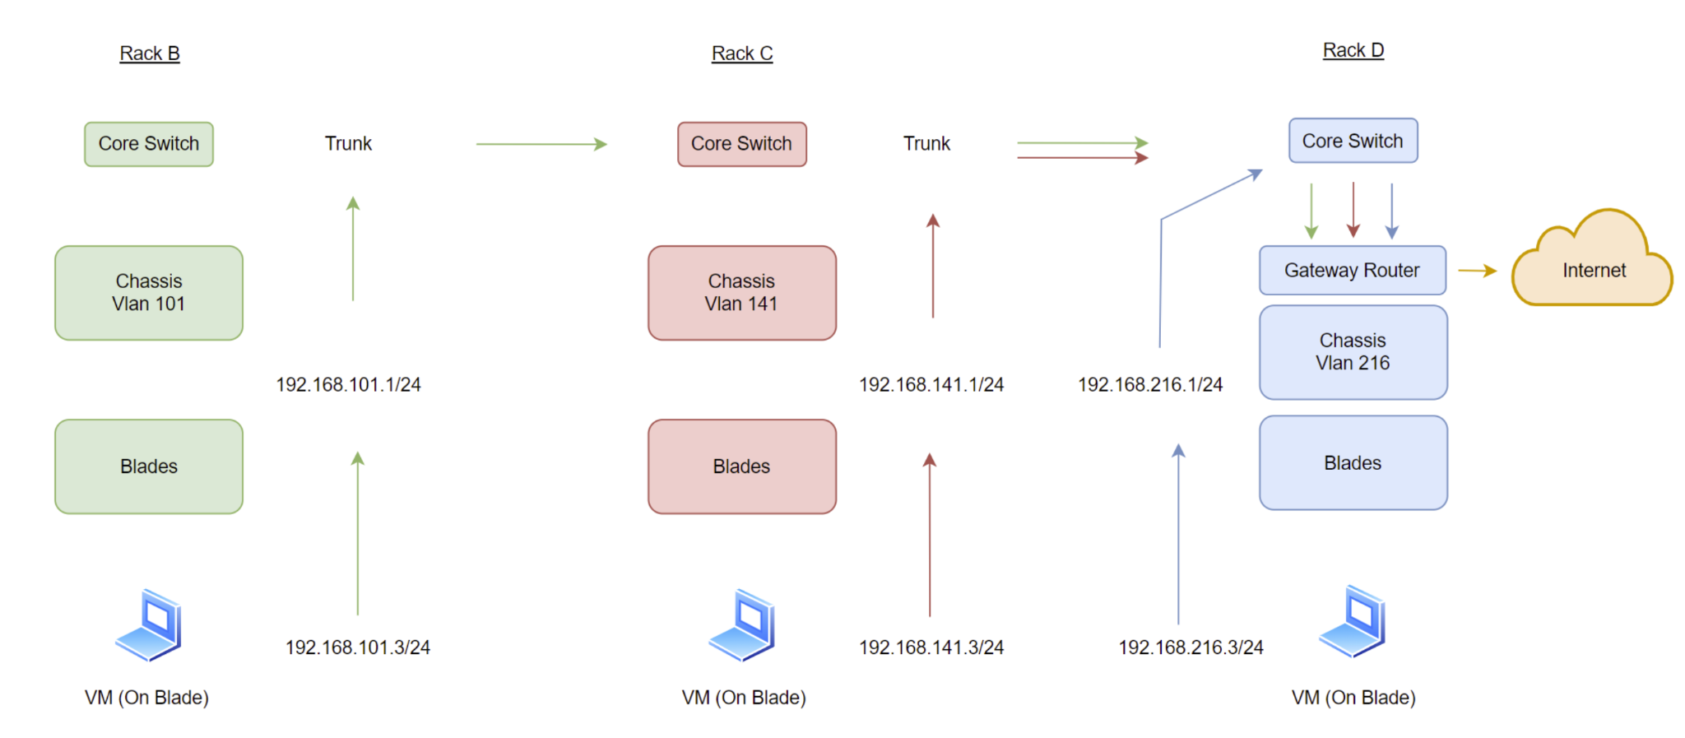

Argument
With how the server room is currently set up there are many possible ways for students to create an issue of ip overlap with mistyping something. To start, there is IP overlap on VMS on A2 and B1, although on different networks it still is not ideal. Also the management network ips are so close to the VM IPs, it can be easily mistyped and a VM be put on the wrong network, which can create issues. With our proposed solution the 10.0.x.x network will strictly be set up for management or other key components. With this method VMs will be set to a 192.168.x.x network. This should eliminate the problem with mis-typing of confusion when it comes to setting IPs since the networks are completely different.

As of now with how the Vlans are set there seems to be no strong structure with the management being on 10 and being seen on VLAN 666 and other confusions. With the proposed solution student VLANs would be <VLANs 1-216>, Management would be 254 and storage on 253. This should help organize them and make it more uniform when it comes to setting things up.

Currently how routing is set up it takes the trust of the student to put their information in multiple places opening up the chance of mis-inputs or just not knowing what they are doing. With the proposed solution we would trunk all the ports that are needed to route things from VMs to out and vice versa.

Steps/Testing
Before we attempt to implement this solution we will take a few key steps to lessen the chances of disaster. Before we even attempt to implement our solution to the servers we will first test it on the rolling racks in the server room. We would set it up as follows the core switch would be represented as the table top rack, the chassis would be represented by the top switch (on the rolling rack), the blade will be represented by a laptop with a static IP and a VM will be represented by a VM running on the laptop with a VM on a static 192.168.x.x IP. To prove it works we will ping from the VM on the laptop to an external device on the network (A router we will set up as a gateway). While we set them up in the test environment we will log and save all the commands for easier transfer to the servers later on. After we are able to ping all the way through we will demonstrate it to Professor Burk/ the others server admins for their inputs, and change accordingly. After all those steps we will then back-up the current configurations for disaster recovery in the event this new set up fails. After that we will then implement our solution.
