# Backup enhancement

The backup enhancement relies on the local database that each Peer keeps. Since each Peer attempts to track what is available on the system, whenever a PUTCHUNK is received they can check if enough STORED messages have already been received for the specific Peer and as such, stop themselves from storing the file and sending a STORED response message. The main function related to this enhancement is pictured below.

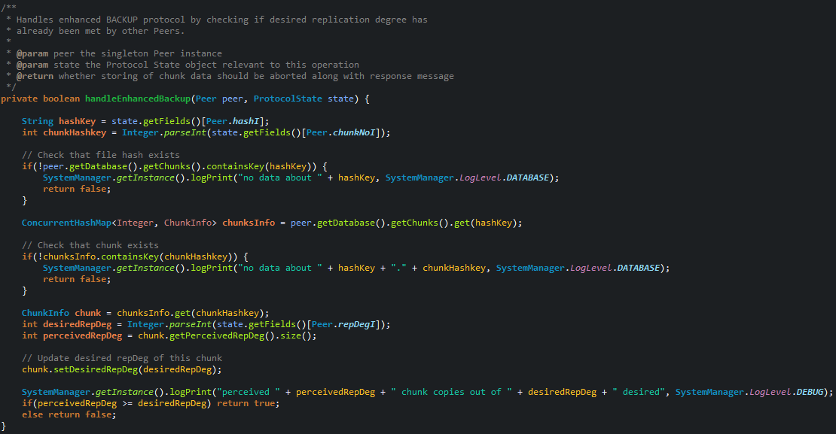

Figure - replication degree already met check

The database is update whenever a STORED, PUTCHUNK or DELETE message is received and as such is fairly up to date as long as the Peer is online.

# Concurrency Design

The concurrency of the system mostly follows the suggestions on the course’s webpage up to point 6.

The Peer maintains a ScheduledExecutorService for running protocols and timeout threads, as pictured.



Figure 2 - the Peer's scheduled executor service field

Whenever the test client invokes a system protocol, an executor thread is created to handle the request.



Figure 3 - test client requests threading implementation

If the request happens to be a RESTORE protocol then the invocation uses a scheduled timeout, which allows the RESTORE to run for a set amount of time before being considered that the file cannot be restored. The timeout is proportional to the total amount of chunks to be restored.

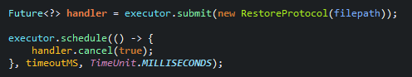

Figure 4 - RESTORE protocol scheduled thread

The thread running a RESTORE protocol instance gets interrupted by the “handler.cancel(true)” call and stops whenever it next polls the interrupted flag.

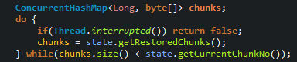

Figure 5 - checking interrupted flag

As said before, the timeout threads also use this executor service to run the random delay before sending response messages. This is done by scheduling a thread to run after the delay as passed.



Figure 6 - timeout handler implementation

As for the message reception channels, each maintains an ExecutorService to run the message processing. This allows each channel to keep listening for new messages.



Figure 7 - the Service Channel's executor service field

As each message arrives, the listening thread submits a new handler to the executor service to run the processing.

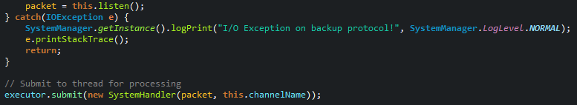

Figure 8 - submitting received message for processing

## What additional threading could be done?

There are at least three ways in which the threading could be improved:

1. Usage of java.nio as suggested to keep the I/O non-blocking.
2. Usage of concurrent queues to keep the messages received and a separate thread would submit these to the channel executor service.
3. For BACKUP protocol different threads could handle a subset of the total chunks to backup. Same could be applied to RESTORE protocol.