Network-Specific BGP Route Reconfiguration During Yemen's January 2020 FALCON Disruption: A Multi-Collector Measurement Study
Ezzaldeen Al-Tayar¹, Abdullateef Ali¹,*
¹ Faculty of Engineering and Information Technology, Taiz University, Taiz, Yemen
Ezzaldeen Al-Tayar: azzaltayyar@gmail.com
* Corresponding author: Abdullateef Ali, abullateef.ali@taiz.edu.ye
Author contributions: Ezzaldeen Al-Tayar: Conceptualization, Investigation, Writing – original draft. Abdullateef Ali: Investigation, Data curation, Resources. Both authors reviewed and approved the final manuscript.

Abstract
We investigate origin-adjacent BGP AS_PATH reconfiguration across two RIPE RIS routing checkpoints during Yemen's reported January 2020 FALCON disruption (9 January 08:00 to 10 January 00:00 UTC) in RRC00, RRC01 and RRC10. Six original, checksum-documented event RIBs yielded 11,419 first-checkpoint peer–prefix records. Among comparable same-origin routes, AS30873 neighbor-change fractions were 64.73–67.98%, compared with 4.05–14.10% in AS12486; unequal prefix inventories (105 versus six) and dependent observations preclude causal network-to-network inference. A pre-outcome-fixed, one-week-earlier 16-hour reference comparison used six additional original RIBs: AS30873 changed only 0.41–0.90% across the same three collectors, giving event-minus-reference differences of 64.32–67.08 percentage points. The descriptive contrast persisted within identical peer–prefix key sets, but one reference interval cannot establish an ordinary-churn distribution or cable-specific causality. For AS12486, no eligible IPv6 origin route was retained at the event endpoint (0/54, 0/24 and 0/13 across collectors), so its neighbor-change fractions effectively cover retained IPv4 routes and do not imply IPv6 service loss. Separately, publisher-original January 2020 IODA raster calibration reproduced a secondary BGP-versus-active normalized proxy difference of +50.8 percentage points (45.8–55.2 under deterministic analyst choices); raw 2020 IODA time series remain unavailable. We provide source-auditable, observation-, prefix- and peer-qualified evidence of network-specific routing-state changes, without inferring physical cable paths, functional recovery or affected-user proportions.
Keywords: Submarine cables; Internet resilience; BGP; structural-functional divergence; critical infrastructure; Yemen.

1. Introduction
Submarine telecommunications cables form the physical backbone of international digital communications. The International Telecommunication Union (ITU) states that these systems carry more than 99% of global data traffic and identifies physical exposure, repair delay, geographic concentration, and dependence on a small number of cable systems as major resilience challenges [1]. In July 2026, the ITU-ICPC International Advisory Body on Submarine Cable Resilience approved recommendations emphasizing route diversity, infrastructure redundancy, improved risk identification, preparedness, and faster repair [2]. These priorities are especially consequential for underserved or geographically constrained countries whose international connectivity can converge on a small number of physical and logical dependencies.
Yemen provides a technically important event-based empirical case setting because international connectivity has historically depended heavily on the FALCON submarine cable system while backup options have been limited, operationally constrained, or incompletely activated. A cable failure therefore cannot be understood only as a physical infrastructure event. It can cause Border Gateway Protocol (BGP) routing withdrawal or path switching, expose national transit concentration, affect prefixes belonging to multiple organizational operators, degrade service even when some BGP reachability remains, and produce long recovery trajectories that are not captured by static vulnerability metrics.
Recent Internet measurement research has substantially advanced cross-layer cable/IP cartography and physical-network exposure analysis. Nautilus [3] maps likely IP links to candidate submarine cables with confidence scores, Xaminer [4] evaluates cross-layer physical/network exposure, and Calypso [5] maps traceroute-derived digital routes across submarine systems. Recent multilayer studies further show that multilayer representation and shared physical risk are not, by themselves, sufficient novelty claims [6,7]. Multi-source outage research has also established that control-plane visibility can diverge from data-plane or active reachability during large Internet disruptions [8,9]. Accordingly, this study does not claim the first cable-to-IP map, the first multilayer Internet model, the first cascading-failure model, or the first observation of control-/forwarding-plane decoupling. Its narrower empirical question is how a large structural-functional divergence manifests during a physically anchored submarine-cable disruption in a highly dependent national critical-infrastructure setting, and what that evidence implies for redundancy and recovery interpretation.
The study therefore uses the Red Sea-Yemen connectivity setting as an event-based resilience case rather than as a claim of unique geography. A three-layer dependency architecture (submarine infrastructure, international routing, and national autonomous-system (AS)/BGP resources) is retained as an organizing model, but the released quantitative claims are limited to evidence that is actually instantiated and validated.

1.1 Research Aim and Questions
The primary aim is to determine what source-native routing observations and differently scoped functional indicators jointly establish about Yemen's January 2020 FALCON disruption, without treating them as measurements of a common national service variable. We compare event-associated changes with a retrospectively selected, outcome-blind, one-week-earlier 16-hour reference using the same collectors and endpoint rules, test consistency across observation units, reconcile a restricted historical RIB-to-RIB replay, quantify the bounded published-plot IODA discrepancy, and examine the limitations of independent public ping evidence and a separate 2023 event.
- RQ1. Which changes in source-native 2020 BGP origin visibility and immediate-AS_PATH adjacency are consistently observed by RRC00, RRC01 and RRC10 at matched historical peer-prefix vantage points?
- RQ2. How do independently sourced 2020 capacity reports, plot-digitized IODA signals and narrowly scoped RIPE Atlas pings qualify the interpretation of preserved or adapted BGP paths?
- RQ3. How robust are routing observations to collector selection and IODA-based signal differences to reasonable extraction/window choices, given dependence among repeated peer-prefix and probe observations?
- RQ4. What additional measurement-boundary lesson follows from the original November 2023 IODA maintenance episode, and why can it not be treated as a direct replication of the January 2020 failure?

1.2 Contributions
- C1. A source-auditable, twelve-RIB historical comparison: six RIBs for the January 9–10 event-associated window (11,419 first-checkpoint peer–prefix records) and six for a January 2–3 historical reference window fixed before analysis of its outcomes. Across RRC00, RRC01 and RRC10, the AS30873 observation-weighted neighbor-change shares differ by +64.32 to +67.08 percentage points between windows; exact peer–prefix intersections retain the descriptive direction. Released per-prefix/per-peer records support independent reaggregation, not event-time physical-cable causal attribution or an estimate of ordinary-churn probability.
- C2. A separately scoped historical RRC00 16-hour UPDATE-to-RIB reconciliation covering 192 source archives and 6,586 matched ending candidate-prefix states. The existing archived replay audit was inspected; a fresh independent replay of all UPDATE bytes was not performed for this revision.
- C3. Secondary January 2020 IODA published-PNG reconstruction with original publisher URLs and SHA-256, pixel-level recalibration, +50.8 percentage-point AS30873 normalized BGP-minus-active contrast and a 45.8–55.2-point deterministic analyst-choice range. The 2020 provider-native numerical series was not recovered.
- C4. A controlled cross-source interpretation reporting original public RIPE Atlas single-target 2020 responses separately, with source-native November 2023 IODA tests including the original 75-window analysis and an independent, nonoverlapping 75-setting robustness check of both median- and mean-normalized contrasts.
- C5. A practical evidence-to-claim protocol for deciding whether source provenance, temporal sampling, observer selection, construct comparability, dependence and counterfactual requirements support a descriptive or causal statement; it is an auditable reporting method, not a new generic cable-to-AS mapping algorithm.

2. Related Work and Research Gap

2.1 Cross-Layer Submarine Cable Mapping
Nautilus [3] established that cross-layer Internet cartography can map IP links to likely submarine cables using public datasets, geolocation, traceroute evidence, and confidence scoring. Calypso [5] extends the evidence base using traceroute and real-world validation to associate digital routes with submarine cables. Weaver et al. [10] address a complementary measurement problem: estimating submarine-segment latency from deployed traceroute infrastructure with path-change-aware methods, while showing that existing measurement systems cannot generally recover dynamic latency variability caused by congestion. Together, these studies motivate confidence-aware mapping and careful separation between what a measurement signal can observe and what it cannot. The present study therefore treats cable/path association as an inferred input rather than a novelty claim.

2.2 Cross-Layer Exposure, Multilayer Robustness, and Cascading Failure
Xaminer [4] is the closest methodological comparator because it evaluates interactions between physical and network-layer failures and produces cross-layer risk profiles. Recent multilayer and shared-risk work [6,7], together with broader telecommunications and interdependent-infrastructure resilience studies [11,12], further narrows any architecture-only novelty claim. Complementary resilience-design literature addresses trans-oceanic cable systems, multilevel redundancy, path diversification, optical survivability, disaster-aware carrier networks, and risk-zone-diversified network design [19-24]. The present paper therefore does not position the three-layer representation itself as the discovery. Instead, the empirical contribution is the event-based comparison of distinct measurement families and the interpretation of their divergence under a known physical cable disruption. The dependency architecture is used to interpret this evidence and to define testable conditions for effective, rather than nominal, redundancy.

2.3 Control-Plane and Forwarding-Plane Divergence in Internet Outages
Multi-source Internet outage research has long shown that control-plane evidence should be interpreted alongside data-plane or reachability measurements. Dainotti et al. [8] combined BGP control-plane observations with several data-plane sources to characterize country-scale outages and showed that the two perspectives need not agree. More recently, Jahromi and Jaskolka [9] analyzed Iranian shutdowns using passive scans, active probing, and RIPE RIS BGP snapshots and found that BGP announcements can remain stable while forwarding-plane reachability collapses. These studies establish that control-/forwarding-plane decoupling is not itself a new phenomenon.
Prior studies established that BGP visibility and active probing can diverge [8,9], while Nautilus, Xaminer and Calypso addressed cross-layer cable/IP exposure and mapping [3–5]. Our narrower contribution is the source-auditable reconstruction of a dated, physically reported infrastructure incident into 11,419 observer-qualified BGP routing records across three collectors, followed by explicitly different prefix-, peer- and observation-weighted descriptive checks. The 105-versus-six-prefix mismatch and the lack of cable-path ground truth bound the scope of inference. The separate IODA and capacity sources are context, not a new cross-layer causal estimator.

2.4 Dynamic Resilience and Uncertainty
Dynamic resilience research motivates treating disruption and recovery as time-dependent [13,16-18], while uncertainty and sensitivity studies emphasize explicit treatment of epistemic uncertainty and parameter dependence [14,15]. The available Yemen event record, however, does not support estimation of a stochastic holding-time model. Accordingly, the main analysis uses an explicit state-transition architecture and event windows. A semi-Markov extension remains a future modeling option if a sufficiently large and measurement-consistent event sample becomes available; it is not presented here as an estimated result or a core contribution.

2.5 Research Gap
The unmet empirical need addressed here is event-specific, independently inspectable two-checkpoint route-adjacency evidence and a disciplined distinction between such BGP observations and noncommensurate functional/capacity indicators. Compared with prior multi-source outage studies [8,9], the incremental contribution is the recovered January 2020 RIPE peer–prefix provenance, within-identical-peer comparisons and explicit claim-admissibility documentation; it is neither the first observation of BGP/active disagreement nor a new general cable/IP mapping technique [3–5]. The 2023 IODA maintenance event is not a controlled replication of the 2020 failure.
Table 1 Closest methodological comparators and the research boundary addressed by the present study
Work | Established contribution | Overlap with this study | Remaining boundary addressed here
Nautilus [3] | Confidence-scored IP↔submarine-cable mapping | Cross-layer mapping input | Not an event-based national comparison of control-plane and functional-service signals
Xaminer [4] | Cross-layer physical/network exposure and risk profiles | Physical↔network failure analysis | No Yemen event-based comparison of routing visibility and active reachability
Calypso [5] | Traceroute-based digital-route↔cable mapping | Mapping/validation evidence | Not a cross-event, measurement-family-specific national resilience analysis
Lang et al. [6] | ISP/IXP multilayer model + SRLG robustness | Multilayer/shared physical risk | Static connectivity robustness; not this event-specific multi-signal divergence analysis
Wu & Neumueller [7] | Multiplex physical/overlay cascade + historical cable faults | Cascading infrastructure coupling | Different overlay/system objective; no national event-based structural-functional signal comparison
Dainotti et al. [8] | Multi-source BGP and data-plane outage characterization | Establishes need for cross-signal outage measurement | Not a submarine-cable-anchored Yemen critical-infrastructure case
Jahromi & Jaskolka [9] | BGP + active reachability/passive scans during Iran shutdowns; control/forwarding-plane decoupling | Direct conceptual overlap with structural-functional divergence | Administrative forwarding-plane shutdown mechanism rather than a physically anchored submarine-cable failure; different dependency objective
Present study | Original 2020 multi-RRC AS_PATH-neighbor observations; restricted RRC00 UPDATE-to-RIB reconciliation; separately qualified functional signals | Uses cross-layer architecture as context, not novelty by itself | Source-scoped routing and cross-signal evidence, not measured physical cable attribution, universal outage severity, or topology-wide cascade effects

3. Study Context and Scope
The empirical setting is Yemen's January 2020 FALCON disruption, sampled through public network-routing and event-reporting sources. Original two-checkpoint 2020 RIPE RIS AS_PATH observations have been reconstructed from six source-authenticated RIBs and reaggregated at individual peer–prefix resolution. They do not establish the physical event-time cable-to-AS topology, a topology-wide cascade or the precise data-plane paths used by packets. Public cable maps, RIPE Atlas, IODA and operational-capacity reporting are kept as distinct evidence families; sensitive coordinates and proprietary operator traffic records are outside scope (Table 2).
Table 2 Operational definitions and evidence classes for the dependency architecture
Element | Operational definition | Evidence class
Physical submarine layer | Cable systems, landing dependencies, cable–landing relationships | Public/authoritative or confidence-aware inferred
International routing layer | Upstream/transit ASes and observed BGP paths connecting Yemen externally | Observed/inferred from RIS, RouteViews, CAIDA
National logical layer | Yemeni ASes, originated prefixes, provider/peer dependencies, resource–origin relationships | Observed/inferred
Functional measurement families | Q_control(t), Q_active(t), Q_capacity(t), and Q_connectivity(t), normalized within source/family where defensible | Observed or derived; not collapsed into one latent Q(t)

4. Data Sources, Provenance, and Event Design
Table 3 summarizes the primary data sources, their analytical roles, and their principal limitations.
Table 3 Primary data sources, analytical uses, and key limitations
Source | Use | Key limitation
RIPE Routing Information Service (RIPE RIS) / RIPEstat [25] | Original 2020 RRC00/01/10 two-snapshot BGP state; original RRC00 16-hour A/W replay | Collector and peer selection; endpoint liveness is not continuous session verification
Center for Applied Internet Data Analysis (CAIDA) AS Relationships / BGPStream [26] | AS relationship inference and historical MRT processing | Relationships are inferred; not operator ground truth
RIPE Atlas [27] | One public archived January 2020 ICMP target (measurement 8307351); source-native, source-scoped response rate | One destination and seven probing IDs; not country-/AS-wide reachability
Internet Outage Detection and Analysis (IODA) [28] | 2020 published-plot-derived BGP/active proxies; 2023 source-native BGP/ping-/24 series | 2020 native samples not recovered; 2023 distinct event and small /24 counts
Cloudflare Radar | Observed traffic/connectivity validation | Not topology ground truth
TeleGeography/public cable maps | Cable systems and landing context | Public routes are stylized; detailed data can be licensed
World Bank / operator notices / event reports | Historical event severity, recovery, and causal anchors | Different sources measure different quantities

4.1 Historical Event Hierarchy
Table 4 summarizes the historical events and their roles in the analysis.
Table 4 Historical event hierarchy and role in the analysis
Event | Role | Observed evidence used
9 Jan 2020 FALCON cut | Primary empirical case | Reported ~80% capacity loss; original 2020 RRC00/01/10 peer-matched AS_PATH changes; 192-file RRC00 candidate-prefix replay [25,29,30]
30 Jan 2020 second disruption | Contextual second disruption only | Second several-hour national disruption during the continuing FALCON outage; renewed degradation is supported [30], but the exact additional failed physical/backup component remains lower confidence.
21–25 Jan 2022 Yemen outage | Qualitative different-failure-mode challenge | Near-total nation-scale connectivity loss lasting ~4 days [31]
10 Nov 2023 FALCON maintenance | Same-component cross-event transferability challenge | Confirmed scheduled FALCON maintenance; national connectivity reported at 33%; main disruption 00:10-04:45 UTC [32-35]
2024/2025 Red Sea disruptions | Context only | Regional multi-cable and rerouting evidence; used cautiously for Yemen-specific inference

UTC observational timeline. The 9 January 08:00 RIB precedes the incident report's approximate 09:00 deterioration narrative; reported active-signal degradation intensifies around 18:00; the second source RIB is at 10 January 00:00. These are source-qualified checkpoints and reported/plot-indicated phases, not validated minute-level fault onset or repair times. The IODA acute window (approximately 18:00–00:00) and the BGP RIB comparison therefore describe different temporal estimands.

4.2 Aggregate IODA Structural–Functional Proxy
IODA [28] reports distinct connectivity signals rather than a single interchangeable measure. Its BGP signal aggregates /24 networks visible via Route Views/RIPE RIS peers, whereas its active-probing signal estimates /24 networks that respond to active measurements. These signals are normalized separately. The January 2020 source plots were retrieved from the original links in the contemporaneous incident report [30], with publisher-byte hashes and the source-native 1840 × 874 pixel resolution verified on 28 October 2026. The present 2020 IODA evidence is nonetheless restricted to image-digitized, separately normalized signals and is secondary to original source-native 2020 routing data. An additional phase audit recalculates BGP-minus-active retention differences for the named baseline, early-degradation, acute, and post-midnight windows from the redistributed window summaries. This reanalysis cannot reconstruct timestamps, prove cross-signal temporal synchronization, provide confidence intervals, or substitute for raw samples. Later GitHub Actions tests of the official IODA v2 raw endpoint returned HTTP 200 with an empty data envelope for 8–12 January 2020 for AS30873, AS12486, and Yemen; BGP- and active-probing-specific requests also provided no original samples. Attempts to verify legacy CAIDA endpoints from the cloud runner failed at the network/TLS stage. These results establish non-retrieval from the tested interfaces, not permanent absence from every archive. For a supplementary comparison, original IODA BGP-visibility and active-probing series were obtained for AS30873 and AS12486 during the November 2023 scheduled maintenance episode. Section 8.3 analyzes their source-specific pre-event, disruption, and post-event windows without treating these observations as replacements for the 2020 plot-derived evidence.

4.3 Source-Native 2020 RIPE RIS BGP Acquisition and Replay
Historical source acquisition. For each of RRC00, RRC01 and RRC10, the research pipeline downloaded the full RIPE RIS RIBs at 9 January 08:00 and 10 January 00:00 UTC, checked compressed-file SHA-256 and gzip integrity, and exported 11,419 first-checkpoint peer–prefix rows. The frozen export with route-level provenance is preserved at GitHub commit 907b59027807ab292d33886d36e65e2bb07f63c6, and provided as six-collector-AS-stratified CSVs in Online Resource 1. Independent reaggregation of the released rows reproduced six changed/retained totals and matched per-prefix and per-peer group totals. The audit validates released source-native endpoint observations; it is not a fresh external re-download of all six large RIPE files.
The two RIB timestamps are sampled checkpoints, not independently verified cable fault-onset or repair times. Peer identity comprises collector, peer ASN and peer IP; qualifying the second-snapshot peer using its whole-RIB presence controls simple endpoint disappearance but cannot guarantee continuous uptime. We retain all first-snapshot target-origin observations and mark independently eligible, same-origin retained, absent/other-origin and unparseable states separately. The immediate origin-adjacent AS_PATH neighbor is the ASN directly preceding the target origin after ignoring repeated prepending of the origin ASN; malformed paths, ambiguous origins or duplicate peer/prefix states are excluded or cause extraction to fail. The full 16-hour UPDATE replay, using a fixed 116-prefix candidate universe, is validated for RRC00 only; its archived report must not be conflated with the three-collector two-RIB export.
To avoid pseudo-replication, the most granular published observational key is (collector, peer ASN, peer IP, prefix). First-snapshot target-origin rows were included only if the same peer ASN/IP appeared anywhere in the complete second RIB; a comparison additionally requires the same origin-prefix at that endpoint and a parsable immediate upstream in both AS_PATHs. The individual exporter records eligible, retained, absent origin, neighbor comparable and neighbor changed flags for every first-snapshot row. Within each collector–AS, we compute (i) the observation-weighted changed/retained fraction, (ii) the distribution and equal-prefix mean/median of within-prefix changed/comparable fractions, and (iii) equal-peer mean/median after grouping by the exact peer ASN+IP. A matched-peer sensitivity intersects the two AS-specific observed peer lists within the same collector and subtracts the two within-peer percentages; this is a paired descriptive diagnostic, not difference-in-differences. A further leave-one-prefix-out check tests the sensitivity of the observation-weighted fraction. Prefixes, peers and collectors are correlated, and 105 versus six observed prefix inventories are not exchangeable. Complete per-prefix and per-peer CSVs and original RIB manifests are linked in Online Resource 1 (Tables S10 and S11).
Non-event reference test (pre-outcome date selection): the comparison uses 2 Jan 2020 08:00 to 3 Jan 2020 00:00 UTC and the same 16-hour endpoint definitions as the main event window. The date was committed in the public extractor prior to processing its output. Original reference RIB file hashes are retained and eligibility exclusions, address-family composition and fixed-key sensitivity are archived. This is a single calendar-matched historical reference, not an assumed incident-free causal control.

4.4 Independent Historical RIPE Atlas Control
For January 2020 we additionally audit public RIPE Atlas ICMP measurement 8307351 directed at 195.94.0.34, catalogued under target AS12486 [27,37]. We retain timestamped original measurement IDs, per-day response counts and the number of contributing probe IDs. Because these observations target one address and seven probing IDs, no national, AS-wide or independent-binomial inference is attached to the observed response fraction. Negative searches of other publicly indexed measurements are not interpreted as proof that no historical measurement exists.

5. Cross-Layer Dependency Architecture
For interpretation, the study retains three structural dependency domains: submarine infrastructure, international routing/connectivity, and national AS/BGP resources. Cross-layer relationships indicate how logical connectivity may depend on common physical resources. The architecture is conceptual unless a dependency edge is supported by public evidence or validated mapping; it is not treated as a fully observed topology. The organizing architecture is shown in Fig. 1.
Functional performance is represented by a vector of measurement-specific states Q_m(t), where m indexes the measurement family. The primary families are Q_control(t) for routing/control-plane visibility, Q_active(t) for active reachability, Q_capacity(t) for reported international capacity, and Q_connectivity(t) for country-level connectivity or traffic indicators. Each family may be normalized to its own pre-event baseline when the source supports that operation. Values from different families are not averaged into a latent Q(t), and resilience integrals are not compared across families unless the measurement semantics and time bases are commensurable.
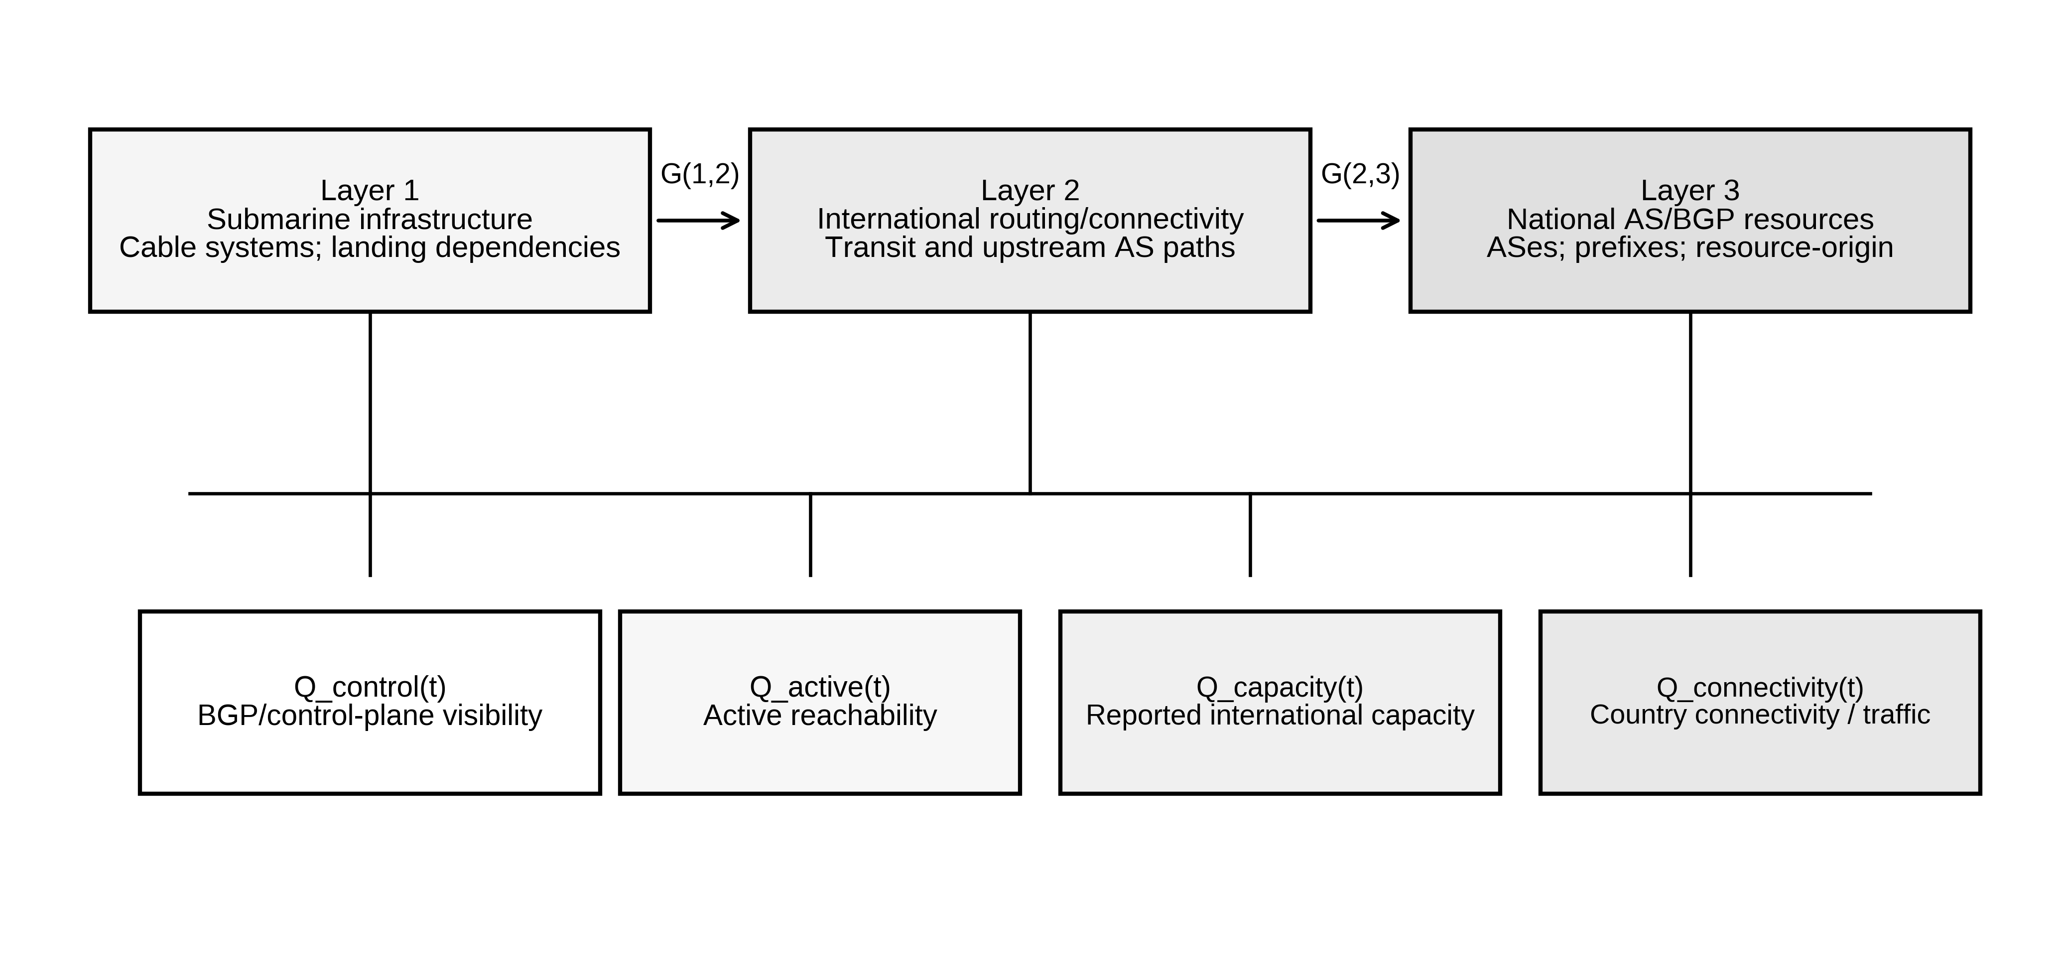
Fig. 1 Dependency architecture used to interpret physical, routing, and national-AS relationships; functional evidence is analyzed through measurement-specific Q_m(t) signals rather than as a fourth network layer

5.1 Cross-Layer Mapping
Cable/path associations and dependency edges are retained as conceptual or source-supported links, not assumed physical cable traces. The reconstructed January 2020 AS_PATH adjacency is a logical BGP neighbor observation, and no route is assigned to a specific physically disjoint backup cable. Figure 1 is an interpretive architecture, not a measured geographic topology.

5.2 Resource–Origin Dependency
Resource-origin analysis captures the fact that organizationally distinct resources can share an origin ASN. Representative current observations show this pattern for some Yemen Mobile, YOU, and Sabafon resources associated with AS30873. This is interpreted as evidence that organizational labels alone do not establish routing independence; it is not used to infer that all operator traffic shares one path or that the same concentration held during the 2020 event.

6. Measurement-Specific Resilience and Dependency Analysis
Event phases are used descriptively, not to fit latent semi-Markov holding-time distributions. Such an extension was considered during project development but is not empirically estimable from these heterogeneous incidents; neither event timing nor transition probabilities are assumed to have been prospectively preregistered.

6.1 Route-Level Metrics: Definitions and Withholding Rules
For each collector, the observational unit is the first-checkpoint tuple (peer ASN, peer IP, origin prefix). Eligibility requires the exact same peer to be present anywhere in the second full RIB; endpoint matching is not continuous session-liveness evidence. Same-origin retention is the fraction of eligible observations with the same target origin at the second checkpoint. Immediate-neighbor change is conditional on same-origin retention and parsable AS_PATHs, ignoring consecutive origin ASN prepends. A missing target origin is not automatically an explicit BGP withdrawal: route absence can arise from local policies, origin changes, or observation limitations. The study reports three nonidentical estimands—observation-weighted, equally weighted per-prefix, and equally weighted per-peer proportions—without treating peer/prefix repetitions as independent Internet users or physical paths. The separately archived 16-hour RRC00 UPDATE replay covers only its historical 116 candidate prefixes.

6.2 Measurement-Family-Specific Functional Resilience
For each measurement family m, normalized retention can be written q_m(t)=X_m(t)/B_m, where B_m is a pre-event baseline defined within that same source and signal family. Maximum loss, area loss, and recovery thresholds are meaningful only within a sufficiently sampled and semantically consistent time series. Because the present evidence does not provide such a continuous, homogeneous trace across the full 2020 recovery period, the manuscript does not release a 27-day scalar resilience-loss integral or T_R(90/95/99) as empirical estimates.

6.3 Structural–Functional Dual Axis
The primary structural-functional comparison is contemporaneous but signal-specific: routing/control-plane retention and active-reachability retention are normalized to their own pre-event medians and compared as separate proportions. Their difference is interpreted as a descriptive divergence between measurement families, not as a difference between two estimates of the same latent quantity.

6.4 AI-Assisted Code Development and Human Verification
ChatGPT (OpenAI) was used to assist with drafting and reviewing selected analysis and reproducibility scripts. It did not generate empirical observations or substitute for source data. All scripts used for reported results were manually inspected, executed against the stated inputs, and their numerical outputs were checked by the authors. Fail-closed validation rules were retained so that empty or unvalidated raw inputs could not be converted into reported results.

7. Event Comparison and Evidence Boundaries

7.1 Cross-Event Transferability Design
The 2020 FALCON cut is the primary empirical case. The 2023 scheduled FALCON maintenance event is used as a same-component cross-event transferability challenge, not as a homogeneous predictive-validation sample, because the operational context and measurement semantics differ. The 2022 national outage is retained as a qualitative different-failure-mode challenge. No parameter is silently refitted to force agreement across events.

7.2 Machine Learning Exclusion
Machine learning is not part of the final contribution set. The available historical events are too few and heterogeneous to support a defensible predictive model, and deterministic scenario-grid rows are not treated as independent empirical samples.

8. Results
The results are ordered by evidentiary priority: original January 2020 RRC observations first, published-plot-derived 2020 IODA and single-target Atlas second, and the distinct 2023 maintenance event third. The frozen August 2026 concentration snapshot is contextual and is relegated to Online Resource 1 (Table S8).

8.1 2020 FALCON Disruption: Structural Adaptation with Severe Functional Loss
Yemen's January 2020 FALCON disruption is the principal case. Contemporaneous World Bank reporting describes approximately 80% lost international Internet capacity for nearly a week [29], while an independent incident account reports marked routing and active-measurement changes [30]. Capacity loss is a documentary operational quantity, not a fraction calculated from BGP records, and the two sampled RIB checkpoints alone do not identify physical cable-specific transitions.
Two authenticated full RIB snapshots per RIS collector (RRC00, RRC01, RRC10), taken at 08:00 UTC on 9 January and 00:00 UTC on 10 January 2020, were compared using collector/peer-ASN/peer-IP/prefix identities. AS30873 retained 6,220/6,602 eligible observations at RRC00, 2,180/2,582 at RRC01, and 1,341/1,419 at RRC10. Of these retained observations, 4,157/6,220, 1,482/2,180, and 868/1,341 changed the AS immediately preceding the target origin in AS_PATH. By comparison, AS12486 changed in only 23/366, 6/148, and 11/78 retained observations, respectively. On retained AS30873 observations, previously present immediate predecessor AS15412 disappeared at the second checkpoint and AS174 appeared adjacent to the target origin in all three collectors. These are dependent route-observation counts, not independent Internet paths or a source of user-level service percentages [25].
Transition-specific evidence from the released first-snapshot peer–prefix records identifies the actual origin-adjacent AS_PATH neighbor changes. For AS30873, transitions from AS15412 to AS174 account for 2,793, 1,089 and 593 comparable observations in RRC00, RRC01 and RRC10, respectively; other observed transitions to AS174 originate from AS3491 and AS8529, while the AS174→AS174 observations are unchanged. In the AS12486 sample, the main changed transitions involve AS15412→AS197206 or AS15412→AS6762, rather than the AS30873 pattern. Complete directional transition counts, and their conditional denominators, are provided in supplementary Table S12 and Figure S3. These are AS_PATH adjacency observations, not physical alternative-cable paths or flow measurements.
Address-family qualification (Table S13) is essential to the interpretation of AS12486 as a comparator. In the event-associated interval, AS12486 had 54, 24 and 13 eligible IPv6 first-checkpoint peer–prefix observations in RRC00, RRC01 and RRC10, respectively; NONE retained the same target origin under the endpoint matching rule (0/54, 0/24 and 0/13). The corresponding one-week-earlier reference fractions were 54/54, 23/23 and 13/13 retained. Consequently, the published AS12486 immediate-neighbor-change denominators are effectively confined to retained IPv4 observations, not an overall demonstration of stability across both address families. A missing matching IPv6 origin at one sampled checkpoint is not by itself an observed BGP withdrawal, loss of packet reachability or service outage. AS30873 includes comparable observations from both address families.
Table 5 summarizes the source-native 2020 two-snapshot observations. In the newly released first-snapshot row-level exports, RRC00 contains 7,039 target-origin peer–prefix rows, RRC01 2,870 and RRC10 1,510 (11,419 total). Across these records, 11,293 were eligible under endpoint peer-presence matching, 10,333 were retained with a comparable immediate origin-adjacent neighbor, and 6,547 had changed that neighbor. The reported per-AS numerators and denominators agree with the original source-audit logs for all three collectors. Figure 2 and Table 6 now distinguish observation-weighted rates from distributional summaries of each prefix and each peer. A separate RRC00 analysis replayed 192 original five-minute UPDATE archives (105,695 announcements and 5,024 withdrawals in the selected candidate-prefix universe), reconciling 6,586 terminal candidate-universe peer–prefix states to the end RIB with no recorded origin/path mismatch. It is a bounded RRC00 event-stream reconstruction, not proof of complete UPDATE replay in RRC01/10, continuous peer health, or physical cable causality. A fixed before reference-window outcome inspection, identical-duration January 2–3 historical reference (six additional RIBs) produced only 0.48%, 0.90% and 0.41% AS30873 neighbor changes in RRC00, RRC01 and RRC10, compared with 66.83%, 67.98% and 64.73% in the event-associated window; see §8.1.4 and Table S14. This is a contrast against one fixed reference interval, not an anomaly test or causal counterfactual.
Table 5. Original 2020 RIPE RIS matched routing checkpoints. Neighbor changes are conditional on retained peer–prefix routes; AS12486 comparable changes are IPv4-only (eligible event IPv6 retained: 0/54, 0/24, 0/13; Table S13).
Origin AS | Collector | Retained / eligible | Retention (%) | Neighbor changed / retained (%)
AS30873 | RRC00 | 6,220 / 6,602 | 94.21 | 4,157 / 6,220 (66.83)
AS30873 | RRC01 | 2,180 / 2,582 | 84.43 | 1,482 / 2,180 (67.98)
AS30873 | RRC10 | 1,341 / 1,419 | 94.50 | 868 / 1,341 (64.73)
AS12486 | RRC00 | 366 / 427 | 85.71 | 23 / 366 (6.28)
AS12486 | RRC01 | 148 / 172 | 86.05 | 6 / 148 (4.05)
AS12486 | RRC10 | 78 / 91 | 85.71 | 11 / 78 (14.10)
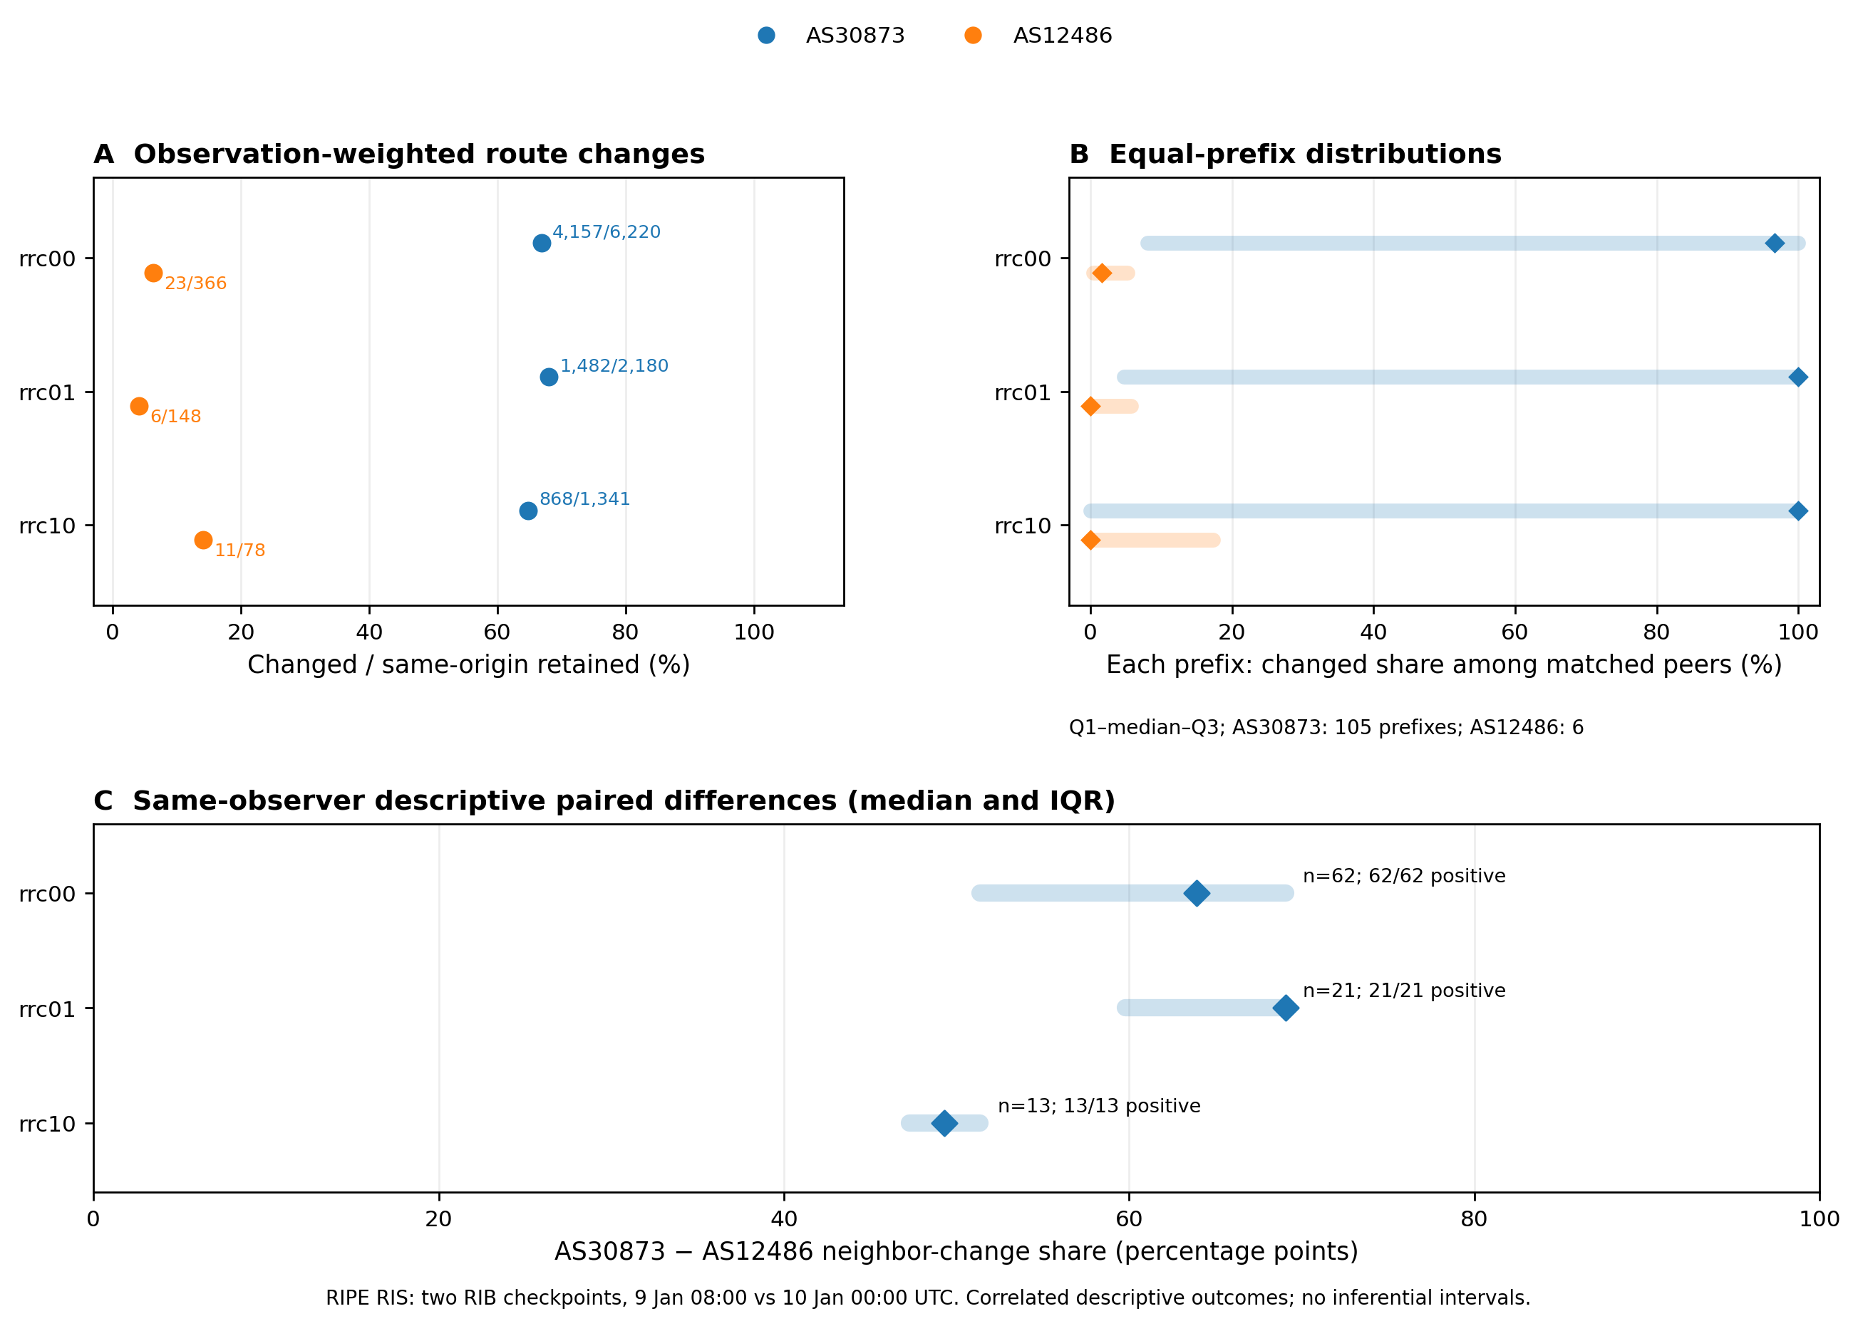
Fig. 2. January 2020 RIPE RIS BGP route-neighbor changes at three distinct observational units: (A) observation-weighted changed/retained peer–prefix shares with original numerators/denominators, (B) per-prefix Q1–median–Q3 distributions (105 AS30873 prefixes and six AS12486 prefixes), and (C) paired within-identical-peer percentage-point differences, showing medians and interquartile ranges. IQRs describe observed heterogeneity and are NOT confidence intervals. All panels use two 08:00/00:00 UTC source RIB checkpoints; neither independent samples nor physical cable paths are implied.
Distributional checks (Table 6; Fig. 2). Equal-prefix median AS30873 change shares were 96.67%, 100% and 100% across RRC00/01/10, versus 1.64%, 0% and 0% for AS12486. Equal-peer medians were 69.07%, 69.07% and 65.98%, versus 0%, 0% and 16.67%. On the identical peer-ASN/IP identities that observed both networks, all 62, 21 and 13 collector-specific comparisons were positive, with median within-peer gaps of +63.92, +69.07 and +49.31 percentage points. These are descriptive differences over sharply unequal prefix inventories, not independent hypothesis tests or an untreated-control design.
Source-native per-prefix distributions were heterogeneous. AS30873 had zero-change prefix counts of 26/105, 26/105 and 30/105 across RRC00/01/10 and all-changed counts of 45/105, 53/105 and 53/105. AS12486 had only six matched prefixes per collector. Leave-one-prefix-out checks preserve the descriptive direction, not statistical confidence or cable causality (Tables S10–S11).
Table 6. Source-native 2020 within-collector distributional sensitivity, computed from individual peer–prefix CSV exports. Equal-unit statistics use the arithmetic mean and median of per-prefix or per-peer change fractions; no significance tests are implied.
Collector | Origin AS | Matched prefixes | Prefix mean / median (%) | Matched peers | Peer mean / median (%)
RRC00 | AS30873 | 105 | 67.01 / 96.67 | 110 | 67.74 / 69.07
RRC00 | AS12486 | 6 | 6.42 / 1.64 | 62 | 6.18 / 0.00
RRC01 | AS30873 | 105 | 68.04 / 100.00 | 40 | 74.19 / 69.07
RRC01 | AS12486 | 6 | 3.95 / 0.00 | 26 | 3.85 / 0.00
RRC10 | AS30873 | 105 | 64.75 / 100.00 | 23 | 65.34 / 65.98
RRC10 | AS12486 | 6 | 14.10 / 0.00 | 13 | 14.10 / 16.67

8.1.1 Aggregate IODA Evidence of Structural-Functional Divergence
The separately baseline-normalized, publisher-image-derived acute-window IODA signals show 95.7% retention for AS30873 BGP visibility and 44.8% for its active-probing proxy (Fig. 3), a +50.8-percentage-point difference between *noncommensurate* measurement families. AS12486 has 100% acute-window median retention for both signals, despite a small transient dip in the active trace (approximately 95.6% retention under mean normalization). These are pixel-digitized plot-proxy summaries, not comparable endpoint service shares, affected-user fractions or directly synchronized source-native 2020 IODA series. The original source-publisher images and the extraction calibration have now been independently rechecked.
A documented 20,250-setting deterministic robustness grid perturbs the archived baseline/event windows, pixel origin and axis scale, RGB extraction tolerance, and the choice of mean versus median. Re-execution on the unchanged publisher-linked AS30873 PNG yielded a byte-identical sensitivity CSV relative to the archived grid (SHA-256 in Online Resource 1). The AS30873 difference ranges from +45.8074 to +55.1698 percentage points across analyst choices. Neither grid quantiles nor its number of settings represent sampling uncertainty, a confidence interval or independent replications.
Original-image provenance and calibration gate. On 28 October 2026, both publisher-linked IODA PNGs for the January 2020 event [30] were retrieved at the original 1840 × 874-pixel resolution and fingerprinted; their direct links and SHA-256 digests appear in Online Resource 1. The chart title identifies AS30873 even though the publisher URL filename spells “as30783”. Re-extraction with the archived axes (x=112–1779, zero y=632, 252 pixels per normalized unit) and exact signal RGB colors reproduced the AS30873 median-retention contrast (BGP 95.6522% versus active 44.8378%; gap +50.8144 percentage points) and AS12486 zero median gap. The entire 20,250-setting sensitivity CSV was also reproduced byte-for-byte. This closes the published-image and raster-calculation reproducibility questions, but not recovery of original IODA 2020 numerical samples. The chart aggregates roughly three samples per pixel; neither plot columns nor analyst settings are independent observations. The two monitoring signals have different measurement semantics. The 2020 plot proxy therefore remains secondary and exploratory, not a measure of lost capacity, affected users, or a cable-causal effect.
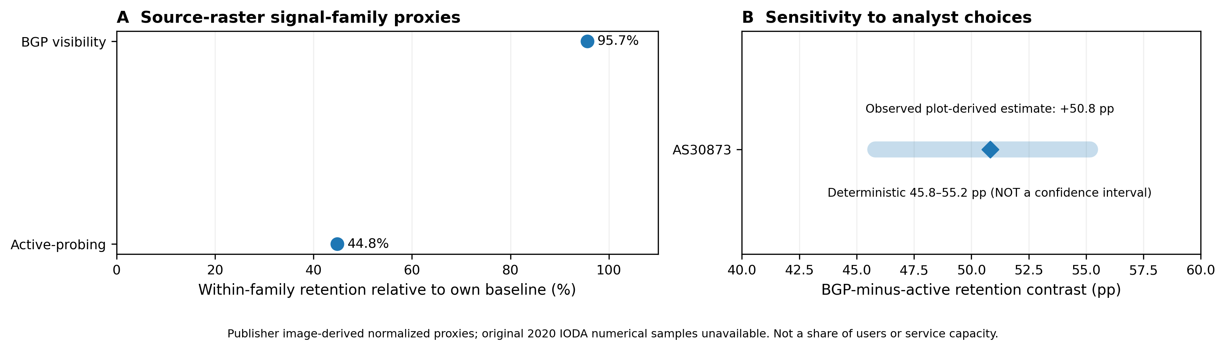
Fig. 3. Secondary, publisher-image-reproduced January 2020 IODA proxy contrast. (A) AS30873 median BGP visibility and active-responsive proxies, each relative to its OWN pre-event baseline (95.7% and 44.8%), and (B) the separately normalized BGP-minus-active descriptive +50.8-pp contrast with its 45.8–55.2-pp deterministic analyst-choice range. The band is NOT a confidence interval or a percentage of subscribers, network capacity or actual packet delivery. Original 2020 IODA numerical time-series were not recovered.

8.1.2 Phase-Level Audit and Summary-Statistic Sensitivity
Four predefined January 2020 plot windows are summarized in Online Resource 1, Table S1. For AS30873, image-derived, within-family-normalized BGP-minus-active median contrasts are +56.1 percentage points in the early phase, +50.8 in the acute phase and +44.6 after midnight. These categorical summaries cannot be interpreted as a continuous recovery rate because the original provider numerical series and matched underlying sample times were not obtained. The small AS12486 active-probing dip shows that a stable median need not imply uninterrupted reachability.
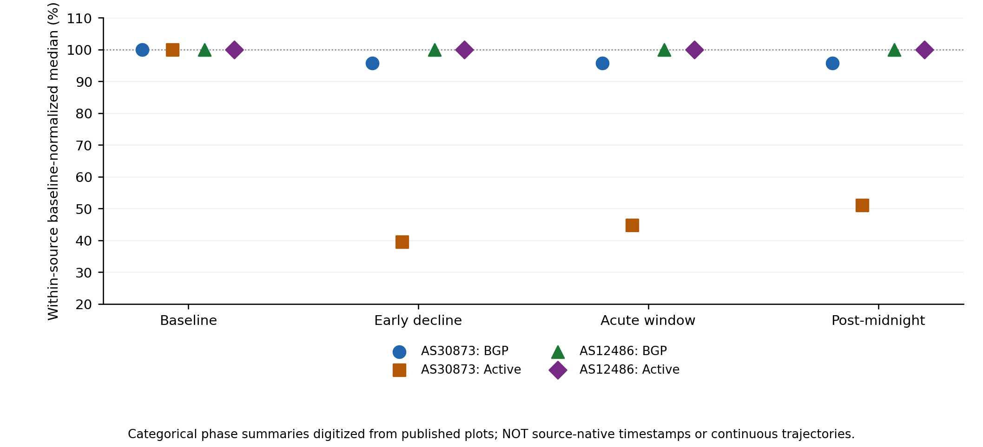
Fig. 4 Exploratory categorical phase-level median proxies re-digitized from the original source-published January 2020 IODA rasters. Marker disconnection emphasizes that these are aggregated plot-derived phases, not a recovered time series, confidence intervals, or direct measurement of service restoration.

8.1.3 Independent Public RIPE Atlas Single-Target Control
Original public Atlas measurement 8307351 supplied 3,360 dated ping results to the single IPv4 destination 195.94.0.34 during 8–12 January 2020 UTC; 3,343 results included a response and 17 did not, for a source-scoped response proportion of 99.49%. Seven probing IDs contributed. Daily responsive/test results were 663/673, 670/672, 669/672, 670/672 and 671/671, respectively. Excluding each calendar day in turn gives a four-day response range of approximately 99.37–99.74%; this is a deterministic leave-one-day-out check, not a sampling confidence interval. Target-AS12486 association comes from RIPE Atlas catalogue metadata, not an independently validated historical per-ping origin lookup. The experiment cannot serve as original IODA ping-/24 data or as evidence of reachability across Yemen or AS30873 [27,37].

8.1.4 One-week-earlier 16-hour historical RIPE RIS reference-window comparison
To evaluate whether the large January 9–10 BGP-adjacency contrasts also occur at a nearby historical reference window, we retrospectively selected 2 January 2020 08:00 UTC to 3 January 2020 00:00 UTC (16 h, one week earlier), fixing that date before inspecting its reference-window outcomes but after the reported event and its first analyses. The identical source-native two-RIB, full-RIB peer-presence, target-origin, immediate-neighbor, and comparable peer–prefix rules were applied separately to RRC00/RRC01/RRC10 and AS30873/AS12486. All 12 source RIBs (six reference; six event), source SHA-256 checks, record-level CSV exports, and the calculation script are documented in Online Resource 1, Tables S14–S15 and Figure S4.
For AS30873, reference-window changed-neighbor fractions were 0.48% (29/6047) in RRC00, 0.90% (23/2549) in RRC01, 0.41% (6/1464) in RRC10, versus event-window rates of 66.83%, 67.98%, 64.73% in the same collector order. The corresponding differences were 66.35 pp, 67.08 pp, 64.32 pp. For AS12486, the reference rates were 0.00%, 0.00%, 0.00%, versus event-window rates 6.28%, 4.05%, 14.10% (RRC00, RRC01, RRC10).
Restricting each comparison to the identical peer-ASN/peer-IP/prefix keys with a parseable origin-adjacent neighbor in BOTH windows gave AS30873 differences of 66.67 pp (n=5965), 66.97 pp (n=2180), 64.35 pp (n=1341). These are dependent observation-level diagnostics, not inferential confidence intervals. A single preselected 16-hour comparator is evidence against an equally high rate of routine path-adjacency churn in THAT window, but does not establish an ordinary-churn sampling distribution, a statistical anomaly threshold, or a causal cable effect. The prefix inventory, observer set and endpoint retention can differ between dates; the original 105-versus-six network prefix imbalance remains.

8.2 January 2022 Outage as a Qualitative Failure-Mode Challenge
The January 2022 event is retained as an external qualitative failure-mode challenge. Public reporting indicates a near-total nationwide connectivity disruption lasting about four days [31], but the accessible evidence does not establish a sufficiently complete and homogeneous physical-to-routing causal chain for quantitative scoring in the same manner as the 2020 FALCON event. Accordingly, the event is not presented as an equivalent numerical holdout.

8.3 November 2023 FALCON Maintenance as a Transferability Challenge
The scheduled 10 November 2023 FALCON maintenance event provides a same-component but operationally distinct challenge. Contemporary sources document a disruption and its maintenance context [32–35]. It tests whether the measurement-interpretation rule survives a second incident—not whether the 2020 and 2023 disruptions share causal mechanics, precise baselines or comparable magnitudes. Table 7 summarizes the cross-event comparison. Native IODA signal values below are restricted to the 2023 event window and must not be equated to customer traffic, national capacity or 2020 plot-digitized samples.
Table 7 Cross-event comparison and interpretive role
Event | Functional severity | Duration/recovery anchor | Interpretive role
FALCON 2020 | ~80% capacity loss; emergency service 20–30% | Severe loss reported for almost a week; physical repair later reported separately | Primary event: native multi-RRC routing evidence plus plot-derived 2020 IODA; not matched data-plane validation
Yemen outage 2022 | Near-total national connectivity loss | ~4 days | Qualitative failure-mode challenge
FALCON maintenance 2023 | National connectivity reported at 33% at severe point | ~275 min main disruption | Same-component transferability challenge

8.3.1 Native IODA Observation Check for the 2023 Maintenance Window
The current IODA v2 raw API returned original BGP-visibility and ping-/24 active-probing time series for AS30873 and AS12486 spanning 9–11 November 2023. To anchor the independent comparison to the reported incident timing [32–35], we used a fixed baseline of 9 November 00:00–10 November 00:00 UTC, a disruption window of 10 November 00:10–04:45 UTC, and a post-window of 10 November 05:00–11 November 00:00 UTC. For each AS and measurement family separately, we computed median retention R = 100 × median(X during disruption) / median(X during baseline). Native BGP observations have five-minute cadence and active-probing observations ten-minute cadence; complete event-window coverage was confirmed for both families in both ASes.
Within AS30873, the baseline/event medians are 884/356 observed BGP-/24 units and 10/6 active-responsive /24 units, giving native 2023 median retentions of 40.3% and 60.0%, respectively. The within-event difference (BGP minus active) is −19.7 percentage points. For AS12486, BGP medians are 25/25 and active-probing medians 4/4, giving 100% median retention for each family. The post-event medians in both ASes returned to their respective baseline medians. These descriptive results are in Table 8 and Fig. 5.
AS and IODA family | Baseline median | Event median | Retention (%) | Event samples
AS30873 · BGP visibility | 884 | 356 | 40.3 | 55 / 55
AS30873 · Ping /24 | 10 | 6 | 60.0 | 28 / 28
AS12486 · BGP visibility | 25 | 25 | 100.0 | 55 / 55
AS12486 · Ping /24 | 4 | 4 | 100.0 | 28 / 28
Table 8 Original IODA median observations for 10 November 2023; each retention is normalized to its own AS/family pre-event median (not a traffic or customer percentage). All expected disruption samples were present.
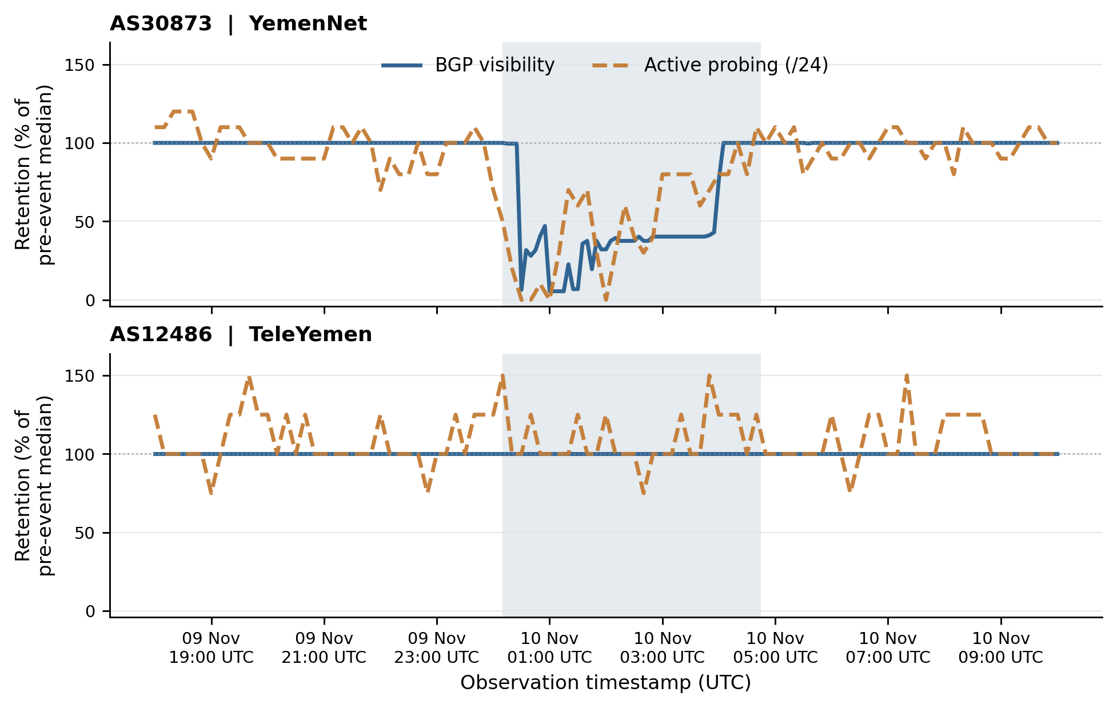
Fig. 5 Original November 2023 IODA BGP and ping-/24 series for AS30873 and AS12486, each relative to its own baseline median; shading denotes reported maintenance disruption. Native 2023 signals are not equivalent to throughput, customer availability or original January 2020 IODA samples.
Evidence boundary: AS30873 exhibits a greater relative reduction in its BGP signal than in the active-probing median within the 2023 window, whereas both AS12486 medians remain at baseline. The AS12486 result does not exclude short transients, and the small integer ping-/24 baseline medians (10 in AS30873 and 4 in AS12486) limit generalization from small changes in responsive-prefix counts. Neither the difference in retention direction between this native 2023 comparison and the plot-derived 2020 estimate nor the observed 2023 restoration pattern proves a shared physical mechanism; the events are not exchangeable experiments. The unmodified IODA response JSON, validation windows, sample counts, hashes, and replication script outputs are included in the accompanying native-IODA 2023 audit supplement, maintained separately from Online Resource 1.
A source-native window-sensitivity analysis changed 2023 baseline length (12, 18 or 24 hours) and five alternative starts and ends, yielding 75 configurations per AS/signal (300 combinations across four AS/signal families); each passed the stated 95% sample-coverage rule. In AS30873, median BGP retention remained 37.557–40.271%, active ping-/24 retention 55.0–65.0%, and the paired BGP-minus-active gap −24.729 to −14.729 percentage points. Both AS12486 event median retention families remained 100% in the tested configurations. These are sensitivity settings, not independent experimental replications or probabilistic confidence intervals. Notably, the signed 2023 gap differs from the positive 2020 plot-derived gap; rather than assume an invariant sign, we treat the difference as a warning against using BGP or active indicators as event-invariant substitutes for one another.

8.3.2 Independent Source-JSON Reproduction and Nonoverlapping Window Sensitivity
We independently reprocessed the unchanged November 2023 IODA API response JSON from the archived native-data supplement. The original four median retention values were reproduced exactly for AS30873 and AS12486, and the original JSON SHA-256 values were checked against the source audit. We then specified a stricter, nonoverlapping robustness grid: baseline lengths of 12, 18 or 24 h ending at 00:00 UTC on 10 November 2023, and event start/end offsets of −10, −5, 0, +5 or +10 min relative to the report-aligned 00:10–04:45 UTC window. All 75 designs per AS contained complete samples at each signal’s original 5- or 10-minute cadence; no interpolation or overlapping pre-event/event windows was permitted.
For AS30873, the BGP-minus-ping-/24 retention contrast was −19.73 percentage points under all 75 paired median specifications. Replacing the median with the signal-specific baseline-normalized arithmetic mean preserved its negative direction across all 75 paired specifications (−6.44 to −1.79 pp). For AS12486, both median retention indicators remained at 100% and their difference was exactly zero across all 75 specifications; the mean-based signal gap ranged from −2.18 to +1.91 pp, changing sign across specifications (39 negative and 36 positive). Consequently, direction stability is supported for AS30873 under the tested 2023 design alternatives, but not for a universal signal-ordering claim across networks. These deterministic configurations are analyst-choice perturbations rather than independent trials or confidence intervals.
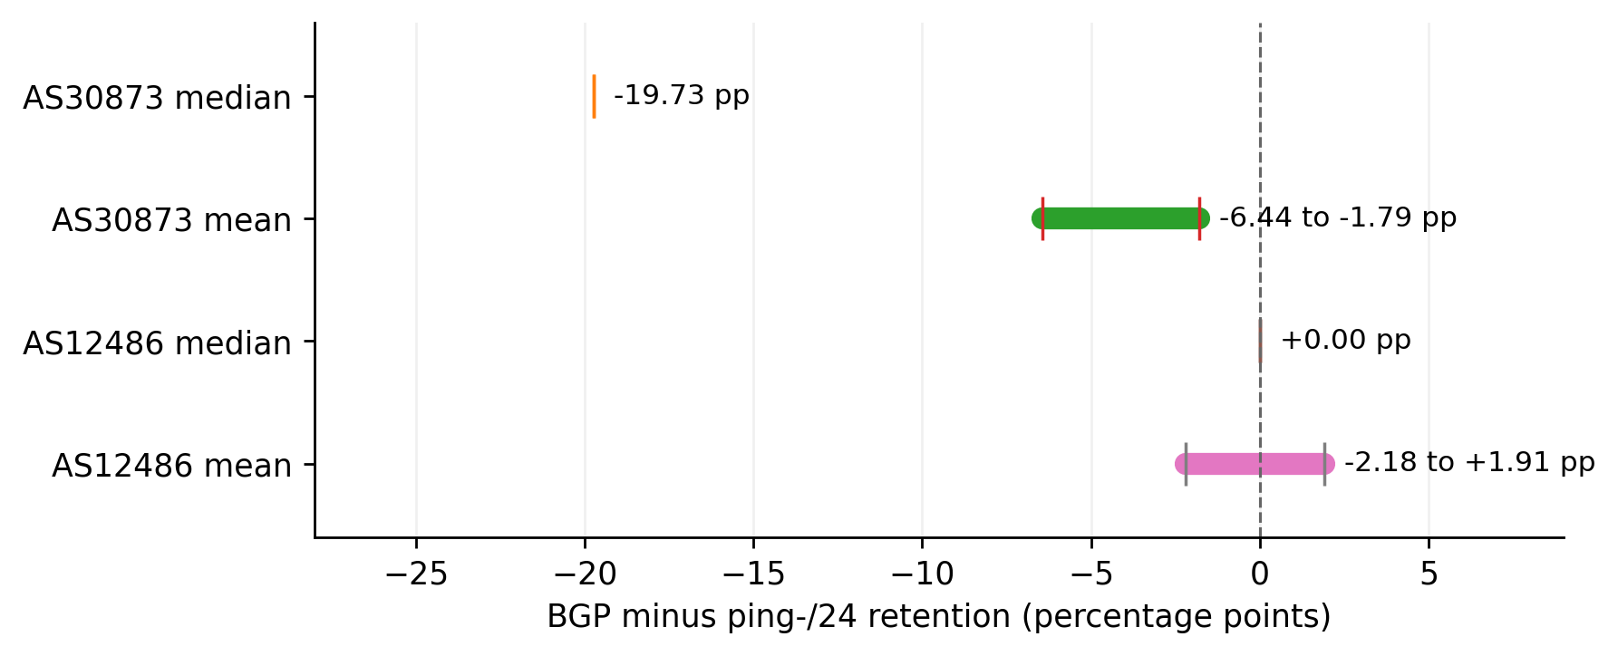
Fig. 6 Additional nonoverlapping event-window sensitivity from source-native November 2023 IODA JSON. Horizontal spans denote the minimum–maximum of 75 deterministic alternative specifications per AS and estimator; the dashed vertical line is zero BGP-minus-ping retention difference. These are not statistical confidence intervals and the two measurement families retain different source semantics.

8.4 Evidence-Constrained Results
- Finding 1: SHA-256-verified RIPE RIS January 2020 RIBs show substantial AS30873 origin-adjacent BGP reconfiguration across three collectors, supported under observation-, peer- and prefix-qualified summaries (Tables 5–6; Fig. 2).
- Finding 2: The separate archived 192-file RRC00 UPDATE replay reconciles 6,586 endpoint candidate-prefix states; full RRC01/RRC10 interval replay and continuous peer health remain unverified.
- Finding 3: Independently reproduced 2020 IODA publisher-raster signals show a descriptive +50.8-point cross-family baseline-retention contrast (45.8–55.2 deterministic analysis-choice range); provider-native IODA 2020 numerical samples remain unavailable.
- Finding 4: Native source-JSON IODA from a different November 2023 FALCON maintenance incident produces a negative BGP-minus-ping retention contrast for AS30873, precluding any claim that the sign or magnitude is universal.
- Finding 5: Neither the BGP path-state records nor reported capacity or active proxies identify physical cable-specific packet paths, affected subscribers or a causal intervention effect. The August 2026 snapshot is contextual only (Table S8).

8.5 Secondary 2020 IODA Sensitivity
The historical 20,250-setting analyst-choice grid reproduces the +45.8 to +55.2-point AS30873 normalized proxy-contrast range from the original publisher PNG (Fig. 3; Online Resource 1, Table S6). Image retrieval, dimensions, source SHA-256 and pixel-column extraction are verified, but the original January 2020 IODA numeric samples remain unavailable. This robustness pertains to digitization choices, not independent observations or confidence intervals.

8.6 Observational-Unit and Common-Peer Diagnostics
The main source-native sensitivity results appear once in Table 6 and Fig. 2. They show that observation-, prefix- and peer-equal fractions are different estimands; changing the unit alters numerical magnitudes but preserves the descriptive between-AS direction across all three RIS collectors. The full released CSVs permit exact peer ASN/IP matching and leave-one-prefix-out checks (Online Resource 1, Tables S10–S11).
The shared-observer comparison rejects only a narrowly defined descriptive equality pattern in the observed samples. AS12486 cannot be an exchangeable untreated counterfactual to AS30873 because its six matched prefixes, routing relations and network exposure differ substantially. No independent-sample p-values or cable-level causal effect sizes are claimed.
For every reported fraction we distinguish its denominator: source-route record, matched prefix or matched peer. The 96 matched-peer comparisons include repeated observers and routes across collectors and are not independent experiments. See Online Resource 1 for complete observation counts and distributions.
Collector-stratified and leave-one-prefix-out summaries sustain a descriptive source-qualified association, not any causal null-test rejection. Source-time resolution is limited to two BGP checkpoints, plus a distinct RRC00 interval audit; physical cable-path mapping and a matched unaffected network are unavailable.
Attributing individual changed paths to the physical FALCON break would require independently documented cable/AS dependencies, exact fault and repair timestamps, matching historical coverage and a credible untreated comparison. These are absent; the result remains an auditable two-checkpoint routing case study.

9. Robustness and Evidence Boundaries
Original six-RIB SHA-256 provenance, released 11,419 source-derived rows and independent row-to-group accounting support the empirical BGP estimand. Per-prefix and per-peer summaries address observer-weighting sensitivity, but sample dependence and nonexchangeable 105-versus-six-prefix inventories preclude causal inference. The publisher-image-verified 2020 IODA sensitivity grid addresses pixel choices only, while the separate 2023 native IODA exercise probes interpretation across a different event. Exact source files, hash gates, and executable reproductions are in Online Resource 1.
These checks support evidence-bounded control-plane reconfiguration co-occurring with reported operational degradation; they do not establish a per-route physical cause, data-plane restoration or a cross-network average intervention effect.

10. Discussion

10.1 Beyond Provider Counts
The result extends beyond counting upstream providers: original 2020 RIPE peer–prefix records demonstrate heterogeneity of observed origin-adjacent AS_PATH changes under three different units of aggregation. Such route reconfiguration is compatible with adaptation but is neither a physically disjoint cable reroute nor a measure of delivered traffic or service capacity. The contribution is its reproducibility and source-to-claim discipline during a dated critical-infrastructure disruption.

10.2 Why Structural Reachability Is Not Enough
Control-plane visibility and active reachability can disagree, as established by previous studies [8,9]. Here, IODA publisher images supply a separately normalized, deterministic 2020 proxy contrast, and historical capacity reporting supplies still another construct. No direct operational-availability percentage follows from subtracting those signals.

10.3 Recovery as a Distinct Dimension
The archived RRC00 UPDATE audit records 16 hours of candidate-prefix events and reconciles its end state, but it does not provide a traffic-quality recovery curve or independently timestamp cable repair. RRC01 and RRC10 are supported only at two RIB checkpoints. Recovery requires time-stamped operator and active-measurement evidence beyond these data.

10.4 Policy and Engineering Implications
For resilience planning, the defensible implication is to test independence under the relevant failure mode rather than rely on nominal provider counts. A logically different upstream that still shares the failed physical dependency cannot protect against that same failure mode by definition; benefit from physical diversity should therefore be treated as an engineering design condition to be verified in an instantiated topology, not as an empirical intervention effect demonstrated by this paper. This interpretation is consistent with international emphasis on geographic diversity, infrastructure redundancy, preparedness, and timely repair [1,2] and with broader network-resilience design principles [20,22,24]. The paper does not estimate the cost, deployable capacity, or optimal siting of alternative infrastructure, and it intentionally excludes sensitive operational location details.

10.5 Relation to Contemporary Cross-Layer and Multilayer Work
Nautilus [3], Xaminer [4] and Calypso [5] address cross-layer mapping/exposure; Dainotti et al. [8] and Jahromi and Jaskolka [9] establish control-/forwarding-plane differences. Our limited addition is a dated, three-collector, source-auditable route-adjacency reconstruction with multiple observational units and a public evidence-to-claim workflow. We do not present a novel general mapping technique or a universal infrastructure-resilience estimator.

10.6 Causal Identification, Negative Controls, and External Validity
The observed origin-adjacent neighbor transitions (Table S12) and IPv4/IPv6 selection effects (Table S13) were reaggregated from the released event-window peer–prefix records. The separately selected January 2–3, 2020 reference-window analysis, fixed before its outcome inspection was subsequently completed on six additional source-original RIPE RIS RIBs with documented download hashes and gzip checks. Its row-level exports and the six event-versus-reference contrasts were reproduced using the same endpoint and eligibility definitions (Tables S14–S15; Fig. S4). This one reference window is descriptive historical context; it cannot determine the normal-churn distribution, quantify a cable-specific causal effect, or establish that the comparator date was entirely disruption-free.
The identifiable quantity is a conditional change in the immediate origin-adjacent AS_PATH neighbor between two observed RIB checkpoints. It is not the causal effect of a cable intervention: event-time physical network dependence, uninterrupted BGP session health and a matched untreated network are unobserved. Some routes may change for unrelated policy or routing reasons.
Comparator qualification. AS12486 offers a contemporaneous descriptive comparison in the same broad national setting, not an exchangeable untreated control; its prefix inventory (six versus 105), upstreams and customers differ. Same-observer and leave-one-prefix diagnostics limit observer-selection explanations, but do not identify a cable effect or falsify a causal null hypothesis.
The defensible generalizable lesson is methodological: BGP path visibility must not be equated with service reachability or capacity, especially when monitoring units and data provenance differ. Numerical Yemen 2020 fractions and the sign of any BGP-versus-active proxy contrast do not transport across incidents.
Stronger causal identification would require verified intervention times, physical cable-to-AS dependencies, repeated baseline/control periods, stable peer panels and original synchronized active/traffic observations. Such evidence is not present here.
The new January 2–3 two-checkpoint reference window tests an important alternative description: short-horizon adjacent-AS churn in one earlier period under the same method (not the population distribution of ordinary churn). AS30873 exhibits far smaller matched-neighbor changes in this one earlier window than during January 9–10 across all three RRCs (Table S14; Figure S4), including when conditioning on identical eligible peer–prefix keys (Table S15). This strengthens event specificity at the level of measured BGP endpoints, not the identification of a particular cable-dependent path, a population anomaly probability or continuous physical outage evolution.

10.7 Cross-Event Transportability Stress Test
November 2023 source-native IODA shows an opposite-sign cross-family difference in AS30873 during maintenance, under a different mechanism and sampling design. It challenges an invariant measurement-sign assumption; it is neither a replication nor a statistical counterfactual to the January 2020 break.
Table 9. External transferability checks and their inferential scope. These cases are deliberately not pooled as a statistical meta-analysis because their exposures, measurements, denominators, and outcomes differ.
Case / evidence | Observed qualitative pattern | What transfers / what does not
Yemen FALCON, Jan 2020 [25,29,30] | AS30873 neighbor reconfiguration coincides with severe reported service/capacity degradation. | Shows that BGP route presence is not service restoration; no universal route percentages or per-route cable attribution.
Yemen FALCON maintenance, Nov 2023 [28,32–35] | Native IODA BGP retention ~40.3%; ping-/24 retention ~60.0% for AS30873. | Measurement families can diverge with an opposite sign; not a replicated cut or common causal parameter.
Mediterranean fibre-cable outage, RIPE NCC [38] | Some networks lost BGP reachability, others rerouted via BGP or lower-layer circuits with congestion/latency. | Independent example of heterogeneous mechanisms; no shared denominator to transfer Yemen percentages.
WACS cable disruption, Togo, Jan 2020 [30] | Contemporaneous reported cable and land-backup faults with network disruption. | Context for physically dependent redundancy; lacks comparable source-native matched peer-prefix analysis here.
What transfers across settings is an evidence rule, not a numerical effect: report control-plane, active and operational-capacity indicators separately, with each source's denominator and uncertainty limitations.
Any future cross-event causal analysis requires common source-native metrics, independent physical incident timing, corroborated physical dependencies and multiple unaffected comparison panels. This design is outside the present study.

11. Limitations
- Public routing and measurement data provide partial Internet visibility and cannot recover proprietary operator traffic matrices or internal topology.
- Public submarine cable maps often generalize cable routes; precise route coordinates are intentionally neither required nor reported.
- Historical evidence sources measure different constructs (capacity, BGP visibility, active reachability, and country-level connectivity/traffic). They are analyzed as separate measurement families and are not treated as interchangeable observations of one latent national-performance variable.
- The original January 2020 IODA provider numerical arrays were not recovered. The two publisher-linked 1840 × 874 PNGs were retrieved and fingerprinted, and the historical pixel extraction plus 20,250-setting deterministic grid was reproduced byte-for-byte. This closes the *raster provenance/reproduction* limitation only; plot-derived, separately normalized signals remain secondary and their apparent timing and sampling uncertainty cannot be calibrated to raw provider measurements.
- All six original 2020 RIPE endpoint RIBs were checksum-gated and decoded into 11,419 source-native first-checkpoint records with released per-peer and per-prefix files. Endpoint peer presence does not prove continuous uptime, and disappearance of target-origin routes is not automatically an explicit withdrawal. The separate RRC00 16-hour UPDATE replay remains restricted to 116 historical candidate prefixes; equivalent interval analysis is unavailable for RRC01/RRC10.
Original source records are supplied to reviewers in a frozen, checksum-indexed CSV artifact alongside six input RIB URLs and digests. Reaggregation checks match six route-change numerators/denominators and all per-peer/per-prefix group sums. Public-source access is independent of any claimed continuous peer-session or cable topology observation.
The 105-versus-six-prefix difference and overlapping observer panels are nonexchangeable; paired common-peer counts cannot be interpreted as independent control observations or normal-theory confidence intervals. Claims are strictly conditional on each collector's sampled routes.
- The public Atlas ICMP control uses one destination, seven probing IDs, and a five-day time window. A high reply rate cannot be extrapolated to AS12486, AS30873, or Yemen. The target ASN is catalogue metadata rather than confirmed historical target-origin state for every packet. Consecutive tests and observations from the same probe are correlated, so a conventional independent-binomial confidence interval would be misleading [27,37].
- Representative mobile-operator prefixes sharing AS30873 demonstrate a resource–origin dependency pattern but do not prove that every resource or all operator traffic shares the same path.
- The study does not estimate empirical intervention effects or the available capacity of a physically independent alternative. The discussion of shared versus independent failure dependencies is an engineering implication of the dependency definitions and should not be read as measured superiority of a deployed intervention.
- Machine learning and explainable artificial intelligence are omitted because the available historical events are too few and heterogeneous, and deterministic scenario-grid rows do not constitute independent empirical training evidence.
- The Red Sea–Yemen corridor is an analytical scope definition and should not be interpreted as a formally designated telecommunications corridor.
- The one-week-prior 16-hour reference interval is a single historically chosen comparison. It was fixed before its result was inspected but is not an estimated distribution of normal routing change. Additional negative-control dates, time-of-day variability, and independent physical fault timing would be needed to identify statistical exceptionalness or cable causality.

12. Reproducibility and Research Integrity
The reproducibility package separates source-native January 2020 RIPE event and one-week-earlier reference RIB exports, original November 2023 IODA JSON, raster-derived January 2020 IODA readings, historical RRC00 UPDATE audit metadata and contextual event documents. Reviewer files include the complete 11,419-row, three-collector frozen CSV export with its per-prefix/per-peer tables and original RIB SHA-256 manifest. Each claim is linked to a frozen code/version identifier or a named supplementary table, with non-commensurate proxy estimands explicitly qualified. Historical full RIB and UPDATE binaries are retrieved from their official providers, not republished in this package.
Evidence status (28 October 2026): source-native two-checkpoint event and reference RIB reconstruction and peer–prefix reaggregation are complete at RRC00/RRC01/RRC10. The 192-file RRC00 UPDATE-to-RIB result is a separate archived execution whose published audit matched 6,586 ending states; this manuscript revision did not independently replay its raw UPDATE bytes. Both January 2020 IODA *publisher PNGs* were retrieved, SHA-256 verified and re-digitized; the complete 20,250-setting raster-derived grid was reproduced. The original January 2020 *IODA numerical time series* remains unavailable. No source supplies continuous peer-session uptime or measured physical cable path attribution.
Frozen original-source evidence: event 2020 peer–prefix exports and audits at GitHub commit 907b59027807ab292d33886d36e65e2bb07f63c6; reference 2020 peer–prefix exports and audits at e7d0f51729ef8fffe138fa7fc34a3130455e1ad2. The reviewer bundle includes these source-derived CSVs and source URL/checksum evidence for all 12 original RIB files and can be inspected without GitHub credentials. Unmodified RIPE RIB binaries remain available from https://data.ris.ripe.net/ but are not redistributed; source-publisher IODA image provenance and secondary sensitivity CSVs are separately documented in Online Resource 1.

12.1 Evidence-to-Claim Admissibility and Independent Robustness Audit
To make the measurement boundary operational rather than rhetorical, each empirical statement is admitted only after five checks: (G1) source identity and checksum or documentary provenance; (G2) event timestamp and observer continuity or explicitly limited checkpoint coverage; (G3) preservation of the measurement construct and denominator; (G4) sensitivity to the collector, estimator or analysis window, while retaining dependence among repeated observations; and (G5) a valid counterfactual before any causal-effect wording. Failure of G5 does not discard a valid descriptive observation, but changes its permissible claim class to source-scoped association or interpretation. Table 10 documents how these gates were applied. The reviewer-initiated unit-of-analysis audit additionally requires (G6) an explicit accounting of clustering and selection: retain raw, eligible and matched counts; report results under peer–prefix, within-peer and within-prefix definitions without pooling incompatible estimands.
Table 10. Operational evidence-to-claim admissibility audit, distinguishing evidence that is original, plot-derived, documentary or contextual. “Limited” is a boundary on inference rather than an indication that the original source is fabricated.
Evidence family and verification | Admissible observation | Rejected extrapolation
RIPE RIS 2020: six RIB snapshots; peer-ASN/IP-qualified [25] | Source-native 2020 RIB decoding across RRC00/01/10: 11,419 first-checkpoint peer–prefix rows, with complete per-prefix/per-peer change distributions. | Per-route physical cable path, causal loss, user reachability, or uninterrupted peer uptime.
RRC00: 192 MRT UPDATE archives, checkpoint replay [25] | Within 116 historic candidate prefixes, terminal state agrees with 6,586 RIB states. | Whole-country BGP state and event-to-event generalization; global lost-prefix fraction.
IODA 2020 publisher raster PNGs; SHA-256 and pixel extraction verified [28,30] | Source-image-reproduced normalized 2020 BGP/active plot proxy: +50.8144 pp AS30873 acute-gap; deterministic window/RGB/axis perturbation grid reproduced byte-for-byte. | Original 2020 IODA numeric samples, same-denominator user reachability, packet delivery, physical cable causation, or inference from the deterministic settings as independent samples.
RIPE Atlas 2020: public single-target measurement [27,37] | Response fraction for one address observed through seven probing IDs. | AS12486-wide or national reachability, population-level 95% CI.
IODA Nov 2023: original JSON, separately checked SHA-256 [28] | Within-event 2023 median and mean signal differences; bounded timing sensitivity. | Same physical mechanism or comparable numerical 2020 causal effect.
TeleYemen/World Bank capacity reporting [29] | Historically reported magnitude and duration of national capacity loss. | Numerical equality of capacity, BGP route visibility and responsive /24 counts.
August 2026 origin snapshot [36] | Dated network concentration context only. | Back-projection of modern ASN structure to 2020.
Reproduction sequence (Online Resource 1): (i) verify the 12 original RIPE RIS RIB source URLs and SHA-256 records—six January 9–10 event files and six January 2–3 reference files—and use the source-native parser if independently reconstructing these large archives; (ii) check the included 11,419 first-checkpoint EVENT rows and the reference-window peer–prefix CSVs, recomputing the six event and six reference AS/collector summaries and the fixed-key intersection (Tables S14–S15); (iii) reproduce per-prefix/per-peer and IPv4/IPv6 summaries and distinguish the separate historical RRC00 192-archive UPDATE replay; (iv) check the 2020 publisher IODA PNG URLs and SHA-256 and reproduce the deterministic 20,250-setting raster grid; (v) reproduce 2023 native IODA JSON summaries. The public source binaries are not redistributed, and no result is interpreted as an independent-user sample or a causal effect. Code/REPRODUCE.md contains clean-machine commands and the exact scope of each validation.
The fixed before reference-window outcome inspection January 2–3 comparator provides descriptive event context: across the same three collectors, AS30873 had 0.41–0.90% changed-neighbor shares in the reference interval versus 64.73–67.98% on January 9–10 (64.32–67.08 percentage-point gaps). The comparison is robust in a fixed peer–prefix cohort but not a causal falsification test or a sampled normal-variation distribution.

13. Conclusion
In the January 2020 FALCON case, source-audited RIPE RIS data show large network-specific origin-adjacent AS_PATH reconfiguration between two event-associated RIB checkpoints. Across the same three collectors, a fixed before reference-window outcome inspection one-week-earlier 16-hour reference had only 0.41–0.90% changed-neighbor shares in AS30873 versus 64.73–67.98% during the reported disruption; the descriptive contrast also persisted on identical peer–prefix keys. This strengthens the event-specific historical measurement but cannot show how statistically unusual the change is across routine periods or attribute individual paths to the cable. The AS12486 comparator is not an unaffected experimental control: its different six-prefix inventory and zero retained eligible IPv6 observations at the event endpoint make its IPv4-based neighbor-change shares a conditional, incomplete view. No population reachability, physical path disjointness, continuous BGP uptime or direct capacity-restoration estimate follows.
Original source-raster images also reproduce the January 2020 IODA normalized BGP-versus-active proxy contrast, but no original 2020 IODA provider time series was recovered. A separate historical RRC00 UPDATE replay reconciles bounded ending route states; source-native 2023 maintenance IODA tests only the stability of the measurement-interpretation rule across a different event. Together, the work offers a checkable event-specific evidence-to-claim protocol, not a new generic cable-to-AS map, physical restoration estimate or generalizable outage-effect coefficient.

References
[1] International Telecommunication Union. (2026). International Advisory Body approves landmark report to strengthen submarine cable resilience. Press release, 10 July 2026. https://www.itu.int/en/mediacentre/Pages/PR-2026-07-10-Submarine-cable-resilience-report.aspx
[2] International Telecommunication Union. (2026). International Advisory Body on Submarine Cable Resilience: Report of the Working Groups 2026. https://www.itu.int/pub/S-IAB-WG
[3] Ramanathan, A., & Abdu Jyothi, S. (2023). Nautilus: A framework for cross-layer cartography of submarine cables and IP links. Proceedings of the ACM on Measurement and Analysis of Computing Systems, 7(3), Article 46. https://doi.org/10.1145/3626777
[4] Ramanathan, A., Sankaran, R., & Abdu Jyothi, S. (2024). Xaminer: An Internet cross-layer resilience analysis tool. Proceedings of the ACM on Measurement and Analysis of Computing Systems, 8(1), Article 16. https://doi.org/10.1145/3639042
[5] Wang, C. J., Zhang, Y., Dong, Q., Carisimo, E., Durairajan, R., & Bustamante, F. E. (2025). Threading the ocean: Mapping digital routes across submarine cables using Calypso. In Proceedings of ACM SIGCOMM 2025 (short paper, 3 pp.). https://doi.org/10.1145/3718958.3750512
[6] Lang, B., Roughan, M., & Ye, M. (2026). Robustness analysis of Australia's Internet using a multilayer network model. arXiv:2606.18737. https://doi.org/10.48550/arXiv.2606.18737
[7] Wu, W., & Neumueller, A. (2026). Bitcoin under stress: Measuring infrastructure resilience 2014–2025. arXiv:2602.14372. https://doi.org/10.48550/arXiv.2602.14372
[8] Dainotti, A., Squarcella, C., Aben, E., Claffy, K. C., Chiesa, M., Russo, M., & Pescapè, A. (2014). Analysis of country-wide Internet outages caused by censorship. IEEE/ACM Transactions on Networking, 22(6), 1964–1977. https://doi.org/10.1109/TNET.2013.2291244
[9] Jahromi, A. S., & Jaskolka, J. (2026). A multi-perspective study of the Internet shutdown in Iran. arXiv:2605.00187. https://doi.org/10.48550/arXiv.2605.00187
[10] Weaver, M., Veitch, D., Barford, P., Bustamante, F. E., & Carisimo, E. (2026). Monitoring latency on submarine cables: Limitations and opportunities. 1st New Ideas in Networked Systems (NINeS 2026), OASIcs, 139, 16:1–16:24. https://doi.org/10.4230/OASIcs.NINeS.2026.16
[11] Owen, R., Bryant, A. R., Finch, L., Franklin, D., Abdollahi, M., & Abolhasan, M. (2025). Failures and resilience in the IP era: Navigating the fragility of modern telecommunications networks—The sovereign functions. IEEE Access, 13, 155759–155777. https://doi.org/10.1109/ACCESS.2025.3602054
[12] Venkatasubramanian, B. V., Laoudias, C., & Panteli, M. (2025). Cascading failures and resilience in interdependent critical infrastructures: A dynamic approach. IEEE Systems Journal, 19(4), 999–1010. https://doi.org/10.1109/JSYST.2025.3629327
[13] Caetano, H. O., Desuó Neto, L., Fogliatto, M. S. S., & Maciel, C. D. (2024). Resilience assessment of critical infrastructures using dynamic Bayesian networks and evidence propagation. Reliability Engineering & System Safety, 241, 109691. https://doi.org/10.1016/j.ress.2023.109691
[14] Cavalieri, F., & Franchin, P. (2020). Seismic risk of infrastructure systems with treatment of and sensitivity to epistemic uncertainty. Infrastructures, 5(11), 103. https://doi.org/10.3390/infrastructures5110103
[15] Liu, X., Zio, E., Borgonovo, E., & Plischke, E. (2024). A systematic approach of global sensitivity analysis and its application to a model for the quantification of resilience of interconnected critical infrastructures. Energies, 17(8), 1823. https://doi.org/10.3390/en17081823
[16] Ferrario, E., Pedroni, N., & Zio, E. (2015). Analysis of the robustness and recovery of critical infrastructures by goal tree–success tree: Dynamic master logic diagram, within a multistate system-of-systems framework, in the presence of epistemic uncertainty. ASCE-ASME Journal of Risk and Uncertainty in Engineering Systems, Part B, 1(3), 031001. https://doi.org/10.1115/1.4030439
[17] Johansen, C., & Tien, I. (2018). Probabilistic multi-scale modeling of interdependencies between critical infrastructure systems for resilience. Sustainable and Resilient Infrastructure, 3(1), 1–15. https://doi.org/10.1080/23789689.2017.1345253
[18] Mottahedi, A., Sereshki, F., Ataei, M., Nouri Qarahasanlou, A., & Barabadi, A. (2021). The resilience of critical infrastructure systems: A systematic literature review. Energies, 14(6), 1571. https://doi.org/10.3390/en14061571
[19] Omer, M., Nilchiani, R., & Mostashari, A. (2009). Measuring the resilience of the trans-oceanic telecommunication cable system. IEEE Systems Journal, 3(3), 295–303. https://doi.org/10.1109/JSYST.2009.2022570
[20] Sterbenz, J. P. G., Hutchison, D., Çetinkaya, E. K., Jabbar, A., Rohrer, J. P., Schöller, M., & Smith, P. (2014). Redundancy, diversity, and connectivity to achieve multilevel network resilience, survivability, and disruption tolerance (invited paper). Telecommunication Systems, 56(1), 17–31. https://doi.org/10.1007/s11235-013-9816-9
[21] Rohrer, J. P., Jabbar, A., & Sterbenz, J. P. G. (2009). Path diversification: A multipath resilience mechanism. In 7th International Workshop on Design of Reliable Communication Networks (DRCN 2009) (pp. 343–351). https://doi.org/10.1109/DRCN.2009.5339988
[22] Ashraf, M., Idrus, S. M., Iqbal, F., Butt, R. A., & Faheem, M. (2018). Disaster-resilient optical network survivability: A comprehensive survey. Photonics, 5(4), 35. https://doi.org/10.3390/photonics5040035
[23] de Sousa, A., Rak, J., Barbosa, F., Santos, D., & Mehta, D. (2020). Improving the survivability of carrier networks to large-scale disasters. In J. Rak & D. Hutchison (Eds.), Guide to Disaster-Resilient Communication Networks (pp. 175–192). Springer. https://doi.org/10.1007/978-3-030-44685-7_7
[24] Wan, Y., Feng, C., Wu, K., & Wang, J. (2025). RZDD: Risk zone-diversified network design for disaster resilience. IEEE Transactions on Dependable and Secure Computing, 22(1), 505–517 (online 2024). https://doi.org/10.1109/TDSC.2024.3406703
[25] RIPE NCC. Routing Information Service (RIS): MRT data archives and raw collection documentation. https://ris.ripe.net/docs/mrt/
[26] CAIDA. BGPStream: Historical BGP monitoring data and processing documentation. https://bgpstream.caida.org/
[27] RIPE NCC. RIPE Atlas: Measurements REST API documentation. https://atlas.ripe.net/docs/apis/rest-api-manual/measurements/
[28] Internet Outage Detection and Analysis (IODA). IODA measurement platform and HTTP API documentation. Georgia Tech Internet Intelligence Lab. https://ioda.inetintel.cc.gatech.edu/
[29] World Bank. (2020). Yemen Monthly Economic Update: January 2020 (published 21 February 2020). https://www.worldbank.org/en/country/yemen/publication/yemen-monthly-economic-update-january-2020
[30] Belson, D. (2020). Internet Disruption Report: January 2020. Internet Disruption Report, 23 February 2020. https://internetdisruption.report/2020/02/23/internet-disruption-report-january-2020/
[31] NetBlocks. (2022). Internet connectivity knocked out in Yemen after airstrike. 21 January 2022. https://netblocks.org/reports/internet-connectivity-knocked-out-in-yemen-after-airstrike-PAYbNoBe
[32] Belson, D. (2024). Q4 2023 Internet disruption summary. Cloudflare Blog, 22 January 2024. https://blog.cloudflare.com/q4-2023-internet-disruption-summary/
[33] NetBlocks. (2023). YemenNet outage: Reported overall national connectivity at 33% of ordinary levels, 10 November 2023. Social-media update reproduced in The Times of Israel (secondary reproduction of original statement). https://www.timesofisrael.com/liveblog_entry/yemen-officials-blame-maintenance-for-nationwide-internet-outage/
[34] Global Cloud Xchange / FLAG. (2023). Clarification: Yemen Internet outage. https://flagtel.com/clarification-yemen-internet-outage/
[35] Gambrell, J. (2023). Internet collapses in war-torn Yemen over “maintenance” involving undersea line. Associated Press, 10 November 2023. Accessible syndicated copy: https://www.wsls.com/news/world/2023/11/10/internet-collapses-in-war-torn-yemen-after-recent-attacks-by-houthi-rebels-targeting-israel-us/
[36] bgp.tools. (2026). Public BGP table and ASN resources; authors’ archived 9 August 2026 origin-snapshot assembly. https://bgp.tools/kb/api. Snapshot counts are study-derived from the archived export, not currently verifiable against a time-frozen bgp.tools public page.
[37] RIPE NCC. (2020). RIPE Atlas public measurement 8307351: Archived ICMP results for destination 195.94.0.34, 8–12 January 2020. https://atlas.ripe.net/api/v2/measurements/8307351/results/?start=1578441600&stop=1578873599 (original-result audit log in study repository; direct live endpoint not independently retrieved in this review).
[38] RIPE NCC. (n.d.). Mediterranean Fibre Cable Cut: Analysis and Conclusions. RIPE Network Coordination Centre. https://www.ripe.net/analyse/archived-projects/mediterranean-fibre-cable-cut/conclusions/

Statements and Declarations

Funding
No funding was received for conducting this study or for the preparation of this manuscript.

Competing interests
The authors have no relevant financial or non-financial interests to disclose.

Data availability
The reviewer archive supplies source-derived peer–prefix CSVs for six event RIBs (January 9–10, 2020; 11,419 first-checkpoint rows) and six earlier reference RIBs (January 2–3), with source URLs and SHA-256 hashes. Raw MRT files are available at RIPE and are not redistributed. A bounded historical RRC00 192-UPDATE replay exists but was not rerun here. The original publisher-linked 2020 IODA PNGs were checksum-verified and digitized; provider-native 2020 numerical series remain unavailable. The separate November 2023 IODA JSON is included.
BGP endpoint changes measure conditional routing states, not packet or population reachability. IODA 2020 is a separately normalized plot-derived comparison; 2023 is a different incident. No cable-specific causal share or continuous peer-session uptime is inferred.

Code availability
Scripts, checksums and exact paths are in the archive and Online Resource 1. Source export commits: event 907b59027807ab292d33886d36e65e2bb07f63c6; reference e7d0f51729ef8fffe138fa7fc34a3130455e1ad2; publisher-raster audit a51805e39f900ca0bdcbd83a32b6dce597b9a345. Fresh raw-RIB parsing requires Internet access and pybgpkit-parser; image work requires Pillow. Third-party redistribution rights are not assumed.

Ethics approval
Not applicable. The study used public and aggregate telecommunications and Internet-measurement data and involved no human participants or animals.

Ethics, security and dual-use statement
The study concerns defensive Internet resilience and uses public historical aggregates. It avoids disclosure of vulnerable infrastructure coordinates, operational attack instructions and unsupported conflict attribution, separating reported events from measured routing observations.

Supplementary information
Online Resource 1 includes Tables S1–S15, Figures S3–S4, original-source BGP CSVs, the 12-RIB URL/hash manifest, published IODA-2020 pixel provenance, IODA-2023 source JSON, executable code and evidence limits. Original IODA-2020 numerical samples remain unavailable.

