Online Resource 1
FALCON: source-auditable supplementary methods, Tables S1–S15, January 2020 historical routing evidence, calibration, and reproducibility (29 October 2026)
Status (29 October 2026; event and reference RIB records and IODA publisher-raster evidence audited): 2020 RRC00/RRC01/RRC10 original RIPE RIS two-RIB peer–prefix extraction is complete for 11,419 historical observations. Two original publisher-linked January 2020 IODA PNGs were retrieved at 1840 × 874 pixels with source URL metadata and SHA-256 checks, and the 2020 plot digitization and complete 20,250-setting sensitivity CSV were independently reproduced exactly. Original source-native IODA 2020 numeric samples remain unavailable; the raster proxy is exploratory secondary evidence, not direct user/packet reachability. The source-native November 2023 IODA event is separate. Full UPDATE replay remains limited to the archived RRC00 candidate-prefix analysis.

Table S1. January 2020 published-plot IODA phase summaries (EXPLORATORY)
AS | Phase | BGP median % | Active median % | Gap pp
AS30873 | pre_event_baseline | 100.00 | 100.00 | -0.00
AS30873 | early_degradation | 95.65 | 39.53 | +56.12
AS30873 | acute_event | 95.65 | 44.84 | +50.81
AS30873 | post_midnight | 95.65 | 51.03 | +44.62
AS12486 | pre_event_baseline | 100.00 | 100.00 | +0.00
AS12486 | early_degradation | 100.00 | 100.00 | +0.00
AS12486 | acute_event | 100.00 | 100.00 | +0.00
AS12486 | post_midnight | 100.00 | 100.00 | +0.00
Original publisher-plot pixels are now retrievable and verified. Values are image-digitized normalized signal summaries (NOT source-native 2020 IODA numeric samples). The raster is aggregated and time-mapping approximate; columns and sensitivity settings are not independent samples. No inferential confidence interval is claimed.

Table S2. January 2020 original-RIB aggregate unit-sensitivity audit
RRC | Origin | Peer-prefix % | Peer median % | Prefix median % | Any-change prefix
RRC00 | 12486 | 6.28 | 0.00 | 1.64 | 4/6
RRC00 | 30873 | 66.83 | 69.07 | 96.67 | 79/105
RRC01 | 12486 | 4.05 | 0.00 | 0.00 | 2/6
RRC01 | 30873 | 67.98 | 69.07 | 100.00 | 79/105
RRC10 | 12486 | 14.10 | 16.67 | 0.00 | 2/6
RRC10 | 30873 | 64.73 | 65.98 | 100.00 | 75/105
The original-RIB aggregate and unit-change calculations are backed by the complete 11,419-row three-collector source-native CSVs enclosed in Evidence/BGP_2020, rather than only by archived audit JSON. The Table S2 summary derives from RIB matched-peers and matched-prefix denominators; historical 2020 IODA is separate plot-derived evidence.

Table S3. Collector-specific between-AS contrasts, not causal effects
RRC | Peer-prefix gap pp | Prefix-any-change gap pp
RRC00 | +60.55 | +8.57
RRC01 | +63.93 | +41.90
RRC10 | +50.63 | +38.10
Large differences can vary with aggregation unit and sampling density; neither is a cable-specific causal effect.

Table S4. Original IODA November 2023 outcomes and sensitivity
Native original JSON source: Supplement/IODA_2023_Original_JSON_SourceArtifact.zip. Full 150-row median/mean window grid supplied as Table_S4_IODA_2023_150_windows.csv. This table is NOT a January 2020 replication. Baseline and event source windows are kept disjoint.
Four source-native median-retention rows are supplied as Table_S4_IODA_2023_Retentions.csv; the complete source is the archived provider API JSON.

Table S5. Source original 2020 RIPE RIS RIB URLs and SHA-256s
All six RIB file identifiers, expected compressed byte counts, SHA-256 hashes and source URLs are in Table_S5_Original_RIB_Manifest.csv. The hash list is an authors’ historical audit manifest, not proof that this supplement contains the binary RIBs. The source archives were not downloaded independently for this revision.

Table S6. January 2020 raster-digitization sensitivity (20,250 configurations)
Source-image-reproduced 20,250-setting raster sensitivity grid: Table_S6_IODA_2020_20250_Deterministic_Settings.csv. Re-run against unchanged publisher AS30873 PNG produced a CSV byte-identical to the archived release, SHA-256 fa9720246ec52edb6770c8637f52da260856908574fb490a4d49f0e825245e12. Range +45.8074 to +55.1698 pp. Each setting is an analyst choice, not an independent measurement or confidence interval. Calibrated source raster is verified, but source-native 2020 IODA numbers remain unavailable.

Table S7. RIPE Atlas 2020, single-target original audit metadata
RIPE Atlas measurement 8307351 for 195.94.0.34: seven probe IDs and 3,343 positive-reply measurement results out of 3,360 in the January 8–12, 2020 archived source audit. See the INCLUDED Supplement/Atlas_2020_audit.zip (audit.json) for aggregated hourly/daily counts, source URLs and original API response SHA-256. The 1.39 MB original per-result source API response bytes are not redistributed in this reviewer archive, and individual result payloads are not independently replayed here. This is a one-target aggregate diagnostic, not Yemen-wide reachability or independent validation of 2020 IODA.

Table S8. Optional August 2026 routing-concentration context
Table_S8_2026_CONTEXT_ONLY.csv. This is an observational snapshot from a different year and is not primary 2020 FALCON evidence. Corresponding supplementary Figure S2 is also 2026-context only.

Source-native BGP reprocessing and fail-closed gates
Reproduction status: source-native individual two-RIB export completed in GitHub Actions (frozen commit 907b59027807ab292d33886d36e65e2bb07f63c6) for RRC00/RRC01/RRC10. The reviewer bundle directly includes all 11,419 first-checkpoint source-decoded peer–prefix rows, each prefix's within-peer change distribution and each observer's within-prefix change distribution, plus source RIB URLs, SHA-256s and output audit JSON. To regenerate them from RIPE official archives, install pybgpkit-parser and run the frozen tools/ripe2020_peer_prefix_source_native_final.py with FALCON_RRC=rrc00, rrc01 and rrc10 on a network-connected host. Valid output must reproduce all six comparator count checks. Whole-RIB peer presence at both endpoints is not continuous peer session proof.
Official original archive: https://data.ris.ripe.net/ . Source-naming convention: https://ris.ripe.net/docs/mrt/ . The 192 update source SHA-256 entries are recorded at the authors’ private GitHub repository in results/ripe_2020_source_original_16h_aw_manifest.json; independent reviewers need authorized access to that repository or a copy of the list. Public URLs alone do not prove the recorded source data were re-parsed.

Published IODA 2020 plot provenance and permissions
Original incident article: https://internetdisruption.report/2020/02/23/internet-disruption-report-january-2020/ . Direct unchanged publisher PNGs: https://internetdisruption.report/wp-content/uploads/2020/02/jan-910-yemen-as30783-ioda.png (caption AS30873; PNG actually labelled AS30873) and https://internetdisruption.report/wp-content/uploads/2020/02/jan-910-yemen-as12486-ioda.png . Both were fetched in a provenance-logged GitHub Actions run and are 1840 × 874 PNGs. SHA-256: AS30873 229b9ed3e0e169c78331b7e50f0a2af9f47f88c3d0b73d0524db633d14977efd; AS12486 fb4be5c7d169a659a1b7f5c207eb56c5390d20faaf60705dc0d34610466a612c. Independent RGB trace extraction verified 1661 BGP and active columns for AS30873 and 1668 BGP / 1617 active columns for AS12486. The direct figure is publisher-owned; these image copies are for private calibration review only, not publication or relicensing. Native IODA 2020 numeric arrays were not obtained.

2020 IODA primary series NOT recovered. Both original publisher-raster PNGs (1840 × 874 pixels) have been retrieved and SHA-256 checked; color-column extraction and an independently rerun 20,250-setting deterministic sensitivity grid agree exactly with the previous archived file. The raster provenance and numerical re-extraction gate are CLOSED, but raw provider numerical samples, sampling timing and independently measured service reachability remain UNAVAILABLE. Full raster audit metadata, calibration script and CSV are included as separate reviewer materials; publisher-owned images are linked by exact URLs rather than redistributed as licensed publication figures.
COMPLETE / VERIFIED: (i) 2020 two-checkpoint RIPE RIB original-source CSVs and per-unit reconstructions (11,419 rows); (ii) source-publisher IODA 2020 raster fingerprinting and pixel extraction; (iii) 20,250-setting raster deterministic sensitivity rerun; (iv) native November 2023 IODA JSON reproduction. REMAINING PRIMARY-SOURCE LIMITS: provider-native IODA 2020 numerical samples; continuous peer-session telemetry; RRC01/RRC10 full UPDATE replay; any credible network-to-physical-cable causal counterfactual. These are not implicitly closed by the available computations.

Table S9. Independent audit gates and remaining primary-source limitations
Evidence / experiment | Result of this revision | Publication status
2020 RRC00/01/10 archived two-snapshot audits | New source-original six-RIB peer–prefix CSVs recovered and all six original counts matched. Independent row-to-group reaggregation passed 24 checks. | Completed source-native two-checkpoint extraction; archived 192-file update replay is a separate RRC00 workflow.
2020 RRC00 16-hour replay audit | Stored report asserts 192 contiguous UPDATE inputs, 110,719 candidate update records, 6,586 vs 6,586 end states, zero Origin/AS_PATH mismatches; manifest cross-checks passed. | Auditor verifies recorded arithmetic, not source execution.
2020 peer-prefix and per-prefix distributions | Full 11,419 original-source first-route rows produced, with 105 AS30873 and six AS12486 matched prefixes per collector, per-prefix/per-peer distributions and 96 matched observer comparisons. | Two-RIB extraction COMPLETE: original MRT hashes verified; reviewer CSVs saved at commit 907b590. Full RRC01/10 A/W replay still open.
Published January 2020 IODA rasters | Both original publisher PNGs retrieved and SHA-256 recorded, image label AS30873 independently confirmed despite filename typo, original pixel calibration rechecked and all 20,250 sensitivity settings reproduced exactly. | Original published-image gate CLOSED. Still EXPLORATORY SECONDARY: underlying original 2020 IODA numeric series absent; plots are not confidence intervals or customer reachability.
November 2023 original IODA JSON | Four native retention results and window grid reproduced in previous audit. | Can remain as independently recalculated source-native historical results.

Reproduction instructions for primary-source closure
1. Obtain the TWELVE original compressed RIPE RIS RIB files, at 9 January 08:00 and 10 January 00:00 UTC (six event RIBs) and 2 January 08:00 and 3 January 00:00 UTC (six reference RIBs), for RRC00, RRC01 and RRC10. Original timestamps, URLs, bytes and SHA-256 values are listed in Supplement/Reference_And_Event_Original_RIB_12_SHA256.json. Verify SHA-256 and gzip integrity before source decoding; the original binaries are not redistributed.
2. Verify locally downloaded source bytes and gzip CRC using Code/fetch_original_2020_ribs.py (event manifest) and/or the original repository parser source; source checks must fail closed on hash mismatches. The event and reference six-RIB collections are separate datasets with different snapshot windows and counts.
3. BOTH SOURCE-NATIVE ENDPOINT PAIRS COMPLETED: original RIB files were processed into peer–prefix CSVs in Evidence/BGP_2020/{rrc00,rrc01,rrc10}/ for the event and Evidence/Reference_2020_20200102/{rrc00,rrc01,rrc10}/ for the one-week-earlier reference. Raw event export is pinned at 907b59027807ab292d33886d36e65e2bb07f63c6; reference export at e7d0f51729ef8fffe138fa7fc34a3130455e1ad2. Verify each individual audit.json and reproduce group/fixed-key analyses using the included scripts. These two-snapshot analyses are separate from the historical RRC00 UPDATE replay.
4. From the extracted archive root, run Code/verify_reviewer_bundle.py for source-export numerical and SHA-256 checks, then run Code/compare_2020_event_vs_non_event.py --event-root Evidence/BGP_2020 --reference-root Evidence/Reference_2020_20200102 --output-dir QA/REPRODUCED_REFERENCE_LOCAL. These verify the released observation-level exports and their aggregate calculations; they do NOT substitute for downloading and decoding the original 12 RIPE MRT compressed RIB binaries.
5. IODA 2020 ORIGINAL-IMAGE GATE CLOSED: obtain the original-size PNG bytes from the two direct publisher URLs above (no resizing), verify source hashes, and run Code/recheck_ioda2020_original_pngs.py with the historical x=112–1779, zero y=632 and RGB colors. The recheck reproduces AS30873 +50.8144 pp and AS12486 0 pp. Then run Code/digitization_sensitivity.py on the AS30873 source PNG and verify its full CSV SHA-256 fa9720246ec52edb6770c8637f52da260856908574fb490a4d49f0e825245e12. These tests do NOT recover original IODA numeric samples.
6. The source webpage calls the AS30873 graph "CAIDA IODA graph for AS30873", but its linked image pathname ends "as30783-ioda.png". This filename discrepancy must be preserved and never silently treated as evidence of the graph’s ASN without checking the figure content.
Original source article (third-party): https://internetdisruption.report/2020/02/23/internet-disruption-report-january-2020/ .
Auditable source-export and release checks: QA/BGP_rowlevel_independent_validation.json and QA/FINAL_RELEASE_GATES_2026-10-29.json. IODA 2020 published-image provenance: Evidence/IODA_2020_Original_Publisher_Image_URLs_and_SHA256.json; pixel recalibration: Evidence/pixel_level_recalibration_audit.json; deterministic sensitivity: Evidence/ioda_2020_original_raster_20250_settings.csv. Historical blocked-image statements were superseded for the original publisher rasters only; original IODA 2020 provider-native numerical samples remain unavailable.

Table S10. New January 2020 source-native per-prefix/per-peer distributions
The committed public-source RIPE RIS RIB exports contain one observation for each initial (collector, peer ASN, peer IP, origin prefix). The two snapshots are 9 Jan 08:00 and 10 Jan 00:00 UTC. The files below summarize the full 11,419-source-row extraction. Matched prefix denominators: 105 for AS30873 and 6 for AS12486 at each collector; these networks are not exchangeable. The complementary Table_S10_2020_BGP_Prefix_Peer_SourceNative_Summary.csv contains machine-readable values. No conventional independent-sample confidence intervals are calculated.
Collector | Origin AS | Matched prefixes | Prefix mean / median (%) | Matched peers | Peer mean / median (%)
RRC00 | AS30873 | 105 | 67.01 / 96.67 | 110 | 67.74 / 69.07
RRC00 | AS12486 | 6 | 6.42 / 1.64 | 62 | 6.18 / 0.00
RRC01 | AS30873 | 105 | 68.04 / 100.00 | 40 | 74.19 / 69.07
RRC01 | AS12486 | 6 | 3.95 / 0.00 | 26 | 3.85 / 0.00
RRC10 | AS30873 | 105 | 64.75 / 100.00 | 23 | 65.34 / 65.98
RRC10 | AS12486 | 6 | 14.10 / 0.00 | 13 | 14.10 / 16.67
Machine-readable full source-native CSVs are enclosed in Evidence/BGP_2020/rrc00, rrc01 and rrc10, and immutable at https://github.com/EZZALDEEN049/falcon-yemen-resilience/tree/907b59027807ab292d33886d36e65e2bb07f63c6/results/ripe2020_peer_prefix_original/ . Each collector directory includes BGP_2020_peer_prefix_records.csv, BGP_2020_prefix_distributions.csv, BGP_2020_peer_distributions.csv, BGP_2020_validated_unit_summaries.csv, audit.json and individual_output_status.json. This package contains matching data even when repository access is private.

Table S11. Same-peer paired neighbor-change comparison (descriptive only)
Within each collector, join AS-specific peer summaries on both original peer ASN and peer IP; per-peer changed fractions have non-identical underlying AS prefix inventories. Table S11 reports 62/62, 21/21 and 13/13 positive paired descriptive differences. Do not treat the 96 collector-specific pairs as independent route- or user-level observations. Full CSVs and counts are enclosed and source-frozen.
Collector | Common peers | Positive pairs | Median difference (pp) | IQR (pp)
RRC00 | 62 | 62/62 | +63.92 | +51.37 to +69.07
RRC01 | 21 | 21/21 | +69.07 | +59.79 to +69.07
RRC10 | 13 | 13/13 | +49.31 | +47.25 to +51.37

Frozen artifacts, code, source rights and audit limits
The deliverable ZIP contains frozen original-source BGP 2020 CSVs, audit.json, SHA256SUMS, source IODA 2023 JSON, pixel-column data and calibration outputs. Files are indexed in FILES_MANIFEST_SHA256.json and Data_Dictionary.md. Third-party publisher PNGs are not granted republication rights by their retrievability; direct original publisher URLs and full source hashes are given in the appendix. Source-native RIPE MRT binaries remain at RIPE. The original 2020 IODA numerical provider data are unavailable.

Additional audit — Table S12. Directional BGP adjacency transitions (source-native 2020 RIB checkpoints)
Table S12 is a complete enumeration of pre→post immediate-AS_PATH-neighbor transition pairs among 10,333 retained comparable observations. The input rows came from original RIPE RIB archives at 2020-01-09 08:00 and 2020-01-10 00:00 UTC for RRC00, RRC01 and RRC10. It is not a route-traffic or cable-path transition table. Full CSV: Table_S12_2020_Adjacency_Transitions_by_Collector.csv.
Collector | Origin AS | Largest three transitions (n) | Total matched
RRC00 | 30873 | 15412→174: 2793; 174→174: 2063; 3491→174: 729 | 6220
RRC00 | 12486 | 15412→15412: 279; 6762→6762: 61; 15412→197206: 12 | 366
RRC01 | 30873 | 15412→174: 1089; 174→174: 698; 8529→174: 208 | 2180
RRC01 | 12486 | 15412→15412: 120; 6762→6762: 21; 15412→197206: 4 | 148
RRC10 | 30873 | 15412→174: 593; 174→174: 473; 3491→174: 140 | 1341
RRC10 | 12486 | 15412→15412: 51; 6762→6762: 13; 15412→6762: 6 | 78
Figure S3. Most frequent source-native immediate-AS_PATH origin-adjacent transitions, INCLUDING unchanged pairs such as AS174→AS174. Counts are endpoint-matched peer–prefix observations; they do not identify traffic volume, physical paths, or cable-specific causes.
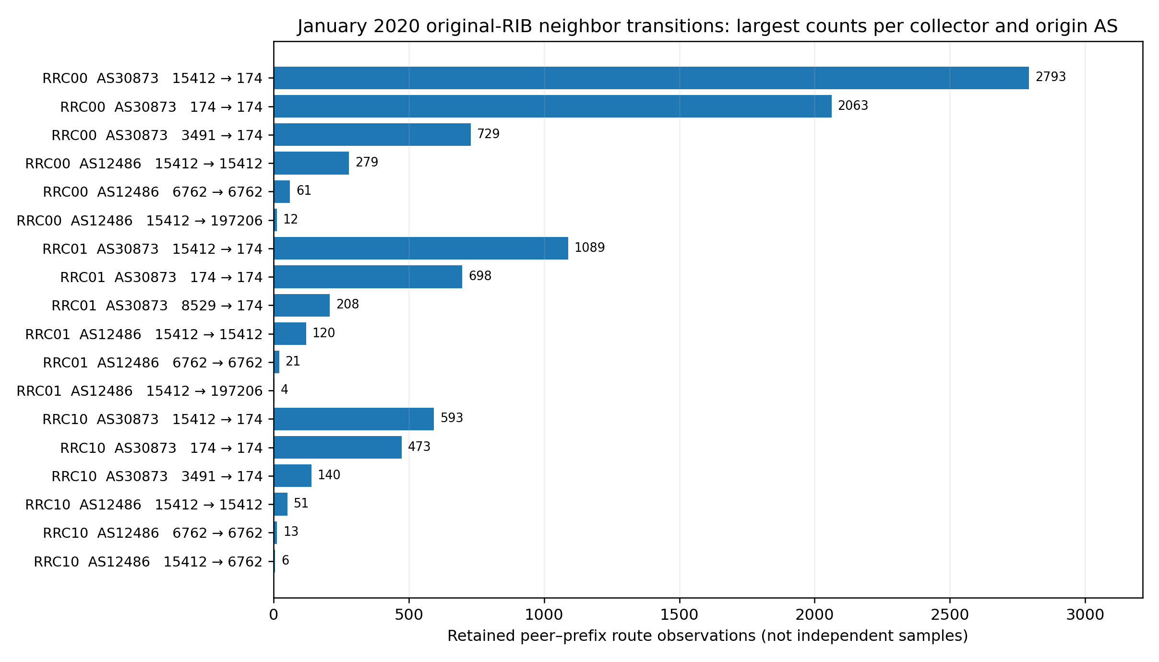

Additional audit — Table S13. IPv4/IPv6 observation selection and parsing
Address-family strata are inferred solely from the prefix strings in the original 11,419 CSV observations. Same-peer presence is tested at two endpoints; “not retained” can reflect target origin loss, policy, session behavior, or other unobserved causes, and is not a directly observed withdrawal. Full CSV: Table_S13_2020_IPv4_IPv6_Selection_and_Transitions.csv.
RRC | AS | AF | Initial | Retained | Changed / Comparable
RRC00 | 30873 | IPv4 | 6173 | 5820 | 3879 / 5820
RRC00 | 30873 | IPv6 | 438 | 400 | 278 / 400
RRC00 | 12486 | IPv4 | 373 | 366 | 23 / 366
RRC00 | 12486 | IPv6 | 55 | 0 | 0 / 0
RRC01 | 30873 | IPv4 | 2493 | 2029 | 1358 / 2029
RRC01 | 30873 | IPv6 | 198 | 151 | 124 / 151
RRC01 | 12486 | IPv4 | 154 | 148 | 6 / 148
RRC01 | 12486 | IPv6 | 25 | 0 | 0 / 0
RRC10 | 30873 | IPv4 | 1316 | 1261 | 815 / 1261
RRC10 | 30873 | IPv6 | 103 | 80 | 53 / 80
RRC10 | 12486 | IPv4 | 78 | 78 | 11 / 78
RRC10 | 12486 | IPv6 | 13 | 0 | 0 / 0

Status update — completed one-week-earlier source-native reference reconstruction
The historical January 2 08:00 UTC to January 3 00:00 UTC, 2020 reference comparison was selected retrospectively AFTER the event had occurred but fixed BEFORE the reference-window outcomes were examined. All six additional original-source RIPE RIS RIB files were checksum-logged and processed; peer–prefix exports are preserved in GitHub commit e7d0f51729ef8fffe138fa7fc34a3130455e1ad2. The comparison was independently reaggregated and smoke-tested from exported records. The event and reference windows each span 16 hours. The fixed selection is NOT prospective preregistration, an estimate of a population distribution of normal churn, or a causal control.

S14. Source-native January 2020 pre-event reference comparison
Source-documented historical RIS RIBs: 2 January 2020, 08:00 UTC → 3 January 2020, 00:00 UTC (retrospective reference); 9 January 2020, 08:00 UTC → 10 January 2020, 00:00 UTC (event-associated). Both windows span 16 hours. The reference date was fixed before its outcomes were examined, not before the event or event-result review. Rates are conditional on parseable, retained, same-origin peer–prefix records; neither window measures continuous peer uptime, traffic volume or directly observed withdrawals.
RRC | AS | Reference changed/comp. | Reference % | Event changed/comp. | Event % | Delta pp
RRC00 | 30873 | 29/6047 | 0.48 | 4157/6220 | 66.83 | 66.35
RRC00 | 12486 | 0/410 | 0.00 | 23/366 | 6.28 | 6.28
RRC01 | 30873 | 23/2549 | 0.90 | 1482/2180 | 67.98 | 67.08
RRC01 | 12486 | 0/172 | 0.00 | 6/148 | 4.05 | 4.05
RRC10 | 30873 | 6/1464 | 0.41 | 868/1341 | 64.73 | 64.32
RRC10 | 12486 | 0/97 | 0.00 | 11/78 | 14.10 | 14.10
Difference = event-window changed-neighbor fraction minus reference-window changed-neighbor fraction in percentage points. This is not a confidence interval or a national-reachability estimate. Use the accompanying CSV for full denominators, eligible/retained counts, equal-prefix and equal-peer summaries, and IPv4/IPv6 strata.

S15. Comparison restricted to identical peer–prefix keys
RRC | AS | Keys in both | Event % | Reference % | Difference pp
RRC00 | 30873 | 5965 | 67.16 | 0.49 | 66.67
RRC00 | 12486 | 349 | 6.59 | 0.00 | 6.59
RRC01 | 30873 | 2180 | 67.98 | 1.01 | 66.97
RRC01 | 12486 | 143 | 4.20 | 0.00 | 4.20
RRC10 | 30873 | 1341 | 64.73 | 0.37 | 64.35
RRC10 | 12486 | 78 | 14.10 | 0.00 | 14.10
The fixed-key set is the intersection of (peer ASN, peer IP, exact prefix) among comparable target-origin records in BOTH windows. Conditioning on this intersection may induce survivorship/observer-selection bias; it is supplementary, not a causal matched-pair estimator.

Figure S4. Event vs pre-event reference, three RIPE RIS collectors
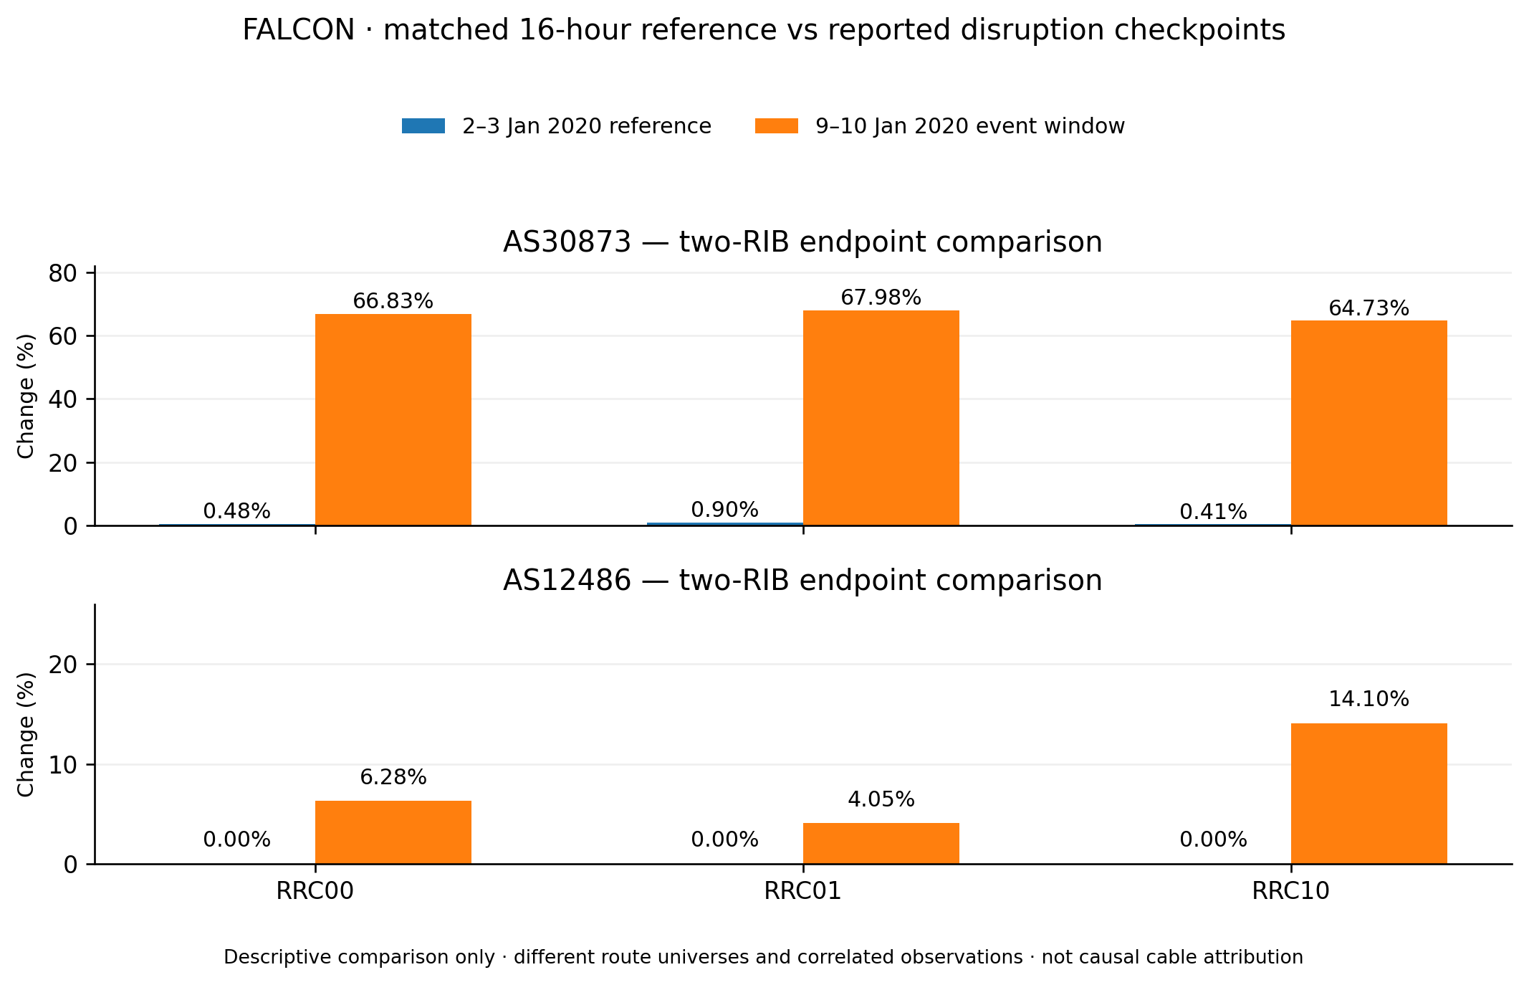
Descriptive bars are exact changed/comparable RIB-endpoint ratios with original record-level denominators. No confidence intervals are implied.

Source provenance and limitations
The supporting archive contains original-source audit.json and row-level CSV for EACH collector for both January 2–3 reference and January 9–10 event intervals, source URL and SHA-256 manifests for all 12 input RIBs, and executable standard-library reaggregation/paired-key comparison scripts. Same-origin route absence in a RIB is not necessarily an explicit withdrawal, and observing a peer in two checkpoints does not establish continuous session uptime. The earlier window is not independently proven free of all unrelated network events; it is a dated, fixed descriptive reference.

