Structural-Functional Divergence During Submarine-Cable Disruptions: Evidence from Yemen's FALCON Dependence
Ezzaldeen Al-Tayar¹, Abdullateef Ali¹,*
¹ Faculty of Engineering and Information Technology, Taiz University, Taiz, Yemen
Ezzaldeen Al-Tayar: azzaltayyar@gmail.com
* Corresponding author: Abdullateef Ali, abullateef.ali@taiz.edu.ye
Author contributions: Ezzaldeen Al-Tayar: Conceptualization, Investigation, Writing – original draft. Abdullateef Ali: Investigation, Data curation, Resources. Both authors reviewed and approved the final manuscript.

Abstract
National Internet resilience can be overstated when control-plane visibility is treated as equivalent to user-facing service. This study examines Yemen's dependence on the FALCON submarine cable using analytically separate Border Gateway Protocol (BGP) visibility, active reachability, reported capacity, and country-level connectivity indicators. The January 2020 FALCON cut is the primary event. Public reporting indicates approximately 80% loss of international capacity for almost a week, alongside observed loss of an AS15412 dependency and rapid AS30873 routing failover. Digitization of previously published normalized IODA plots gives acute-window median retention of 95.7% for the AS30873 BGP-visibility proxy and 44.8% for active probing, a descriptive 50.8-percentage-point gap. Reanalysis of existing plot-derived window summaries finds gaps of 56.1, 50.8, and 44.6 percentage points during early degradation, the acute window, and the post-midnight period, respectively. AS12486 has 100% acute-window median active-probing retention but only 95.6% mean retention, highlighting sensitivity to the summary statistic. A factorial digitization/window sensitivity grid bounds the acute AS30873 gap between 45.8 and 55.2 points. An August 2026 BGP-origin snapshot indicates present-day concentration only and is not projected backward to 2020. Comparison with the November 2023 FALCON maintenance event is qualitative because measurement families and operating regimes differ. Native historical IODA samples and matched-vantage MRT/BGPStream reconstructions were not available for this analysis; therefore route-level change, topology-wide cascade, and predictive-recovery claims remain withheld. The supported contribution is an event-specific, measurement-aware assessment of the mismatch between visibility and reachability under a documented physical cable disruption.
Keywords: Submarine cables; Internet resilience; BGP; structural-functional divergence; critical infrastructure; Yemen.

1. Introduction
Submarine telecommunications cables form the physical backbone of international digital communications. The International Telecommunication Union (ITU) states that these systems carry more than 99% of global data traffic and identifies physical exposure, repair delay, geographic concentration, and dependence on a small number of cable systems as major resilience challenges [1]. In July 2026, the ITU-ICPC International Advisory Body on Submarine Cable Resilience approved recommendations emphasizing route diversity, infrastructure redundancy, improved risk identification, preparedness, and faster repair [2]. These priorities are especially consequential for underserved or geographically constrained countries whose international connectivity can converge on a small number of physical and logical dependencies.
Yemen provides a technically important event-based empirical case setting because international connectivity has historically depended heavily on the FALCON submarine cable system while backup options have been limited, operationally constrained, or incompletely activated. A cable failure therefore cannot be understood only as a physical infrastructure event. It can cause Border Gateway Protocol (BGP) routing withdrawal or path switching, expose national transit concentration, affect prefixes belonging to multiple organizational operators, degrade service even when some BGP reachability remains, and produce long recovery trajectories that are not captured by static vulnerability metrics.
Recent Internet measurement research has substantially advanced cross-layer cable/IP cartography and physical-network exposure analysis. Nautilus [3] maps likely IP links to candidate submarine cables with confidence scores, Xaminer [4] evaluates cross-layer physical/network exposure, and Calypso [5] maps traceroute-derived digital routes across submarine systems. Recent multilayer studies further show that multilayer representation and shared physical risk are not, by themselves, sufficient novelty claims [6,7]. Multi-source outage research has also established that control-plane visibility can diverge from data-plane or active reachability during large Internet disruptions [8,9]. Accordingly, this study does not claim the first cable-to-IP map, the first multilayer Internet model, the first cascading-failure model, or the first observation of control-/forwarding-plane decoupling. Its narrower empirical question is how a large structural-functional divergence manifests during a physically anchored submarine-cable disruption in a highly dependent national critical-infrastructure setting, and what that evidence implies for redundancy and recovery interpretation.
The study therefore uses the Red Sea-Yemen connectivity setting as an event-based resilience case rather than as a claim of unique geography. A three-layer dependency architecture (submarine infrastructure, international routing, and national autonomous-system (AS)/BGP resources) is retained as an organizing model, but the released quantitative claims are limited to evidence that is actually instantiated and validated.

1.1 Research Questions
- RQ1. How did control-plane and functional-service indicators respond during the January 2020 FALCON disruption?
- RQ2. How does the descriptive gap between BGP visibility and active reachability vary by event phase and observed AS during the January 2020 FALCON disruption?
- RQ3. What does the current resource-origin concentration pattern reveal about potential common dependencies without assuming that the 2026 snapshot represents the 2020 topology?
- RQ4. How transferable are event-specific severity and recovery patterns from the unplanned 2020 FALCON cut to the scheduled 2023 FALCON maintenance event?

1.2 Contributions
- C1. A measurement-family-specific resilience design that keeps routing visibility, active reachability, reported capacity, and country-level connectivity/traffic indicators analytically distinct.
- C2. An event-specific structural-functional divergence result, augmented by a window-level and mean-versus-median audit of existing plot-derived signals for AS30873 and AS12486; all findings remain at the descriptive aggregate-proxy level supported by the evidence.
- C3. A resource-origin dependency analysis that uses the current BGP snapshot as present-day concentration context while explicitly avoiding historical back-projection to 2020.
- C4. A cross-event transferability analysis contrasting the unplanned 2020 cut with the scheduled 2023 maintenance event without treating heterogeneous measurement families as directly interchangeable.
- C5. A reproducible evidence-provenance and robustness workflow that withholds unsupported route-level, stochastic-recovery, and machine-learning claims, and quantifies the sensitivity of the raster-derived central result rather than treating digitization choices as fixed.

2. Related Work and Research Gap

2.1 Cross-Layer Submarine Cable Mapping
Nautilus [3] established that cross-layer Internet cartography can map IP links to likely submarine cables using public datasets, geolocation, traceroute evidence, and confidence scoring. Calypso [5] extends the evidence base using traceroute and real-world validation to associate digital routes with submarine cables. Weaver et al. [10] address a complementary measurement problem: estimating submarine-segment latency from deployed traceroute infrastructure with path-change-aware methods, while showing that existing measurement systems cannot generally recover dynamic latency variability caused by congestion. Together, these studies motivate confidence-aware mapping and careful separation between what a measurement signal can observe and what it cannot. The present study therefore treats cable/path association as an inferred input rather than a novelty claim.

2.2 Cross-Layer Exposure, Multilayer Robustness, and Cascading Failure
Xaminer [4] is the closest methodological comparator because it evaluates interactions between physical and network-layer failures and produces cross-layer risk profiles. Recent multilayer and shared-risk work [6,7], together with broader telecommunications and interdependent-infrastructure resilience studies [11,12], further narrows any architecture-only novelty claim. Complementary resilience-design literature addresses trans-oceanic cable systems, multilevel redundancy, path diversification, optical survivability, disaster-aware carrier networks, and risk-zone-diversified network design [19-24]. The present paper therefore does not position the three-layer representation itself as the discovery. Instead, the empirical contribution is the event-based comparison of distinct measurement families and the interpretation of their divergence under a known physical cable disruption. The dependency architecture is used to interpret this evidence and to define testable conditions for effective, rather than nominal, redundancy.

2.3 Control-Plane and Forwarding-Plane Divergence in Internet Outages
Multi-source Internet outage research has long shown that control-plane evidence should be interpreted alongside data-plane or reachability measurements. Dainotti et al. [8] combined BGP control-plane observations with several data-plane sources to characterize country-scale outages and showed that the two perspectives need not agree. More recently, Jahromi and Jaskolka [9] analyzed Iranian shutdowns using passive scans, active probing, and RIPE RIS BGP snapshots and found that BGP announcements can remain stable while forwarding-plane reachability collapses. These studies establish that control-/forwarding-plane decoupling is not itself a new phenomenon.
The contribution here is therefore not the generic observation that BGP visibility can persist during functional loss. The narrower novelty is an event-specific demonstration of a large structural-functional divergence during a physically anchored submarine-cable disruption in a highly dependent national critical-infrastructure setting, coupled with explicit measurement-family separation, common-dependency interpretation, and reproducible sensitivity analysis of the available evidence.

2.4 Dynamic Resilience and Uncertainty
Dynamic resilience research motivates treating disruption and recovery as time-dependent [13,16-18], while uncertainty and sensitivity studies emphasize explicit treatment of epistemic uncertainty and parameter dependence [14,15]. The available Yemen event record, however, does not support estimation of a stochastic holding-time model. Accordingly, the main analysis uses an explicit state-transition architecture and event windows. A semi-Markov extension remains a future modeling option if a sufficiently large and measurement-consistent event sample becomes available; it is not presented here as an estimated result or a core contribution.

2.5 Research Gap
The research gap addressed here is narrower than a generic multilayer, cascading-failure, or control-/forwarding-plane divergence gap. Prior work already establishes that control-plane and data-plane evidence can decouple during national outages [8,9], and cross-layer tools can identify likely cable/IP associations and physical-network exposure [3-5]. What remains underdeveloped is event-specific resilience inference for a known submarine-cable failure in a highly dependent national setting when heterogeneous evidence families must be kept separate and common dependencies interpreted cautiously. This paper addresses that measurement and interpretation gap by documenting the 2020 structural-functional divergence, contextualizing present-day resource-origin concentration without historical back-projection, and testing cross-event transferability without forcing heterogeneous evidence into a single scalar performance trace. Table 1 summarizes the closest methodological comparators and the boundary addressed by this study.
Table 1 Closest methodological comparators and the research boundary addressed by the present study
Work | Established contribution | Overlap with this study | Remaining boundary addressed here
Nautilus [3] | Confidence-scored IP↔submarine-cable mapping | Cross-layer mapping input | Not an event-based national comparison of control-plane and functional-service signals
Xaminer [4] | Cross-layer physical/network exposure and risk profiles | Physical↔network failure analysis | No Yemen event-based comparison of routing visibility and active reachability
Calypso [5] | Traceroute-based digital-route↔cable mapping | Mapping/validation evidence | Not a cross-event, measurement-family-specific national resilience analysis
Lang et al. [6] | ISP/IXP multilayer model + SRLG robustness | Multilayer/shared physical risk | Static connectivity robustness; not this event-specific multi-signal divergence analysis
Wu & Neumueller [7] | Multiplex physical/overlay cascade + historical cable faults | Cascading infrastructure coupling | Different overlay/system objective; no national event-based structural-functional signal comparison
Dainotti et al. [8] | Multi-source BGP and data-plane outage characterization | Establishes need for cross-signal outage measurement | Not a submarine-cable-anchored Yemen critical-infrastructure case
Jahromi & Jaskolka [9] | BGP + active reachability/passive scans during Iran shutdowns; control/forwarding-plane decoupling | Direct conceptual overlap with structural-functional divergence | Administrative forwarding-plane shutdown mechanism rather than a physically anchored submarine-cable failure; different dependency objective
Present study | Event-based measurement-family separation, raster-sensitivity testing, and dependency interpretation | Uses cross-layer architecture as context, not novelty by itself | Physically anchored structural-functional divergence, event-context transferability, and frozen present-day origin-dependence context; route-level multilayer execution withheld

3. Study Context and Scope
The empirical setting comprises Yemen's international connectivity through the Red Sea and adjacent routes, observable international transit relationships, national AS/prefix resources, and public functional-connectivity evidence. The study intentionally excludes proprietary traffic matrices, operator-internal router topology, precise sensitive infrastructure coordinates, and unverified capacity values. Evidence is classified as OBSERVED, INFERRED, DERIVED, or SIMULATED. The three-layer dependency model is used as an organizing architecture; because route-level historical reconstruction is not yet validated, the paper does not claim a fully instantiated event-time supra-adjacency network or topology-wide cascade effect sizes. Table 2 summarizes the operational definitions and evidence classes used in the organizing architecture.
Table 2 Operational definitions and evidence classes for the dependency architecture
Element | Operational definition | Evidence class
Physical submarine layer | Cable systems, landing dependencies, cable–landing relationships | Public/authoritative or confidence-aware inferred
International routing layer | Upstream/transit ASes and observed BGP paths connecting Yemen externally | Observed/inferred from RIS, RouteViews, CAIDA
National logical layer | Yemeni ASes, originated prefixes, provider/peer dependencies, resource–origin relationships | Observed/inferred
Functional measurement families | Q_control(t), Q_active(t), Q_capacity(t), and Q_connectivity(t), normalized within source/family where defensible | Observed or derived; not collapsed into one latent Q(t)

4. Data Sources, Provenance, and Event Design
Table 3 summarizes the primary data sources, their analytical roles, and their principal limitations.
Table 3 Primary data sources, analytical uses, and key limitations
Source | Use | Key limitation
RIPE Routing Information Service (RIPE RIS) / RIPEstat [25] | Historical/current BGP state and updates | Collector visibility; historical update access requires archive/BGPStream
Center for Applied Internet Data Analysis (CAIDA) AS Relationships / BGPStream [26] | AS relationship inference and historical MRT processing | Relationships are inferred; not operator ground truth
RIPE Atlas [27] | round-trip time (RTT), loss, traceroute, external-to-Yemen measurements | In-country probe coverage may be sparse
Internet Outage Detection and Analysis (IODA) [28] | AS/country BGP visibility and active-probing time-series evidence | Signals measure different constructs; current manuscript uses plot digitization plus quantitative sensitivity analysis, while native API samples remain preferred.
Cloudflare Radar | Observed traffic/connectivity validation | Not topology ground truth
TeleGeography/public cable maps | Cable systems and landing context | Public routes are stylized; detailed data can be licensed
World Bank / operator notices / event reports | Historical event severity, recovery, and causal anchors | Different sources measure different quantities

4.1 Historical Event Hierarchy
Table 4 summarizes the historical events and their roles in the analysis.
Table 4 Historical event hierarchy and role in the analysis
Event | Role | Observed evidence used
9 Jan 2020 FALCON cut | Primary empirical case | ~80% international capacity loss; 20-30% emergency service; AS15412 loss and failover reported [29,30]
30 Jan 2020 second disruption | Contextual second disruption only | Second several-hour national disruption during the continuing FALCON outage; renewed degradation is supported [30], but the exact additional failed physical/backup component remains lower confidence.
21–25 Jan 2022 Yemen outage | Qualitative different-failure-mode challenge | Near-total nation-scale connectivity loss lasting ~4 days [31]
10 Nov 2023 FALCON maintenance | Same-component cross-event transferability challenge | Confirmed scheduled FALCON maintenance; national connectivity reported at 33%; main disruption 00:10-04:45 UTC [32-35]
2024/2025 Red Sea disruptions | Context only | Regional multi-cable and rerouting evidence; used cautiously for Yemen-specific inference

4.2 Aggregate IODA Structural–Functional Proxy
IODA [28] reports distinct connectivity signals rather than a single interchangeable measure. Its BGP signal aggregates /24 networks visible via Route Views/RIPE RIS peers, whereas its active-probing signal estimates /24 networks that respond to active measurements. These signals are normalized separately. The present 2020 evidence is restricted to previously published normalized IODA plots, digitized as a bounded descriptive fallback. An additional phase audit recalculates BGP-minus-active retention differences for the named baseline, early-degradation, acute, and post-midnight windows from the redistributed window summaries. This reanalysis cannot reconstruct timestamps, prove cross-signal temporal synchronization, provide confidence intervals, or substitute for raw samples. The official IODA HTTP API supports raw time-series retrieval, but an attempt to retrieve the necessary 2020 series from this execution environment failed at the network/DNS stage. The failure is not treated as evidence that IODA lacks the data; native samples remain the priority for future inference.

5. Cross-Layer Dependency Architecture
For interpretation, the study retains three structural dependency domains: submarine infrastructure, international routing/connectivity, and national AS/BGP resources. Cross-layer relationships indicate how logical connectivity may depend on common physical resources. The architecture is conceptual unless a dependency edge is supported by public evidence or validated mapping; it is not treated as a fully observed topology. The organizing architecture is shown in Fig. 1.
Functional performance is represented by a vector of measurement-specific states Q_m(t), where m indexes the measurement family. The primary families are Q_control(t) for routing/control-plane visibility, Q_active(t) for active reachability, Q_capacity(t) for reported international capacity, and Q_connectivity(t) for country-level connectivity or traffic indicators. Each family may be normalized to its own pre-event baseline when the source supports that operation. Values from different families are not averaged into a latent Q(t), and resilience integrals are not compared across families unless the measurement semantics and time bases are commensurable.
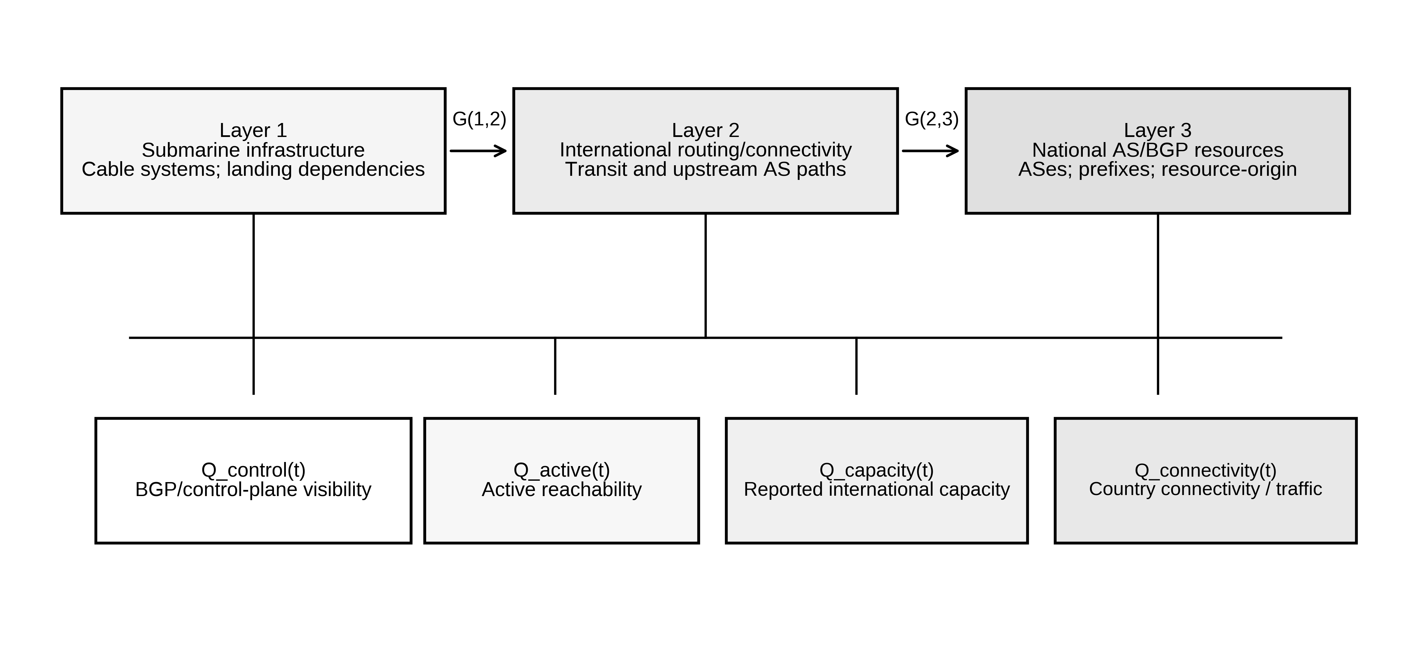
Fig. 1 Dependency architecture used to interpret physical, routing, and national-AS relationships; functional evidence is analyzed through measurement-specific Q_m(t) signals rather than as a fourth network layer

5.1 Cross-Layer Mapping
Cable/path associations and dependency edges are retained only when supported by public operator information, traceroute geography, BGP-path evidence, landing context, or historical event response. Confidence labels remain useful for future event-time graph reconstruction, but this revision does not report quantitative mapping-branch robustness because the required route-level historical input is not yet validated.

5.2 Resource–Origin Dependency
Resource-origin analysis captures the fact that organizationally distinct resources can share an origin ASN. Representative current observations show this pattern for some Yemen Mobile, YOU, and Sabafon resources associated with AS30873. This is interpreted as evidence that organizational labels alone do not establish routing independence; it is not used to infer that all operator traffic shares one path or that the same concentration held during the 2020 event.

6. Measurement-Specific Resilience and Dependency Analysis
The temporal analysis distinguishes Normal, Disruption, Adaptation, and Recovery phases at the event level. The purpose is descriptive and falsifiable: event windows organize what is observed without assuming memoryless or fitted stochastic transition times. A semi-Markov formulation was pre-specified during project development, but no holding-time distribution can be estimated credibly from the sparse, heterogeneous historical events. It is therefore removed from the main contribution set and retained only as a possible future extension.

6.1 Route-Level Metrics: Definitions and Withholding Rules
Structural quantities such as prefix visibility retention, route-observation retention, upstream switching, provider-set churn, AS-path inflation, cascade size, and cascade depth require valid historical route-state data from comparable vantage points. Those quantities are defined in Online Resource 1 but are not released numerically in this manuscript because the attempted checkpoint bundle failed validation. The main paper therefore avoids claims about which dependency 'most strongly' amplifies failure at the route level.

6.2 Measurement-Family-Specific Functional Resilience
For each measurement family m, normalized retention can be written q_m(t)=X_m(t)/B_m, where B_m is a pre-event baseline defined within that same source and signal family. Maximum loss, area loss, and recovery thresholds are meaningful only within a sufficiently sampled and semantically consistent time series. Because the present evidence does not provide such a continuous, homogeneous trace across the full 2020 recovery period, the manuscript does not release a 27-day scalar resilience-loss integral or T_R(90/95/99) as empirical estimates.

6.3 Structural–Functional Dual Axis
The primary structural-functional comparison is contemporaneous but signal-specific: routing/control-plane retention and active-reachability retention are normalized to their own pre-event medians and compared as separate proportions. Their difference is interpreted as a descriptive divergence between measurement families, not as a difference between two estimates of the same latent quantity.

6.4 AI-Assisted Code Development and Human Verification
ChatGPT (OpenAI) was used to assist with drafting and reviewing selected analysis and reproducibility scripts. It did not generate empirical observations or substitute for source data. All scripts used for reported results were manually inspected, executed against the stated inputs, and their numerical outputs were checked by the authors. Fail-closed validation rules were retained so that empty or unvalidated raw inputs could not be converted into reported results.

7. Event Comparison and Evidence Boundaries

7.1 Cross-Event Transferability Design
The 2020 FALCON cut is the primary empirical case. The 2023 scheduled FALCON maintenance event is used as a same-component cross-event transferability challenge, not as a homogeneous predictive-validation sample, because the operational context and measurement semantics differ. The 2022 national outage is retained as a qualitative different-failure-mode challenge. No parameter is silently refitted to force agreement across events.

7.2 Machine Learning Exclusion
Machine learning is not part of the final contribution set. The available historical events are too few and heterogeneous to support a defensible predictive model, and deterministic scenario-grid rows are not treated as independent empirical samples.

8. Results

8.1 Present-Day BGP-Origin Concentration as Context
A frozen prefix-level public-routing snapshot assembled on 9 August 2026 [36] contains 150 IPv4 prefixes across AS30873, AS12486, and AS204317. AS30873 accounts for 76.0% of the frozen prefix set, AS12486 for 21.33%, and AS204317 for 2.67%, corresponding to an origin-prefix Herfindahl–Hirschman Index (HHI) of approximately 0.624. After collapsing overlapping more-specific prefixes, the unique /24-equivalent address-space shares are approximately 95.88%, 3.67%, and 0.44%, yielding an HHI of approximately 0.921. These values establish present-day origin concentration in the assembled snapshot only. They are not interpreted as the routing state of January 2020, market share, subscriber share, or traffic share. Historical concentration reconstruction remains a separate empirical task. The corresponding concentration shares are summarized in Table 5 and visualized in Fig. 2.
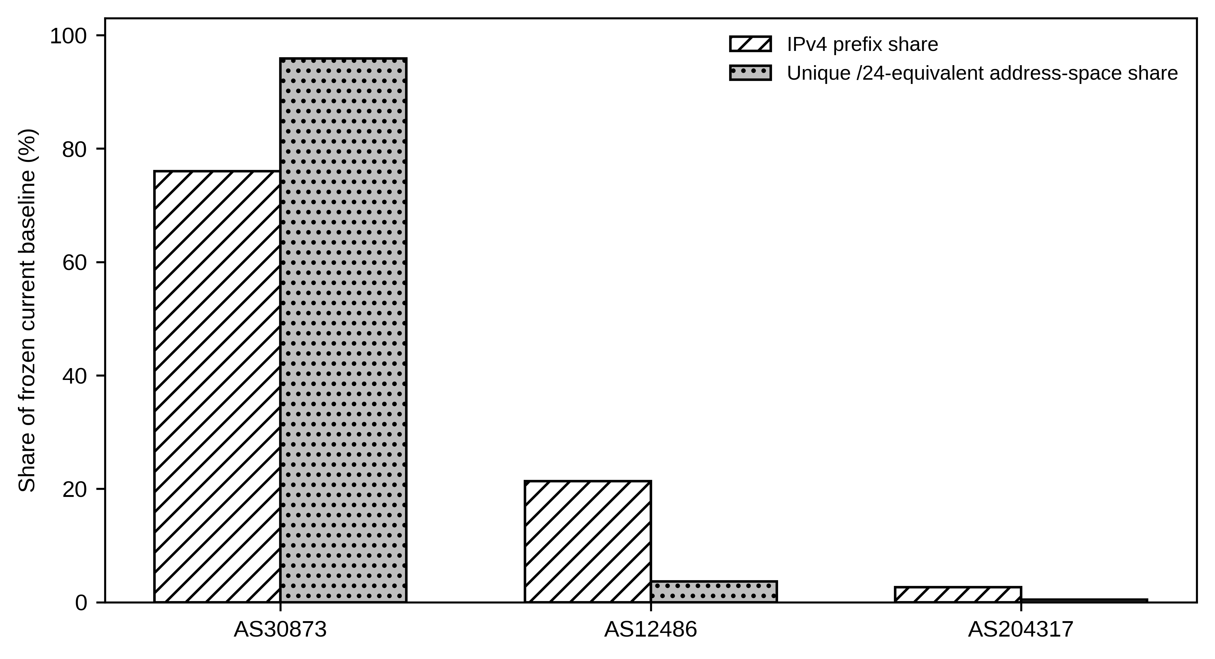
Fig. 2 Present-day BGP-origin concentration in the frozen assembled 9 August 2026 snapshot; the result is contextual and is not back-projected to the 2020 disruption
Table 5 Present-day BGP-origin concentration in the frozen 9 August 2026 snapshot
Origin ASN | Share of observed IPv4 prefixes | Share of unique /24-equivalent originated IPv4 space
AS30873 | 76.00% | 95.88%
AS12486 | 21.33% | 3.67%
AS204317 | 2.67% | 0.44%

8.2 2020 FALCON Disruption: Structural Adaptation with Severe Functional Loss
The January 2020 FALCON cut is the primary event. World Bank reporting indicates an approximately 80% loss of Yemen's international Internet capacity for almost a week [29]. Independent event monitoring reports a much stronger impact on AS30873 than AS12486, loss of an AS15412 dependency, and rapid AS30873 failover to alternate upstream providers [30]. This combination is important because it documents routing adaptation while functional service remained severely constrained; however, it does not by itself quantify route-level retention or path diversity.
Historical route-level reconstruction remains unresolved in this revision. The attempted RIPEstat checkpoint bundle returned empty route states and was rejected. Official RIPE RIS MRT archives [25] and CAIDA BGPStream [26] provide a technically appropriate route to reconstruct historical RIB/update evidence from multiple collectors, and scripts for that primary-data upgrade are supplied in Online Resource 1. Until that execution passes a comparable-vantage-point validity check, prefix-visibility retention, route-observation retention, upstream switching, provider churn, AS-path inflation, and route-level path diversity remain withheld.

8.2.1 Aggregate IODA Evidence of Structural-Functional Divergence
Using previously published normalized IODA plots as a bounded fallback, AS30873 retained approximately 95.7% of its pre-event median BGP-visibility proxy during the acute 18:00-00:00 UTC window, whereas the active-probing proxy retained approximately 44.8%, a descriptive difference of 50.8 percentage points. Across the same named windows, AS12486's BGP and active-probing median retention were approximately at baseline, although the active-probing trace contained a brief dip. A check based on the digitized window-level means found acute AS12486 active-probing retention of 95.6%, despite its 100% median retention. This matters because a stable median does not rule out a transient degradation. Neither the 50.8-point difference nor the cross-AS contrast estimates a route-level loss fraction, customer impact, or two observations of one latent service variable (Fig. 3).
Raster digitization is an acknowledged measurement limitation. To test whether the central result depends on reasonable extraction choices, a pre-specified full-factorial sensitivity grid perturbed the pre-event baseline start (±2 h), baseline end (±60 min), acute-window start and end (each ±60 min), y-axis zero (±2 pixels), y-axis scale (±2 pixels per normalized unit), red-green-blue (RGB) matching tolerance (0-2 per channel), and the summary statistic (median versus mean). The grid generated 20,250 valid parameter settings, which should not be interpreted as independent experiments. Across the grid, the AS30873 BGP-minus-active retention divergence ranged from 45.8 to 55.2 percentage points; the 5th-95th percentile range was 47.5-53.4 points around the central estimate of 50.8 points. Y-axis scale and RGB-tolerance perturbations were invariant within numerical precision over the tested ranges. This robustness analysis does not convert raster-derived values into native IODA samples, but it shows that the qualitative structural-functional divergence is not an artifact of one fixed digitization/window choice.
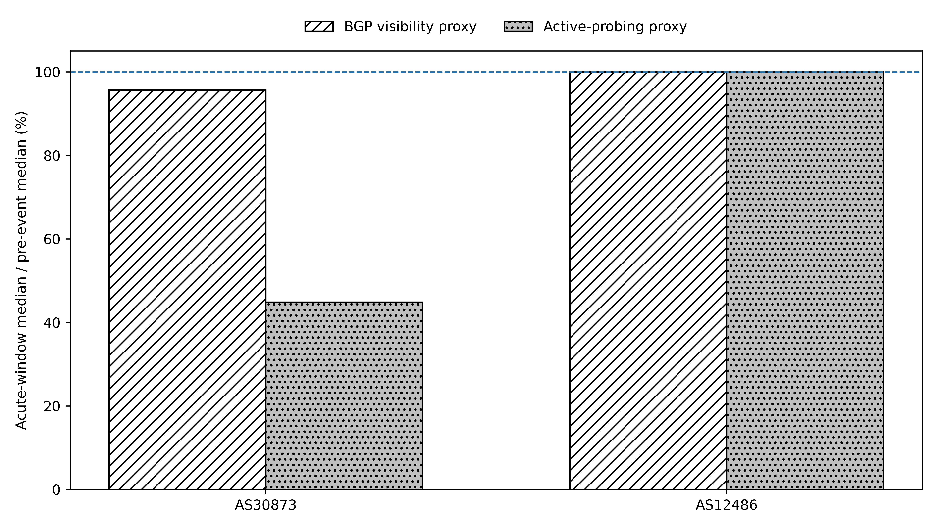
Fig. 3 Aggregate IODA signal retention during the 9 January 2020 acute window; BGP visibility and active probing are normalized within their own signal families, and the AS30873 central divergence of 50.8 percentage points remains 45.8–55.2 points across the raster-sensitivity grid

8.2.2 Phase-Level Audit and Summary-Statistic Sensitivity
A new audit of the redistributed aggregate digitization table compares four pre-defined plot windows without inventing native samples. Using median retention normalized separately to each AS/signal's baseline, AS30873 has a BGP-minus-active gap of 56.1 percentage points during early degradation, 50.8 during the acute event, and 44.6 post-midnight. The descriptive decline in this gap should not be interpreted as a continuous recovery rate: the source consists of aggregated raster columns with no exported timestamp series, and the timing and measurement constructs are not identical. AS12486 has 100.0% acute active-probing median retention but only 95.6% mean retention when each is compared with its matching baseline statistic, consistent with a short dip that the median suppresses. This secondary result qualifies claims about an unaffected comparator; it does not establish an independent network path, user-level service continuity, or a statistically significant difference. Full decimal values, inputs, and extraction scope are supplied in Online Resource 1, Table S1.
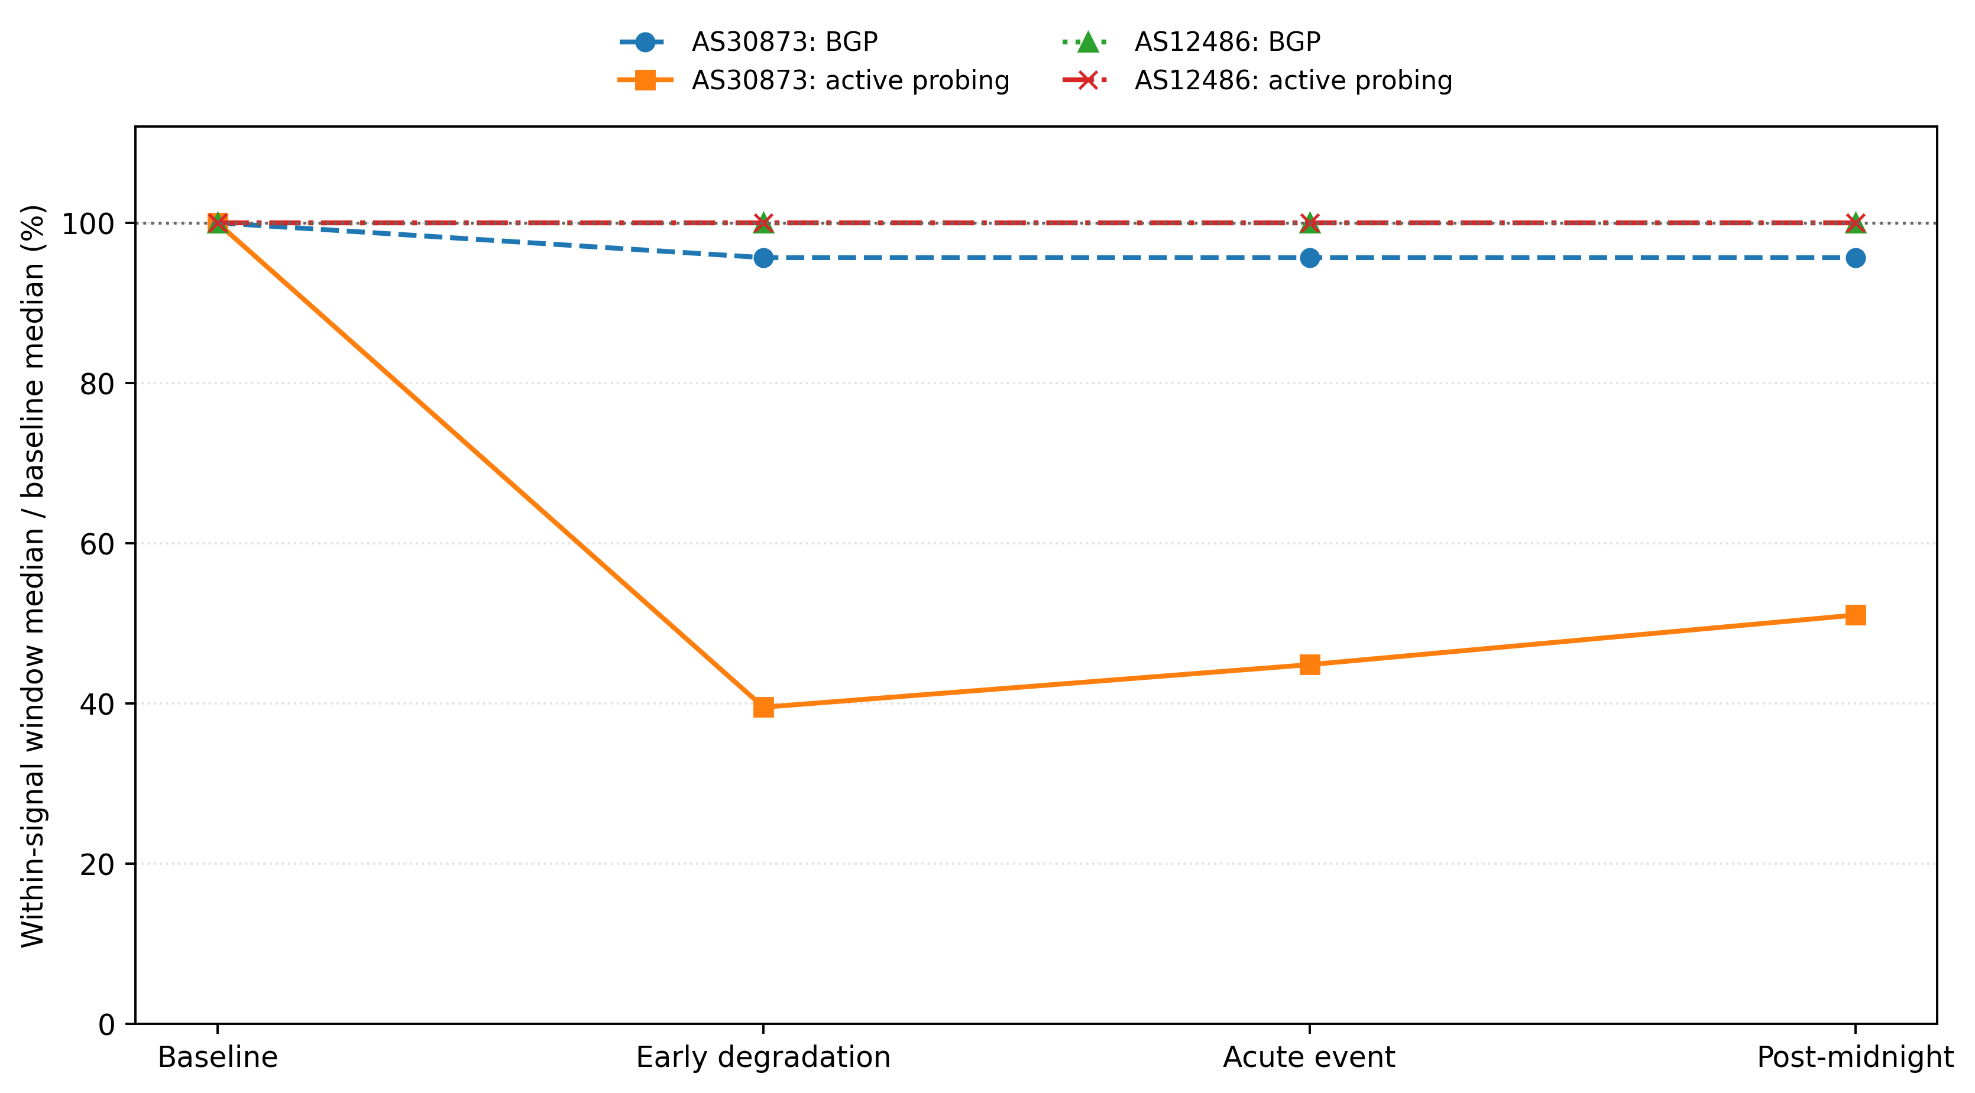
Fig. 4 Plot-derived phase-specific median retention relative to each signal and AS baseline. The curves recompute existing digitized window summaries; they are not native IODA time series, confidence intervals, or evidence of a continuous recovery process.

8.3 January 2022 Outage as a Qualitative Failure-Mode Challenge
The January 2022 event is retained as an external qualitative failure-mode challenge. Public reporting indicates a near-total nationwide connectivity disruption lasting about four days [31], but the accessible evidence does not establish a sufficiently complete and homogeneous physical-to-routing causal chain for quantitative scoring in the same manner as the 2020 FALCON event. Accordingly, the event is not presented as an equivalent numerical holdout.

8.4 November 2023 FALCON Maintenance as a Transferability Challenge
The scheduled FALCON maintenance event of 10 November 2023 offers a same-component but operationally different comparison. Cloudflare reported a country- and AS30873-level disruption from approximately 00:10 to 04:45 UTC [32], NetBlocks reported national connectivity at 33% of ordinary levels during the severe period [33], and Global Cloud Xchange confirmed scheduled maintenance [34]; contemporary reporting also documented the outage context [35]. The event is therefore used to test whether qualitative severity/recovery interpretations developed from the unplanned 2020 cut transfer to a planned maintenance regime. Because the underlying signals are not identical measurement families, no predictive error such as |0.20-0.33| is reported. Table 6 summarizes the cross-event comparison and interpretive role.
Table 6 Cross-event comparison and interpretive role
Event | Functional severity | Duration/recovery anchor | Interpretive role
FALCON 2020 | ~80% capacity loss; emergency service 20–30% | Severe loss reported for almost a week; physical repair later reported separately | Primary empirical case; capacity evidence not treated as a universal latent Q(t)
Yemen outage 2022 | Near-total national connectivity loss | ~4 days | Qualitative failure-mode challenge
FALCON maintenance 2023 | National connectivity reported at 33% at severe point | ~275 min main disruption | Same-component transferability challenge

8.5 Main Evidence-Constrained Findings
- Finding 1: The 2020 FALCON event documents routing adaptation in AS30873 while national functional capacity remained severely constrained, showing that adaptation is not equivalent to service restoration.
- Finding 2: In published normalized IODA plots, acute AS30873 BGP-visibility retention is about 95.7% and active-probing retention about 44.8%, a 50.8-percentage-point descriptive gap (45.8-55.2 across the raster-sensitivity grid). The same plot-derived summary table yields AS30873 phase-specific gaps of 56.1 points in early degradation and 44.6 points post-midnight. AS12486 acute active-probing mean retention is 95.6%, although its median is 100%. These quantities are comparisons of separate proxies, not independent experimental replicates or native time-series estimates.
- Finding 3: The 9 August 2026 BGP snapshot is highly concentrated at the origin level, but this is treated as present-day context rather than evidence that the same concentration existed in January 2020.
- Finding 4: The 2023 scheduled FALCON maintenance event is materially different from the unplanned 2020 cut in operational context and duration, so a universal event-independent recovery parameterization is not supported.
- Finding 5: Route-level BGP change metrics, native-IODA inferential statistics, scalar 27-day resilience-loss estimates, and machine-learning/explainable-AI performance remain withheld pending valid primary-data execution.

8.6 Sensitivity Analysis of Plot-Derived IODA Evidence
The raster-sensitivity analysis evaluates the stability of the primary descriptive result under plausible alternatives for event-window placement, baseline placement, axis calibration, color matching, and mean-versus-median aggregation. The AS30873 acute gap ranged from 45.8 to 55.2 percentage points across 20,250 parameter combinations, with the 5th-95th percentile of the evaluated grid at 47.5-53.4 points. These settings are not independent experiments: RGB tolerance and y-axis scale were nearly invariant and many results repeat. Consequently, these percentiles describe robustness across analyst choices, not a probabilistic confidence interval. A separate four-window analysis of existing aggregate plot-derived values shows phase variation and AS12486 mean/median sensitivity (Fig. 4; Online Resource 1), but cannot verify temporal autocorrelation, sampling error, or sub-window dynamics.

9. Robustness and Evidence Boundaries
The principal robustness rule is measurement and provenance consistency. Observed, inferred, derived, and simulated quantities are not promoted across evidence classes. For the central plot-derived IODA result, robustness is additionally tested through a full-factorial digitization/window sensitivity grid; the structural-functional divergence remains 45.8-55.2 percentage points. The generated settings are not treated as independent experiments, and dimensions that were invariant over the tested range are reported as such. The 2020 and 2023 events are compared only for transferability of interpretation, and heterogeneous signals are not converted into a predictive-error statistic. The 2022 event remains a qualitative failure-mode challenge. Unvalidated route-level metrics and mapping-branch effect sizes remain withheld until historical MRT/BGPStream reconstruction and event-time cross-layer mapping are executed with comparable vantage points.
The current evidence supports the structural-functional divergence claim at the aggregate measurement-signal level, supports the robustness of that conclusion to reasonable raster extraction choices, and supports present-day origin concentration as contextual evidence. It does not support topology-wide ranking of the strongest dependencies, empirical intervention effect sizes, stochastic semi-Markov estimates, or machine-learning performance.

10. Discussion

10.1 Beyond Provider Counts
The 2020 case supports a distinction between nominal and effective redundancy. AS30873 reportedly failed over after loss of an AS15412 dependency, but service remained severely constrained. This does not prove that a specific alternative physical topology would have solved the event; rather, it demonstrates why counting providers or routes is insufficient without testing whether the alternatives remain independent under the initiating failure mode.

10.2 Why Structural Reachability Is Not Enough
The strongest empirical message is not the generic discovery that BGP and forwarding-plane evidence can diverge; this is established in [8,9]. The paper instead describes a substantial, event-specific discrepancy between separately normalized visibility and active-probing proxies during a known FALCON cable failure. Existing plot-derived phases show AS30873 gap variation of 56.1 to 44.6 percentage points across early, acute, and post-midnight windows, but these aggregate medians do not constitute a high-resolution recovery curve. Conversely, AS12486's acute active-probing median stayed at baseline while the mean declined modestly; a median alone can hide transient losses. These descriptive diagnostics reinforce the case for retaining signal-specific evidence. Native IODA historical exports and carefully reconstructed MRT observations are still needed before attributing route-level effects or estimating population-wide service loss.

10.3 Recovery as a Distinct Dimension
Recovery remains a distinct dimension, but the present evidence does not justify a single continuous national Q(t) trace across the full 2020 recovery period. Capacity reports, active probing, BGP visibility, and 2023 connectivity measurements are therefore kept separate. The contrast between the prolonged unplanned 2020 disruption and the much shorter scheduled 2023 maintenance event illustrates that an event-independent recovery parameterization is not supported by the available cases. Because the events differ in operational context and measurement family, this comparison is not presented as a general law of event-class dependence or as a direct comparison of commensurable resilience integrals.

10.4 Policy and Engineering Implications
For resilience planning, the defensible implication is to test independence under the relevant failure mode rather than rely on nominal provider counts. A logically different upstream that still shares the failed physical dependency cannot protect against that same failure mode by definition; benefit from physical diversity should therefore be treated as an engineering design condition to be verified in an instantiated topology, not as an empirical intervention effect demonstrated by this paper. This interpretation is consistent with international emphasis on geographic diversity, infrastructure redundancy, preparedness, and timely repair [1,2] and with broader network-resilience design principles [20,24]. The paper does not estimate the cost, deployable capacity, or optimal siting of alternative infrastructure, and it intentionally excludes sensitive operational location details.

10.5 Relation to Contemporary Cross-Layer and Multilayer Work
Nautilus [3] and Calypso [5] inform the mapping problem, Xaminer [4] provides a benchmark for cross-layer exposure analysis, and recent multilayer/shared-risk work [6,7] demonstrates that architecture alone is no longer a sufficient novelty claim. Likewise, earlier and contemporary outage studies already establish control-/forwarding-plane divergence as a general measurement phenomenon [8,9]. The contribution retained here is therefore deliberately narrower: an event-based, measurement-aware demonstration of a large divergence during a known submarine-cable disruption, a quantitative robustness analysis of the available raster-derived signal comparison, and disciplined interpretation of present-day resource-origin concentration. A future raw-data extension using native IODA time series and BGPStream/MRT would permit stronger event-time multilayer and route-level claims that are intentionally withheld in this version.

11. Limitations
- Public routing and measurement data provide partial Internet visibility and cannot recover proprietary operator traffic matrices or internal topology.
- Public submarine cable maps often generalize cable routes; precise route coordinates are intentionally neither required nor reported.
- Historical evidence sources measure different constructs (capacity, BGP visibility, active reachability, and country-level connectivity/traffic). They are analyzed as separate measurement families and are not treated as interchangeable observations of one latent national-performance variable.
- The 2020 IODA comparison is digitized from normalized raster plots and supports only bounded descriptive inference. A full-factorial grid yields an AS30873 gap of 45.8-55.2 percentage points across 20,250 parameter settings, not independent experiments. The 5th-95th percentile across these settings is not a confidence interval. The phase comparison likewise uses existing window-summary aggregates, rather than raw timestamped IODA samples; unequal raster-column counts and absent pixel-level source images limit independent checking, fine-scale temporal alignment, autocorrelation modeling, recovery estimation, and sampling uncertainty. The AS12486 acute mean/median difference further shows the danger of claiming no impact from a stable median. Native IODA samples remain preferable for inferential work [28].
- Historical BGP route-level metrics for 2020/2022/2023 are not released. A prior RIPEstat checkpoint bundle contained empty route states; a subsequent check could not access MRT/BGPStream archives from the available execution environment. Neither retrieval failure is interpreted as zero routes. Historical replay requires a verified event-time prefix inventory, compatible RIS/RouteViews collectors and peer IPs, an initial RIB, and all relevant announcements AND withdrawals. In particular, an origin-AS filter on updates may omit originless withdrawal messages; the supplementary guarded offline replay instead prescribes prefix-scoped updates without that filter. Full historical prefix coverage and peer liveness must be audited before population-level PVR/ROR, provider churn, AS-path inflation, or path-diversity estimates can be released [25,26].
- Representative mobile-operator prefixes sharing AS30873 demonstrate a resource–origin dependency pattern but do not prove that every resource or all operator traffic shares the same path.
- The study does not estimate empirical intervention effects or the available capacity of a physically independent alternative. The discussion of shared versus independent failure dependencies is an engineering implication of the dependency definitions and should not be read as measured superiority of a deployed intervention.
- Machine learning and explainable artificial intelligence are omitted because the available historical events are too few and heterogeneous, and deterministic scenario-grid rows do not constitute independent empirical training evidence.
- The Red Sea–Yemen corridor is an analytical scope definition and should not be interpreted as a formally designated telecommunications corridor.

12. Reproducibility and Research Integrity
The work separates OBSERVED, INFERRED, DERIVED, and SIMULATED evidence. Online Resource 1 contains source aggregates, an August 2026 frozen BGP-origin snapshot, code, figures, provenance, sensitivity-grid results, and a reviewer-facing README. The updated `reproduce_all.py` entry point recalculates concentration HHI and the central plot-derived IODA gap, verifies saved sensitivity bounds, computes a four-window mean/median audit, and generates Figures 2-4 from redistributed evidence. `phase_audit.py` regenerates the new Table S1 and Figure 4. `validate_native_ioda.py` enforces source identity, minimum sample and coverage rules on future native downloads; `historical_bgp_replay_v2.py` preserves withdrawal handling and unique collector-peer-IP identity for future historical BGP extracts. Four offline guardrail tests passed, but no native IODA or event-time BGP measurements were obtained here, and no new historical network metrics are claimed. Figure-level pixel digitization from third-party source images remains non-reproducible from the redistributed bundle alone. Release of stronger results is contingent upon separately validated raw data.

13. Conclusion
National Internet resilience should not be inferred from control-plane visibility or nominal provider counts alone. Independent sources associate the January 2020 FALCON cut with severe loss of international capacity despite routing adaptation [29,30]. From published normalized IODA plots, acute AS30873 BGP-visibility and active-probing proxy retention are 95.7% and 44.8%, respectively, yielding a 50.8-point descriptive divergence (45.8-55.2 under raster/window sensitivity variations). A secondary audit of the existing plot-derived summaries finds the gap at 56.1 points during early degradation and 44.6 points post-midnight; AS12486 retains a baseline-level active-probing median yet has a 95.6% acute-window mean. These phase/summary-statistic contrasts expose the limits of one fixed window or statistic; they do not imply native time-series validation. Current origin concentration (2026) is contextual rather than a reconstructed 2020 topology, and comparison with 2023 scheduled maintenance remains qualitative. The defensible inference is that measurement-specific visibility, functional reachability, and physically independent alternatives must be assessed separately. Event-time native IODA and MRT/BGPStream data are still prerequisites for topology-wide cascades, quantified route failover, and causal intervention-effect claims.

References
[1] International Telecommunication Union. (2026). International Advisory Body approves landmark report to strengthen submarine cable resilience. ITU, 10 July 2026.
[2] International Telecommunication Union & International Cable Protection Committee. (2026). IAB Working Group Recommendations: Timely Deployment & Repair; Risk Identification, Monitoring & Mitigation; Fostering Connectivity & Geographic Diversity. Accessed 9 August 2026.
[3] Ramanathan, A., & Abdu Jyothi, S. (2023). Nautilus: A framework for cross-layer cartography of submarine cables and IP links. Proceedings of the ACM on Measurement and Analysis of Computing Systems, 7(3), Article 46. https://doi.org/10.1145/3626777
[4] Ramanathan, A., Sankaran, R., & Abdu Jyothi, S. (2024). Xaminer: An Internet cross-layer resilience analysis tool. Proceedings of the ACM on Measurement and Analysis of Computing Systems, 8(1), Article 16. https://doi.org/10.1145/3639042
[5] Wang, C. J., Zhang, Y., Dong, Q., Carisimo, E., Durairajan, R., & Bustamante, F. E. (2025). Threading the ocean: Mapping digital routes across submarine cables using Calypso. ACM SIGCOMM 2025. https://doi.org/10.1145/3718958.3750512
[6] Lang, B., Roughan, M., & Ye, M. (2026). Robustness analysis of Australia's Internet using a multilayer network model. arXiv:2606.18737. https://doi.org/10.48550/arXiv.2606.18737
[7] Wu, W., & Neumueller, A. (2026). Bitcoin under stress: Measuring infrastructure resilience 2014–2025. arXiv:2602.14372. https://doi.org/10.48550/arXiv.2602.14372
[8] Dainotti, A., Squarcella, C., Aben, E., Claffy, K. C., Chiesa, M., Russo, M., & Pescapè, A. (2014). Analysis of country-wide Internet outages caused by censorship. IEEE/ACM Transactions on Networking, 22(6), 1964–1977. https://doi.org/10.1109/TNET.2013.2291244
[9] Jahromi, A. S., & Jaskolka, J. (2026). A multi-perspective study of the Internet shutdown in Iran. arXiv:2605.00187. https://doi.org/10.48550/arXiv.2605.00187
[10] Weaver, M., Veitch, D., Barford, P., Bustamante, F. E., & Carisimo, E. (2026). Monitoring latency on submarine cables: Limitations and opportunities. 1st New Ideas in Networked Systems (NINeS 2026), OASIcs, 139, 16:1–16:24. https://doi.org/10.4230/OASIcs.NINeS.2026.16
[11] Owen, R., Bryant, A. R., Finch, L., Franklin, D., Abdollahi, M., & Abolhasan, M. (2025). Failures and resilience in the IP era: Navigating the fragility of modern telecommunications networks—The sovereign functions. IEEE Access, 13, 155759–155777. https://doi.org/10.1109/ACCESS.2025.3602054
[12] Venkatasubramanian, B. V., Laoudias, C., & Panteli, M. (2025). Cascading failures and resilience in interdependent critical infrastructures: A dynamic approach. IEEE Systems Journal. https://doi.org/10.1109/JSYST.2025.3629327
[13] Caetano, H. O., Desuó Neto, L., Fogliatto, M. S. S., & Maciel, C. D. (2024). Resilience assessment of critical infrastructures using dynamic Bayesian networks and evidence propagation. Reliability Engineering & System Safety, 241, 109691. https://doi.org/10.1016/j.ress.2023.109691
[14] Cavalieri, F., & Franchin, P. (2020). Seismic risk of infrastructure systems with treatment of and sensitivity to epistemic uncertainty. Infrastructures, 5(11), 103. https://doi.org/10.3390/infrastructures5110103
[15] Liu, X., Zio, E., Borgonovo, E., & Plischke, E. (2024). A systematic approach of global sensitivity analysis and its application to a model for the quantification of resilience of interconnected critical infrastructures. Energies, 17(8), 1823. https://doi.org/10.3390/en17081823
[16] Ferrario, E., Pedroni, N., & Zio, E. (2015). Analysis of the robustness and recovery of critical infrastructures within a multistate system-of-systems framework in the presence of epistemic uncertainty. ASCE-ASME Journal of Risk and Uncertainty in Engineering Systems, Part B, 1(3), 031001. https://doi.org/10.1115/1.4030439
[17] Johansen, C., & Tien, I. (2018). Probabilistic multi-scale modeling of interdependencies between critical infrastructure systems for resilience. Sustainable and Resilient Infrastructure, 3(1), 1–15. https://doi.org/10.1080/23789689.2017.1345253
[18] Mottahedi, A., Sereshki, F., Ataei, M., Nouri Qarahasanlou, A., & Barabadi, A. (2021). The resilience of critical infrastructure systems: A systematic literature review. Energies, 14(6), 1571. https://doi.org/10.3390/en14061571
[19] Omer, M., Nilchiani, R., & Mostashari, A. (2009). Measuring the resilience of the trans-oceanic telecommunication cable system. IEEE Systems Journal, 3(3), 295–303. https://doi.org/10.1109/JSYST.2009.2022570
[20] Sterbenz, J. P. G., Hutchison, D., Çetinkaya, E. K., Jabbar, A., Rohrer, J. P., Schöller, M., & Smith, P. (2014). Redundancy, diversity, and connectivity to achieve multilevel network resilience, survivability, and disruption tolerance. Telecommunication Systems, 56(1), 17–31. https://doi.org/10.1007/s11235-013-9816-9
[21] Rohrer, J. P., Jabbar, A., & Sterbenz, J. P. G. (2009). Path diversification: A multipath resilience mechanism. In 7th International Workshop on Design of Reliable Communication Networks (DRCN 2009) (pp. 343–351). https://doi.org/10.1109/DRCN.2009.5339988
[22] Ashraf, M., Idrus, S. M., Iqbal, F., Butt, R. A., & Faheem, M. (2018). Disaster-resilient optical network survivability: A comprehensive survey. Photonics, 5(4), 35. https://doi.org/10.3390/photonics5040035
[23] de Sousa, A., Rak, J., Barbosa, F., Santos, D., & Mehta, D. (2020). Improving the survivability of carrier networks to large-scale disasters. In J. Rak & D. Hutchison (Eds.), Guide to Disaster-Resilient Communication Networks (pp. 175–192). Springer. https://doi.org/10.1007/978-3-030-44685-7_7
[24] Wan, Y., Feng, C., Wu, K., & Wang, J. (2024). RZDD: Risk zone-diversified network design for disaster resilience. IEEE Transactions on Dependable and Secure Computing. https://doi.org/10.1109/TDSC.2024.3406703
[25] RIPE NCC. (2024). Routing Information Service (RIS): Route Collection Raw Data—MRT Files documentation.
[26] CAIDA. (2026). BGPStream documentation and data-provider interfaces for Route Views and RIPE RIS historical BGP data. Accessed 9 August 2026.
[27] RIPE NCC. (2026). RIPE Atlas measurement platform documentation. Accessed 9 August 2026.
[28] Internet Outage Detection and Analysis (IODA). (2026). IODA Resources and HTTP API documentation. Georgia Institute of Technology Internet Intelligence Lab. Accessed 9 August 2026.
[29] World Bank. (2020). Yemen Monthly Economic Update, January 2020. World Bank.
[30] Belson, D. (2020). Internet Disruption Report: January 2020. Internet Disruption Report.
[31] NetBlocks. (2022). Internet connectivity knocked out in Yemen after airstrike. January 2022.
[32] Cloudflare. (2024). Q4 2023 Internet Disruption Summary. Cloudflare Radar/Blog.
[33] NetBlocks. (2023). YemenNet outage metrics: Overall national connectivity at 33% of ordinary levels. 10 November 2023.
[34] Global Cloud Xchange. (2023). Clarification: Yemen Internet Outage. GCX.
[35] Gambrell, J. (2023). Internet collapses in war-torn Yemen over 'maintenance' involving undersea line. Associated Press, 10 November 2023.
[36] bgp.tools. (2026). Public BGP origin snapshots for AS30873, AS12486, and AS204317, frozen/assembled 9 August 2026. Accessed 9 August 2026.

Statements and Declarations

Funding
No funding was received for conducting this study or for the preparation of this manuscript.

Competing interests
The authors have no relevant financial or non-financial interests to disclose.

Data availability
Public or research-accessible evidence sources include RIPE RIS [25], CAIDA BGPStream [26], RIPE Atlas [27], IODA [28], public event reports [29–35], and the public BGP-origin source used for the frozen present-day snapshot [36]. Online Resource 1 contains the plot-derived IODA evidence and provenance used in the manuscript, the complete raster-sensitivity output, a frozen prefix-level BGP-origin snapshot (bgp_origin_snapshot_2026-08-09.csv) from which HHI is recalculated, and primary-data acquisition/reconstruction scripts. Third-party raw data remain subject to provider terms.

Code availability
Online Resource 1 contains a reproduction entry point that recalculates the locally supportable numerical results and figures, together with the IODA raw-signal acquisition script, the historical BGPStream/MRT reconstruction script, and validation checks that prevent empty or non-comparable raw inputs from being converted into results.

Ethics approval
Not applicable. The study used public and aggregate telecommunications and Internet-measurement data and involved no human participants or animals.

Ethics, security and dual-use statement
The study addresses defensive telecommunications resilience. It uses public and aggregate information and intentionally excludes precise vulnerable infrastructure coordinates, operational sabotage instructions, target-selection logic, and unsupported conflict attribution. Historical event attribution is separated from observed disruption evidence unless independently confirmed.

Supplementary information
Online Resource 1 (ESM.zip): reproducibility package containing supporting data, analysis code, robustness results, figures, provenance files, validation logs, and primary-data acquisition/reconstruction scripts.

