**ФИО Ekaterina Anatol’evna Zakomornaya______________________________________ группа ___ST1-336-22______ дата__09.11.2022_________**

**Задание**

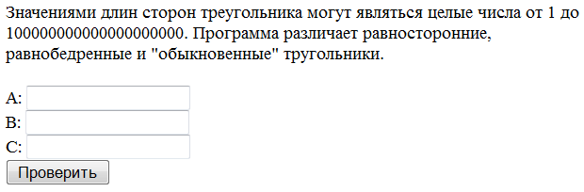

Перед вами скрин-шоT приложения. Напишите основные идеи тестов (в логичном порядке), которые вы выполните для проверки работоспособности этой программы, классифицируйте их.

|  |  |  |
| --- | --- | --- |
| 1. Create a triangle with minimal integers (functional) | 1. Create an equilateral triangle with maximum hip lengths of =100000000000000000000-1 (functional) | 1. Create a triangle with C = ♣☺♂ A=♣☺♂ B=♣☺♂ (functional) |
| 1. Create an equilateral triangle with minimal integers (functional) | 1. Create a triangle with maximal+1 integers (functional) | 1. Create a triangle with C = ALTER TABLE USERS ADD Column A= ALTER TABLE USERS ADD Column B=ALTER TABLE USERS ADD Column (security) |
| 1. Create an isosceles triangle with minimum hip lengths of 1 (functional) | 1. Create an equilateral triangle with maximal-1 integers (functional) | 1. Create a triangle with C = <script>alert(«I hacked this!»)</script> A= <script>alert(«I hacked this!»)</script> B= <script>alert(«I hacked this!»)</script> (security) |
| 1. Create a triangle with maximal integers (functional) | 1. Create an equilateral triangle with maximal+1 integers (functional) | 1. Create a triangle with C = 2 2 A= 2 2 B=2 2 (functional) |
| 1. Create an equilateral triangle with maximal integers (functional) | 1. Create an equilateral triangle with maximum hip lengths of =100000000000000000001 (functional) |  |
| 1. Create an isosceles triangle with maximum hip lengths of 100000000000000000000 (functional) | 1. Create a triangle with minimal fractional numbers (functional) |  |
| 1. Create a triangle with A=0 and BC min positive integers (functional) | 1. Create an equilateral triangle with minimal fractional numbers (functional) |  |
| 1. Create a triangle with B=0 and BC min positive integers (functional) | 1. Create an equilateral triangle with minimum hip lengths of 1.1 (functional) |  |
| 1. Create a triangle with C=0 and AC min positive integers (functional) | 1. Create a triangle with A = empty B=20 C=25 (functional) |  |
| 1. Create a triangle with A=-1 and BC min positive integers (functional) | 1. Create a triangle with B = empty A=60 C=25 (functional) |  |
| 1. Create a triangle with B=-1 and BC min positive integers (functional) | 1. Create a triangle with C = empty A=60 B=25555 (functional) |  |
| 1. Create a triangle with C=-1 and AC min positive integers (functional) | 1. Create a triangle with A = Abc 123, !@#$%^&*()_+|-=\[]{};':"<>/.,? Мама мыла раму B=20 C=25 (functional) | 1. Q In Description of the program треугольник or тругольник? UX |
| 1. Create a triangle with maximal-1 integers (functional) | 1. Create a triangle with B = Abc 123, !@#$%^&*()_+|-=\[]{};':"<>/.,? Мама мыла раму A=20 C=25 (functional) |  |
| 1. Create an equilateral triangle with maximal-1 integers (functional) | 1. Create a triangle with C = Abc 123, !@#$%^&*()_+|-=\[]{};':"<>/.,? Мама мыла раму A=20 B=25 (functional) |  |