**ФИО Ekaterina Anatol’evna Zakomornaya______________________________________ группа ___ST1-336-22______ дата__09.11.2022_________**

**Задание 1**

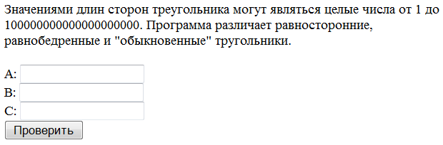

Перед вами скрин-шоT приложения. Напишите основные идеи тестов (в логичном порядке), которые вы выполните для проверки работоспособности этой программы, классифицируйте их.

|  |  |  |
| --- | --- | --- |
| 1. Create a triangle with minimal integers (functional) | 1. Create an equilateral triangle with maximum hip lengths of =100000000000000000000-1 (functional) | 1. Create a triangle with C = ♣☺♂ A=♣☺♂ B=♣☺♂ (functional) |
| 1. Create an equilateral triangle with minimal integers (functional) | 1. Create a triangle with maximal+1 integers (functional) | 1. Create a triangle with C = ALTER TABLE USERS ADD Column A= ALTER TABLE USERS ADD Column B=ALTER TABLE USERS ADD Column (security) |
| 1. Create an isosceles triangle with minimum hip lengths of 1 (functional) | 1. Create an equilateral triangle with maximal-1 integers (functional) | 1. Create a triangle with C = <script>alert(«I hacked this!»)</script> A= <script>alert(«I hacked this!»)</script> B= <script>alert(«I hacked this!»)</script> (security) |
| 1. Create a triangle with maximal integers (functional) | 1. Create an equilateral triangle with maximal+1 integers (functional) | 1. Create a triangle with C = 2 2 A= 2 2 B=2 2 (functional) |
| 1. Create an equilateral triangle with maximal integers (functional) | 1. Create an equilateral triangle with maximum hip lengths of =100000000000000000001 (functional) |  |
| 1. Create an isosceles triangle with maximum hip lengths of 100000000000000000000 (functional) | 1. Create a triangle with minimal fractional numbers (functional) |  |
| 1. Create a triangle with A=0 and BC min positive integers (functional) | 1. Create an equilateral triangle with minimal fractional numbers (functional) |  |
| 1. Create a triangle with B=0 and BC min positive integers (functional) | 1. Create an equilateral triangle with minimum hip lengths of 1.1 (functional) |  |
| 1. Create a triangle with C=0 and AC min positive integers (functional) | 1. Create a triangle with A = empty B=20 C=25 (functional) |  |
| 1. Create a triangle with A=-1 and BC min positive integers (functional) | 1. Create a triangle with B = empty A=60 C=25 (functional) |  |
| 1. Create a triangle with B=-1 and BC min positive integers (functional) | 1. Create a triangle with C = empty A=60 B=25555 (functional) |  |
| 1. Create a triangle with C=-1 and AC min positive integers (functional) | 1. Create a triangle with A = Abc 123, !@#$%^&*()_+|-=\[]{};':"<>/.,? Мама мыла раму B=20 C=25 (functional) | 1. Q In Description of the program треугольник or тругольник? UX |
| 1. Create a triangle with maximal-1 integers (functional) | 1. Create a triangle with B = Abc 123, !@#$%^&*()_+|-=\[]{};':"<>/.,? Мама мыла раму A=20 C=25 (functional) |  |
| 1. Create an equilateral triangle with maximal-1 integers (functional) | 1. Create a triangle with C = Abc 123, !@#$%^&*()_+|-=\[]{};':"<>/.,? Мама мыла раму A=20 B=25 (functional) |  |

**Задание 2**

Перед вами скрин-шот приложения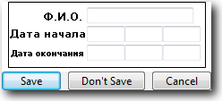, принимающего от сотрудников и сохраняющего в базу данных даты желаемого начала и окончания отпуска. Напишите тест-кейсы, которые Вы выполните для проверки работоспособности этой программы в рамках смоук теста.

Q. Is it possible to enter the date continuously from the keyboard namely whether there is an automatic transition in the start and end of the vacation field?

Q. . End date field name must be less in font than the name of the start date field?

Q. Why the button [Don’t Save] ?

|  |  |  |  |  |
| --- | --- | --- | --- | --- |
| **ID** | **Priority** | **Test Description** | **Expected results** | **Comment** |
| A1 | smoke | **Title** save valid data  **Steps:**  1 Open app following the link  2 Input in field ‘ФИО ’ ‘Закоморная Екатерина Анатольевна’  3 Input in fields ‘Дата начала’ ‘1’’12’’2022’  4 Input in fields ‘Дата окончания’ ’15’’12’’2022’  5 Click [Save] | 1 app is opened  2 In field ‘ФИО ’ ‘Закоморная Екатерина Анатольевна’ is displayed  3 In fields ‘Дата начала’ ‘1’’12’’2022’ is displayed  4 In fields ‘Дата окончания’ ’15’’12’’2022’ is displayed  5 Your data is Saved TBD | Q. after clicking the [Save] what happens? |
| A2 | smoke | **Title** save invalid data name  **Steps:**  1 Open app following the link  2 Input in field ‘ФИО ’ ‘♣☺♂’  3 Input in fields ‘Дата начала’ ‘1’’12’’2022’  4 Input in fields ‘Дата окончания’ ‘15’’12’’2022’  5 Click [Save] | 1 app is opened  2 In field ‘ФИО ’ ‘♣☺♂’ is displayed TBD  3 In fields ‘Дата начала’ ‘1’’12’’2022’is displayed  4 In fields ‘Дата окончания’ ‘15’’12’’2022’is displayed  5 The message about error is displayed TBD | Q. after entering invalid data is there a prompt that you have entered the wrong name |
| A3 | smoke | **Title** save invalid data past start date  **Steps:**  1 Open app following the link  2 Input in field ‘ФИО ’ ‘Закоморная Екатерина Анатольевна’  3 Input in fields ‘Дата начала’ ‘1’’12’’2021’  4 Input in fields ‘Дата окончания’ ’15’’12’’2022’  5 Click [Save] | 1 app is opened  2 In field ‘ФИО ’ ‘Закоморная Екатерина Анатольевна’ is displayed  3 In fields ‘Дата начала’ ‘1’’12’’2021’ is displayed TBD  4 In fields ‘Дата окончания’ ’15’’12’’2022’ is displayed  5 The message about error is displayed TBD | Q. after entering invalid start date is there a prompt that you have entered the wrong start date |
| A4 | smoke | **Title** save invalid data empty form  **Steps:**  1 Open app following the link  2 Input in field ‘ФИО ’ ‘Закоморная Екатерина Анатольевна’  3 Click [Save] | 1 app is opened  2 In field ‘ФИО ’ ‘Закоморная Екатерина Анатольевна’ is displayed  5 The message about error is displayed TBD | Q. after you enter blank values a prompt appears you have not entered date values |
| A5 | smoke | **Title**  **Steps: cancel data save**  1 Open app following the link  2 Input in field ‘ФИО ’ ‘Закоморная Екатерина Анатольевна’  3 Input in fields ‘Дата начала’ ‘1’’12’’2022’  4 Input in fields ‘Дата окончания’ ’15’’12’’2022’  5 Click [Cancel] | 1 app is opened  2 In field ‘ФИО ’ ‘Закоморная Екатерина Анатольевна’ is displayed  3 In fields ‘Дата начала’ ‘1’’12’’2022’ is displayed  4 In fields ‘Дата окончания’ ’15’’1’’2022’ is displayed  5 App with empty value is displayed TBD | Q. after clicking the [Cancel] what happens? |
| A6 | smoke | **Title**  **Steps: don’t save data**  1 Open app following the link  2 Input in field ‘ФИО ’ ‘Закоморная Екатерина Анатольевна’  3 Input in fields ‘Дата начала’ ‘1’’12’’2022’  4 Input in fields ‘Дата окончания’ ’15’’12’’2022’  5 Click [Don’t Save] | 1 app is opened  2 In field ‘ФИО ’ ‘Закоморная Екатерина Анатольевна’ is displayed  3 In fields ‘Дата начала’ ‘1’’12’’2022’ is displayed  4 In fields ‘Дата окончания’ ’15’’12’’2022’ is displayed  5 App with value is displayed TBD | Q. after clicking the [Don’t Save] what happens? |
| A7 | smoke | **Title** save invalid data name  **Steps:**  1 Open app following the link  2 Input in field ‘ФИО ’ ‘Ofrjvjhyfz Yrfnthbyf Fgfnjkmtdyf’  3 Input in fields ‘Дата начала’ ’1’’12’’2022’  4 Input in fields ‘Дата окончания’ ’15’’12’’2022’  5 Click [Save] | 1 app is opened  2 In field ‘ФИО ’ ‘Ofrjvjhyfz Yrfnthbyf Fgfnjkmtdyf’’ is displayed TBD  3 In fields ‘Дата начала’ ‘1’’12’’2022’ is displayed  4 In fields ‘Дата окончания’ ’15’’12’’2022’ is displayed  5 The message about error is displayed TBD | Q. after entering invalid data is there a prompt that you have entered the wrong name |
| A8 | smoke | **Title** save invalid data name start and end date TBD  **Steps:**  1 Open app following the link  2 Input in field ‘ФИО ’ ‘Закоморная Екатерина Анатольевна’  3 Input in fields ‘Дата начала’ ‘1’ ‘декабря’ ‘2022’  4 Input in fields ‘Дата окончания’ ’15’ ‘декабря’ ‘2022’  5 Click [Save] | 1 app is opened  2 In field ‘ФИО ’ ‘Закоморная Екатерина Анатольевна’’ is displayed  3 In fields ‘Дата начала’ ‘1’’’’2022’ is displayed  4 In fields ‘Дата окончания’ ’15’’’’2022’ is displayed  5 The message about error is displayed TBD | What format data name start and end date TBD  What error is displayed |
| A9 | smoke | **Title** copy paste from keyboard save valid data with double lastname  **Steps:**  1 Open app following the link  2 Copy and paste ‘ФИО ’ ‘Закоморная-Наумчик Екатерина Анатольевна’  3 Input in fields ‘Дата начала’ ‘1’’12’’2022’  4 Input in fields ‘Дата окончания’ ’15’’12’’2022’  5 Click [Save] | 1 app is opened  2 In field ‘ФИО ’ ‘Закоморная-Наумчик Екатерина Анатольевна’’ is displayed  3 In fields ‘Дата начала’ ‘1’’12’’2022’ is displayed  4 In fields ‘Дата окончания’ ’15’’12’’2022’ is displayed  5 Your data is Saved TBD | TBD format field name |
| A10 | smoke | **Title** save valid data non-employee    **Steps:**  1 Open app following the link  2 Input in field ‘ФИО ’ ‘Иванова Екатерина Анатольевна’  3 Input in fields ‘Дата начала’ ‘1’’12’’2022’  4 Input in fields ‘Дата окончания’ ’15’’12’’2022’  5 Click [Save] | 1 app is opened  2 In field ‘ФИО ’ ‘Иванова Екатерина Анатольевна’ is displayed  3 In fields ‘Дата начала’ ‘1’’12’’2022’ is displayed  4 In fields ‘Дата окончания’ ’15’’12’’2022’ is displayed  5 Your data is not Saved TBD | Q. after clicking the [Save] non-employee what happens? |
|  |  |  |  |  |
|  |  |  |  |  |
|  |  |  |  |  |
|  |  |  |  |  |
|  |  |  |  |  |
|  |  |  |  |  |
|  |  |  |  |  |

**Задание 3**

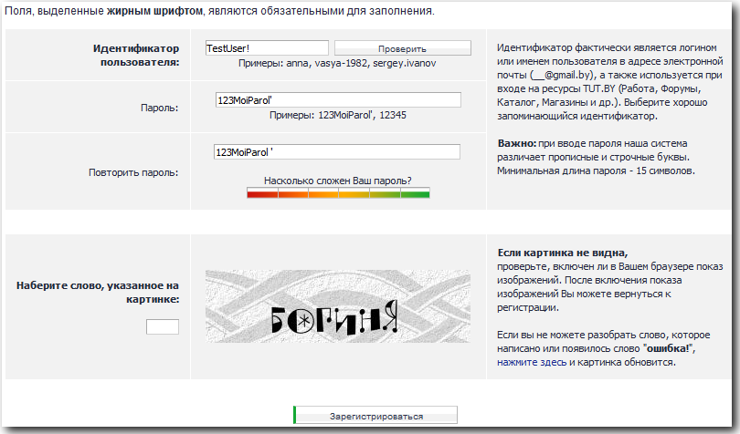Напишите баг-репорты по проблемам, которые как вам кажется присутствуют в «Форме регистрации нового пользователя портала TUT.BY» на этом скриншоте.

|  |
| --- |
|  |

|  |
| --- |
| **Bug ID D1** |
| **Summary**  **Required fields are marked in bold and it is more convenient for the user if the required fields are marked with \*** |
| Description  Actual result: ‘Поля выделенные жирным шрифтом являются обязательными’  Expected result: ‘Поля * являются обязательными’ |
| Severity ➊ ➋ ➌ ➍ 🄌 (обозначьте желаемую, 0 – для enhancement, 1 – самая критичная, критичнее некуда!) 3 |
| Steps to reproduce   1. Open app following the link <http://www.tut.by/> 2. Click [Зарегистрироваться] TBD 3. Look at the text at the top ‘Поля выделенные жирным шрифтом являются обязательными’ |
| **Bug ID D2** |
| **Summary**  **Example password unsafe hint** |
| Description  Under the password field there are password hints and lazy users can copy them which jeopardizes the user's personal data  Actual result: Example password is displayedunder the password field  Expected result: Example password is not displayedunder the password field |
| Severity ➊ ➋ ➌ ➍ 🄌 (обозначьте желаемую, 0 – для enhancement, 1 – самая критичная, критичнее некуда!) 3 |
| Steps to reproduce   1. Open app following the link <http://www.tut.by/> 2. Click [Зарегистрироваться] TBD 3. Look at the text under the password field ‘Примеры: ’ |
| **Bug ID D3 TBD required fields** |
| **Summary**  **Fields password and repeat password are not in bold but logic they are required** |
| Description  Actual result:  Fields ‘Пароль’ ‘Повторите пароль’ are not in bold but logic they are required  Expected result:  Fields ‘Пароль’ ‘Повторите пароль’ are in bold or there are not required |
| Severity ➊ ➋ ➌ ➍ 🄌 (обозначьте желаемую, 0 – для enhancement, 1 – самая критичная, критичнее некуда!) 1 |
| Steps to reproduce   1. Open app following the link <http://www.tut.by/> 2. Click [Зарегистрироваться] TBD 3. Look at name fields ‘Пароль’ and ‘Повторите пароль’ |
| **Bug ID D4** |
| **Summary The field where you need to specify the word indicated in the picture is convenient for the user to place under the picture** |
| Description  Actual result:  The field where you need to specify the word indicated in the picture is displayed left the picture  Expected result:  The field where you need to specify the word indicated in the picture is displayed under the picture |
| Severity ➊ ➋ ➌ ➍ 🄌 (обозначьте желаемую, 0 – для enhancement, 1 – самая критичная, критичнее некуда!) 4 |
| Steps to reproduce  1. Open app following the link http://www.tut.by/  2. Click [Зарегистрироваться] TBD  3. Look at field ‘Наберите слово указанное на картинке’ |
| **Bug ID D5** |
| **Summary**  **The height of the field’s names and the fields are not at the same level** |
| Description  Actual result:  The height of the field’s names and the fields are not at the same level  Expected result:  The height of the field’s names and the fields are at the same level |
| Severity ➊ ➋ ➌ ➍ 🄌 (обозначьте желаемую, 0 – для enhancement, 1 – самая критичная, критичнее некуда!) 4 |
| Steps to reproduce  1. Open app following the link http://www.tut.by/  2. Click [Зарегистрироваться] TBD  3. Look at all field’s names and the fields |

**Спасибо за участие!**