Your name \_\_Ekaterina Anatol’evna Zakomornaya\_\_\_\_\_\_\_\_\_\_\_\_\_\_\_\_\_\_\_\_\_\_\_\_\_\_\_\_\_\_\_\_\_\_\_\_\_\_ Date \_11/25/2022\_\_\_\_\_\_\_\_\_\_\_\_\_\_\_

**Good luck!**

**Introduction to the project:**

|  |  |
| --- | --- |
| Imagine that you are assigned to a new project as a tester.  Testing team: you and test team lead Mike.  This is a small mobile project for iOS.  “Canteen menu” application is developed for a huge company located all over the world. Application is targeted on company’s canteens stuff. It will be used for week menu management (creation, edition, etc).  Canteen employees are equipped with iPads or iPhones X.  After login to the application user (canteen employee) is redirected to “Menu List” screen with the list of menus for different company’s canteens (in different locations), “Country”, “City”, “Canteen” filters.  **New feature “Menu Editor” will be implemented during the upcoming iteration.**  Your task is:   1. Review the requirements for the new feature provided by BA Barbara 2. In case of any questions you have to write email to Barbara with request to clarify your questions 3. Provide estimations for test activities for this feature by email to your test lead Mike 4. Write test cases for the feature 5. Review provided screens with the implemented feature 6. Find and submit bugs in case of any 7. Send test results and your decision about quality of the feature to Mike (\*optional)   **Below you will find requirements for the feature and templates for emails, test cases, bug reports, etc. Please fill in only those templates that you think reasonable in scope of this feature. You can write any additional information if required.** | E:\lectures\Test 3\1.png |
| **Requirements for the new feature:**  AS an administrator  I CAN **create menu**:   1. I am in “Menu List” screen 2. I click “create” button - “Menu Editor” screen opens 3. I type canteen name in “Menu name” field 4. I choose canteen from list and click it 5. I select “To” date from date picker 6. I select “From” date from date picker 7. I click “save” button – “Menu List” screen opens, new menu is added to the list | E:\lectures\Test 3\2crop.png |
| AS an administrator  I CAN **edit menu**:   1. I am in “Menu List” screen 2. I click edit icon C:\Users\Lidziya_Smirnova\Desktop\Icons\89031-200.png - “Menu Editor” screen opens 3. From the dates panel I choose date I want to add dish offers to 4. In dish categories list I choose category I want to add dish offers to 5. If there are no dishes in the category – empty field is displayed 6. If the number of dishes exceeds the screen – the list can be scrolled 7. I can remove dish from the list 8. “Add dish” feature will be implemented later | |
| E:\lectures\Test 3\2.png | E:\lectures\Test 3\2a.png |

**Clarification letter to BA regarding new feature:**

|  |  |
| --- | --- |
| **To:** | Barbara Smith |
| **CC:** | test team lead Mike |
| **Subject:** | to clarify some requirements for the new feature “Menu Editor” to create menu “Canteen menu” |
| Hello, Barbara,  I hope you are well.  I write you to clarify some requirements for the new feature “Menu Editor”.  List of questions:  1. Field “To” in what format will be? Dd/mm/yy or mm/dd/yy?  2. Field “From” in what format will be? Dd/mm/yy or mm/dd/yy?  3. Field canteen name in “Menu name” in Latin or Cyrillic  4. Do you need a button name or just a symbol? and after click what happen?    5. Is the range “From” “To” limited to a week?  6. From what day of week starts Sunday or Monday?  7. Is a GUI requirements present? Which ones?  As a reply to this email,  **Send me, please, your answers on my questions** (in a mail body).  I would be grateful if you could do this before lunch tomorrow.  Best regards,  **Ekaterina Zakomornaya**  Cell: +375 29 262 78 48  Skype: enaumchik | |

**Test estimations for new feature to Test team lead:**

|  |  |
| --- | --- |
| **To:** | Mike |
| **CC:** | Barbara Smith |
| **Subject:** | estimations for test activities for the new feature “Menu Editor” to create menu “Canteen menu” |
| Hello, Mike,  I hope you are well.  Testing of the new feature “Menu Editor” to create menu “Canteen menu” will take 5 days.  E:\lectures\Test 3\2crop.png  Time to write test cases: 40 test cases \* 10 minutes = 400 minutes  Time for 1 run of all test cases: 40 \* 10 minutes Time to run one test case = 400 minutes  Time for 3 runs of all test cases \* 3 number of runs = 1200 minutes    Writing time, 3 runs = 1600 minutes = 27 hours  +20% additional tasks = 33 hours  + 35% risks (incorrect operation of the main functionality of the application, bug fixes, clarification of requirements with the customer, lack of Internet, illness of employees) = 45 hours = 6 days  Mike, for testing new feature I need login to the application as an administrator (canteen employee). Send me this login please.  As a reply to this email,  **Send me, please, your questions if you have any** (in a mail body).  I would be grateful if you could do this before lunch tomorrow.  Best regards,  **Ekaterina Zakomornaya**  Cell: +375 29 262 78 48  Skype: enaumchik | |

**Test cases for new feature:**

|  |  |  |  |  |  |  |  |
| --- | --- | --- | --- | --- | --- | --- | --- |
| **ID** | **Priority** | **Type of testing** | **Module** | **Test Description** | **Expected results** | **Passed/Failed** | **Comments** |
| Y1 | smoke | functional | feature “Menu Editor” | **Title:** **feature “Menu Editor” “Canteen menu” open**  **Steps:**  **1** Click favicon app which you download  **2** Enter your login to the application as an administrator (canteen employee) TBD  **3** Press [enter] TBD  **4** Click [Create] | **1** App which you download  Open  **2** Your login to the application as an administrator TBD (canteen employee) is displayed  3 “Menu list” Canteen menu is displayed  4 “Menu Editor” Canteen menu is displayed | passed | E:\lectures\Test 3\2crop.png |
| Y2 | smoke | functional | feature “Menu Editor” | **Title:** **Create menu ‘Test menu’**  **Steps:**  **1** Click favicon app which you download  **2** Enter your login to the application as an administrator (canteen employee) TBD  **3** Press [enter] TBD  **4** Click [Create]  **5** Input ‘Test menu’ in field Menu Name  **6 Click on** dropdown list to choose carteen  7 Scroll and click from dropdown list Canteen (Minsk)  **8** In field From input 17.11.2017  **9**In field To input 21.11.2017  10 Click [Save] | **1** App which you download  Open  **2** Your login to the application as an administrator TBD (canteen employee) is displayed  **3** “Menu list” Canteen menu is displayed  **4** “Menu Editor” Canteen menu is displayed  5 ‘Test menu’ is displayed  6 Dropdown list is displayed  7 Canteen (Minsk) is displayed  8 17.11.2017 is displayed  9 21.11.2017 is displayed  10 Menu **‘**Test menu’ is displayed in page menu list with new menu ‘Test menu’ | **Passed** | Menu **‘**Test menu’ is displayed in page menu list with new menu ‘Test menu’ |
| **ID** | **Priority** | **Type of testing** | **Module** | **Test Description** | **Expected results** | **Passed/Failed** | **Comments** |
| Y3 | smoke | functional | feature “Menu Editor” | **Title:** **Edit menu ‘Test menu’**  **Steps:**  **1** Click favicon app which you download  **2** Enter your login to the application as an administrator (canteen employee) TBD  **3** Press [enter] TBD  **4** Click [Create]  **5** Input ‘Test menu’ in field Menu Name  **6 Click on** dropdown list to choose carteen  **7** Scroll and click from dropdown list Canteen (Minsk)  **8** In field From input 17.12.2022  **9**In field To input 21.12.2022  **10** Click [Save]  **11** click icon C:\Users\Lidziya_Smirnova\Desktop\Icons\89031-200.pngnear **menu ‘Test menu’** | **1** App which you download  Open  **2** Your login to the application as an administrator TBD (canteen employee) is displayed  **3** “Menu list” Canteen menu is displayed  **4** “Menu Editor” Canteen menu is displayed  **5** ‘Test menu’ is displayed  **6** Dropdown list is displayed  **7** Canteen (Minsk) is displayed  **8** 17.12.2022 is displayed  **9** 21.12.2022 is displayed  **10** Menu **‘**Test menu’ is displayed in page menu list with new menu ‘Test menu’  **11** “Menu Editor” is displayed  With days buttons 17,18,19,20,21  and dish categories list and tab menu dishes | **Failed** | 11 “Menu Editor” is displayed  Without days buttons 17,18,19,20,21  and without dish categories list and tab menu dishes |
| Y4 | smoke | functional | feature “Menu Editor” | **Title:** **Edit menu ‘Test menu’ past years**  **Steps:**  **1** Click favicon app which you download  **2** Enter your login to the application as an administrator (canteen employee) TBD  **3** Press [enter] TBD  **4** Click [Create]  **5** Input ‘Test menu’ in field Menu Name  **6 Click on** dropdown list to choose carteen  **7** Scroll and click from dropdown list Canteen (Minsk)  **8** In field From input 17.11.2017  **9**In field To input 21.11.2017  **10** Click [Save]  **11** click icon C:\Users\Lidziya_Smirnova\Desktop\Icons\89031-200.pngnear **menu ‘Test menu’** | **1** App which you download  Open  **2** Your login to the application as an administrator TBD (canteen employee) is displayed  **3** “Menu list” Canteen menu is displayed  **4** “Menu Editor” Canteen menu is displayed  **5** ‘Test menu’ is displayed  **6** Dropdown list is displayed  **7** Canteen (Minsk) is displayed  **8** 17.11.2017 is displayed  **9** 21.11.2017 is displayed  **10** Menu **‘**Test menu’ is displayed in page menu list with new menu ‘Test menu’  **11** “Menu Editor” is displayed  With days buttons 17,18,19,20,21  and dish categories list and tab menu dishes | **Failed** | 11 “Menu Editor” is displayed  Without days buttons 17,18,19,20,21  and without dish categories list and tab menu dishes  And error is displayed ‘Oooooops…..’ |
| Y5 | smoke | stress | feature “Menu Editor” | **Title:** **Edit menu ‘Test menu’ past years with low battery**  **Precondition: battery is low**  **Steps:**  **1** Click favicon app which you download  **2** Enter your login to the application as an administrator (canteen employee) TBD  **3** Press [enter] TBD  **4** Click [Create]  **5** Input ‘Test menu’ in field Menu Name  **6 Click on** dropdown list to choose carteen  **7** Scroll and click from dropdown list Canteen (Minsk)  **8** In field From input 17.11.2017  **9**In field To input 21.11.2017  **10** Click [Save]  **11** click icon C:\Users\Lidziya_Smirnova\Desktop\Icons\89031-200.pngnear **menu ‘Test menu’** | **1** App which you download  Open  **2** Your login to the application as an administrator TBD (canteen employee) is displayed  **3** “Menu list” Canteen menu is displayed  **4** “Menu Editor” Canteen menu is displayed  **5** ‘Test menu’ is displayed  **6** Dropdown list is displayed  **7** Canteen (Minsk) is displayed  **8** 17.11.2017 is displayed  **9** 21.11.2017 is displayed  **10** Menu **‘**Test menu’ is displayed in page menu list with new menu ‘Test menu’  **11** “Menu Editor” is displayed  With days buttons 17,18,19,20,21  and dish categories list and tab menu dishes | **Untested** |  |
| ChL1 | smoke | functional | feature “Menu Editor” | **Title:** **feature “Menu Editor” “Canteen menu” open in**  Different types of connections (cellular/Wi-Fi) |  | **Untested** | Check list |
| ChL2 | smoke | functional | feature “Menu Editor” | **Title:** **feature “Menu Editor” “Canteen menu” open in**  Screen orientation (landscape/portrait) |  | **Untested** | Check list |
| ChL3 | smoke | compatibility | feature “Menu Editor” | **Title:** **feature “Menu Editor” “Canteen menu” open when** incoming call  (Interrupt testing) |  | **Untested** | Check list |
| ChL4 | smoke | compatibility | feature “Menu Editor” | **Title:** **feature “Menu Editor” “Canteen menu” open**  on different devices from different manufacturers |  | **Untested** | Check list |

**“Menu Editor” feature is ready for testing:**

Developers have finished implementation of “Menu Editor” feature. Build with the feature is released and successfully installed.

When editing the menu you see the following screen:

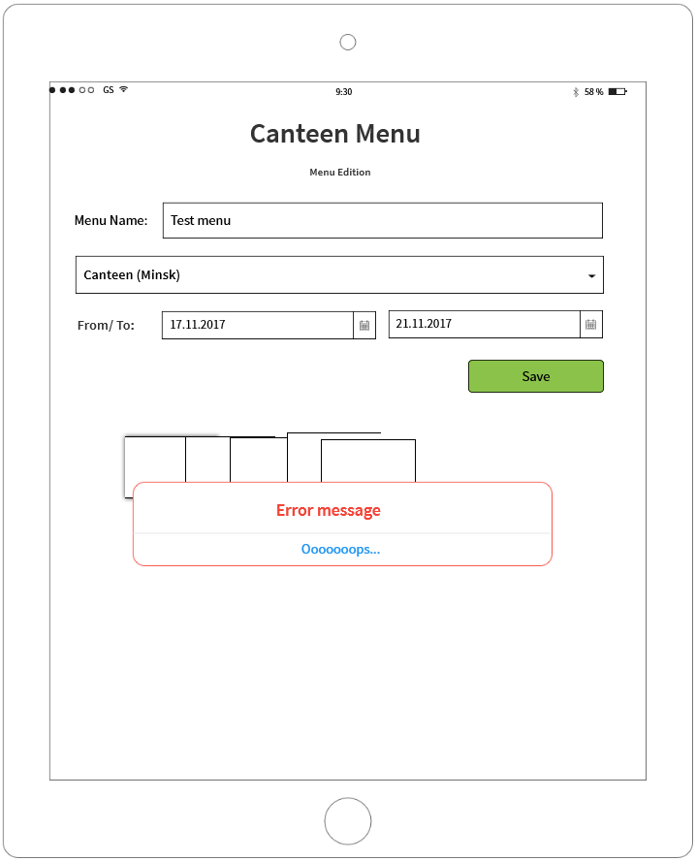

**If you see any bugs in this screen, you can post them below:**

**Bug reports:**

|  |  |
| --- | --- |
| **Bug ID** | **T1** |
| **Summary** | Error is displayed ‘Oooooops…..’ after edit menu ‘Test menu’ past years |
| **Description** | Actual result  Error is displayed ‘Oooooops…..’  Expected result  Error is displayed “Sorry your operation is impossible’ |
| **Severity** | Medium |
| **Priority** | Normal |
| **Steps to reproduce** | **1** Click favicon app which you download  **2** Enter your login to the application as an administrator (canteen employee) TBD  **3** Press [enter] TBD  **4** Click [Create]  **5** Input ‘Test menu’ in field Menu Name  **6 Click on** dropdown list to choose carteen  **7** Scroll and click from dropdown list Canteen (Minsk)  **8** In field From input 17.11.2017  **9**In field To input 21.11.2017  **10** Click [Save]  **11** click icon C:\Users\Lidziya_Smirnova\Desktop\Icons\89031-200.pngnear **menu ‘Test menu’** |
| **Attachment** | E:\lectures\Test 3\4.png |
| Status | Opened |
| Reproducible | Always |
| Workaround | Yes |
| Environment | IOS 13 |
| Symptom | Incorrect operation |
| **Bug ID** | **T2** |
| **Summary** | Name Menu Editor incorrect and displayed as Menu Edition |
| **Description** | Actual result  Menu Edition  Expected result  Menu Editor |
| **Severity** | Medium |
| **Priority** | Normal |
| **Steps to reproduce** | **1** Click favicon app which you download  **2** Enter your login to the application as an administrator (canteen employee) TBD  **3** Press [enter] TBD  **4** Click [Create]  **5** Input ‘Test menu’ in field Menu Name  **6 Click on** dropdown list to choose carteen  **7** Scroll and click from dropdown list Canteen (Minsk)  **8** In field From input 17.11.2017  **9**In field To input 21.11.2017  **10** Click [Save]  **11** click icon C:\Users\Lidziya_Smirnova\Desktop\Icons\89031-200.pngnear **menu ‘Test menu’**  12 Look at name page menu edition |
| **Attachment** |  |
| Status | Opened |
| Reproducible | Always |
| Workaround | Yes |
| Environment | IOS 13 |
| Symptom | Cosmetic flaw |
| **Bug ID** | **T3** |
| **Summary** | No button search |
| **Description** | Actual result  button search is absent  Expected result  button search is present |
| **Severity** | Medium |
| **Priority** | Normal |
| **Steps to reproduce** | **1** Click favicon app which you download  **2** Enter your login to the application as an administrator (canteen employee) TBD  **3** Press [enter] TBD  **4** Click [Create]  **5** Input ‘Test menu’ in field Menu Name  **6 Click on** dropdown list to choose carteen  **7** Scroll and click from dropdown list Canteen (Minsk)  **8** In field From input 17.11.2017  **9**In field To input 21.11.2017  **10** Click [Save]  **11** click icon C:\Users\Lidziya_Smirnova\Desktop\Icons\89031-200.pngnear **menu ‘Test menu’**  12 Look at button search |
| **Attachment** |  |
| Status | Opened |
| Reproducible | Always |
| Workaround | Yes |
| Environment | IOS 13 |
| Symptom | Cosmetic flaw |

**Test result report to Test team lead:**

|  |  |
| --- | --- |
| **To:** | Mike |
| **CC:** |  |
| **Subject:** | TRR testing new feature “Menu Editor” to create menu “Canteen menu” |
| Hello, Mike,  I hope you are well.  **Testing of the new feature “Menu Editor” started today.**  **Summary:** 3 bugs found  **Browsers mobile: IOS 13**  **Test Status: Yellow**  **Test Analysis:** Although there are 3 bugs found today, it seems as expected at the  current stage of the project, as this is the first build feature. Quality is so-so, but it is ok for the current stage of the project.  **Plans for next week:** complete test cases creation, receive build 1.0.1, start test execution.  **New bugs found:**   |  |  | | --- | --- | | 1 | Error is displayed ‘Oooooops…..’ after edit menu ‘Test menu’ past years | | 2 | Name Menu Editor incorrect and displayed as Menu Edition | | 3 | No button search |   **All bugs statistics:**   |  |  |  |  |  |  | | --- | --- | --- | --- | --- | --- | | **Status** | **Quantity** | **Severity** | | | | | **Critical** | **Major** | **Medium** | **Minor** | | Submitted | 3 | 0 | 0 | 3 | 0 |   As a reply to this email,  **Send me, please, your questions if you have any** (in a mail body).  I would be grateful if you could do this before lunch tomorrow.  Best regards,  **Ekaterina Zakomornaya**  Cell: +375 29 262 78 48  Skype: enaumchik | |

**Thank you!**