**Test result report Team 1**

**ITAcademyTeam1 (**<https://www.it-academy.by/>**)**

**24.10-21.11.2022**

**Test team:**

|  |  |  |
| --- | --- | --- |
| **Name** | **Position** | **Role in the project** |
| Bolgar Angelina | Tester, Team Lead 2 week | Vision, teambilding, organization, basic check of builds, revision of test scenarios, functional testing |
| Zakomornaya Ekaterina | Team Lead 1, 4 weeks, Tester | Vision, teambilding, organization, basic check of builds, revision of test scenarios, functional testing |
| Pavlovich Olga | Tester, Team Lead 3 week | Vision, teambilding, organization, basic check of builds, revision of test scenarios, functional testing |

**Test process description:**

**Test environment:** OC Windows 11, macOS Mojave 10.14.6,

**Browsers:** Google Chrome, Safari, Firefox

**Mobile OS:** IOS V 14.8.1, Android V 12

**Test Level:** System testing.

**Test types used:**Functional, GUI, Localization and API testing.

All test scenarios where created based on modules <https://www.it-academy.by/>.

All test suites performed manually, execution details see at: Qase test suites.

**Qase:** [https://app.qase.io/](https://app.qase.io/" \t "_blank)

**Login:** esnbu@mailto.plus

**Password**: 987654321

**Folder Team 1 access:**

[https://drive.google.com/drive/folders/1kL6a4KS9oRtdiIqu74b2JZwMh-2z8ts\_?usp=sharing](https://drive.google.com/drive/folders/1kL6a4KS9oRtdiIqu74b2JZwMh-2z8ts_?usp=sharing" \t "_blank)

**JIRA Dashboard:**

[https://jr.it-academy.by/secure/RapidBoard.jspa?rapidView=725&projectKey=ST336221](https://jr.it-academy.by/secure/RapidBoard.jspa?rapidView=725&projectKey=ST336221" \t "_blank)

**Summary:** 62 bugs found. All 15 modules are covered with test cases in Qase: Start page, Menu, Footer, Education, Upcoming starts, Distance learning, EPAM trainings, IT Practicum, News, About the center, Employment, Reviews, Success stories, General, Ask a question to a specialist. 5 Test runs completed: [Test run 2022/11/20 Safari v. 14.1.2 (14611.3.10.1.7)](https://app.qase.io/run/Team1/dashboard/10), [Test run 2022/11/20 Mobile OS: IOS 14.8.1](https://app.qase.io/run/Team1/dashboard/9), [Test run 2022/11/20 Mobile Android v.12](https://app.qase.io/run/Team1/dashboard/8), [Test run 2022/11/13 Google Chrome V 107.0.5304.107](https://app.qase.io/run/Team1/dashboard/5), [Test run 2022/11/13 Mozilla Firefox V](https://app.qase.io/run/Team1/dashboard/2)

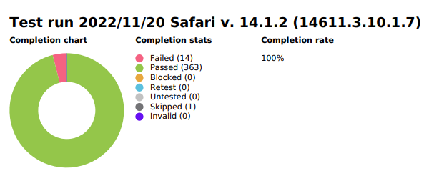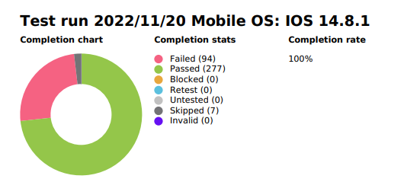

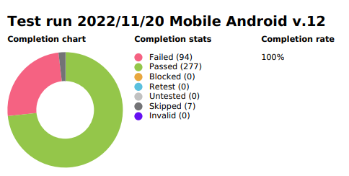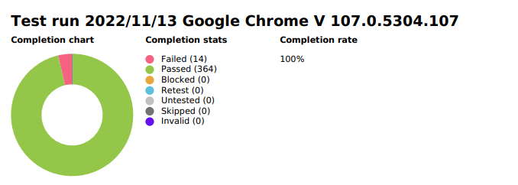

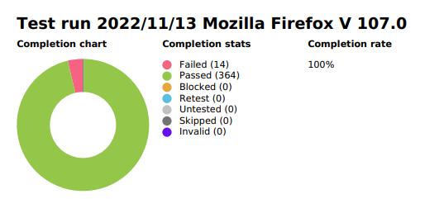

**Test Status: Yellow**

**Test Analysis:**Despite the large number of site modules and the large amount of test verification, the site <https://www.it-academy.by/> was tested. In Mobile OS: IOS 14.8.1 and Mobile Android v.12 have been identified critical bugs about broken Giperlink in pop-up menu to open section. A lot of Minor GUI bugs have been identified. Problem with slow loading on some pages. Identifiedbroken links, a problem with chat in some cities, a filtering problem. But we should pay attention to the functionality and usability mobile version <https://www.it-academy.by/> associated with broken links on the main pop-up menu and a lot of GUI bugs because it is directly affects course sales.

**Plans for next week:** Сreating presentation about testing web-site

**Testing timetable:**

|  |  |  |  |  |
| --- | --- | --- | --- | --- |
| **Tester** | **Week** | **Date** | **Description** | **Duration** |
| Bolgar Angelina | First | 25.10.2022 | Сreate a list of application modules | 4 hours |
| Discussion with team members on creating a working check-list file and how to make  changes to it | 1.5 hours |
| 26.10.2022 | Сreate Smoke and Critical path check-lists | 2 hours |
| Discussion with team members on creating a smoke check-list file | 2 hours |
| Investigate a problem with cover in check-lists | 2 hours |
| 27.10.2022 | Searching about website testing. | 2 hours |
| 28.10.2022 | Сreate Smoke check-list for "Education" module. | 2 hours |
| 30.10.2022 | Сreate Smoke check-list for "Education" module. | 1 hours |
| Second | 01.11.2022 | Team meeting | 0.5 hour |
| 02.11.2022 | Сreate Smoke check-list and test cases for "Training courses" module. | 2 hours |
| Сreate Smoke test cases for "Training courses" module. | 2 hours |
| 03.11.2022 | Сreate Smoke test cases for "Education" module. | 2 hours |
| Team meeting | 1 hour |
| 04.11.2022 | Сreate test cases for "Education" module. | 2 hours |
| 05.11.2022 | Сreate test cases for "Education" module. | 5 hours |
| 06.11.2022 | Сreate test cases for "Education" module. | 1 hour |
| Third | 07.11.2022 | Team meeting | 1 hour |
| 09.11.2022 | Сreate test cases for "Education" module. | 5 hour |
| Bugs reporting | 2 hour |
| 11.11.2022 | Team meeting | 0.5 hour |
| 12.11.2022 | Сreate test cases for "Education" module. | 5 hour |
| Bugs reporting | 1 hour |
| 13.11.2022 | Team meeting | 2,5 hours |
| Bugs reporting | 1 hour |
| Fours | 15.11.2022 | Team meeting | 1,5 hours |
| Documentation fix based on peer-to-peer | 1 hour |
| 16.11.2022 | Documentation fix based on peer-to-peer | 2,5 hours |
| Сreate test cases for "Education" module. | 5 hour |
| 17.11.2022 | Team meeting | 1,5 hours |
| Bugs reporting | 5 hours |
| 19.11.2022 | Pass first test run Mozilla Firefox V 107.0 | 5 hours |
| Pass second test run Google Chrome V 107.0.5304.107 | 5 hours |
| 20.11.2022 | Documentation fix | 0.5 hour |
| 21.11.2022 | Jira documentation fix | 0.5 hour |
| Zakomornaya Ekaterina | First | 25.10.2022 | Discussion with team members on creating a working check-list file and how to make  changes to it | 1.5 hours |
| Distribution of the test environment (who will be in which browser test) | 30 minutes |
| Сreate a list of application modules | 4 hours |
| 26.10.2022 | Discussion with team members on creating a smoke check-list file | 2 hours |
| 27.10.2022 | Meeting with team members about modules [https://www.it-academy.by/](https://www.it-academy.by/" \t "_blank) | 30 minutes |
| Create Meeting Follow-up | 1 hour |
| Exploring the concept of a top-level check-list. Learning the functionality of creating check-lists in Jira,Qase | 1 hour |
| 28.10.2022 | Сreate Smoke check-list for module Footer | 2 hour |
| 31.10.2022 | Create TRR 24-30.10.2022 | 1 hour |
| Second | 01.11.2022 | Team meeting | 0.5 hour |
| 01.11.2022 | Сreate check-list critical path for module Footer, Upcoming starts, Employment, Success story | 2 hour |
| 02.11.2022 | Сreate smoke test cases in Qase | 1 hour |
| 03.11.2022 | Сreate smoke test cases in Qase | 4 hours |
| Team meeting | 1 hour |
| 04.11.2022 | Сreate smoke test cases in Qase | 1 hour |
| 05.11.2022 | Сreate smoke test cases in Qase | 1 hour |
| 06.11.2022 | Сreate smoke test cases in Qase | 4 hours |
| Third | 07.11.2022 | Team meeting | 1hour |
| 08.11.2022 | Сreate smoke test cases in Qase | 1hour |
| 09.11.2022 | Сreate smoke test cases in Qase | 1hour |
| 10.11.2022 | Сreate smoke test cases in Qase | 1hour |
| 11.11.2022 | Сreate smoke test cases in Qase | 1hour |
| Team meeting | 0.5 hour |
| 12.11.2022 | Сreate bug report in JIRA | 1hour |
| 13.11.2022 | Team meeting | 2,5 hours |
| Bugs reporting | 6 hours |
| Fours | 14.11.2022 | Documentation fix based on peer-to-peer | 2 hours |
| 15.11.2022 | Team meeting | 1,5 hours |
| Documentation fix based on peer-to-peer | 1 hour |
| Vision of presentation the project | 0.5 hour |
| 16.11.2022 | Documentation fix based on peer-to-peer | 4 hours |
| Bugs reporting | 2 hours |
| 17.11.2022 | Team meeting | 1,5 hours |
| Bugs reporting | 2 hours |
| 18.11.2022 | Bugs reporting | 2 hours |
| 19.11.2022 | Pass first test run Mobile OS: IOS 14.8.1 | 5 hours |
| Bugs reporting | 2 hours |
| 20.11.2022 | Pass second test run Mobile OS: IOS 14.8.1 | 5 hours |
| Сreate bug report in JIRA | 2 hours |
| 21.11.2022 | Create TRR 24.10-21.11.2022 | 3 hours |
| Pavlovich Olga | First | 25.10.2022 | Сreate a list of application modules | 1 hour |
| Discussion with team members on creating a working check-list file and how to make | 1.5 hours |
| 26.10.2022 | Learning work in Jira, Qace | 2 hours |
| 27.10.2022 | Meeting with team members about modules [https://www.it-academy.by/](https://www.it-academy.by/" \t "_blank) | 30 minutes |
| 28.10.2022 | Create check-lists for modules Main page, Тренинги EPAM, IT практикум | 2 hours |
| 30.10.2022 | Create check-lists for modules Новости, о центре | 1.5 hours |
| Second | 01.11.2022 | Team meeting | 0.5 hour |
| 02.11.2022 | Creating test cases for module Main page | 3 hours |
| 03.11.2022 | Team meeting | 1 hour |
| 04.11.2022 | Creating test cases for module "Тренинги EPAM", Main page | 2 hours |
| 05.11.2022 | Creating test cases for module "IT практикум" | 2 hours |
| 06.11.2022 | Creating test cases for module "Новости" | 1 hour |
| Third | 07.11.2022 | Creating test cases for module "О центре" | 2 hours |
| Team meeting | 1 hour |
| 08.11.2022 | Creating test cases for module "О центре" | 2 hours |
| 09.11.2022 | Creating test cases in Qase | 3 hours |
| 10.11.2022 | Creating test cases in Qase | 2 hours |
| 11.11.2022 | Team meeting | 0.5 hour |
| 12.11.2022 | Create check-lists for model "Menu" | 2 hours |
| 13.11.2022 | Create test cases for module "Menu" | 3 hours |
| Team meeting | 2,5 hours |
| Bugs reporting | 1 hour |
| Create test cases for module "Manager chat" | 1 hour |
| Fours | 14.11.2022 | Create TRR 07-13.11.22 | 1 hour |
| 15.11.2022 | Team meeting | 1,5 hours |
| Documentation fix based on peer-to-peer | 1 hours |
| 20.11.2022 | Pass test run Mobile OS: android v.12 | 9 hours |
| Pass test run : Safari v. 14.1.2 (14611.3.10.1.7) | 2 hours |
| Bugs reporting | 1 hours |
| 21.11.2022 | Bugs reporting | 1 hours |
| Korolenok Denis | First | 25.10.2022 | Сreate a list of application modules | 3 hours |
| Discussion with team members on creating a working check-list file and how to make | 1.5 hours |
| 29.10.2022 | Searching about website testing. | 1,5 hours |
| 30.10.2022 | Сreate Smoke check-list for "Menu" module. | 2 hours |
| Second | 01.11.2022 | Team meeting | 0,5 hour |
| 02.11.2022 | Сreate Smoke check-list for "Дистанционное обучение" module. | 1 hour |
| 03.11.2022 | Team meeting | 1 hour |
| 4.11.2022 | Сreate test cases for "Отзывы" module. | 2 hour |
| 05.11.2022 | Сreate test cases for "Отзывы" module. | 1 hour |
| 06.11.2022 | Сreate test cases for "Отзывы" module. | 2 hour |
| Third | 07.11.- 08.11.2022 | Team meeting Сreating test cases for module "Menu" | 1hour 6 hours |
| 10.11.2022 | Left the project |  |

**New bugs found:**

|  |  |  |  |  |
| --- | --- | --- | --- | --- |
| № | ID | Bugs | Severity | Who found the bug |
| 1 | [ST336221-12](https://jr.it-academy.by/browse/ST336221-125)6 | No text wrapping container names in accordion menu 'Answers and questions' in education | Minor | Ekaterina |
| 2 | [ST336221-125](https://jr.it-academy.by/browse/ST336221-125) | the number of preparatory courses is not displayed | Medium | Olga |
| 3 | [ST336221-12](https://jr.it-academy.by/browse/ST336221-123)3 | Deviation from the template for writing contact information | Minor | Olga |
| 4 | [ST336221-12](https://jr.it-academy.by/browse/ST336221-122)2 | the city is automatically put Minsk, if you do not choose | Minor | Olga |
| 5 | [ST336221-12](https://jr.it-academy.by/browse/ST336221-121)1 | in nav-menu hyperlinks to open sections doesn't work in mobile version | Critical | Olga |
| 6 | [ST336221-12](https://jr.it-academy.by/browse/ST336221-120)0 | The background is absent in tab Sites map | Minor | Ekaterina |
| 7 | [ST336221-11](https://jr.it-academy.by/browse/ST336221-119)9 | Navigation button down scroll is abcent in employment program in mobile os IOS | Minor | Ekaterina |
| 8 | [ST336221-11](https://jr.it-academy.by/browse/ST336221-119)8 | Navigation button down scroll is abcent in Career in IT in mobile os IOS | Minor | Ekaterina |
| 9 | [ST336221-11](https://jr.it-academy.by/browse/ST336221-119)7 | The background is absent in Career in IT in Employment in section container "Карьера ит специалиста" | Minor | Ekaterina |
| 10 | [ST336221-11](https://jr.it-academy.by/browse/ST336221-119)6 | Navigation button down scroll is abcent in Who to study in mobile os IOS | Minor | Ekaterina |
| 11 | [ST336221-11](https://jr.it-academy.by/browse/ST336221-119)5 | The background is absent in Who to study in Employment in section container "На кого учиться" | Minor | Ekaterina |
| 12 | [ST336221-11](https://jr.it-academy.by/browse/ST336221-119)4 | The background is absent in Employment in section container "Наша цель-ваше трудоустройство" | Minor | Ekaterina |
| 13 | [ST336221-11](https://jr.it-academy.by/browse/ST336221-119)3 | Navigation button down scroll is abcent in Employment in mobile os IOS | Minor | Ekaterina |
| 14 | [ST336221-11](https://jr.it-academy.by/browse/ST336221-119)2 | in menu Giperlink 'Success stories' doesn't work | Critical | Ekaterina |
| 15 | [ST336221-11](https://jr.it-academy.by/browse/ST336221-119)1 | in menu Giperlink 'Отзывы' doesn't work | Critical | Ekaterina |
| 16 | [ST336221-11](https://jr.it-academy.by/browse/ST336221-119)0 | in menu Giperlink 'IT Практикум' doesn't work | Critical | Ekaterina |
| 17 | ST336221-109 | in menu Giperlink 'Тренинги Epam' doesn't work | Critical | Ekaterina |
| 18 | ST336221-108 | in menu Giperlink 'Distance learning' doesn't work | Critical | Ekaterina |
| 19 | ST336221-107 | in menu Giperlink 'Upcoming start's doesn't work | Critical | Ekaterina |
| 20 | ST336221-106 | blocks "tasks" and "Achievements" on the page "About IT academy" do not have a space between them when the window width is reduced (1200px - 1399px) | Minor | Angelina |
| 21 | ST336221-105 | the text "Системное и сетевое администрирование" in the card is cut off when the window size is reduced | Minor | Angelina |
| 22 | ST336221-104 | text "Подготовительные курсы" not centered on card when window width is reduced | Minor | Angelina |
| 23 | ST336221-103 | buttons in a course card don't have space between them when the window width is reduced if the buttons happen to be one below the other | Minor | Angelina |
| 24 | ST336221-102 | Сourse names in sub-modules are not hyperlinks. Although course names in modules are hyperlinks | Minor | Angelina |
| 25 | ST336221-101 | chat is missing on all pages(bottom right corner) if you select a city (except Minsk) in the "select city" dropdown list (or city selection window) | Minor | Angelina |
| 26 | ST336221-100 | the city, which we click on in the footer, is not displayed in the dropdown list after clicking | Minor | Angelina |
| 27 | ST336221-99 | there is no background for the logo-slider of companies and the "promotions and news" block in the "Upcoming starts" tab | Minor | Angelina |
| 28 | ST336221-98 | there is no mts and life operators number on the "consultation and appointment" form in the "Upcoming starts" tab | Minor | Angelina |

**All bugs statistics:**

|  |  |  |  |  |  |
| --- | --- | --- | --- | --- | --- |
| **Status** | **Quantity** | **Severity** | | | |
| **Critical** | **Major** | **Medium** | **Minor** |
| Submitted | 62 | 7 | 7 | 11 | 37 |