Supplementary Information
TranscriptMetaAnalyst: a graphical interface for the gene-level meta-analysis of RNA-Seq and microarray studies
All results in this file were produced with the scripts in dev/supplementary/ of the TranscriptMetaAnalyst (TMA) repository, with fixed random seeds (seed 2026). They can be reproduced with NOT_CRAN=true Rscript dev/supplementary/run_all.R. Software: R 4.6.1; TranscriptMetaAnalyst 2.0.0; DESeq2 1.52.0; limma 3.68.5; edgeR 4.10.7. The test suite of the package has 822 testthat expectations in 161 tests (0 failed).

S1. Batch-effect case study
Data. The simulated benchmark data of dev/simulate_studies.R were used, so that the truly differentially expressed genes are known. The data have 6 studies × 6 samples (3 control vs 3 treated) and 30,000 genes, with negative-binomial counts; 10% of the genes are truly DE (|log2FC| = 1.5, same direction in all studies), and every study has its own gene-wise baseline shift. In every study, the samples were split into two batches that are balanced with condition (batch 1: 2 control + 1 treated; batch 2: 1 control + 2 treated). The counts of batch 2 were multiplied by gene-specific log-normal factors (meanlog 0, sdlog 0.5, and sdlog 1 as a strong-batch scenario; a separate set of factors per study).
Detection. Before any differential expression analysis, batch_check() (the Check for batch effects box of the app) flagged 6 of the 6 studies with sdlog 0.5 and 6 of 6 with sdlog 1, because batch explained as much of the variance of the first principal components as condition, or more (Table S1).
Table S1. batch_check() on the simulated data with a batch effect: share of the variance of the first principal components explained by condition and by batch, per study.
sdlog | Study | Samples | Condition (%) | Batch (%) | Flagged
0.5 | A | 6 | 28.0 | 31.1 | yes
0.5 | B | 6 | 26.6 | 30.6 | yes
0.5 | C | 6 | 26.4 | 31.6 | yes
0.5 | D | 6 | 27.9 | 32.1 | yes
0.5 | E | 6 | 28.6 | 31.8 | yes
0.5 | F | 6 | 27.9 | 32.3 | yes
1.0 | A | 6 | 16.6 | 76.4 | yes
1.0 | B | 6 | 18.3 | 74.7 | yes
1.0 | C | 6 | 18.3 | 76.9 | yes
1.0 | D | 6 | 18.2 | 72.5 | yes
1.0 | E | 6 | 18.4 | 76.7 | yes
1.0 | F | 6 | 17.5 | 73.4 | yes
Correction. The data were analysed in four ways: (i) the original data without a batch effect (reference), (ii) the data with the batch effect, batch ignored, (iii) batch in the DE model (~ batch + condition), and (iv) ComBat-seq on the raw counts, each with DESeq2 and Fisher’s or the inverse-normal method (Table S2, Figure S1). With sdlog 0.5 and Fisher’s method, the sensitivity (TPR) was 86.2% without a batch effect, 83.4% with batch ignored, 81.8% with batch in the model and 84.9% with ComBat-seq; the false discovery proportions (FDP) were 0.6%, 0.6%, 0.7% and 7.5%. With the strong batch effect (sdlog 1), ignoring batch lowered the TPR to 68.6%, while batch in the DE model kept it at 82.5% with an FDP of 0.8%. ComBat-seq recovered more true DEGs but at a higher FDP (7.5%), in line with the known over-confidence of tests on batch-corrected data (Nygaard et al., 2016); TMA therefore recommends batch in the DE model.
Table S2. Meta-analysis DEGs (DESeq2 per study) for each batch strategy: number of DEGs, sensitivity (TPR) and false discovery proportion (FDP) against the 3,000 truly DE genes, and overlap (Jaccard index) with the DEGs of the reference analysis (no batch effect, same meta-analysis method).
sdlog | Strategy | Meta-analysis | DEGs | TPR (%) | FDP (%) | Jaccard vs reference
0.5 | No batch effect (reference) | Fisher | 2603 | 86.2 | 0.6 | 1.000
0.5 | Batch ignored | Fisher | 2516 | 83.4 | 0.6 | 0.933
0.5 | Batch in the DE model | Fisher | 2472 | 81.8 | 0.7 | 0.912
0.5 | ComBat-seq | Fisher | 2751 | 84.9 | 7.5 | 0.840
0.5 | No batch effect (reference) | Inverse normal | 2613 | 86.7 | 0.5 | 1.000
0.5 | Batch ignored | Inverse normal | 2516 | 83.5 | 0.4 | 0.933
0.5 | Batch in the DE model | Inverse normal | 2466 | 81.8 | 0.5 | 0.914
0.5 | ComBat-seq | Inverse normal | 2682 | 84.5 | 5.5 | 0.862
1.0 | No batch effect (reference) | Fisher | 2603 | 86.2 | 0.6 | 1.000
1.0 | Batch ignored | Fisher | 2063 | 68.6 | 0.2 | 0.762
1.0 | Batch in the DE model | Fisher | 2493 | 82.5 | 0.8 | 0.917
1.0 | ComBat-seq | Fisher | 2747 | 84.7 | 7.5 | 0.840
1.0 | No batch effect (reference) | Inverse normal | 2613 | 86.7 | 0.5 | 1.000
1.0 | Batch ignored | Inverse normal | 2095 | 69.7 | 0.1 | 0.777
1.0 | Batch in the DE model | Inverse normal | 2489 | 82.4 | 0.6 | 0.918
1.0 | ComBat-seq | Inverse normal | 2683 | 84.6 | 5.4 | 0.860
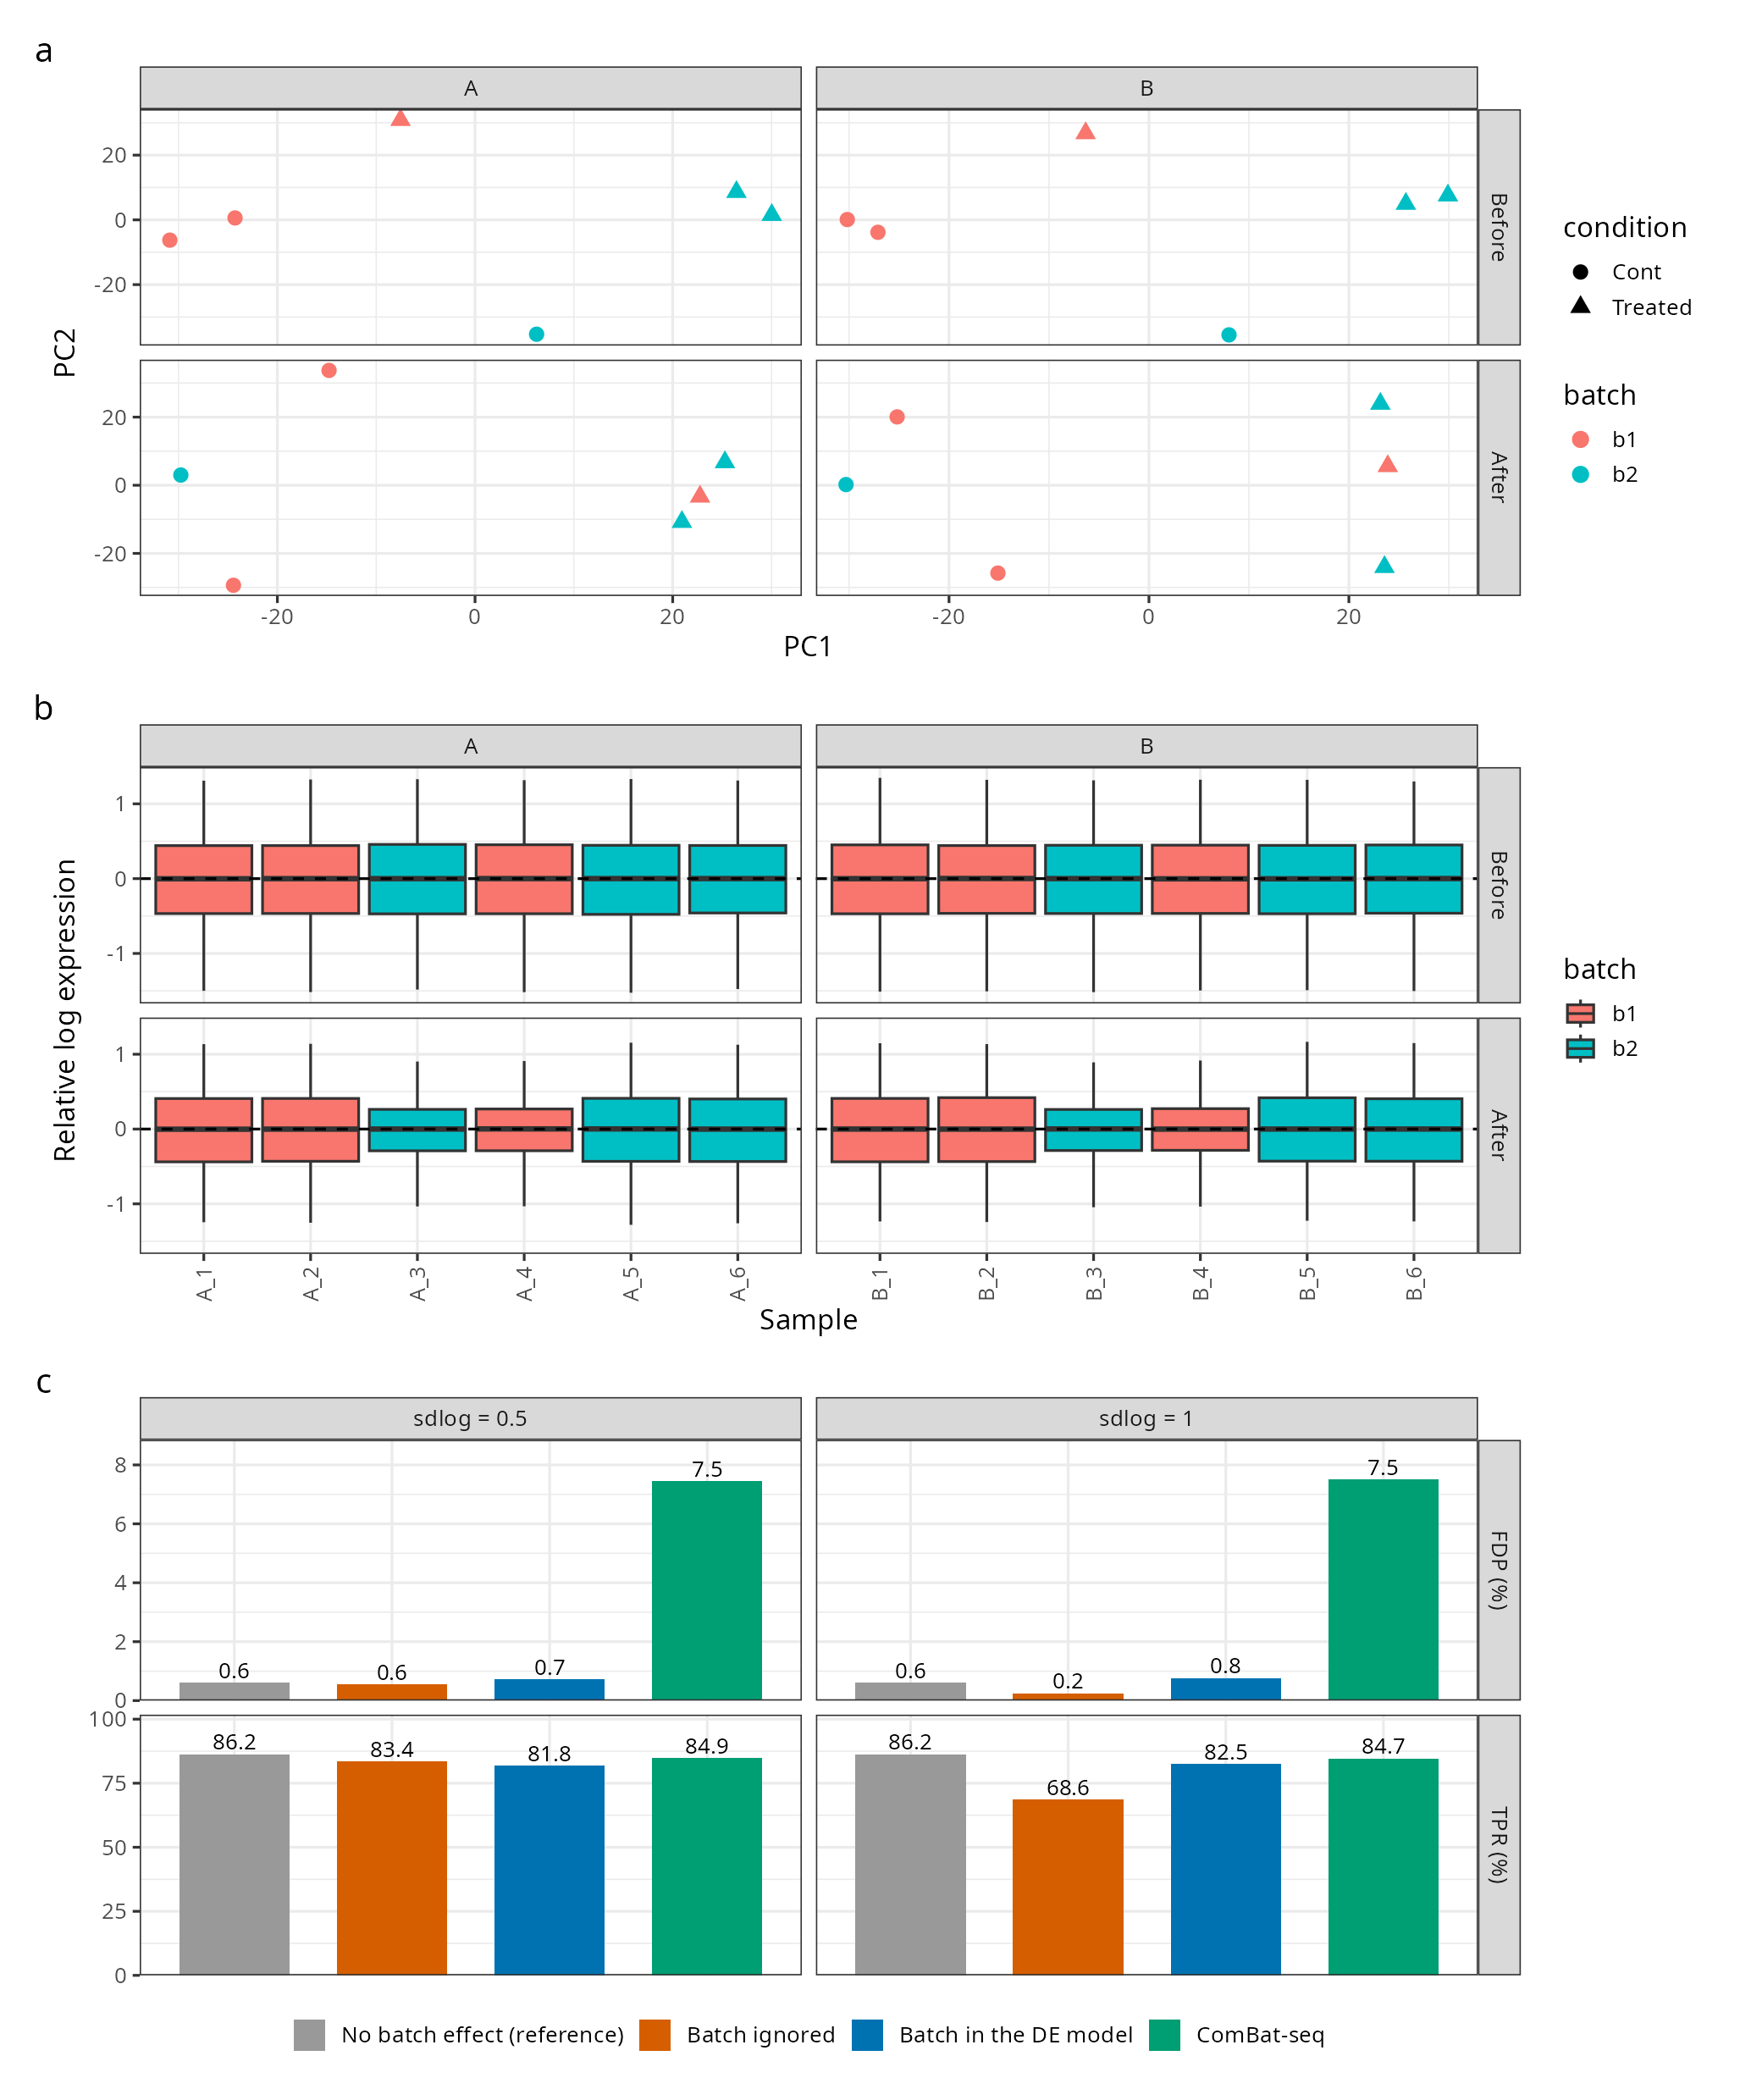
Figure S1 (Figure 3 of the manuscript). Batch-effect case study (sdlog 0.5). (a) PCA of two of the six studies before and after ComBat-seq correction, coloured by batch. (b) Relative log expression of the same samples before and after the correction. (c) TPR and FDP of the meta-analysis DEGs (DESeq2 + Fisher) for the four strategies, with sdlog 0.5 and 1.
Between-study differences. Differences between studies (for example in sequencing depth, library preparation or baseline expression) do not need a correction, because every study is analysed separately and only its p-values enter the meta-analysis. To show this, the same simulation was drawn twice from the same random numbers, with and without the gene-wise baseline shift of each study. The per-study p-values were almost unchanged (Spearman correlation 0.996–0.996; median absolute difference in log10 p 0.015; 99.3–99.4% of the genes with the same call at adjusted p < 0.05), and the meta-analysis found 2599 and 2606 DEGs (Jaccard index 0.970). The small remaining differences come from the counts themselves, which change with the expected values.

S2. RNA-Seq demo case study
The bundled RNA-Seq demo (three studies of Synechocystis sp., 2 control vs 2 treated samples each, 3405 genes after filtering) was analysed with each DE method and both meta-analysis methods (Table S3). With DESeq2 and Fisher’s method, the meta-analysis found 373 DEGs, of which 1 were new (not significant in any single study) and 27 study DEGs were side-tracked (significant in a study but not in the meta-analysis). 84.5% of the DESeq2 meta-DEGs (315 of 373) were also found with both edgeR and limma-voom (Table S4).
Table S3. RNA-Seq demo: meta-analysis DEGs with each DE and meta-analysis method. New: meta-DEGs not significant in any study; side-tracked: study DEGs not found by the meta-analysis (metaRNASeq IDD/IRR).
DE method | Meta-analysis | Meta-DEGs | New (%) | Side-tracked (%) | Study DEGs (A / B / C)
DESeq2 | Fisher | 373 | 1 (0.27) | 27 (6.77) | 377 / 73 / 59
DESeq2 | Inverse normal | 328 | 6 (1.83) | 77 (19.3) | 377 / 73 / 59
edgeR | Fisher | 376 | 27 (7.18) | 80 (18.65) | 399 / 6 / 120
edgeR | Inverse normal | 312 | 27 (8.65) | 144 (33.57) | 399 / 6 / 120
limma-voom | Fisher | 369 | 29 (7.86) | 83 (19.62) | 404 / 8 / 85
limma-voom | Inverse normal | 303 | 29 (9.57) | 149 (35.22) | 404 / 8 / 85

Table S4. Overlap of the meta-analysis DEGs between analyses: share (%) of the DEGs of the row analysis also found by the column analysis.
analysis | DESeq2 + Fisher | DESeq2 + Inverse normal | edgeR + Fisher | edgeR + Inverse normal | limma-voom + Fisher | limma-voom + Inverse normal
DESeq2 + Fisher | 100.0 | 86.6 | 86.3 | 73.7 | 86.1 | 72.4
DESeq2 + Inverse normal | 98.5 | 100.0 | 90.9 | 81.7 | 90.2 | 80.8
edgeR + Fisher | 85.6 | 79.3 | 100.0 | 82.2 | 93.6 | 78.5
edgeR + Inverse normal | 88.1 | 85.9 | 99.0 | 100.0 | 95.8 | 93.3
limma-voom + Fisher | 87.0 | 80.2 | 95.4 | 81.0 | 100.0 | 80.5
limma-voom + Inverse normal | 89.1 | 87.5 | 97.4 | 96.0 | 98.0 | 100.0

S3. Microarray case study
The bundled microarray demo combines three GEO series of wild-type Synechocystis sp. PCC 6803 on platform GPL15867 (GSE82120, GSE63352, GSE68250), grown at high CO2 (HC) and 3 h or 24 h after the shift to low CO2 (LC). After probe collapsing (the probe with the highest mean expression per gene; probes without a gene or with several genes removed) and intersection, 3,358 genes were measured in all three studies (Table S5). With Fisher’s method, the meta-analysis found 1051 DEGs for LC_3h vs HC (two studies; GSE82120 has no 3 h samples) and 1,861 for LC_24h vs HC (three studies) (Table S6).
Table S5. Microarray demo: data preparation per study.
Study | Samples | Probes | Probes without a gene | Probes with several genes | Genes | log2 applied
GSE82120 | 12 | 10080 | 20 | 0 | 3358 | no
GSE63352 | 6 | 10080 | 20 | 0 | 3358 | no
GSE68250 | 6 | 10080 | 20 | 0 | 3358 | no

Table S6. Microarray demo: meta-analysis DEGs (Fisher’s method).
Comparison | Studies | Genes | Meta-DEGs | Up | Down | New (%) | Side-tracked (%)
LC_24h vs HC | 3 | 3358 | 1861 | 1075 | 786 | 120 (6.45) | 54 (3.01)
LC_3h vs HC | 2 | 3358 | 1051 | 466 | 585 | 279 (26.55) | 69 (8.2)
Known low-CO2-inducible genes. All 12 checked genes of the inorganic-carbon concentrating mechanism and of the flv4-2 operon were up-regulated meta-analysis DEGs in both comparisons (Table S7). Their locus tags were checked against KEGG (organism syn, list retrieved on 2026-10-22) and UniProt (taxon 1111708); some literature symbols (sbtA, cupA, flv4, flv2) are not used by these databases, and KEGG names cmpC/cmpD as nrtC/nrtD, so all names are given.
Table S7. Known low-CO2-inducible genes in the microarray meta-analysis: mean log2 fold change across studies (LC vs HC) and whether the gene is a meta-analysis DEG.
Locus | Literature name | System | KEGG | UniProt | log2FC 3 h | log2FC 24 h | Meta-DEG (3 h / 24 h)
slr1512 | sbtA | Na+/HCO3- symporter SbtA | unknown protein | P73953 (slr1512) | 3.15 | 3.22 | yes / yes
slr1513 | sbtB | SbtA-associated protein SbtB | unknown protein | P73954 (slr1513) | 3.01 | 2.94 | yes / yes
slr0040 | cmpA | BCT1 HCO3- transporter | cmpA; bicarbonate transporter | Q55460 (cmpA slr0040) | 3.68 | 4.20 | yes / yes
slr0041 | cmpB | BCT1 HCO3- transporter | cmpB; unknown protein | Q55461 (cmpB slr0041) | 3.82 | 4.16 | yes / yes
slr0043 | cmpC | BCT1 HCO3- transporter | nrtC; nitrate transport protein; NrtC | Q55462 (cmpC slr0043) | 3.11 | 3.46 | yes / yes
slr0044 | cmpD | BCT1 HCO3- transporter | nrtD; nitrate transport protein; NrtD | Q55463 (cmpD slr0044) | 2.23 | 3.22 | yes / yes
sll1732 | ndhF3 | NDH-1(3) CO2 uptake complex | ndhF; NADH dehydrogenase subunit 5 | P73395 (ndhF) | 3.00 | 3.41 | yes / yes
sll1733 | ndhD3 | NDH-1(3) CO2 uptake complex | ndhD3; NADH dehydrogenase subunit 4 | P73394 (ndhD3) | 3.41 | 4.07 | yes / yes
sll1734 | cupA | NDH-1(3) CO2 uptake complex | unknown protein | P73393 (sll1734) | 2.92 | 3.63 | yes / yes
sll0217 | flv4 | flv4-2 operon | potential FMN-protein | P72723 (dfa2 sll0217) | 3.02 | 3.70 | yes / yes
sll0218 | sll0218 | flv4-2 operon | unknown protein | P72722 (sll0218) | 3.91 | 4.99 | yes / yes
sll0219 | flv2 | flv4-2 operon | potential FMN-protein | P72721 (dfa4 sll0219) | 3.88 | 5.08 | yes / yes
Functional enrichment. The up-regulated meta-DEGs were tested against all tested genes with STRING and KEGG (Tables S8 and S9). LC_24h vs HC: 1075 up-regulated DEGs; STRING functional enrichment (STRING version 12.0); organism: Synechocystis sp. PCC6803 (1148); background: all 3358 tested genes (3117 recognised by STRING). LC_3h vs HC: 466 up-regulated DEGs; STRING functional enrichment (STRING version 12.0); organism: Synechocystis sp. PCC6803 (1148); background: all 3358 tested genes (3117 recognised by STRING).
Table S8. STRING enrichment of the up-regulated meta-DEGs (top 10 terms by FDR, publications excluded).
Comparison | Category | Term | FDR
LC_24h vs HC | - | no term at FDR < 0.05 | -
LC_3h vs HC | Component | Membrane | 0.00013
LC_3h vs HC | Component | Integral component of membrane | 0.0016
LC_3h vs HC | NetworkNeighborAL | Oxidoreductase activity, acting on NAD(P)H, quinone or similar compound as acceptor, and NmrA-like family | 0.0017
LC_3h vs HC | NetworkNeighborAL | Oxidoreductase activity, acting on NAD(P)H, quinone or similar compound as acceptor | 0.0017
LC_3h vs HC | Keyword | Membrane | 0.0023
LC_3h vs HC | Function | Quinone binding | 0.0028
LC_3h vs HC | NetworkNeighborAL | Mixed, incl. NADH-ubiquinone/plastoquinone oxidoreductase chain 4L, and Proton-conducting membrane transporter | 0.0038
LC_3h vs HC | NetworkNeighborAL | Oxidative phosphorylation, and Cytochrome b6f complex | 0.0046
LC_3h vs HC | Keyword | Plastoquinone | 0.0048
LC_3h vs HC | Keyword | Quinone | 0.0048

Table S9. KEGG pathway enrichment of the up-regulated meta-DEGs (KEGG pathway enrichment (clusterProfiler) (KEGG pathway database of 2026/10/21); organism: Synechocystis sp. PCC 6803 (syn); background: all 3358 tested genes (981 recognised by KEGG).).
Comparison | Pathway | q
LC_24h vs HC | Two-component system | 7.5e-04
LC_3h vs HC | Oxidative phosphorylation | 5.7e-05

S4. Performance
Table S10 lists the computer used. Table S11 gives the run time and memory of the meta-analysis pipeline before and after the refactoring of the code, from dev/BENCHMARKS.md. In the app, the time from clicking Load demo data to the results was 8.9 s for the RNA-Seq demo and 4.8 s for the microarray demo (median of 3 runs, each in a new app session; Table S12).
Table S10. Computer and software used for the timings.
Item | Value
Operating system | Pop!_OS 24.04 LTS
CPU | AMD Ryzen 5 220 w/ Radeon 740M Graphics
Logical cores | 12
RAM (GB) | 13.3
R | 4.6.1
TranscriptMetaAnalyst | 2.0.0
DESeq2 | 1.52.0
edgeR | 4.10.7
limma | 3.68.5
metaRNASeq | 1.0.8
shiny | 1.14.0

Table S11. Pipeline benchmarks (dev/BENCHMARKS.md): demo (3 studies x 4 samples, 3,405 genes) and simulated data (6 studies x 6 samples, 30,000 genes). Memory is that allocated in the main R process and cannot be measured for the parallel run.
Dataset | Pipeline | Median time | Memory allocated | Result kept in memory | Meta-DEGs
Demo | before | 3.28 s | 533 MB | 6.3 MB | 373
Demo | after, serial | 3.70 s | 521 MB | 2.9 MB | 373
Demo | after, parallel | 2.85 s | n/a | 2.9 MB | 373
Simulated | before | 23.2 s | 3.58 GB | 120.9 MB | 2,600
Simulated | after, serial | 23.2 s | 3.40 GB | 44.7 MB | 2,603
Simulated | after, parallel | 8.34 s | n/a | 44.7 MB | 2,603

Table S12. Time from clicking ‘Load demo data’ to the results in the app (headless Chrome, a new app session per run; includes the analysis in a background process and the drawing of the results).
Run | RNA-Seq demo (s) | Microarray demo (s)
1 | 8.9 | 4.8
2 | 8.6 | 5.3
3 | 9.6 | 4.8

S5. The ready-to-run analysis bundle
After an analysis, Download reproducible analysis (ZIP) in the RNA-Seq and Microarray tabs gives a bundle with the code, setup and data of that analysis, ready to run on another computer (Table S13). setup.R installs the same TMA release with BiocManager and lists every package whose version differs from the original run; analysis.R repeats the analysis with every setting of the run, including the plot display options of each comparison (heatmap and volcano options, figure format and size) and the enrichment choices, reads the data in data/ with relative paths and writes the same files as results/ to rerun/. For GEO imports, the bundle also contains the downloaded series files and the sample-to-condition mapping, so it runs offline. The example below is the bundle of the RNA-Seq demo analysis (DESeq2 + Fisher; ZIP of 606 KB). Re-running its analysis.R with Rscript took 11.6 s and reproduced all 6 result tables of the run exactly (6 of 6 byte-identical).
Table S13. Files of the example bundle (tma_analysis/).
File | Size (KB)
analysis.R | 3.0
data/counts.txt | 269.6
data/design.txt | 0.2
README.md | 1.5
results/Treated_vs_Cont_A_DEGs.csv | 32.0
results/Treated_vs_Cont_B_DEGs.csv | 18.5
results/Treated_vs_Cont_C_DEGs.csv | 10.4
results/Treated_vs_Cont_heatmap_data.csv | 82.1
results/Treated_vs_Cont_heatmap.pdf | 37.7
results/Treated_vs_Cont_meta_analysis_results.csv | 215.8
results/Treated_vs_Cont_pca.pdf | 5.4
results/Treated_vs_Cont_pdist.pdf | 5.1
results/Treated_vs_Cont_upset.pdf | 6.6
results/Treated_vs_Cont_venndiagram.pdf | 7.3
results/Treated_vs_Cont_volcano_data.csv | 169.7
results/Treated_vs_Cont_volcano_plot.pdf | 193.5
session_info.txt | 6.6
settings.json | 1.1
setup.R | 5.1
The README of the example bundle:
# Reproducible TranscriptMetaAnalyst analysis
This folder repeats an RNA-Seq meta-analysis made with TranscriptMetaAnalyst (TMA) 2.0.0, on the demo data bundled with TranscriptMetaAnalyst, with every setting of the run.
## Run it
From this folder:
Rscript setup.R # once: installs this TMA release and checks the package versions Rscript analysis.R # repeats the analysis and writes the results to rerun/
Expected run time: about 1 minute (the analysis took 4 s in the app; saving the figures adds a little).
## Contents
| File | Content |
|---|---|
| `analysis.R` | The analysis with all settings of the run: analysis methods, plot display options and enrichment choices. Reads `data/`, writes `rerun/`. |
| `setup.R` | Installs the TMA release used and lists any package whose version differs from the original run. |
| `settings.json` | Every analysis and display setting, machine-readable. |
| `data/` | The input data as used in the analysis. |
| `results/` | The tables and figures of the original run. |
| `session_info.txt` | R and package versions of the original run. |
Comparisons: Treated vs Cont.
## Checking the re-run
`rerun/` gets the same files as `results/`. The tables (`*_meta_analysis_results.csv`, `*_DEGs.csv`, `*_heatmap_data.csv`, `*_volcano_data.csv`) should be identical when the package versions match; figures can differ in small details between systems. Enrichment results come from online services and need an internet connection; they can change when a service updates its database.

