Student Enrollment & Course Management System (SECMS)
A Salesforce-Based Academic Enrollment Solution

User Story
The Student Enrollment & Course Management System (SECMS) is a comprehensive Salesforce application designed to streamline and automate the academic enrollment operations of an educational institute. The system enables administrators, enrollment officers, and instructors to efficiently manage student records, course offerings, enrollments, instructor assignments, approval processes, payments, and reporting, all within a single, unified Salesforce environment.

1. Introduction

1.1 Project Overview
This project aims to centralize all student, course, and enrollment-related data within a single Salesforce application to ensure easy data access, structured workflows, and accurate reporting. The system allows Enrollment Officers to manage student admissions, course registrations, and communication effectively, while instructors and administrators gain full transparency into course allocations and academic progress. The solution also enables automated instructor assignment, task creation, validation checks, and multi-level approval processes for enrollment management.
With Salesforce Flows, Approval Processes, Validation Rules, Reports, and Dashboards, the organization can ensure that all enrollment operations, from admission to course completion, are handled systematically and monitored continuously through key performance indicators such as enrollment volume, revenue, student status distribution, and pending approvals.

1.2 Purpose
The primary purpose of SECMS is to replace manual and fragmented enrollment processes with a scalable, automated, and secure Salesforce solution that ensures:
- Accurate student data management
- Structured enrollment workflows
- Automated approvals and validations
- Transparent reporting and monitoring

2. Ideation Phase

2.1 Problem Statement (Customer Problem Statement Template)
PS | I am (Customer) | I'm trying to | But | Because | Which makes me feel
PS-1 | Enrollment Officer | manage student enrollments efficiently | enrollment data is scattered | systems are manual and unintegrated | frustrated and error-prone
PS-2 | Administrator | track enrollments and revenue | reporting is delayed | data is not centralized | uncertain in decision-making

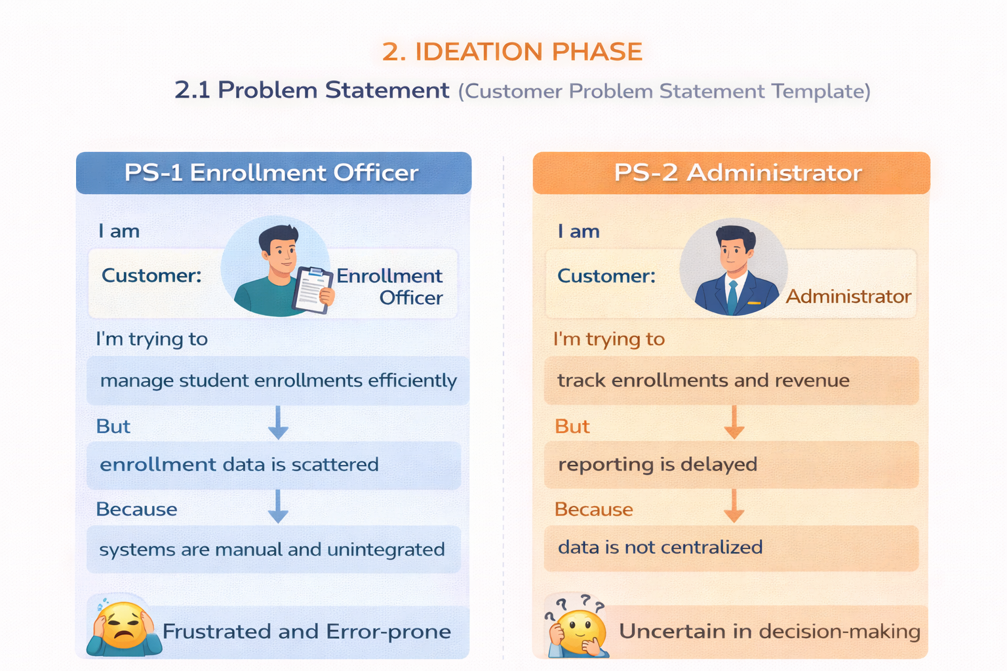

2.2 Empathy Map Canvas
User Persona: Enrollment Officer
- Think & Feel: Concerned about double bookings and revenue loss
- Hear: Complaints from students and management
- See: Multiple spreadsheets and emails
- Say & Do: Rechecks data and follows up manually
- Pain: Duplicate entries and approval bottlenecks
- Gain: Automation, dashboards, and faster processing
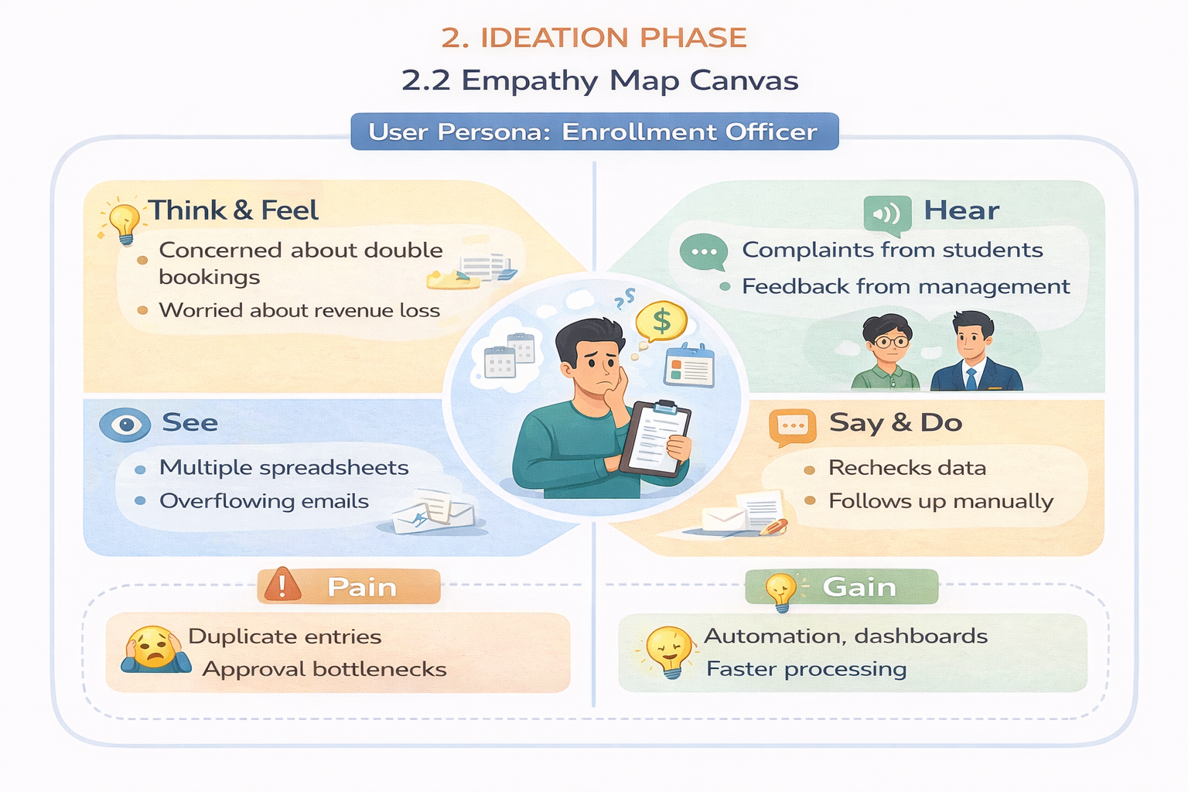

2.3 Brainstorming & Idea Prioritization

Step 1 – Brainstormed Ideas
- Spreadsheet automation
- Standalone enrollment portal
- ERP integration
- Salesforce-based enrollment system

Step 2 – Grouping
- Manual solutions
- Semi-automated solutions
- Fully automated cloud solutions

Step 3 – Prioritization
The Salesforce-based SECMS was selected as the final solution due to its high feasibility and high impact.
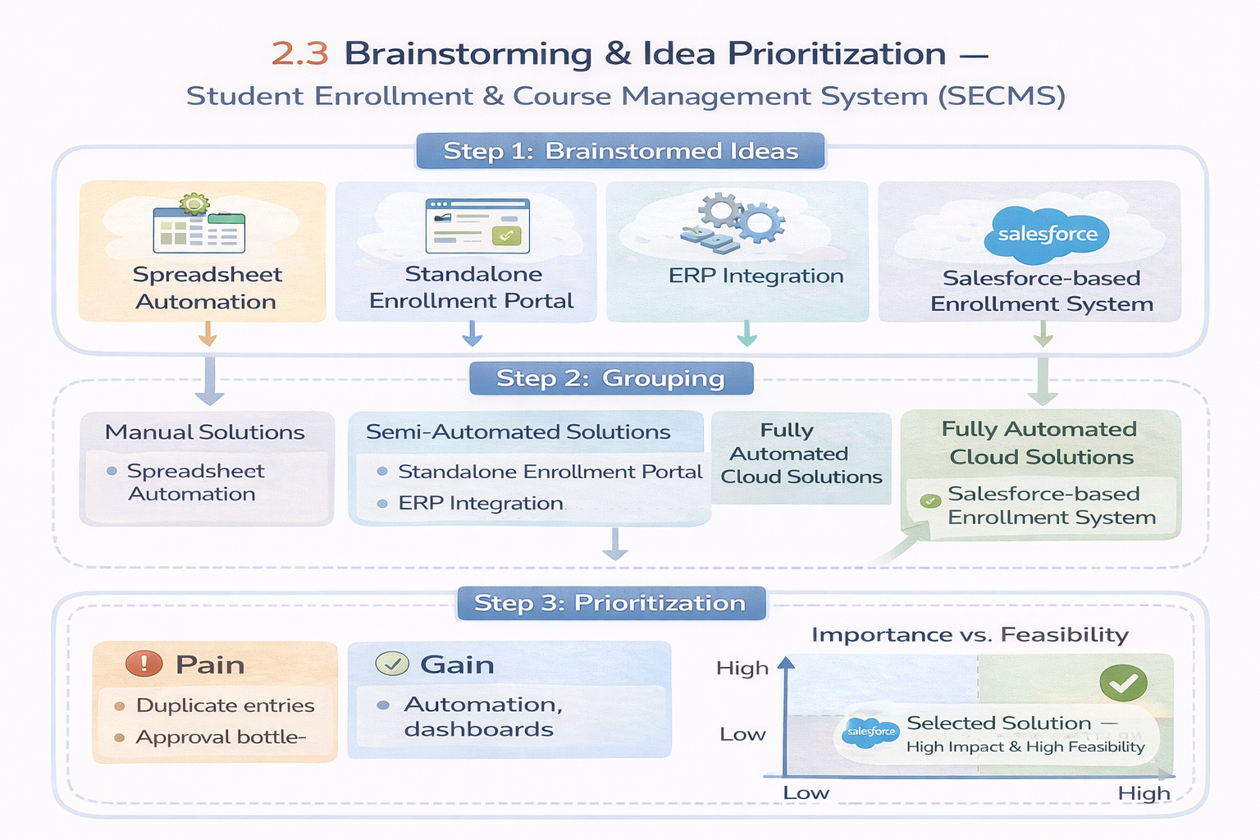

3. Requirement Analysis Phase

3.1 Customer Journey Map
The customer journey covers the following stages:
- Awareness & Registration
- Course Selection
- Enrollment Request
- Fee Payment
- Approval
- Instructor Assignment
- Reporting & Completion
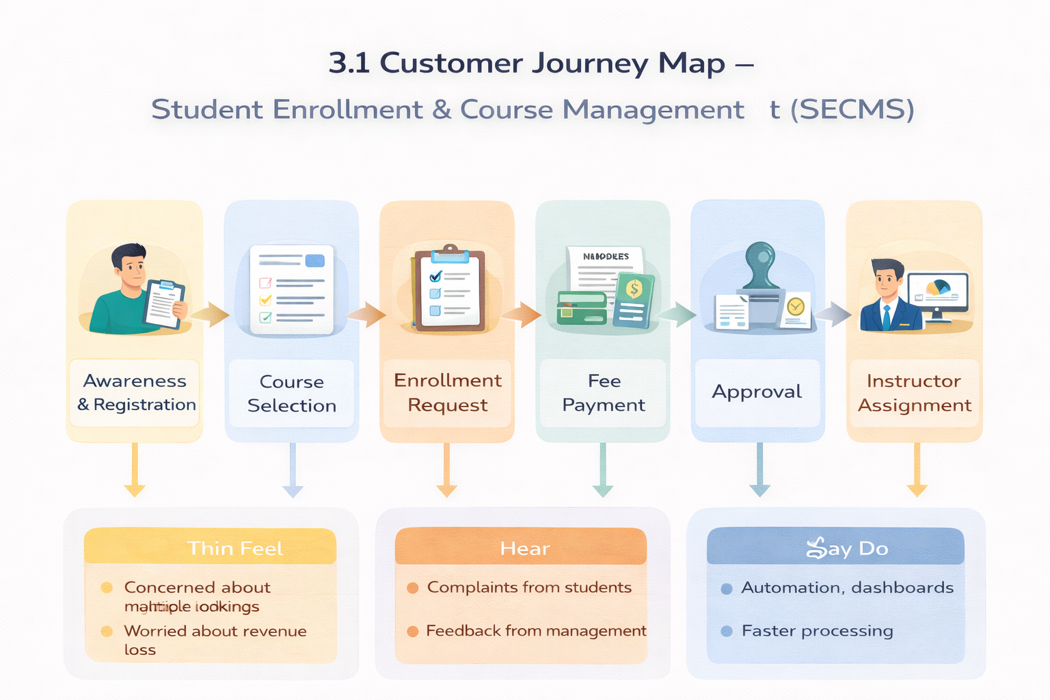

3.2 Solution Requirements

Functional Requirements
FR No | Epic | Description
FR-1 | Student Management | Manage student records
FR-2 | Course Management | Create and manage courses
FR-3 | Enrollment Processing | Request, approve, and reject enrollments
FR-4 | Instructor Assignment | Auto-assign instructors
FR-5 | Reporting | Dashboards and reports

Non-Functional Requirements
NFR-1: Usability
The system shall provide a simple, intuitive, and user-friendly interface that enables enrollment officers, administrators, instructors, and students to perform operations efficiently with minimal training. Navigation shall be organized through clearly labeled tabs, dashboards, and forms to reduce user effort and errors.
Examples:
- Quick student registration form
- One-click enrollment approval
- Role-based dashboards
NFR-2: Security
The system shall ensure the confidentiality, integrity, and protection of student and institutional data through secure authentication, authorization, and access controls. Sensitive information such as personal data, enrollment history, and academic records shall only be accessible to authorized users.
Examples:
- Only admins can modify course details
- Instructors view only assigned students
- Students cannot access other student records
NFR-3: Reliability
The system shall operate consistently and accurately without failures during enrollment processing, approvals, and reporting. Automation logic shall execute correctly to avoid duplicate or incorrect enrollments.
Examples:
- No duplicate course registration
- Accurate status updates after approvals
- Consistent report generation
NFR-4: Performance
The system shall provide fast response times for all operations to ensure a smooth and uninterrupted user experience, especially during peak admission periods.
Examples:
- Quick dashboard refresh
- Fast search for student records
- No lag during bulk uploads
NFR-5: Scalability
The system shall support future growth in the number of students, courses, departments, and users without degradation in performance or functionality. It shall allow easy addition of new modules and features.
Examples:
- Add new departments without redesign
- Handle increased admissions annually
- Extend to mobile or portal integration
NFR-6: Availability
The system shall be continuously accessible to users during institutional working hours and must minimize downtime. The platform shall support high availability for academic operations.
Examples:
- 24/7 cloud access
- Reliable during peak admission season
- Automatic backup of student records

3.3 Data Flow Diagram
- The user inputs student and enrollment data.
- The system validates and stores the records.
- The approval process routes the data.
- Reports and dashboards consume the processed data.
In summary, the system processes enrollment requests, validates data, routes approvals, assigns instructors, and generates reports.
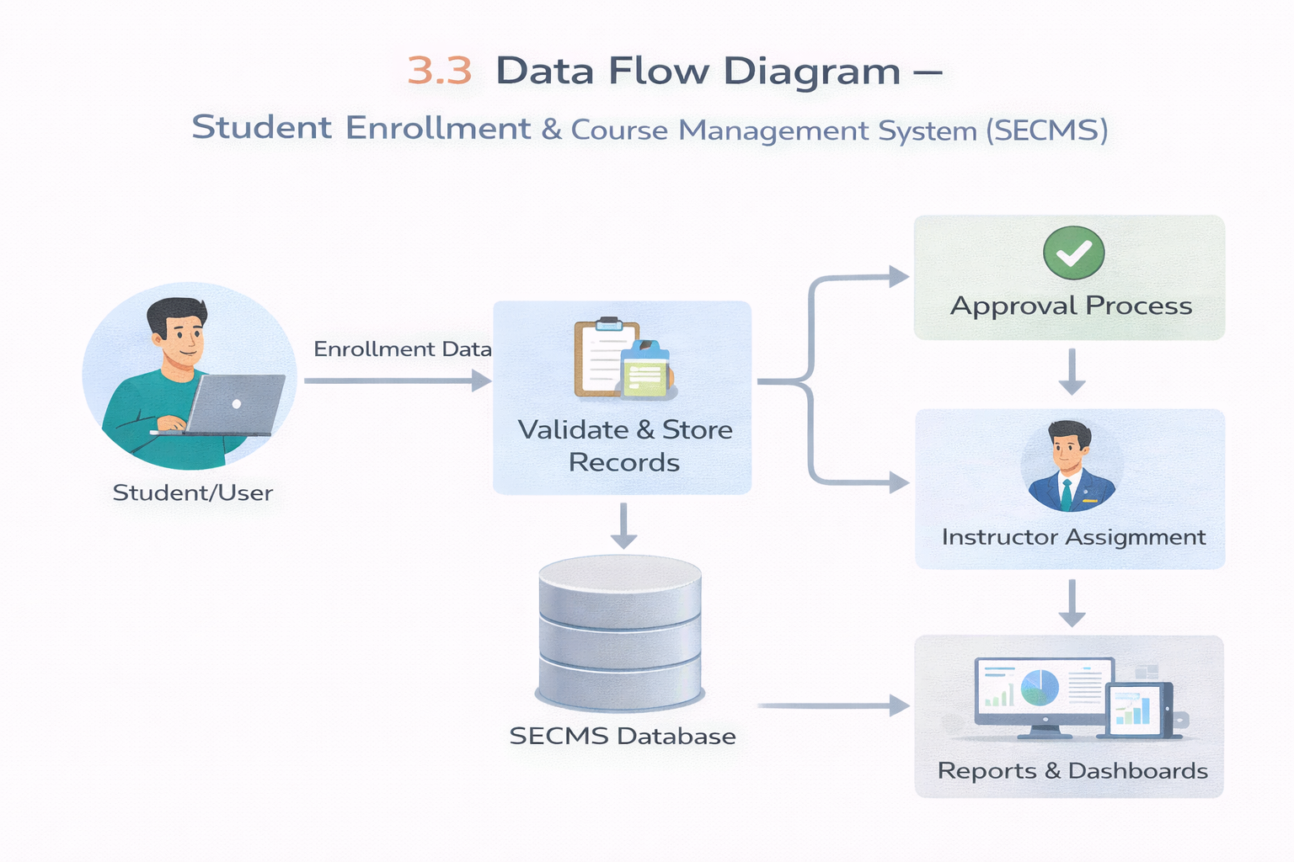

3.4 Technology Stack
Layer | Technology
UI | Salesforce Lightning
Logic | Salesforce Flows
Database | Salesforce Objects
Automation | Validation Rules, Approval Process
Reporting | Reports & Dashboards

4. Project Design Phase

4.1 Problem–Solution Fit
SECMS directly addresses fragmented enrollment workflows by aligning user behavior, constraints, and automation through Salesforce-native capabilities.
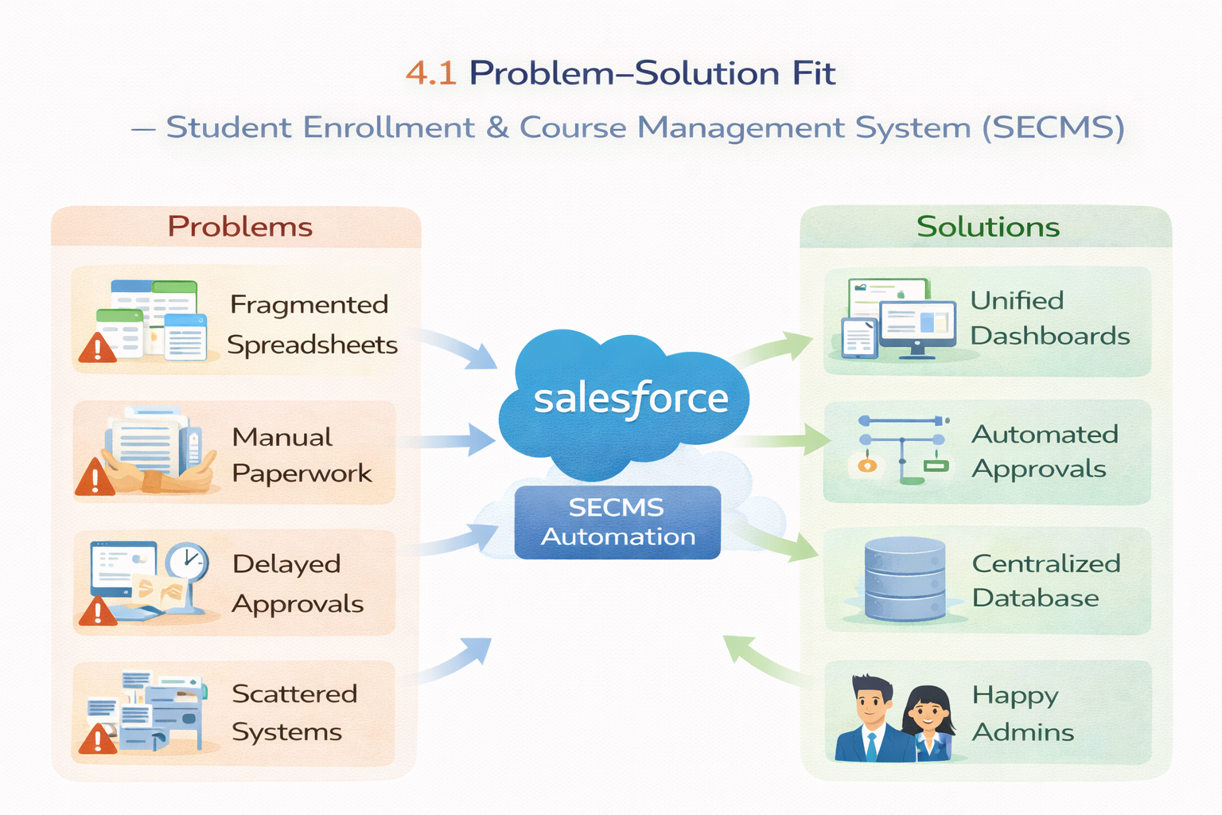

4.2 Proposed Solution
Parameter | Description
Problem | Manual enrollment handling
Solution | Salesforce-based SECMS
Novelty | End-to-end automation
Social Impact | Improved student experience
Revenue Model | Institutional deployment
Scalability | Multi-department support

4.3 Solution Architecture
The architecture integrates Salesforce objects, automation flows, approval processes, dashboards, and security layers into a single, connected solution.
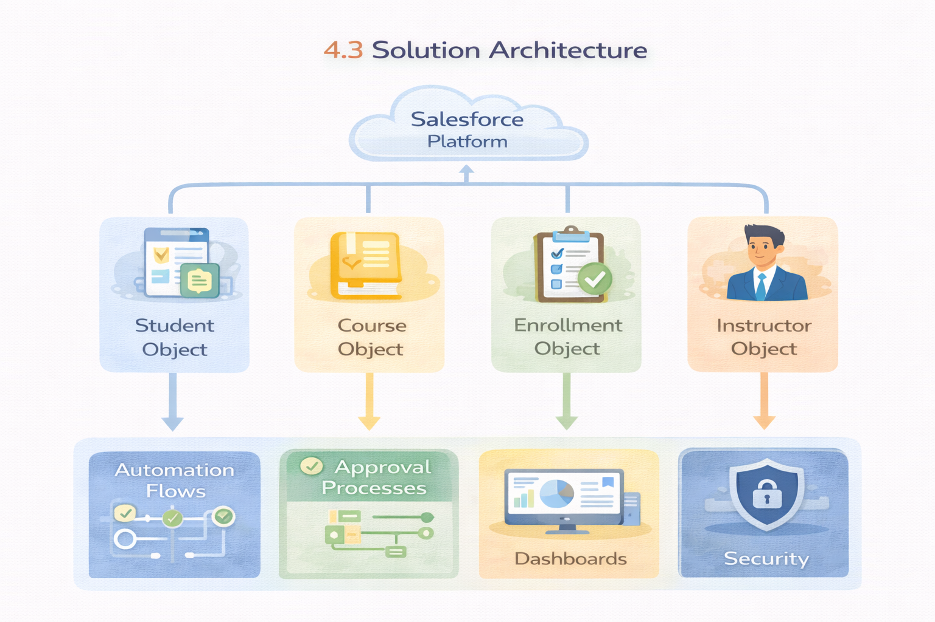

5. Project Planning & Scheduling

5.1 Project Planning
- Agile methodology
- Epics → Stories → Story Points
- Sprint-based execution
- Velocity calculation used for estimation

5.2 Product Backlog, Sprint Schedule, and Estimation
Sprint | Functional Requirement (Epic) | User Story No. | User Story / Task | Story Points | Priority | Team Members
Sprint-1 | Developer Setup | USN-1 | As a system administrator, I want to create a Salesforce developer account so that I can configure and deploy the Student Enrollment system. | 1 | High | Member1
Sprint-1 | Data Modeling | USN-2 | As an admin, I want to create custom objects for Student, Course, Enrollment, and Instructor so that academic data can be stored and managed efficiently. | 3 | High | Member2
Sprint-2 | Data Modeling | USN-3 | As a user, I want dedicated tabs for each object so that I can easily navigate between students, courses, enrollments, and instructors. | 3 | High | Member3
Sprint-2 | Data Modeling | USN-4 | As an admin, I want to create relevant fields such as student details, course information, and enrollment status so that complete records can be captured accurately. | 5 | High | Member4
Sprint-2 | Data Modeling | USN-5 | As an enrollment officer, I want a centralized Lightning App so that I can access all academic operations from one interface. | 3 | High | Member4
Sprint-2 | Data Modeling | USN-6 | As an admin, I want to define relationships between students, courses, and enrollments so that the system can logically link and track academic activities. | 5 | Medium | Member1
Sprint-2 | Data Modeling | USN-7 | As a user, I want customized page layouts so that only relevant information is displayed, improving clarity and ease of data entry. | 5 | High | Member2
Sprint-3 | Automation | USN-8 | As a system, I want to validate input data such as mandatory fields and enrollment limits so that incorrect or incomplete records are prevented. | 3 | High | Member4
Sprint-3 | Automation | USN-9 | As a system, I want automated flows to handle enrollment processing and notifications so that manual effort is reduced and processes become faster. | 3 | High | Member4
Sprint-3 | Automation | USN-10 | As an administrator, I want an approval process for enrollment requests so that registrations are verified before confirmation. | 5 | High | Member1
Sprint-4 | Security | USN-11 | As an admin, I want to configure role-based security so that users can only access data relevant to their responsibilities. | 5 | High | Member2
Sprint-5 | Reports | USN-12 | As a manager, I want reports on student enrollments, course registrations, and instructor assignments so that I can monitor academic operations. | 4 | High | Member3
Sprint-6 | Dashboards | USN-13 | As a manager, I want visual dashboards showing enrollment statistics and trends so that I can quickly analyze system performance. | 4 | Medium | Member4

5.3 Project Tracker, Velocity & Burndown Chart
Sprint | Total Story Points | Duration | Sprint Start Date | Sprint End Date (Planned) | Story Points Completed (as on Planned End Date) | Sprint Release Date (Actual)
Sprint-1 | 20 | 6 Days | 24 Oct 2022 | 29 Oct 2022 | 20 | 29 Oct 2022
Sprint-2 | 20 | 6 Days | 31 Oct 2022 | 05 Nov 2022
Sprint-3 | 20 | 6 Days | 07 Nov 2022 | 12 Nov 2022
Sprint-4 | 20 | 6 Days | 14 Nov 2022 | 19 Nov 2022

6. Project Development Phase

Project Flow
The development of SECMS was carried out through the following milestones:
- Milestone 1: Salesforce Developer Account Creation
- Milestone 2: Custom Object Creation (Student, Course, Enrollment, Instructor)
- Milestone 3: Fields Creation
- Milestone 4: Create Relationships
- Milestone 5: Validation Rules
- Milestone 6: Approval Process
- Milestone 7: Tabs Creation
- Milestone 8: Lightning App Creation
- Milestone 9: Page Layouts and Record Types
- Milestone 10: Flows (Automation)
- Milestone 11: Reports
- Milestone 12: Dashboards
- Milestone 13: Security Setup

What You Will Learn
1. Real-time Salesforce project implementation
2. Designing custom objects and relationships
3. Creating page layouts and record types
4. Writing validation rules
5. Building automation with flows
6. Creating approval workflows
7. Developing reports and dashboards
8. Setting up security with profiles, permission sets, and sharing
9. End-to-end application testing

Milestone 1 – Salesforce Developer Account

Introduction
Are you new to Salesforce? Not sure exactly what it is or how to use it? Don’t know where to start your learning journey? If you answered yes to any of these questions, this module is for you.
Salesforce is a game-changing technology with a host of productivity-boosting features that help you sell smarter and faster. As you work through this module, we will take you through these features and answer the question, “What is Salesforce, anyway?”

What Is Salesforce?
Salesforce is a customer success platform designed to help you sell, service, market, analyze, and connect with your customers. It has everything you need to run your business from anywhere. Using standard products and features, you can manage relationships with prospects and customers, collaborate and engage with employees and partners, and store your data securely in the cloud. Before Salesforce, contacts, emails, follow-up tasks, and prospective deals might have been organized in scattered, disconnected tools.
Reference video: https://youtu.be/r9EX3lGde5k

Activity 1: Creating a Developer Account
Create a developer org in Salesforce by following these steps:
1. Go to https://developer.salesforce.com/signup
2. On the sign-up form, enter the following details:
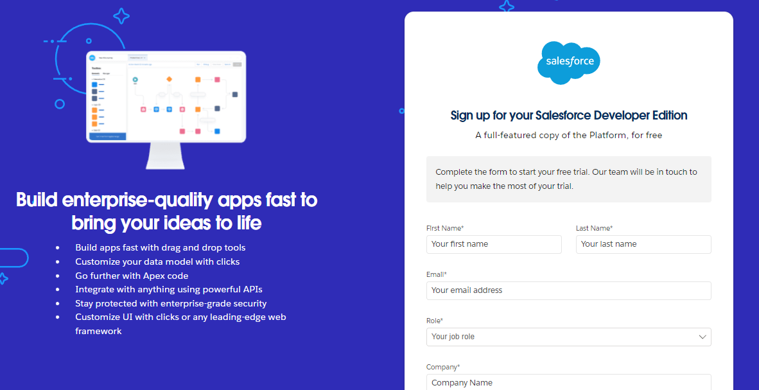
- First name and Last name
- Email
- Role: Developer
- Company: College Name
- Country: India
- Postal Code: your PIN code
- Username: a combination of your name and company. This need not be an actual email ID; any value in the format username@organization.com is accepted.
3. Click Sign me up after filling in these details.

Activity 2: Account Activation
1. Go to the inbox of the email ID that you used while signing up and click Verify Account to activate your account. The email may take 5–10 minutes to arrive.
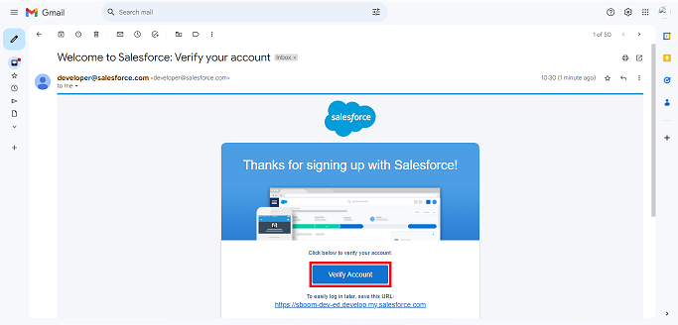
2. Click Verify Account.
3. Give a password, answer a security question, and click Change Password.
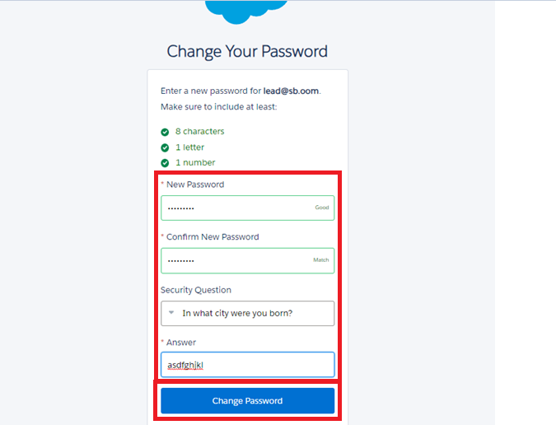
4. You will then be redirected to your Salesforce Setup page.
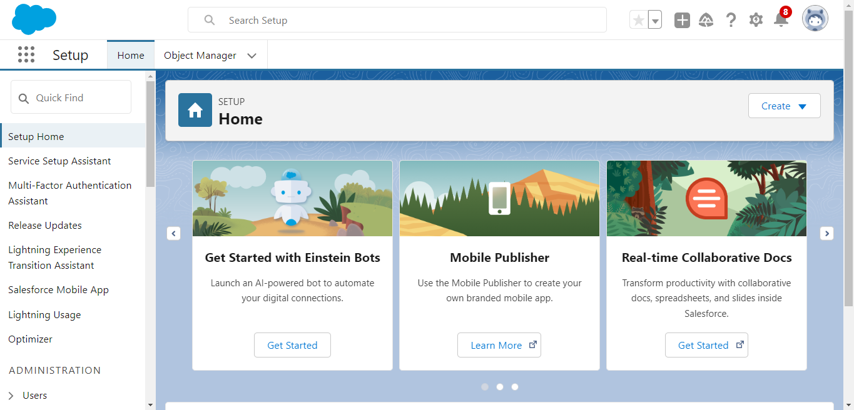

Milestone 2 – Objects

Activity 1: Creating the Student Object
The purpose of creating the Student custom object is to store and manage information about students, such as their personal details, contact information, and enrollment status.
To create the Student object:
1. Go to the Setup page.
2. Click Object Manager.
3. Click Create → Custom Object.
4. Enter the details as below:
- Label: Student
- Plural Label: Students
- Object Name: Student
- Record Name: Student Name
- Data Type: Text
- Under Optional Features, select: Allow Reports, Allow Activities (optional but recommended), and Track Field History (optional)
- Under Search Status, select: Allow Search
5. Click Save.
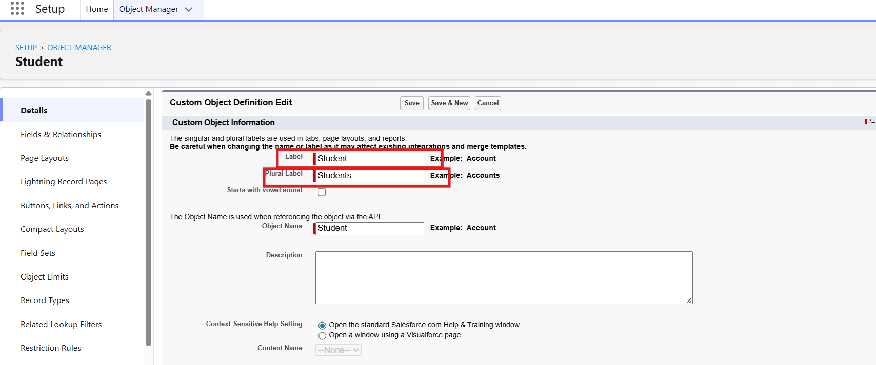
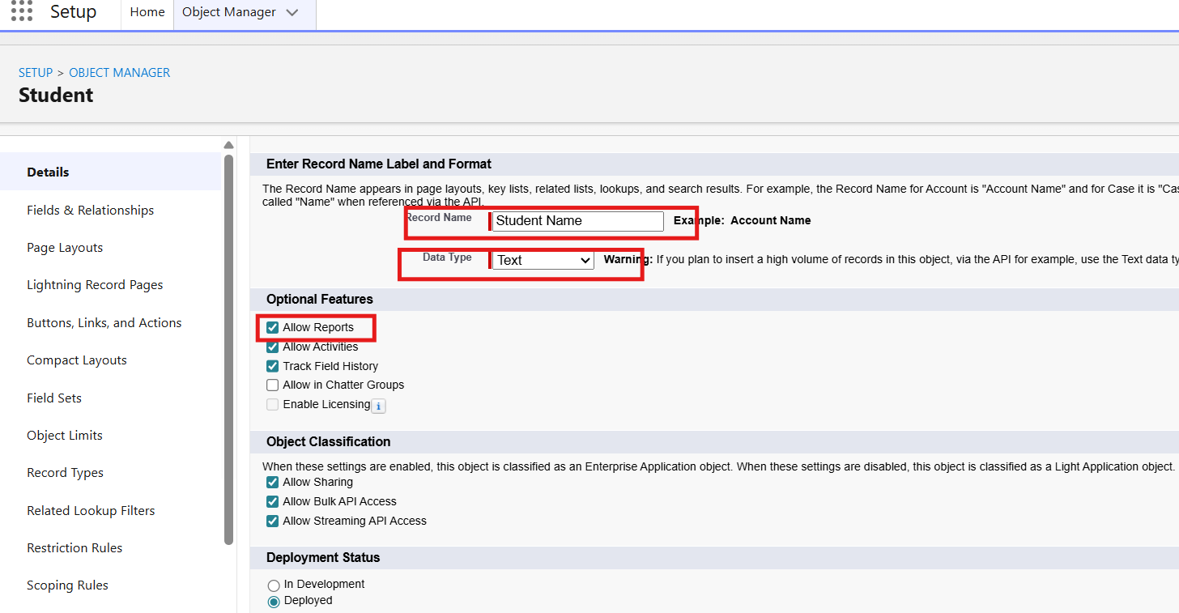
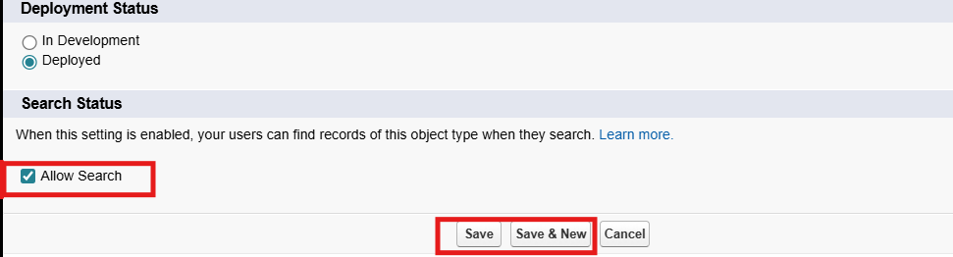
In the same way, create the Course, Instructor, and Enrollment objects.

Milestone 3 – Fields
Table 1: Student Object Fields
Field Label | Data Type
Student Name | Text (Standard)
Email | Email
Phone | Phone
Date of Birth | Date
Student Status | Picklist
Address | Text Area

Table 2: Course Object Fields
Field Label | Data Type
Course Name | Text (Standard)
Category | Picklist
Duration | Number/Text
Course Fee | Currency
Description | Text Area

Table 3: Instructor Object Fields
Field Label | Data Type
Instructor Name | Text (Standard)
Instructor Code | Text
Expertise | Picklist
Phone | Phone
Email | Email

Table 4: Enrollment Object Fields
Field Label | Data Type
Student | Lookup (Student)
Course | Lookup (Course)
Instructor | Lookup (Instructor)
Enrollment Date | Date
Enrollment Status | Picklist
Fees Paid | Checkbox
Total Amount | Currency
Comments | Text Area

Milestone 4 – Create Relationships

Activity 1: Create a Lookup from Enrollment to Student
1. Go to Setup → click Object Manager.
2. Type Enrollment in Quick Find → click the Enrollment__c object.
3. Click Fields & Relationships → click New.
4. Select Lookup Relationship → click Next.
5. For Related To, select Student__c → click Next.
6. Enter Field Label: Student (API Name: Student__c).
7. Click Next through Field-Level Security and Layout options (ensure it is visible and added to the layout).
8. Click Save.
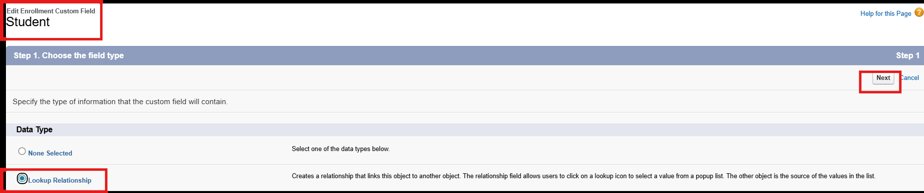
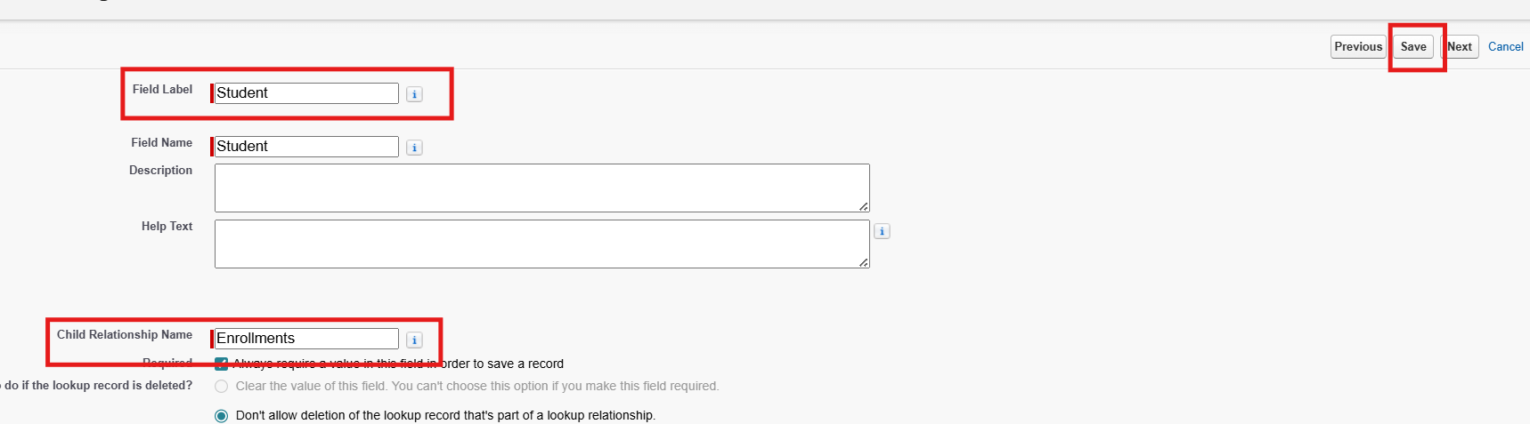

Activity 2: Create a Lookup from Enrollment to Course
Purpose:
To link each Enrollment to a Course.
Steps:
1. Go to Setup → Object Manager → Enrollment__c.
2. Click Fields & Relationships → New.
3. Select Lookup Relationship → Next.
4. Related To: select Course__c → click Next.
5. Field Label: Course (API Name: Course__c).
6. Click Next (set visibility and layout) → Save.
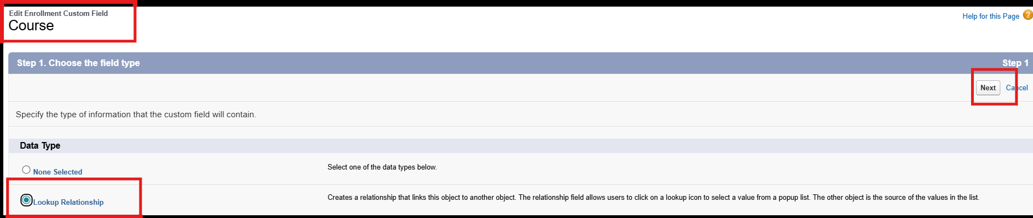
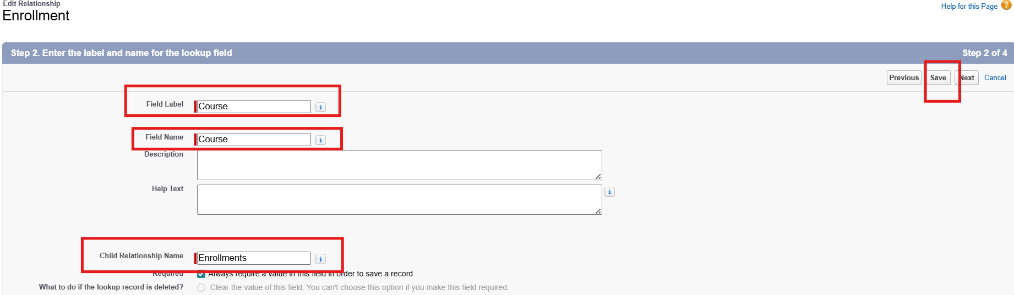

Activity 3: Create a Lookup from Enrollment to Instructor
Purpose:
To store which Instructor is assigned to a particular Enrollment.
Steps:
1. Go to Setup → Object Manager → Enrollment__c.
2. Click Fields & Relationships → New.
3. Choose Lookup Relationship → Next.
4. Related To: select Instructor__c → Next.
5. Field Label: Instructor (API Name: Instructor__c).
6. Complete the Field-Level Security and Page Layout options → Save.
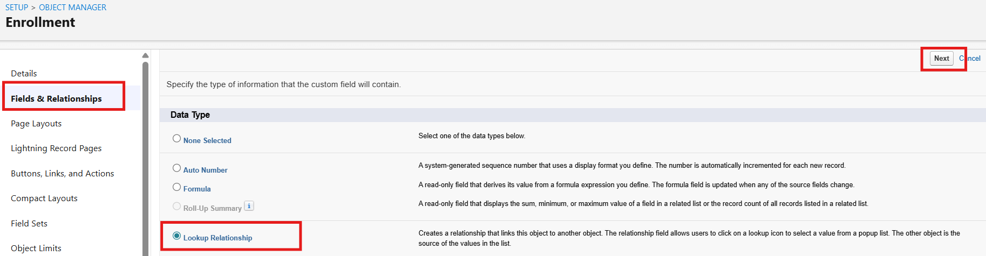
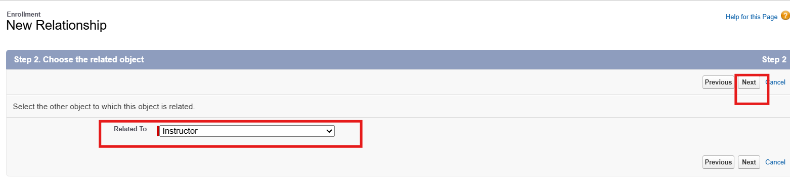
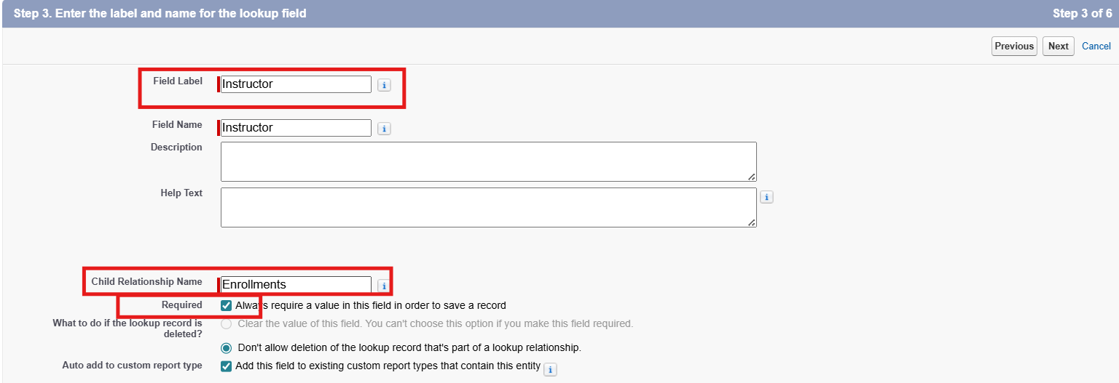
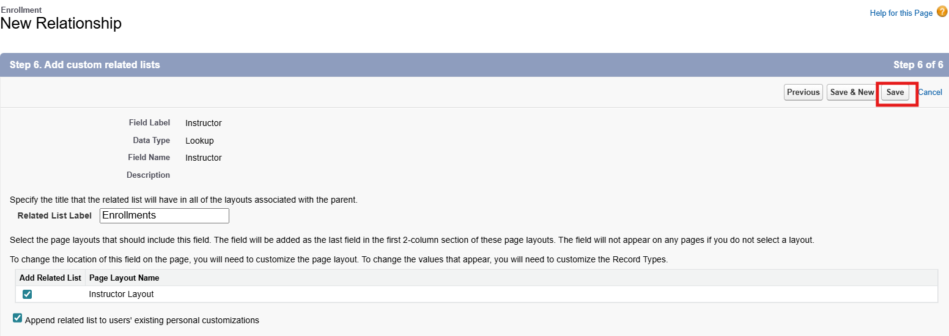

Milestone 5 – Validation Rules

Activity 1: Student Email Domain Validation
Purpose:
To ensure students use only allowed institutional email addresses.
Steps:
1. Go to Setup → Object Manager → Student__c.
2. Click Validation Rules → New.
3. Rule Name: Student_Email_Domain_Validation.
4. Error Condition Formula (example for @student.edu): NOT(CONTAINS(Email__c, "@student.edu"))
5. Error Message: Email must be a valid student institutional email.
6. Error Location: Field → Email__c.
7. Click Save.
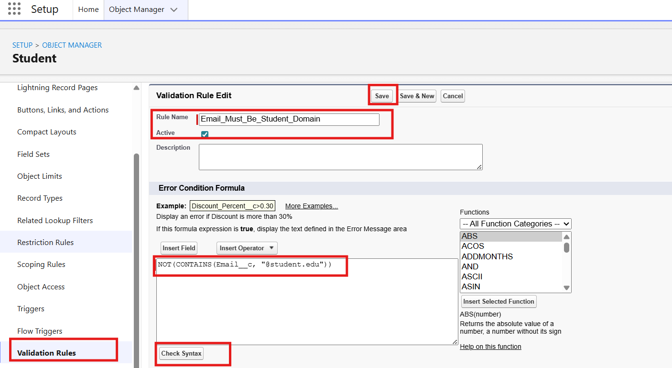
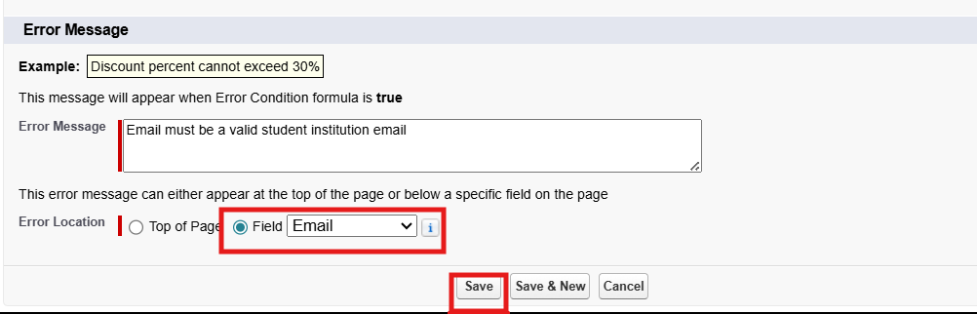

Activity 2: Fees Must Be Paid Before Approval
Purpose:
To prevent an Enrollment from being approved until fees are paid.
Steps:
1. Go to Setup → Object Manager → Enrollment__c.
2. Click Validation Rules → New.
3. Rule Name: Fees_Must_Be_Paid_Before_Approval.
4. Error Condition Formula: AND(ISPICKVAL(Enrollment_Status__c, "Approved"), Fees_Paid__c = FALSE)
5. Error Message: Fees must be paid before approving an enrollment.
6. Error Location: Top of Page (or field as needed).
7. Click Save.
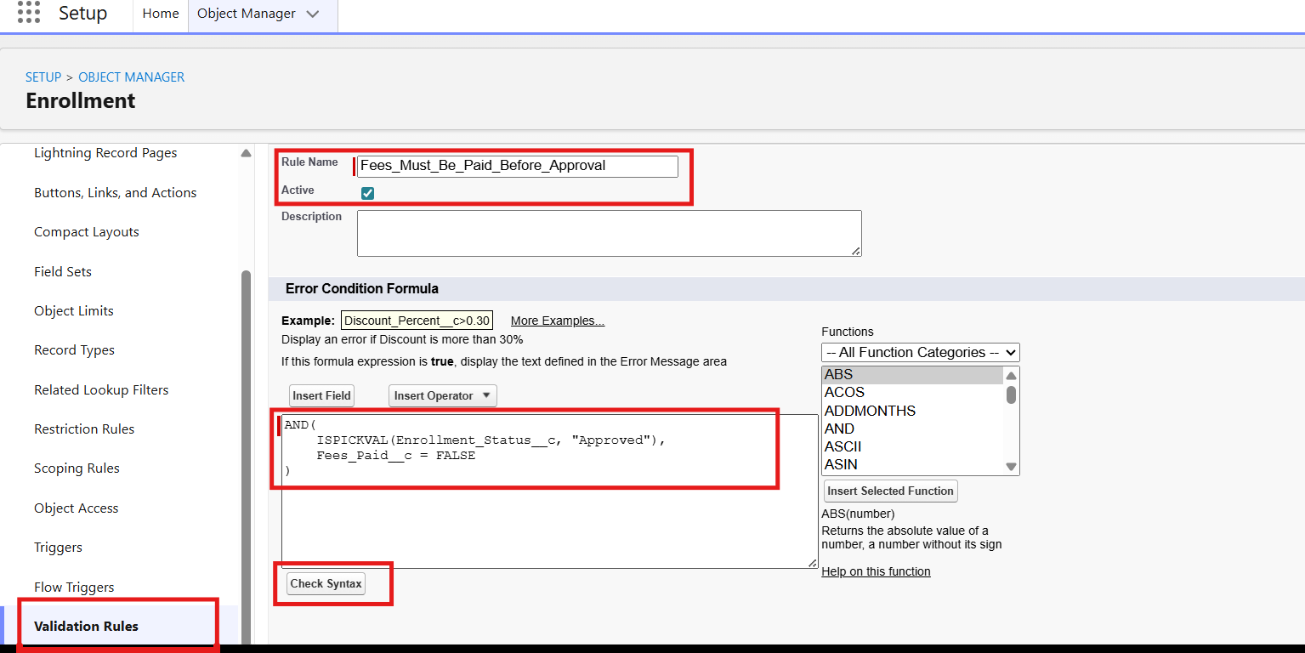
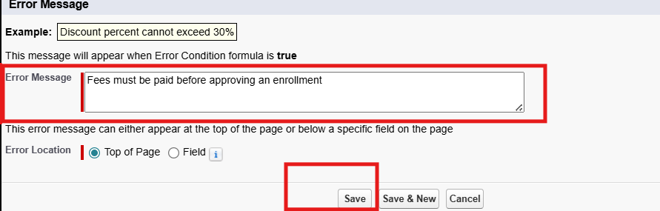

Milestone 6 – Approval Process

Activity 1: Create an Approval Process for Enrollment Requests
Purpose:
To route Enrollment requests to the Training Manager for approval or rejection.
Steps:
1. Go to Setup → Approval Processes → select Enrollment__c.
2. Click Create New Approval Process → Use Standard Setup.
3. Process Name: Approval_Enrollment_Request.
4. Entry Criteria: Enrollment_Status__c = "Requested".
5. Save and configure the steps.
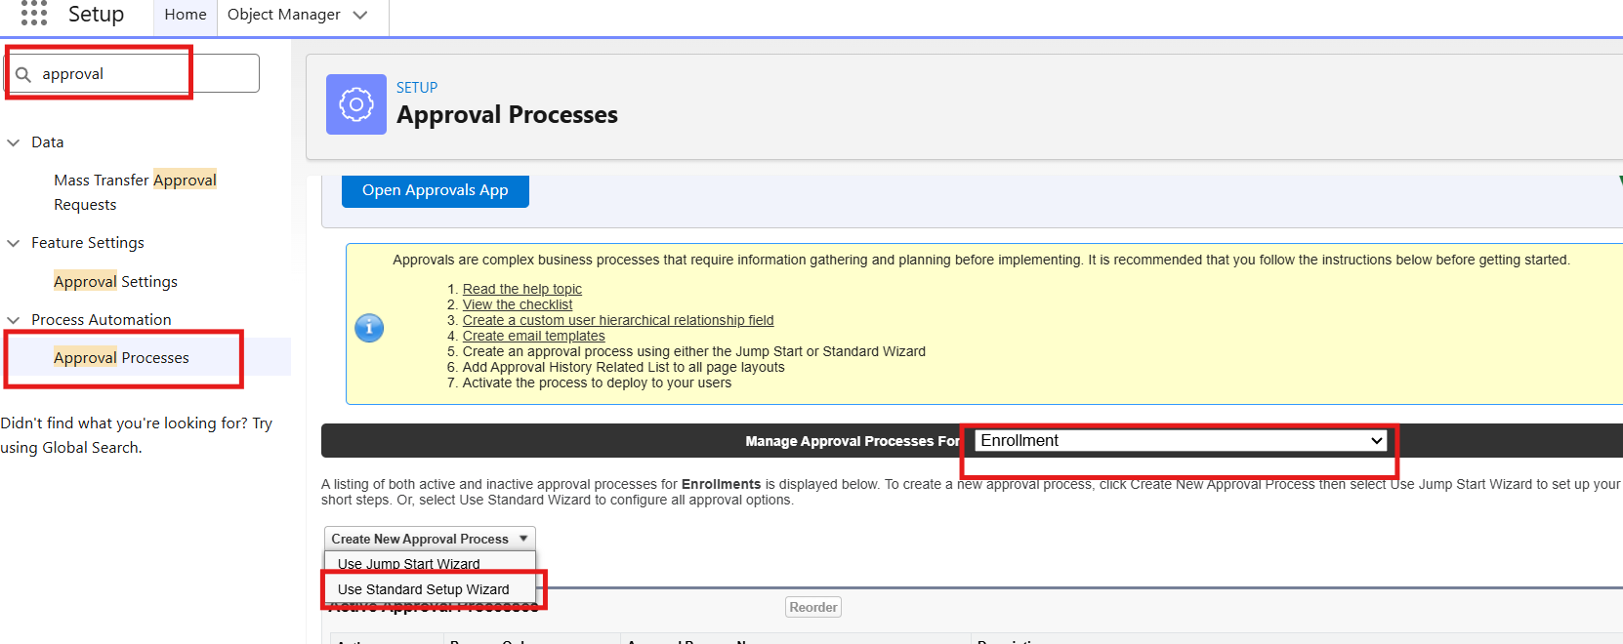
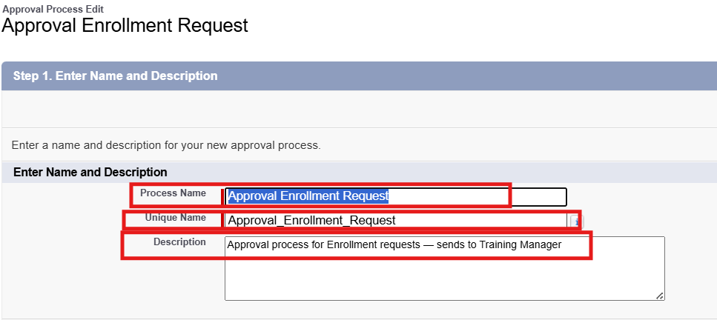
6. Add an Approval Step.
7. Approver: a specific Training Manager user.
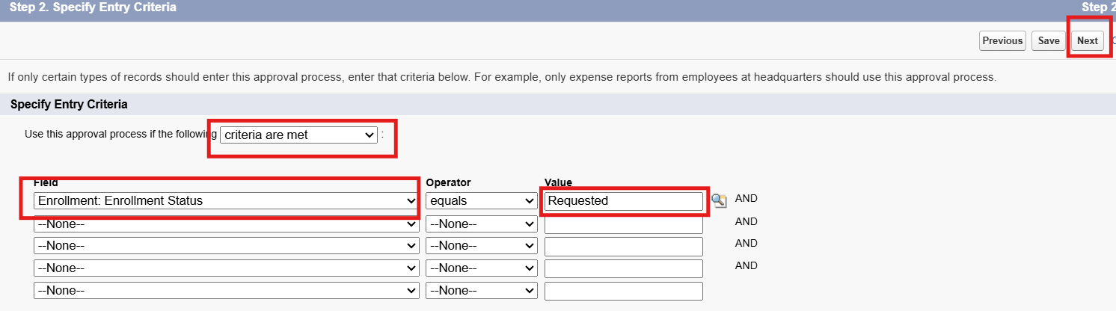
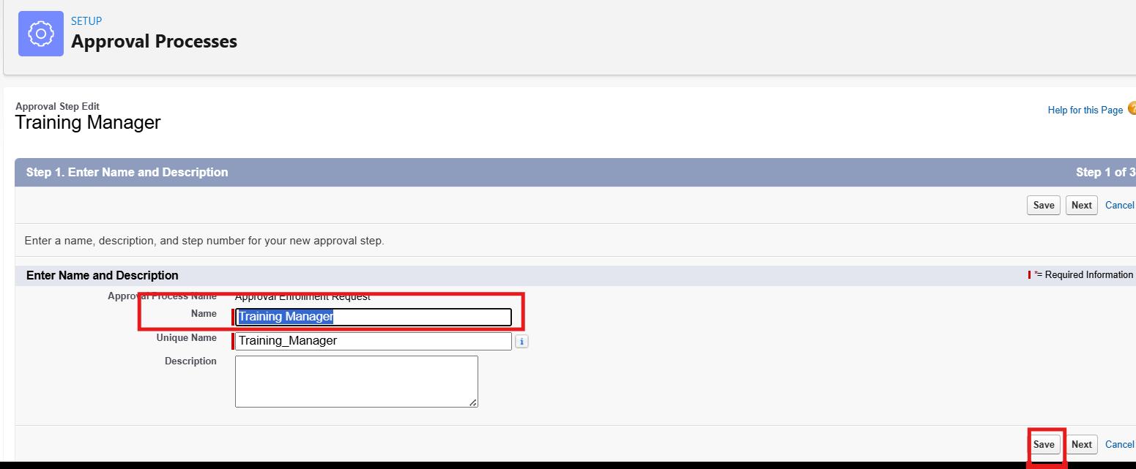
8. Under Final Approval Actions:
9. Add a Field Update to set Enrollment_Status__c = "Approved".
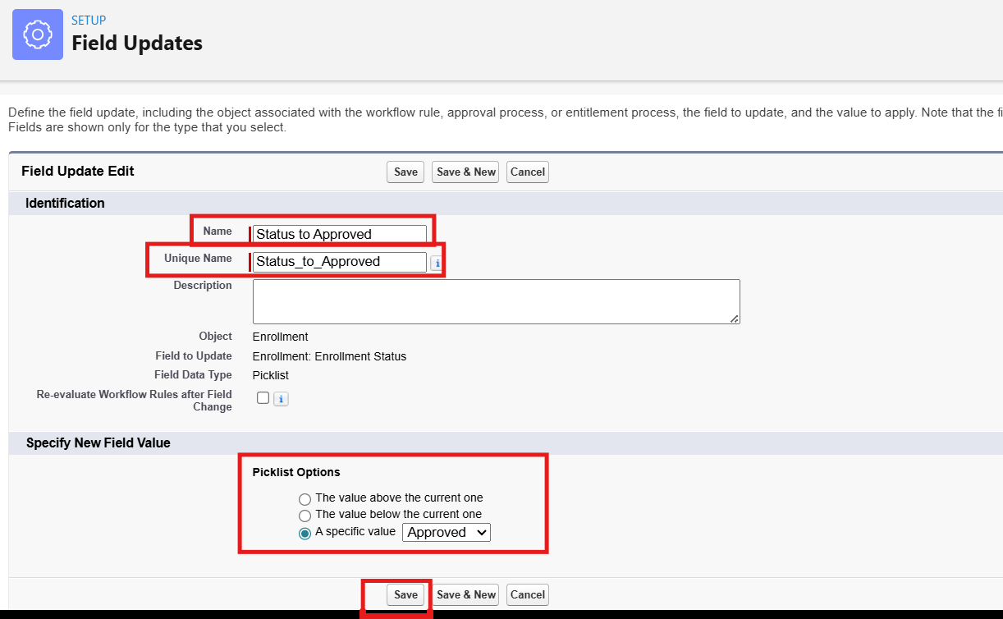
10. Under Final Rejection Actions:
11. Add a Field Update to set Enrollment_Status__c = "Rejected".
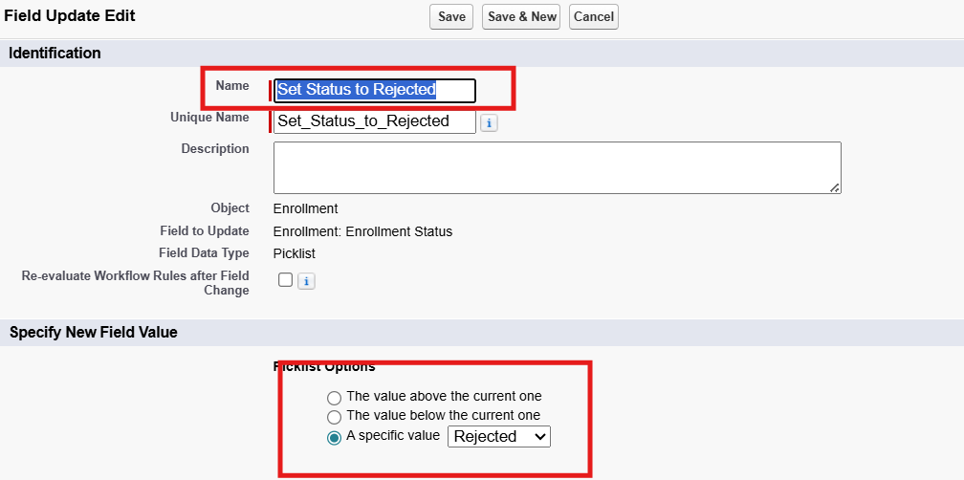
12. Add an Email Alert to send a rejection email to the student.
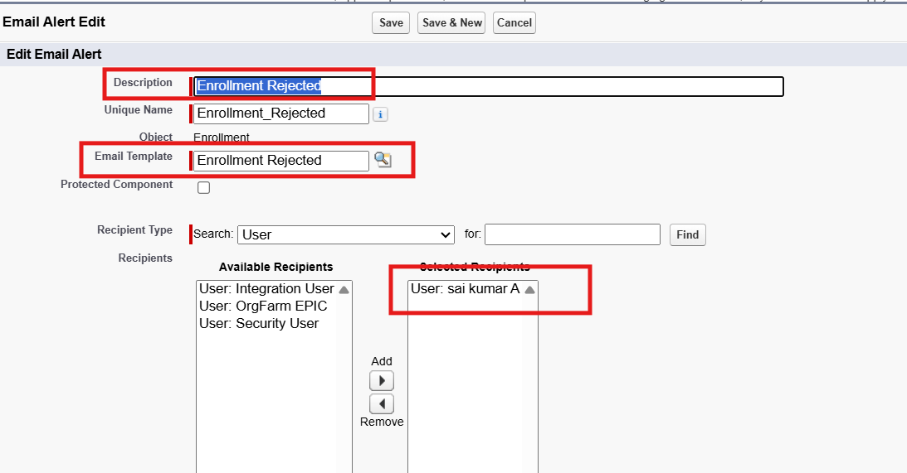
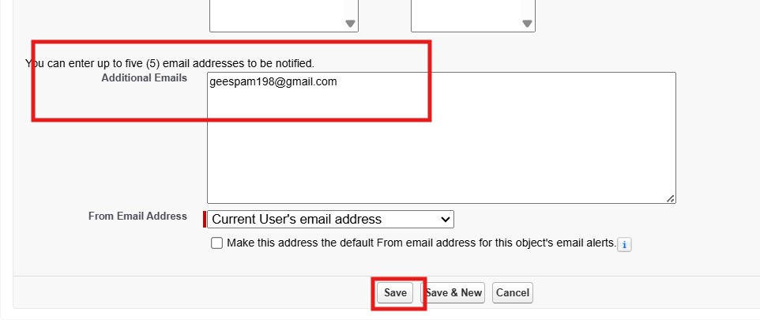
13. Activate the approval process.

Milestone 7 – Tabs

Activity 1: Creating a Tab for the Student Object
1. Go to Setup and, in the Quick Find box, type Tabs.
2. Under Custom Object Tabs, click New.
3. Select Student from the object list.
4. Choose a tab style (icon).
5. Click Next, assign the tab to all profiles, and then click Save.
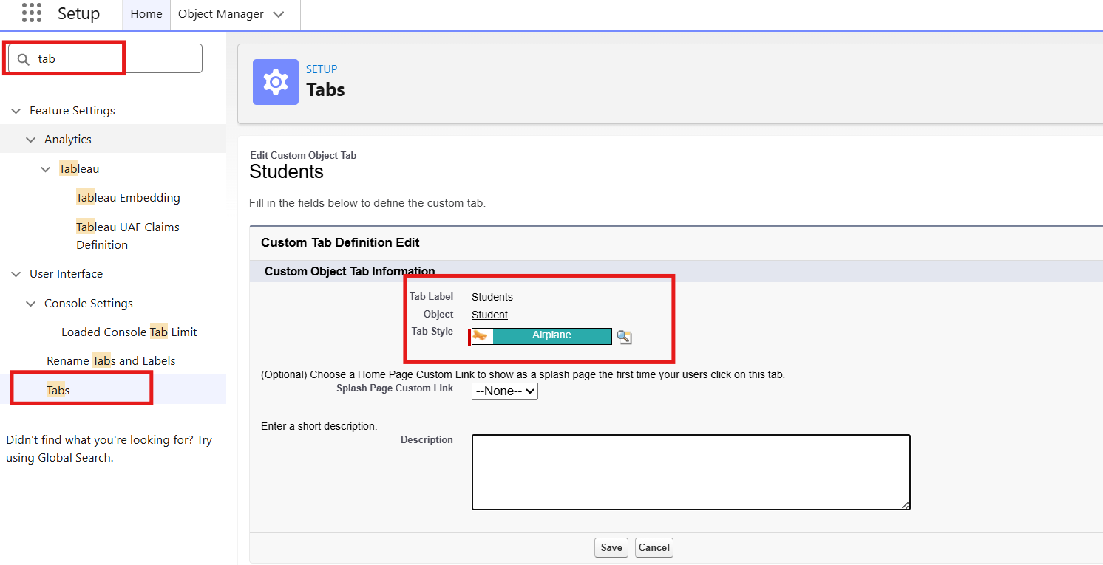

Activity 2: Creating the Remaining Tabs
Now create the tabs for the remaining objects: Courses, Instructors, and Enrollment. Follow the same steps as in Activity 1.

Milestone 8 – The Lightning App

Activity 1: Creating the Lightning Application for the Project
1. Navigate to Setup.
2. Enter App Manager in the Quick Find search box.
3. Click New Lightning App.
4. Provide the app details. App Name: Student Enrollment & Course Management. The Developer Name auto-fills. The Description is optional but can describe the purpose of the app.
5. Click Next and choose the following settings. App Branding (optional): add a logo or select a color theme. Navigation Style: choose Standard Navigation.
6. Click Next and assign the app to specific profiles (for example, Admin, Enrollment Officer, and Instructor).
7. Click Next to select the items (tabs) to be included in the app. Add: Student, Course, Instructor, Enrollment, Reports, Dashboards, Home, and Tasks.
8. Click Next and review the app settings.
9. Finally, click Save & Finish.
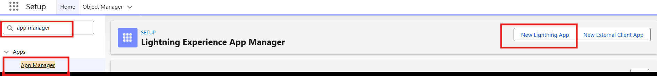
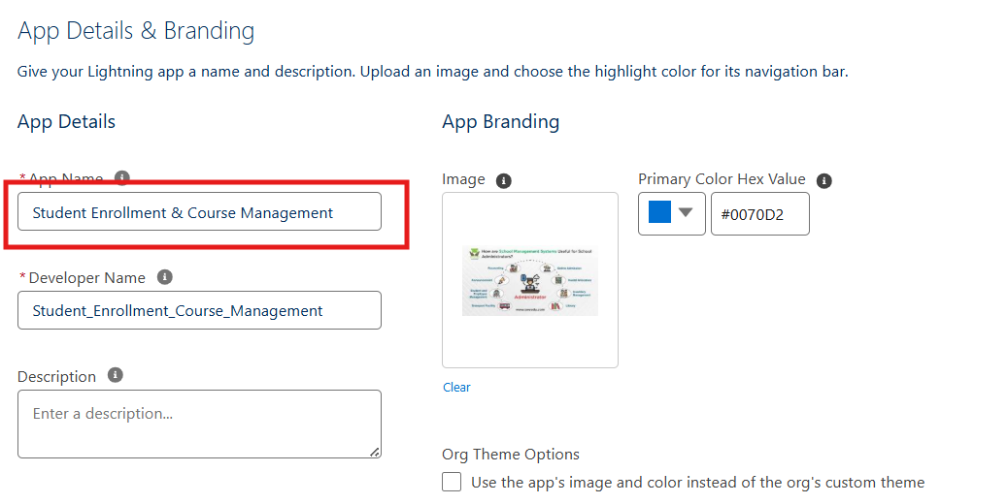
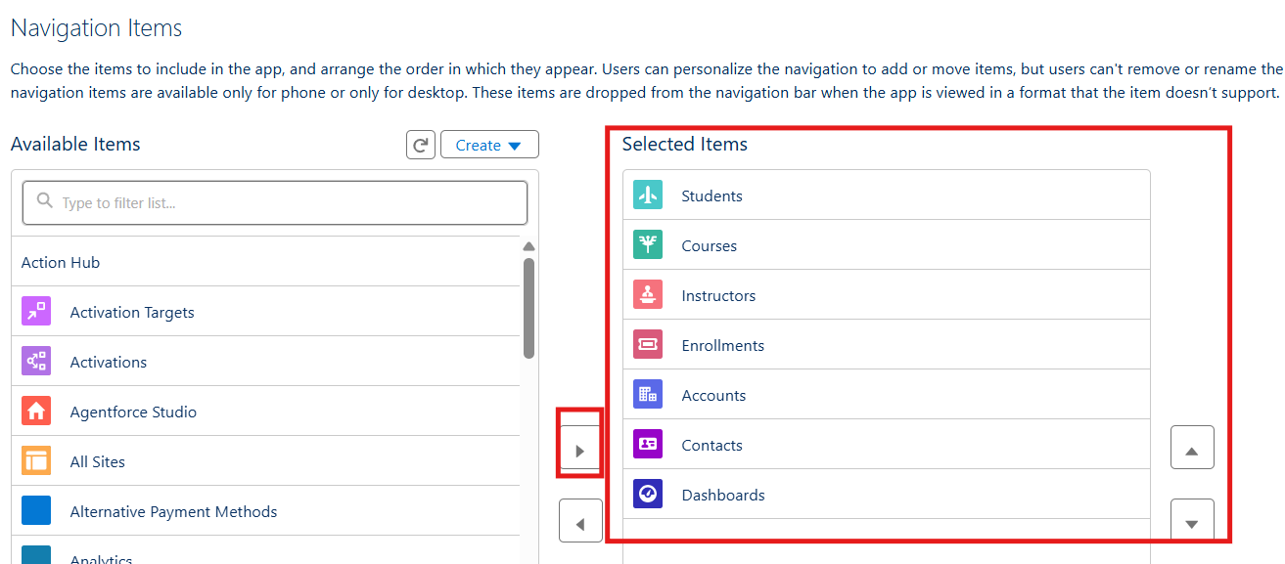
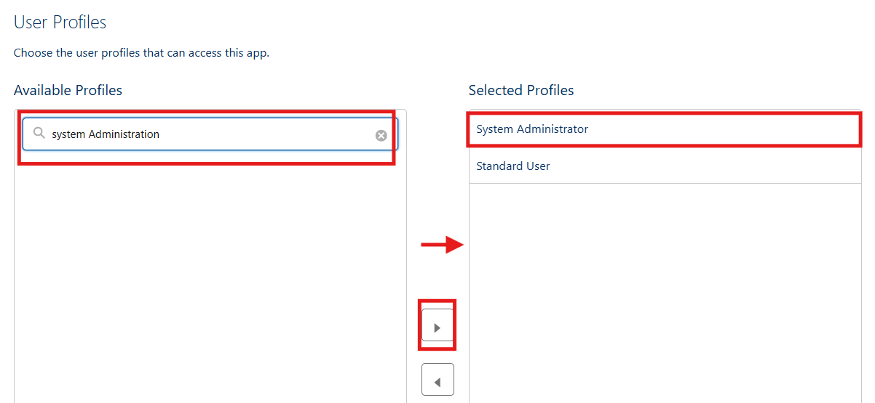

Milestone 9 – Page Layouts and Record Types

Activity 1: Create Record Types for Enrollment
Purpose:
To separate the New Enrollment and Re-Enrollment processes.
Steps:
1. Go to Setup → Object Manager → Enrollment__c.
2. Click Record Types → New.
3. For the first record type: Existing Record Type: Master; Record Type Label: New Enrollment; enable it for the required profiles (Admin, Enrollment Officer); select the default Page Layout → Save & New.
4. For the second record type: Record Type Label: Re-Enrollment; enable it for the same profiles; select the default Page Layout → Save.
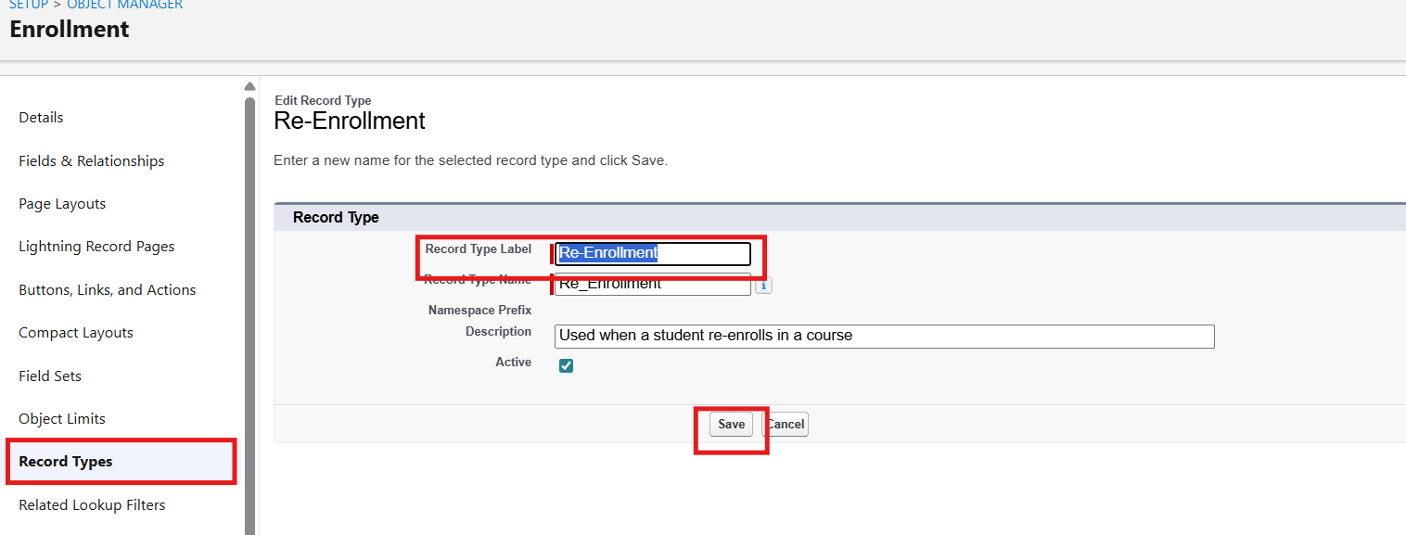
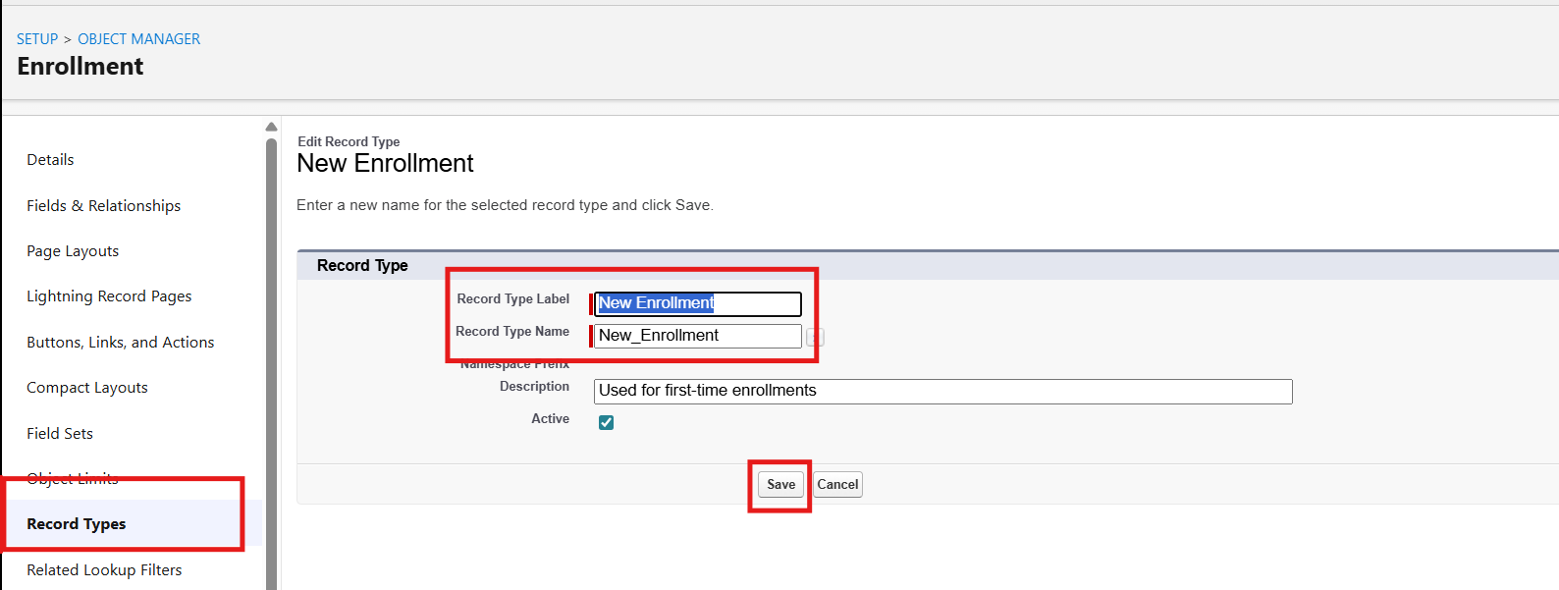

Activity 2: Separate Page Layouts for Each Enrollment Record Type
Purpose:
To show different fields for New Enrollment and Re-Enrollment records.
Steps:
1. On the Enrollment__c object, click Page Layouts.
2. Click New to create a layout for New Enrollment. Clone the existing Enrollment Layout and name it New Enrollment Layout. Keep the fields relevant to first-time enrollment (Student, Course, Instructor, Enrollment Date, Status, Fees, etc.) and remove any unnecessary re-enrollment fields. Click Save.
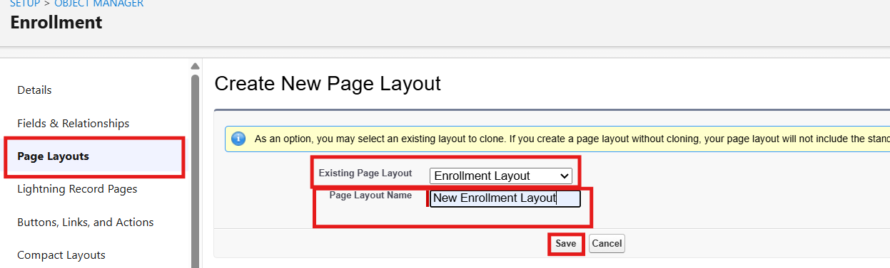
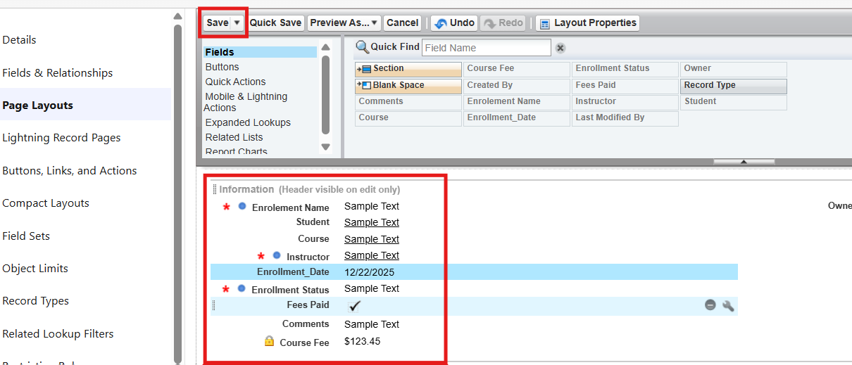
3. Click New again to create the Re-Enrollment Layout. Clone the existing layout, name it Re-Enrollment Layout, and include fields such as the previous enrollment reference (if any), Re-Enrollment Reason, Status, Fees, etc. Click Save.
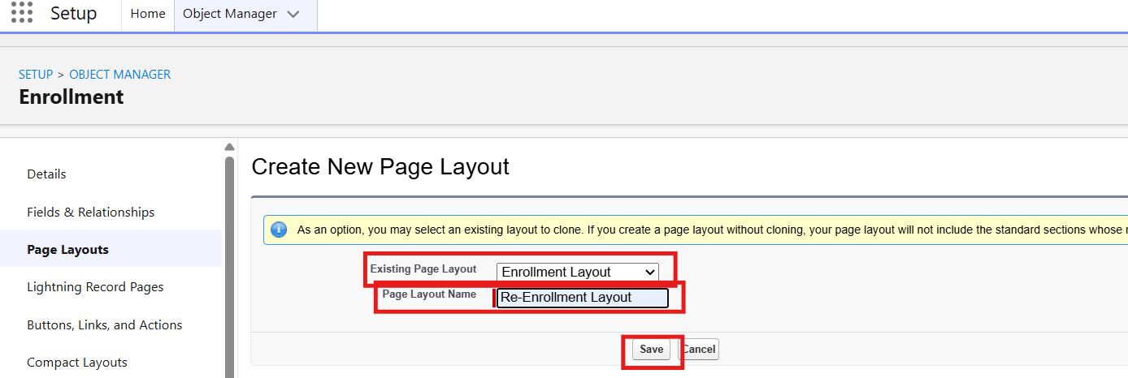
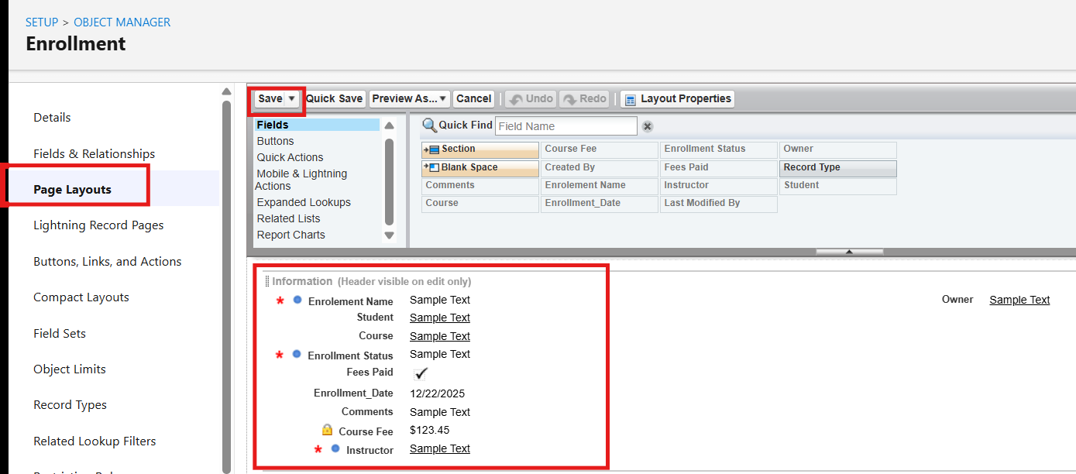
4. Click Page Layout Assignment → Edit Assignment.
5. For each profile and record type, assign New Enrollment → New Enrollment Layout.
6. Assign Re-Enrollment → Re-Enrollment Layout.
7. Click Save.

Activity 3: Add Related Lists to Parent Objects
Purpose:
To see all Enrollments from the Student, Course, and Instructor records.
a) Student → Enrollment Related List
1. Go to Setup → Object Manager → Student__c.
2. Click Page Layouts and open the main layout.
3. In the palette, select Related Lists.
4. Drag the Enrollments related list onto the layout.
5. Customize the columns if needed → Save.
b) Course → Enrollment Related List
1. Go to Object Manager → Course__c → Page Layouts.
2. Open the layout and add the Enrollments related list.
3. Save.
c) Instructor → Enrollment Related List
1. Go to Object Manager → Instructor__c → Page Layouts.
2. Open the layout and add the Enrollments related list.
3. Save.

Milestone 10 – Automation with Flow

Activity 1: Auto-Populate Enrollment Date (Record-Triggered Flow)
Purpose:
To set Enrollment_Date__c to today’s date when an Enrollment is created.
Steps:
1. Go to Setup → Flows → New Flow.
2. Select Record-Triggered Flow → Create.
3. Object: Enrollment__c.
4. Trigger: A record is created.
5. Optimize the flow for Actions and Related Records → Done.
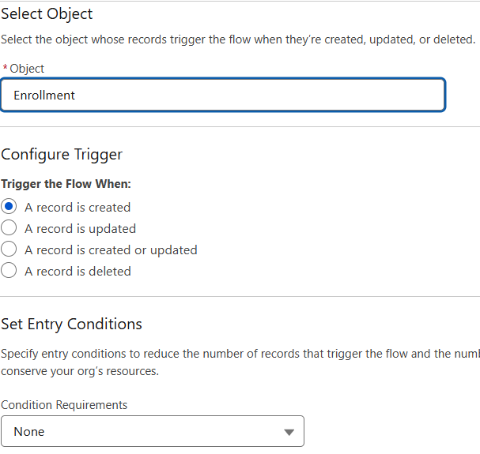
6. Add an Update Records element. Label: Set Enrollment Date. Use the record that triggered the flow. Field: Enrollment_Date__c → Value: $Flow.CurrentDate.
7. Save the flow as SetEnrollmentDate and click Activate.
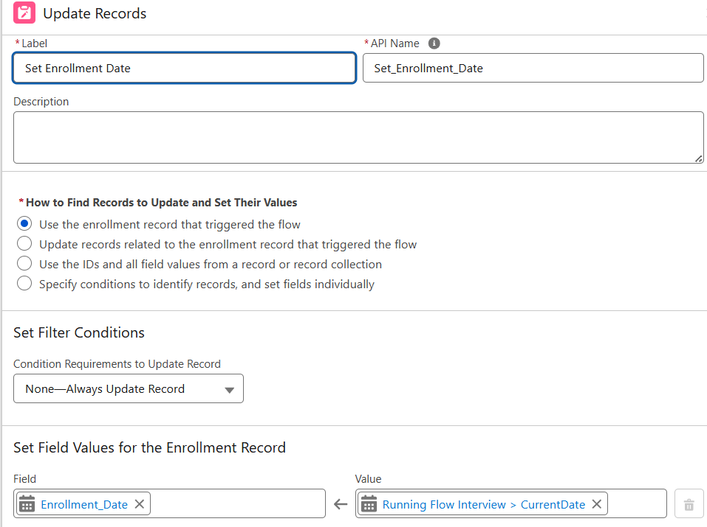

Activity 2: Send Email When an Enrollment Is Approved
Purpose:
When Enrollment_Status__c = Approved, send an email to the student, alert the admin, and set the Student status to Active.
Steps (high level):
1. Create an Email Template and an Email Alert for the student notification.
2. Go to Flows → New → Record-Triggered Flow.
3. Object: Enrollment__c; trigger on update.
4. Condition: Enrollment_Status__c Equals "Approved".
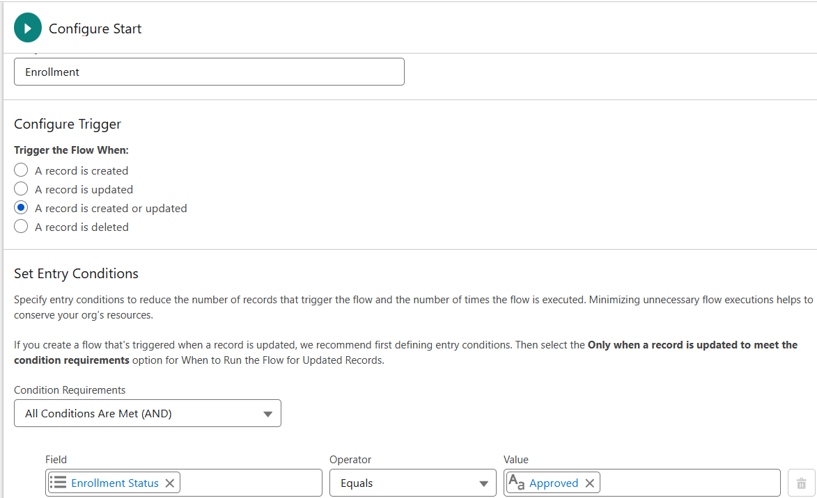
5. Add a Get Records element to fetch the related Student__c record.
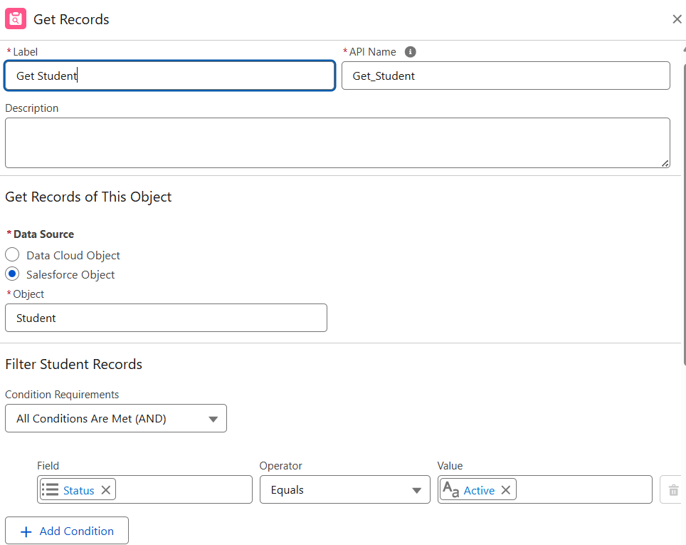
6. Add an Action (Email Alert) to send the email to the student.
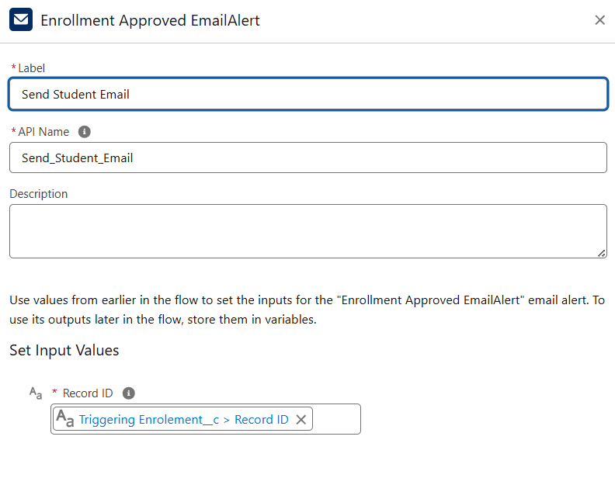
7. Add an Action to notify the Admin if needed.
8. Add an Update Records element to set Student__c.Status__c = "Active".
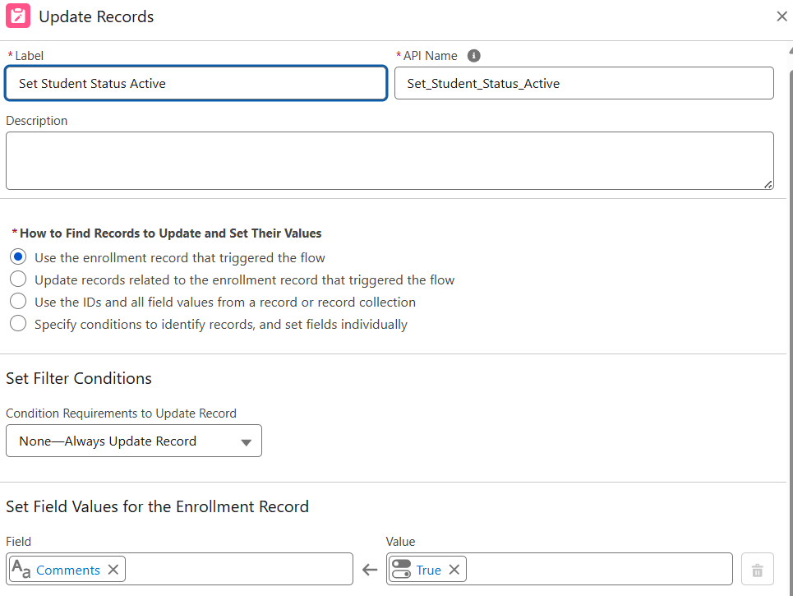
9. Save the flow as Enrollment Approved Action and click Activate.

Activity 3: Auto-Assign Instructor Based on Course Category
Purpose:
To assign an Instructor automatically based on the Course category.
Rules:
- Technical → Instructor A
- Language → Instructor B
- Non-Technical → Instructor C
Steps:
1. Prepare Instructor__c records with codes (for example, INSTR_A, INSTR_B, INSTR_C).
2. Create a Record-Triggered Flow on Enrollment__c (created/updated).
3. Add a Get Records element to fetch the related Course__c.
4. Add a Decision element on Course__r.Category__c.
5. Define the outcomes: Technical, Language, and Non-Technical.
6. For each outcome:
7. Get the Instructor record (A/B/C) based on code or name.
8. Update Records: set Instructor__c = Get_Instructor_X.Id.
9. Save the flow as AutoAssign_Instructor and click Activate.
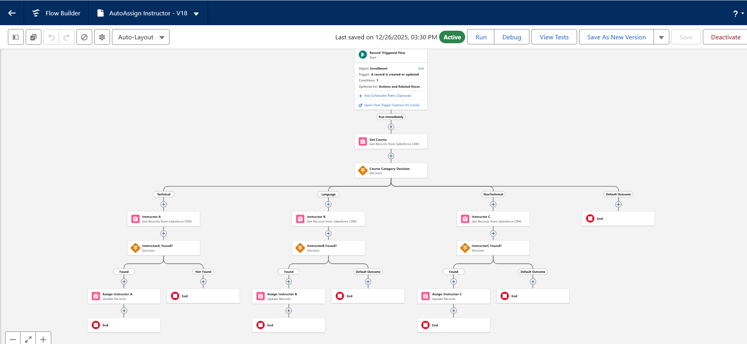

Activity 4: Auto-Create a Task for Follow-Up
Purpose:
When an Enrollment is in the “Requested” status, create a follow-up task for the Admin.
Steps:
1. Create a Record-Triggered Flow on Enrollment__c.
2. Trigger: record created or updated, with the condition Enrollment_Status__c = "Requested".
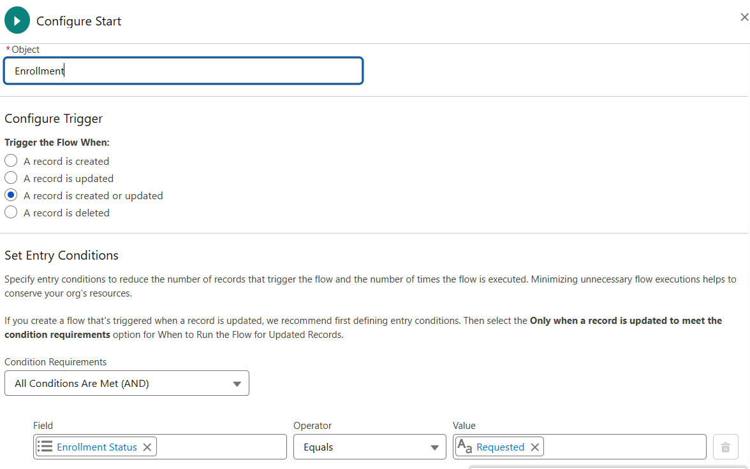
3. Add a Get Records element to fetch the Admin user (by Username / Profile).
4. Add a Formula (Date): TODAY() + 2 for the due date.
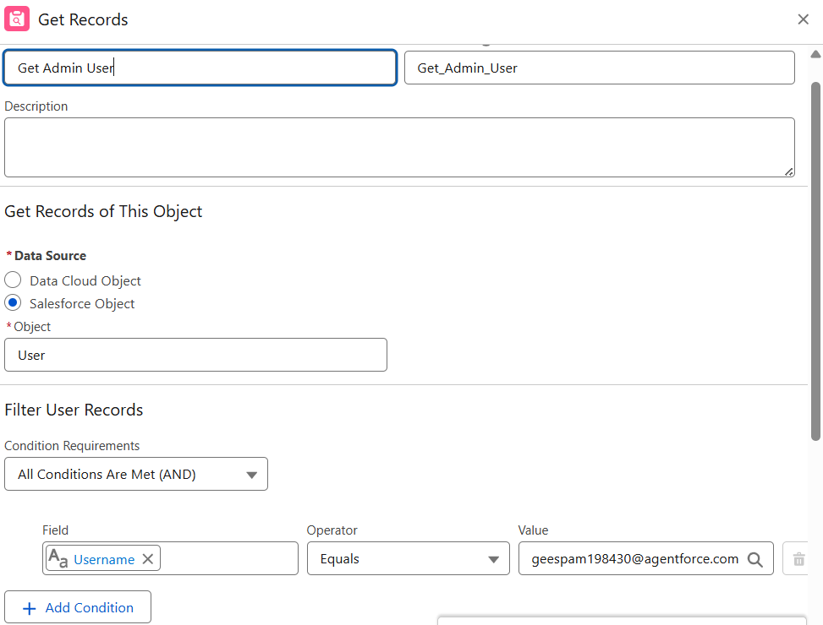
5. Add a Create Records element for the Task.
6. Subject: Follow up on enrollment request.
7. OwnerId: Admin user Id.
8. WhatId: Enrollment Id.
9. ActivityDate: formula Today + 2.
10. Save the flow as Create_Followup_Task and click Activate.
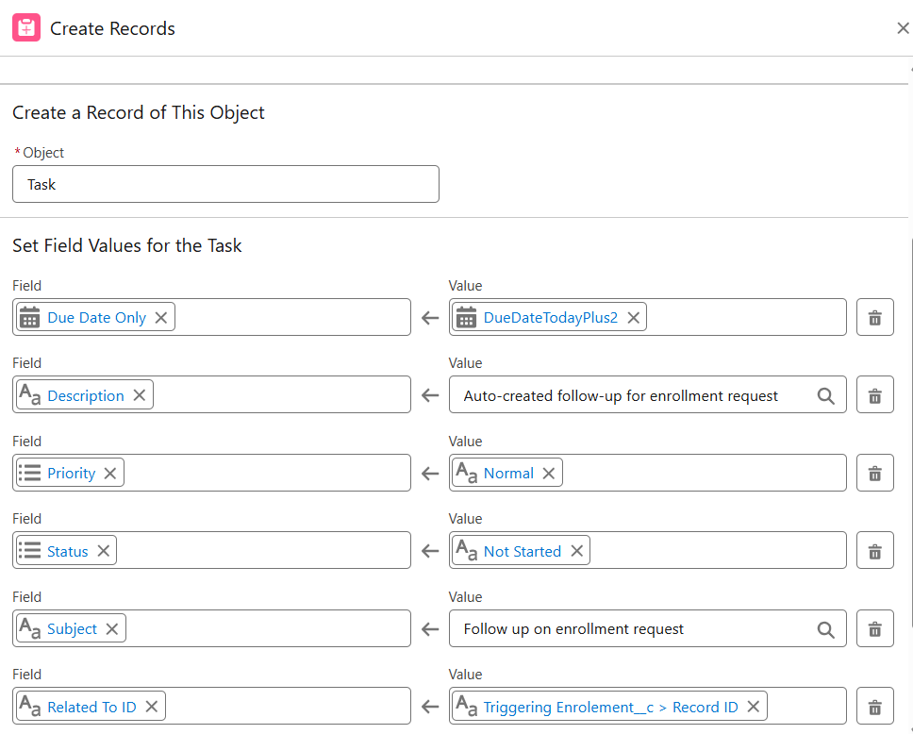

Milestone 11 – Reports

Activity 1: Create the “Students by Status” Report
1. Go to Reports → New Report.
2. Report Type: Students.
3. Group rows by Status__c.
4. Add columns as needed (Name, Email, Phone).
5. Save the report as Students by Status.
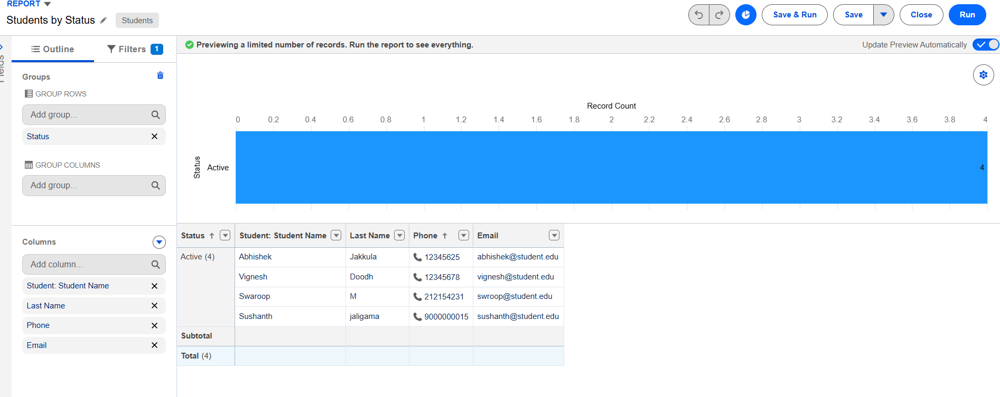

Activity 2: Create the “Enrollments by Course” Report
1. New Report → Report Type: Enrollments.
2. Group rows by Course__r.Name.
3. Show the Record Count per course.
4. Save the report as Enrollments by Course.
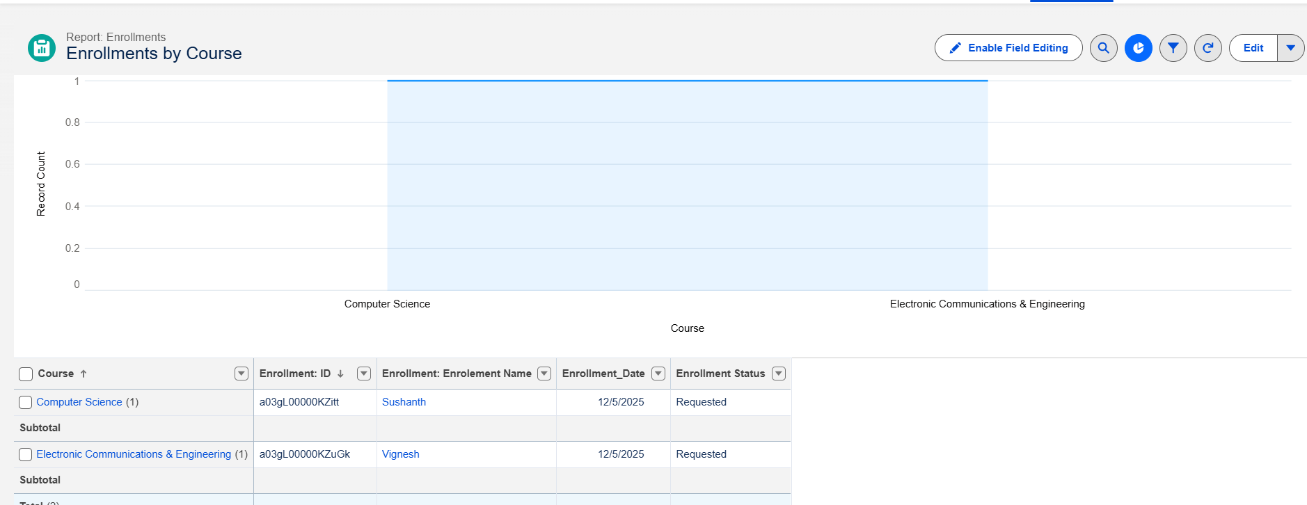

Activity 3: Create the “Pending Enrollment Approvals” Report
1. New Report → Enrollments report type.
2. Filter: Enrollment_Status__c = "Requested".
3. Add columns (Student, Course, Owner, Created Date).
4. Save the report as Pending Enrollment Approvals.
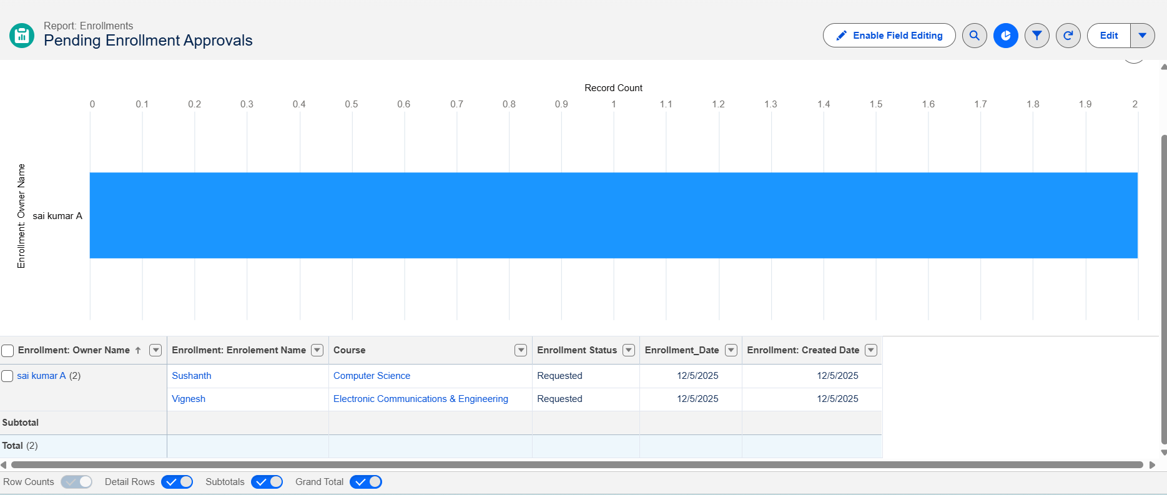

Activity 4: Create the “Revenue Report (Fees Paid)” Report
1. New Report → Enrollments report type.
2. Filter: Fees_Paid__c = TRUE.
3. Group by Course__r.Name.
4. Summarize Course_Fee__c or a similar fee field.
5. Save the report as Revenue Report – Fees Paid.
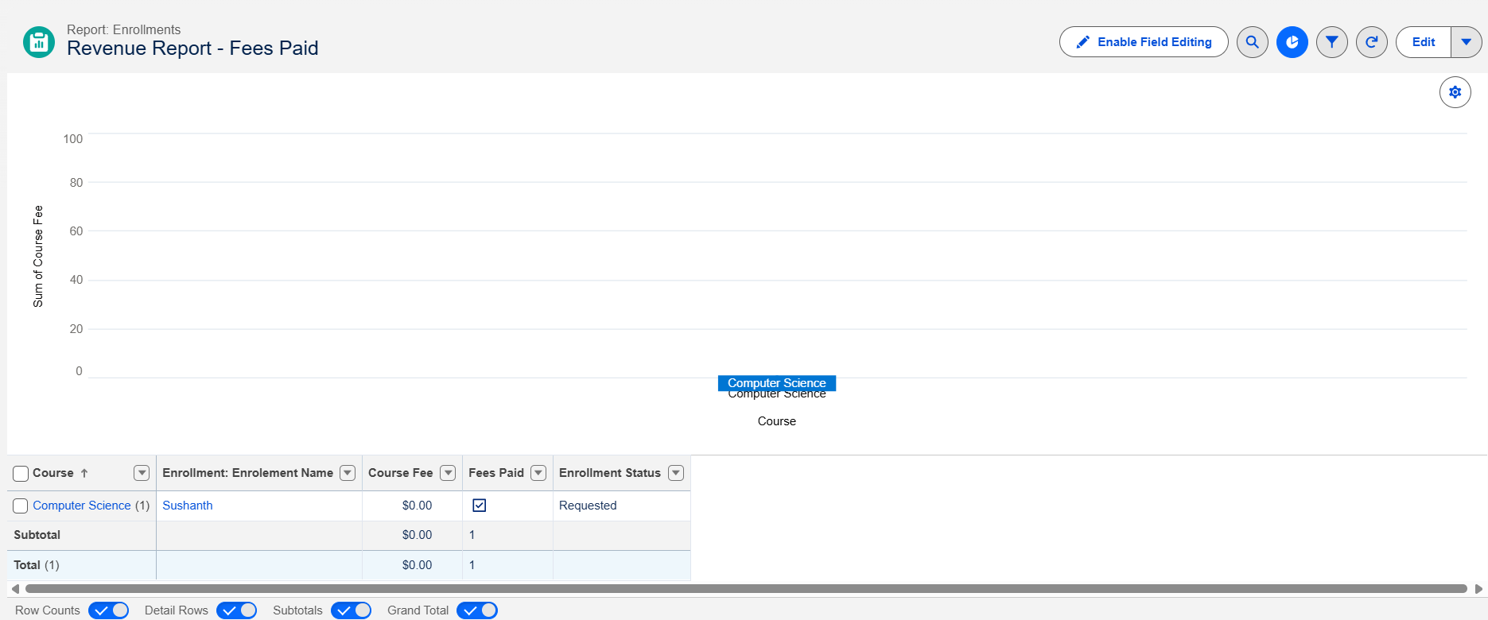

Milestone 12 – Dashboards

Activity 1: Create the “Student Management Dashboard”
1. Go to Dashboards → New Dashboard.
2. Name: Student Management Dashboard.
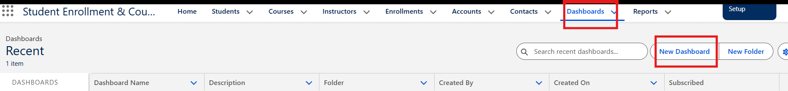
3. Select a folder → Create.
4. Select the new dashboard folder and click Save.
Add the following components:
- Donut Chart → using the Students by Status report.
- Bar Chart → using the Enrollments by Course report.
- Gauge → using the Revenue Report – Fees Paid (sum of the revenue field).
- Table → using the Pending Enrollment Approvals report.
5. Arrange the components on the canvas.
6. Click Save → Done.
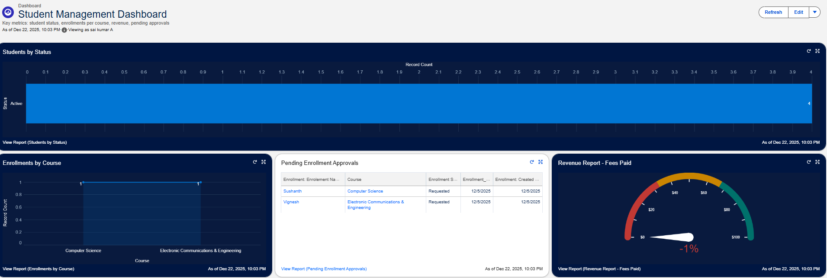

Milestone 13 – Security Setup

Activity 1: Configure Profiles
1. Go to Setup → Profiles → New (or Clone Profiles).
Required profiles:
- Admin – Full access.
- Enrollment Officer – Create and update Enrollments.
- Instructor – Read-only access to assigned Enrollments.
2. Steps (example for the Enrollment Officer profile): set the Profile Name to Enrollment Officer.
3. In Object Settings: Enrollment__c → Read, Create, Edit; Student__c / Course__c → Read (and Edit if required).
4. Save.
Repeat the same steps for the Instructor profile with Read-Only access on Enrollments.

Activity 2: Create Permission Sets
1. Go to Setup → Permission Sets → New.
2. Create Custom Object Access (additional access to project objects if needed).
3. Create Dashboard Editor (Create/Customize Reports & Dashboards permissions).
4. Assign the permission sets to the relevant users.

Activity 3: Configure Sharing & Organization-Wide Defaults (OWD)
1. Go to Setup → Sharing Settings.
2. Set the Organization-Wide Defaults: Students (Student__c): Public Read/Write; Courses (Course__c): Public Read/Write; Enrollments (Enrollment__c): Private.
3. Save.
For Instructor access to assigned Enrollments, optionally add a User lookup on Enrollment (Instructor User) and use a simple Record-Triggered Flow to set OwnerId = Instructor User, so that instructors can see only their own records.

7. Functional & Performance Testing
During the testing phase, screenshots were captured from the Salesforce user interface to verify the proper functioning of all implemented features of the Student Enrollment & Course Management System (SECMS). The testing covered student, course, instructor, and enrollment record creation; validation rule checks for mandatory fields, eligibility, and enrollment constraints; verification of record type behavior for New Enrollment and Re-Enrollment; and flow execution for automated enrollment approvals, instructor assignment, and follow-up tasks. In addition, screenshots of the generated reports and dashboards were documented to validate accurate data visualization, enrollment tracking, and performance monitoring.
The screenshots captured during testing are submitted along with this document.

8. Advantages & Disadvantages

Advantages
- Centralized data
- Automated workflows
- Real-time reporting

Disadvantages
- Salesforce dependency
- Requires initial configuration effort

9. Conclusion
The Salesforce Student Enrollment & Course Management System successfully streamlines the entire student academic lifecycle, from student registration and course creation to enrollment management, instructor assignment, approvals, revenue tracking, and reporting. By leveraging Salesforce’s automation tools such as validation rules, flows, approval processes, and dashboards, the system improves data accuracy, operational efficiency, and decision-making. This project demonstrates how Salesforce can transform manual academic processes into a scalable, reliable, and user-friendly digital solution.

10. Future Scope
- Payment gateway integration
- Student self-service portal
- Analytics-driven insights
- Mobile access support

11. Appendix
- Source Code: Salesforce Configuration
- Dataset: Salesforce Objects
- GitHub / Demo: https://drive.google.com/file/d/1CWuWRzsE0aqA-_FoqcRMGFWXOqMjC5Gu/view?usp=drivesdk

Thank You

