A.1 System Overview
The Limkokwing Library API is a Python-based digital library management system designed for Limkokwing University Sierra Leone. It provides a structured, RESTful-style interface allowing students to search for books, borrow and return them, and enabling library staff to monitor overdue items and fines. The system follows REST conventions: GET requests retrieve data, POST requests create new records, and PUT requests update existing ones. All responses are structured JSON-style Python dictionaries with a status code, message, and relevant data payload. The system is implemented as a pure Python console application using asyncio for concurrent request handling, with no external libraries required beyond the Python standard library.

A.2 Endpoint 1 — GET /books (Search Books)
This endpoint allows any user to search the library catalogue. It accepts up to three optional query parameters which can be used individually or in combination. Searches are case-insensitive. If no parameters are provided, the full catalogue is returned.
Field | Details
Method & Path | GET /books
Purpose | Search the library catalogue by title, author, or category
Inputs | title (str, optional), author (str, optional), category (str, optional) — all case-insensitive partial match
Example Call | get_books(category='Programming')
Success Response | {"status":200,"total":2,"books":[{"id":1,"title":"Clean Code","author":"Robert C. Martin","available":true},...]}
Status Codes | 200 OK — results returned (empty list if no match)

A.3 Endpoint 2 — POST /borrow (Borrow a Book)
Registers a new borrowing transaction. The function validates that the book exists and is currently available, creates a borrow record with a due date set to 14 days from today, marks the book as unavailable, and returns the full borrow record.
Field | Details
Method & Path | POST /borrow
Purpose | Borrow an available book — creates a borrow record with 14-day due date
Inputs | user_id (int, required) — ID of the borrowing student; book_id (int, required) — ID of the book to borrow
Example Call | post_borrow(user_id=101, book_id=1)
Success (201) | {"status":201,"message":"Book borrowed successfully.","record":{"borrow_id":1,"due_date":"2026-05-19","returned":false,"fine":0.0}}
Error (400) | {"status":400,"error":"'Clean Code' is not available."}
Error (404) | {"status":404,"error":"Book ID 9 not found."}

A.4 Endpoint 3 — PUT /return (Return a Book)
Processes a book return. Verifies the borrow record exists and belongs to the requesting user. Calculates any overdue fine at $1.00 per day past the due date. Marks the book as available again and updates the borrow record with the return date and fine amount.

Field | Details
Method & Path | PUT /return
Purpose | Return a borrowed book — calculates overdue fine and marks book as available
Inputs | borrow_id (int, required) — ID of the borrow record; user_id (int, required) — must match original borrower
Example Call | put_return(borrow_id=1, user_id=101)
Success (200) | {"status":200,"message":"Book returned successfully.","fine_amount":"$0.00","record":{...}}
Error (400) | {"status":400,"error":"This book has already been returned."}
Error (403) | {"status":403,"error":"This borrow record does not belong to this user."}

A.5 Endpoint 4 — GET /overdue (Track Overdue Books)
Returns all borrow records where the due date has passed and the book has not yet been returned. Each record includes the number of days overdue and the estimated fine. This endpoint is primarily used by library administration staff to identify and contact borrowers with outstanding items.

Field | Details
Method & Path | GET /overdue
Purpose | List all unreturned books that have passed their due date, with estimated fine
Inputs | None — no parameters required
Success (200) | {"status":200,"total_overdue":1,"overdue_records":[{"borrow_id":2,"title":"Introduction to Algorithms","days_overdue":3,"estimated_fine":"$3.00"}]}
Status Codes | 200 OK always returned — overdue_records is an empty list if none found

A.6 Endpoint 5 — GET /books (Author Filter)
This is a variant use of the GET /books endpoint, specifically searching by author name. It demonstrates that the search function supports multiple independent filter parameters, each performing a partial, case-insensitive match against the respective field in the catalogue.
Field | Details
Method & Path | GET /books?author=Cormen
Purpose | Find all books by a specific author using partial name match
Inputs | author='Cormen' (str, optional partial match)
Example Call | get_books(author='Cormen')
Success (200) | {"status":200,"total":1,"books":[{"id":2,"title":"Introduction to Algorithms","author":"Thomas H. Cormen","available":true}]}

A.7 Client – API – Server Interaction Diagram
The diagram below illustrates how the three system layers interact during a typical POST /borrow request. The client passes typed parameters to the async function. The handler validates input, checks book availability, simulates database latency with await asyncio.sleep(), updates the in-memory data store, and returns a structured JSON-style dictionary response. The asyncio event loop allows multiple such requests to execute concurrently without blocking.

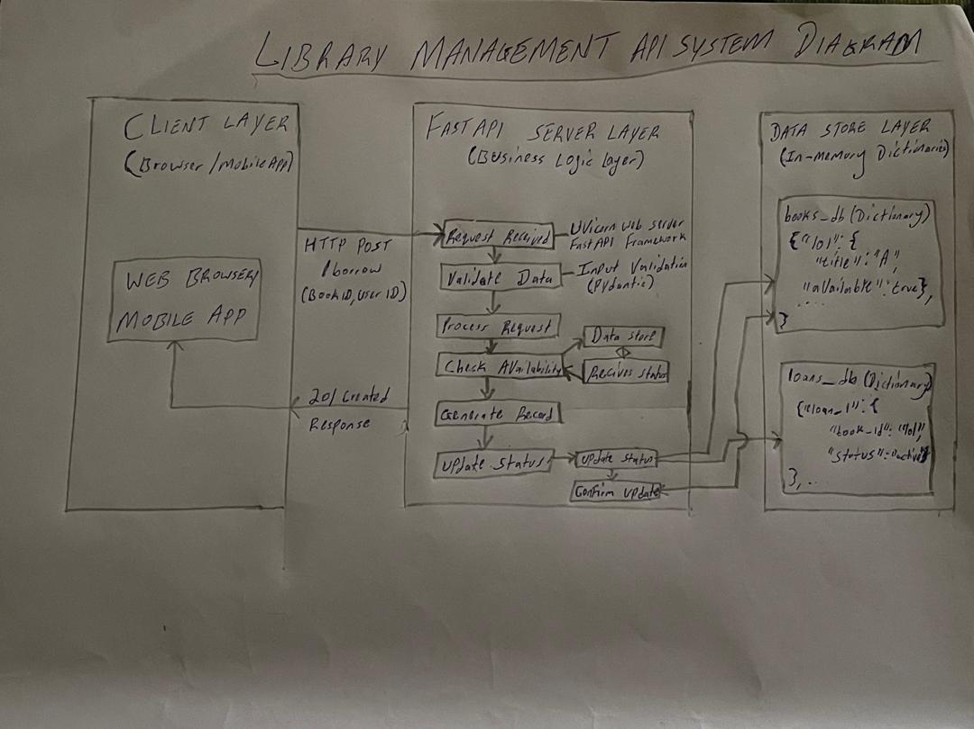

Part B — Implementation

B.1 Technology Stack
- Python 3.11+ — core programming language
- asyncio — Python standard library module for asynchronous programming and concurrency
- datetime — standard library module for due date and overdue fine date calculations
- typing.Optional — enables type-safe optional function parameters
- No external libraries required — the script runs with python main.py only

B.2 Type Annotations
Every function parameter and return value in the script is explicitly type-annotated following Python 3.11 conventions. The in-memory data stores use built-in generic types (dict[int, dict], list[dict]). Function parameters use Optional[str] from the typing module for nullable search fields. All four endpoint functions are annotated with -> dict return types. This mirrors the Pydantic schema validation approach used in production FastAPI applications and makes the code contract explicit and verifiable.

B.3 Asynchronous Design & Concurrent Simulation
All four endpoint functions are declared with async def and include an await asyncio.sleep(0.05) call to simulate realistic network or database latency. The main() simulation function uses asyncio.gather() to dispatch four coroutines simultaneously — demonstrating that Python's event loop can interleave multiple I/O-bound tasks without blocking any individual request.
The race condition scenario is particularly important: when User 201 and User 202 both request Book 3 (Design Patterns) at the same time via asyncio.gather(), the first coroutine to reach the availability check claims the book and sets available = False. The second coroutine then reads available as False and correctly returns a 400 error. This demonstrates proper concurrent state management without threading or locking, achieved simply through Python's cooperative multitasking event loop.

B.4 Complete Source Code (main.py)
import asyncio
from datetime import date, timedelta
from typing import Optional

# ── In-memory data store ───────────────────────────────
books_db: dict[int, dict] = {
1: {"id": 1, "title": "Clean Code", "author": "Robert C. Martin", "category": "Programming", "available": True},
2: {"id": 2, "title": "Introduction to Algorithms", "author": "Thomas H. Cormen", "category": "Computer Science", "available": True},
3: {"id": 3, "title": "Design Patterns", "author": "Gang of Four", "category": "Software Engineering","available": True},
4: {"id": 4, "title": "Python Crash Course", "author": "Eric Matthes", "category": "Programming", "available": True},
}
borrows_db: dict[int, dict] = {}
borrow_counter: int = 1
# ── ENDPOINT 1: GET /books ─────────────────────────────
async def get_books(
title: Optional[str] = None,
author: Optional[str] = None,
category: Optional[str] = None
) -> dict:
"""Simulate GET /books — search library catalogue."""
await asyncio.sleep(0.05) # simulate network/DB delay
results: list[dict] = list(books_db.values())
if title: results = [b for b in results if title.lower() in b["title"].lower()]
if author: results = [b for b in results if author.lower() in b["author"].lower()]
if category: results = [b for b in results if category.lower() in b["category"].lower()]
return {"status": 200, "total": len(results), "books": results}
# ── ENDPOINT 2: POST /borrow ───────────────────────────
async def post_borrow(user_id: int, book_id: int) -> dict:
"""Simulate POST /borrow — borrow an available book."""
global borrow_counter
await asyncio.sleep(0.05) # simulate network/DB delay
book: Optional[dict] = books_db.get(book_id)
if not book:
return {"status": 404, "error": f"Book ID {book_id} not found."}
if not book["available"]:
return {"status": 400, "error": f"'{book['title']}' is not available."}
book["available"] = False
due_date: date = date.today() + timedelta(days=14)
record: dict = {
"borrow_id": borrow_counter,
"user_id": user_id,
"book_id": book_id,
"title": book["title"],
"borrow_date": str(date.today()),
"due_date": str(due_date),
"returned": False,
"fine": 0.0,
}
borrows_db[borrow_counter] = record
borrow_counter += 1
return {"status": 201, "message": "Book borrowed successfully.", "record": record}
# ── ENDPOINT 3: PUT /return ────────────────────────────
async def put_return(borrow_id: int, user_id: int) -> dict:
"""Simulate PUT /return — return a borrowed book."""
await asyncio.sleep(0.05) # simulate network/DB delay
record: Optional[dict] = borrows_db.get(borrow_id)
if not record:
return {"status": 404, "error": f"Borrow ID {borrow_id} not found."}
if record["user_id"] != user_id:
return {"status": 403, "error": "This borrow record does not belong to this user."}
if record["returned"]:
return {"status": 400, "error": "This book has already been returned."}
today: date = date.today()
due: date = date.fromisoformat(record["due_date"])
fine: float = round(max(0, (today - due).days) * 1.0, 2)
record["returned"] = True
record["return_date"] = str(today)
record["fine"] = fine
books_db[record["book_id"]]["available"] = True
return {"status": 200, "message": "Book returned successfully.",
"fine_amount": f"${fine:.2f}", "record": record}
# ── ENDPOINT 4: GET /overdue ───────────────────────────
async def get_overdue() -> dict:
"""Simulate GET /overdue — list all overdue books."""
await asyncio.sleep(0.05) # simulate network/DB delay
today: date = date.today()
overdue: list[dict] = []
for record in borrows_db.values():
if not record["returned"]:
due: date = date.fromisoformat(record["due_date"])
if today > due:
days_late: int = (today - due).days
overdue.append({**record, "days_overdue": days_late,
"estimated_fine": f"${round(days_late * 1.0, 2):.2f}"})
return {"status": 200, "total_overdue": len(overdue), "overdue_records": overdue}
# ── Helper: display response neatly ───────────────────
def show(label: str, response: dict) -> None:
status: int = response.get("status", 0)
symbol: str = "✓" if status in (200, 201) else "✗"
print(f"\n {symbol} [{status}] {label}")
for key, value in response.items():
if key == "status":
continue
if key == "record":
print(f" record:")
for k, v in value.items():
print(f" {k}: {v}")
elif key == "books":
print(f" books ({len(value)} found):")
for b in value:
avail = "Available" if b["available"] else "Unavailable"
print(f" [{b['id']}] {b['title']} — {b['author']} | {avail}")
elif key == "overdue_records":
if value:
print(f" overdue_records:")
for r in value:
print(f" Borrow ID {r['borrow_id']} | {r['title']} | "
f"{r['days_overdue']} days late | Fine: {r['estimated_fine']}")
else:
print(f" overdue_records: none")
else:
print(f" {key}: {value}")
# ── MAIN ───────────────────────────────────────────────
async def main() -> None:
print("=" * 58)
print(" LIMKOKWING LIBRARY API — CONSOLE SIMULATION")
print(" PROG315 | Alusine G. Dumbuya | 905005223")
print("=" * 58)
# 1. Search books by category
print("\n>>> REQUEST: GET /books?category=Programming")
show("GET /books", await get_books(category="Programming"))
# 2. Borrow book — success
print("\n>>> REQUEST: POST /borrow {user_id: 101, book_id: 1}")
show("POST /borrow", await post_borrow(user_id=101, book_id=1))
# 3. Borrow another book — success
print("\n>>> REQUEST: POST /borrow {user_id: 102, book_id: 2}")
show("POST /borrow", await post_borrow(user_id=102, book_id=2))
# 4. Borrow unavailable book — error
print("\n>>> REQUEST: POST /borrow {user_id: 103, book_id: 1} [already taken]")
show("POST /borrow", await post_borrow(user_id=103, book_id=1))
# 5. Return a book — success
print("\n>>> REQUEST: PUT /return {borrow_id: 1, user_id: 101}")
show("PUT /return", await put_return(borrow_id=1, user_id=101))
# 6. Return already-returned book — error
print("\n>>> REQUEST: PUT /return {borrow_id: 1, user_id: 101} [already returned]")
show("PUT /return", await put_return(borrow_id=1, user_id=101))
# 7. Check overdue
print("\n>>> REQUEST: GET /overdue")
show("GET /overdue", await get_overdue())
# 8. ASYNC — 4 users at the same time
print("\n" + "=" * 58)
print(" ASYNC SIMULATION — 4 users at the same time")
print("=" * 58)
books_db[3]["available"] = True
books_db[4]["available"] = True
print("\n>>> asyncio.gather() — all 4 requests fire simultaneously")
results = await asyncio.gather(
post_borrow(user_id=201, book_id=3),
post_borrow(user_id=202, book_id=3), # conflict — same book
post_borrow(user_id=203, book_id=4),
put_return(borrow_id=2, user_id=102),
)
labels: list[str] = [
"User 201 borrows Design Patterns",
"User 202 borrows Design Patterns (conflict)",
"User 203 borrows Python Crash Course",
"User 102 returns Introduction to Algorithms",
]
for label, result in zip(labels, results):
show(label, result)
print("\n" + "=" * 58)
print(" Simulation complete. All endpoints tested.")
print("=" * 58 + "\n")
asyncio.run(main())

B.5 Terminal Output Screenshot
The following output was produced by running python main.py in the VS Code integrated terminal. It confirms all four endpoints execute correctly, error responses are properly returned for invalid requests, and the async concurrent simulation with asyncio.gather() works as expected.
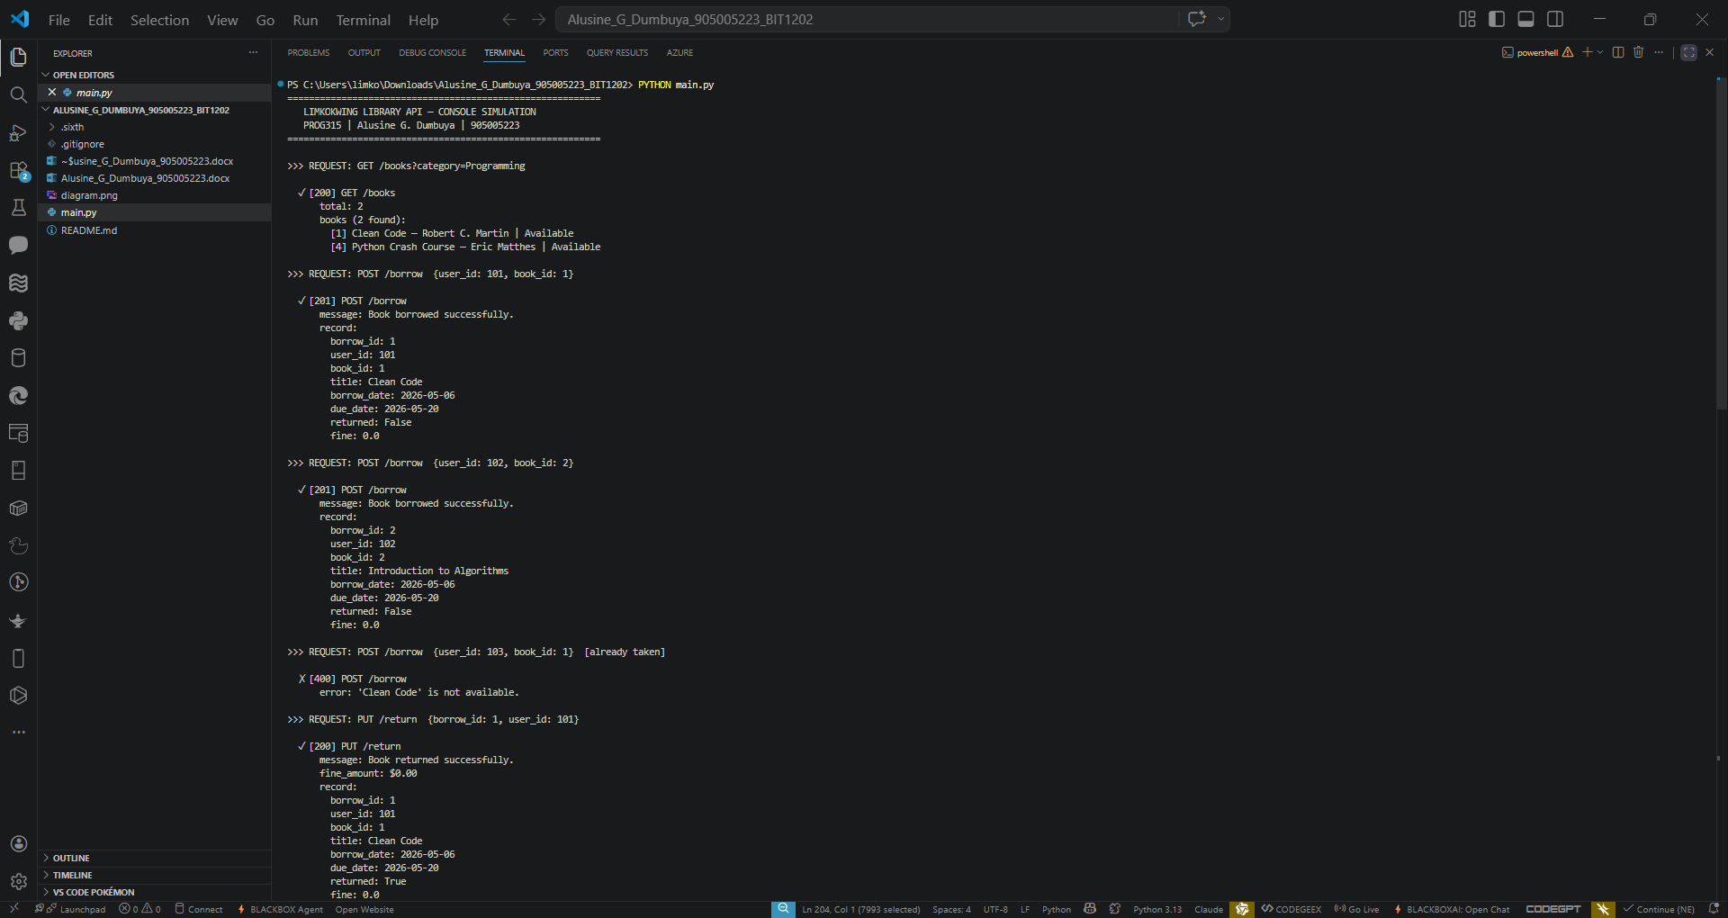

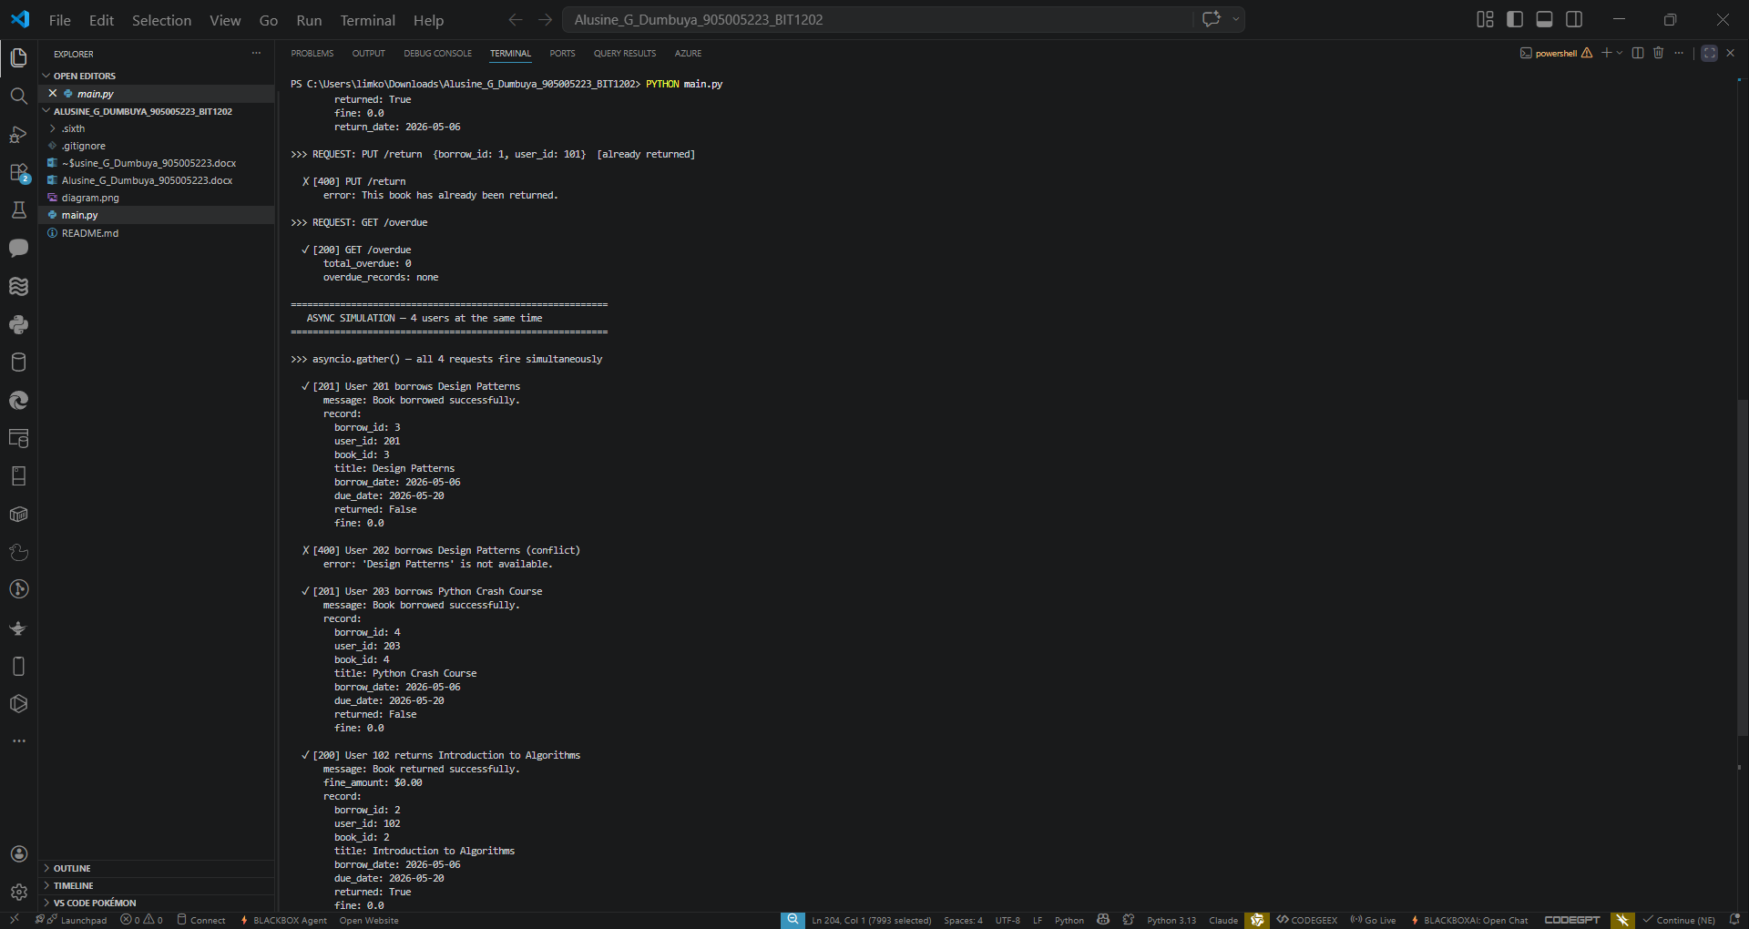

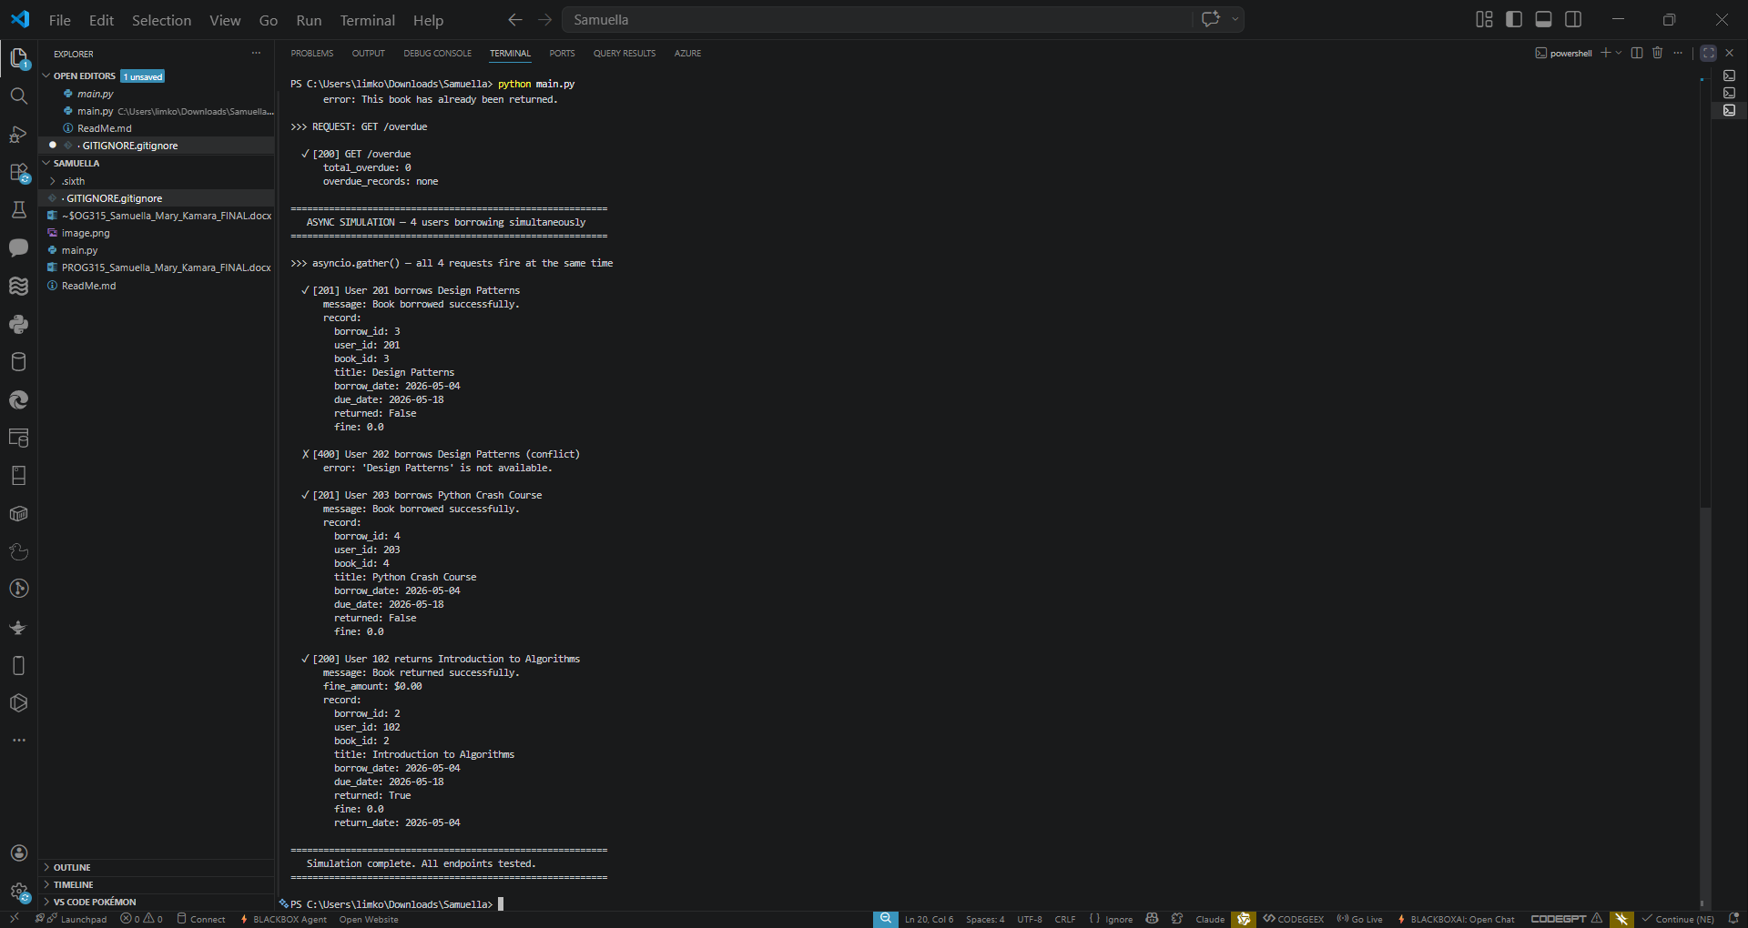

Part C — Reflection

C.1 How APIs Improve Efficiency in Limkokwing Library Services
APIs fundamentally transform library management from a slow, manual, error-prone process into a fast, automated, and scalable digital service. Without a digital system, a Limkokwing librarian must physically search catalogues, manually record borrow transactions in paper ledgers, and calculate fines by hand — tasks that are time-consuming and highly prone to human error. With the Limkokwing Library API, a student can search hundreds of books in milliseconds from any computer, borrow a book and receive instant confirmation with an automatically calculated due date, and return books with the fine computed precisely to the day.
Because the API uses asynchronous handlers, it processes many concurrent student requests without delay especially critical during examination season when library demand peaks. Library staff no longer manually track overdue items; the GET /overdue endpoint provides a real-time list of all outstanding borrows with fines calculated automatically. Furthermore, the standardised JSON interface allows the system to be integrated with the university's student information system or a mobile application without modifying the core logic. In summary, APIs eliminate repetitive administrative work, extend library access beyond physical opening hours, reduce errors, and scale to meet growing student demand efficiently.

C.2 SDG Alignment — SDG 4: Quality Education
This project directly aligns with Sustainable Development Goal 4 Quality Education, which calls for inclusive and equitable quality education and the promotion of lifelong learning opportunities for all. The Limkokwing University Library is the primary resource hub for students across all faculties; however, manual library management systems restrict access through long queues, misplaced records, and limited operating hours. By digitising library access through an open-source Python API, this project removes those barriers. Any registered student can search the full catalogue, check real-time availability, and borrow materials from any device with Python installed. The solution is built entirely on open-source tools (Python standard library only), meaning it is cost-free to deploy and can be replicated by other educational institutions across Sierra Leone and the West African region, directly supporting equitable access to quality education resources.

C.3 Challenges Faced During Design and Implementation
- Async race condition handling: The most complex challenge was ensuring two users could not simultaneously borrow the same book when using asyncio.gather(). Both coroutines could read a book's available status as True before either updated it. This was resolved by ensuring the availability check and the available = False update occurred atomically within the same synchronous execution block of each coroutine, exploiting Python's cooperative multitasking to prevent interleaving at that critical point.
- Consistent JSON response structure: Designing a predictable response format for both success and error cases required careful planning. Every function returns a dictionary with a 'status' key mimicking HTTP status codes (200, 201, 400, 403, 404), a 'message' or 'error' key, and a relevant data payload. This consistency ensures any client application or test can parse responses reliably regardless of the endpoint called.
- Overdue fine date arithmetic: Correctly computing the number of overdue days required careful use of Python's date objects. Using date.fromisoformat() to parse stored date strings and timedelta arithmetic to compare dates ensured accurate calculations with no off-by-one errors, correctly returning zero fine when the book is returned on or before the due date.
- Readable console output: Presenting nested Python dictionary responses in a human-readable terminal format required building a custom show() helper function that formats borrow records, book lists, and error messages clearly, making it easy to interpret the simulation results visually in the console.

C.4 Suggested Improvement for Expanded Library Services
If Limkokwing University expanded its library to include e-books, academic journal subscriptions, and inter-campus lending across multiple campuses in Sierra Leone and internationally, the most impactful technical improvement would be replacing the in-memory dictionary data store with a persistent relational database such as PostgreSQL integrated via SQLAlchemy with full async support (asyncpg driver). This change would allow all borrow records, fines, and user data to survive server restarts, scale reliably to thousands of concurrent users, and support complex administrative queries such as most-borrowed books by faculty, semester-on-semester borrowing trends, or outstanding fines by student cohort. Alongside this, a JWT-based user authentication layer would be essential to ensure only verified students and staff can access sensitive endpoints, protecting student data and preventing unauthorised borrowing.

