1. Introduction
This iis a basic interactive graphical user interface made with Java Swing. The program uses a JFrame, JPanel and JLabel and also demonstrates inheritance, a constructor, an ImageIcon and simple event handling.

2. Main Requirements
- Create a JFrame using the variable frame.
- Add a JPanel to the JFrame.
- Add a JLabel containing the required welcome message.
- Set the title to Java Swing Assignment.
- Set the frame size to 800 × 800 pixels.
- Close the program when the window close button is used.
- Use an ImageIcon.
- Demonstrate inheritance and a constructor.
- Allow the JLabel text to be changed.
- Allow the JPanel background to be changed.
- Provide a GUI wireframe and a screenshot of the running application.

3. Wireframe
The wireframe below shows the planned arrangement of the main controls and information on the GUI.
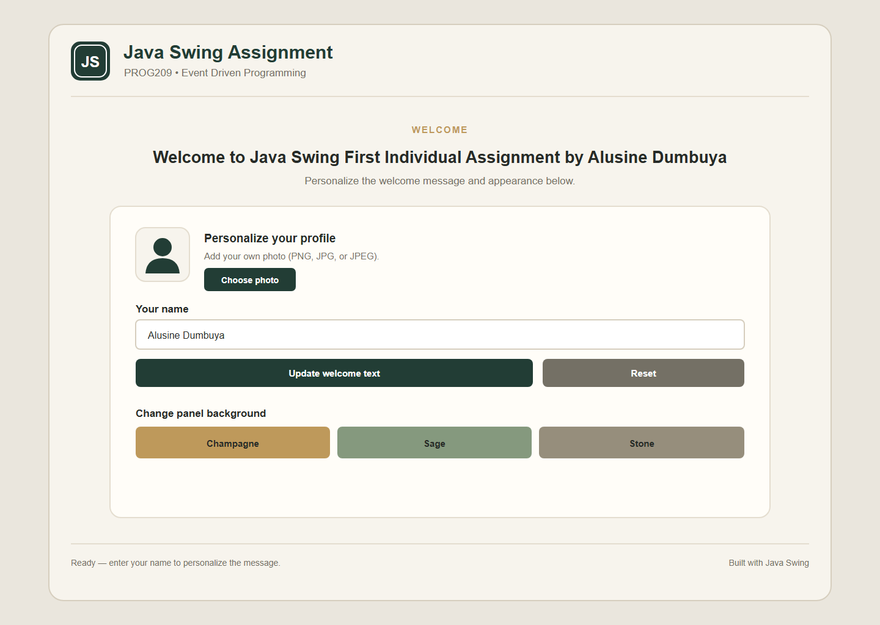

4. Screenshot of the Running Application
The screenshot below was taken while the Java Swing application was running. It shows the implemented GUI and the interactive controls.
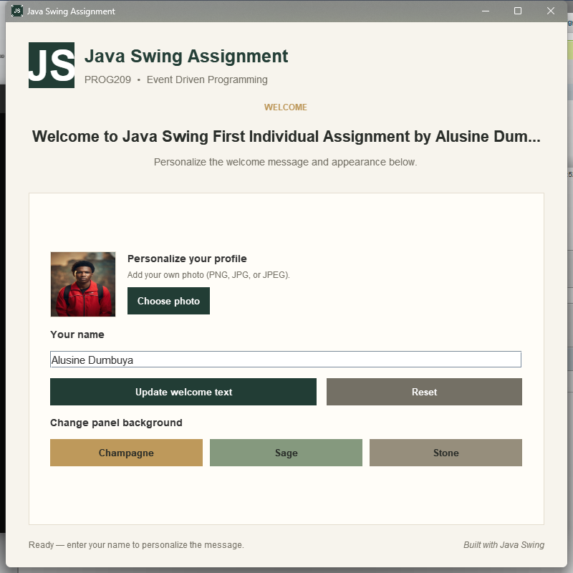

.

5. How the Program Works
- SwingAssignment creates the main JFrame and sets its title, size and close operation.
- WelcomePanel extends JPanel, which demonstrates inheritance.
- The constructor creates the GUI and connects the buttons to event listeners.
- The JLabel displays the required welcome message.
- The name field and Update welcome text button change the message.
- The Champagne, Sage and Stone buttons change the panel background.
- The Reset button returns the interface to its starting state.
- ImageIcon is used for the application icon.

6. Testing
Test | Action | Result
Launch | Run the program | Application opens
Welcome text | Open the application | Required message is displayed
Change text | Enter a name and click Update | Welcome message changes
Change background | Click a colour button | Panel background changes
Reset | Click Reset | Original state returns
Close | Close the window | Application exits

7. Conclusion
The completed program demonstrates the required Java Swing components and event-driven features. The wireframe and runtime screenshot are included as evidence of the design and implementation.

Appendix A — Source File
The complete source code is included in the project under src/SwingAssignment.java.

