IS 609 Week 10 Homework

Ben Arancibia

October 31, 2015

**469**

1. The following data were obtained for the growth of a sheep population introduced into a new environment on the island of Tasmania



1. Make an estimate of M by graphing P(t)

pt <- data.frame(year=c(1814,1824,1834,1844,1854,1864), Pt=c(125,275,830,1200,1750,1650))  
pt$PtDiff <- rep(NA, nrow(pt))  
for(i in 2:nrow(pt))  
{  
 pt$PtDiff[i] <- pt$Pt[i] - pt$Pt[i - 1]  
}  
pt

## year Pt PtDiff  
## 1 1814 125 NA  
## 2 1824 275 150  
## 3 1834 830 555  
## 4 1844 1200 370  
## 5 1854 1750 550  
## 6 1864 1650 -100

maxPtDiff <- max(pt$PtDiff, na.rm=TRUE)  
PtAtMaxDiff <- na.exclude(pt[pt$PtDiff == maxPtDiff,]$Pt)  
estimatedM <- PtAtMaxDiff * 2  
library(ggplot2)

## Warning: package 'ggplot2' was built under R version 3.1.3

dfMax <- data.frame(x=c(1814, 1865), y=c(PtAtMaxDiff, PtAtMaxDiff))  
g1 <- ggplot(data=pt) +   
 geom_line(aes(x=year, y=Pt)) +   
 geom_abline(intercept=estimatedM, slope=0, colour="red")   
g1

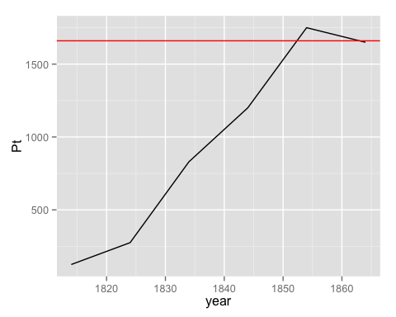

1. Plot ln[P/(M - P)] against t. If a logistic curve seems reasonable, estimate rM and t*.

M <- 1751  
pt$LnPMP <- log(pt$Pt/(M - pt$Pt))  
pt

## year Pt PtDiff LnPMP  
## 1 1814 125 NA -2.5655646  
## 2 1824 275 150 -1.6803199  
## 3 1834 830 555 -0.1040343  
## 4 1844 1200 370 0.7783420  
## 5 1854 1750 550 7.4673711  
## 6 1864 1650 -100 2.7934101

g1 <- ggplot(data=pt) +   
 geom_line(aes(x=year, y=LnPMP))   
g1

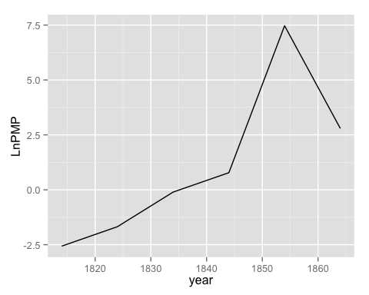

Seems reasonable....though there is a large spike betwee 1850 and 1860. If a logistic curve seems reasonable, estimate rM and t*.

rM <- (pt$LnPMP[length(pt$LnPMP)] - pt$LnPMP[1]) / (pt$year[length(pt$year)] - pt$year[1])  
rM

## [1] 0.1071795

t <- -1 * pt$LnPMP[1] / rM  
t

## [1] 23.93708

pt$year[1] + t

## [1] 1837.937

**478**

1. Suggest other phenomena for which the model described in the text might be used.

The model explained in the text could be used for any problem that has a substance dissolving in a liquid. An example of a problem is below.

A population of insects in a region will grow at a rate that is proportional to their current population. In the absence of any outside factors the population will triple in two weeks time. On any given day there is a net migration into the area of 15 insects and 16 are eaten by the local bird population and 7 die of natural causes. If there are initially 100 insects in the area will the population survive? If not, when do they die out?

**481**

1)

1. Using the estimate that db = 0.054v^2, where 0.054 has dimension ft*hr2/mi2, show that the constant k in equation 11.29 has the value of 19.9 ft/sec^2
2. Using the data in Table 4.4, plot db in ft versus v^2/2in ft2/sec2 to estimate 1/k directly