**AZURE DATA FUNDAMENTALS: DP 900**

A REPORT

submitted by

**Eakshitha Cheppali (22BPS1184)**

*in partial fulfilment for the award*

of

**B. Tech. Computer Science and Engineering**

**School of Computer Science and Engineering**

**April 2024**





**Certificate:**

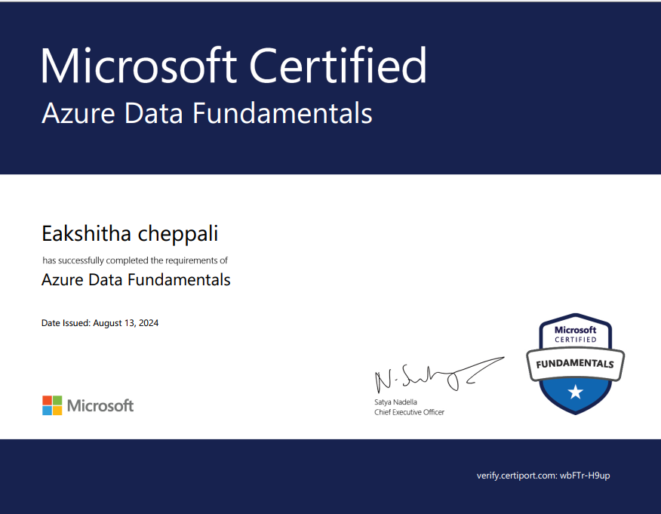

**Scorecard:**

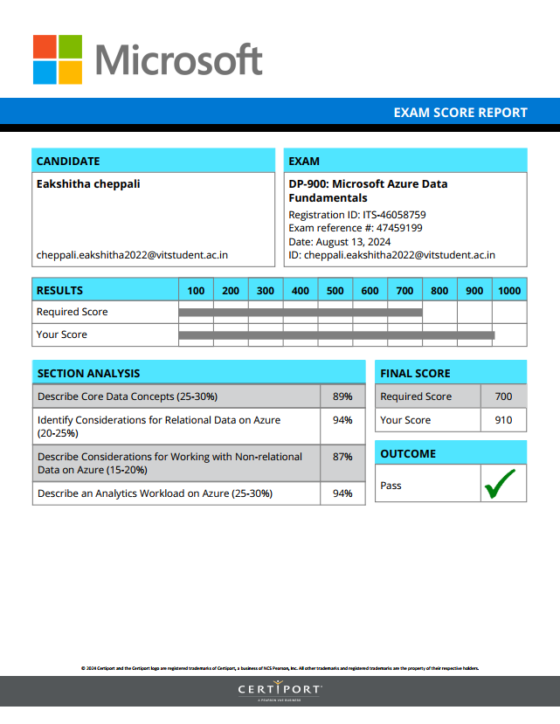

**ACKNOWLEDGEMENT**

I would like to express my sincere gratitude to **Dr. Renuka Devi** , Head of the Department, B.Tech Computer Science and Engineering, SCSE, VIT Chennai, for his invaluable guidance and unwavering support throughout the course of this internship. His leadership has been instrumental in fostering an environment of academic and professional excellence.

I am deeply thankful to **Dr. Ganesan R**, Dean of the School of Computer Science & Engineering, VIT Chennai, for providing the resources and opportunities that have enriched my learning experience.

I would also like to extend my appreciation to **Dr. Parvathi R**, Associate Dean (Academics), School of Computer Science & Engineering, VIT Chennai, for her academic mentorship and insightful feedback, which have been crucial to my development.

My heartfelt thanks go to **Dr. Geetha S**, Associate Dean (Research), School of Computer Science & Engineering, VIT Chennai, for her support and encouragement, which greatly motivated me to explore new perspectives in my work.

Finally, I wish to acknowledge the unwavering support of my family and friends, whose encouragement has been a constant source of strength and motivation during this journey.

**CONTENTS**

|  |  |  |
| --- | --- | --- |
| **Chapter** | **Title** | **Page** |
|  | Title Page | 1 |
|  | Declaration | 2 |
|  | Certificate | 3 |
|  | Course certificate | 4 |
|  | Scorecard | 5 |
|  | Acknowledgement | 6 |
|  | Table of contents | 7 |
|  | List of Figures | 8 |
|  | List of Abbreviation | 9 |
|  | Abstract | 10 |
| 1 | Introduction | 12 |
| 2 | Chapter 1: core data concepts | 13 |
| 3 | Chapter 2: Relational data in Azure | 17 |
| 4 | Chapter 3: Non Relational data in Azure | 20 |
| 5 | Chapter 4: Modern data Warehousing | 24 |
| 6 | Chapter 5: Data Analytics with Azure | 26 |
| 7 | Chapter 6: Securing data in Azure | 29 |
|  |  |  |
|  | Conclusion | 30 |
|  | References | 30 |

**LIST OF FIGURES**

|  |  |
| --- | --- |
| **Title** | **Page** |
| Fig 1: structured Data | 14 |
| Fig 2: semi structured data | 14 |
| Fig 3: Unstructured Data | 15 |
| Fig 4: Relational Database | 16 |
| **Fig 5:** **OLTP** | 17 |
| **Fig 6: OLAP** | 17 |
| **Fig 7: Indexes** | 18 |
| Fig 8: Non- Relational Data | 21 |
| Fig 9: Blob storage | 21 |
| Fig 10: Table storage | 23 |
| Fig 11: Data Warehouse | 24 |
| Fig 12: Azure Synapse | 25 |
| **Fig 13: Data Ingestion Pipelines** | 14 |

**LIST OF ABBREVIATIONS**

|  |  |
| --- | --- |
| **Abbreviation** | **Expansion** |
| ACID | Properties that ensure reliable database transactions |
| AI | Artificial Intelligence |
| API | Application Programming Interface |
| CRUD | Create, Read, Update, Delete |
| IoT | Internet of Things |
| JSON  SQL | JavaScript Object Notation  Structured Query Language |

**ABSTRACT**

The Microsoft Azure Data Fundamentals (DP-900) course offers a comprehensive introduction to essential data concepts and their application within the Microsoft Azure ecosystem. It is designed to help beginners understand how data is stored, processed, and analyzed in the cloud, with a focus on Azure’s key data services. The course starts by exploring core data concepts, laying the foundation by introducing various types of data (structured, semi-structured, and unstructured), and how they are stored across different systems. This foundational knowledge prepares learners to better understand data management, governance, and integration across the cloud.

The next module dives into relational data in Azure, where learners gain hands-on experience with Azure SQL Database. This service, based on Microsoft SQL Server, allows users to manage structured data in a relational model. The course covers how to design and query relational databases using SQL, while emphasizing the scalability and security benefits of Azure’s cloud environment. Topics such as tables, indexes, joins, and transactions are explored to provide a solid grasp of relational data principles in the cloud.

Following this, the course explores non-relational data in Azure, focusing on NoSQL databases like Azure Cosmos DB. This section highlights how NoSQL databases can efficiently store and retrieve unstructured or semi-structured data, which is increasingly common in modern applications like IoT, social media, and content management systems. Azure Cosmos DB's global distribution and multi-model support make it a powerful tool for businesses requiring high scalability and low-latency data access.

The final module introduces data analytics in Azure, showcasing services that enable businesses to gain insights from vast amounts of data. It covers tools like Azure Data Lake for storing large datasets, Azure Synapse Analytics for running analytics workloads, and Azure Machine Learning for building data-driven models. By the end of the course, learners will have the skills to not only manage and store data effectively but also apply analytics tools to derive meaningful insights from both structured and unstructured dataset

**INTRODUCTION**

**Introduction to Microsoft Azure Data Fundamentals:**

In today’s data-driven world, the ability to manage, analyze, and derive insights from data is more crucial than ever. Microsoft Azure, a leading cloud platform, offers powerful services to help businesses and individuals harness the potential of data in the cloud. The Microsoft Azure Data Fundamentals (DP-900) course is designed to introduce learners to core data concepts and provide a foundational understanding of how data is managed and analyzed using Azure's extensive set of tools. Whether you’re an aspiring data engineer, analyst, or just looking to understand cloud data solutions, this course offers a practical and accessible path to learning how to leverage Azure’s data services for a wide range of applications.

The course begins with an exploration of core data concepts, helping learners understand different data types, storage solutions, and how data is structured and used in modern applications. It provides clarity on key topics such as relational and non-relational data, transactional and analytical processing, and the role of cloud computing in data management. As learners progress, they will be introduced to specific Azure services, including Azure SQL Database, Azure Cosmos DB, and Azure Data Factory, each of which plays a critical role in storing, processing, and moving data within the Azure environment.

Additionally, the course covers data analytics tools in Azure, such as Azure Synapse Analytics and Azure Machine Learning, which empower users to perform high-level data analysis and build intelligent applications. Through practical, hands-on exercises, learners will gain experience using these services to address real-world challenges, from managing transactional data to extracting meaningful insights from large datasets.

In this era of rapid technological change, data literacy is an essential skill, and Microsoft Azure Data Fundamentals provides a clear, practical introduction to the world of data in the cloud.

**CHAPTER 1: CORE DATA CONCEPTS**

* 1. **Introduction**

In today's world, data is a vital resource for businesses and organizations across various industries. Over the past few decades, the volume of data generated by systems, applications, and devices has seen significant growth. This expansion has made data increasingly accessible and valuable for organizations looking to improve efficiency, make informed decisions, and drive innovation. Data solutions, which include various software technologies and platforms, are essential for the collection, analysis, and storage of valuable information.

The need to understand and work with data is becoming a core skill for professionals in every field. In this chapter, we explore the core concepts of data, the different types of data, and the ways in which data is represented and stored. By understanding these concepts, learners will be equipped with the foundational knowledge needed to delve deeper into data management and analytics.

* + 1. **What is Data**

Data is a collection of facts, such as numbers, descriptions, or observations, used to record information. It is organized into structures that represent entities important to an organization, such as customers, products, or sales orders. These entities typically have one or more attributes, or characteristics, such as a customer's name, address, or phone number. Data plays a crucial role in supporting business decisions, enhancing customer experiences, and improving operational efficiency

**1.2 Classifying Data: Structured, Semi-structured, and Unstructured**

Data can be categorized into three main types: **structured data**, **semi-structured data**, and **unstructured data**. Understanding these classifications is key to knowing how data can be processed, stored, and analysed.

**1.2.1 Structured Data**

Structured data refers to data that adheres to a fixed schema, meaning that all data within a given set has the same fields or properties. Most structured data is stored in tabular formats, where the data is represented in rows and columns. For example, a table might list customers and their attributes, such as name, address, and phone number.

Structured data is often stored in relational databases, where multiple tables can reference each other using keys, forming a relational model. The use of structured data is common in business systems where consistency and quick access to information are essential.

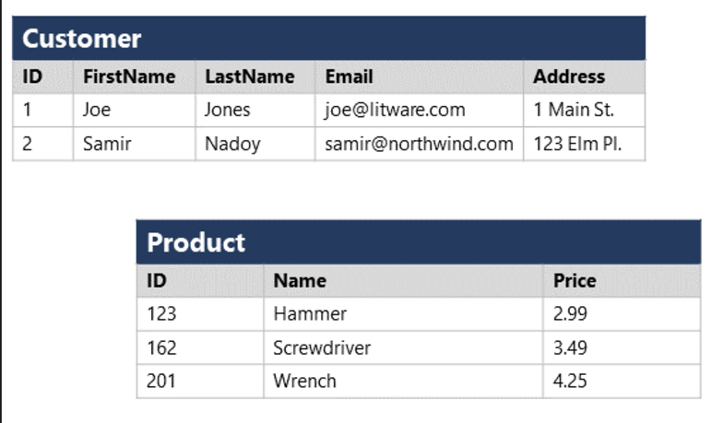

Fig 1: structured Data

**1.2.2 Semi-structured Data**

Semi-structured data contains some organization but allows for variation in the format. It doesn’t conform to a rigid schema like structured data, but still contains tags or markers that define elements within the data.

A common example of semi-structured data is **JSON** (JavaScript Object Notation). In JSON, different instances of the same data entity can have varying attributes. For instance, while most customers may have an email address, some may have multiple addresses or none at all.

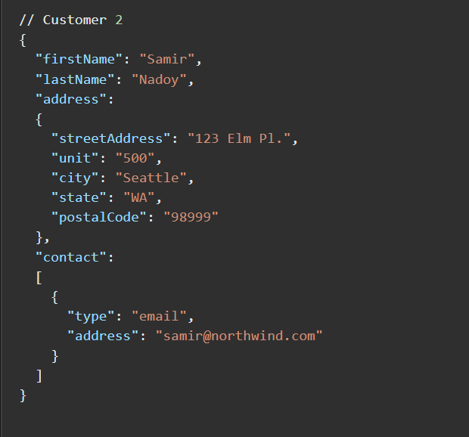

Fig 2: semi structured data

**1.2.3 Unstructured Data**

Unstructured data does not have a predefined structure or organization, making it more challenging to store and analyze. Examples include documents, images, videos, audio files, and binary data. Unlike structured or semi-structured data, unstructured data cannot be easily processed in a tabular format or using conventional relational models.

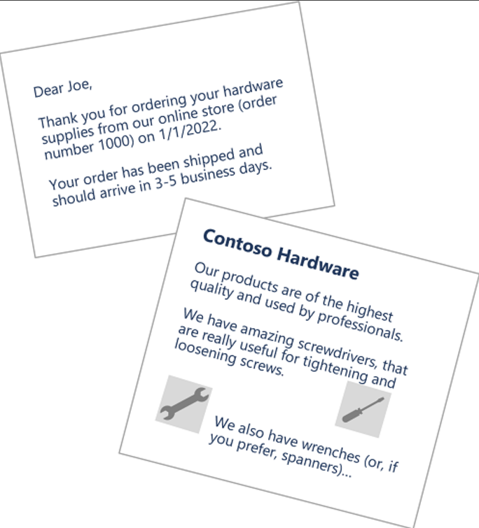

Fig 3: Unstructured Data

**1.3 Data Storage Systems**

Organizations need to store and manage data in a way that facilitates efficient access and analysis. The choice of data storage depends on the type of data and the use case. There are two broad categories of data storage systems:

**1.3.1 File Stores**

File stores are systems that store data as files. This data can be anything from documents to multimedia files. File storage is flexible, allowing users to store data in a variety of formats, but it may not be as efficient for querying or analyzing large volumes of data.

**JSON (JavaScript Object Notation)**: A lightweight, text-based format used for data exchange between systems, organizing data into key-value pairs and arrays. It's flexible and commonly used for semi-structured data, especially in web applications.

**BLOB (Binary Large Object)**: A storage format used for large binary data like images, audio, and video files. BLOBs are raw binary data that require specialized applications to interpret and display.

**1.3.2 Databases**

Databases store data in structured or semi-structured formats and provide a mechanism to store, retrieve, and manage large volumes of information. Databases offer several advantages, such as faster querying, indexing, and the ability to maintain relationships between different types of data.

There are several types of databases, including:

* **Relational Databases**: Use a tabular structure where data is stored in rows and columns.

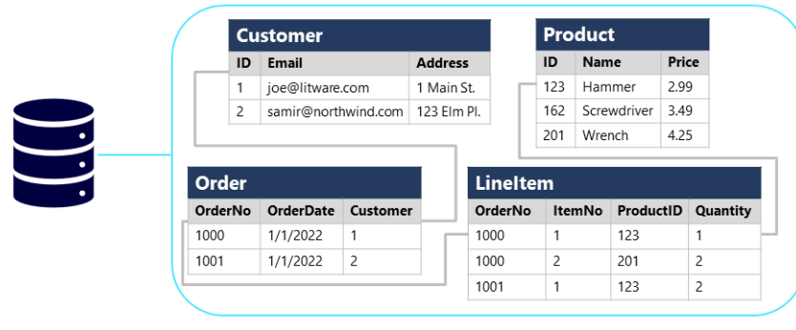

Fig 4: Relational Database

* **NoSQL Databases**: Designed to handle semi-structured or unstructured data, offering flexibility in how data is stored and queried.

Key-value database, Document databases, column family database, graph databases

**1.4 Types of Data Workloads**

Understanding how data is processed is essential for designing effective data solutions. Data workloads can be classified into two main types: **transactional** and **analytical**.

**1.4.1 Transactional Data Processing (OLTP)**

Transactional data processing refers to systems that record events or transactions, such as financial transactions or customer orders. These systems are designed to handle high-volume, real-time transactions. **Online Transactional Processing (OLTP)** systems are optimized for speed and accuracy, allowing organizations to track individual transactions efficiently. The main goal is to follow ACID properties

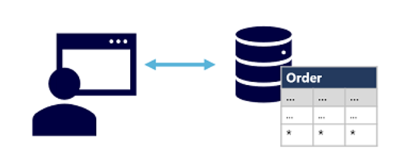

Fig 5: OLTP

**1.4.2 Analytical Data Processing (OLAP)**

Analytical data processing involves large-scale data analysis, typically for business intelligence and reporting. Unlike transactional systems, which are optimized for quick, real-time data entry, **Online Analytical Processing (OLAP)** systems are optimized for querying and analyzing large volumes of historical data to generate reports, visualizations, and insights. Analytical processing often requires complex queries, aggregations, and multi-dimensional data models.

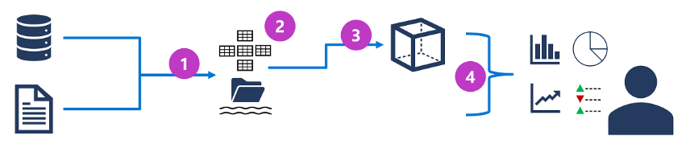

Fig 6: OLAP

**CHAPTER 2: EXPLORE FUNDAMENTAL RELATIONAL DATA CONCEPTS**

**2.1. Introduction to Relational Data**

**2.1.1 Relational Database Model:**  
A relational database organizes data in tables, which are made up of rows (records) and columns (attributes). Each table represents an entity, such as Customer, Product, or Order, and the rows contain individual instances of these entities. For example, a row in a Customer table might contain the details of a specific customer, such as their name, address, and contact details. The relational model uses foreign keys to represent relationships between different entities and primary keys to uniquely identify each record within a table.

**2.1.2 Normalization:**

Normalization is a technique used to minimize redundancy and ensure data integrity. This is achieved by decomposing a large, complex table into smaller, related tables. The primary goal of normalization is to separate data into its most granular level, ensuring that each piece of information is stored only once, which makes it easier to maintain and update. There are several normal forms that guide the normalization process. The use of primary and foreign keys links the tables together, ensuring the consistency of the data.

**2. Database Objects**

**Views**:  
A **view** is essentially a saved query or virtual table in a database. It allows users to query and access data from one or more tables as if they were a single table, without altering the underlying data. Views are beneficial for simplifying complex queries and can provide a level of security by restricting access to certain data in a table

**Stored Procedures**:  
A **stored procedure** is a set of SQL queries that are stored in the database and can be executed on demand. Stored procedures can encapsulate complex business logic and can be reused across multiple applications or queries, thus promoting efficiency and reducing the need for repeated code. They can also accept parameters to perform dynamic operations.

**Indexes**:  
An **index** is a database structure used to quickly locate and retrieve data from a table. Similar to an index in a book, a database index provides a fast lookup method for certain columns, improving query performance. However, creating too many indexes can slow down data modification operations like INSERT, UPDATE, and DELETE, as the indexes also need to be updated.

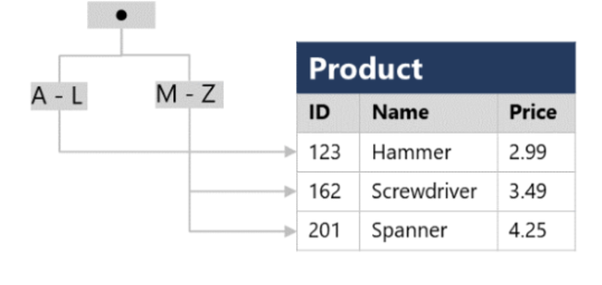

Fig 7: Indexes

**3. SQL Overview**

**SQL (Structured Query Language)**:

SQL is the standard language used for interacting with relational databases. It allows you to perform a variety of operations such as querying data, inserting or updating records, and managing the database schema. SQL has been standardized by ANSI and ISO, but different database management systems (DBMS) such as Microsoft SQL Server, MySQL, and Oracle have developed their own variations or extensions of SQL, known as dialects.

**SQL Dialects**:

While SQL is standardized, each DBMS adds its own features or syntax:

* + **Transact-SQL (T-SQL)**: Used by Microsoft SQL Server and Azure SQL services, it extends SQL with procedural programming constructs.
  + **PL/SQL**: A dialect used by Oracle, which adds procedural features like loops and conditional statements to SQL.
  + **pgSQL**: PostgreSQL’s procedural language that allows developers to write functions and triggers in SQL.

**4. SQL Statement Types**

SQL statements are classified into three main categories:

**Data Definition Language (DDL):**DDL statements are used to define, modify, and remove database structures like tables, views, and indexes. They are responsible for the database schema.

* CREATE: Creates a new object, such as a table or view.
* ALTER: Modifies an existing object (e.g., adding a column to a table).
* DROP: Deletes an object from the database (e.g., dropping a table).
* RENAME: Renames an existing database object.

**Data Control Language (DCL)**:  
DCL statements are used to control access to database objects. These statements manage the permissions and security of the database.

* GRANT: Assigns permissions to a user (e.g., allowing them to view or modify data).
* DENY: Denies specific permissions to a user.
* REVOKE: Removes previously granted permissions

**Data Manipulation Language (DML)**:  
DML statements are used to manipulate the data stored in tables. These operations allow for reading, inserting, updating, and deleting data.

* SELECT: Retrieves data from one or more tables.
* INSERT: Adds new data to a table.
* UPDATE: Modifies existing data.
* DELETE: Removes data from a table.

**5. Common SQL Operations**

* SELECT:  
  The SELECT statement is the most commonly used SQL operation for retrieving data. You can use WHERE clauses to filter results, ORDER BY to sort the data, and JOIN to combine data from multiple tables
* INSERT:  
  The INSERT statement adds new rows to a table. It can be used to insert one or multiple rows at a time, depending on the SQL dialect.
* UPDATE:  
  The UPDATE statement is used to modify existing records in a table. You should always include a WHERE clause to specify which records should be updated to avoid updating all records unintentionally.
* DELETE:  
  The DELETE statement removes rows from a table. As with UPDATE, it is critical to include a WHERE clause to prevent accidental deletion of all rows.

**CHAPTER 3:**

**EXPLORE NON-RELATIONAL DATA IN AZURE**

**3.1 Introduction to Non-Relational Data**

Non-relational data, often referred to as NoSQL, contrasts with traditional relational data in its structure, storage, and flexibility. While relational databases organize data into tables with predefined schemas, non-relational data allows for greater flexibility by accommodating unstructured and semi-structured data formats. These data types do not need a fixed schema and are designed to scale horizontally across distributed systems.

Azure provides a range of cloud-based services designed to store and manage non-relational data, offering scalability, flexibility, and cost-effective solutions for applications dealing with large volumes of unstructured or semi-structured data.

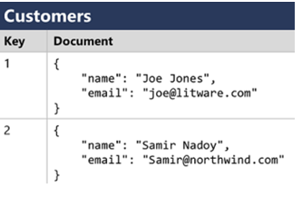

Fig 8: Non- Relational Data

**2. Azure Storage Services for Non-Relational Data**

Azure offers several storage services specifically designed for handling non-relational data. These services provide both performance and scalability, making them ideal for cloud-based applications that need to store and manage large datasets with varying formats.

**2.1. Azure Blob Storage**

Azure Blob Storage is a service designed to store massive amounts of unstructured data. The data is stored in **blobs**, which are objects that can contain data of various types, including text, images, videos, and documents.

* **Blob Types**:
  + **Block Blobs**: Ideal for storing large amounts of data that is uploaded and downloaded in blocks (e.g., media files, backups). Block blobs support efficient uploads and downloads in blocks of data.
  + **Page Blobs**: Optimized for read/write operations and used primarily for virtual machine disks. A page blob supports random access to pages of 512 bytes.
  + **Append Blobs**: Designed for situations where new data is continuously appended, such as logging data. These blobs are ideal for scenarios where data grows over time and the previous data cannot be modified.

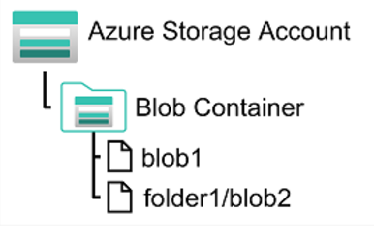

Fig 9: Blob storage

* **Key Features of Azure Blob Storage**:
  + **Massive Scalability**: Azure Blob Storage can handle petabytes of data, making it suitable for large-scale data storage needs.
  + **Access Tiers**: Blob storage offers three access tiers—Hot, Cool, and Archive. These tiers allow users to optimize costs by storing data that is accessed frequently in the Hot tier, infrequently accessed data in the Cool tier, and rarely accessed data in the Archive tier.
* **Use Cases**:
  + **Backup and Disaster Recovery**: Storing large backups or data snapshots.
  + **Big Data Analytics**: Supporting analytics workloads by providing storage for vast amounts of unstructured data.

**2.2. Azure Table Storage**

Azure Table Storage is a NoSQL key-value store designed to store structured, semi-structured, or unstructured data. This service is highly scalable and efficient for applications that need fast access to large amounts of data.

* **Data Model**: Data in Azure Table Storage is organized into **tables**, with each row containing a **partition key** and **row key**. These keys help efficiently query and organize data in a way that supports scalability.
* **Key Features**:
  + **Partitioning**: Tables are split into partitions based on the partition key, which helps with scalability and performance. Data retrieval is faster when partition keys are used effectively in queries.
  + **Scalability**: Azure Table Storage automatically scales to meet the needs of applications by distributing data across multiple servers.
  + **Flexible Schema**: While rows in the same table must have the same partition key, they can contain different columns. This flexible structure allows for varied data formats.
* **Use Cases**:
  + **Logging**: Store application logs or telemetry data.
  + **Cataloging**: Store catalog data like product inventories, where each row represents an individual product with varying attributes.

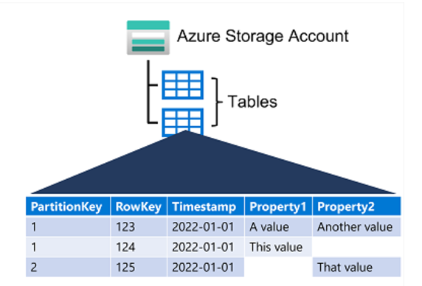

Fig 10 :Table storage

**2.3. Azure Cosmos DB**

Azure Cosmos DB is a globally distributed, multi-model database service designed for mission-critical applications that require high availability, low latency, and massive scalability. Unlike Azure Table Storage, Cosmos DB supports multiple data models, including document, graph, column-family, and key-value.

* **Core Features**:
  + **Multiple Data Models**: Cosmos DB supports various NoSQL data models, such as document-based (using MongoDB API), key-value, graph (using Gremlin API), and column-family.
  + **Global Distribution**: Cosmos DB is built to provide low-latency, high-availability access to data across globally distributed regions, making it perfect for applications that need to support users from multiple geographic locations.
  + **Automatic Scaling**: Cosmos DB can automatically scale throughput and storage to meet the demands of growing applications without manual intervention.
* **Use Cases**:
  + **Real-time Applications**: Ideal for applications that require low-latency, such as real-time analytics or IoT systems.
  + **Global Applications**: Used by applications that require data replication across multiple geographic locations to provide fast access globally.

**2.4. Azure Data Lake Storage Gen2**

Azure Data Lake Storage Gen2 combines the capabilities of Azure Blob Storage and the Hadoop Distributed File System (HDFS) to provide a highly scalable data lake for big data analytics. It is built on top of Azure Blob Storage but provides advanced features for analytics workloads.

* **Hierarchical Namespace**: Unlike standard Blob Storage, Data Lake Gen2 supports a hierarchical namespace, allowing data to be organized in a file system-like structure with directories and subdirectories.
* **Compatibility**: Data Lake Storage Gen2 is compatible with Azure Analytics services like Azure Databricks, HDInsight, and Azure Synapse Analytics, enabling seamless integration with big data processing tools.
* **Key Features**:
  + **High Performance**: Optimized for big data workloads, with high throughput and low-latency data access.
  + **Cost Optimization**: Supports multiple storage tiers and policies for data lifecycle management, helping to reduce costs by automatically moving data to cheaper tiers based on usage.
* **Use Cases**:
  + **Big Data Analytics**: Storing and processing large datasets for analytics and machine learning.
  + **Data Lakes**: Creating centralized storage for vast amounts of raw, unstructured data that can be processed later.

**CHAPTER 4: MODERN DATA WAREHOUSING**

**4.1 Understanding Data Warehousing**

In today’s data-driven world, organizations need systems that can store, manage, and analyze large volumes of information from various sources. Data warehousing is designed to meet this requirement by offering a centralized repository optimized for high-performance analytics and reporting. Unlike transactional databases, which support day-to-day operations, data warehouses focus on storing historical data, making it easier for businesses to derive insights for strategic decision-making.

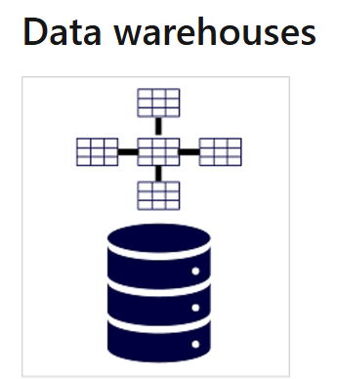

Fig 11: Data Warehouse

**Example**: A global retail chain may utilize a data warehouse to analyze historical sales data across different regions, helping forecast demand, optimize inventory, and understand customer preferences.

**4.2 Overview of Azure Synapse Analytics**

Azure Synapse Analytics is an advanced, integrated analytics service that combines big data processing, data integration, and analytics on a single platform. It is specifically designed to offer

**Key Features**:

1. **Serverless Querying**: Execute on-demand queries directly on data stored in Azure Data Lake without the need for infrastructure provisioning.
2. **Integrated Pipelines**: Build seamless ETL (Extract, Transform, Load) workflows for data ingestion and transformation.
3. **Security**: Azure Synapse includes robust security features like encryption, role-based access control, and integration with Azure Active Directory.

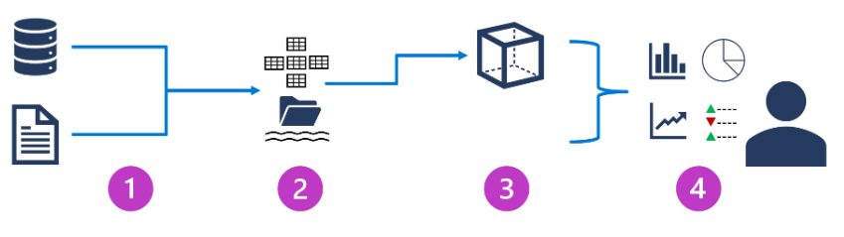

Fig 12 : Azure Synapse

**4.3 Advantages of Modern Data Warehousing**

1. **Unified Data Platform**: Brings together structured and unstructured data, providing a comprehensive view of business operations.
2. **Scalability**: Azure Synapse allows dynamic scaling to handle workloads of varying sizes while maintaining consistent performance.
3. **Advanced Analytics**: The platform uses machine learning and AI to detect patterns and predict future trends.
4. **Example**: A healthcare provider could leverage Azure Synapse to analyze patient data, identifying trends in disease outbreaks or treatment outcomes.

**4.4 Real-World Use Cases for Data Warehousing**

* **Retail**: Analyzing customer purchase history to refine marketing strategies and personalize recommendations.
* **Finance**: Using historical data to monitor stock market trends or assess portfolio performance.
* **Healthcare**: Aggregating clinical trial data to support drug development and medical research.

**4.5 Data Warehousing Challenges**

1. **Cost Control**: Processing and storing vast datasets can quickly become expensive.
2. **Data Integration**: Integrating data from disparate sources can lead to inconsistencies or errors
3. **Real-Time Processing:** Data warehouses are often optimized for batch processing, which can limit real-timedata analysis. Azure Synapse helps mitigate these challenges by offering features like automated optimization and integration tools.

**CHAPTER 5:**

**DATA ANALYTICS WITH AZURE**

**5.1 The Role of Data Analytics**

Data analytics involves processing raw data to discover valuable insights, patterns, and trends. In the modern business landscape, data analytics drives decision-making, improves operational efficiency, and allows businesses to offer personalized customer experiences.

**Analogy:** Think of navigating through a dense forest without a map—this is how companies operate without data analytics. By analyzing their data, organizations create a "map" that reveals key opportunities, risks, and the most effective paths forward.

**5.2 Azure’s Data Analytics Ecosystem**

Azure provides an extensive range of tools to support data analytics. These tools cater to all types of analytics: descriptive (what happened), predictive (what might happen), and prescriptive (what should be done).

**5.3 Key Azure Tools for Data Analytics**

**Azure Power BI**: A powerful business intelligence tool that transforms raw data into interactive dashboards and reports.  
Example: A retail business uses Power BI to track sales trends and identify top-selling products.

**Azure Stream Analytics:** Enables real-time analytics on data streams from sources like IoT devices and social media feeds.  
Example: A logistics company uses Stream Analytics to optimize fleet routes in real-time.

**Azure Machine Learning:** Facilitates predictive analytics by building models to forecast future trends.  
Example: A bank uses machine learning models to predict loan default risks based on customer data.

**Azure Synapse Analytics:** A comprehensive platform that integrates data warehousing, data integration, and analytics for end-to-end analysis.  
Example: A healthcare provider uses Synapse to analyze patient records for insights on improving treatments.

**5.4 Applications of Data Analytics in Real-World Scenarios**

Azure analytics fuels innovation across diverse industries:

* **Healthcare**: Analyzing patient data to predict disease trends and optimize resource allocation.
* **Retail**: Personalizing product recommendations by analyzing shopping behaviors and browsing patterns.
* **Finance**: Detecting fraudulent activities in real-time by analyzing transactional data.
* **Manufacturing**: Improving production efficiency by identifying bottlenecks through real-time data analytics.

**Humanized Example**: Consider an online grocery store that tracks customer purchase patterns. It observes a growing demand for organic products during specific months and uses Azure Power BI to adjust inventory and run targeted promotions, ultimately increasing sales.

**5.5 Ethical Considerations in Data Analytics**

With the power to extract insights from vast amounts of data comes the responsibility to ensure that analytics practices are ethical and transparent.

**Bias**: Data analytics may unintentionally favor certain groups if the data being analyzed is biased.

**Privacy:** Organizations must respect customer privacy and ensure data is used responsibly and with consent.  
Azure provides governance tools such as Azure Policy and Role-Based Access Control to enforce ethical practices in data analytics.

**5.6 Challenges in Data Analytics**

While data analytics offers immense benefits, several challenges remain:

1. **Data Quality**: Incomplete or inconsistent data can lead to misleading insights.
2. **Complexity**: Implementing advanced analytics often requires specialized expertise.
3. **Cost Management**: Real-time processing and handling large datasets can quickly escalate in cost.  
   Azure addresses these issues with user-friendly interfaces, cost-management tools, and scalable analytics capabilities.

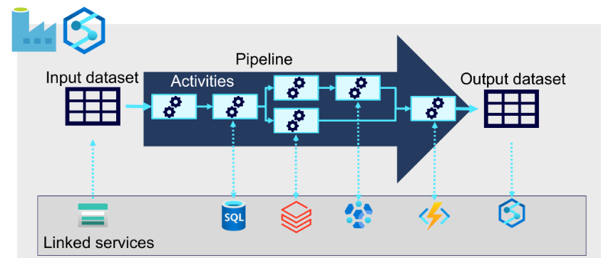

Fig 13: Data Ingestion Pipelines

Power BI, developed by Microsoft and launched in 2015, is a powerful business analytics tool designed to help users visualize and analyze data effectively. It enables the creation of interactive dashboards and reports, allowing users to connect to a wide variety of data sources such as Excel, SQL Server, and cloud-based platforms like Azure and Salesforce. With built-in data transformation tools, customizable visualizations, and AI-driven features like natural language Q&A and predictive analytics, Power BI makes data insights accessible even to non-technical users. It supports collaboration through integration with Microsoft Teams and offers cross-platform accessibility via desktop, mobile, and cloud-based services, making it a versatile solution for modern business intelligence needs.

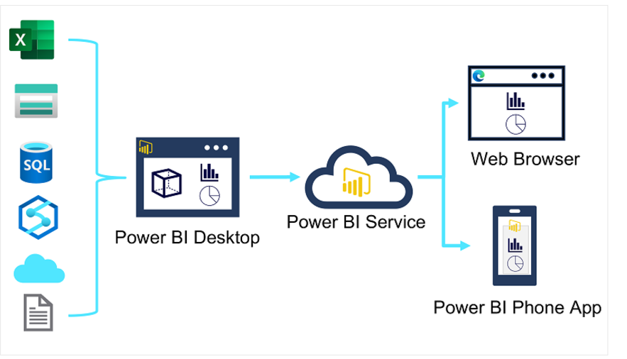

Fig 14: Power BI

**Conclusion**

Data analytics is more than just about extracting numbers—it's about uncovering insights and telling a story through data. By utilizing Azure’s suite of analytics tools, organizations can drive innovation, optimize business processes, and enhance customer experiences. Whether it’s predicting customer preferences, detecting fraud, or improving operational efficiency, Azure's powerful data analytics capabilities empower businesses to transform data into actionable strategies while maintaining ethical standards.

**CHAPTER 6: SECURING DATA IN AZURE**

**6.1 The Need for Data Security**

As data becomes increasingly valuable, it also becomes a prime target for cyber threats. Organizations must prioritize data security, not only to comply with regulatory requirements but also to maintain customer trust and safeguard operational integrity.

**6.2 Azure Security Features**

Azure offers a wide array of security solutions designed to protect your data:

1. **Azure Security Center**: Provides unified security management and threat protection for Azure resources.
2. **Azure Key Vault**: Safeguards encryption keys and secrets, ensuring secure data access.
3. **Azure Policy**: Helps organizations enforce compliance standards and best practices automatically.  
   **Example**: A financial institution can utilize Azure Key Vault to securely manage and protect sensitive transaction data.

**6.3 Global Compliance Standards**

Azure adheres to key global compliance frameworks to ensure data security and privacy:

* **GDPR**: Ensures compliance with data protection laws in the EU.
* **HIPAA**: Guarantees secure handling of healthcare-related data.
* **ISO/IEC 27001**: A globally recognized standard for information security management.

**6.4 Security Challenges in Data Protection**

1. **Data Breaches**: Unauthorized access to sensitive data can lead to financial and reputational harm.
2. **Compliance Adherence**: Continuously adapting to evolving regulations remains a challenge.
3. **Insider Threats**: Monitoring and preventing misuse of data by authorized personnel is critical.  
   Azure’s built-in threat detection, monitoring, and governance tools help mitigate these risks, offering robust defense mechanisms to safeguard data.

**CONCLUSION**

In conclusion, Azure provides a robust suite of services for managing non-relational data, offering organizations flexibility, scalability, and cost efficiency. From Azure Blob Storage for storing large amounts of unstructured data to Azure Cosmos DB for globally distributed applications, each service is designed to meet specific needs. Whether it's handling key-value pairs, documents, or massive data lakes, Azure’s non-relational storage solutions provide the necessary tools to store, manage, and analyze data efficiently.

By leveraging these services, businesses can ensure that their data is accessible, scalable, and optimized for performance. With options like Azure Table Storage and Azure Data Lake Storage Gen2, users can handle a wide variety of workloads, from simple data retrieval to complex big data analytics. Additionally, Azure’s ability to integrate with other services such as Azure Databricks, HDInsight, and Azure Synapse Analytics enhances the capability to perform advanced analytics and machine learning.

Ultimately, understanding the strengths and use cases of these non-relational storage solutions enables organizations to design a data strategy that aligns with their application requirements, ensuring seamless performance, cost efficiency, and scalability in the cloud. As data needs continue to grow and evolve, Azure’s flexible, cloud-based storage options offer the tools necessary for future-proofing your data architecture

**REFERENCES**

1. Microsoft, "Azure AI Fundamentals: AI Overview," Microsoft Learn. [Online]. Available: <https://learn.microsoft.com/en-us/training/paths/azure-ai-fundamentals/>. [Accessed: Nov. 2024].
2. Microsoft, "Azure Cognitive Services Overview," Microsoft Azure. [Online]. Available: <https://azure.microsoft.com/en-us/services/cognitive-services/>. [Accessed: Nov. 2024].
3. Microsoft, "Azure Machine Learning Documentation," Microsoft Learn. [Online]. Available: <https://learn.microsoft.com/en-us/azure/machine-learning/>. [Accessed: Nov. 2024].
4. Microsoft, "Azure Form Recognizer Documentation," Microsoft Learn. [Online]. Available: <https://learn.microsoft.com/en-us/azure/applied-ai-services/form-recognizer/>. [Accessed: Nov. 2024].
5. Microsoft, "Azure Synapse Analytics Overview," Microsoft Learn. [Online]. Available: <https://learn.microsoft.com/en-us/azure/synapse-analytics/>. [Accessed: Nov. 2024].
6. Microsoft, "Azure Security Center Documentation," Microsoft Learn. [Online]. Available: <https://learn.microsoft.com/en-us/azure/security-center/>. [Accessed: Nov. 2024].
7. Microsoft, "Azure Data Fundamentals: Module Library," Microsoft Learn. [Online]. Available: <https://learn.microsoft.com/en-us/training/courses/dp-900t00>. [Accessed: Nov. 2024].