Name : Eakshitha Cheppali
Reg No : 22BPS1184
Experiment : Mqtt and Via protocol communication
1. Via protocol:

Aim:
To implement a client-server communication system using Node.js that simulates VIA protocol communication, where the server generates random anomaly data (e.g., temperature or pressure drop), and the client sends requests, receives responses, and sends confirmations.

Process :
- Setup:
  - Initialize a Node.js project with npm init.
  - Install the required package using npm install via.
- Server Design (server.js):
  - Uses Node's built-in net module to create a TCP server.
  - Listens on port 6000 and waits for client connections.
  - Parses REQUEST messages from the client.
  - Sends back a RESPONSE|TYPE|VALUE|TIMESTAMP.
  - Logs confirmation (CONFIRM|TYPE) from the client.
- Client Design (client.js):
  - Connects to the server on port 6000.
  - Sends simulated requests like REQUEST|TEMP_ANOMALY and REQUEST|PRESSURE_DROP.
  - Receives and logs server responses.
  - Sends back confirmation messages for each response.
- Message Format (VIA Protocol):
  - Standardized as REQUEST|TYPE, RESPONSE|TYPE|VALUE|TIMESTAMP, and CONFIRM|TYPE.
- Execution:
  - The server is run using node server.js.
  - The client is run using node client.js.
  - Logs are printed to the console showing full request-response-confirm flow.
Code :
Client.js:
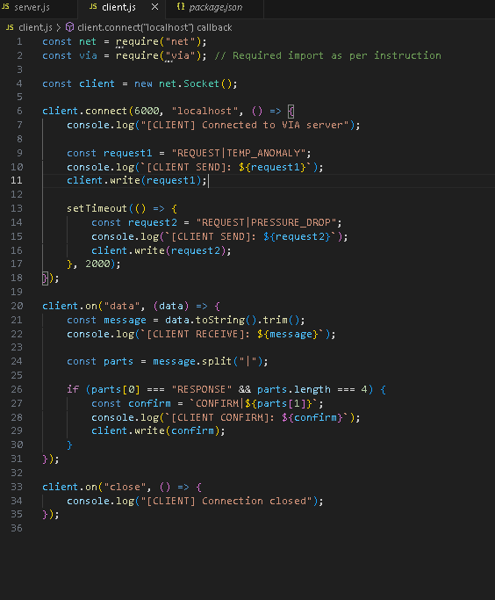

Server.js:
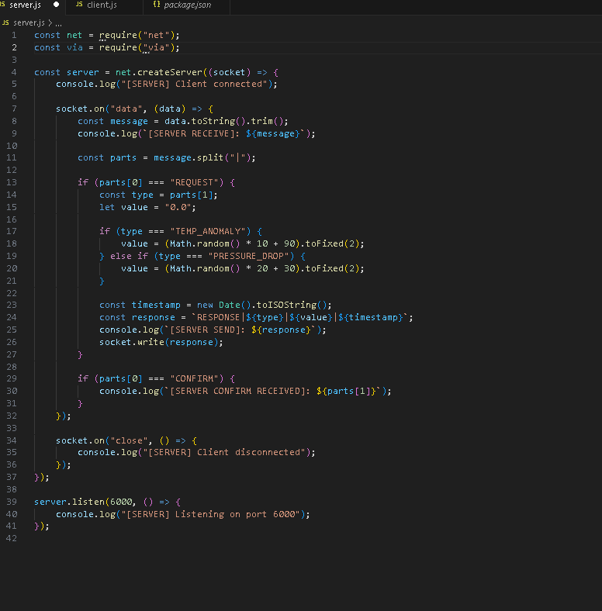

Output screenshots:
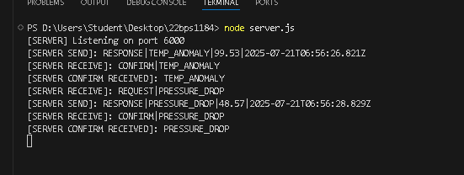

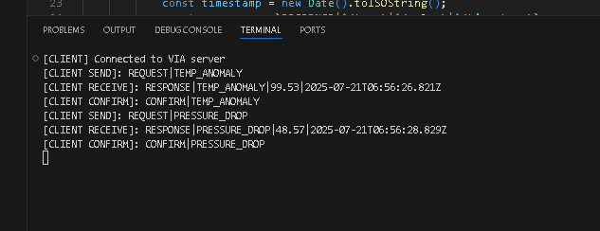

Conclusion:
The project successfully simulates a basic VIA protocol-based communication system using Node.js and TCP sockets. It demonstrates how a client can send data requests to a server, receive formatted anomaly data such as temperature or pressure readings, and confirm the reception of that data. This setup models a simple but effective command-response-confirmation communication pattern often used in real-time monitoring systems, highlighting the usefulness of structured protocols like VIA in client-server architectures.
2. MQTT PROTOCOL
Aim :
To implement a real-time MQTT-based communication system using Node.js where:
- A Publisher continuously sends temperature data.
- A Subscriber (Client) listens to the temperature.
- If the temperature falls below a threshold (30°C), the Subscriber sends an alert back.
- The Publisher listens for and logs this alert.
Process :
- Install mqtt using npm
- Created a Publisher (publisher.js):
  - Sends random temperature values every 2 seconds to the topic sensor/temp.
  - Also listens for alerts on topic alerts/temp.
- Created a Subscriber (subscriber.js):
  - Listens to the sensor/temp topic.
  - Checks the temperature.
  - If temperature is less than 30°C, sends an alert to topic alerts/temp.
- Publisher receives the alert and prints it to the console.
Code:
Publisher.js:
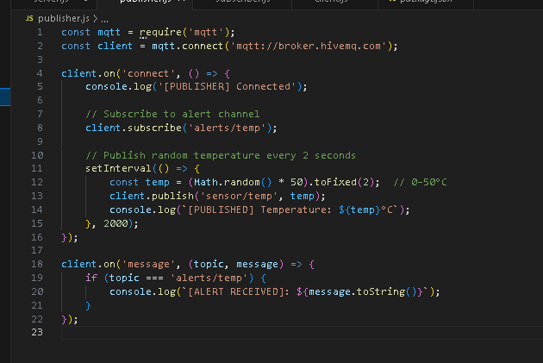

Subscriber.js:
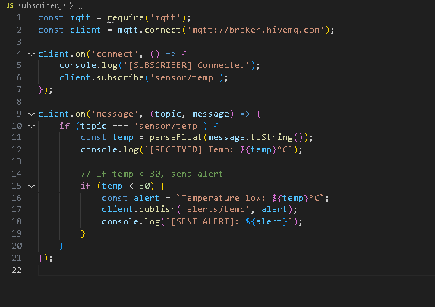
Output screen shots:
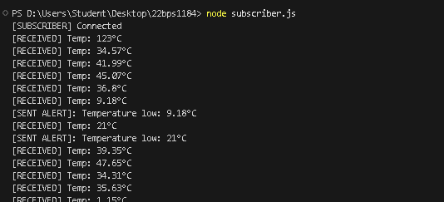
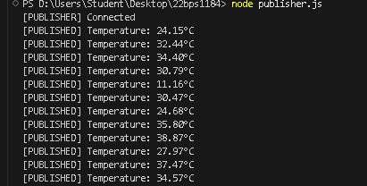

Conclusion:
In this project, we successfully implemented a basic real-time communication system using the MQTT protocol in Node.js. A publisher continuously generated and sent random temperature data, while a subscriber monitored this data in real time. Whenever the temperature fell below 30°C, the subscriber sent an alert message back to the publisher. This demonstrated a two-way communication model where devices can exchange data and respond to conditions dynamically. The project showcases how MQTT can be effectively used for lightweight, efficient communication in IoT applications such as remote monitoring, automation, and sensor-based systems.

