**Milestone 2**

**Overview of product , research on product and Risk Factors**

**Production selection : Rice**

1. **Introduction Rice is a staple food for a significant portion of India’s population and a critical agricultural product. India is one of the largest producers and consumers of rice globally, with West Bengal leading in production. Given its importance in food security and trade, rice has a complex supply chain involving multiple stakeholders, from farmers to distributors. This document explores the supply chain of rice, focusing on West Bengal, and identifies the risk factors that could disrupt its availability, cost, and quality.**

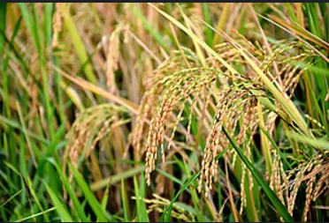

**2. Overview of the Rice Supply Chain The rice supply chain involves several interconnected stages:**

1. **Cultivation: Rice is primarily grown in regions with fertile soil and abundant water. In India, major production states include West Bengal, Uttar Pradesh, Punjab, Bihar, and Andhra Pradesh. West Bengal is the largest contributor, producing over 15% of the nation’s rice.**
2. **Harvesting: Rice is harvested during three primary seasons: Aus, Aman, and Boro. The timing and methods of harvesting significantly impact the quality and yield.**
3. **Processing and Packaging: Post-harvest, rice undergoes milling to remove the husk and bran, producing polished rice. It is then packaged for distribution.**
4. **Storage: Rice is stored in warehouses and silos to ensure a steady supply throughout the year. Proper storage is crucial to prevent spoilage.**
5. **Distribution: The rice is transported to markets, wholesalers, and retailers across India and internationally.**
6. **Consumption: Rice reaches end consumers, including households, restaurants, and food manufacturers.**

**3. Risk Factors in the Rice Supply Chain The rice supply chain faces risks that can disrupt production, distribution, and pricing. These risks are categorized into environmental, economic, geopolitical, and logistical factors.**

**A. Environmental Risks**

1. **Climate Change and Weather Events:**
   * **Rice cultivation depends heavily on monsoons and stable weather conditions. Irregular rainfall, floods, droughts, and cyclones can severely impact production.**
   * **Impact: Reduced yields, delays in harvesting, and lower quality due to waterlogging or drought stress. For instance, cyclones in West Bengal frequently damage crops and infrastructure.**
2. **Pests and Diseases:**
   * **Pests like rice stem borers and diseases such as bacterial leaf blight can devastate crops.**
   * **Impact: Increased costs for pest control, reduced productivity, and potential crop failure.**

**B. Economic Risks**

1. **Price Volatility:**
   * **Prices fluctuate due to changes in supply, demand, and production costs. Poor harvests or export bans can drive prices up.**
   * **Impact: Unpredictable costs for consumers and businesses, creating market instability.**
2. **Input Costs:**
   * **Rising costs of seeds, fertilizers, and labor put financial pressure on farmers.**
   * **Impact: Reduced profitability and potential abandonment of rice farming by smallholders.**

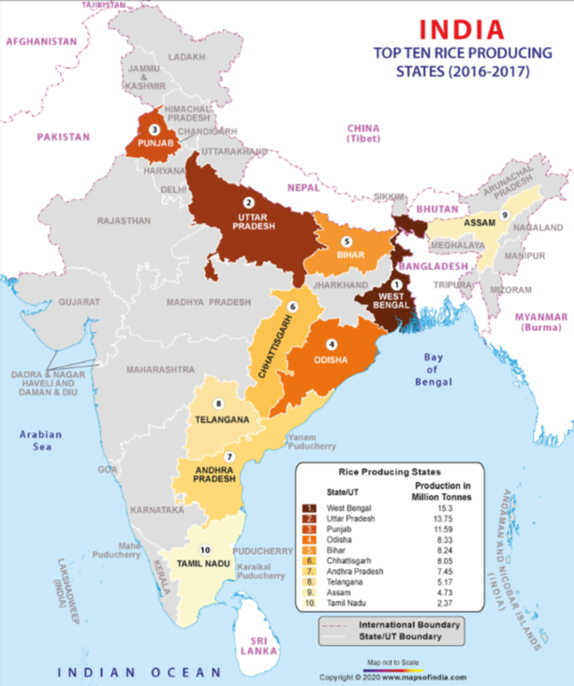

**C. Geopolitical Risks**

1. **Policy and Regulatory Changes:**
   * **Government policies on Minimum Support Price (MSP), export bans, or import tariffs can affect the supply chain.**
   * **Impact: Sudden policy changes can create uncertainty for farmers and traders.**
2. **Land Ownership and Tenure Issues:**
   * **Land fragmentation and disputes over ownership can limit large-scale farming.**
   * **Impact: Inefficient production practices and reduced economies of scale.**

**D. Logistical Risks**

1. **Transportation and Infrastructure:**
   * **Poor road connectivity and inadequate storage facilities in rural areas hinder the timely movement of rice.**
   * **Impact: Delays in delivery, increased costs, and post-harvest losses.**
2. **Supply Chain Complexity:**
   * **The involvement of multiple stakeholders increases the risk of bottlenecks at various stages.**
   * **Impact: Inefficiencies and higher costs.**

**E. Natural Disaster Risks**

1. **Floods and Cyclones:**
   * **West Bengal’s vulnerability to natural disasters like floods and cyclones poses significant risks to rice cultivation.**
   * **Impact: Large-scale crop destruction, infrastructure damage, and supply chain disruptions.**
2. **Droughts:**
   * **Insufficient rainfall during critical growing periods can reduce yields.**
   * **Impact: Lower production and increased reliance on irrigation.**

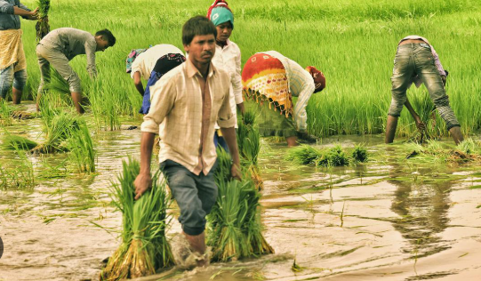

**4. Mitigation Strategies for Risk Management To address these risks, stakeholders in the rice supply chain can implement several strategies:**

1. **Climate-Resilient Practices:**
   * **Promote the use of drought-resistant and flood-tolerant rice varieties.**
   * **Implement water management practices like System of Rice Intensification (SRI) to optimize water use.**
2. **Infrastructure Development:**
   * **Invest in modern storage facilities to reduce post-harvest losses.**
   * **Improve rural road networks and transportation systems.**
3. **Policy Interventions:**
   * **Ensure stable MSP policies to protect farmers from price volatility.**
   * **Provide subsidies and low-interest loans for small farmers to adopt modern farming techniques.**
4. **Diversification and Buffering:**
   * **Encourage crop diversification to reduce dependency on rice alone.**
   * **Maintain buffer stocks to stabilize supply during disruptions.**
5. **Technology Adoption:**
   * **Use AI and satellite technology for weather forecasting and crop monitoring.**
   * **Implement blockchain for supply chain traceability, ensuring transparency and quick response to disruptions.**
6. **Community and Stakeholder Engagement:**
   * **Build strong relationships with farmers, cooperatives, and local governments to ensure smooth operations.**
   * **Conduct training programs to educate farmers on sustainable practices.**

**5. Conclusion The rice supply chain in India, particularly in West Bengal, is vulnerable to various risks that threaten its stability and efficiency. Addressing these risks requires a combination of technological innovation, policy support, and community involvement. By adopting proactive measures, stakeholders can ensure a resilient and sustainable rice supply chain, securing food availability and economic stability for millions of people.**