# **Computer Architecture and Technology Convergence Assignment**

# Eamon White / G00364645

Table of Contents

Q1. Binary Arithmetic 2

Q1.1 2

Q1.2 2

Q1.3 2

Q1.4 3

Q1.5 3

Q2. Linux Assignment 3

Q2.1 3

Q2.2 4

Q2.3 6

Q2.4 7

# Q1. Binary Arithmetic

### Q1.1

|  |  |  |  |  |  |  |
| --- | --- | --- | --- | --- | --- | --- |
| 1 | 1 | 0 | 1 | 1 |  | Decimal |
|  | 0 | 1 | 0 | 1 | 1 | 11 |
|  | 1 | 1 | 0 | 1 | 1 | 27 |
| **1** | **0** | **0** | **1** | **1** | **0** | **38** |

### Q1.2

#### Q1.2.1

|  |  |  |  |  |  |  |  |  |
| --- | --- | --- | --- | --- | --- | --- | --- | --- |
| Binary (31) | 0 | 0 | 0 | 1 | 1 | 1 | 1 | 1 |
| Invert | 1 | 1 | 1 | 0 | 0 | 0 | 0 | 0 |
| Add 1 | **1** | **1** | **1** | **0** | **0** | **0** | **0** | **1** |

(256 – 31 = 225 => 2252 = -3110)

#### Q1.2.2

|  |  |  |  |  |  |  |  |  |
| --- | --- | --- | --- | --- | --- | --- | --- | --- |
| Binary (59) | 0 | 0 | 1 | 1 | 1 | 0 | 1 | 1 |
| Invert | 1 | 1 | 0 | 0 | 0 | 1 | 0 | 0 |
| Add 1 | **1** | **1** | **0** | **0** | **0** | **1** | **0** | **1** |

(256 – 59 = 197 => 1972 = -5910)

### Q1.3

|  |  |  |  |  |  |  |  |  |
| --- | --- | --- | --- | --- | --- | --- | --- | --- |
| Binary (233) | 1 | 1 | 1 | 0 | 1 | 0 | 0 | 1 |

(256 – 233 = 23 => 2332 = -2310)

### Q1.4

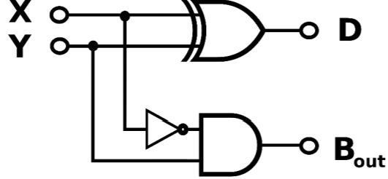

|  |  |  |  |
| --- | --- | --- | --- |
| X | Y | D | B |
| 0 | 0 | 0 | 0 |
| 0 | 1 | 1 | 1 |
| 1 | 0 | 1 | 0 |
| 1 | 1 | 0 | 0 |

### Q1.5

A

B

C

D

# Q2. Linux Assignment

### Q2.1

**Reference:** <https://fossbytes.com/a-z-list-linux-command-line-reference/>

* echo hello world: Displays whatever text is input on the screen (e.g. hello world)
* passwd: Changes user password
* date: Displays system date and time
* hostname: Displays the system’s ip address
* arch: Displays machine hardware name (e.g. 64-bit version of the x86 instruction set)
* uname -a: Displays system information
* dmesg | more: Examine and control the kernel ring buffer (fossbytes)
* uptime: Displays how long the system has been running
* whoami: Displays the username of the current user
* who: Displays who is currently logged-in to the system
* last: Displays a list of recent logins on the system
* finger: Displays user data, including the information listed in *.plan* and *.project* in each user’s home directory (fossbytes)
* w: Displays who is logged-in
* top: Displays real-time view of processes running on the system (fossbytes)
* echo $SHELL: Displays the location and name of the shell being used
* echo {con,pre} {sent,fer} {s,ed}: Displays the text only, without commas and curly braces, but with spaces between the text separated by commas and braces
* man ls: Displays the manual page for the *list* command
* man who: Displays the manual page for the *who* command
* clear: Clears the terminal window of all commands and results
* cal 2000: Displays the calendar for the year 2000
* cal 9 1752: Displays the 9th calendar month (September) of the year 1752. In this month the Julian Calendar was replaced by the Gregorian Calendar. The Julian Calendar was 11 days behind the Gregorian – due to lack of leap-year adjustments – so the days between Sep 3 and Sep 13 inclusive were lost
* yes please: Repeatedly displays a line with a specified string (e.g. please) until killed (Ctrl+c)
* time sleep 5: Suspends execution of a command for 5 seconds
* history: Shows the command history

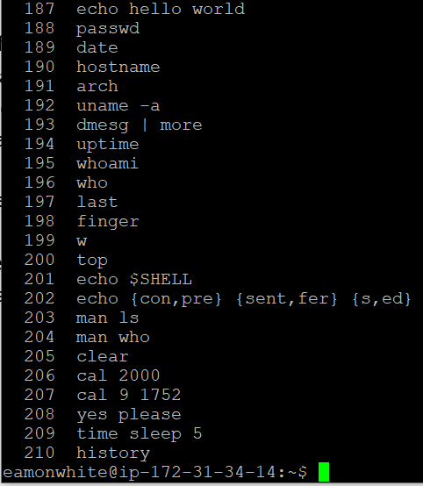

### Q2.2

Fri Apr 26 10:08:33 UTC 2019

ip-172-31-34-14

x86_64

Linux ip-172-31-34-14 4.4.0-1075-aws #85-Ubuntu SMP Thu Jan 17 17:15:12 UTC 2019 x86_64 x86_64 x86_64 GNU/Linux

10:08:33 up 38 days, 23:19, 4 users, load average: 0.00, 0.00, 0.00

eamonwhite

eamonwhite pts/0 2019-04-26 10:08 (51.171.224.136)

cristilupchian pts/1 2019-04-24 10:01 (46.7.94.200)

lisaroessel pts/2 2019-04-26 07:05 (87.198.171.156)

alessandraguerrarios pts/5 2019-04-26 09:43 (87.198.171.156)

Login Name Tty Idle Login Time Office Office Pho ne

alessandraguerrarios pts/5 10 Apr 26 09:43 (87.198.171.156)

cristilupchian pts/1 1d Apr 24 10:01 (46.7.94.200)

eamonwhite pts/0 Apr 26 10:08 (51.171.224.136)

lisaroessel pts/2 3 Apr 26 07:05 (87.198.171.156)

10:08:33 up 38 days, 23:19, 4 users, load average: 0.00, 0.00, 0.00

USER TTY FROM LOGIN@ IDLE JCPU PCPU WHAT

eamonwhi pts/0 51.171.224.136 10:08 0.00s 0.05s 0.00s w

cristilu pts/1 46.7.94.200 Wed10 45:25m 0.54s 0.54s -bash

lisaroes pts/2 87.198.171.156 07:05 3:32 0.10s 0.02s vim tea.sh

alessand pts/5 87.198.171.156 09:43 10:16 0.64s 0.59s top

top - 10:08:55 up 38 days, 23:20, 4 users, load average: 0.00, 0.00, 0.00

Tasks: 137 total, 1 running, 134 sleeping, 2 stopped, 0 zombie

%Cpu(s): 0.0 us, 0.0 sy, 0.0 ni,100.0 id, 0.0 wa, 0.0 hi, 0.0 si, 0.0 st

KiB Mem : 1014436 total, 176420 free, 98212 used, 739804 buff/cache

KiB Swap: 0 total, 0 free, 0 used. 682464 avail Mem

Change delay from 3.0 to q

PID USER PR NI VIRT RES SHR S %CPU %MEM TIME+ COMMAND

1 root 20 0 185408 6132 4132 S 0.0 0.6 1:08.99 /lib/system+

2 root 20 0 0 0 0 S 0.0 0.0 0:00.02 [kthreadd]

3 root 20 0 0 0 0 S 0.0 0.0 0:34.17 [ksoftirqd/+

5 root 0 -20 0 0 0 S 0.0 0.0 0:00.00 [kworker/0:+

7 root 20 0 0 0 0 S 0.0 0.0 0:55.05 [rcu_sched]

8 root 20 0 0 0 0 S 0.0 0.0 0:00.00 [rcu_bh]

9 root rt 0 0 0 0 S 0.0 0.0 0:00.00 [migration/+

10 root rt 0 0 0 0 S 0.0 0.0 0:16.53 [watchdog/0]

11 root 20 0 0 0 0 S 0.0 0.0 0:00.00 [kdevtmpfs]

12 root 0 -20 0 0 0 S 0.0 0.0 0:00.00 [netns]

13 root 0 -20 0 0 0 S 0.0 0.0 0:00.00 [perf]

14 root 20 0 0 0 0 S 0.0 0.0 0:00.00 [xenwatch]

15 root 20 0 0 0 0 S 0.0 0.0 0:00.00 [xenbus]

17 root 20 0 0 0 0 S 0.0 0.0 0:00.91 [khungtaskd]

18 root 0 -20 0 0 0 S 0.0 0.0 0:00.00 [writeback]

19 root 25 5 0 0 0 S 0.0 0.0 0:00.00 [ksmd]

20 root 39 19 0 0 0 S 0.0 0.0 0:07.62 [khugepaged]

### Q2.3

#### Q2.3.1

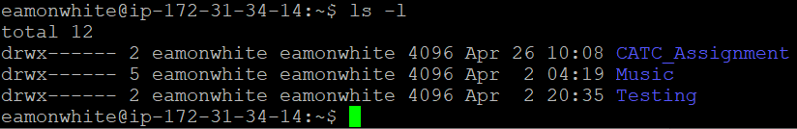

#### Q2.3.2

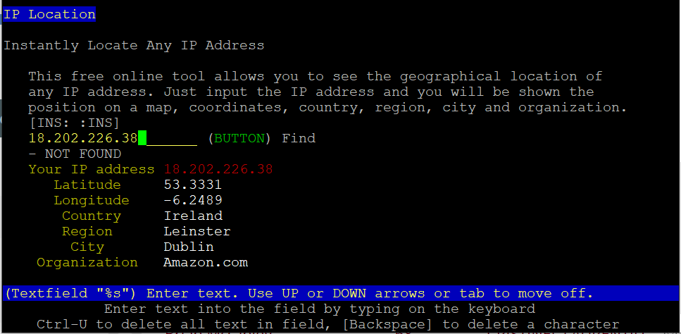

### Q2.4

#### Q2.4.1

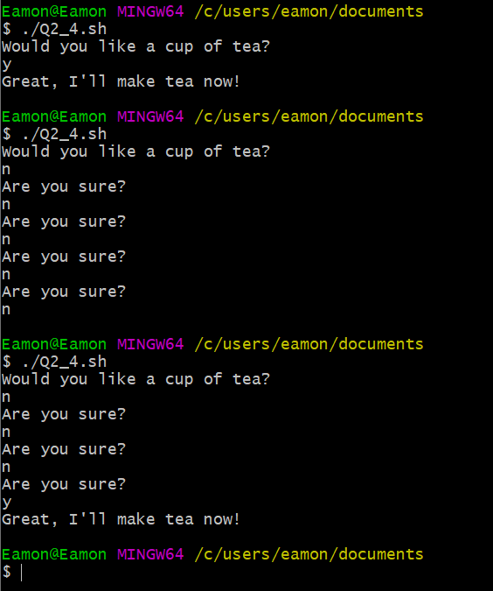

#### Q2.4.2

#!/bin/bash

echo "Would you like a cup of tea?"

read answer

count=1

if [ $answer == "n" ]

then

while [ $count -le 5 ]

do

echo "Are you sure?"

read answer

if [ $answer == "y" ]

then

echo "Great, I'll make tea now!"

break

fi

count=$(( count+1 ))

done

elif [ $answer == "y" ]

then

echo "Great, I'll make tea now!"

fi

