MOVEMENT IN THE PYROCENE: A GLOBAL META-ANALYSIS OF ANIMAL MOVEMENT RESPONSES TO FIRE

CHLOE L. MCAULEY^{1*}, EAMONN I.F. WOOSTER¹, TIM S. DOHERTY^{2,} MITCHELL A. COWAN³, CHRIS J. JOLLY^{4,5}, GRANT D. LINLEY¹, AMY SIMPSON¹, DYLAN M. WESTAWAY^{1,7}, BEN WILSON¹, DALE G. NIMMO¹
Affiliations:
1 Gulbali Institute, School of Agricultural, Environmental and Veterinary Sciences, Charles
Sturt University, Albury, NSW, Australia
2 Fire Science Program, Biodiversity and Conservation Science, Department of Biodiversity, Conservation and Attractions, Kings Park, Western Australia, Australia
3 School of Agriculture and Environment, University of Western Australia,
Crawley, WA, Australia
4 School of Natural Sciences, Macquarie University, Macquarie Park, New South Wales, Australia
5 Research Institute for the Environment and Livelihoods, Charles Darwin University, Darwin, Northern Territory, Australia
7 Australian Wildlife Conservancy, Subiaco, WA, 6009, Australia

* Corresponding author
mcauleychloelee@gmail.com

Target Journal – Global Change Biology
Key words
Home range, movement distances, disturbance, biologging, resource tracking

Abstract
Fire has shaped the earth’s surface for hundreds of millions of years, consuming vegetation and transforming the resource landscape for animals. Movement is a foundational mechanism by which animals respond to environmental change, yet we lack a quantitative synthesis testing how post-fire movements vary across movement types, taxa, fire characteristics and environmental context. We conducted the first global systematic review and meta-analysis synthesising how fire, a globally ubiquitous and rapidly changing disturbance, affects the movement of terrestrial vertebrates. From 84 studies identified during the systematic review, we calculated 112 effect sizes from 42 studies, representing 40 species across four classes. Phylogenetic multilevel meta-analytic models were used to estimate overall movement responses to fire, and to test whether responses varied by movement type, taxonomic classes, biome, body mass, and fire characteristics. Our results revealed fire had small positive overall effect on animal movement (Hedge’s g = 0.2, 95% CI [0.00–0.40], k = 112), although responses were highly variable. Of our model predictors, linear distance movements and prescribed fires were the only moderators that demonstrated clear, yet small positive effects. Uncertain, small positive effects were detected for birds and mammals. We hypothesise resource redistribution, site fidelity, and mobility interact with fine-scale fire characteristics to mediate responses. The variability we found underscores the importance of movement as a plastic behavioural response for taxa occurring in fire-prone landscapes. As fire regimes continue to shift rapidly, further research is needed to better understand the mechanisms driving movement responses and predict how altered fire activity will reshape animal movements into the future.
home range size, movement distances and rates, tortuosity, space use

Main
Fire burns ~3–5% of Earth’s ice-free land surface each year and has shaped ecosystems for hundreds of millions of years (Bowman et al., 2009; He et al., 2019). Fire consumes vegetation, altering resources across scales, from microhabitats (∼m²) to vast landscapes (∼10¹⁰ m²) (Linley et al., 2022). Such changes create challenges for animals that must adapt their behaviour to persist within post-fire landscapes (Doherty et al., 2022; Sitters & Di Stefano, 2020).This challenge is compounded when fire regimes shift rapidly beyond the range of variability to which species are adapted (Jones et al., 2023; Nimmo et al., 2021),such as rapid increases in the frequency and extent of extreme fire events (Cunningham et al., 2024).
Movement is a primary mechanism by which animals keep pace with environmental change (Abrahms et al., 2021). Movement emerges from interactions among external drivers, an animal’s internal state, and its navigation and motion capacity (Nathan et al., 2008). Fire can strongly modify those drivers—depending on event characteristics (e.g., size, severity)—by redistributing resources (e.g., food, vegetation cover) and landmarks (e.g., cues of suitable habitat), and reshaping risk landscapes (e.g., predation; Doherty et al. (2022)). Resulting movement responses should therefore vary among ecosystems, because abiotic and biotic setting (e.g., climate, predator guilds, refuge availability; Robinson et al. (2013)) mediate post-fire conditions, and because resident fauna differ in their evolutionary exposure to particular fire regimes (Nimmo et al., 2021). Superimposed on these ecosystem-level constraints, species traits shaping navigation and movement (e.g., volancy, body size) should further influence the movement patterns that emerge after fire (Marrocco et al., 2025).
Fire reshapes animal movement across scales (Nimmo et al., 2019). Short-term responses include rapid displacement from fire and directional movements towards recently burn areas to exploit transient foraging opportunities (McGregor et al., 2016a; Morollón et al., 2022). By altering landscape structure, fire can also modify fine-scale movement paths, affecting tortuosity (Miritis et al., 2025). Longer-term responses involve shifts in space use and home-range size; for example, bighorn sheep (Ovis canadensis) in Wyoming (USA) expanded home ranges by >200% following wildfire and prescribed burns (Clapp & Beck, 2016). Despite a large number of studies, we still lack a quantitative synthesis testing whether post-fire movement responses are consistent across movement types and taxa, and how they vary with fire characteristics and environmental context.
Here, we present a global systematic review and meta-analysis of fire effects on terrestrial vertebrate movement. We compiled 185 cases, yielding 111 effect sizes from 42 studies spanning 40 taxa and six continents. We quantify fire effects on movement and test whether responses vary among movement types, taxonomic groups, fire characteristics, biomes, and body size. We hypothesised that responses would depend on ecosystem context, fire characteristics (e.g., burn extent, time since fire), and traits constraining movement capacity (e.g., flight capability/volancy, body size). We predicted that fire would increase movement distances and displacement, and alter path tortuosity and space use as animals track redistributed resources. Specifically, we predicted that (i) movement would increase with fire extent (Bowman et al., 2009); (ii) responses would be greater after wildfire than prescribed fire (Ezzy, 2022; van Wagtendonk & Lutz, 2007); and (iii) effect sizes would increase with body mass, given scaling of space use and resource demand (Jetz et al., 2004; Straus et al., 2024; Tamburello et al., 2015).

Materials and Methods

Systematic review
We conducted a systematic review to identify studies investigating the influence of fire on our animal movement categories. Database searches were undertaken in Scopus, Web of Science, and ProQuest Dissertation and Theses Global between 15th May 2024 and 29th August 2024. Search terms relating to animal movement were combined with terms relating to fire and terrestrial vertebrates to identity suitable studies (Supplementary Information 1). To be considered for inclusion in the systematic review, studies needed to meet the following criteria: (i) published in either a peer reviewed article, Master’s thesis, or PhD thesis; (ii) field studies with before–after fire, burnt–unburnt, or before–after control–impact designs (BACI); and (iii) provided an evaluation of movement responses to fire in free-ranging terrestrial vertebrates. We considered terrestrial vertebrates as animals primarily distributed in terrestrial biomes, or animals that used terrestrial habitat features for key life stages, such as reproduction or hibernation. All returned results were filtered to include only articles or theses published in English, and filters were applied in the databases to limit the results to relevant disciplines (Supplementary Information 1). Additional studies were identified by snowball searches of reference lists from two review articles returned in database searches (Nimmo et al., 2019; Nimmo et al., 2021), and one additional review paper known to the authors (Volkmann et al., 2020). Database searches, snowball searches, and title and abstract screening were done by C.L.M. Full text screening was performed by C.L.M, B.W, D.W, C.J.J, M.A.C, E.I.F.W and G.D.L.

Data extraction
From each study, we extracted metadata on movement response (home range, linear distance, tortuosity, or other space use metrics), fire type (wildfire, prescribed fire or both), burn extent (hectares), time since fire (days between fire event and end of data collection), study design (before–after, control–impact, or before–after control–impact), geographic coordinates (latitude and longitude), country, and other covariates (Supplementary Information 1, Table S1.1). Following Doherty et al. (2021), home range responses comprised area-based measures of space use; and linear distance responses captured straight-line displacement between relocations (e.g., daily distance travelled), as well as movement rate (e.g., linear distance travelled per unit of time). Path tortuosity quantified deviations from a straight line (e.g., turning-angle metrics). Movement and space-use measures not accommodated by these categories were grouped as other space use metrics. This category of responses examined variation in foraging and patch use behaviour, capturing how fire influenced site fidelity (e.g., percentage of home range outside fire perimeter before and after fire, proportion of relocations within the burn perimeter before and after fire), post-fire space use partitioning of burnt and unburnt habitat, and time allocation (e.g., mean residency time, time to return, proportion of time spent foraging) of individuals. We initially included this category to conduct a complimentary meta-analysis examining how fire influences movement decisions (i.e., where animals move), as distinct from movement characteristics (i.e., how animals move) which are captured by the other movement categories. However, due to insufficient sample size, this analysis was not conducted. Consequentially, studies reporting other space use metrics were retained for the systematic review but excluded from the meta-analysis. Sample sizes, means, and measures of variation (e.g., standard error, standard deviation and confidence intervals) of movement responses were extracted from tables, text, supplementary materials, or figures. Where necessary, data in figures were digitised using WebPlotDigitizer (Ankit, 2025). The sampling unit was typically the number of tracked individuals or independent movement paths.
To minimise potential confounding from seasonal effects in before–after designs, we recorded the timing of data collection and noted any additional management activities that could interact with fire (e.g. logging, mechanical thinning, or livestock grazing). Classification of burnt and unburnt habitat of animal populations followed the authors’ definitions. As such, movement data extracted from populations exposed to burnt habitat were not necessarily constrained to fire scars and included data from animals the study authors categorised as impacted by fire (e.g. a defined portion of the home range overlapped with the burn extent). In the case of chronosequence studies, we extracted data for the fire age closest to the fire event, or, in before–after studies, for the combination of time periods that minimised seasonal confounding. When demographic subgroups (e.g. males and females, adults and juveniles) were presented, each subgroup was treated as a separate case unless the sample size fell below inclusion thresholds; in such cases, subgroups were pooled if responses were similar in magnitude and direction.
We defined prescribed fires as those intentionally ignited by people for management or cultural purposes, and wildfires as those ignited by natural causes and unintentional or unauthorised anthropogenic sources (e.g., arson). Fire type was recorded according to the authors’ description of the event. Time since fire was defined as the maximum period (days) between the fire event and the end of data collection, as stated by authors or calculated by us using information provided within the article. To account for variability in sampling duration across the dataset, we chose to extract maximum over other measures of time since fire. This approach provides a more representative measure of post-fire conditions experienced by study animals tracked over longer periods of time. Burn extent (area burnt, ha) was obtained directly from source studies where available. Not all studies reported all the fire characteristics listed above.
We extracted or derived several additional covariates to use as moderators in the meta-analysis. Biome was determined for each study location using the coordinates provided by authors or estimated from site descriptions, overlaid with the terrestrial biome classification of Olson et al. (2001) via the geodata package (Hijmans et al., 2025) implemented in R version 4.4.2 (R Core Team, 2024). Body mass data (mean or maximum adult body mass, depending on the taxonomic class) were obtained for each species from published databases including AvoNet (Tobias et al., 2022), ReptTraits (Oskyrko, 2024), and Phylacine (Faurby et al., 2018). Body mass data from databases were supplemented with those from literature where necessary. Binomial names were recorded for all effect sizes based on the original publications, and updated where necessary using the rotl package (Michonneau et al., 2016). Taxonomic class was extracted from the National Center for Biotechnology Information database using the tax_name function within the taxize R package (Chamberlain & Szöcs, 2013). Data extraction was conducted by C.L.M and E.I.F.W.

Meta-analysis
To qualify for data inclusion in the meta-analysis, studies were required to meet the following criteria: (i) they provided sufficient information to calculate sample sizes, means, and measures of variation (standard deviations, standard errors, or confidence intervals) for each treatment group; (ii) each treatment group had a sample size of at least five; (iii) methods were standardised across treatment groups; and (iv) potential confounding effects of other environmental variables were considered minimal. To minimise seasonal confounding in before–after designs, only studies in which data were collected during the same or adjacent seasons were included in subsequent analyses.
We used the following formula from Morris (2008) to convert before–after control–impact studies to control–impact studies to calculate effect sizes:
$d_{ppc1}= c(\frac{Mₚₒₛₜ,ₜ - Mₚᵣₑ,ₜ}{ SDₚᵣₑ,ₜ} ) - c꜀(\frac{Mₚₒₛₜ,꜀ - Mₚᵣₑ,꜀}{SDₚᵣₑ,꜀})$
Following Morris (2008), we used the pretest (before) SD values for the control and treatment groups. All analyses were performed using R version 4.4.2 (R Core Team, 2024) in RStudio (Posit team, 2025). Hedge’s g, using the unbiased estimate of sampling variances, was calculated for each study using the escalc function in the metafor package (Viechtbauer, 2010). Hedge’s g is a standardized mean difference method that includes a bias corrector for small sample sizes (Viechtbauer, 2010). By providing a standardised measure between control and treatment groups, Hedge’s g allows for aggregation and comparison of multiple movement responses. For home range, linear distance and other space use responses, a positive effect size indicates mean values were greater in the fire treatment group. A positive tortuosity effect size indicates more directed, less tortuous movement. For other space use, positive effect size values indicate animals in the fire treatment group either increased time spent within burn perimeters, or reduced the overlap of activity areas post-fire (with reduced overlap of activity areas suggesting movement away from burnt habitat post-fire). To ensure consistent directionality of effect sizes across the dataset, values were multiplied values by -1 where necessary. We used the effect size benchmarks outlined in Nakagawa and Cuthill (2007), as g >0.2 for a small effect, >0.5 for moderate and >0.8 for large, and considered an effect to be significant when 95% confidence intervals did not overlap zero. Effect size calculation was done by C.M and E.I.F.W.
To quantify the effect of fire on animal movement, we constructed phylogenetic multi-level meta-analytic models using the rma.mv function in the metafor package (Viechtbauer, 2010). These models weighted each effect size by the inverse of the sampling variance, allowing the models to account for uncertainty in effect sizes. This resulted in effects with smaller sampling variances having higher weight in the models. To account for nonindependence amongst effect sizes, we included study ID (a unique identifier assigned to each article or thesis), observation ID (a unique identifier assigned to each effect size), phylogenetic relatedness, and the species binomial name as random effects (Nakagawa & Santos, 2012). We included observation ID to account for within study heterogeneity and nonindependence arising from multiple movement metrics being measured from a single individual or related population (e.g., home range size and linear distance) (Nakagawa & Santos, 2012). Phylogenies were obtained from the Open Tree of Life, using the tnrs_match_names function in the rotl package (Michonneau et al., 2016). Phylogenetic random effect values were a correlation matrix of branch lengths representing the phylogenetic relatedness between species. This is important as we would expect closely related species to respond similarly to fire, while species identity accounts for effect sizes of the same species instead of relatedness to another species. We included a variance–covariance matrix in our models to account for non-independence resulting from individuals and populations contributing to multiple effect sizes (Nakagawa & Santos, 2012). We assumed a correlation of r = 0.5 for the same species within the same studies (Mathot et al., 2024; Noble et al., 2017).
We first modelled the overall effect of fire on animal movement by fitting a null model with random effects. We then asked in subsequent models whether movement responses varied according to movement response category, fire type, burn extent, time since fire, biome, body mass, and taxonomic class. The biome and fire type analyses was restricted to groups with a minimum of 10 effect sizes. Models were plotted using the orchaRd package (Nakagawa et al., 2023). Meta-analysis was performed by C.L.M and E.I.F.W.

Study heterogeneity, publication bias and sensitivity analysis
To quantify study heterogeneity, and the proportion of variance attributable to random effects, we calculated I² using the i2_ml function in the orchaRd package (Nakagawa et al., 2023; Nakagawa & Santos, 2012). To test for publication bias, we visually assessed funnel plot asymmetry and ran a multilevel version of Egger’s regression with an approximation of observation precision as a predictor (Nakagawa et al., 2022). We tested for a time lag effect by regressing effect sizes against study year. Finally, we performed a leave-a-study-out test to evaluate the sensitity of the overall model results to influential studies (Viechtbauer & Cheung, 2010). Publication bias testing was done by C.L.M and E.I.F.W.

Results

Systematic review
Our database searches yielded 5,231 records after duplicate removal. Following screening, 84 studies met the eligibility criteria for the systematic review. These studies were conducted across 12 countries and six continents (Figure 1). Most research was conducted in North America (60.7%), followed by Oceania (20.2%). All studies from Oceania were conducted in Australia, while 90.2% of North American studies were from the United States, with the remainder from Canada. In Africa (8.3% of global studies), 71.4% of studies originated from South Africa, with single studies from Kenya and Uganda. South America was represented by a single study from Paraguay. In Asia (6% of global studies), 60% of studies were conducted in Indonesia. Europe (~4% of global studies) was represented by three studies, two from Spain and one from Portugal. Research effort has increased markedly over time. Only nine of the 84 studies were published before 2000, whereas nearly half (48.8%) were published between 2010 and 2019 (Supplementary Information 3, Figure S3.1).
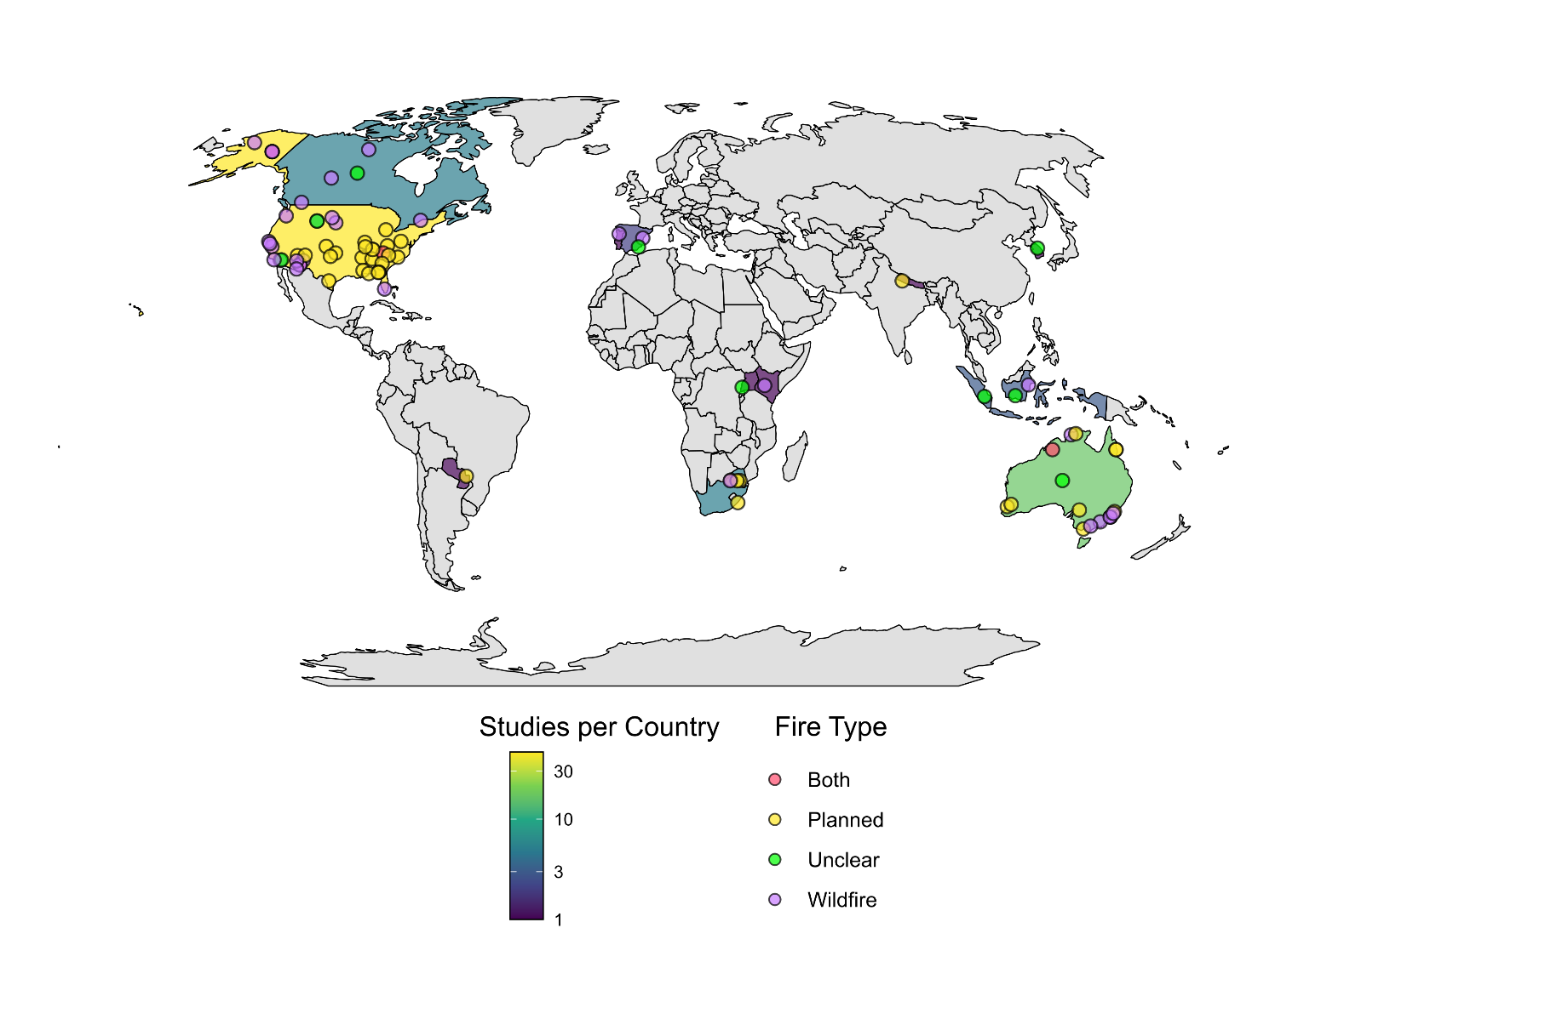
Figure 1: Map illustrating the number of studies per country and locations of the 84 studies included in the systematic review. The color scale shows the number of studies per country, with darker colours indicating fewer studies and lighter colours indicating more studies. The colour of the study points indicate the type of fire the study investigated. Map lines delineate study areas and do not necessarily depict accepted national boundaries.
From the 84 studies, we extracted 185 cases investigating the influence of fire on animal movement for inclusion in the review. Only a single study investigated movement responses to both prescribed fire and wildfire separately (Clapp & Beck, 2016). Over half (n = 102, 55.1%) of all cases investigated movement responses using a control–impact (burnt–unburnt) study design. A before–after design was used in 34.6% of cases and BACI designs accounted for the remaining 10.3%. Home range was the most reported movement responses (45.6% of cases), followed by linear distance (35.1%), other space use (14.1%) and tortuosity (3.8%).
Twelve biomes were represented among the 185 cases included in the review (Supplementary Information 3, Figure S3.2). Most research occurred in temperate biomes, with 20% of cases in ‘Temperate broadleaf and mixed forests’ (n = 37), 26% in ‘Mediterranean forests, woodlands and scrub’ (including sclerophyll forests, n = 26), and 25% in ‘Temperate coniferous forests’ (n = 25). Approximately half of all cases (49.7%) examined the effects of wildfire, while 34.1% investigated prescribed fire. Fire type was not clearly specified for 9.2% of observations, and 7% assessed the combined effects of wildfire and prescribed fire. Within ‘Temperate broadleaf and mixed forests,’ more than half of the cases examined prescribed fires, whereas in ‘Mediterranean forests, woodlands and scrub’ (or sclerophyll forests), most studies focused on wildfire effects. Across the remaining biomes, prescribed fire and wildfires were investigated at similar frequencies.
The dataset encompassed 73 taxa spanning 23 orders and four vertebrate classes. Most taxa belonged to Mammalia (65.9%), followed by Aves (18.9%), Reptilia (13.0%), and Amphibia (2.2%). Among orders, Artiodactyla (even-toed ungulates; 23.8%) and Rodentia (14.1%) were the most frequently represented (Supplementary Information 3, Figure S3.3). Several orders, Accipitriformes, Caprimulgiformes, Piciformes, and Dasyuromorphia, were each represented by a single case. Within Aves, Galliformes was the most frequently studied order, while within Reptilia, Testudines predominated. At the species level, white-tailed deer (Odocoileus virginianus) was the most commonly studied species (12 cases), followed by moose (Alces alces) with 10 cases.

Meta-analysis
From the 185 cases included in the systematic review, we calculated 93 effect sizes from 38 studies examining how fire influenced home range size, linear distance movements and tortuosity. The remaining cases were excluded due to insufficient sample sizes and inadequate data to calculate effect sizes. The overall phylogenetic multilevel meta-analytic model revealed fire had little effect on animal movement (Hedge’s g = 0.18, 95% CI [-0.03 – 0.38], k = 93; Figure 2). However, responses varied substantially among and between species, indicating heterogeneity in responses (Supplementary Information 4, Figure S4.1).

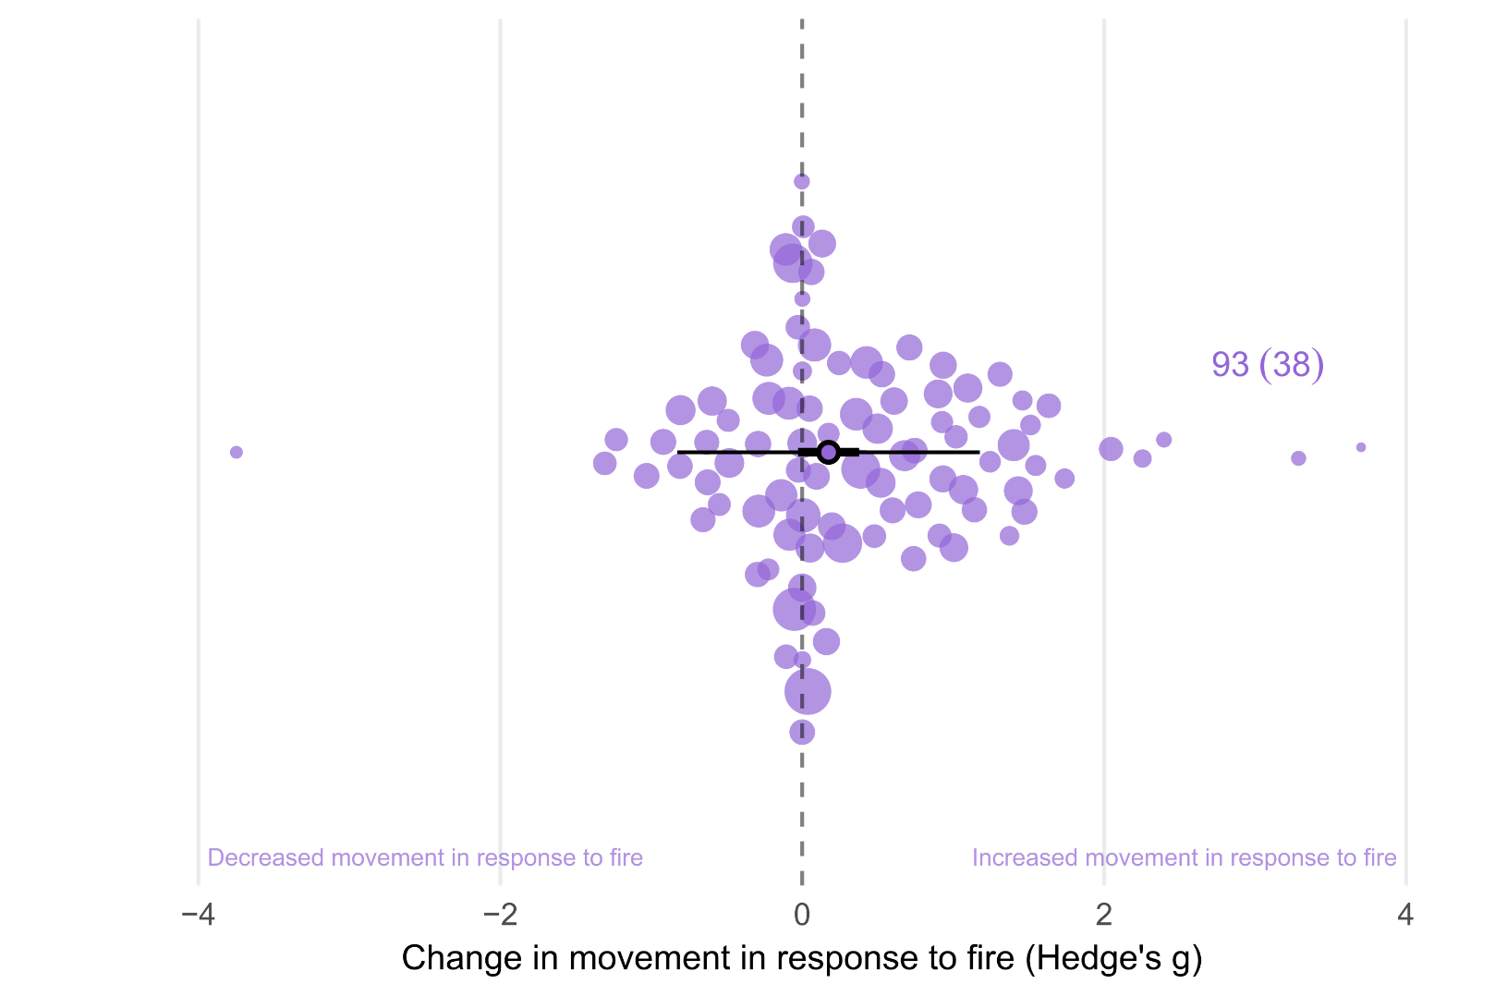
Figure 2: Orchard plot showing the overall estimated effect of fire on animal movement. The outlined point is the meta-analytic mean, the thick horizontal bars are 95% confidence intervals, and the whiskers are 95% prediction intervals. Shaded points are effect sizes (Hedge’s g, k = 93), with point size scaled to show precision (1/SE; i.e., larger points had greater influence). Points are jittered on the y axis to improve readability. The annotation next to the point cloud represents number of effect sizes followed by number of studies in parentheses.

Movement Category
When testing movement category as a moderator, there was no clear effect for home-range size (0.12, [-0.10 – 0.34], 49). Fire had a significant small positive effect on linear distance movements (0.27, [0.02 – 0.52], 40; Figure 3), with no detectable effect on tortuosity (0.15, [-0.34 – 0.65], 4).
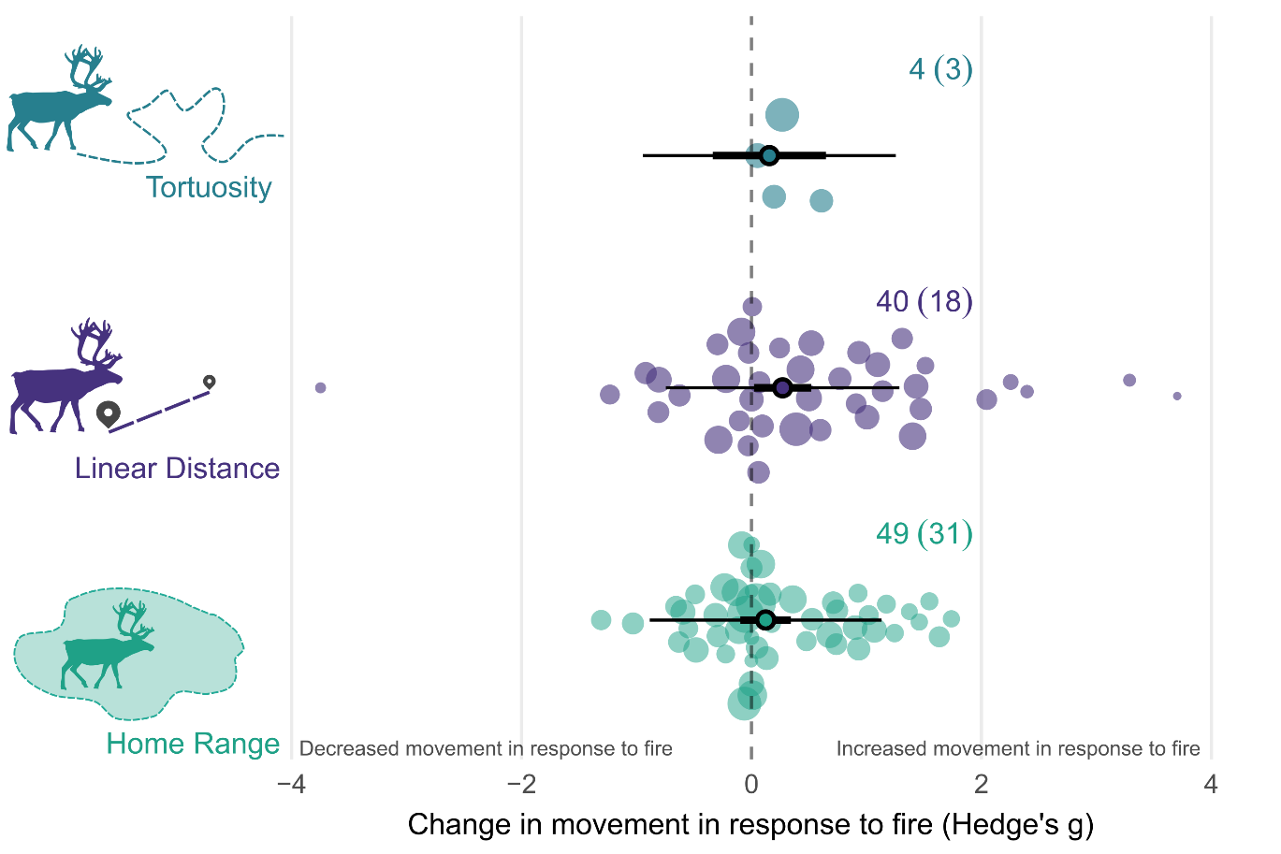
Figure 3: Orchard plot showing the estimated effect of fire on each of the four movement response categories. The outlined point is the meta-analytic mean, the thick horizontal bars are 95% confidence intervals, and the whiskers are 95% prediction intervals. Shaded points are effect sizes (Hedge’s g, k = 93), with point size scaled to show precision (1/SE; i.e., larger points had greater influence). Points are jittered on the y axis to improve readability. The annotation next to the point cloud represents number of effect sizes followed by number of studies in parentheses. Silhouettes are from Phylopic.

Taxonomic Class
When modelling taxonomic class as a moderator, we found no evidence of an effect in mammals (0.18, [-0.10 – 0.47], 58; Figure 4). Comparatively, we found fire had a small positive effect in birds (0.40, [0.01 – 0.79], 20), although confidence intervals associated with this estimate were wide. Fire had no detectable effect on reptile movement (0.00, [-0.42 – 0.42], 14). however the wide confidence intervals reflect considerable uncertainty, likely due to the small number of effect sizes. We did not include Amphibians due to the small sample size (k = 1).
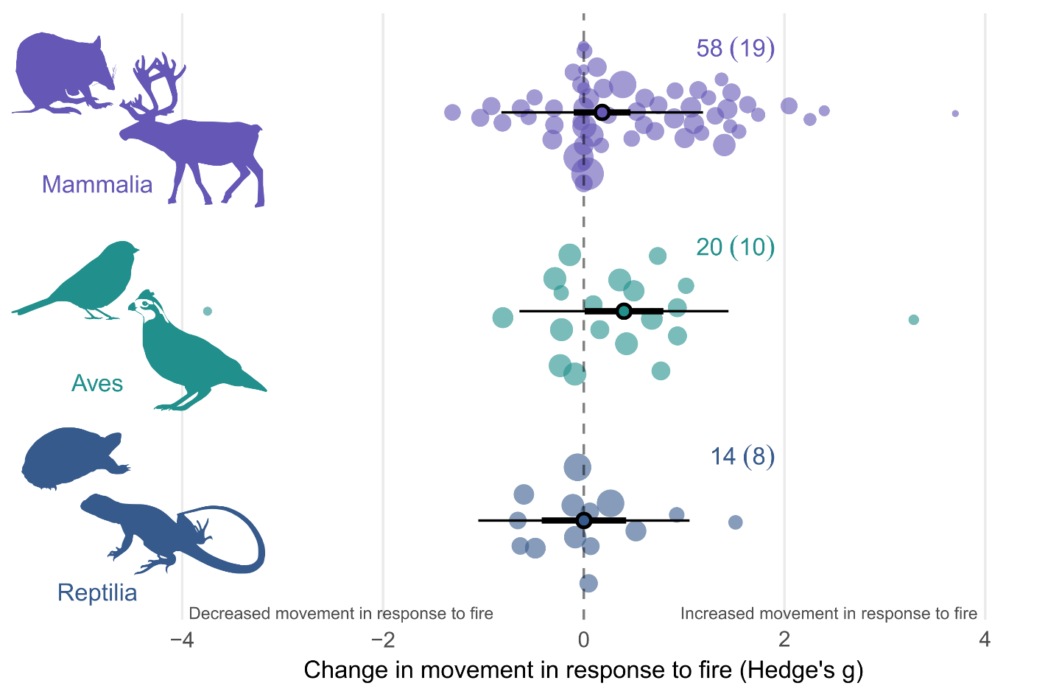

Figure 4: Orchard plot showing the estimated effect of fire on animal movement by taxonomic class. The outlined point is the meta-analytic mean, the thick horizontal bars are 95% confidence intervals, and the whiskers are 95% prediction intervals. Shaded points are effect sizes (Hedge’s g, k = 92), with point size scaled to show precision (1/SE; i.e., larger points had greater influence). Points are jittered on the y axis to improve readability. The annotation next to the point cloud represents number of effect sizes followed by number of studies in parentheses. Silhouettes are from Phylopic.

Fire Type, Burn Extent, & Time Since Fire
Fire type did not influence movement responses, and neither prescribed fire (0.15, [-0.17 – 0.47], 25; Figure 5) nor wildfire (0.08, [-0.37 – 0.52], 52) demonstrated an effect. Time since fire had no clear effect on movement responses (R²_{[marginal]} = 0.04, R²_{[conditional]} = 0.69; -0.05, [-0.17 – 0.07], 91; Supplementary Information 4, Table S4.1). Similarly, we found no evidence of a relationship between burn extent and movement responses (R²_{[marginal]} = 0.07, R²_{[conditional]} = 0.51; 0.05, [-0.04 – 0.13], 62; Supplementary Information 4, Table S4.1).

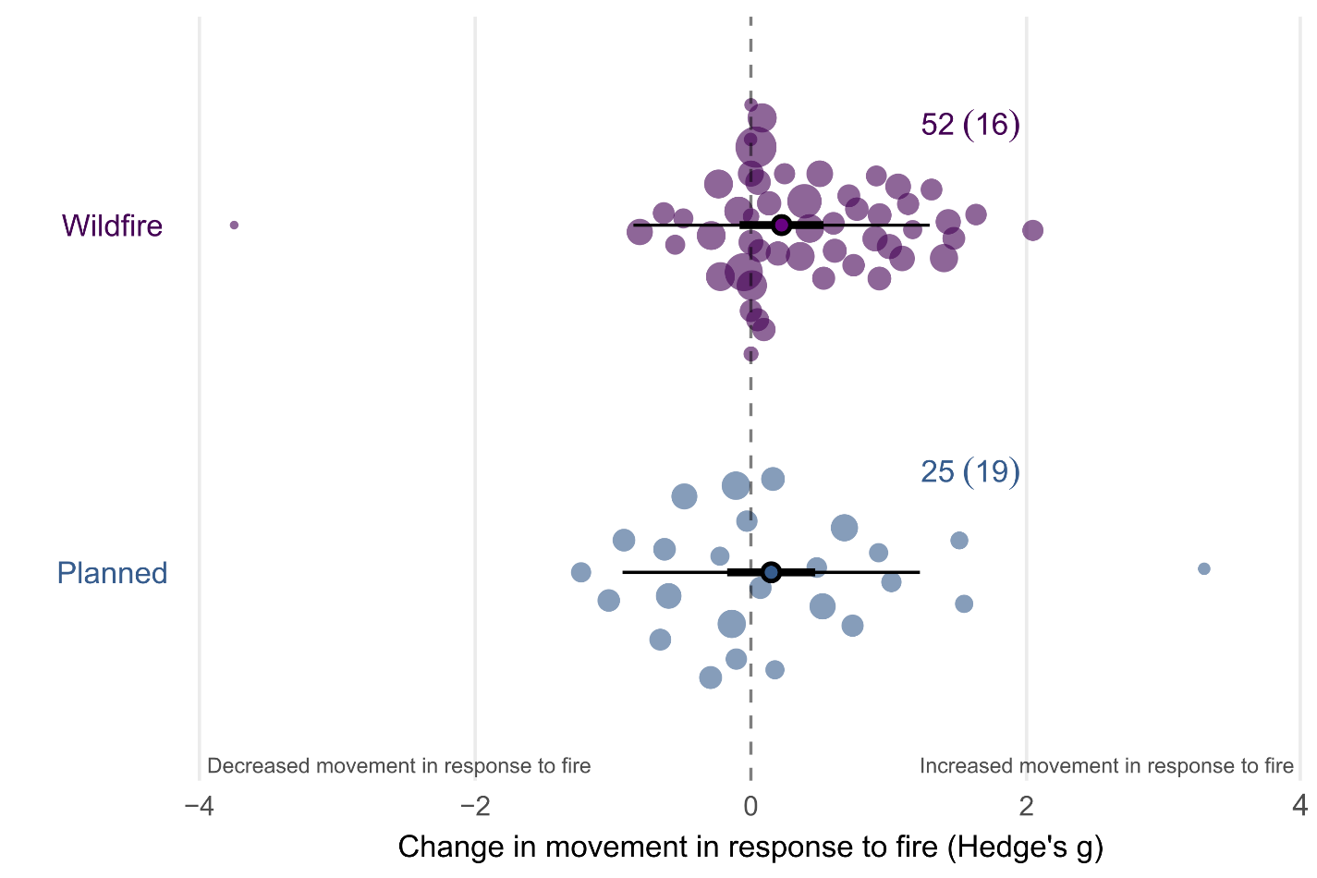
Figure 5: Orchard plot showing the estimated effect of fire on animal movement by fire type. The outlined point is the meta-analytic mean, the thick horizontal bars are 95% confidence intervals, and the whiskers are 95% prediction intervals. Shaded points are effect sizes (Hedge’s g, k = 77), with point size scaled to show precision (1/SE; i.e., larger points had greater influence). Points are jittered on the y axis to improve readability. The annotation next to the point cloud represents number of effect sizes followed by number of studies in parentheses.

Biome
Five biomes had sufficient sample sizes to be included in the biome model. We found that biome had little influence on animal movement responses to fire, with considerably wide confidence levels overlapping zero and for all biomes (k =69, Figure 6; Supplementary Information 4, Table S4.1).
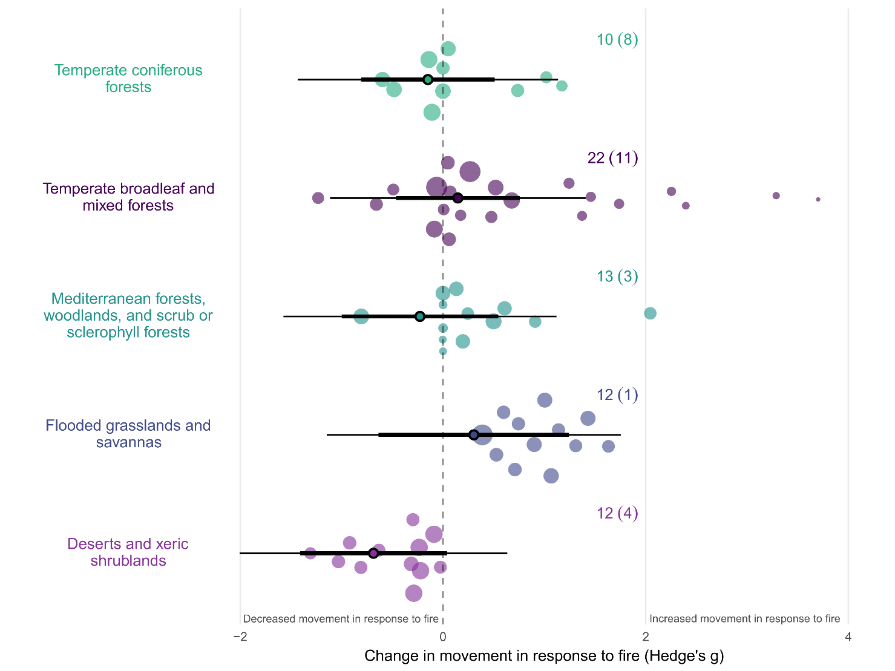
Figure 6: Orchard plot showing the estimated effect of fire on animal movement by biome. The outlined point is the meta-analytic mean, the thick horizontal bars are 95% confidence intervals, and the whiskers are 95% prediction intervals. Shaded points are effect sizes (Hedge’s g, k = 69), with point size scaled to show precision (1/SE; i.e., larger points had greater influence). Points are jittered on the y axis to improve readability. Silhouettes are from Phylopic.

Body Mass
Across the full dataset, body mass ranged from 6.2 grams (Ruby-crowned kinglet, Corthylio calendula) to 175 kg (Plains zebra, Equus burchellii) and was not correlated with animal movement responses to fire (R²_{[marginal]} = 0.00, R²_{[conditional]} = 0.73; 0.00, [-0.07 – 0.07], 93; Supplementary Information 4, Table S4.1). When modelled separately for each taxonomic class, no relationship between body mass and movement response was detected in any group (Supplementary Information 4, Table S4.1). Confidence intervals were large for birds and reptiles.

Study heterogeneity, publication bias and sensitivity
For the overall effect of fire on animal movement, total heterogeneity was 58.87% (I²_{[total]}=58.87), with 16.90% of variation remaining unexplained (I²_{[residuals]}=16.90). Indicating most heterogeneity was accounted for by the random effects. Between-study variation accounted for 42.90% of the estimated heterogeneity (I²_{[study_ID]} =42.90). Phylogenetic relatedness and species identity explained negligible additional heterogeneity in the random-effects-only model (I²_{[species_tree]} =0.00; I²_{[species]} =0.07). Indicating that much of the residual variation remains unrelated to taxonomic structure, and that effect sizes show little evidence of evolutionary or intraspecific clustering.
The results of the multilevel version of Egger’s regression indicated there was no evidence of publication bias or small-study effects on the dataset. We found no statistical asymmetry in the distribution of effect sizes (-0.00, [-0.16 – 0.11], 93). We found evidence of a decline effect in the dataset (-0.03, [-0.06 – -0.01], 93), with the magnitude of effect sizes declining over time. Results of the leave-one-out sensitivity analysis indicated minimal evidence of outlier influence, with confidence intervals of all leave-one-out models within the confidence intervals of the full model (Supplementary Information 2, Figure S2.3)
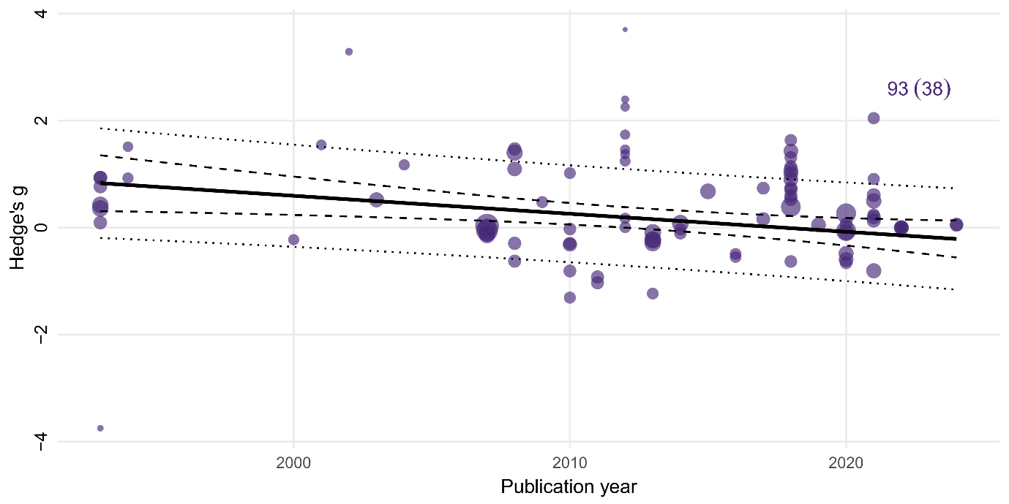

Figure 7: Meta-regression of effect sizes against publication year. Each point represents an individual effect size (Hedge’s g, k = 93), with the point size scaled by precision. The solid line indicates the estimated regression slope, with the 95% confidence interval shown by the dashed lines. The dotted lines show 95% prediction intervals. We found a evidence decline effect in our dataset, with the magnitude of effect sizes declining over time.

Discussion
Animal movement is vital to persistence in fire-prone landscapes (Nimmo et al., 2019). Here, we provide the first global meta-analysis of the influence of fire on animal movements. Consistent with our predictions, we found that animal movements generally increase following fire, although a wide range of responses were recorded. Increases in animal movement in response to fire were most frequent for linear distance movements and following prescribed burns. Our results indicate that increased movement is a relatively widespread behavioural response to fire, potentially enabling animals to track shifting resources across fire-affected landscapes.

Movement Category
We found that movement distances and rates increased after fire, and increases were seen across a diverse suite of species. Contrary to our predictions, we found no clear evidence of fire increasing home range size, despite increases in movement distances. Behavioural responses to post-fire resource redistribution are likely the primary mechanism driving the observed increases in movement distances and rates (Abrahms et al., 2021). In response to altered and spatiotemporally patchy resources, individuals travelled further and faster post-fire. Within the studies we reviewed, reduced forage availability within home ranges (Kreling et al., 2021; Roe et al., 2020) and changes in mate density due to decreased habitat quality (Thompson, 1993) were posited as drivers of increased movement distances. Rather than increasing home range sizes, animals appear to be increasing the frequency of fine-scale movements between resource patches, and moving quickly through post-fire landscapes in search of resources (Miritis et al., 2025).
We hypothesize site fidelity further influences the above patterns. Numerous taxa maintain moderate to high site fidelity following fire and other disturbances, including spotted owls (Strix occidentalis) (Bond et al., 2002), long-nosed potoroos (Potorous tridactylus) (Pla et al., 2024), black-tailed deer (Odocoileus hemionus columbianus) (Kreling et al., 2021), Bachman's sparrows (Peucaea aestivalis) (Cox & Jones, 2007), and mule deer (Odocoileus hemionus) (Brown et al., 2020; Forrester et al., 2024). Site fidelity facilitates familiarity of foraging patches, predation risk and breeding sites (Merkle et al., 2022). For such species, increasing movement within familiar home ranges likely represents a trade-off between the risks and rewards of moving beyond familiar areas (Brown & Kotler, 2004).

Taxonomic groups
We found birds and mammals demonstrated small, albeit uncertain, increases in movement after fire. No detectable effect was seen in reptiles. Doherty et al. (2021) demonstrated similar trends in response to human disturbance; both home ranges and movement distances of birds increasing, mammals demonstrating an increase in movement distances, whilst effects for reptiles were weak with high uncertainty. Higher energetic requirements, combined with greater mobility (Hillman et al., 2014; Straus et al., 2024), likely mean that for birds and mammals, the benefits of increasing movement to access resources outweigh the potential costs (Brown & Kotler, 2004). Contrasting modes of thermoregulation also likely aid in explaining these results, with ectothermic reptiles having lower energetic requirements and heightened ability to remain dormant during times of resource limitation or disturbance (Nagy, 2005). Relative to endothermic taxa, reptiles may be less motivated to increase movement in response to fire, instead responding in ways that reduce activity and predation risk (Fenner & Bull, 2007; Lillywhite et al., 1977). Taken together, these findings suggest that whilst many taxa demonstrate plasticity in movement responses to disturbance, whether natural or anthropogenic, these responses may be constrained by high level physiological and morphological traits (Batista et al., 2023; Straus et al., 2024).

Body Mass
While we found an overall increase in animal movement in response to fire, body mass did not predict the magnitude of this effect within or across taxonomic classes. Given animal movements scale with body mass (Jetz et al., 2004), and previous work has shown that body mass predicts movement responses to disturbance in some taxa (Doherty et al., 2021), this result was unexpected. This suggests that although fire elicits movement responses across a wide range of body sizes, the degree of the response is not mediated by body mass. Instead, functional and/or macroecological traits (Batista et al., 2023; Straus et al., 2024) and fire characteristics (Rickbeil et al., 2017) may be driving the magnitude of movement responses. A caveat to this interpretation is the over-representation of larger mammals in our dataset. Animal body mass constrains the size and battery capacity of tracking devices that can be used, limiting the scope of telemetry research on smaller-bodied species (Kays et al., 2015). Our dataset reflects this bias, mammals comprise over 67% of effect sizes in our analysis, limiting our ability to draw strong inferences about movement responses of small-bodied taxa. As technology continues to advance, our ability to capture robust, high-resolution tracking data from smaller species continues to improve, enhancing our understanding of these processes in small taxa (Crane et al., 2021; Nathan et al., 2022).

Fire characteristics
We found no clear relationship between burn extent or time since fire and any of our movement responses. We interpret this result with caution and suggest that it may be due to the coarse nature of our fire variables. For instance, we were not able to obtain data on several fire characteristics that are likely to affect movement, such as fire severity , season, or pyrodiversity (Nimmo et al., 2019; Rickbeil et al., 2017). Arguably, fine scale burn heterogeneity, rather than total fire extent, is a stronger predictor of animal movement responses (Banks et al., 2015; Fordyce et al., 2016). Further, we could not account for proximity of individuals to the fire perimeter, whether an active edge or burn scar, within our analyses. Variation in the distance between an individual and the fire edge will presumably influence how the fire or burnt habitat is experienced by the individual, and therefore any movement response (Nathan et al., 2008). As such, fires with similar characteristics and burn extent may elicit differential movement responses depending on where an individual is located in relation to either an active fire or unburnt habitat.
Fire type did influence movement: animals exposed to prescribed fire moved more than those experiencing wildfire. Identifying potential mechanisms driving this result is difficult without further investigating additional variables such as long-term pyrodiversity (e.g. a history of fire suppresion; Brisson et al., 2003), seasonality of prescribed burns in relation to pre-European fire regimes (e.g. novel seasonality of burns; Jones et al., 2023), and interactive effects of habitat modification (Doherty et al., 2021). Outside of these factors, one potential explanation is prescribed fires generating more heterogenous burn mosaics. Prescribed fires typically occur in cooler months (Penman et al., 2011; Ryan et al., 2013) and are generally less intense and severe than wildfire (Price et al., 2022), together producing burn heterogeneity (Donovan et al., 2024; Knapp & Keeley, 2006). Greater burn heterogeneity may promote animal movement by providing complementary resources across space (Leonard & Koprowski, 2010), including refugia mitigating predation risk during movement bouts (Cohen et al., 2019; Leahy et al., 2016). Simultaneously, burn heterogeneity can also suppress movements if resources are concentrated and easily accessible, reducing the need to travel (Abrahms et al., 2021). Larger, more severe wildfires remove resources across broad spatial scales (Linley et al., 2022), compelling more mobile species to move in search of resources (Blakey et al., 2022). Equally, the broad scale loss of cover may fundamentally alter the landscape of fear, increasing perceived predation risk (Laundré et al., 2010) and discouraging increased movement (Brown & Kotler, 2004).

Limitations and Future Directions
Most heterogeneity in our dataset remained unexplained, which may reflect either (i) true mechanistic context dependency, where contextual factors are interacting to influence movement responses to fire; or (ii) apparent context dependency, due to differences in the capability of the studies to capture and quantify movement responses (Catford et al., 2022). In the first instance, fine-scale, site-specific characteristics such as burn heterogeneity (Shaw et al., 2021), fire severity (Crabb et al., 2022), and fire history (McGregor et al., 2016b), may be interacting with species traits (Franklin et al., 2025; Pocknee et al., 2023), sex (Thompson, 1993), life history stages (Ganz et al., 2022), and predation risk (Leahy et al., 2016) to modulate movement responses. This aligns with previous work indicating that interactive and synergistic effects are likely to exert strong influence on animal responses to fire (Culhane et al., 2022; Doherty et al., 2022; Ganz et al., 2022). The detection of moderate levels of within-individual variation also suggests intraspecific movement responses are not necessarily consistent across movement types (Flaherty & Gienger, 2020) and sex (Thompson, 1993). In the case of apparent context dependency, a combination of confounding factors, differing statistical power, and methodological differences between studies could also explain the between-study heterogeneity we observed (Catford et al., 2022).
The generalisability of our results is hampered by taxonomic and biogeographic biases evident in the original studies. As previously mentioned, over half the effect sizes in our dataset were drawn from mammals. All reptile effect sizes in our dataset originated from the United States, Canada or Australia, despite high reptile diversity in tropical regions, a bias also noted by Crane et al. (2021). Similarly, the United States, Canada and Australia were overrepresented in the full dataset, a widely recognised trend in fire ecology research, (Geary et al., 2020; Gordon et al., 2025; Jolly et al., 2022), even when searching across multiple languages (Linley et al., 2022). Nevertheless, substantial knowledge gaps remain for smaller, cryptic taxa including reptiles, and tropical fire-prone regions. We recommend expanding research effort to address these biases, particularly as technological and methodological advances improve our ability to disentangle the mechanistic drivers of movement responses (Gomez et al., 2025; Joo et al., 2022).
Incorporating fine-scale fire characteristics, including burn severity, heterogeneity, and seasonality (Geary et al., 2020), as well as trait data (Beltran et al., 2025), into future quantitative analyses will aid in progressing our mechanistic understanding of movement responses to fire. Quantitative syntheses integrating multiple components of the movement ecology paradigm (motion and navigation capacity, external factors and internal state) will improve our ability to predict how animals respond to changing fire regimes (Kelly et al., 2020; Nathan et al., 2008). This includes examining how external attributes (e.g. burn heterogeneity and seasonality), internal state, and traits mediate the differential responses to wildfire and prescribed fire observed in this study. Future studies should endeavour to not only report fine-scale fire characteristics but also incorporate multiple components of the movement ecology framework to facilitate mechanistic analyses (Joo et al., 2022).

Conclusion
Collectively, these findings emphasise that movement functions as a phenotypically plastic behavioural response for many taxa occurring in fire-prone landscapes. Our results demonstrate a high degree of variation in animal movement responses to fire, with both increases and decreases of varying magnitudes detected. The strongest signal was an increase in movement distances and rates, particularly among birds and mammals, and in landscapes affected by prescribed burns. The mechanisms underlying these patterns appear to represent all four components of the movement ecology framework; with both independent and interactive effects of resource redistribution, altered predation risk, changes in navigation capacity, mobility, and site fidelity likely driving movement responses. Taxonomic patterns in our results suggest that highly mobile, endothermic taxa are more likely to respond to fire with increased movement, while less mobile reptiles may instead adopt risk-avoidance strategies. Fire characteristics further mediate movement responses, with movement increasing in association with prescribed burns. Why animals moved more in response to prescribed burns is unclear and requires further examination. However, burn heterogeneity and novel seasonality could be contributing to this pattern. Continued research is needed to understand and predict how rapidly shifting fire regimes will reshape animal movement responses and affect the vulnerability of animals occurring in fire-prone landscapes.

References
Abrahms, B., Aikens, E. O., Armstrong, J. B., Deacy, W. W., Kauffman, M. J., & Merkle, J. A. (2021). Emerging perspectives on resource tracking and animal movement ecology. Trends in Ecology & Evolution, 36(4), 308-320. https://doi.org/10.1016/j.tree.2020.10.018
Ankit, R. (2025). WebPlotDigitizer Version 5.2. https://automeris.io
Banks, S. C., Lorin, T., Shaw, R. E., McBurney, L., Blair, D., Blyton, M. D. J., Smith, A. L., Pierson, J. C., & Lindenmayer, D. B. (2015). Fine-scale refuges can buffer demographic and genetic processes against short-term climatic variation and disturbance: a 22-year case study of an arboreal marsupial. MOLECULAR ECOLOGY, 24(15), 3831-3845. https://doi.org/10.1111/mec.13279
Batista, E. K. L., Figueira, J. E. C., Solar, R. R. C., de Azevedo, C. S., Beirão, M. V., Berlinck, C. N., Brandão, R. A., de Castro, F. S., Costa, H. C., Costa, L. M., Feitosa, R. M., Freitas, A. V. L., Freitas, G. H. S., Galdino, C. A. B., Júnior, J. E. S., Leite, F. S., Lopes, L., Ludwig, S., do Nascimento, M. C., . . . Fernandes, G. W. (2023). In case of fire, escape or die: A trait-based approach for identifying animal species threatened by fire. Fire, 6(6).
Beltran, R. S., Kilpatrick, A. M., Adamczak, S. K., Beumer, L. T., Czapanskiy, M. F., Davidson, S. C., McLean, B. S., Mueller, T., Payne, A. R., Soria, C. D., Weeks, B. C., Williams, T. M., & Salguero-Gómez, R. (2025). Integrating animal tracking and trait data to facilitate global ecological discoveries. Journal of Experimental Biology, 228(Suppl_1), JEB247981. https://doi.org/10.1242/jeb.247981
Blakey, R. V., Sikich, J. A., Blumstein, D. T., & Riley, S. P. D. (2022). Mountain lions avoid burned areas and increase risky behavior after wildfire in a fragmented urban landscape. Current Biology, 32(21), 4762-4768.e4765. https://doi.org/10.1016/j.cub.2022.08.082
Bond, M. L., Gutiérrez, R. J., Franklin, A. B., Lallaye, W. S., May, C. S., & Seamans, M. E. (2002). Short-term effects of wildfires on spotted owl survival, site fidelity, mate fidelity, and reproductive success. Wildlife Society Bulletin, 30(4), 1022-1028.
Bowman, D. M. J. S., Balch, J. K., Artaxo, P., Bond, W. J., Carlson, J. M., Cochrane, M. A., D’Antonio, C. M., DeFries, R. S., Doyle, J. C., Harrison, S. P., Johnston, F. H., Keeley, J. E., Krawchuk, M. A., Kull, C. A., Marston, J. B., Moritz, M. A., Prentice, I. C., Roos, C. I., Scott, A. C., . . . Pyne, S. J. (2009). Fire in the Earth system. Science, 324(5926), 481-484. https://doi.org/10.1126/science.1163886
Brisson, J. A., Strasburg, J. L., & Templeton, A. R. (2003). Impact of fire management on the ecology of collared lizard (Crotaphytus collaris) populations living on the Ozark Plateau. Animal Conservation, 6(3), 247-254. https://doi.org/10.1017/S1367943003003305
Brown, C. L., Smith, J. B., Wisdom, M. J., Rowland, M. M., Spitz, D. B., & Clark, D. A. (2020). Evaluating indirect effects of hunting on mule deer spatial behavior. The Journal of Wildlife Management, 84(7), 1246-1255. https://doi.org/10.1002/jwmg.21916
Brown, J. S., & Kotler, B. P. (2004). Hazardous duty pay and the foraging cost of predation. Ecology Letters, 7(10), 999-1014. https://doi.org/10.1111/j.1461-0248.2004.00661.x
Catford, J. A., Wilson, J. R. U., Pyšek, P., Hulme, P. E., & Duncan, R. P. (2022). Addressing context dependence in ecology. Trends in Ecology & Evolution, 37(2), 158-170. https://doi.org/10.1016/j.tree.2021.09.007
Chamberlain, S., & Szöcs, E. (2013). Taxize: taxonomic search and retrieval in R [version 2; peer review: 3 approved]. F1000Research, 2(191). https://doi.org/10.12688/f1000research.2-191.v2
Clapp, J. G., & Beck, J. L. (2016). Short-term impacts of fire-mediated habitat alterations on an isolated bighorn sheep population. Fire Ecology, 12(3), 80-98. https://doi.org/10.4996/fireecology.1203080
Cohen, B. S., Prebyl, T. J., Collier, B. A., & Chamberlain, M. J. (2019). Spatiotemporal variability of fire characteristics affect animal responses in pyric landscapes. Fire Ecology, 15(1), 41. https://doi.org/10.1186/s42408-019-0058-4
Cox, J. A., & Jones, C. D. (2007). Home range and survival characteristics of male Bachman's Sparrows in an old-growth forest managed with breeding season burns. Journal of Field Ornithology, 78(3), 263-269. https://doi.org/10.1111/j.1557-9263.2007.00113.x
Crabb, M. L., Clement, M. J., Jones, A. S., Bristow, K. D., & Harding, L. E. (2022). Black bear spatial responses to the Wallow Wildfire in Arizona. The Journal of Wildlife Management, 86(3), 1-20. https://doi.org/10.1002/jwmg.22182
Crane, M., Silva, I., Marshall, B. M., & Strine, C. T. (2021). Lots of movement, little progress: A review of reptile home range literature. PeerJ, 9, e11742. https://doi.org/10.7717/peerj.11742
Culhane, K., Sollmann, R., White, A. M., Tarbill, G. L., Cooper, S. D., & Young, H. S. (2022). Small mammal responses to fire severity mediated by vegetation characteristics and species traits. Ecology and Evolution, 12(5), e8918. https://doi.org/10.1002/ece3.8918
Cunningham, C. X., Williamson, G. J., & Bowman, D. M. J. S. (2024). Increasing frequency and intensity of the most extreme wildfires on Earth. Nature Ecology & Evolution, 8(8), 1420-1425. https://doi.org/s41559-024-02452-2
Doherty, T. S., Hays, G. C., & Driscoll, D. A. (2021). Human disturbance causes widespread disruption of animal movement. Nature Ecology & Evolution, 5(4), 513-519. https://doi.org/10.1038/s41559-020-01380-1
Doherty, T. S., Geary, W. L., Jolly, C. J., Macdonald, K. J., Miritis, V., Watchorn, D. J., Cherry, M. J., Conner, L. M., González, T. M., Legge, S. M., Ritchie, E. G., Stawski, C., & Dickman, C. R. (2022). Fire as a driver and mediator of predator–prey interactions. Biological Reviews, 97(4), 1539-1558. https://doi.org/10.1111/brv.12853
Donovan, V. M., Scholtz, R., & Wonkka, C. L. (2024). Fire refugia patch dynamics differ between prescribed fires and wildfires in longleaf pine savanna. Forest Ecology and Management, 569, 122179. https://doi.org/10.1016/j.foreco.2024.122179
Ezzy, L. (2022). Breaking the wildfire cycle: Progressive fire management can shift fire regimes and improve ecosystem condition. A case study from a large conservation reserve in northern Australia. The Rangeland Journal, 44(6), 279-288. https://doi.org/10.1071/RJ22021
Faurby, S., Davis, M., Pedersen, R. Ø., Schowanek, S. D., Antonelli, A., & Svenning, J.-C. (2018). PHYLACINE 1.2: The phylogenetic atlas of mammal macroecology. Ecology, 99(11), 2626-2626. https://doi.org/10.1002/ecy.2443
Fenner, A. L., & Bull, C. M. (2007). Short-term impact of grassland fire on the endangered pygmy bluetongue lizard. Journal of Zoology, 272(4), 444-450. https://doi.org/10.1111/j.1469-7998.2007.00287.x
Flaherty, J. P., & Gienger, C. M. (2020). Habitat selection and movement patterns of copperheads (Agkistrodon contortrix) in fire-altered landscapes. Herpetological Conservation and Biology, 15(1), 150-159.
Fordyce, A., Hradsky, B. A., Ritchie, E. G., & Di Stefano, J. (2016). Fire affects microhabitat selection, movement patterns, and body condition of an Australian rodent (Rattus fuscipes). Journal of Mammalogy, 97(1), 102-111. https://doi.org/10.1093/jmammal/gyv159
Forrester, T. D., Spitz, D. B., Merems, J. L., Wisdom, M. J., Rowland, M. M., Johnson, B. K., Smith, J. B., Levi, T., Long, R. A., & Clark, D. A. (2024). Mule deer selection of fuel reductions is restricted by site fidelity and structured by circadian and seasonal patterns. Forest Ecology and Management, 569. 122005. https://doi.org/10.1016/j.foreco.2024.122005
Franklin, M. J. M., Bradstock, R. A., & Major, R. E. (2025). Relative species mobility is a key determinant of avian diversity in post-megafire recovery. Austral Ecology, 50(11), e70139. https://doi.org/10.1111/aec.70139
Ganz, T. R., DeVivo, M. T., Kertson, B. N., Roussin, T., Satterfield, L., Wirsing, A. J., & Prugh, L. R. (2022). Interactive effects of wildfires, season and predator activity shape mule deer movements. Journal of Animal Ecology, 91(11), 2273-2288. https://doi.org/10.1111/1365-2656.13810
Geary, W. L., Doherty, T. S., Nimmo, D. G., Tulloch, A. I. T., & Ritchie, E. G. (2020). Predator responses to fire: A global systematic review and meta-analysis. Journal of Animal Ecology, 89(4), 955-971. https://doi.org/10.1111/1365-2656.13153
Gomez, S., English, H. M., Bejarano Alegre, V., Blackwell, P. G., Bracken, A. M., Bray, E., Evans, L. C., Gan, J. L., Grecian, W. J., Gutmann Roberts, C., Harju, S. M., Hejcmanová, P., Lelotte, L., Marshall, B. M., Matthiopoulos, J., Mnenge, A. J., Niebuhr, B. B., Ortega, Z., Pollock, C. J., . . . Börger, L. (2025). Understanding and predicting animal movements and distributions in the Anthropocene. Journal of Animal Ecology, 94(6), 1146-1164. https://doi.org/10.1111/1365-2656.70040
Gordon, L., Evans, M. J., Zylstra, P., & Lindenmayer, D. B. (2025). Trends and gaps in prescribed burning research. Environmental Management, 75(4), 746-760. https://doi.org/10.1007/s00267-025-02119-z
Hijmans, R. J., Barbosa, M., Ghos, A., & Mandel, A. (2025). geodata. In (Version 0.6-2) https://github.com/rspatial/geodata
Hillman, S. S., Drewes, R. C., Hedrick, M. S., & Hancock, T. V. (2014). Physiological vagility and its relationship to dispersal and neutral genetic heterogeneity in vertebrates. Journal of Experimental Biology, 217(18), 3356-3364. https://doi.org/10.1242/jeb.105908
Jetz, W., Carbone, C., Fulford, J., & Brown, J. H. (2004). The scaling of animal space use. Science, 306(5694), 266-268. https://doi.org/10.1126/science.1102138
Jolly, C. J., Dickman, C. R., Doherty, T. S., van Eeden, L. M., Geary, W. L., Legge, S. M., Woinarski, J. C. Z., & Nimmo, D. G. (2022). Animal mortality during fire. Global Change Biology, 28(6), 2053-2065. https://doi.org/10.1111/gcb.16044
Jones, G. M., Goldberg, J. F., Wilcox, T. M., Buckley, L. B., Parr, C. L., Linck, E. B., Fountain, E. D., & Schwartz, M. K. (2023). Fire-driven animal evolution in the Pyrocene. Trends in Ecology & Evolution, 38(11), 1072-1084. https://doi.org/10.1016/j.tree.2023.06.003
Joo, R., Picardi, S., Boone, M. E., Clay, T. A., Patrick, S. C., Romero-Romero, V. S., & Basille, M. (2022). Recent trends in movement ecology of animals and human mobility. Movement Ecology, 10(1), 26. https://doi.org/10.1186/s40462-022-00322-9
Kays, R., Crofoot, M. C., Jetz, W., & Wikelski, M. (2015). Terrestrial animal tracking as an eye on life and planet. Science, 348(6240), aaa2478. https://doi.org/10.1126/science.aaa2478
Kelly, L. T., Giljohann, K. M., Duane, A., Aquilué, N., Archibald, S., Batllori, E., Bennett, A. F., Buckland, S. T., Canelles, Q., Clarke, M. F., Fortin, M.-J., Hermoso, V., Herrando, S., Keane, R. E., Lake, F. K., McCarthy, M. A., Morán-Ordóñez, A., Parr, C. L., Pausas, J. G., . . . Brotons, L. (2020). Fire and biodiversity in the Anthropocene. Science, 370(6519), eabb0355. https://doi.org/10.1126/science.abb0355
Knapp, E. E., & Keeley, J. E. (2006). Heterogeneity in fire severity within early season and late season prescribed burns in a mixed-conifer forest. International Journal of Wildland Fire, 15(1), 37-45. https://doi.org/10.1071/WF04068
Kreling, S. E. S., Gaynor, K. M., McInturff, A., Calhoun, K. L., & Brashares, J. S. (2021). Site fidelity and behavioral plasticity regulate an ungulate's response to extreme disturbance. Ecology and Evolution, 11(22), 15683-15694. https://doi.org/10.1002/ece3.8221
Laundré, J. W., Hernández, L., & Ripple, W. J. (2010). The landscape of fear: Ecological implications of being afraid. The Open Ecology Journal, 3(2), 1-7. https://doi.org/10.2174/1874213001003030001
Leahy, L., Legge, S. M., Tuft, K., McGregor, H. W., Barmuta, L. A., Jones, M. E., & Johnson, C. N. (2016). Amplified predation after fire suppresses rodent populations in Australia’s tropical savannas. Wildlife Research, 42(8), 705-716.
Leonard, K. M., & Koprowski, J. L. (2010). Effects of fire on endangered mount graham red squirrels (Tamiasciurus hudsonicus grahamensis): Responses of individuals with known fates. Southwestern Naturalist, 55(2), 217-224. https://doi.org/10.1894/MRD-01.1
Lillywhite, H. B., Friedman, G., & Ford, N. (1977). Color matching and perch selection by lizards in recently burned chaparral. Copeia, 1977(1), 115-121. https://doi.org/10.2307/1443512
Linley, G. D., Jolly, C. J., Doherty, T. S., Geary, W. L., Armenteras, D., Belcher, C. M., Bliege Bird, R., Duane, A., Fletcher, M.-S., Giorgis, M. A., Haslem, A., Jones, G. M., Kelly, L. T., Lee, C. K. F., Nolan, R. H., Parr, C. L., Pausas, J. G., Price, J. N., Regos, A., . . . Nimmo, D. G. (2022). What do you mean, ‘megafire’? Global Ecology and Biogeography, 31(10), 1906-1922. https://doi.org/10.1111/geb.13499
Marrocco, V., Shokri, M., Monti, F., Cozzoli, F., Vignes, F., & Basset, A. (2025). Behavioural constraints to home range allometries in aquatic organisms. Ecology and Evolution, 15(8), e71886. https://doi.org/10.1002/ece3.71886
Mathot, K. J., Arteaga-Torres, J. D., Besson, A., Hawkshaw, D. M., Klappstein, N., McKinnon, R. A., Sridharan, S., & Nakagawa, S. (2024). A systematic review and meta-analysis of unimodal and multimodal predation risk assessment in birds. Nature Communications, 15(1), 4240. https://doi.org/10.1038/s41467-024-48702-6
McGregor, H. W., Legge, S., Jones, M. E., & Johnson, C. N. (2016a). Extraterritorial hunting expeditions to intense fire scars by feral cats. Scientific Reports, 6(1), 22559. https://doi.org/10.1038/srep22559
McGregor, H. W., Cliff, H. B., & Kanowski, J. (2016b). Habitat preference for fire scars by feral cats in Cape York Peninsula, Australia. WILDLIFE RESEARCH, 43(8), 623-633. https://doi.org/10.1071/WR16058
Merkle, J. A., Abrahms, B., Armstrong, J. B., Sawyer, H., Costa, D. P., & Chalfoun, A. D. (2022). Site fidelity as a maladaptive behavior in the Anthropocene. Frontiers in Ecology and the Environment, 20(3), 187-194. https://doi.org/10.1002/fee.2456
Michonneau, F., Brown, J. W., & Winter, D. J. (2016). rotl: An R package to interact with the Open Tree of Life data. Methods in Ecology and Evolution, 7(12), 1476-1481. https://doi.org/10.1111/2041-210X.12593
Miritis, V., Ashman, K., Dickman, C. R., Nimmo, D. G., & Doherty, T. S. (2025). Adapting to novel fire regimes: Using movement to inform conservation of a threatened arboreal mammal. Biological Conservation, 301, 110893. https://doi.org/10.1016/j.biocon.2024.110893
Morollón, S., Pausas, J. G., Urios, V., & López-López, P. (2022). Wildfire response of GPS-tracked Bonelli's eagles in eastern Spain. International Journal of Wildland Fire, 31(9), 901-908. https://doi.org/10.1071/WF22018
Morris, S. B. (2008). Estimating Effect Sizes From Pretest-Posttest-Control Group Designs. Organizational Research Methods, 11(2), 364-386. https://doi.org/10.1177/1094428106291059
Nagy, K. A. (2005). Field metabolic rate and body size. Journal of Experimental Biology, 208(9), 1621-1625. https://doi.org/10.1242/jeb.01553
Nakagawa, S., & Cuthill, I. C. (2007). Effect size, confidence interval and statistical significance: A practical guide for biologists. Biological Reviews, 82(4), 591-605. https://doi.org/10.1111/j.1469-185X.2007.00027.x
Nakagawa, S., & Santos, E. S. A. (2012). Methodological issues and advances in biological meta-analysis. Evolutionary Ecology, 26(5), 1253-1274. https://doi.org/10.1007/s10682-012-9555-5
Nakagawa, S., Lagisz, M., Jennions, M. D., Koricheva, J., Noble, D. W. A., Parker, T. H., Sánchez-Tójar, A., Yang, Y., & O'Dea, R. E. (2022). Methods for testing publication bias in ecological and evolutionary meta-analyses. Methods in Ecology and Evolution, 13(1), 4-21. https://doi.org/https://doi.org/10.1111/2041-210X.13724
Nakagawa, S., Lagisz, M., O'Dea, R. E., Pottier, P., Rutkowska, J., Senior, A. M., Yang, Y., & Noble, D. W. A. (2023). orchaRd 2.0: An R package for visualising meta-analyses with orchard plots. Methods in Ecology and Evolution, 14(8), 2003-2010. https://doi.org/10.1111/2041-210X.14152
Nathan, R., Getz, W. M., Revilla, E., Holyoak, M., Kadmon, R., Saltz, D., & Smouse, P. E. (2008). A movement ecology paradigm for unifying organismal movement research. Proceedings of the National Academy of Sciences, 105(49), 19052-19059. https://doi.org/10.1073/pnas.0800375105
Nathan, R., Monk, C. T., Arlinghaus, R., Adam, T., Alós, J., Assaf, M., Baktoft, H., Beardsworth, C. E., Bertram, M. G., Bijleveld, A. I., Brodin, T., Brooks, J. L., Campos-Candela, A., Cooke, S. J., Gjelland, K. Ø., Gupte, P. R., Harel, R., Hellström, G., Jeltsch, F., . . . Jarić, I. (2022). Big-data approaches lead to an increased understanding of the ecology of animal movement. Science, 375(6582), eabg1780. https://doi.org/10.1126/science.abg1780
Nimmo, D. G., Avitabile, S., Banks, S. C., Bliege Bird, R., Callister, K., Clarke, M. F., Dickman, C. R., Doherty, T. S., Driscoll, D. A., Greenville, A. C., Haslem, A., Kelly, L. T., Kenny, S. A., Lahoz‐Monfort, J. J., Lee, C., Leonard, S., Moore, H., Newsome, T. M., Parr, C. L., . . . Bennett, A. F. (2019). Animal movements in fire‐prone landscapes. Biological Reviews of the Cambridge Philosophical Society, 94(3), 981-998. https://doi.org/10.1111/brv.12486
Nimmo, D. G., Carthey, A. J. R., Jolly, C. J., & Blumstein, D. T. (2021). Welcome to the Pyrocene: Animal survival in the age of megafire. Global Change Biology, 27(22), 5684-5693. https://doi.org/10.1111/gcb.15834
Noble, D. W. A., Lagisz, M., O'Dea, R. E., & Nakagawa, S. (2017). Nonindependence and sensitivity analyses in ecological and evolutionary meta-analyses. Molecular Ecology, 26(9), 2410-2425. https://doi.org/10.1111/mec.14031
Oskyrko, O. M., Chunrong; Meiri, Shai; Du, Weiguo. (2024). ReptTraits: A comprehensive dataset of ecological traits in reptiles.
Penman, T. D., Christie, F. J., Andersen, A. N., Bradstock, R. A., Cary, G. J., Henderson, M. K., Price, O., Tran, C., Wardle, G. M., Williams, R. J., & York, A. (2011). Prescribed burning: How can it work to conserve the things we value? International Journal of Wildland Fire, 20(6), 721-733. https://doi.org/10.1071/WF09131
Pla, M. L., Hradsky, B. A., Di Stefano, J., Farley-Lehmer, T. C., Birnbaum, E. K., & Pascoe, J. H. (2024). High site fidelity and reduced survival of a mycophagous mammal after prescribed fire. Biodiversity and Conservation, 33(13), 3799-3820. https://doi.org/10.1007/s10531-024-02927-5
Pocknee, C. A., Legge, S. M., McDonald, J., & Fisher, D. O. (2023). Modeling mammal response to fire based on species’ traits. Conservation Biology, 37(4), e14062. https://doi.org/10.1111/cobi.14062
Posit team. (2025). RStudio: Integrated Development Environment for R. In (Version 2025.5.0.496) Posit Software, PBC. http://www.posit.co/
Price, O. H., Nolan, R. H., & Samson, S. A. (2022). Fuel consumption rates in resprouting eucalypt forest during hazard reduction burns, cultural burns and wildfires. Forest Ecology and Management, 505, 119894. https://doi.org/10.1016/j.foreco.2021.119894
R Core Team. (2024). R: A Language and Environment for Statistical Computing. In R Foundation for Statistical Computing. https://www.R-project.org/
Rickbeil, G. J. M., Hermosilla, T., Coops, N. C., White, J. C., & Wulder, M. A. (2017). Barren-ground caribou (Rangifer tarandus groenlandicus) behaviour after recent fire events; integrating caribou telemetry data with Landsat fire detection techniques. Global Change Biology, 23(3), 1036-1047. https://doi.org/10.1111/gcb.13456
Robinson, N. M., Leonard, S. W. J., Ritchie, E. G., Bassett, M., Chia, E. K., Buckingham, S., Gibb, H., Bennett, A. F., & Clarke, M. F. (2013). Refuges for fauna in fire-prone landscapes: Their ecological function and importance. Journal of Applied Ecology, 50(6), 1321-1329. https://doi.org/10.1111/1365-2664.12153
Roe, J. H., Kish, A. L., & Nacy, J. P. (2020). Variation and repeatability of home range in a forest-dwelling terrestrial turtle: Implications for prescribed fire in forest management. Journal of Zoology, 310(1), 71-82. https://doi.org/10.1111/jzo.12732
Ryan, K. C., Knapp, E. E., & Varner, J. M. (2013). Prescribed fire in North American forests and woodlands: History, current practice, and challenges. Frontiers in Ecology and the Environment, 11(s1), e15-e24. https://doi.org/10.1890/120329
Shaw, R. E., James, A. I., Tuft, K., Legge, S., Cary, G. J., Peakall, R., & Banks, S. C. (2021). Unburnt habitat patches are critical for survival and in situ population recovery in a small mammal after fire. Journal of Applied Ecology, 58(6), 1325-1335. https://doi.org/10.1111/1365-2664.13846
Sitters, H., & Di Stefano, J. (2020). Integrating functional connectivity and fire management for better conservation outcomes. Conservation Biology, 34(3), 550-560. https://doi.org/10.1111/cobi.13446
Straus, S., Forbes, C., Little, C. J., Germain, R. M., Main, D. A., O'Connor, M. I., Thompson, P. L., Ford, A. T., Gravel, D., & Guzman, L. M. (2024). Macroecological constraints on species' ‘movement profiles’: Body mass does not explain it all. Global Ecology and Biogeography, 33(2), 227-243. https://doi.org/10.1111/geb.13786
Tamburello, N., Isabelle M. Côté, & Dulvy, N. K. (2015). Energy and the scaling of animal space use. The American Naturalist, 186(2), 196-211. https://doi.org/10.1086/682070
Thompson, W. L. (1993). Ecology of Merriam's turkeys in relation to burned and logged areas in southeastern Montana [Ph.D., Montana State University]. United States of America. https://www.proquest.com/dissertations-theses/ecology-merriams-turkeys-relation-burned-logged/docview/304050414/se-2?accountid=10344
Tobias, J. A., Sheard, C., Pigot, A. L., Devenish, A. J. M., Yang, J., Sayol, F., Neate-Clegg, M. H. C., Alioravainen, N., Weeks, T. L., Barber, R. A., Walkden, P. A., MacGregor, H. E. A., Jones, S. E. I., Vincent, C., Phillips, A. G., Marples, N. M., Montaño-Centellas, F. A., Leandro-Silva, V., Claramunt, S., . . . Schleuning, M. (2022). AVONET: morphological, ecological and geographical data for all birds. Ecology Letters, 25(3), 581-597. https://doi.org/https://doi.org/10.1111/ele.13898
van Wagtendonk, J. W., & Lutz, J. A. (2007). Fire regime attributes of wildland fires in Yosemite National Park, USA. Fire Ecology, 3(2), 34-52. https://doi.org/10.4996/fireecology.0302034
Viechtbauer, W. (2010). Conducting Meta-Analyses in R with the metafor Package. Journal of Statistical Software, 36(3), 1 - 48. https://doi.org/10.18637/jss.v036.i03
Viechtbauer, W., & Cheung, M. W. L. (2010). Outlier and influence diagnostics for meta-analysis. Research Synthesis Methods, 1(2), 112-125. https://doi.org/10.1002/jrsm.11
Volkmann, L. A., Hutchen, J., & Hodges, K. E. (2020). Trends in carnivore and ungulate fire ecology research in North American conifer forests. Forest Ecology and Management, 458, 117691. https://doi.org/10.1016/j.foreco.2019.117691

