Abstract
Key words
Fire, disturbance, meta-analysis, movement ecology, systematic review

Introduction
Fire is a spatiotemporally dynamic disturbance process that has operated across the globe for millions of years (Bowman et al., 2009; He et al., 2019). Fire transforms landscapes; fragmenting habitat, initiating ecological succession processes, and influencing animal movement and space use (He et al., 2019; Nimmo et al., 2019). Following the passage of fire, the spatiotemporal distribution and availability of key foraging, breeding or refuge resources are altered for many species (Doherty et al., 2022; Fordyce et al., 2016; He et al., 2019). In response, animals may modify their spatial distribution and movement patterns. However, the effect of fire on space use and movement is highly variable, driven by complex and interacting factors including taxon, animal traits, dietary guild and habitat heterogeneity (Blakey et al., 2022; Cherry et al., 2018; Doherty et al., 2021; Nimmo et al., 2019; Pasch & Koprowski, 2011). Responses to fire may be immediate or short-term, as individuals flee to survive, or escape heat and smoke before returning to the previous home range (Jolly et al., 2022; Morollón et al., 2022; Nimmo et al., 2019). Alternatively, individuals may respond indirectly to post-fire conditions, tracking specific successional stages and associated resource pulses (Gasaway et al., 1989; McGregor et al., 2016a; McGregor et al., 2016b; Povh et al., 2023). When the availability of foraging resources is reduced post-fire, home range size and distances travelled may increase as animals traverse additional areas to meet nutritional requirements (Blakey et al., 2022; Cherry et al., 2018). For many small vertebrates, vegetation cover provides a critical refugia from predators (Doherty et al., 2022; Leahy et al., 2016; McGregor et al., 2015). Successional changes in habitat structure can influence movement behaviours due to increases in predator encounter rate or success (McGregor et al., 2015). Consequentially, individuals may avoid moving through simplified, recently burnt habitats (Doherty et al., 2022; Fordyce et al., 2016). Evidently, movement responses contribute greatly to the suite of adaptive traits and behavioural strategies that facilitate animal survival and persistence in fire-prone landscapes (He et al., 2019; Nimmo et al., 2021; Pausas & Parr, 2018).
Whilst movement facilitates animal responses to fire and post-fire conditions, movement decisions can have significant implications for individual fitness and population persistence (Cosgrove et al., 2018; Hinam & St. Clair, 2008; Templeton et al., 2011). Movement decisions influence energy inputs and expenditure as individuals balance conflicting demands of nutrition, reproduction, competition, and predator avoidance (Brown & Kotler, 2004; Doherty et al., 2019; Hefty & Stewart, 2019). In urban environments, mountain lions (Puma concolor) increase space use, distances travelled, daytime activity and intrasexual overlap post-wildfire (Blakey et al., 2022). For northern saw-whet owls, home range size is inversely related to habitat fragmentation, edge density and provisioning of nests (Hinam & St. Clair, 2008). Such modifications in space use and movement patterns may increase intraspecific competition (Blakey et al., 2022), increase energy expenditure (Pettett et al., 2017), reduce foraging rates and energy inputs, and affect survival of offspring (Hinam & St. Clair, 2008), consequentially impacting fitness. In cases where fire results in the direct mortality of animals (Jolly et al., 2022; Rodríguez-Trejo et al., 2019; Tomas et al., 2021), post-fire population recovery may dependent on dispersal and recruitment (Shaw et al., 2021). If post-fire seral stages create dispersal barriers, unfavoured habitat or increase predation pressure, populations may become extirpated (Templeton et al., 2011).
Globally, fire regimes are changing. Driven by climate change, fuel accumulation and drying, as well as an increased frequency of catastrophic fire weather, the severity and extent of fires have increased in many biogeographic regions (Abatzoglou et al., 2025; Boer et al., 2020; Burton et al., 2024; Ellis et al., 2022; Hagmann et al., 2021; Jolly et al., 2015; Kreider et al., 2024). In other regions, fire suppression and loss of cultural burning has seen the removal of fire from ecosystems for several decades (Hagmann et al., 2021; Ryan et al., 2013; Templeton et al., 2011). Recognition of the adverse socioecological impacts of fire suppression and disruption of cultural burning, as well as the use of prescribed burning as a risk management tool, has seen the recent reintroduction of fire in many systems (Fletcher et al., 2021; Mariani et al., 2022; Ryan et al., 2013). Whilst numerous studies have been published exploring the effects of fire on animal movement, and conceptual frameworks have been developed (Nimmo et al., 2019), this information is yet to be synthesised and quantitatively analysed. Understanding animal movement responses to fire, and the extrinsic and intrinsic factors driving these responses, is crucial to informing conservation efforts and land management in the face of changing fire regimes, climate and ecosystems (Doherty et al., 2024; Nimmo et al., 2021; Pausas & Parr, 2018).
Here, we conduct a global systematic review and meta-analysis of the influence of fire on the movement of terrestrial vertebrates. Our objectives are to: (i) synthesise the literature regarding movement responses to fire, and (ii) analyse the importance of potential predictor variables, including taxonomic, trophic, geographic and environmental factors, in explaining movement responses to fire.

Materials and Methods

Systematic review
We conducted a systematic review to identify studies investigating the influence of fire on animal movement. Database searches were undertaken in Scopus, Web of Science and ProQuest Dissertation and Theses Global between 15th May 2024 and 29th August 2024. Search terms relating to animal movement were combined with terms relating to fire and terrestrial vertebrates to identity suitable studies. To be considered for inclusion in the systematic review and meta-analysis, studies needed to meet the following criteria: (i) published in either a peer reviewed article, Master’s thesis, or PhD thesis; (ii) field studies with before-after, burnt-unburnt, or before-after-control-impact designs; and (iii) provided an evaluation of movement responses to fire in free ranging vertebrates. We considered terrestrial vertebrates as animals primarily distributed in terrestrial biomes, or animals that used terrestrial habitat features for key life stages, such as reproduction or hibernation. This was done by XXX and YYY and XXX and ZZZ – we will report to MERIT standards (Nakagawa Nat comms) which requires each persons initials to be attached to each thing they did. Do this for each job section in the methods.
We aimed to capture literature investigating four categories of quantitative movement responses, home range, linear distance, tortuosity, and other measures of space use. Following Doherty et al. (2021), home range responses included mean area-based measurements, such as home range size and nest area size. Linear distance responses included metrics that measured mean straight-line distances between relocations, such as daily distance travelled, as well as movement rates measured as distance travelled within a given unit of time. Tortuosity provides a measure of how a movement path deviates from a straight-line and was captured by straightness indices and turning angles. Other space use included metrics that quantified other aspects of animal movement decisions and behaviours not captured by the other categories, such as mean residency time, time to return, and proportion of fixes within burnt and unburnt habitats.
All returned results were filtered to include only articles or theses published in English, and filters were applied in the databases to limit the results to relevant disciplines. No date limit was applied. Additional studies were identified by snowball searches of reference lists from review articles returned in database searches, and review papers known to the authors.

Data extraction
To qualify for data-extraction, studies must have met the following criteria: studies must have provided adequate information to calculate sample sizes, means and standard deviations (SDs) for each treatment group, and sample sizes for each treatment group ≥ 5; studies must have used standardised methods across treatment groups, and the confounding effects of other environmental variables considered to be low. Additionally, to minimise seasonal confounding in before-after studies, only studies where data was collected during the same or adjacent seasons were included.
We extracted meta-data from each study on fire type (types of fire in here), study design(types of design in here), location(lat longs? If lat longs replace location with lat longs), country and movement responses(types of movement responses in here). Fire was defined as either planned, fires intentionally lit from anthropogenic sources, or wildfire, fires ignited by natural sources and accidentally lit from anthropogenic sources. Fire type was recorded based on the authors description of the fire event. Sample sizes, means, and variance values were extracted from text, supplementary materials or figures of articles and theses. Information about what was used as sample size. Data was extracted using WebPlotDigitiser (Ankit). To minimise the potential of the time of year data was collected confounding before-after studies, the seasonality of data collection was recorded, as were any other potentially confounding aspects of the study(examples here – I’d be tempted to list of all of these). Classification of burned or unburned populations followed the authors categorisation. Where time series data or multiple treatment and reference groups were provided in a study, we extracted the data for groups closest to the fire event, or the in the case of before-after studies, the groups that minimised seasonal confounding of data collection timing. Where authors provided demographic subgroups of animals, these subgroups where retained, unless the sample size was < 5. In these cases, subgroups were pooled if the study results indicated movement responses were similar in magnitude and direction, and pooling was biologically valid. This was done by C.M. – this kind of thing goes on the end of each section.

Meta analysis

Before-after-control-impact studies were converted to control-impact by subtracting the before value from the after value for control and impact groups (Morris, 2008). Following equation five in Morris (2008), we used the before SDs for the control and treatment groups to calculate effect sizes. All analyses were performed in using R version 4.4.2 (R Core Team, 2024) in RStudio (Posit team, 2025). Hedge’s G, using the unbiased estimates of sampling variances, was calculated for each study using the escalc function in the metafor package (Viechtbauer, 2010). Hedge’s G is a standardized mean difference method that includes a bias corrector for small sample sizes (Viechtbauer, 2010). By providing a standardised measure between control and treatment groups, Hedge’s G allows for aggregation and comparison of multiple movement responses. A negative effect size indicates a decrease in animal movement, and a positive value an increase in animal movement. We used the effect size benchmarks outlined in Nakagawa and Cuthill (2007), as g > 0.2 for a small effect, >0.5 as moderate and >0.8 as large, and considered an effect to be significant when 95% confidence intervals did not overlap zero.
To quantify the effect of fire on animal movement, we constructed phylogenetic mixed effects models using the rma.mv function in the metafor package (Viechtbauer, 2010). These models weigh each effect size by the inverse of the sampling variance, allowing the models to account for data quality. This results in larger sample sizes having higher weight in the models.To account for non-independence within our effect sizes, we included study ID (a unique identifier assigned to each article or thesis), observation ID (a unique identifier assigned to each effect size), species phylogeny, and species identity (non-phylogenetic species identification) as random effects (Nakagawa & Santos, 2012). Phylogenies were obtained from the Open Tree of Life, using the rotl package (Michonneau et al., 2016). Phylogenetic random effect values are a correlation matrix of branch lengths representing the phylogenetic relatedness between species. This is important as we would expect closely related species to respond similarly to fire, while species identity accounts for the effects sizes of the same species instead of relatedness to another species. We included a variance-covariance matrix in our models to account for non-independence resulting from individuals and populations contributing to multiple effect sizes (Nakagawa & Santos, 2012). We assumed a correlation of r = 0.5 for the same species within the same studies.
First, we modelled the overall effect of fire on animal movement. We then asked in subsequent models how movement response category, fire type, fire size, maximum burn age, biome, body mass, taxonomic class, species, and body mass by class influenced movement responses to fire. Models were plotted using the orchaRd package (Nakagawa et al., 2023). Body mass data was extracted from AvoNet (Tobias et al., 2022), ReptTraits (Oskyrko, 2024) and Phylacine (Faurby et al., 2018), and supplemented with values from the literature when body mass values were not available in the databases. Terrestrial biomes (Olson et al., 2001) were extracted using the geodat package (Hijmans et al., 2025). Where exact locations were not provided by authors, coordinates of the approximate study location were estimated using Google Earth and used to extract biomes.

Study heterogeneity, publication bias and sensitivity analysis
To quantify study heterogeneity, and the proportion of variance attributable to the random effects, we calculated I² using the i2_ml function in the orchaRd package (Nakagawa et al., 2023; Nakagawa & Santos, 2012). For overall effect of fire on animal movement, total heterogeneity was XX (I²_{[total]}=XX), with X amounts of variation remaining unexplained I²_{[residuals]}=XX). Repeat above for each of the random effects that the I2 function returns. To test for publication bias resulting from biases in outcome reporting, we visually assessed funnel plot asymmetry and ran a multilevel version of Egger’s regressions with an approximation of observation precision as a predictor (Nakagawa et al., 2022). We tested for a time lag effect by regressing effect sizes against study year. Finally, we performed a leave-a-study-out-test to evaluate the sensitity of the overall model results to influential studies (Viechtbauer & Cheung, 2010).

Results

Systematic review
Our systematic review returned 5231 records after duplicate removal. Following screening, 84 studies met the review eligibility criteria. These studies were conducted in 12 countries, across six continents (FIGURE). Most studies occurred in North America (60.7 %), followed by Oceania (20.2%). The United States of America accounted for 90.2% of studies in North America, with the remaining studies from Canada. In Africa, 71.4% of studies were conducted in South Africa, with a single study from each Kenya and Uganda. The South American continent was represented by a single study conducted in Paraguay. Sixty percent of studies in Asia were attributed to studies in Indonesia. Three studies were from Europe, two from Spain and one from Portugal. There was a trend of research effort increasing with time, with only nine of the 84 studies published prior to 2000 (FIGURE). The majority of studies (48.8%) were published between 2010 and 2019.

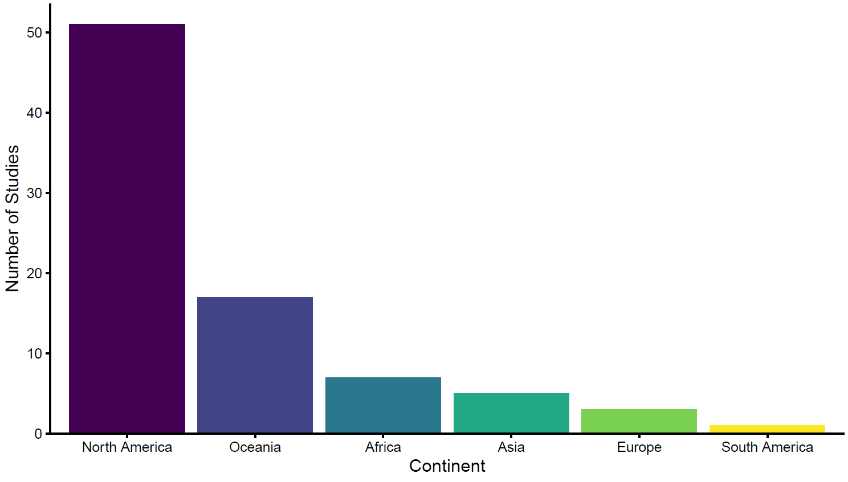

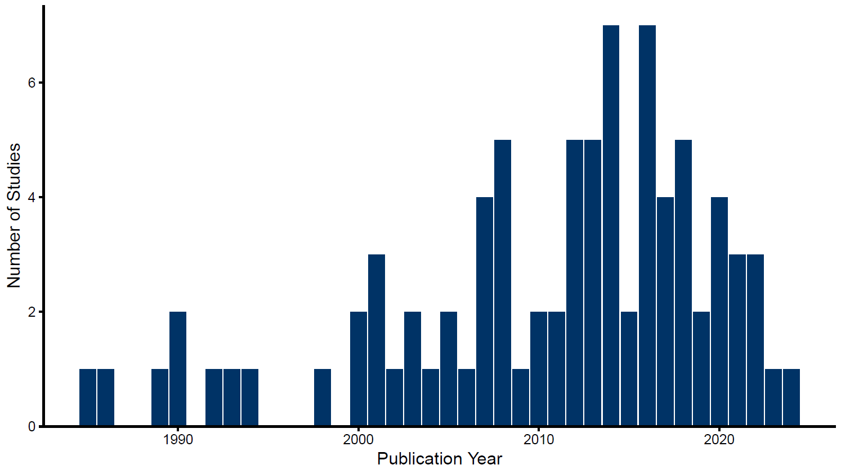

From the 84 studies, we extracted 185 cases investigating the influence of fire on animal movement metrics for inclusion in the review. Only a single study investigated movement responses to both planned and wildfire fire separately (Clapp & Beck, 2016). Similarly, all but one study investigated movement responses in a single species (Venter et al., 2014). Over half (n = 102, 55.1 %) of all cases investigated movement responses using a burnt-unburnt study design. A before-after study design was used in 34.6% of cases and before-after control-impact designs accounted for the remaining 10.3%. Investigations of home range metrics accounted for 45.6% of cases, followed by linear distance (35.1%) and other space use (14.1%).
Twelve biomes were represented in the 185 cases (FIGURE). Most research occurred in temperate biomes, with 20% of cases in Temperate broadleaf and mixed forests, 26% in Mediterranean forests, woodlands, and scrub or sclerophyll forests, and 25% in Temperate coniferous forests. Approximately half (49.7%) of cases examined the effect of wildfire on movement, while 34.1% assessed the effect of planned burns. The type of fire evaluated was unclear for 9.2% of observations, and 7% considered the combined effect of wildfire and planned burns. Within the Temperate broadleaf and mixed forests biome, over half of cases examined the effect of planned fire. Conversely, over half of all cases in Mediterranean forests, woodlands, and scrub or sclerophyll forests investigated how wildfire affected movement.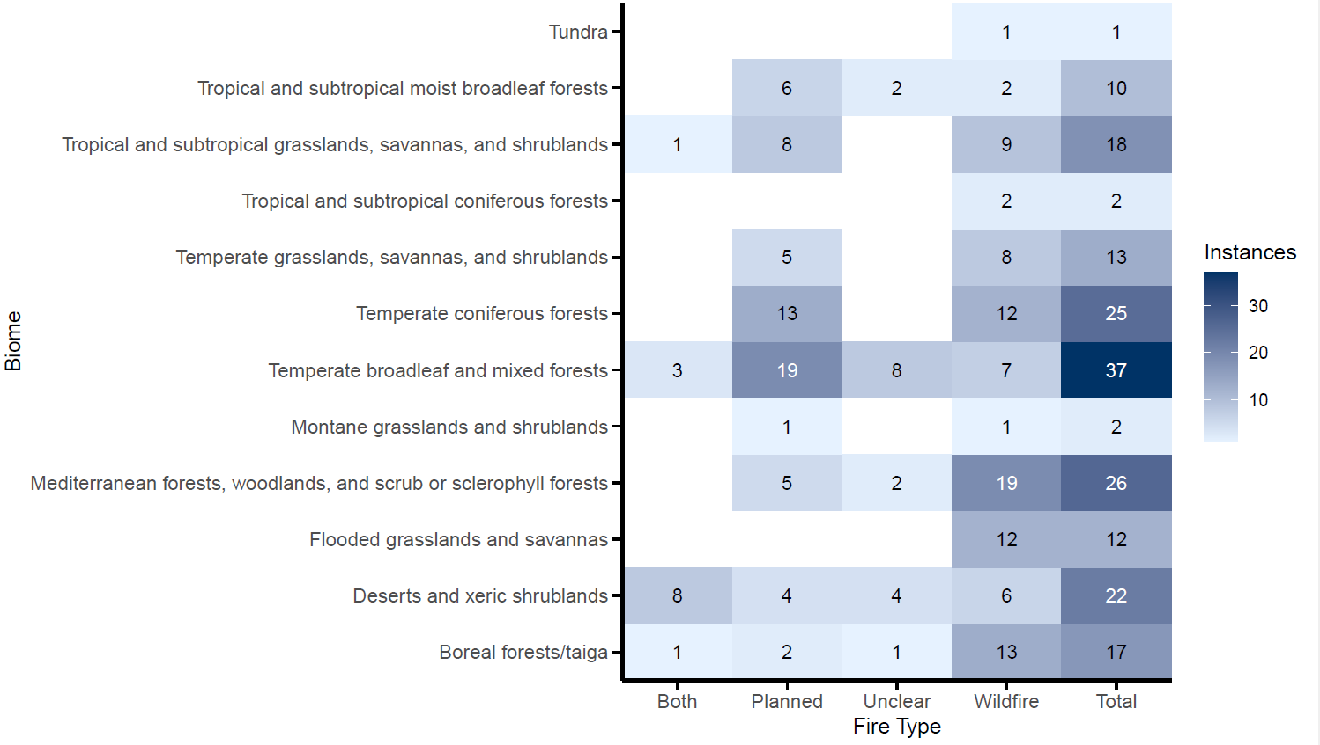

The movement response of 73 taxa across 23 orders and four classes were examined. Most taxa were within the Mammalia class (65.9%), followed by Aves (18.9%), Reptilia (13%) and Amphibia (2.2%). When considering cases by order, Artiodactyla (even toed undulates, 23.8%) and Rodentia (14.1%) were the most frequently studied (FIGURE). The orders Accipitriformes, Caprimulgiformes, Piciformes and Dasyuromorphia were all represented by a single case. Within Aves, Galliformes was the most frequently studied order. Testudines was the most frequently studied order within Reptilia. The most frequently studied species was white-tailed deer (Odocoileus virginianus), with 12 cases, followed by moose (Alces alces) with 10.
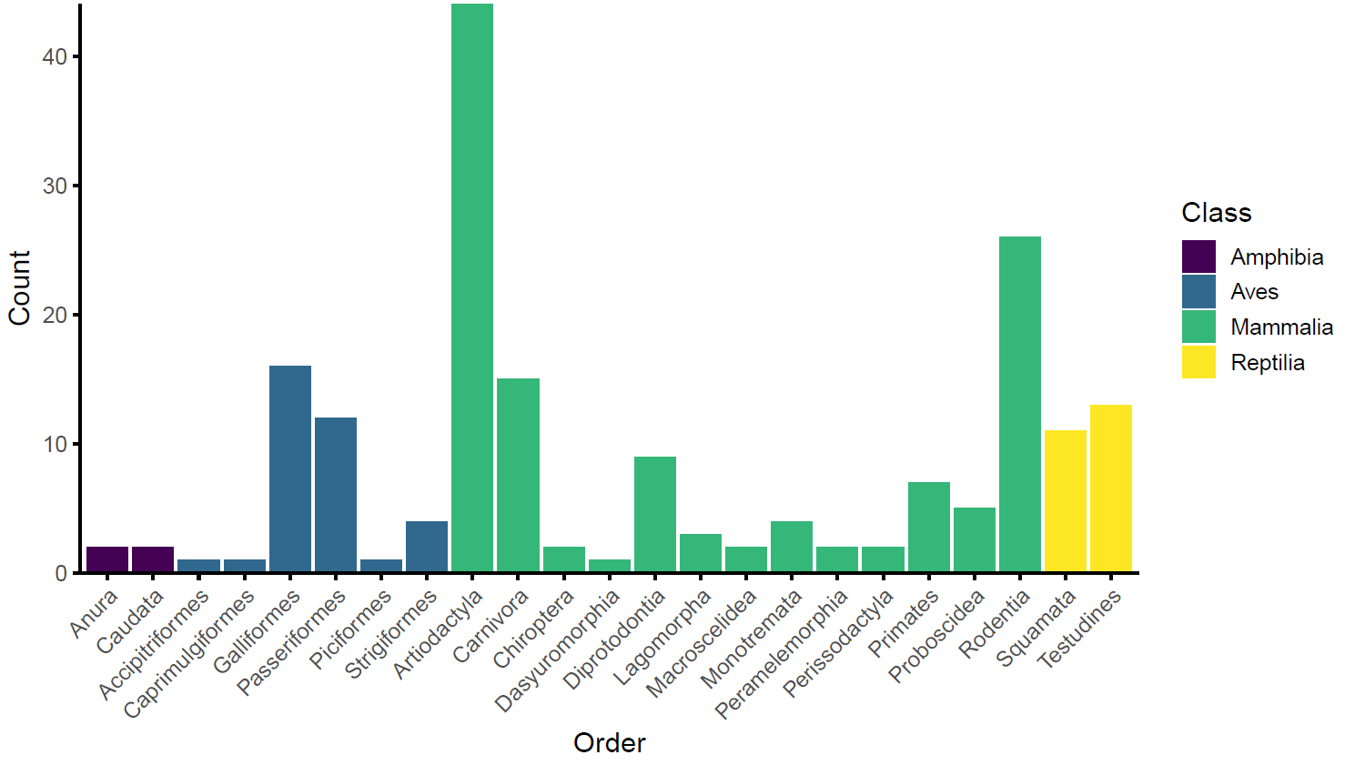

Meta analysis

We found that fire had an overall significant positive effect on animal movement, with movements increasing with fire (estimated effect size 0.2147, 95% confidence intervals [0.0244 - 0.4051], p = 0.0244). Remaining heterogeneity FIGURE
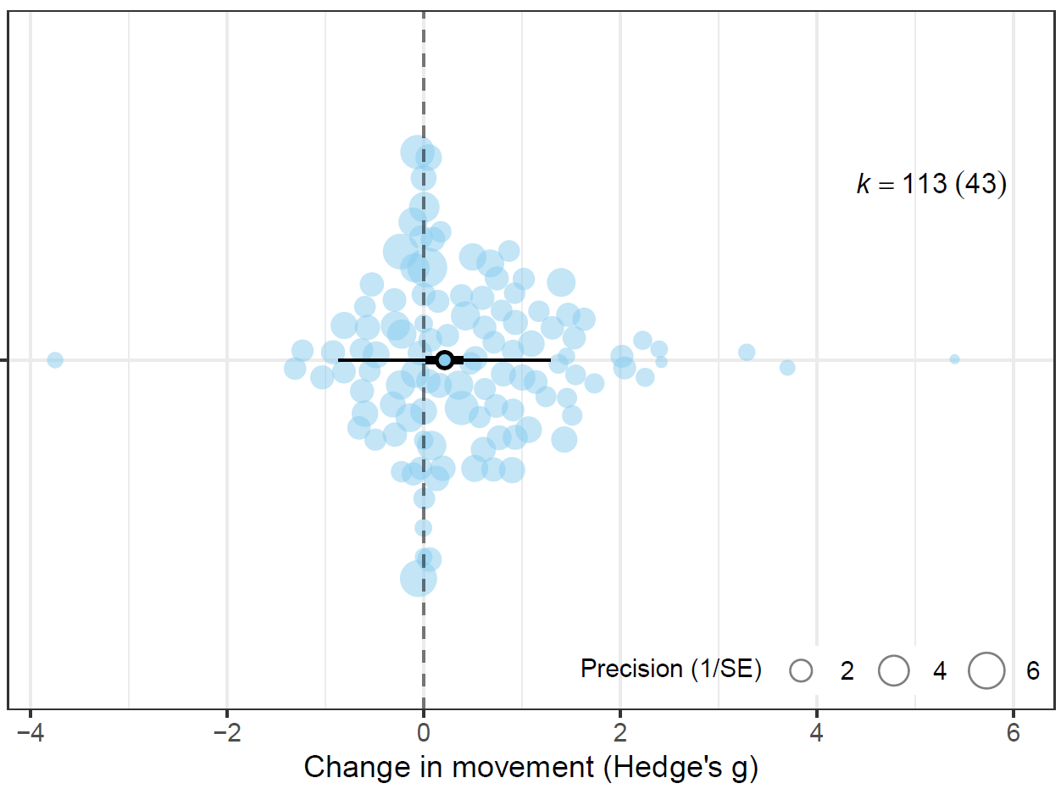
A single species, Chlorocebus aethiops grivet, demonstrated a significant, large positive mean effect size (1.32 [0.0607 - 2.5701], p = 0.0402) (FIGURE). All other mean effect sizes had confidence intervals that overlapped zero, indicating that fire had no effect on the movement of these species. Hylocichla mustelina, wood thrush, returned a significant, large positive effect size from a single case. This was the only significant individual effect size, with the confidence intervals of all other individual effect sizes overlapping zero.
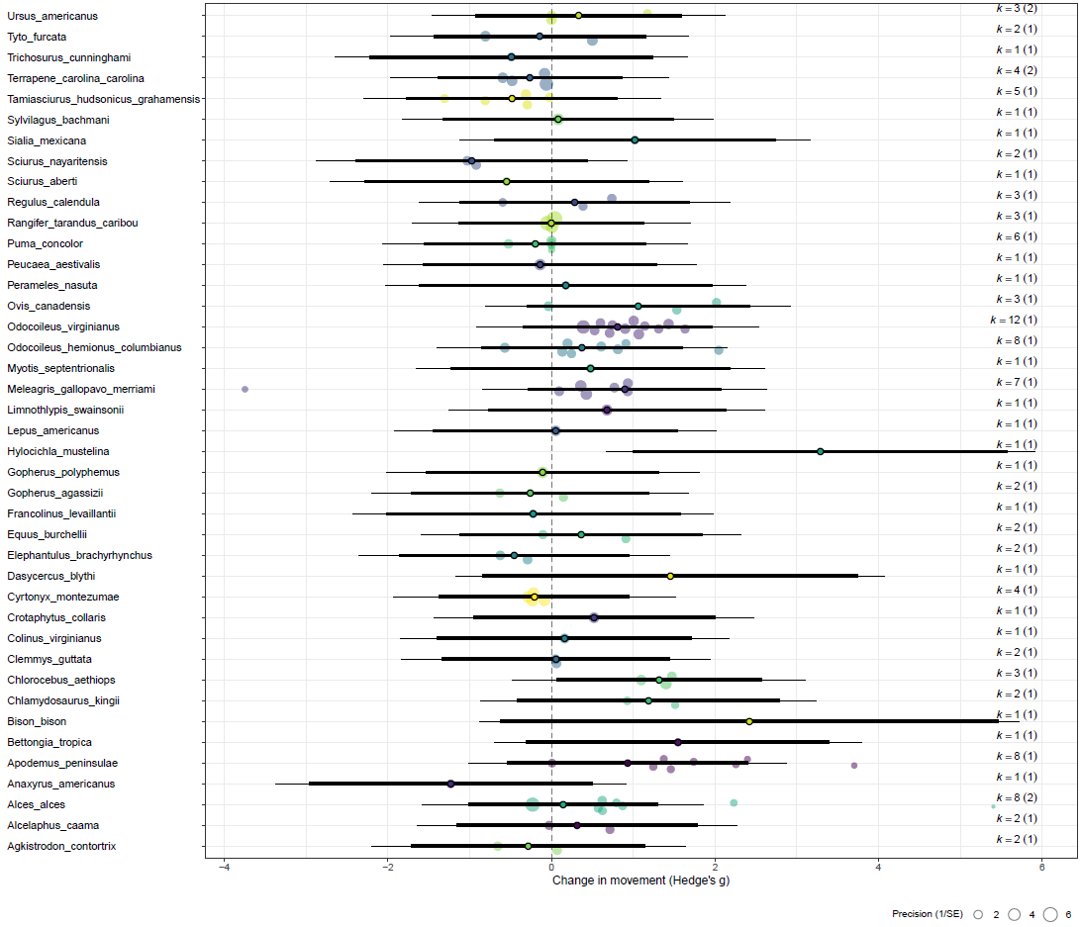

Movement Category
Movement category was not a significant predictor of movement responses (SUPP). However, fire had a significant yet small positive effect on linear distance movements (0.3027 [0.0432 - 0.5621], p = 0.0227). The effect of fire on other space use metrics was also small but non-significant. Remaining heterogeneity in the movement category model was similar to the null model, with 38.11% unexplained. FIGURE
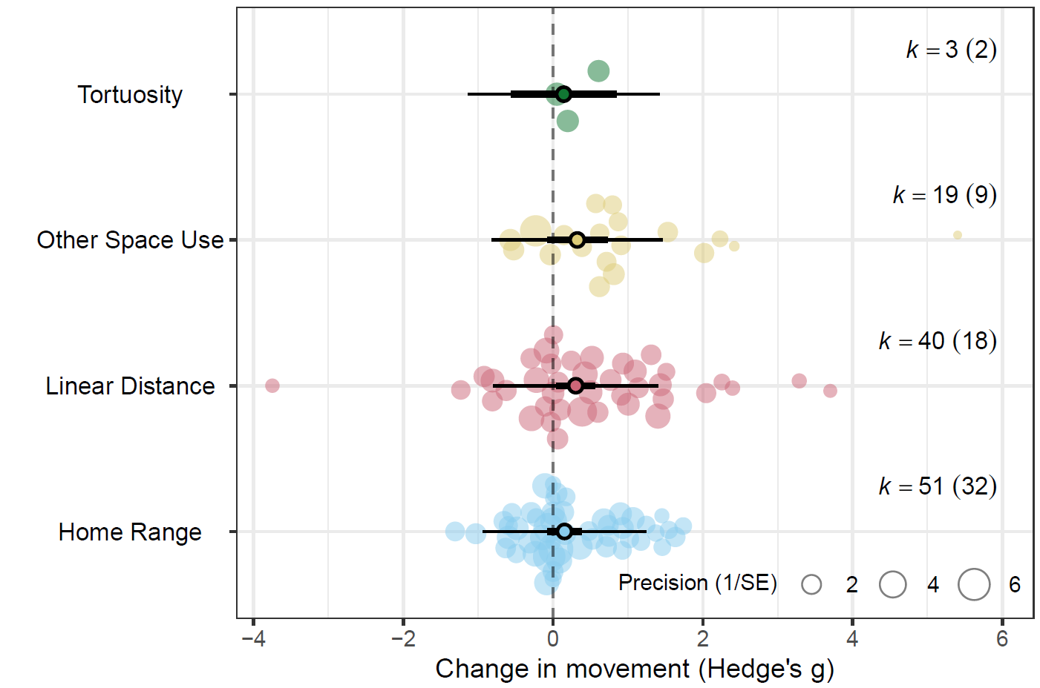

Taxonomy
The class model indicated class had a marginal, but non-significant, influence on animal movement in relation to fire (p = 0.0588). A small effect size was observed in birds (0.350 [-0.039, 0.739], p = 0.077) and mammals (0.271 [0.018, 0.524], p = 0.036), with although this effect was only significant in mammals.
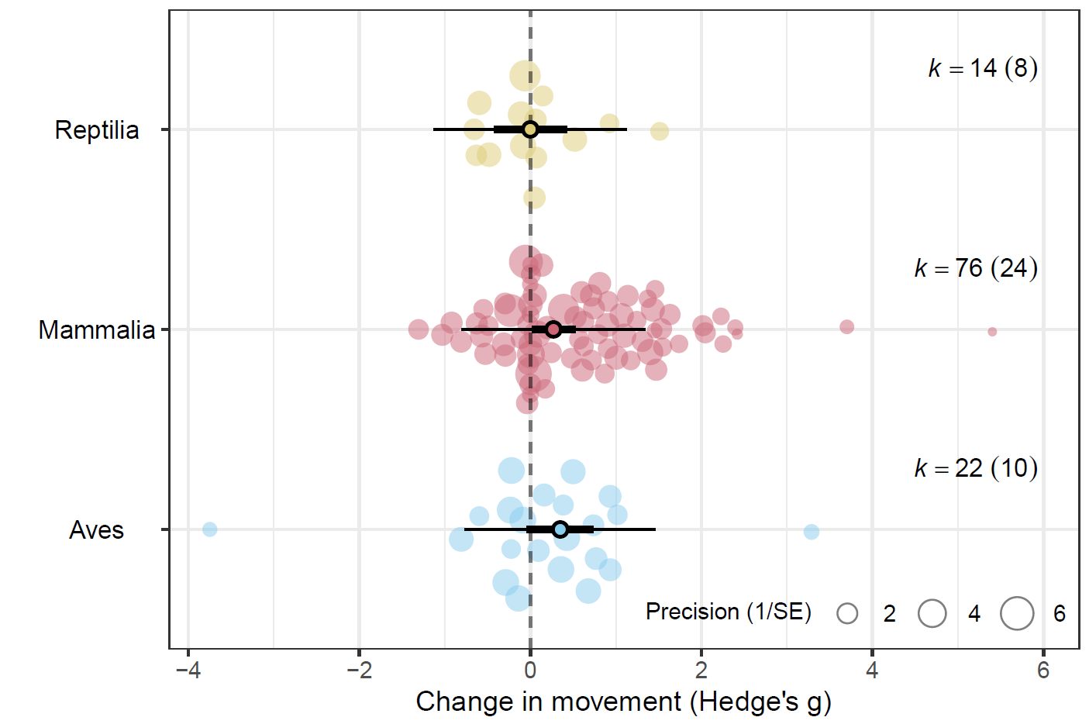

Biome
Biome had a significant predictive effect on animal movement following fire (p = 0.0331); however, the magnitude and direction of this effect varied between biomes. A large significant effect was observed in ‘Tropical and subtropical grasslands, savannas, and shrublands’ (0.8256 [0.2189 - 1.4323], p = 0.0082). Moderate, yet non-significant, positive effects were observed in Flooded grasslands and savannas (0.7803 [-0.0785 - 1.6392], p = 0.0744) and Temperate grasslands, savannas, and shrublands (0.5893 [-0.0076 - 1.186], p = 0.0529). Effect sizes in the remaining biomes were small or negative. FIGURE
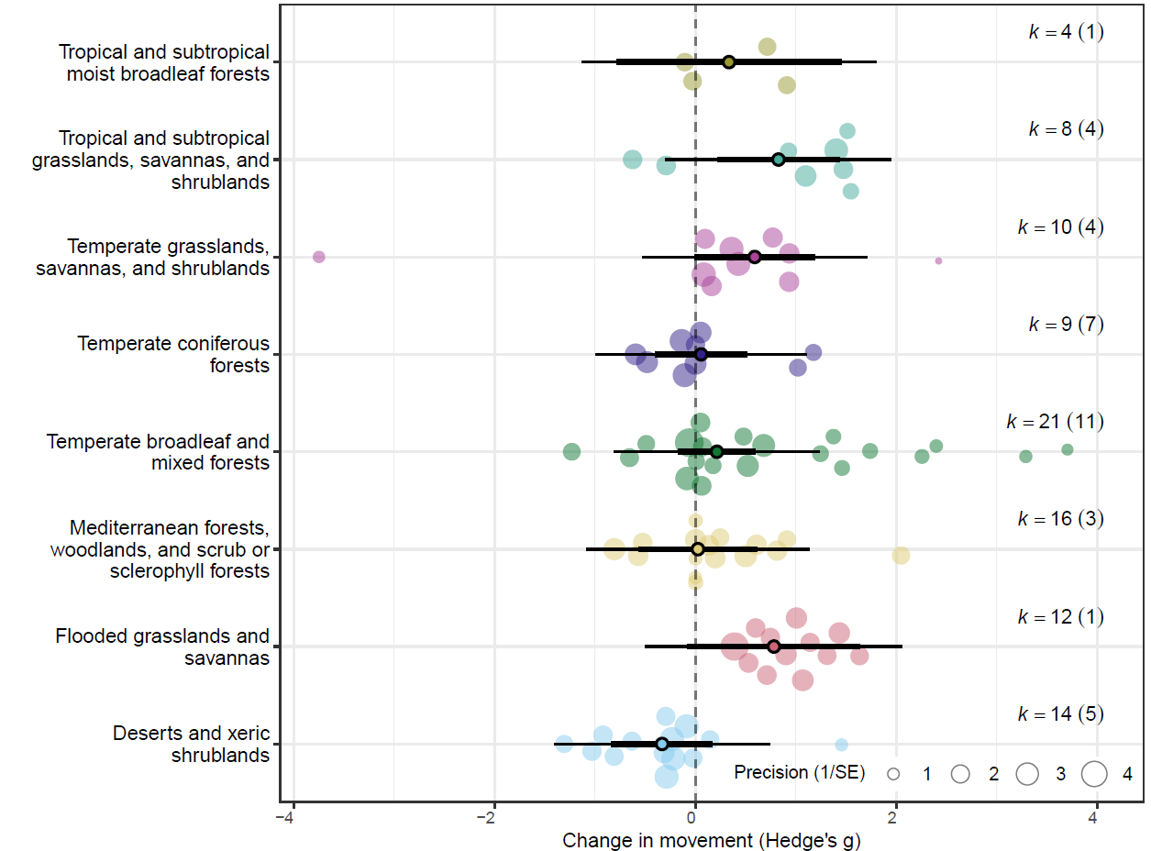

Fire Type, Fire Size & Maximum Burn Age
Fire type, planned or wildfire, did not predict variation in effect sizes (p = 0.4266), and differences in effect sizes between the two groups were non-significant. However, planned burns had a significant small, positive effect on movement (0.3131 [0.0048 - 0.6215], p = 0.0466) FIGURE. Residual heterogeneity was significant (p< .0001). Neither maximum burn age (β = –0.047 [–0.163 to 0.070], p = 0.43), or fire size (β = 0.0021 [-0.1125 to 0.1167], p = 0.97) was a significant moderator of effect size. Indicating there was no relationship between either burn age or fire size and animal movement responses.
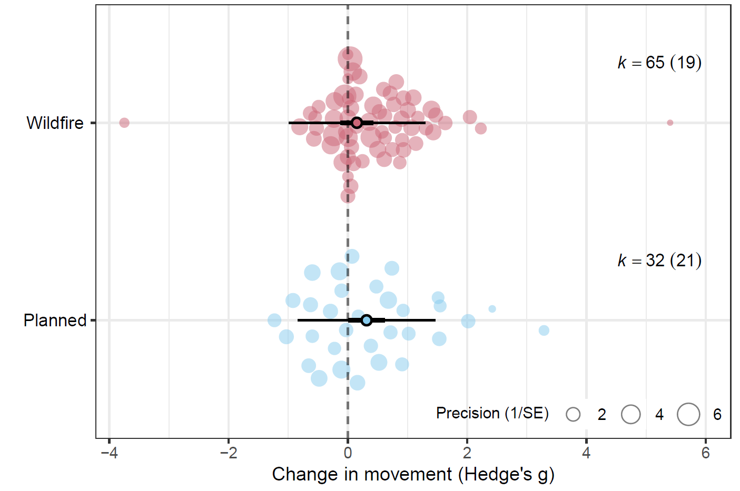

Body Mass
We modelled the effect of body mass on the overall data set, as well as each taxonomic class. Body mass did not affect animal movement responses to fire. Residual heterogeneity was low in the reptile model (p = 0.3963), and remained high in all other models SUPP.

Study heterogeneity, publication bias and sensitivity analysis
The I² value for the random effects only model was 61.59%, indicating a moderate to high level of true heterogeneity in the full dataset. Across study variation (study ID) accounted for 28.32% of the estimated heterogeneity. The remaining heterogeneity in effect sizes was explained by observation-level variation (observation ID I² 33.26%), indicating residual variation unexplained by the random effects. Neither phylogenetic relatedness or species identity accounted for any additional heterogeneity in the random effects only model, suggesting limited evolutionary or intraspecific structuring in effect sizes.
The results of the multilevel version of Egger’s regression indicated there was no evidence of publication bias or small-study effects on the dataset. We found no statistical asymmetry in the distribution of effect sizes (β = -0.0778, [-0.2204, 0.0648], p = 0.282). We found a significant decline effect in the dataset (β = -0.0227, [-0.0433, -0.002], p = 0.0317), with the magnitude of effect sizes declining over time (FIGURE). Results of the leave-one-out sensitivity analysis indicated minimal evidence of outlier influence, with confidence intervals of all leave-one-out models within the confidence intervals of the full model (SUPP).
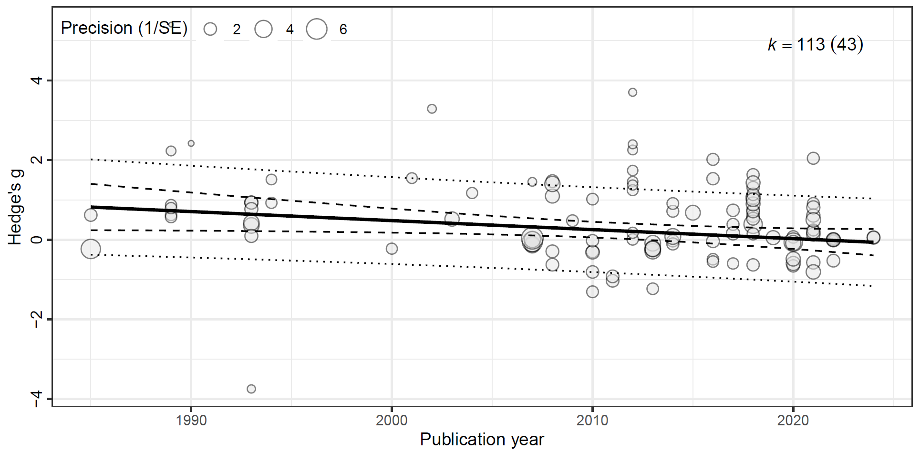

Discussion
Animal movement responses to fire are highly heterogeneous and often context dependent (Doherty et al., 2022; Doherty et al., 2023; Ganz et al., 2022; Geary et al., 2020), and this is reflected in the results of our meta-analysis. The results of our overall model reveal a small, yet positive effect of fire on animal movement, indicating that animal movements generally increase following fire. When comparing the strength of this effect between the movement categories, the linear distance category demonstrated small, yet significant positive effect, although movement category was not a strong predictor of effect size. HOW AND WHY FIRE MAY AFFECT LINEAR MOVEMENTS AND OTHER MOVEMENTS? what species are showing increases? Are these prey species? Could this be attributed to predation risk or perceived risk in open habitats? Could this be attributed to changes in predator behaviour? Altered perception? Stobo‐Wilson et al. (2021) for discussion of expectation that home range increases as resource availability decreases (also relevant for biome discussion).
TOPIC SENTENCE RE VARIANCE MODERATORS. The detection of moderate levels of within-individual variation suggests individual movement responses are not necessarily consistent across the movement categories. For example, an increase in home range size may not correlate with an increase in daily distance travelled and vice versa. EXPAND, EXPLAINATION FOR THIS? Notably, phylogenetic relatedness and non-phylogenetic species identity accounted for negligible variance in any of the model. EXPAND, EXPLAINATION FOR THIS?
Significant residual heterogeneity remained among effect sizes for most models, with between-study and within-individual heterogeneity generally accounting for some variance in most models. Between-study heterogeneity suggests either (i) the presence of meaningful differences in animal movement responses between studies, or (ii) differences in the capability of the studies to capture and quantify movement responses. In the first instance, site specific factors such as fire patchiness (Shaw et al., 2021) and fire severity (Crabb et al., 2022) may be driving animal movement responses. Fire is a spatiotemporally dynamic process; within a single fire extent, burn severity may range from complete canopy combustion through to incomplete combustion of the ground layer, leaving mid layers intact (Cherry et al., 2018; Yarnell et al., 2008). Similarly, a single fire extent may encompass a mosaic of burnt and unburnt vegetation, with or without heterogeneity in severity (Berry et al., 2016; Crabb et al., 2022; Lacki et al., 2009). The scale at which these fire characteristics and environmental conditions vary in relation to individual movement capacity is also an important consideration (Berry et al., 2016; Nathan et al., 2008; Nimmo et al., 2019) If post-fire conditions are unfavoured, highly mobile animals may shift the home range to adjacent, preferred habitats, as demonstrated by quokkas Setonix brachyurus following prescribed burns (Povh et al., 2023). In other cases, variation in burn severities across the fire extent may mediate habitat selection, yet have minimal effect on home range size, as seen in American black bears Ursus americanus following the extensive 2011 Wallow Wildfire in Arizona (Crabb et al., 2022). The authors propose heterogeneity in burn severity retained adequate foraging cover from established vegetation, and may have increased the productivity and foraging quality of grasses and herbs growing in areas affected by low severity fire (Crabb et al., 2022). With adequate resources available within the home range, there was no need to increase movement post fire (Crabb et al., 2022). SEE ALSO (Cohen et al., 2019)
In addition to site specific factors, variation in species traits, hunting behaviour, and foraging strategies may also be contributing to heterogeneity in movement responses between studies (Ganz et al., 2022; Geary et al., 2020; Pocknee et al., 2023). Our meta-analysis dataset included effect sizes from 13 orders across three classes, representing a broad range of life history strategies, hunting behaviours and foraging strategies. Our results found phylogenetic relatedness did not explain heterogeneity in effect sizes. Therefore, any variability in traits, life histories and behaviours that do contribute to movement responses occur likely at lower taxonomic ranks and are not consistent across higher levels such as order. EXPAND. Hunting behaviours vary across predators, as to does preferred habitat to hunt in (Doherty et al., 2022; Kauffman et al., 2007). SEE ALSO (Moran et al., 2021) for discussion RE condition and risky behaviour.
SEE ALSO (Driscoll et al., 2021). EXAPND – Other processes that may interact with fire to influence movement. Unfortunately, our sample size precluded a robust evaluation of interactive effects.
SECOND CASE - differences in the capability of the studies to capture and quantify movement responses “(i) confounding factors that are inconsistently measured or accounted for across studies, (ii) problems with statistical inference (e.g., differing statistical power or accuracy), or (iii) methodological differences across studies (e.g., differing times since fire) (Catford et al. 2022)” from Doherty et al. (2023). Furthermore, previous research indicates that interactive and synergistic effects are also likely to exert strong influence on animal responses to fire, and this may also be contributing to the high level of between study heterogeneity we found (Culhane et al., 2022; Doherty et al., 2022; Ganz et al., 2022)
Apart from biome, we found no clear relationship between our predictor variables and movement responses to fire. In contrast to site specific, localised factors, the resolution of the extrinsic predictor variables we investigated are much coarser, and do not incorporate spatial or temporal environmental heterogeneity. This may aid in explaining why variables we expected to be influential, such fire size and fire type, were not. Within the studies we reviewed, we extracted qualitative descriptors of burn severity and patchiness when provided, or inferred severity from post-fire descriptions of vegetation condition. Generally, burn severity was variable, resulting in a mosaic of differing burn severities and unburnt patches within a single fire extent (eg. Cherry et al., 2018; Crabb et al., 2022; Lacki et al., 2009). Burn heterogeneity, rather than total fire extent, is likely a stronger mediator of resource distribution and availability within the landscape, and therefore a stronger predictor of animal movement responses. We expected the strength of effect sizes to decrease with maximum treatment age, however found no relationship. Discuss temporal scaling of resources post fire/veg succession and seral stages. Discuss differences between biomes/veg types in the weather/climate drivers of productivity (eg. Unpredictability/boom and bust in arid or xeric habitats), as well as veg composition.
Biome type was a significant predictor of effect size. (EXPAND - types of movement, is space use contributing to results (ie are animals spending less time in post fire habitats?). Savanna results make sense – less productive ecosystems, individuals need to move greater distances to find resources. See references in intro of (Ganz et al., 2022) for discussion of peak foraging abundance in xeric landscapes)
WILDFIRE TYPE NOT SIGNIFICANT PREDICTOR – But planned burns demonstrated significant positive effect. Why? What could explain this? Attributes of planned burns? Management approaches (ie are planned burns similar/different to burns of historic regimes)? Again, look at species here – are grazers that are attracted to burned areas post fire contributing to this (eg space use metric)? Less precision in Wildfire results?
BODY MASS NOT SIGNIFICANT PREDICTOR. Despite correlation between body mass and movement/allometric scaling SEE (Doherty et al., 2019; Jetz et al., 2004; Tamburello et al., 2015).
LIMITATIONS – Cases not included due to small sizes/inadequate data to calculate effect sizes, quantitative fire attributes, no interactive effects modelled
IMPLICATIONS – Importance of results, future directions, please report more about fire treatments = disentangle effect of fire attributes from other site variables. Context dependency – importance of considering interactive effects, fine scale environmental variables and species traits

Conclusions

References

Abatzoglou, J. T., Kolden, C. A., Cullen, A. C., Sadegh, M., Williams, E. L., Turco, M., & Jones, M. W. (2025). Climate change has increased the odds of extreme regional forest fire years globally. Nature Communications, 16(1), 6390. https://doi.org/10.1038/s41467-025-61608-1
Ankit, R. WebPlotDigitizer. In (Version 5.2) https://automeris.io
Berry, L. E., Lindenmayer, D. B., Dennis, T. E., Driscoll, D. A., & Banks, S. C. (2016). Fire severity alters spatio–temporal movements and habitat utilisation by an arboreal marsupial, the mountain brushtail possum (Trichosurus cunninghami). International Journal of Wildland Fire, 25(12), 1291-1302.
Blakey, R. V., Sikich, J. A., Blumstein, D. T., & Riley, S. P. D. (2022). Mountain lions avoid burned areas and increase risky behavior after wildfire in a fragmented urban landscape. Current Biology, 32(21), 4762-4768.e4765. https://doi.org/10.1016/j.cub.2022.08.082
Boer, M. M., Resco de Dios, V., & Bradstock, R. A. (2020). Unprecedented burn area of Australian mega forest fires. Nature Climate Change, 10(3), 171-172. https://doi.org/10.1038/s41558-020-0716-1
Bowman, D. M. J. S., Balch, J. K., Artaxo, P., Bond, W. J., Carlson, J. M., Cochrane, M. A., D’Antonio, C. M., DeFries, R. S., Doyle, J. C., Harrison, S. P., Johnston, F. H., Keeley, J. E., Krawchuk, M. A., Kull, C. A., Marston, J. B., Moritz, M. A., Prentice, I. C., Roos, C. I., Scott, A. C., . . . Pyne, S. J. (2009). Fire in the Earth System. Science, 324(5926), 481-484. https://doi.org/10.1126/science.1163886
Brown, J. S., & Kotler, B. P. (2004). Hazardous duty pay and the foraging cost of predation. Ecology Letters, 7(10), 999-1014. https://doi.org/10.1111/j.1461-0248.2004.00661.x
Burton, C., Lampe, S., Kelley, D. I., Thiery, W., Hantson, S., Christidis, N., Gudmundsson, L., Forrest, M., Burke, E., Chang, J., Huang, H., Ito, A., Kou-Giesbrecht, S., Lasslop, G., Li, W., Nieradzik, L., Li, F., Chen, Y., Randerson, J., . . . Mengel, M. (2024). Global burned area increasingly explained by climate change. Nature Climate Change, 14(11), 1186-1192. https://doi.org/10.1038/s41558-024-02140-w
Cherry, M. J., Chandler, R. B., Garrison, E. P., Crawford, D. A., Kelly, B. D., Shindle, D. B., Godsea, K. G., Miller, K. V., & Conner, L. M. (2018). Wildfire affects space use and movement of white-tailed deer in a tropical pyric landscape. Forest Ecology and Management, 409, 161-169. https://doi.org/10.1016/j.foreco.2017.11.007
Clapp, J. G., & Beck, J. L. (2016). Short-term impacts of fire-mediated habitat alterations on an isolated bighorn sheep population. Fire Ecology, 12(3), 80-98. https://doi.org/10.4996/fireecology.1203080
Cohen, B. S., Prebyl, T. J., Collier, B. A., & Chamberlain, M. J. (2019). Spatiotemporal variability of fire characteristics affect animal responses in pyric landscapes. Fire Ecology, 15(1), 41. https://doi.org/10.1186/s42408-019-0058-4
Cosgrove, A. J., McWhorter, T. J., & Maron, M. (2018). Consequences of impediments to animal movements at different scales: A conceptual framework and review. Diversity and Distributions, 24(4), 448-459. https://doi.org/10.1111/ddi.12699
Crabb, M. L., Clement, M. J., Jones, A. S., Bristow, K. D., & Harding, L. E. (2022). Black bear spatial responses to the Wallow Wildfire in Arizona. The Journal of Wildlife Management, 86(3), 1-20. https://doi.org/10.1002/jwmg.22182
Culhane, K., Sollmann, R., White, A. M., Tarbill, G. L., Cooper, S. D., & Young, H. S. (2022). Small mammal responses to fire severity mediated by vegetation characteristics and species traits. Ecology and Evolution, 12(5), e8918. https://doi.org/10.1002/ece3.8918
Doherty, T. S., Fist, C. N., & Driscoll, D. A. (2019). Animal movement varies with resource availability, landscape configuration and body size: a conceptual model and empirical example. Landscape Ecology, 34(3), 603-614. https://doi.org/10.1007/s10980-019-00795-x
Doherty, T. S., Hays, G. C., & Driscoll, D. A. (2021). Human disturbance causes widespread disruption of animal movement. Nature Ecology & Evolution, 5(4), 513-519. https://doi.org/10.1038/s41559-020-01380-1
Doherty, T. S., Geary, W. L., Jolly, C. J., Macdonald, K. J., Miritis, V., Watchorn, D. J., Cherry, M. J., Conner, L. M., González, T. M., Legge, S. M., Ritchie, E. G., Stawski, C., & Dickman, C. R. (2022). Fire as a driver and mediator of predator–prey interactions. Biological Reviews, 97(4), 1539-1558. https://doi.org/10.1111/brv.12853
Doherty, T. S., Watchorn, D. J., Miritis, V., Pestell, A. J. L., & Geary, W. L. (2023). Cats, foxes and fire: Quantitative review reveals that invasive predator activity is most likely to increase shortly after fire. Fire Ecology, 19(1), 22. https://doi.org/10.1186/s42408-023-00183-6
Doherty, T. S., Macdonald, K. J., Nimmo, D. G., Santos, J. L., & Geary, W. L. (2024). Shifting fire regimes cause continent-wide transformation of threatened species habitat. Proceedings of the National Academy of Sciences, 121(18), e2316417121. https://doi.org/10.1073/pnas.2316417121
Driscoll, D. A., Armenteras, D., Bennett, A. F., Brotons, L., Clarke, M. F., Doherty, T. S., Haslem, A., Kelly, L. T., Sato, C. F., Sitters, H., Aquilué, N., Bell, K., Chadid, M., Duane, A., Meza-Elizalde, M. C., Giljohann, K. M., González, T. M., Jambhekar, R., Lazzari, J., . . . Wevill, T. (2021). How fire interacts with habitat loss and fragmentation. Biological Reviews, 96(3), 976-998. https://doi.org/10.1111/brv.12687
Ellis, T. M., Bowman, D. M. J. S., Jain, P., Flannigan, M. D., & Williamson, G. J. (2022). Global increase in wildfire risk due to climate-driven declines in fuel moisture. Global Change Biology, 28(4), 1544-1559. https://doi.org/10.1111/gcb.16006
Faurby, S., Davis, M., Pedersen, R. Ø., Schowanek, S. D., Antonelli, A., & Svenning, J.-C. (2018). PHYLACINE 1.2: The Phylogenetic Atlas of Mammal Macroecology. Ecology, 99(11), 2626-2626. https://doi.org/10.1002/ecy.2443
Fletcher, M.-S., Romano, A., Connor, S., Mariani, M., & Maezumi, S. Y. (2021). Catastrophic bushfires, Indigenous fire knowledge and reframing science in southeast Australia. Fire, 4(3).
Fordyce, A., Hradsky, B. A., Ritchie, E. G., & Di Stefano, J. (2016). Fire affects microhabitat selection, movement patterns, and body condition of an Australian rodent (Rattus fuscipes). Journal of Mammalogy, 97(1), 102-111. https://doi.org/10.1093/jmammal/gyv159
Ganz, T. R., DeVivo, M. T., Kertson, B. N., Roussin, T., Satterfield, L., Wirsing, A. J., & Prugh, L. R. (2022). Interactive effects of wildfires, season and predator activity shape mule deer movements. Journal of Animal Ecology, 91(11), 2273-2288. https://doi.org/10.1111/1365-2656.13810
Gasaway, W. C., Dubois, S. D., Boertje, R. D., Reed, D. J., & Simpson, D. T. (1989). Response of radio-collared moose to a large burn in central Alaska. Canadian Journal of Zoology, 67(2), 325-329. https://doi.org/10.1139/z89-047
Geary, W. L., Doherty, T. S., Nimmo, D. G., Tulloch, A. I. T., & Ritchie, E. G. (2020). Predator responses to fire: A global systematic review and meta-analysis. Journal of Animal Ecology, 89(4), 955-971. https://doi.org/10.1111/1365-2656.13153
Hagmann, R. K., Hessburg, P. F., Prichard, S. J., Povak, N. A., Brown, P. M., Fulé, P. Z., Keane, R. E., Knapp, E. E., Lydersen, J. M., Metlen, K. L., Reilly, M. J., Sánchez Meador, A. J., Stephens, S. L., Stevens, J. T., Taylor, A. H., Yocom, L. L., Battaglia, M. A., Churchill, D. J., Daniels, L. D., . . . Waltz, A. E. M. (2021). Evidence for widespread changes in the structure, composition, and fire regimes of western North American forests. Ecological Applications, 31(8), e02431. https://doi.org/10.1002/eap.2431
He, T., Lamont, B. B., & Pausas, J. G. (2019). Fire as a key driver of Earth's biodiversity. Biological Reviews, 94(6), 1983-2010. https://doi.org/10.1111/brv.12544
Hefty, K. L., & Stewart, K. M. (2019). Flexible resource use strategies of a central-place forager experiencing dynamic risk and opportunity. Movement Ecology, 7(1), 23. https://doi.org/10.1186/s40462-019-0168-2
Hijmans, R. J., Barbosa, M., Ghos, A., & Mandel, A. (2025). geodata. In (Version 0.6-2) https://github.com/rspatial/geodata
Hinam, H., & St. Clair, C. (2008). High levels of habitat loss and fragmentation limit reproductive success by reducing home range size and provisioning rates of northern saw-whet owls. Biological Conservation, 141, 524-535. https://doi.org/10.1016/j.biocon.2007.11.011
Jetz, W., Carbone, C., Fulford, J., & Brown, J. H. (2004). The scaling of animal space use. Science, 306(5694), 266-268. https://doi.org/10.1126/science.1102138
Jolly, C. J., Dickman, C. R., Doherty, T. S., van Eeden, L. M., Geary, W. L., Legge, S. M., Woinarski, J. C. Z., & Nimmo, D. G. (2022). Animal mortality during fire. Global Change Biology, 28(6), 2053-2065. https://doi.org/10.1111/gcb.16044
Jolly, W. M., Cochrane, M. A., Freeborn, P. H., Holden, Z. A., Brown, T. J., Williamson, G. J., & Bowman, D. M. J. S. (2015). Climate-induced variations in global wildfire danger from 1979 to 2013. Nature Communications, 6(1), 7537. https://doi.org/10.1038/ncomms8537
Kauffman, M. J., Varley, N., Smith, D. W., Stahler, D. R., MacNulty, D. R., & Boyce, M. S. (2007). Landscape heterogeneity shapes predation in a newly restored predator–prey system. Ecology Letters, 10(8), 690-700. https://doi.org/10.1111/j.1461-0248.2007.01059.x
Kreider, M. R., Higuera, P. E., Parks, S. A., Rice, W. L., White, N., & Larson, A. J. (2024). Fire suppression makes wildfires more severe and accentuates impacts of climate change and fuel accumulation. Nature Communications, 15(1), 2412. https://doi.org/10.1038/s41467-024-46702-0
Lacki, M. J., Cox, D. R., Dodd, L. E., & Dickinson, M. B. (2009). Response of northern bats (Myotis septentrionalis) to prescribed fires in eastern Kentucky forests. Journal of Mammalogy, 90(5), 1165-1175. https://doi.org/10.1644/08-MAMM-A-349.1
Leahy, L., Legge, S. M., Tuft, K., McGregor, H. W., Barmuta, L. A., Jones, M. E., & Johnson, C. N. (2016). Amplified predation after fire suppresses rodent populations in Australia’s tropical savannas. Wildlife Research, 42(8), 705-716.
Mariani, M., Connor, S. E., Theuerkauf, M., Herbert, A., Kuneš, P., Bowman, D., Fletcher, M.-S., Head, L., Kershaw, A. P., Haberle, S. G., Stevenson, J., Adeleye, M., Cadd, H., Hopf, F., & Briles, C. (2022). Disruption of cultural burning promotes shrub encroachment and unprecedented wildfires. Frontiers in Ecology and the Environment, 20(5), 292-300. https://doi.org/10.1002/fee.2395
McGregor, H., Legge, S., Jones, M. E., & Johnson, C. N. (2015). Feral cats are better killers in open habitats, revealed by animal-borne video. PLoS One, 10(8), e0133915. https://doi.org/10.1371/journal.pone.0133915
McGregor, H., Cliff, H., B. , & Kanowski, J. (2016a). Habitat preference for fire scars by feral cats in Cape York Peninsula, Australia. Wildlife Research, 43(8), 623-633. https://doi.org/10.1071/WR16058
McGregor, H. W., Legge, S., Jones, M. E., & Johnson, C. N. (2016b). Extraterritorial hunting expeditions to intense fire scars by feral cats. Scientific Reports, 6(1), 22559. https://doi.org/10.1038/srep22559
Michonneau, F., Brown, J. W., & Winter, D. J. (2016). rotl: An R package to interact with the Open Tree of Life data. Methods in Ecology and Evolution, 7(12), 1476-1481. https://doi.org/10.1111/2041-210X.12593
Moran, N. P., Sánchez-Tójar, A., Schielzeth, H., & Reinhold, K. (2021). Poor nutritional condition promotes high-risk behaviours: A systematic review and meta-analysis. Biological Reviews, 96(1), 269-288. https://doi.org/10.1111/brv.12655
Morollón, S., Pausas, J., Urios, V., & López-López, P. (2022). Wildfire response of GPS-tracked Bonelli’s eagles in eastern Spain. International Journal of Wildland Fire, 31, 901-908. https://doi.org/10.1071/WF22018
Morris, S. B. (2008). Estimating Effect Sizes From Pretest-Posttest-Control Group Designs. Organizational Research Methods, 11(2), 364-386. https://doi.org/10.1177/1094428106291059
Nakagawa, S., & Cuthill, I. C. (2007). Effect size, confidence interval and statistical significance: A practical guide for biologists. Biological Reviews, 82(4), 591-605. https://doi.org/10.1111/j.1469-185X.2007.00027.x
Nakagawa, S., & Santos, E. S. A. (2012). Methodological issues and advances in biological meta-analysis. Evolutionary Ecology, 26(5), 1253-1274. https://doi.org/10.1007/s10682-012-9555-5
Nakagawa, S., Lagisz, M., Jennions, M. D., Koricheva, J., Noble, D. W. A., Parker, T. H., Sánchez-Tójar, A., Yang, Y., & O'Dea, R. E. (2022). Methods for testing publication bias in ecological and evolutionary meta-analyses. Methods in Ecology and Evolution, 13(1), 4-21. https://doi.org/https://doi.org/10.1111/2041-210X.13724
Nakagawa, S., Lagisz, M., O'Dea, R. E., Pottier, P., Rutkowska, J., Senior, A. M., Yang, Y., & Noble, D. W. A. (2023). orchaRd 2.0: An R package for visualising meta-analyses with orchard plots. Methods in Ecology and Evolution, 14(8), 2003-2010. https://doi.org/10.1111/2041-210X.14152
Nathan, R., Getz, W. M., Revilla, E., Holyoak, M., Kadmon, R., Saltz, D., & Smouse, P. E. (2008). A movement ecology paradigm for unifying organismal movement research. Proceedings of the National Academy of Sciences, 105(49), 19052-19059. https://doi.org/10.1073/pnas.0800375105
Nimmo, D. G., Avitabile, S., Banks, S. C., Bliege Bird, R., Callister, K., Clarke, M. F., Dickman, C. R., Doherty, T. S., Driscoll, D. A., Greenville, A. C., Haslem, A., Kelly, L. T., Kenny, S. A., Lahoz‐Monfort, J. J., Lee, C., Leonard, S., Moore, H., Newsome, T. M., Parr, C. L., . . . Bennett, A. F. (2019). Animal movements in fire‐prone landscapes. Biological Reviews of the Cambridge Philosophical Society, 94(3), 981-998. https://doi.org/10.1111/brv.12486
Nimmo, D. G., Carthey, A. J. R., Jolly, C. J., & Blumstein, D. T. (2021). Welcome to the Pyrocene: Animal survival in the age of megafire. Global Change Biology, 27(22), 5684-5693. https://doi.org/10.1111/gcb.15834
Olson, D. M., Dinerstein, E., Wikramanayake, E. D., Burgess, N. D., Powell, G. V. N., Underwood, E. C., D'Amico, J. A., Itoua, I., Strand, H. E., Morrison, J. C., Loucks, C. J., Allnutt, T. F., Ricketts, T. H., Kura, Y., Lamoreux, J. F., Wettengel, W. W., Hedao, P., & Kassem, K. R. (2001). Terrestrial Ecoregions of the World: A New Map of Life on Earth: A new global map of terrestrial ecoregions provides an innovative tool for conserving biodiversity. BioScience, 51(11), 933-938. https://doi.org/10.1641/0006-3568(2001)051[0933:TEOTWA]2.0.CO;2
Oskyrko, O. M., Chunrong; Meiri, Shai; Du, Weiguo. (2024). ReptTraits: A comprehensive dataset of ecological traits in reptiles.
Pasch, B., & Koprowski, J. L. (2011). Impacts of fire suppression on space use by Mexican fox squirrels. Journal of Mammalogy, 92(1), 227-234. https://doi.org/10.1644/10-MAMM-A-133.1
Pausas, J. G., & Parr, C. L. (2018). Towards an understanding of the evolutionary role of fire in animals. Evolutionary Ecology, 32(2), 113-125. https://doi.org/10.1007/s10682-018-9927-6
Pettett, C. E., Johnson, P. J., Moorhouse, T. P., Hambly, C., Speakman, J. R., & Macdonald, D. W. (2017). Daily energy expenditure in the face of predation: Hedgehog energetics in rural landscapes. Journal of Experimental Biology, 220(3), 460-468. https://doi.org/10.1242/jeb.150359
Pocknee, C. A., Legge, S. M., McDonald, J., & Fisher, D. O. (2023). Modeling mammal response to fire based on species’ traits. Conservation Biology, 37(4), e14062. https://doi.org/10.1111/cobi.14062
Posit team. (2025). RStudio: Integrated Development Environment for R. In (Version 2025.5.0.496) Posit Software, PBC. http://www.posit.co/
Povh, L. F., Willers, N., Shephard, J. M., & Fleming, P. A. (2023). A conservation-significant threatened mammal uses fire exclusions and shifts ranges in the presence of prescribed burning. International Journal of Wildland Fire, 32(9), 1291-1303. https://doi.org/10.1071/WF22196
R Core Team. (2024). R: A Language and Environment for Statistical Computing. In R Foundation for Statistical Computing. https://www.R-project.org/
Rodríguez-Trejo, D. A., Pausas, J. G., & Miranda-Moreno, A. G. (2019). Plant responses to fire in a Mexican arid shrubland. Fire Ecology, 15(1), 11. https://doi.org/10.1186/s42408-019-0029-9
Ryan, K. C., Knapp, E. E., & Varner, J. M. (2013). Prescribed fire in North American forests and woodlands: History, current practice, and challenges. Frontiers in Ecology and the Environment, 11(s1), e15-e24. https://doi.org/10.1890/120329
Shaw, R. E., James, A. I., Tuft, K., Legge, S., Cary, G. J., Peakall, R., & Banks, S. C. (2021). Unburnt habitat patches are critical for survival and in situ population recovery in a small mammal after fire. Journal of Applied Ecology, 58(6), 1325-1335. https://doi.org/10.1111/1365-2664.13846
Stobo‐Wilson, A. M., Cremona, T., Murphy, B. P., & Carthew, S. M. (2021). Resource availability drives variation in a marsupial glider’s home‐range size. Journal of Zoology, 315(3), 199-212. https://doi.org/10.1111/jzo.12906
Tamburello, N., Isabelle M. Côté, & Dulvy, N. K. (2015). Energy and the scaling of animal space use. The American Naturalist, 186(2), 196-211. https://doi.org/10.1086/682070
Templeton, A. R., Brazeal, H., & Neuwald, J. L. (2011). The transition from isolated patches to a metapopulation in the eastern collared lizard in response to prescribed fires. Ecology, 92(9), 1736-1747. https://doi.org/10.1890/10-1994.1
Tobias, J. A., Sheard, C., Pigot, A. L., Devenish, A. J. M., Yang, J., Sayol, F., Neate-Clegg, M. H. C., Alioravainen, N., Weeks, T. L., Barber, R. A., Walkden, P. A., MacGregor, H. E. A., Jones, S. E. I., Vincent, C., Phillips, A. G., Marples, N. M., Montaño-Centellas, F. A., Leandro-Silva, V., Claramunt, S., . . . Schleuning, M. (2022). AVONET: morphological, ecological and geographical data for all birds. Ecology Letters, 25(3), 581-597. https://doi.org/https://doi.org/10.1111/ele.13898
Tomas, W. M., Berlinck, C. N., Chiaravalloti, R. M., Faggioni, G. P., Strüssmann, C., Libonati, R., Abrahão, C. R., do Valle Alvarenga, G., de Faria Bacellar, A. E., de Queiroz Batista, F. R., Bornato, T. S., Camilo, A. R., Castedo, J., Fernando, A. M. E., de Freitas, G. O., Garcia, C. M., Gonçalves, H. S., de Freitas Guilherme, M. B., Layme, V. M. G., . . . Morato, R. (2021). Distance sampling surveys reveal 17 million vertebrates directly killed by the 2020’s wildfires in the Pantanal, Brazil. Scientific Reports, 11(1), 23547. https://doi.org/10.1038/s41598-021-02844-5
Venter, J. A., Nabe-Nielsen, J., Prins, H. H. T., & Slotow, R. (2014). Forage patch use by grazing herbivores in a South African grazing ecosystem. Acta Theriologica, 59(3), 457-466. https://doi.org/10.1007/s13364-014-0184-y
Viechtbauer, W., & Cheung, M. W. L. (2010). Outlier and influence diagnostics for meta-analysis. Research Synthesis Methods, 1(2), 112-125. https://doi.org/10.1002/jrsm.11
Viechtbauer, W. (2010). Conducting Meta-Analyses in R with the metafor Package. Journal of Statistical Software, 36(3), 1 - 48. https://doi.org/10.18637/jss.v036.i03
Yarnell, R. W., Metcalfe, D. J., Dunstone, N., Burnside, N., & Scott, D. M. (2008). The impact of fire on habitat use by the short-snouted elephant shrew (Elephantulus brachyrhynchus) in North West Province, South Africa. African Zoology, 43(1), 45-52. https://doi.org/10.1080/15627020.2008.11407405

