MOVEMENT IN THE PYROCENE: A GLOBAL META-ANALYSIS OF ANIMAL MOVEMENT RESPONSES TO FIRE

CHLOE L. MCAULEY^{1*}, EAMONN I.F. WOOSTER¹, TIM S. DOHERTY^{2,} MITCH A. COWAN^{1,3}, CHRIS J. JOLLY⁴, GRANT D. LINLEY¹, AMY SIMPSON¹, DYLAN WESTAWAY¹, BEN WILSON¹, DALE G. NIMMO¹
Affiliations:
1 Gulbali Institute, School of Agricultural, Environmental and Veterinary Sciences, Charles
Sturt University, Albury, NSW, Australia
2 Fire Science Program, Biodiversity and Conservation Science, Department of Biodiversity, Conservation and Attractions, Kings Park, Western Australia, Australia
3 School of Agricultural and Environmental Sciences, University of Western Australia,
Crawley, WA, Australia
4 School of Natural Sciences, Macquarie University, Macquarie Park, New South Wales, Australia

* Corresponding author
cmcauley@csu.edu.au

Target Journal – Global Change Biology
Key words
Fire, disturbance, meta-analysis, movement ecology, systematic review

Abstract

Main
Fire is a spatiotemporally dynamic disturbance process that has operated across the globe for hundreds of millions of years (Bowman et al., 2009; He et al., 2019). Fire transforms landscapes, initiating ecological succession processes that shape biotic communities and ecosystem function over varying spatial and temporal scales (Greenwood et al., 2022). For animals, these dynamics manifest as changes in the availability of food, shelter and breeding resources, and shifts in competition and predation pressure, with flow-on effects for animal fitness and survival (Doherty et al., 2022; He et al., 2019). In response, animals can alter their behaviour to minimise risk, maximise access to resources and improve survival (Nimmo et al., 2019).
Understanding how animals respond to fire and other disturbances requires recognising the central role of movement in shaping these responses. Movement decisions emerge from interactions between an animal’s internal state, mobility and navigation capacity, as well as external drivers (Nathan et al., 2008; Nathan et al., 2022). The competing demands of nutrition, reproduction, and predator avoidance influence how, where, and when animals move (Nathan et al., 2008; Wooster et al., 2024). By shaping the external environment, disturbance exerts a major influence on movement decisions (Doherty et al., 2021; Gomez et al., 2025; Tucker et al., 2018). In doing so, disturbance has profound consequences for animals (Cosgrove et al., 2018; Fahrig, 2007), including competition (Blakey et al., 2022), energy expenditure (Pettett et al., 2017), foraging success (Hinam & St. Clair, 2008) and ultimately survival (refs). These effects can scale up through space and time to drive population dynamics (Cosgrove et al., 2018; Gomez et al., 2025; Templeton et al., 2007).
Fire triggers a variety of animal movements across different spatial and temporal scales (Nimmo et al., 2019). In the short term—ranging from the hours during a fire to the days immediately after—animals may move to escape fire and leave the burnt area (Nimmo et al., 2021), or to quickly exploit new opportunities in the wake of a fire (Hovick et al., 2017; McGregor et al., 2016b). When the availability of resources is reduced after fire, movements, including distance travelled and home range size, can increase as animals move further to meet their ecological requirements (Blakey et al., 2022; Cherry et al., 2018). Other species may move less to reduce their energetic requirements and avoid traversing risky post-fire landscapes (Nowack et al., 2016). Over longer periods, from months to years and even decades, individuals adjust their movements to track resources (Gasaway et al., 1989; McGregor et al., 2016a). Their ability to exploit optimal habitat can be the difference between local persistence and extinction (Templeton et al., 2011). Therefore, movement represents an adaptive trait and a behavioural strategy that facilitates animal survival and persistence in fire-prone landscapes (He et al., 2019; Nimmo et al., 2021; Pausas & Parr, 2018).
Fire regimes are changing across the globe (Bowman et al., 2020; Cunningham et al., 2024). Anthropogenic climate and land use changes are major drivers of increased fire severity and extent in multiple biogeographic regions (Abatzoglou et al., 2025; Burton et al., 2024; Kreider et al., 2024). Sound understanding of animal movement is fundamental to predicting how animals will respond to shifting fire regimes (Nimmo et al., 2019). While numerous studies have explored the effects of fire on animal movement, these are largely taxon- or context-specific, and no quantitative synthesis has yet evaluated whether general patterns emerge across taxa and ecosystems.
Here, we conduct the first global systematic review and meta-analysis of the influence of fire on movement by terrestrial vertebrates. We synthesised 113 effect sizes derived from 73 taxa across 84 published studies and six continents to assess how fire attributes, taxonomy, and biogeography influence animal responses to fire. We hypothesised that, overall, fire would increase animal movement as individuals make more long-ranging, tortuous movements in search of resources, leading to larger home ranges after fire. Further, we predicted; (i) movement would increase with spatial extent of burnt area, because of the increased spatial extent of altered resources (Bowman et al., 2009); (ii) relative to planned burns, movement responses would be greater in response to wildfire, due to differential seasonality, severity and extent (Ezzy, 2022; van Wagtendonk & Lutz, 2007); and (iii) effect sizes would increase with species-level body mass, given that space use increases with body size, and larger animals are likely to have greater resource requirements (Jetz et al., 2004; Straus et al., 2024; Tamburello et al., 2015).

Materials and Methods

Systematic review
We aimed to capture literature investigating four categories of animal movement, namely home range size, linear distance moved, tortuosity, and other measures of space use. Following Doherty et al. (2021) home range responses included area-based measurements of space use, such as home range size and nest area size. Linear distance metrics were those that measured straight-line distances between relocations, such as daily distance travelled, as well as distance travelled per unit of time. Tortuosity provides a measure of how a movement path deviates from a straight-line and was captured by straightness indices and turning angles. Other space use metrics included those that quantified other aspects of animal movement decisions and behaviours not captured by the previous categories, such as mean residency time, time to return, and proportion of fixes within burnt and unburnt habitats.
We conducted a systematic review to identify studies investigating the influence of fire on animal movement. Database searches were undertaken in Scopus, Web of Science and ProQuest Dissertation and Theses Global between 15th May 2024 and 29th August 2024. Search terms relating to animal movement were combined with terms relating to fire and terrestrial vertebrates to identity suitable studies (Supplementary Information 1). To be considered for inclusion in the systematic review studies needed to meet the following criteria: (i) published in either a peer reviewed article, Master’s thesis, or PhD thesis; (ii) field studies with before–after fire, burnt–unburnt, or before–after control–impact designs; and (iii) provided an evaluation of movement responses to fire in free-ranging terrestrial vertebrates. We considered terrestrial vertebrates as animals primarily distributed in terrestrial biomes, or animals that used terrestrial habitat features for key life stages, such as reproduction or hibernation. All returned results were filtered to include only articles or theses published in English, and filters were applied in the databases to limit the results to relevant disciplines (Supplementary Information 1). Additional studies were identified by snowball searches of reference lists from two review articles returned in database searches (Nimmo et al., 2019; Nimmo et al., 2021), and one review paper known to the authors (Volkmann et al., 2020). Database searches, snowball searches, and title and abstract screening were done by C.L.M. Full text screening was performed by C.L.M, B.W, D.W, C.J.J, M.A.C, E.I.F.W and G.D.L.

Data extraction
From each study, we extracted metadata on fire type (wildfire or planned), fire size (hectares), maximum burn age (months), study design (before–after, control–impact, or before–after control–impact), geographic coordinates (latitude and longitude), country, and movement response (home range, linear distance, tortuosity, or other space use metrics) (Supplementary Information 1, Table S1.1). We defined planned fires as those intentionally ignited by people, and wildfires as those ignited by natural causes or unintentionally by anthropogenic sources. Fire type was recorded according to the authors’ description of the event. Fire size (area burned, ha) and maximum burn age (time since fire, years) were obtained directly from source studies where available.
Sample sizes, means, and measures of variation were extracted from tables, text, supplementary materials, or figures. Where necessary, data in figures were digitised using WebPlotDigitizer (Ankit, 2025). The sampling unit was typically the number of tracked individuals or independent movement paths. To minimise potential confounding from seasonal effects in before–after designs, we recorded the timing of data collection and noted any additional management activities that could interact with fire (e.g. logging, mechanical thinning, or livestock grazing).
Classification of burned and unburned animal populations followed the authors’ definitions. As such, movement data extracted from burned populations were not necessarily constrained to fire scars and included data from animals the study authors categorised as impacted by fire (e.g. a defined portion of the home range overlapped with the burn extent). When studies reported multiple time periods or treatment contrasts, we extracted data for the comparison closest to the fire event, or, in before–after studies, for the combination that minimised seasonal confounding. When demographic subgroups (e.g. males and females, adults and juveniles) were presented, each subgroup was treated as a separate case unless the sample size fell below inclusion thresholds; in such cases, subgroups were pooled if responses were similar in magnitude and direction.
In addition to study-level variables, we extracted or derived several covariates used as moderators in the meta-analysis. Biome was determined for each study location using the coordinates provided by authors or estimated from site descriptions, overlaid with the terrestrial biome classification of Olson et al. (2001) via the geodata package (Hijmans et al., 2025) implemented in R version 4.4.2 (R Core Team, 2024). Body mass data were obtained for each species from published trait databases including AvoNet (Tobias et al., 2022), ReptTraits (Oskyrko, 2024), and Phylacine (Faurby et al., 2018), supplemented with literature values where necessary. Species identity were recorded for all effect sizes based on the original publications. Taxonomic class was extracted from the National Center for Biotechnology Information database using the tax_name function within the taxize R package (Chamberlain & Szöcs, 2013). Data extraction was conducted by C.L.M and E.I.F.W.

Meta-analysis
To qualify for data inclusion in the meta-analysis, studies were required to meet the following criteria: (i) they provided sufficient information to calculate sample sizes, means, and measures of variation (standard deviations, standard errors, or 95% confidence intervals) for each treatment group; (ii) each treatment group had a sample size of at least five; (iii) methods were standardised across treatment groups; and (iv) the potential confounding effects of other environmental variables were considered minimal. To minimise seasonal confounding in before–after designs, only studies in which data were collected during the same or adjacent seasons were included in subsequent analyses.
We used the following formula from Morris (2008) to convert before–after control–impact studies to control–impact studies to calculate effect sizes.
$d_{ppc1}= c(\frac{Mₚₒₛₜ,ₜ - Mₚᵣₑ,ₜ}{ SDₚᵣₑ,ₜ} ) - c꜀(\frac{Mₚₒₛₜ,꜀ - Mₚᵣₑ,꜀}{SDₚᵣₑ,꜀})$
Following Morris (2008) we used the pretest (before) SD values for the control and treatment groups. All analyses were performed in using R version 4.4.2 (R Core Team, 2024) in RStudio (Posit team, 2025). Hedge’s G, using the unbiased estimate of sampling variances, was calculated for each study using the escalc function in the metafor package (Viechtbauer, 2010). Hedge’s G is a standardized mean difference method that includes a bias corrector for small sample sizes (Viechtbauer, 2010). By providing a standardised measure between control and treatment groups, Hedge’s G allows for aggregation and comparison of multiple movement responses. A negative effect size indicates a decrease in animal movement, and a positive value an increase in animal movement. We used the effect size benchmarks outlined in Nakagawa and Cuthill (2007), as g > 0.2 for a small effect, >0.5 as moderate and >0.8 as large, and considered an effect to be significant when 95% confidence intervals did not overlap zero. Effect size calculation was done by C.M and E.I.F.W.
To quantify the effect of fire on animal movement, we constructed phylogenetic multi-level meta analytic models using the rma.mv function in the metafor package (Viechtbauer, 2010). These models weigh each effect size by the inverse of the sampling variance, allowing the models to account for uncertainty in effect sizes. This results in larger sample sizes having higher weight in the models. To account for non-independence amongst effect sizes, we included study ID (a unique identifier assigned to each article or thesis), observation ID (a unique identifier assigned to each effect size), species phylogeny, and species identity (non-phylogenetic species identification) as random effects (Nakagawa & Santos, 2012). Phylogenies were obtained from the Open Tree of Life, using the tnrs_match_names function in the rotl package (Michonneau et al., 2016). Phylogenetic random effect values are a correlation matrix of branch lengths representing the phylogenetic relatedness between species. This is important as we would expect closely related species to respond similarly to fire, while species identity accounts for the effects sizes of the same species instead of relatedness to another species. We included a variance-covariance matrix in our models to account for non-independence resulting from individuals and populations contributing to multiple effect sizes (Nakagawa & Santos, 2012). We assumed a correlation of r = 0.5 for the same species within the same studies.
We first modelled the overall effect of fire on animal movement by fitting ‘fire’ as the only fixed effect in the model. We then asked in subsequent models whether movement responses varied according to movement category, fire type, fire size, maximum burn age, biome, body mass, taxonomic class and species. . Models were plotted using the orchaRd package (Nakagawa et al., 2023). Meta-analysis was performed by C.L.M and E.I.F.W.

Study heterogeneity, publication bias and sensitivity analysis
To quantify study heterogeneity, and the proportion of variance attributable to the random effects, we calculated I² using the i2_ml function in the orchaRd package (Nakagawa et al., 2023; Nakagawa & Santos, 2012). To test for publication bias resulting from biases in outcome reporting, we visually assessed funnel plot asymmetry and ran a multilevel version of Egger’s regressions with an approximation of observation precision as a predictor (Nakagawa et al., 2022). We tested for a time lag effect by regressing effect sizes against study year. Finally, we performed a leave-a-study-out-test to evaluate the sensitity of the overall model results to influential studies (Viechtbauer & Cheung, 2010). Publication bias testing was done by C.L.M and E.I.F.W.

Results

Systematic review
Our database searches yielded 5,231 records after duplicate removal. Following screening, 84 studies met the eligibility criteria. These studies were conducted across 12 countries and six continents (Figure 1). Most research was conducted in North America (60.7%), followed by Oceania (20.2%). Within North America, 90.2% of studies were from the United States, with the remainder from Canada. In Africa, 71.4% of studies originated from South Africa, with single studies from Kenya and Uganda. South America was represented by a single study from Paraguay. In Asia, 60% of studies were conducted in Indonesia, while Europe was represented by three studies, two from Spain and one from Portugal. Research effort has increased markedly over time. Only nine of the 84 studies were published before 2000, whereas nearly half (48.8%) were published between 2010 and 2019 (Supplementary Information 3, Figure S3.1).
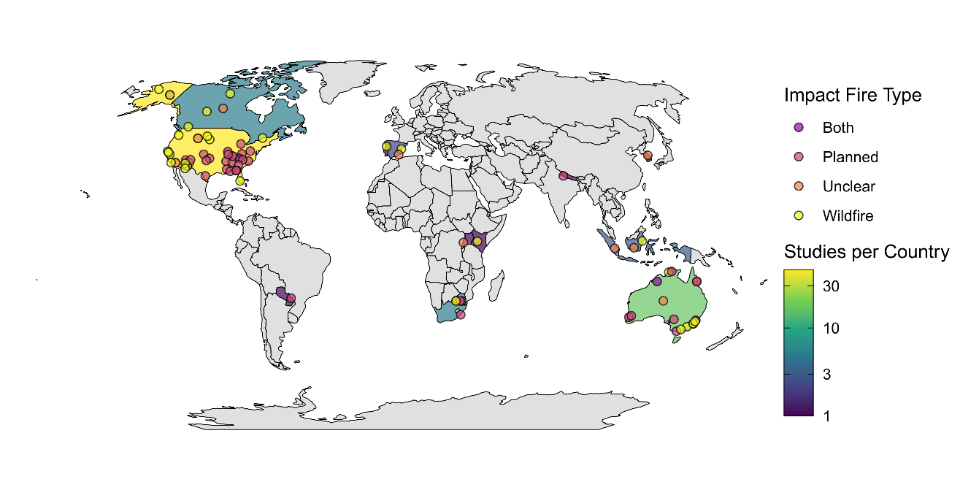
Figure 1: Map illustrating the number of studies per country and locations of the 84 studies included in the review. The color scale shows the number of studies per country, with darker colours indicating fewer studies, and lighter colours indicating more studies. The colour of the study points indicate the type of fire the study investigated.
From the 84 studies, we extracted 185 cases investigating the influence of fire on animal movement for inclusion in the review. Only a single study investigated movement responses to both planned and wildfire fire separately (Clapp & Beck, 2016), although other studies investigated the combined effect of wildfire and planned burns. Similarly, all but one study investigated movement responses in a single species (Venter et al., 2014). Over half (n = 102, 55.1%) of all cases investigated movement responses using a burnt–unburnt study design. A before–after study design was used in 34.6% of cases and before–after control–impact designs accounted for the remaining 10.3%. Investigations of home range metrics accounted for 45.6% of cases, followed by linear distance (35.1%) and other space use (14.1%).
Twelve biomes were represented among the 185 cases included in the review (Supplementary Information 3, Figure S3.2). Most research occurred in temperate biomes, with 20% of cases in Temperate broadleaf and mixed forests, 26% in Mediterranean forests, woodlands and scrub (including sclerophyll forests), and 25% in Temperate coniferous forests. Approximately half of all cases (49.7%) examined the effects of wildfire on animal movement, while 34.1% investigated planned burns. The fire type was not clearly specified for 9.2% of observations, and 7% assessed the combined effects of wildfire and planned burns. Within Temperate broadleaf and mixed forests, more than half of the cases examined planned fires, whereas in Mediterranean forests, woodlands and scrub (or sclerophyll forests), most studies focused on wildfire effects.
The dataset encompassed 73 taxa spanning 23 orders and four vertebrate classes. Most taxa belonged to Mammalia (65.9%), followed by Aves (18.9%), Reptilia (13.0%), and Amphibia (2.2%). Among orders, Artiodactyla (even-toed ungulates; 23.8%) and Rodentia (14.1%) were the most frequently represented (Supplementary Information 3, Figure S3.3). Several orders, Accipitriformes, Caprimulgiformes, Piciformes, and Dasyuromorphia, were each represented by a single case. Within Aves, Galliformes was the most frequently studied order, while within Reptilia, Testudines predominated. At the species level, white-tailed deer (Odocoileus virginianus) was the most commonly studied species (12 cases), followed by moose (Alces alces) with 10 cases.

Meta-analysis
From the 185 cases included in the systematic review, we calculated 113 effect sizes from 43 studies. The remaining 72 cases did not meet the criteria for inclusion in the meta-analysis. The phylogenetic multilevel meta-analytic model revealed a significant positive overall effect of fire on animal movement (Hedge’s g [95% CI] = 0.21 [0.02–0.41], p = 0.024; Figure 2). On average, animals occupying fire-affected habitats moved more than those in unburnt areas. However, responses varied substantially among species, indicating high interspecific heterogeneity (Supplementary Information 4, Figure S4.1).

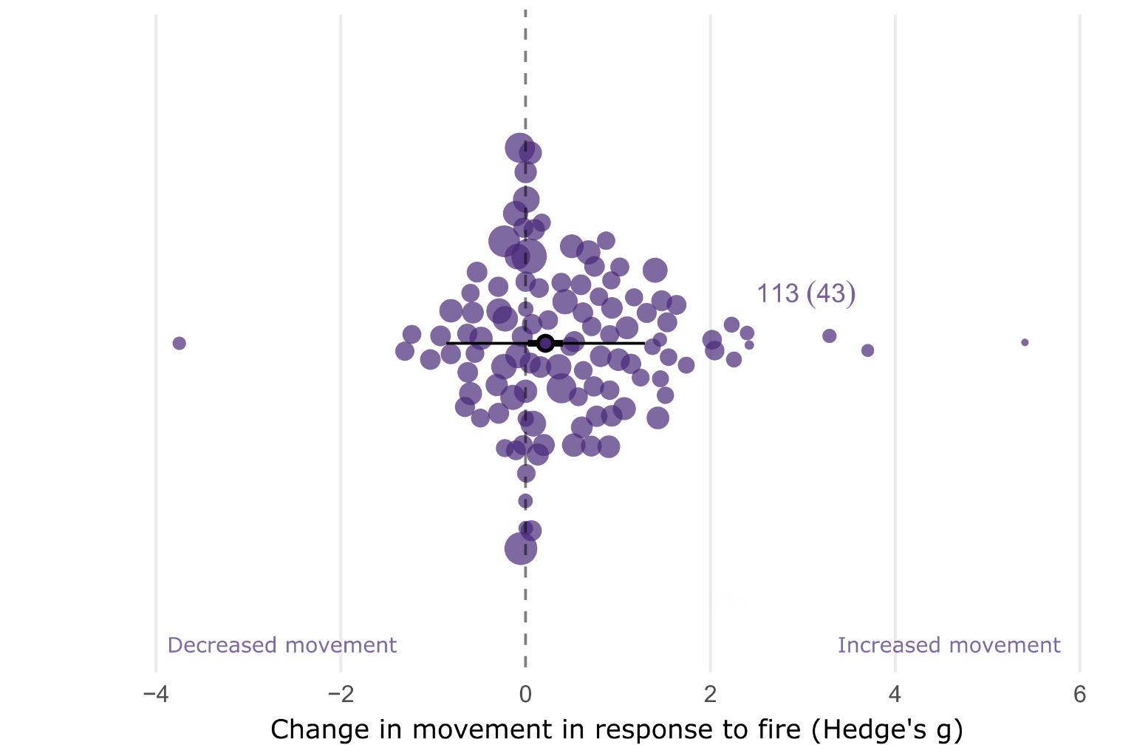
Figure 2: Orchard plot showing the overall estimated effect of fire on animal movement. The outlined point is the meta-analytic mean, the thick horizontal bars are 95% confidence intervals and the whiskers are 95% prediction intervals. Shaded points are effect sizes (Hedge’s g, n = 113), with point size scaled to show precision (1/SE; i.e., larger points had greater influence).. Points are jittered on the y axis to improve readability.

Movement Category
When modelling movement category as a moderator, fire had a small but significant positive effect on linear distance movements (0.30 [0.04–0.56], 0.023; Figure 3). (Hedge’s g = 0.30, 95% CI = 0.04–0.56, p = 0.023; Figure 3). The effect of fire on ‘other’ space-use was also positive but non-significant (Hedge’s g = 0.32, 95% CI = –0.08–0.72, p = 0.11). Effects on home-range size (Hedge’s g = 0.15, 95% CI = –0.07–0.38, p = 0.18) and tortuosity (Hedge’s g = 0.14, 95% CI = –0.56–0.85, p = 0.69) were also non-significant.
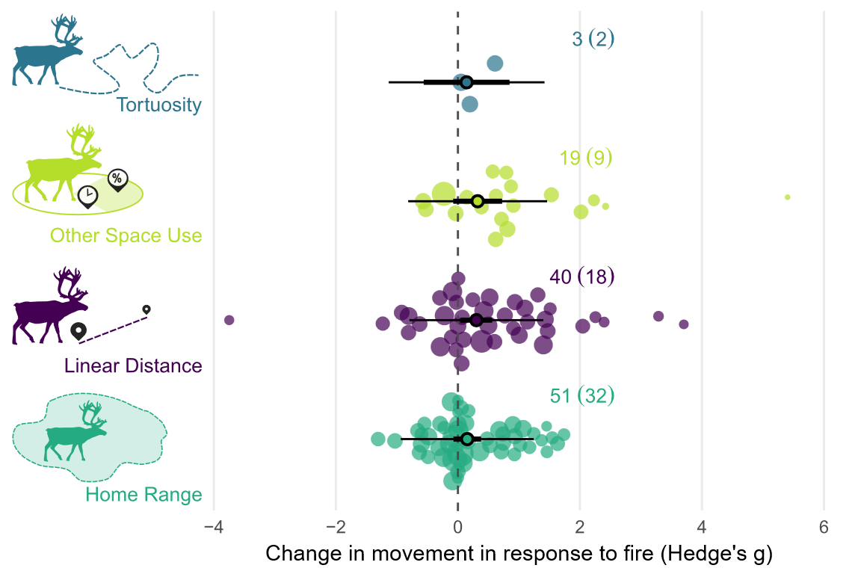
Figure 3: Orchard plot showing the estimated effect of fire on each of the four movement response categories. The meta-analytic mean is represented by the outlined point, with the thick horizontal bars showing 95% confidence interval and the whiskers the 95% prediction intervals. Each shaded point represents an effect size (Hedge’s g, n = 113), with the size of the point scaled to show precision within the model (1/SE) and larger points having a greater influence on the model. Effect size is shown on the x axis, and points are jittered on the y axis to improve readability.

Taxonomy
When modelling taxonomic class as a moderator, fire had a small but significant positive effect on movement in mammals (Hedge’s g = 0.27, 95% CI = 0.02–0.52, p = 0.036; Figure 4). A small, positive effect was also observed in birds (Hedge’s g = 0.35, 95% CI = –0.04–0.74, p = 0.077). By contrast, no effect of fire on movement was detected in reptiles (Hedge’s g = 0.00, 95% CI = –0.42–0.42, p = 0.999).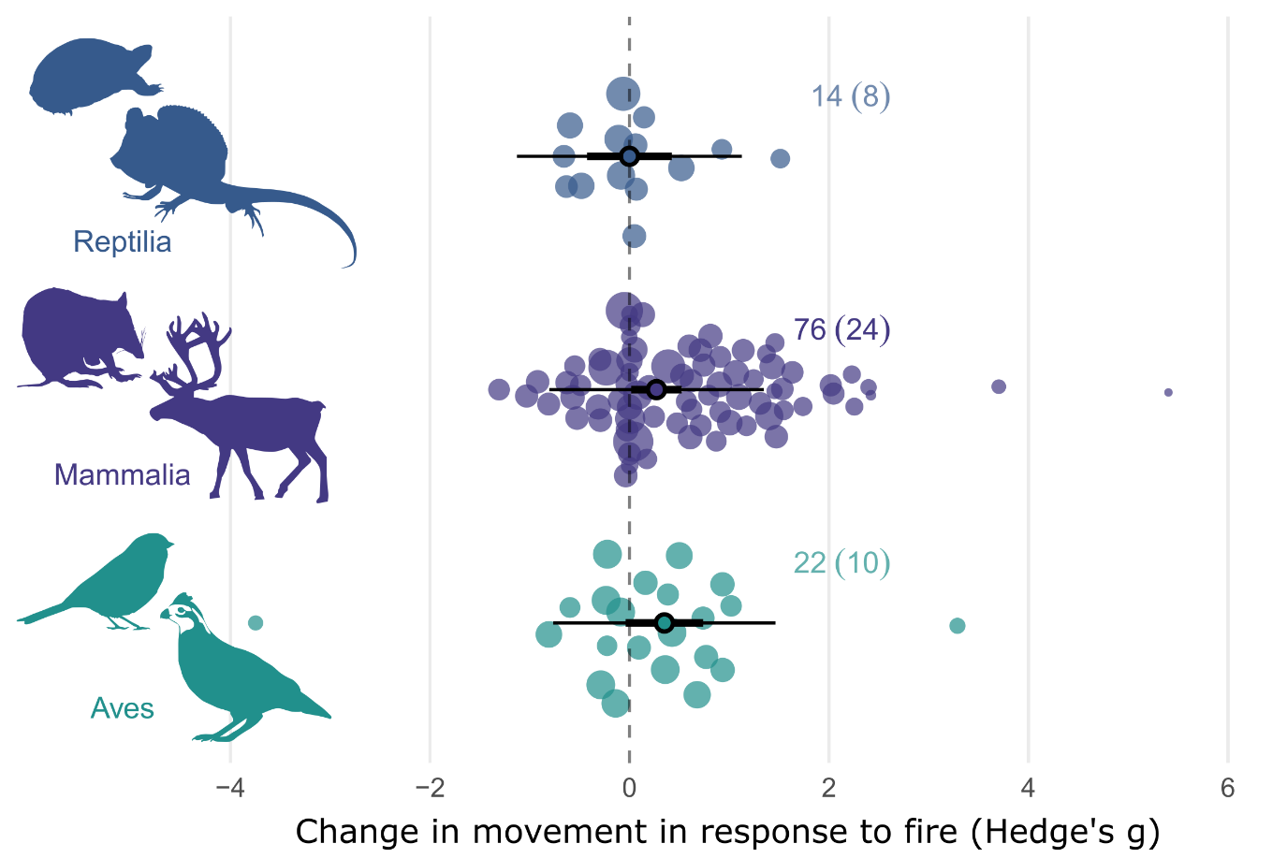
Figure 4: Orchard plot showing the estimated effect of fire on animal movement by taxonomic class. The meta-analytic mean is represented by the outlined point; thick horizontal bars indicate 95 % confidence intervals, and whiskers denote 95 % prediction intervals. Each shaded point represents an individual effect size (Hedge’s g, n = 109), with point size scaled by precision (1/SE), such that larger points have greater influence on the model. Effect size is shown on the x-axis, with points jittered along the y-axis for clarity.

Fire Type, Fire Size & Maximum Burn Age
When comparing the effect of fire type, either planned or wildfire, on animal movement, we found that planned burns had a significant small, positive effect on movement (Hedge’s g = 0.313, 95% CI = 0.005, 0.622, p = 0.0466; Figure 5). When modelling the effect of maximum burn age on movement responses we found no correlation between maximum burn age and movement responses (β = –0.047 [95% CI = –0.163, 0.070], p = 0.43; Supplementary Information 4, Table S4.1). Similarly, we found no relationship between fire size and movement responses (β = 0.002 [95% CI = -0.113, 0.117], p = 0.97; Supplementary Information 4, Table S4.1).

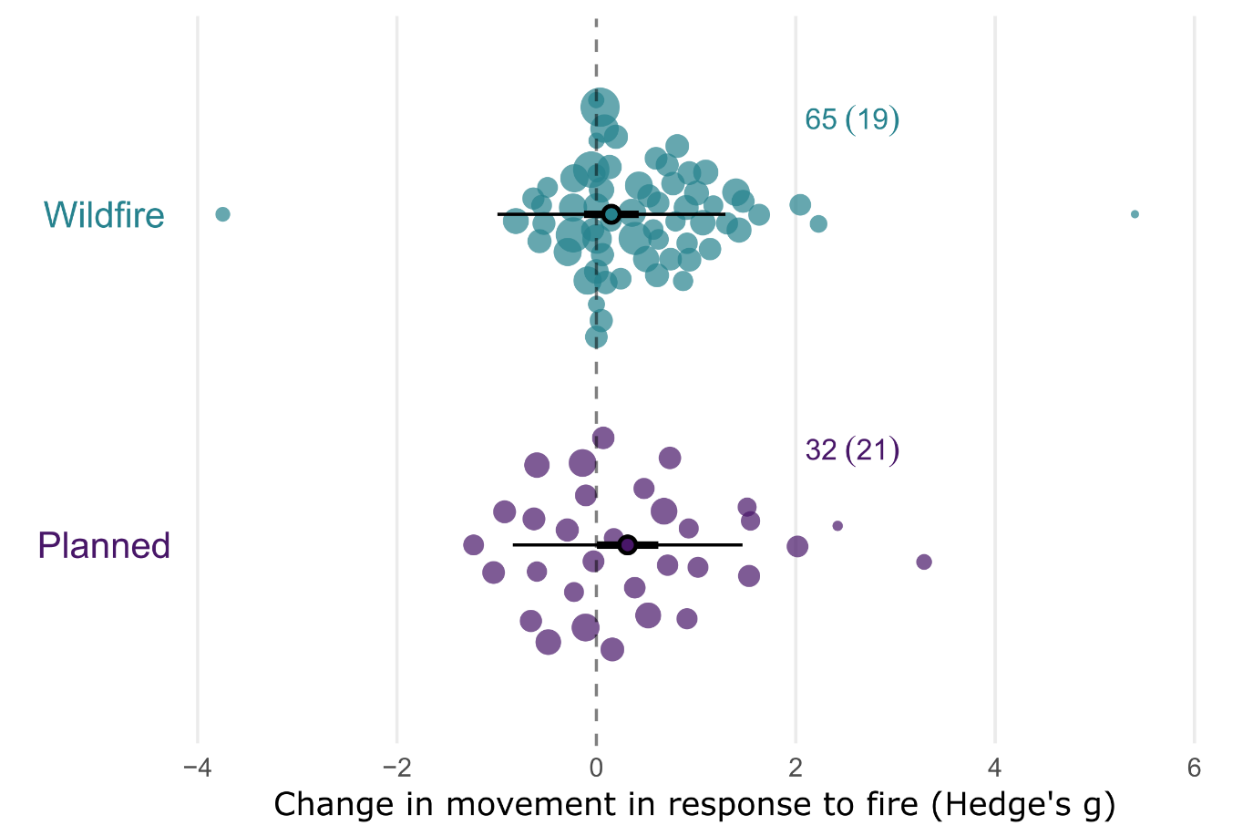
Figure 5: Orchard plot showing the estimated effect of fire on animal movement by fire type. The meta-analytic mean is represented by the outlined point, with the thick horizontal bars showing 95% confidence interval and the whiskers the 95% prediction intervals. Each shaded point represents an effect size (Hedge’s g, n = 97), with the size of the point scaled to show precision within the model (1/SE) and larger points having a greater influence on the model. Effect size is shown on the x axis, and points are jittered on the y axis to improve readability.

Biome
The phylogenetic multilevel meta-analytic model indicated that biome significantly influenced animal movement responses to fire, although the magnitude and direction of effects varied across biomes (Figure 6). A large and significant positive effect was detected in tropical and subtropical grasslands, savannas and shrublands (Hedge’s g = 0.83, 95% CI = 0.22–1.43, p = 0.008). Moderate, marginally positive effects were observed in flooded grasslands and savannas (Hedge’s g = 0.78, 95% CI = –0.08–1.64, p = 0.074) and temperate grasslands, savannas and shrublands (Hedge’s g = 0.59, 95% CI = –0.01–1.19, p = 0.053). Deserts and xeric shrublands exhibited a negative but non-significant effect, while all remaining biomes showed no significant responses (Supplementary Information 4, Table S4.1).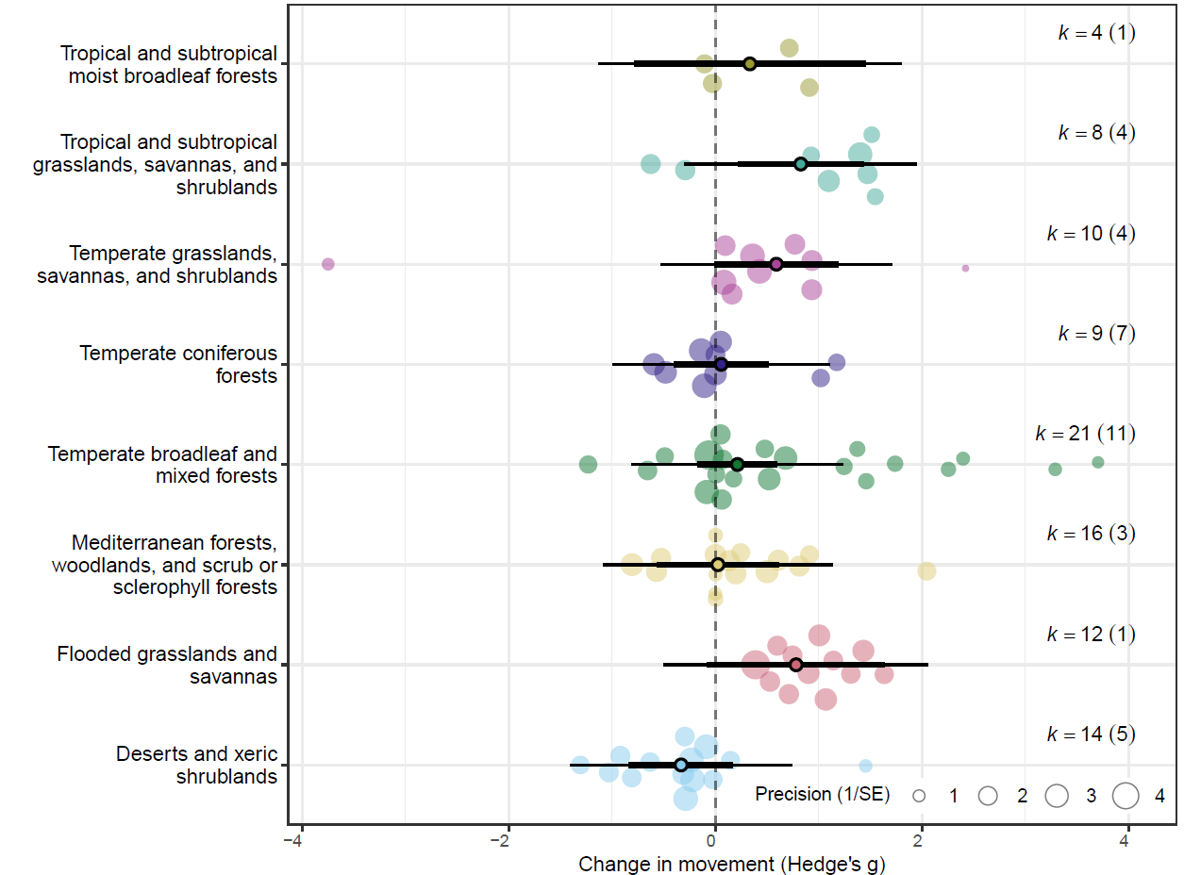
Figure 6: Orchard plot showing the estimated effect of fire on animal movement by biome. The meta-analytic mean is represented by the outlined point, with the thick horizontal bars showing 95% confidence interval and the whiskers the 95% prediction intervals. Each shaded point represents an effect size (Hedge’s g, n = 113), with the size of the point scaled to show precision within the model (1/SE) and larger points having a greater influence on the model. Effect size is shown on the x axis, and points are jittered on the y axis to improve readability.

Body Mass
Across the full dataset, body mass was not correlated with animal movement responses to fire (β = 0.02, 95% CI = –0.04–0.08, p = 0.52; Supplementary Information 4, Table S4.1). When modelled separately for each taxonomic class, no significant relationship between body mass and movement response was detected in any group (Supplementary Information 4, Table S4.1).

Study heterogeneity, publication bias and sensitivity
For overall effect of fire on animal movement, total heterogeneity was 61.59% (I²_{[total]}=61.59), with 33.26% of variation remaining unexplained I²_{[residuals]}=33.26), indicating a moderate to high level of true heterogeneity in the full dataset. Across study variation accounted for 28.32% of the estimated heterogeneity (I2_{[study_ID]}=28.32). Neither phylogenetic relatedness or species identity accounted for any additional heterogeneity in the random effects only model, suggesting both residual variation unexplained by the random effects, and limited evolutionary or intraspecific structuring in effect sizes.
The results of the multilevel version of Egger’s regression indicated there was no evidence of publication bias or small-study effects on the dataset. We found no statistical asymmetry in the distribution of effect sizes (β = -0.078 [-0.220, 0.065], p = 0.282). We found a significant decline effect in the dataset (β = -0.023, [-0.043, -0.002], p = 0.032), with the magnitude of effect sizes declining over time (Figure 7). Results of the leave-one-out sensitivity analysis indicated minimal evidence of outlier influence, with confidence intervals of all leave-one-out models within the confidence intervals of the full model (Supplementary Information 2, Figure S2.3)
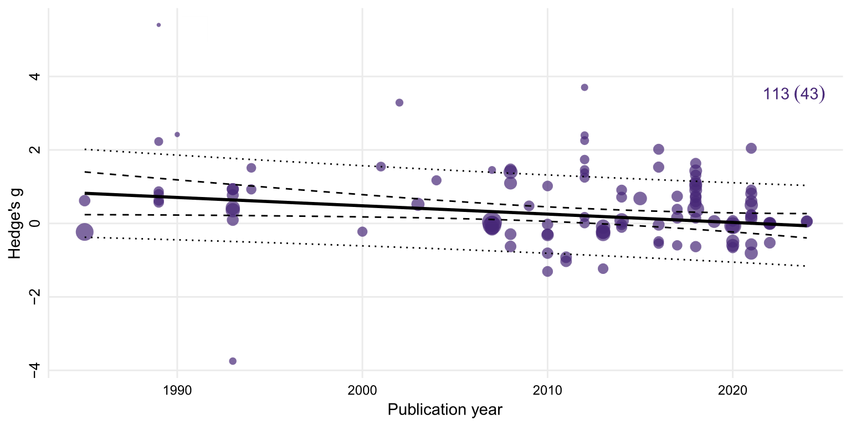
Figure 7: Meta-regression of effect sizes against publication year. Each point represents an individual effect size (Hedge’s g, n = 133), with the point size scaled by precision. The solid line indicates the estimated regression slope, with the 95% confidence interval shown by the dashed lines. The dotted lines show 95% prediction intervals. We found a significant decline effect in our dataset, with the magnitude of effect sizes declining over time.

Discussion
p C
Para 1: Main finding, remind the reader what the study is and why its cool, remind the reader why it’s important (150 words)
Animal movement responses to fire are highly heterogeneous and often context dependent (Doherty et al., 2022; Doherty et al., 2023; Ganz et al., 2022; Geary et al., 2020), and this is reflected in the results of our meta-analysis. The results of our overall model reveal a small, yet positive effect of fire on animal movement, indicating that animal movements generally increase following fire.
Para 2: Explain the main finding. Explore potential mechanmisms for the overall result, avoid going into specifics about taxa or biomes. Focus on the main metric that drove the response (linear distance). Use the case studies and their intepretations to help explain them, as well as general theory and findings about how disturbance affects movement (recognising fire is not like urbanisation or land clearing, but that previous meta analsysis on those topics might provide some insights) (150-200 words)
When comparing the strength of this effect between the movement categories, the linear distance category demonstrated small, yet significant positive effect, although movement category was not a strong predictor of effect size.
HOW AND WHY FIRE MAY AFFECT LINEAR MOVEMENTS AND OTHER MOVEMENTS? what species are showing increases? Are these prey species? Could this be attributed to predation risk or perceived risk in open habitats? Could this be attributed to changes in predator behaviour? Altered perception? Stobo‐Wilson et al. (2021) for discussion of expectation that home range increases as resource availability decreases (also relevant for biome discussion).
Para 3. Explore taxonomic and biome results, and explain them. (200 words)
Apart from biome, we found no clear relationship between our predictor variables and movement responses to fire. In contrast to site specific, localised factors, the resolution of the extrinsic predictor variables we investigated are much coarser, and do not incorporate spatial or temporal environmental heterogeneity. This may aid in explaining why variables we expected to be influential, such fire size and fire type, were not. Within the studies we reviewed, we extracted qualitative descriptors of burn severity and patchiness when provided or inferred severity from post-fire descriptions of vegetation condition. Generally, burn severity was variable, resulting in a mosaic of differing burn severities and unburnt patches within a single fire extent (eg. Cherry et al., 2018; Crabb et al., 2022; Lacki et al., 2009). Burn heterogeneity, rather than total fire extent, is likely a stronger mediator of resource distribution and availability within the landscape, and therefore a stronger predictor of animal movement responses. We expected the strength of effect sizes to decrease with maximum treatment age, however found no relationship. Discuss temporal scaling of resources post fire/veg succession and seral stages. Discuss differences between biomes/veg types in the weather/climate drivers of productivity (eg. Unpredictability/boom and bust in arid or xeric habitats), as well as veg composition.
Biome type was a significant predictor of effect size. (EXPAND - types of movement, is space use contributing to results (ie are animals spending less time in post fire habitats?). Savanna results make sense – less productive ecosystems, individuals need to move greater distances to find resources. See references in intro of (Ganz et al., 2022) for discussion of peak foraging abundance in xeric landscapes)

In addition to site specific factors, variation in species traits, hunting behaviour, and foraging strategies may also be contributing to heterogeneity in movement responses between studies (Ganz et al., 2022; Geary et al., 2020; Pocknee et al., 2023). Our meta-analysis dataset included effect sizes from 13 orders across three classes, representing a broad range of life history strategies, hunting behaviours and foraging strategies. Our results found phylogenetic relatedness did not explain heterogeneity in effect sizes. Therefore, any variability in traits, life histories and behaviours that do contribute to movement responses occur likely at lower taxonomic ranks and are not consistent across higher levels such as order. EXPAND. Hunting behaviours vary across predators, as to does preferred habitat to hunt in (Doherty et al., 2022; Kauffman et al., 2007). SEE ALSO (Moran et al., 2021) for discussion RE condition and risky behaviour.

Para 4. Explore fire attributes; why did planned fire influence movement more than wildfire? Unexpected result. (150-200 words)
WILDFIRE TYPE NOT SIGNIFICANT PREDICTOR – But planned burns demonstrated significant positive effect. Why? What could explain this? Attributes of planned burns? Management approaches (ie are planned burns similar/different to burns of historic regimes)? Again, look at species here – are grazers that are attracted to burned areas post fire contributing to this (eg space use metric)? Less precision in Wildfire results?

TOPIC SENTENCE RE VARIANCE MODERATORS. The detection of moderate levels of within-individual variation suggests individual movement responses are not necessarily consistent across the movement categories. For example, an increase in home range size may not correlate with an increase in daily distance travelled and vice versa. EXPAND, EXPLAINATION FOR THIS? Notably, phylogenetic relatedness and non-phylogenetic species identity accounted for negligible variance in any of the model. EXPAND, EXPLAINATION FOR THIS?
Para 5. Intraspecific variaiton. Good to discuss. Reflects intrapsecific differences in traits, including resource requirements, behaviour strategies available to the species (e.g., torpor), and mobility. (150 words)
Significant residual heterogeneity remained among effect sizes for most models, with between-study and within-individual heterogeneity generally accounting for some variance in most models. Between-study heterogeneity suggests either (i) the presence of meaningful differences in animal movement responses between studies, or (ii) differences in the capability of the studies to capture and quantify movement responses. In the first instance, site specific factors such as fire patchiness (Shaw et al., 2021) and fire severity (Crabb et al., 2022) may be driving animal movement responses. Fire is a spatiotemporally dynamic process; within a single fire extent, burn severity may range from complete canopy combustion through to incomplete combustion of the ground layer, leaving mid layers intact (Cherry et al., 2018; Yarnell et al., 2008). Similarly, a single fire extent may encompass a mosaic of burnt and unburnt vegetation, with or without heterogeneity in severity (Berry et al., 2016; Crabb et al., 2022; Lacki et al., 2009). The scale at which these fire characteristics and environmental conditions vary in relation to individual movement capacity is also an important consideration (Berry et al., 2016; Nathan et al., 2008; Nimmo et al., 2019) If post-fire conditions are unfavoured, highly mobile animals may shift the home range to adjacent, preferred habitats, as demonstrated by quokkas Setonix brachyurus following prescribed burns (Povh et al., 2023). In other cases, variation in burn severities across the fire extent may mediate habitat selection, yet have minimal effect on home range size, as seen in American black bears Ursus americanus following the extensive 2011 Wallow Wildfire in Arizona (Crabb et al., 2022). The authors propose heterogeneity in burn severity retained adequate foraging cover from established vegetation, and may have increased the productivity and foraging quality of grasses and herbs growing in areas affected by low severity fire (Crabb et al., 2022). With adequate resources available within the home range, there was no need to increase movement post fire (Crabb et al., 2022). SEE ALSO (Cohen et al., 2019)
SEE ALSO (Driscoll et al., 2021). EXAPND – Other processes that may interact with fire to influence movement. Unfortunately, our sample size precluded a robust evaluation of interactive effects.
SECOND CASE - differences in the capability of the studies to capture and quantify movement responses “(i) confounding factors that are inconsistently measured or accounted for across studies, (ii) problems with statistical inference (e.g., differing statistical power or accuracy), or (iii) methodological differences across studies (e.g., differing times since fire) (Catford et al. 2022)” from Doherty et al. (2023). Furthermore, previous research indicates that interactive and synergistic effects are also likely to exert strong influence on animal responses to fire, and this may also be contributing to the high level of between study heterogeneity we found (Culhane et al., 2022; Doherty et al., 2022; Ganz et al., 2022)
BODY MASS NOT SIGNIFICANT PREDICTOR. Despite correlation between body mass and movement/allometric scaling SEE (Doherty et al., 2019; Jetz et al., 2004; Tamburello et al., 2015).
LIMITATIONS – Cases not included due to small sizes/inadequate data to calculate effect sizes, quantitative fire attributes, no interactive effects modelled
IMPLICATIONS – Importance of results, future directions, please report more about fire treatments = disentangle effect of fire attributes from other site variables. Context dependency – importance of considering interactive effects, fine scale environmental variables and species traits

Conclusion

References
Abatzoglou, J. T., Kolden, C. A., Cullen, A. C., Sadegh, M., Williams, E. L., Turco, M., & Jones, M. W. (2025). Climate change has increased the odds of extreme regional forest fire years globally. Nature Communications, 16(1), 6390. https://doi.org/10.1038/s41467-025-61608-1
Ankit, R. (2025). WebPlotDigitizer Version 5.2. https://automeris.io
Berry, L. E., Lindenmayer, D. B., Dennis, T. E., Driscoll, D. A., & Banks, S. C. (2016). Fire severity alters spatio–temporal movements and habitat utilisation by an arboreal marsupial, the mountain brushtail possum (Trichosurus cunninghami). International Journal of Wildland Fire, 25(12), 1291-1302.
Blakey, R. V., Sikich, J. A., Blumstein, D. T., & Riley, S. P. D. (2022). Mountain lions avoid burned areas and increase risky behavior after wildfire in a fragmented urban landscape. Current Biology, 32(21), 4762-4768.e4765. https://doi.org/10.1016/j.cub.2022.08.082
Bowman, D. M. J. S., Balch, J. K., Artaxo, P., Bond, W. J., Carlson, J. M., Cochrane, M. A., D’Antonio, C. M., DeFries, R. S., Doyle, J. C., Harrison, S. P., Johnston, F. H., Keeley, J. E., Krawchuk, M. A., Kull, C. A., Marston, J. B., Moritz, M. A., Prentice, I. C., Roos, C. I., Scott, A. C., . . . Pyne, S. J. (2009). Fire in the Earth system. Science, 324(5926), 481-484. https://doi.org/10.1126/science.1163886
Bowman, D. M. J. S., Kolden, C. A., Abatzoglou, J. T., Johnston, F. H., van der Werf, G. R., & Flannigan, M. (2020). Vegetation fires in the Anthropocene. Nature Reviews Earth & Environment, 1(10), 500-515. https://doi.org/10.1038/s43017-020-0085-3
Burton, C., Lampe, S., Kelley, D. I., Thiery, W., Hantson, S., Christidis, N., Gudmundsson, L., Forrest, M., Burke, E., Chang, J., Huang, H., Ito, A., Kou-Giesbrecht, S., Lasslop, G., Li, W., Nieradzik, L., Li, F., Chen, Y., Randerson, J., . . . Mengel, M. (2024). Global burned area increasingly explained by climate change. Nature Climate Change, 14(11), 1186-1192. https://doi.org/10.1038/s41558-024-02140-w
Chamberlain, S., & Szöcs, E. (2013). Taxize: taxonomic search and retrieval in R [version 2; peer review: 3 approved]. F1000Research, 2(191). https://doi.org/10.12688/f1000research.2-191.v2
Cherry, M. J., Chandler, R. B., Garrison, E. P., Crawford, D. A., Kelly, B. D., Shindle, D. B., Godsea, K. G., Miller, K. V., & Conner, L. M. (2018). Wildfire affects space use and movement of white-tailed deer in a tropical pyric landscape. Forest Ecology and Management, 409, 161-169. https://doi.org/10.1016/j.foreco.2017.11.007
Clapp, J. G., & Beck, J. L. (2016). Short-term impacts of fire-mediated habitat alterations on an isolated bighorn sheep population. Fire Ecology, 12(3), 80-98. https://doi.org/10.4996/fireecology.1203080
Cohen, B. S., Prebyl, T. J., Collier, B. A., & Chamberlain, M. J. (2019). Spatiotemporal variability of fire characteristics affect animal responses in pyric landscapes. Fire Ecology, 15(1), 41. https://doi.org/10.1186/s42408-019-0058-4
Cosgrove, A. J., McWhorter, T. J., & Maron, M. (2018). Consequences of impediments to animal movements at different scales: A conceptual framework and review. Diversity and Distributions, 24(4), 448-459. https://doi.org/10.1111/ddi.12699
Crabb, M. L., Clement, M. J., Jones, A. S., Bristow, K. D., & Harding, L. E. (2022). Black bear spatial responses to the Wallow Wildfire in Arizona. The Journal of Wildlife Management, 86(3), 1-20. https://doi.org/10.1002/jwmg.22182
Culhane, K., Sollmann, R., White, A. M., Tarbill, G. L., Cooper, S. D., & Young, H. S. (2022). Small mammal responses to fire severity mediated by vegetation characteristics and species traits. Ecology and Evolution, 12(5), e8918. https://doi.org/10.1002/ece3.8918
Cunningham, C. X., Williamson, G. J., & Bowman, D. M. J. S. (2024). Increasing frequency and intensity of the most extreme wildfires on Earth. Nature Ecology & Evolution, 8(8), 1420-1425. https://doi.org/s41559-024-02452-2
Doherty, T. S., Fist, C. N., & Driscoll, D. A. (2019). Animal movement varies with resource availability, landscape configuration and body size: a conceptual model and empirical example. Landscape Ecology, 34(3), 603-614. https://doi.org/10.1007/s10980-019-00795-x
Doherty, T. S., Hays, G. C., & Driscoll, D. A. (2021). Human disturbance causes widespread disruption of animal movement. Nature Ecology & Evolution, 5(4), 513-519. https://doi.org/10.1038/s41559-020-01380-1
Doherty, T. S., Geary, W. L., Jolly, C. J., Macdonald, K. J., Miritis, V., Watchorn, D. J., Cherry, M. J., Conner, L. M., González, T. M., Legge, S. M., Ritchie, E. G., Stawski, C., & Dickman, C. R. (2022). Fire as a driver and mediator of predator–prey interactions. Biological Reviews, 97(4), 1539-1558. https://doi.org/10.1111/brv.12853
Doherty, T. S., Watchorn, D. J., Miritis, V., Pestell, A. J. L., & Geary, W. L. (2023). Cats, foxes and fire: Quantitative review reveals that invasive predator activity is most likely to increase shortly after fire. Fire Ecology, 19(1), 22. https://doi.org/10.1186/s42408-023-00183-6
Driscoll, D. A., Armenteras, D., Bennett, A. F., Brotons, L., Clarke, M. F., Doherty, T. S., Haslem, A., Kelly, L. T., Sato, C. F., Sitters, H., Aquilué, N., Bell, K., Chadid, M., Duane, A., Meza-Elizalde, M. C., Giljohann, K. M., González, T. M., Jambhekar, R., Lazzari, J., . . . Wevill, T. (2021). How fire interacts with habitat loss and fragmentation. Biological Reviews, 96(3), 976-998. https://doi.org/10.1111/brv.12687
Ezzy, L. (2022). Breaking the wildfire cycle: Progressive fire management can shift fire regimes and improve ecosystem condition. A case study from a large conservation reserve in northern Australia. The Rangeland Journal, 44(6), 279-288. https://doi.org/10.1071/RJ22021
Fahrig, L. (2007). Non-optimal animal movement in human-altered landscapes. Functional Ecology, 21(6), 1003-1015. https://doi.org/10.1111/j.1365-2435.2007.01326.x
Faurby, S., Davis, M., Pedersen, R. Ø., Schowanek, S. D., Antonelli, A., & Svenning, J.-C. (2018). PHYLACINE 1.2: The phylogenetic atlas of mammal macroecology. Ecology, 99(11), 2626-2626. https://doi.org/10.1002/ecy.2443
Ganz, T. R., DeVivo, M. T., Kertson, B. N., Roussin, T., Satterfield, L., Wirsing, A. J., & Prugh, L. R. (2022). Interactive effects of wildfires, season and predator activity shape mule deer movements. Journal of Animal Ecology, 91(11), 2273-2288. https://doi.org/10.1111/1365-2656.13810
Gasaway, W. C., Dubois, S. D., Boertje, R. D., Reed, D. J., & Simpson, D. T. (1989). Response of radio-collared moose to a large burn in central Alaska. Canadian Journal of Zoology, 67(2), 325-329. https://doi.org/10.1139/z89-047
Geary, W. L., Doherty, T. S., Nimmo, D. G., Tulloch, A. I. T., & Ritchie, E. G. (2020). Predator responses to fire: A global systematic review and meta-analysis. Journal of Animal Ecology, 89(4), 955-971. https://doi.org/10.1111/1365-2656.13153
Gomez, S., English, H. M., Bejarano Alegre, V., Blackwell, P. G., Bracken, A. M., Bray, E., Evans, L. C., Gan, J. L., Grecian, W. J., Gutmann Roberts, C., Harju, S. M., Hejcmanová, P., Lelotte, L., Marshall, B. M., Matthiopoulos, J., Mnenge, A. J., Niebuhr, B. B., Ortega, Z., Pollock, C. J., . . . Börger, L. (2025). Understanding and predicting animal movements and distributions in the Anthropocene. Journal of Animal Ecology, 94(6), 1146-1164. https://doi.org/10.1111/1365-2656.70040
Greenwood, L., Bliege Bird, R., & Nimmo, D. (2022). Indigenous burning shapes the structure of visible and invisible fire mosaics. Landscape Ecology, 37(3), 811-827. https://doi.org/10.1007/s10980-021-01373-w
He, T., Lamont, B. B., & Pausas, J. G. (2019). Fire as a key driver of Earth's biodiversity. Biological Reviews, 94(6), 1983-2010. https://doi.org/10.1111/brv.12544
Hijmans, R. J., Barbosa, M., Ghos, A., & Mandel, A. (2025). geodata. In (Version 0.6-2) https://github.com/rspatial/geodata
Hinam, H., & St. Clair, C. (2008). High levels of habitat loss and fragmentation limit reproductive success by reducing home range size and provisioning rates of northern saw-whet owls. Biological Conservation, 141, 524-535. https://doi.org/10.1016/j.biocon.2007.11.011
Hovick, T. J., McGranahan, D. A., Elmore, R. D., Weir, J. R., & Fuhlendorf, S. D. (2017). Pyric-carnivory: Raptor use of prescribed fires. Ecology and Evolution, 7(21), 9144-9150. https://doi.org/10.1002/ece3.3401
Jetz, W., Carbone, C., Fulford, J., & Brown, J. H. (2004). The scaling of animal space use. Science, 306(5694), 266-268. https://doi.org/10.1126/science.1102138
Kauffman, M. J., Varley, N., Smith, D. W., Stahler, D. R., MacNulty, D. R., & Boyce, M. S. (2007). Landscape heterogeneity shapes predation in a newly restored predator–prey system. Ecology Letters, 10(8), 690-700. https://doi.org/10.1111/j.1461-0248.2007.01059.x
Kreider, M. R., Higuera, P. E., Parks, S. A., Rice, W. L., White, N., & Larson, A. J. (2024). Fire suppression makes wildfires more severe and accentuates impacts of climate change and fuel accumulation. Nature Communications, 15(1), 2412. https://doi.org/10.1038/s41467-024-46702-0
Lacki, M. J., Cox, D. R., Dodd, L. E., & Dickinson, M. B. (2009). Response of northern bats (Myotis septentrionalis) to prescribed fires in eastern Kentucky forests. Journal of Mammalogy, 90(5), 1165-1175. https://doi.org/10.1644/08-MAMM-A-349.1
McGregor, H., Cliff, H., B. , & Kanowski, J. (2016a). Habitat preference for fire scars by feral cats in Cape York Peninsula, Australia. Wildlife Research, 43(8), 623-633. https://doi.org/10.1071/WR16058
McGregor, H. W., Legge, S., Jones, M. E., & Johnson, C. N. (2016b). Extraterritorial hunting expeditions to intense fire scars by feral cats. Scientific Reports, 6(1), 22559. https://doi.org/10.1038/srep22559
Michonneau, F., Brown, J. W., & Winter, D. J. (2016). rotl: An R package to interact with the Open Tree of Life data. Methods in Ecology and Evolution, 7(12), 1476-1481. https://doi.org/10.1111/2041-210X.12593
Moran, N. P., Sánchez-Tójar, A., Schielzeth, H., & Reinhold, K. (2021). Poor nutritional condition promotes high-risk behaviours: A systematic review and meta-analysis. Biological Reviews, 96(1), 269-288. https://doi.org/10.1111/brv.12655
Morris, S. B. (2008). Estimating Effect Sizes From Pretest-Posttest-Control Group Designs. Organizational Research Methods, 11(2), 364-386. https://doi.org/10.1177/1094428106291059
Nakagawa, S., & Cuthill, I. C. (2007). Effect size, confidence interval and statistical significance: A practical guide for biologists. Biological Reviews, 82(4), 591-605. https://doi.org/10.1111/j.1469-185X.2007.00027.x
Nakagawa, S., & Santos, E. S. A. (2012). Methodological issues and advances in biological meta-analysis. Evolutionary Ecology, 26(5), 1253-1274. https://doi.org/10.1007/s10682-012-9555-5
Nakagawa, S., Lagisz, M., Jennions, M. D., Koricheva, J., Noble, D. W. A., Parker, T. H., Sánchez-Tójar, A., Yang, Y., & O'Dea, R. E. (2022). Methods for testing publication bias in ecological and evolutionary meta-analyses. Methods in Ecology and Evolution, 13(1), 4-21. https://doi.org/https://doi.org/10.1111/2041-210X.13724
Nakagawa, S., Lagisz, M., O'Dea, R. E., Pottier, P., Rutkowska, J., Senior, A. M., Yang, Y., & Noble, D. W. A. (2023). orchaRd 2.0: An R package for visualising meta-analyses with orchard plots. Methods in Ecology and Evolution, 14(8), 2003-2010. https://doi.org/10.1111/2041-210X.14152
Nathan, R., Getz, W. M., Revilla, E., Holyoak, M., Kadmon, R., Saltz, D., & Smouse, P. E. (2008). A movement ecology paradigm for unifying organismal movement research. Proceedings of the National Academy of Sciences, 105(49), 19052-19059. https://doi.org/10.1073/pnas.0800375105
Nathan, R., Monk, C. T., Arlinghaus, R., Adam, T., Alós, J., Assaf, M., Baktoft, H., Beardsworth, C. E., Bertram, M. G., Bijleveld, A. I., Brodin, T., Brooks, J. L., Campos-Candela, A., Cooke, S. J., Gjelland, K. Ø., Gupte, P. R., Harel, R., Hellström, G., Jeltsch, F., . . . Jarić, I. (2022). Big-data approaches lead to an increased understanding of the ecology of animal movement. Science, 375(6582), eabg1780. https://doi.org/10.1126/science.abg1780
Nimmo, D. G., Avitabile, S., Banks, S. C., Bliege Bird, R., Callister, K., Clarke, M. F., Dickman, C. R., Doherty, T. S., Driscoll, D. A., Greenville, A. C., Haslem, A., Kelly, L. T., Kenny, S. A., Lahoz‐Monfort, J. J., Lee, C., Leonard, S., Moore, H., Newsome, T. M., Parr, C. L., . . . Bennett, A. F. (2019). Animal movements in fire‐prone landscapes. Biological Reviews of the Cambridge Philosophical Society, 94(3), 981-998. https://doi.org/10.1111/brv.12486
Nimmo, D. G., Carthey, A. J. R., Jolly, C. J., & Blumstein, D. T. (2021). Welcome to the Pyrocene: Animal survival in the age of megafire. Global Change Biology, 27(22), 5684-5693. https://doi.org/10.1111/gcb.15834
Nowack, J., Cooper, C. E., & Geiser, F. (2016). Cool echidnas survive the fire. Proceedings of The Royal Society B-Biological Sciences, 283(1828). https://doi.org/10.1098/rspb.2016.0382
Oskyrko, O. M., Chunrong; Meiri, Shai; Du, Weiguo. (2024). ReptTraits: A comprehensive dataset of ecological traits in reptiles.
Pausas, J. G., & Parr, C. L. (2018). Towards an understanding of the evolutionary role of fire in animals. Evolutionary Ecology, 32(2), 113-125. https://doi.org/10.1007/s10682-018-9927-6
Pettett, C. E., Johnson, P. J., Moorhouse, T. P., Hambly, C., Speakman, J. R., & Macdonald, D. W. (2017). Daily energy expenditure in the face of predation: Hedgehog energetics in rural landscapes. Journal of Experimental Biology, 220(3), 460-468. https://doi.org/10.1242/jeb.150359
Pocknee, C. A., Legge, S. M., McDonald, J., & Fisher, D. O. (2023). Modeling mammal response to fire based on species’ traits. Conservation Biology, 37(4), e14062. https://doi.org/10.1111/cobi.14062
Posit team. (2025). RStudio: Integrated Development Environment for R. In (Version 2025.5.0.496) Posit Software, PBC. http://www.posit.co/
Povh, L. F., Willers, N., Shephard, J. M., & Fleming, P. A. (2023). A conservation-significant threatened mammal uses fire exclusions and shifts ranges in the presence of prescribed burning. International Journal of Wildland Fire, 32(9), 1291-1303. https://doi.org/10.1071/WF22196
R Core Team. (2024). R: A Language and Environment for Statistical Computing. In R Foundation for Statistical Computing. https://www.R-project.org/
Shaw, R. E., James, A. I., Tuft, K., Legge, S., Cary, G. J., Peakall, R., & Banks, S. C. (2021). Unburnt habitat patches are critical for survival and in situ population recovery in a small mammal after fire. Journal of Applied Ecology, 58(6), 1325-1335. https://doi.org/10.1111/1365-2664.13846
Stobo‐Wilson, A. M., Cremona, T., Murphy, B. P., & Carthew, S. M. (2021). Resource availability drives variation in a marsupial glider’s home‐range size. Journal of Zoology, 315(3), 199-212. https://doi.org/10.1111/jzo.12906
Straus, S., Forbes, C., Little, C. J., Germain, R. M., Main, D. A., O'Connor, M. I., Thompson, P. L., Ford, A. T., Gravel, D., & Guzman, L. M. (2024). Macroecological constraints on species' ‘movement profiles’: Body mass does not explain it all. Global Ecology and Biogeography, 33(2), 227-243. https://doi.org/10.1111/geb.13786
Tamburello, N., Isabelle M. Côté, & Dulvy, N. K. (2015). Energy and the scaling of animal space use. The American Naturalist, 186(2), 196-211. https://doi.org/10.1086/682070
Templeton, A. R., Neuwald, J. L., Brazeal, H., & Robertson, R. J. (2007). Restoring demographic processes in translocated populations: The case of collared lizards in the Missouri Ozarks using prescribed forest fires. Israel Journal of Ecology & Evolution, 53(2), 179-196. https://doi.org/10.1560/IJEE.53.2.179
Templeton, A. R., Brazeal, H., & Neuwald, J. L. (2011). The transition from isolated patches to a metapopulation in the eastern collared lizard in response to prescribed fires. Ecology, 92(9), 1736-1747. https://doi.org/10.1890/10-1994.1
Tobias, J. A., Sheard, C., Pigot, A. L., Devenish, A. J. M., Yang, J., Sayol, F., Neate-Clegg, M. H. C., Alioravainen, N., Weeks, T. L., Barber, R. A., Walkden, P. A., MacGregor, H. E. A., Jones, S. E. I., Vincent, C., Phillips, A. G., Marples, N. M., Montaño-Centellas, F. A., Leandro-Silva, V., Claramunt, S., . . . Schleuning, M. (2022). AVONET: morphological, ecological and geographical data for all birds. Ecology Letters, 25(3), 581-597. https://doi.org/https://doi.org/10.1111/ele.13898
Tucker, M. A., Böhning-Gaese, K., Fagan, W. F., Fryxell, J. M., Van Moorter, B., Alberts, S. C., Ali, A. H., Allen, A. M., Attias, N., Avgar, T., Bartlam-Brooks, H., Bayarbaatar, B., Belant, J. L., Bertassoni, A., Beyer, D., Bidner, L., van Beest, F. M., Blake, S., Blaum, N., . . . Mueller, T. (2018). Moving in the Anthropocene: Global reductions in terrestrial mammalian movements. Science, 359(6374), 466-469. https://doi.org/10.1126/science.aam9712
van Wagtendonk, J. W., & Lutz, J. A. (2007). Fire regime attributes of wildland fires in Yosemite National Park, USA. Fire Ecology, 3(2), 34-52. https://doi.org/10.4996/fireecology.0302034
Venter, J. A., Nabe-Nielsen, J., Prins, H. H. T., & Slotow, R. (2014). Forage patch use by grazing herbivores in a South African grazing ecosystem. Acta Theriologica, 59(3), 457-466. https://doi.org/10.1007/s13364-014-0184-y
Viechtbauer, W., & Cheung, M. W. L. (2010). Outlier and influence diagnostics for meta-analysis. Research Synthesis Methods, 1(2), 112-125. https://doi.org/10.1002/jrsm.11
Viechtbauer, W. (2010). Conducting Meta-Analyses in R with the metafor Package. Journal of Statistical Software, 36(3), 1 - 48. https://doi.org/10.18637/jss.v036.i03
Volkmann, L. A., Hutchen, J., & Hodges, K. E. (2020). Trends in carnivore and ungulate fire ecology research in North American conifer forests. Forest Ecology and Management, 458, 117691. https://doi.org/10.1016/j.foreco.2019.117691
Wooster, E. I. F., Gaynor, K. M., Carthey, A. J. R., Wallach, A. D., Stanton, L. A., Ramp, D., & Lundgren, E. J. (2024). Animal cognition and culture mediate predator–prey interactions. Trends in Ecology & Evolution, 39(1), 52-64. https://doi.org/10.1016/j.tree.2023.09.012
Yarnell, R. W., Metcalfe, D. J., Dunstone, N., Burnside, N., & Scott, D. M. (2008). The impact of fire on habitat use by the short-snouted elephant shrew (Elephantulus brachyrhynchus) in North West Province, South Africa. African Zoology, 43(1), 45-52. https://doi.org/10.1080/15627020.2008.11407405

