MOVEMENT IN THE PYROCENE: A GLOBAL META-ANALYSIS OF ANIMAL MOVEMENT RESPONSES TO FIRE

CHLOE L. MCAULEY^{1*}, EAMONN I.F. WOOSTER¹, TIM S. DOHERTY^{2,} MITCH A. COWAN^{1,3}, CHRIS J. JOLLY⁴, GRANT D. LINLEY¹, AMY SIMPSON¹, DYLAN WESTAWAY¹, BEN WILSON¹, DALE G. NIMMO¹
Affiliations:
1 Gulbali Institute, School of Agricultural, Environmental and Veterinary Sciences, Charles
Sturt University, Albury, NSW, Australia
2 Fire Science Program, Biodiversity and Conservation Science, Department of Biodiversity, Conservation and Attractions, Kings Park, Western Australia, Australia
3 School of Agricultural and Environmental Sciences, University of Western Australia,
Crawley, WA, Australia
4 School of Natural Sciences, Macquarie University, Macquarie Park, New South Wales, Australia

* Corresponding author
cmcauley@csu.edu.au

Target Journal – Global Change Biology
Key words
Fire, disturbance, meta-analysis, movement ecology, systematic review

Abstract

Main
Fire is a spatiotemporally dynamic disturbance process that has operated across the globe for hundreds of millions of years (Bowman et al., 2009; He et al., 2019). Fire transforms landscapes, initiating ecological changes that shape biotic communities and ecosystem function over varying spatial and temporal scales (Greenwood et al., 2022; Pellegrini Adam et al., 2021). For animals, these dynamics manifest as changes in the availability of food, shelter and breeding resources, and shifts in competition and predation pressure, with flow-on effects for animal fitness and survival (Doherty et al., 2022; Rossi & Leiner, 2022). In response, animals can alter their behaviour to minimise risk, maximise access to resources, and improve survival (McGinn et al., 2024; Stevens et al., 2025).
Understanding how animals respond to fire and other disturbances requires recognising the central role of movement in shaping these responses. Movement decisions emerge from interactions between an animal’s internal state, mobility and navigation capacity, as well as external drivers (Nathan et al., 2008; Nathan et al., 2022). The competing demands of nutrition, reproduction, and predator avoidance influence how, where, and when animals move (Nathan et al., 2008; Wooster et al., 2024). By shaping the external environment, disturbance exerts a major influence on movement decisions (Doherty et al., 2021; Gomez et al., 2025; Tucker et al., 2018). In doing so, disturbance has profound consequences for animals (Cosgrove et al., 2018; Fahrig, 2007), including competition (Blakey et al., 2022), energy expenditure (Pettett et al., 2017), foraging success (Hinam & St. Clair, 2008) and ultimately survival (Dudley et al., 2022). These effects can scale up through space and time to drive population dynamics (Cosgrove et al., 2018; Gomez et al., 2025; Templeton et al., 2007).
Fire triggers a variety of animal movements (Nimmo et al., 2019). In the short term, ranging from the hours during a fire to the days immediately after, animals may move to escape fire and leave the burnt area (Morollón et al., 2022; Nimmo et al., 2021), or to quickly exploit new opportunities in the wake of a fire (Hovick et al., 2017; McGregor et al., 2016). For instance, following ignition of a wildfire within its usual territory in eastern Spain, a GPS-tracked male Bonelli’s eagle (Aquila fasciata) was observed flying 6 km in the 2 hours immediately after ignition, before returning to the fire perimeter and core territory within 5 days (Morollón et al., 2022). In northern Australian savannahs, feral cats (Felis catus) make long distance, extraterritorial movements to hunt within intensely burnt recent fire scars up to 12.5 km from usual home ranges (McGregor et al., 2016). When the availability of resources is reduced after fire, movements, including distance travelled and home range size, can increase as animals move further to meet their ecological requirements (Blakey et al., 2022). Other species may move less to reduce their energetic requirements and avoid traversing risky post-fire landscapes (Nowack et al., 2016). For example, in the months following a prescribed fire in eastern Australia, torpor frequency and duration in female brown antechinus (Antechinus stuartii) increased two-fold compared to pre-fire and control groups, and daily activity decreased (Stawski et al., 2015). Over longer periods, from months to years and even decades, individuals adjust their movements in response to changing habitat suitability (Cherry et al., 2018; Gasaway et al., 1989) as vegetation recovers and community composition shifts (Harrison et al., 2024; Pellegrini Adam et al., 2021). Their ability to exploit optimal habitat can be the difference between local persistence and extinction (Templeton et al., 2011). Therefore, movement represents an adaptive trait and a behavioural strategy that facilitates animal survival and persistence in fire-prone landscapes (He et al., 2019; Nimmo et al., 2021; Pausas & Parr, 2018).
Fire regimes are changing across the globe (Bowman et al., 2020; Cunningham et al., 2024). Anthropogenic climate and land use changes are major drivers of increased fire severity and extent in multiple biogeographic regions (Abatzoglou et al., 2025; Burton et al., 2024; Kreider et al., 2024). Sound understanding of animal movement is fundamental to predicting how animals will respond to shifting fire regimes (Nimmo et al., 2019). While numerous studies have explored the effects of fire on animal movement, these are largely taxon- or context-specific, and no quantitative synthesis has yet evaluated whether general patterns emerge across taxa and ecosystems.
Here, we conduct the first global systematic review and meta-analysis of the influence of fire on movement by terrestrial vertebrates. We synthesised 113 effect sizes derived from 73 taxa across 84 published studies and six continents to assess how fire attributes, taxonomy, and biogeography influence animal responses to fire. We hypothesised that, overall, fire would increase animal movement as individuals make more long-ranging, tortuous movements in search of resources, leading to larger home ranges after fire. Further, we predicted: (i) movement would increase with spatial extent of burnt area, because of the increased spatial extent of altered resources (Bowman et al., 2009); (ii) relative to planned burns, movement responses would be greater in response to wildfire, due to differential seasonality, severity and extent (Ezzy, 2022; van Wagtendonk & Lutz, 2007); and (iii) effect sizes would increase with species-level body mass, given that space use increases with body size, and larger animals are likely to have greater resource requirements (Jetz et al., 2004; Straus et al., 2024; Tamburello et al., 2015).

Materials and Methods

Systematic review
We aimed to capture literature investigating four categories of animal movement, namely home range size, linear distance moved, tortuosity, and other measures of space use. Following Doherty et al. (2021) home range responses included area-based measurements of space use, such as home range size and nest area size. Linear distance metrics were those that measured straight-line distances between relocations, such as daily distance travelled, as well as distance travelled per unit of time. Tortuosity provides a measure of how a movement path deviates from a straight-line and was captured by straightness indices and turning angles. Other space use metrics included those that quantified other aspects of animal movement decisions and behaviours not captured by the previous categories, such as mean residency time, time to return, and proportion of fixes within burnt and unburnt habitats.
We conducted a systematic review to identify studies investigating the influence of fire on animal movement. Database searches were undertaken in Scopus, Web of Science and ProQuest Dissertation and Theses Global between 15th May 2024 and 29th August 2024. Search terms relating to animal movement were combined with terms relating to fire and terrestrial vertebrates to identity suitable studies (Supplementary Information 1). To be considered for inclusion in the systematic review studies needed to meet the following criteria: (i) published in either a peer reviewed article, Master’s thesis, or PhD thesis; (ii) field studies with before–after fire, burnt–unburnt, or before–after control–impact designs; and (iii) provided an evaluation of movement responses to fire in free-ranging terrestrial vertebrates. We considered terrestrial vertebrates as animals primarily distributed in terrestrial biomes, or animals that used terrestrial habitat features for key life stages, such as reproduction or hibernation. All returned results were filtered to include only articles or theses published in English, and filters were applied in the databases to limit the results to relevant disciplines (Supplementary Information 1). Additional studies were identified by snowball searches of reference lists from two review articles returned in database searches (Nimmo et al., 2019; Nimmo et al., 2021), and one review paper known to the authors (Volkmann et al., 2020). Database searches, snowball searches, and title and abstract screening were done by C.L.M. Full text screening was performed by C.L.M, B.W, D.W, C.J.J, M.A.C, E.I.F.W and G.D.L.

Data extraction
From each study, we extracted metadata on fire type (wildfire or planned), fire size (hectares), maximum burn age (days), study design (before–after, control–impact, or before–after control–impact), geographic coordinates (latitude and longitude), country, and movement response (home range, linear distance, tortuosity, or other space use metrics) (Supplementary Information 1, Table S1.1). We defined planned fires as those intentionally ignited by people, and wildfires as those ignited by natural causes or unintentionally by anthropogenic sources. Fire type was recorded according to the authors’ description of the event. Maximum burn age was defined as the maximum period (days) between the fire event and the end of data collection, as stated by authors or calculated by reviewers using information provided within the article. To account for variability in sampling duration across the dataset, we chose to extract maximum burn age over other measures of time since fire. This approach provides a more representative measure of post-fire conditions experienced by study animals tracked over longer periods of time. Fire size (area burned, ha) was obtained directly from source studies where available.
Sample sizes, means, and measures of variation were extracted from tables, text, supplementary materials, or figures. Where necessary, data in figures were digitised using WebPlotDigitizer (Ankit, 2025). The sampling unit was typically the number of tracked individuals or independent movement paths. To minimise potential confounding from seasonal effects in before–after designs, we recorded the timing of data collection and noted any additional management activities that could interact with fire (e.g. logging, mechanical thinning, or livestock grazing).
Classification of burned and unburned animal populations followed the authors’ definitions. As such, movement data extracted from burned populations were not necessarily constrained to fire scars and included data from animals the study authors categorised as impacted by fire (e.g. a defined portion of the home range overlapped with the burn extent). In the case of chronosequence studies, we extracted data closest to the fire event, or, in before–after studies, for the combination that minimised seasonal confounding. When demographic subgroups (e.g. males and females, adults and juveniles) were presented, each subgroup was treated as a separate case unless the sample size fell below inclusion thresholds; in such cases, subgroups were pooled if responses were similar in magnitude and direction.
In addition to study-level variables, we extracted or derived several covariates used as moderators in the meta-analysis. Biome was determined for each study location using the coordinates provided by authors or estimated from site descriptions, overlaid with the terrestrial biome classification of Olson et al. (2001) via the geodata package (Hijmans et al., 2025) implemented in R version 4.4.2 (R Core Team, 2024). Body mass data (mean or maximum adult body mass, depending on the database) were obtained for each species from published trait databases including AvoNet (Tobias et al., 2022), ReptTraits (Oskyrko, 2024), and Phylacine (Faurby et al., 2018). Body mass data were supplemented with literature values where necessary. Species identity were recorded for all effect sizes based on the original publications, and updated where necessary using the rotl package (Michonneau et al., 2016). Taxonomic class was extracted from the National Center for Biotechnology Information database using the tax_name function within the taxize R package (Chamberlain & Szöcs, 2013). Data extraction was conducted by C.L.M and E.I.F.W.

Meta-analysis
To qualify for data inclusion in the meta-analysis, studies were required to meet the following criteria: (i) they provided sufficient information to calculate sample sizes, means, and measures of variation (standard deviations, standard errors, or 95% confidence intervals) for each treatment group; (ii) each treatment group had a sample size of at least five; (iii) methods were standardised across treatment groups; and (iv) the potential confounding effects of other environmental variables were considered minimal. To minimise seasonal confounding in before–after designs, only studies in which data were collected during the same or adjacent seasons were included in subsequent analyses.
We used the following formula from Morris (2008) to convert before–after control–impact studies to control–impact studies to calculate effect sizes.
$d_{ppc1}= c(\frac{Mₚₒₛₜ,ₜ - Mₚᵣₑ,ₜ}{ SDₚᵣₑ,ₜ} ) - c꜀(\frac{Mₚₒₛₜ,꜀ - Mₚᵣₑ,꜀}{SDₚᵣₑ,꜀})$
Following Morris (2008) we used the pretest (before) SD values for the control and treatment groups. All analyses were performed in using R version 4.4.2 (R Core Team, 2024) in RStudio (Posit team, 2025). Hedge’s G, using the unbiased estimate of sampling variances, was calculated for each study using the escalc function in the metafor package (Viechtbauer, 2010). Hedge’s G is a standardized mean difference method that includes a bias corrector for small sample sizes (Viechtbauer, 2010). By providing a standardised measure between control and treatment groups, Hedge’s G allows for aggregation and comparison of multiple movement responses. A negative effect size indicates a decrease in animal movement, and a positive value an increase in animal movement. We used the effect size benchmarks outlined in Nakagawa and Cuthill (2007), as g > 0.2 for a small effect, >0.5 as moderate and >0.8 as large, and considered an effect to be significant when 95% confidence intervals did not overlap zero. Effect size calculation was done by C.M and E.I.F.W.
To quantify the effect of fire on animal movement, we constructed phylogenetic multi-level meta analytic models using the rma.mv function in the metafor package (Viechtbauer, 2010). These models weigh each effect size by the inverse of the sampling variance, allowing the models to account for uncertainty in effect sizes. This results in effects with smaller sampling variances having higher weight in the models. To account for nonindependence amongst effect sizes, we included study ID (a unique identifier assigned to each article or thesis), observation ID (a unique identifier assigned to each effect size), species phylogeny, and species identity (non-phylogenetic species identification) as random effects (Nakagawa & Santos, 2012). We included observation ID to account for within study heterogeneity and nonindependence arising from multiple movement metrics being measured from a single or related population, for instance home range size and linear distance (Nakagawa & Santos, 2012). Phylogenies were obtained from the Open Tree of Life, using the tnrs_match_names function in the rotl package (Michonneau et al., 2016). Phylogenetic random effect values are a correlation matrix of branch lengths representing the phylogenetic relatedness between species. This is important as we would expect closely related species to respond similarly to fire, while species identity accounts for the effects sizes of the same species instead of relatedness to another species. We included a variance-covariance matrix in our models to account for non-independence resulting from individuals and populations contributing to multiple effect sizes (Nakagawa & Santos, 2012). We assumed a correlation of r = 0.5 for the same species within the same studies.
We first modelled the overall effect of fire on animal movement by fitting a null model (with random effects). We then asked in subsequent models whether movement responses varied according to movement category, fire type, fire size, maximum burn age, biome, body mass, and taxonomic class. Models were plotted using the orchaRd package (Nakagawa et al., 2023). Meta-analysis was performed by C.L.M and E.I.F.W.

Study heterogeneity, publication bias and sensitivity analysis
To quantify study heterogeneity, and the proportion of variance attributable to the random effects, we calculated I² using the i2_ml function in the orchaRd package (Nakagawa et al., 2023; Nakagawa & Santos, 2012). To test for publication bias resulting from biases in outcome reporting, we visually assessed funnel plot asymmetry and ran a multilevel version of Egger’s regressions with an approximation of observation precision as a predictor (Nakagawa et al., 2022). We tested for a time lag effect by regressing effect sizes against study year. Finally, we performed a leave-a-study-out-test to evaluate the sensitity of the overall model results to influential studies (Viechtbauer & Cheung, 2010). Publication bias testing was done by C.L.M and E.I.F.W.

Results

Systematic review
Our database searches yielded 5,231 records after duplicate removal. Following screening, 84 studies met the eligibility criteria. These studies were conducted across 12 countries and six continents (Figure 1). Most research was conducted in North America (60.7%), followed by Oceania (20.2%). All Oceania studies were from Australia, while 90.2% of North American studies were from the United States, with the remainder from Canada. In Africa, 71.4% of studies originated from South Africa, with single studies from Kenya and Uganda. South America was represented by a single study from Paraguay. In Asia, 60% of studies were conducted in Indonesia, while Europe was represented by three studies, two from Spain and one from Portugal. Research effort has increased markedly over time. Only nine of the 84 studies were published before 2000, whereas nearly half (48.8%) were published between 2010 and 2019 (Supplementary Information 3, Figure S3.1).
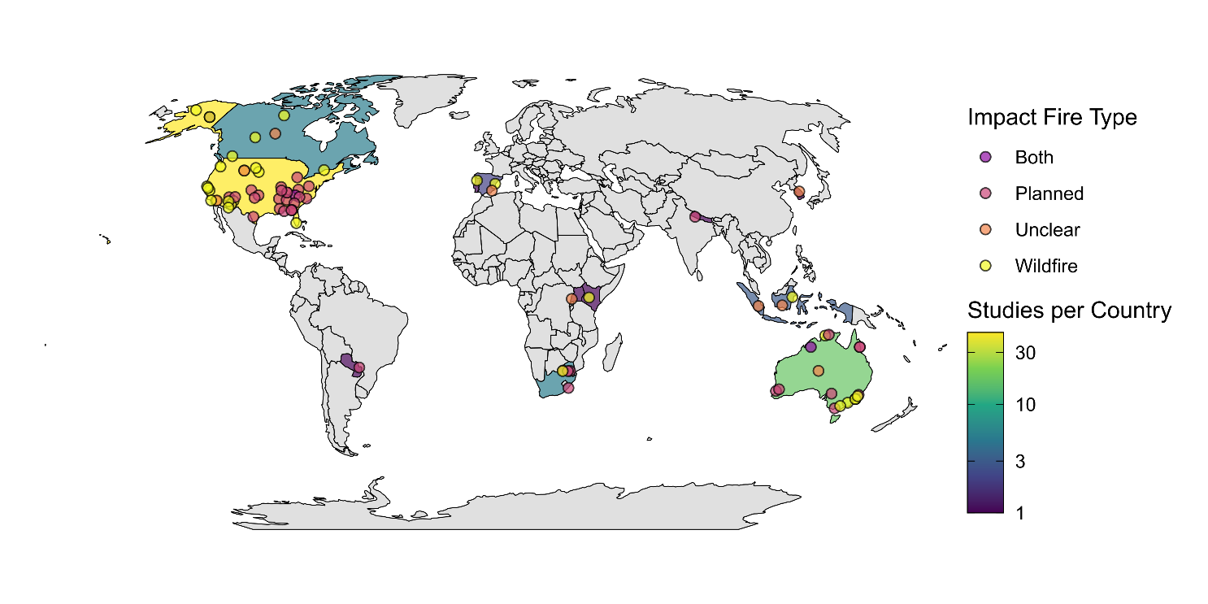
Figure 1: Map illustrating the number of studies per country and locations of the 84 studies included in the systematic review. The color scale shows the number of studies per country, with darker colours indicating fewer studies, and lighter colours indicating more studies. The colour of the study points indicate the type of fire the study investigated.
From the 84 studies, we extracted 185 cases investigating the influence of fire on animal movement for inclusion in the review. Only a single study investigated movement responses to both planned and wildfire fire separately (Clapp & Beck, 2016), although other studies investigated the combined effect of wildfire and planned burns. Similarly, all but one study investigated movement responses in a single species (Venter et al., 2014). Over half (n = 102, 55.1%) of all cases investigated movement responses using a burnt–unburnt study design. A before–after study design was used in 34.6% of cases and BACI designs accounted for the remaining 10.3%. Investigations of home range metrics accounted for 45.6% of cases, followed by linear distance (35.1%) and other space use (14.1%).
Twelve biomes were represented among the 185 cases included in the review (Supplementary Information 3, Figure S3.2). Most research occurred in temperate biomes, with 20% of cases in Temperate broadleaf and mixed forests, 26% in Mediterranean forests, woodlands and scrub (including sclerophyll forests), and 25% in Temperate coniferous forests. Approximately half of all cases (49.7%) examined the effects of wildfire on animal movement, while 34.1% investigated planned burns. Fire type was not clearly specified for 9.2% of observations, and 7% assessed the combined effects of wildfire and planned burns. Within Temperate broadleaf and mixed forests, more than half of the cases examined planned fires, whereas in Mediterranean forests, woodlands and scrub (or sclerophyll forests), most studies focused on wildfire effects.
The dataset encompassed 73 taxa spanning 23 orders and four vertebrate classes. Most taxa belonged to Mammalia (65.9%), followed by Aves (18.9%), Reptilia (13.0%), and Amphibia (2.2%). Among orders, Artiodactyla (even-toed ungulates; 23.8%) and Rodentia (14.1%) were the most frequently represented (Supplementary Information 3, Figure S3.3). Several orders, Accipitriformes, Caprimulgiformes, Piciformes, and Dasyuromorphia, were each represented by a single case. Within Aves, Galliformes was the most frequently studied order, while within Reptilia, Testudines predominated. At the species level, white-tailed deer (Odocoileus virginianus) was the most commonly studied species (12 cases), followed by moose (Alces alces) with 10 cases.

Meta-analysis
From the 185 cases included in the systematic review, we calculated 113 effect sizes from 43 studies. The remaining 72 cases were not included in the meta-analysis, largely due to insufficient sample sizes and inadequate data to calculate effect sizes. The phylogenetic multilevel meta-analytic model revealed a significant positive overall effect of fire on animal movement (Hedge’s g [95% CI] = 0.21 [0.02–0.41], p = 0.024; Figure 2). On average, animals occupying fire-affected habitats moved more than those in unburnt areas. However, responses varied substantially among species, indicating high interspecific heterogeneity (Supplementary Information 4, Figure S4.1).

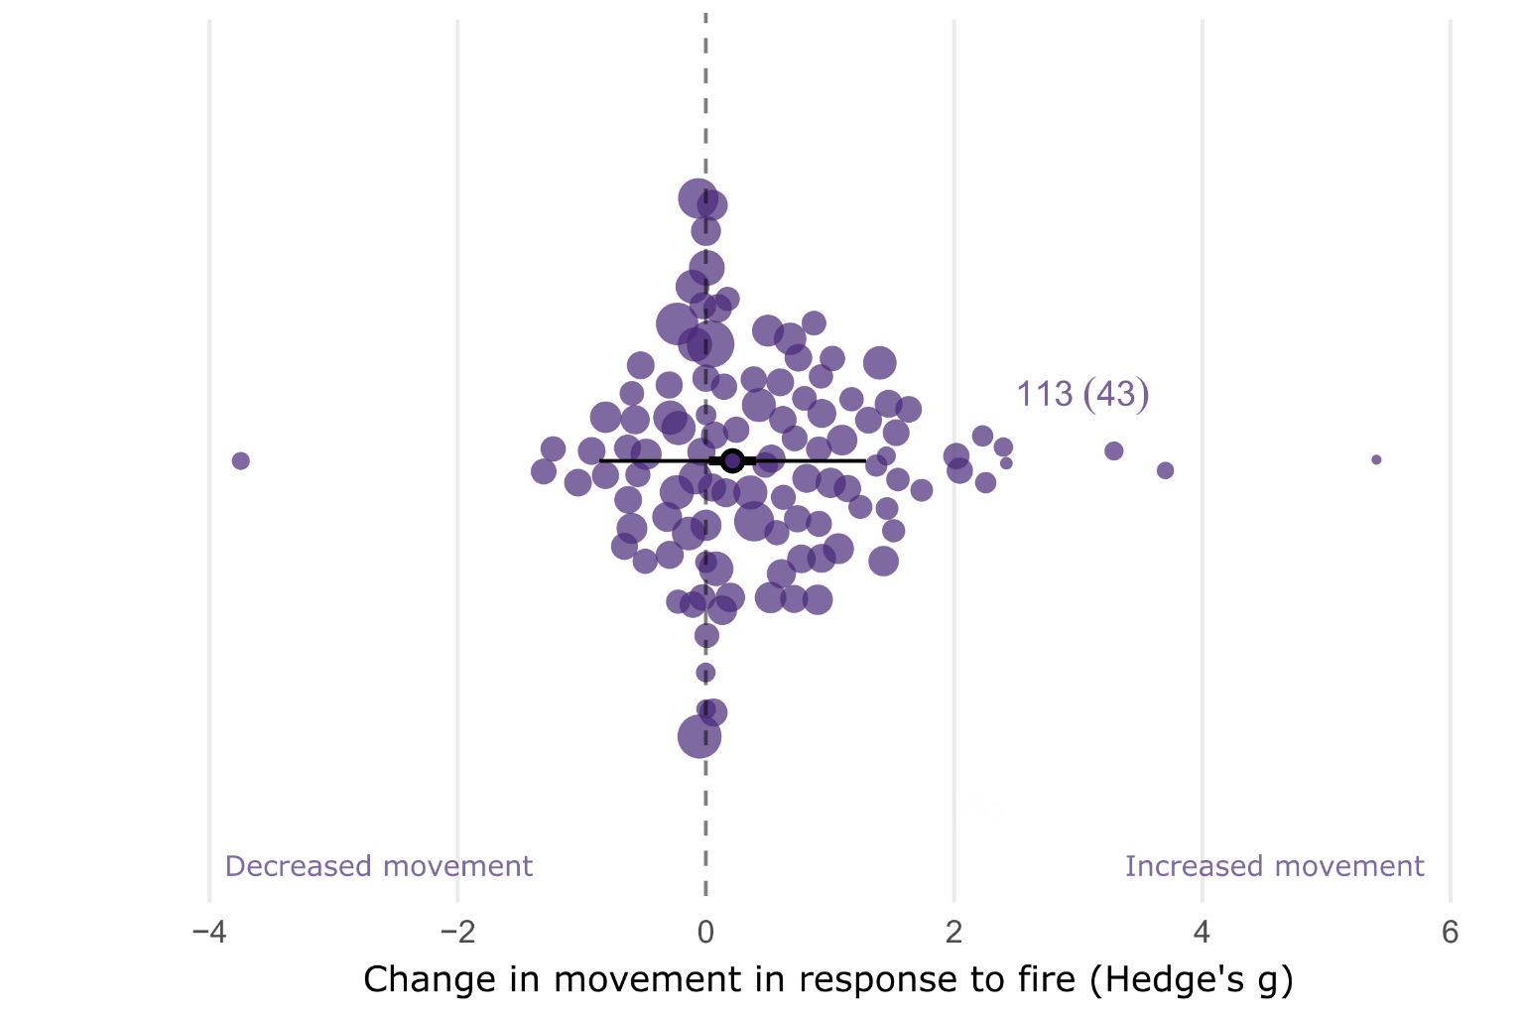
Figure 2: Orchard plot showing the overall estimated effect of fire on animal movement. The outlined point is the meta-analytic mean, the thick horizontal bars are 95% confidence intervals, and the whiskers are 95% prediction intervals. Shaded points are effect sizes (Hedge’s g, n = 113), with point size scaled to show precision (1/SE; i.e., larger points had greater influence). Points are jittered on the y axis to improve readability.

Movement Category
When modelling movement category as a moderator, fire had a small but significant positive effect on linear distance movements (Hedge’s g = 0.30, 95% CI [0.04–0.56]; Figure 3). The effect of fire on other space-use was also positive but non-significant (0.32, [ –0.08–0.72]). Effects on home-range size (0.15, [–0.07–0.38]) and tortuosity (0.14, [0.56–0.85]) were also non-significant.
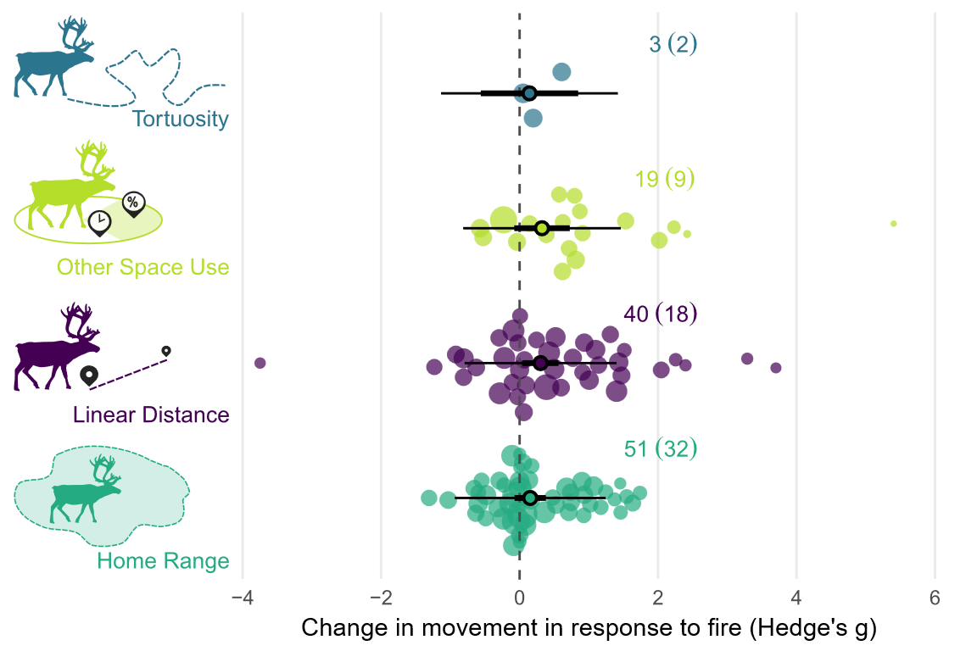
Figure 3: Orchard plot showing the estimated effect of fire on each of the four movement response categories. The meta-analytic mean is represented by the outlined point, with the thick horizontal bars showing 95% confidence interval and the whiskers the 95% prediction intervals. Each shaded point represents an effect size (Hedge’s g, n = 113), with the size of the point scaled to show precision within the model (1/SE) and larger points having a greater influence on the model. Effect size is shown on the x axis, and points are jittered on the y axis to improve readability.

Taxonomy
When modelling taxonomic class as a moderator, fire had a small but significant positive effect on movement in mammals (0.27, [0.02–0.52]; Figure 4). A small, positive effect was also observed in birds, however CIs overlapped zero (0.35, [–0.04–0.74]). In contrast, no effect of fire on movement was detected in reptiles (0.00, [–0.42–0.42]).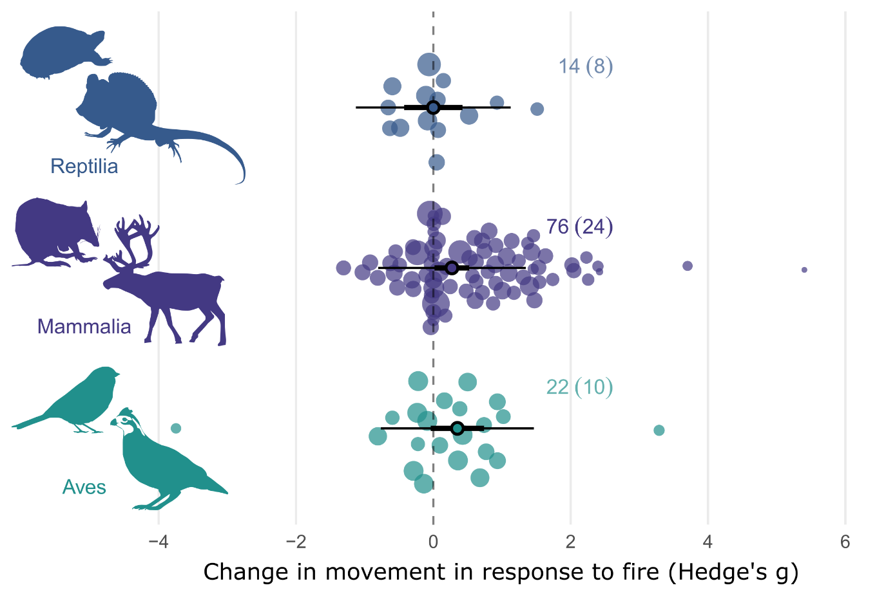
Figure 4: Orchard plot showing the estimated effect of fire on animal movement by taxonomic class. The meta-analytic mean is represented by the outlined point; thick horizontal bars indicate 95 % confidence intervals, and whiskers denote 95 % prediction intervals. Each shaded point represents an individual effect size (Hedge’s g, n = 109), with point size scaled by precision (1/SE), such that larger points have greater influence on the model. Effect size is shown on the x-axis, with points jittered along the y-axis for clarity.

Fire Type, Fire Size, & Maximum Burn Age
When comparing the effect of fire type, either planned or wildfire, on animal movement, we found that planned burns had a significant small, positive effect on movement (0.313, [0.005, 0.622]; Figure 5). When modelling the effect of maximum burn age on movement responses from 107 effect sizes, we found no correlation between maximum burn age and movement responses (β = –0.047, 95% CI [–0.163, 0.070]; Supplementary Information 4, Table S4.1). Similarly, we found no relationship between fire size and movement responses from 65 effect sizes (β = 0.002, [-0.113, 0.117]; Supplementary Information 4, Table S4.1). Fire activity (Pausas 2017) index also nonsig.

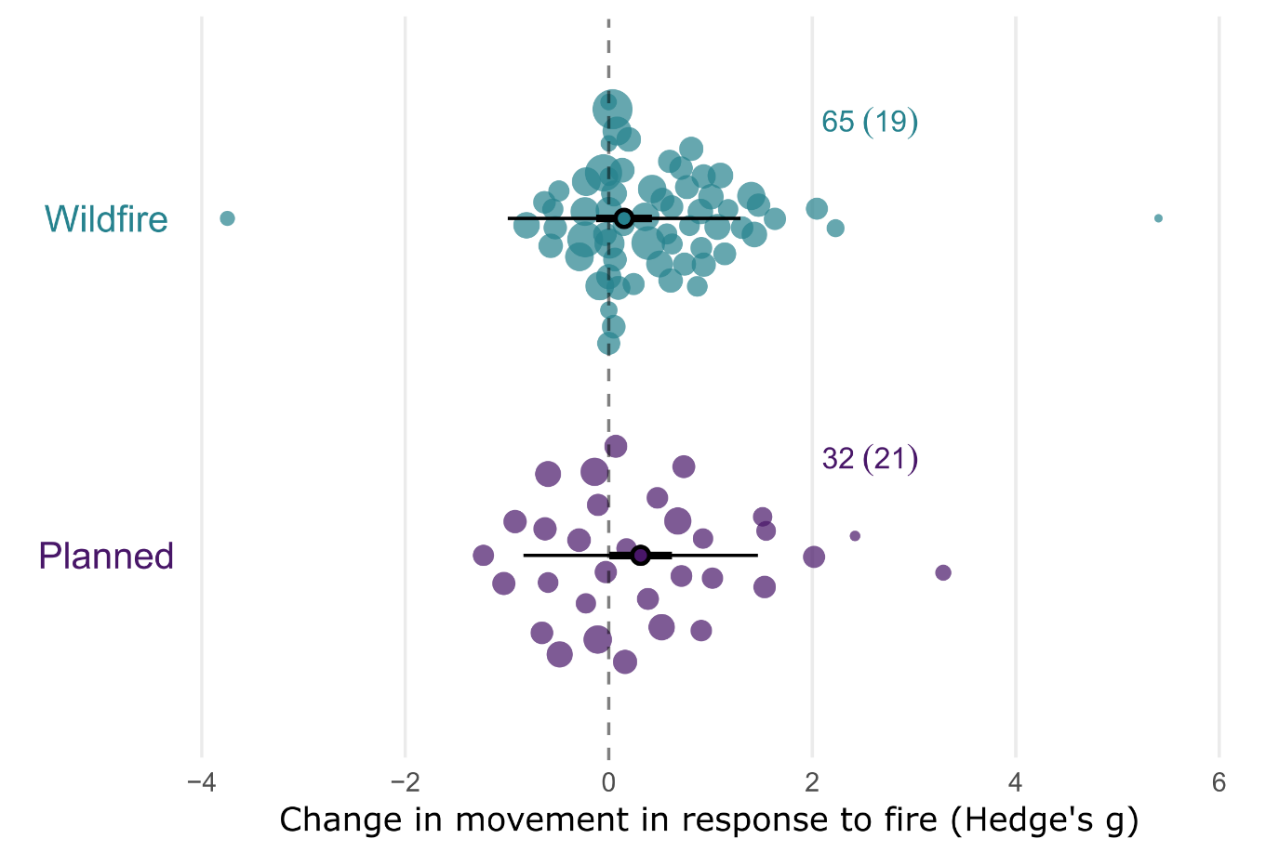
Figure 5: Orchard plot showing the estimated effect of fire on animal movement by fire type. The meta-analytic mean is represented by the outlined point, with the thick horizontal bars showing 95% confidence interval and the whiskers the 95% prediction intervals. Each shaded point represents an effect size (Hedge’s g, n = 97), with the size of the point scaled to show precision within the model (1/SE) and larger points having a greater influence on the model. Effect size is shown on the x axis, and points are jittered on the y axis to improve readability.

Biome
The phylogenetic multilevel meta-analytic model indicated that biome significantly influenced animal movement responses to fire, although the magnitude and direction of effects varied across biomes (Figure 6). A large and significant positive effect was detected in tropical and subtropical grasslands, savannas and shrublands (0.83, [0.22–1.43]). Moderate, marginally positive effects were observed in flooded grasslands and savannas (0.78, [–0.08–1.64]) and temperate grasslands, savannas and shrublands (0.59, [–0.01–1.19]). Deserts and xeric shrublands exhibited a negative but non-significant effect, while all remaining biomes showed no significant responses (Supplementary Information 4, Table S4.1).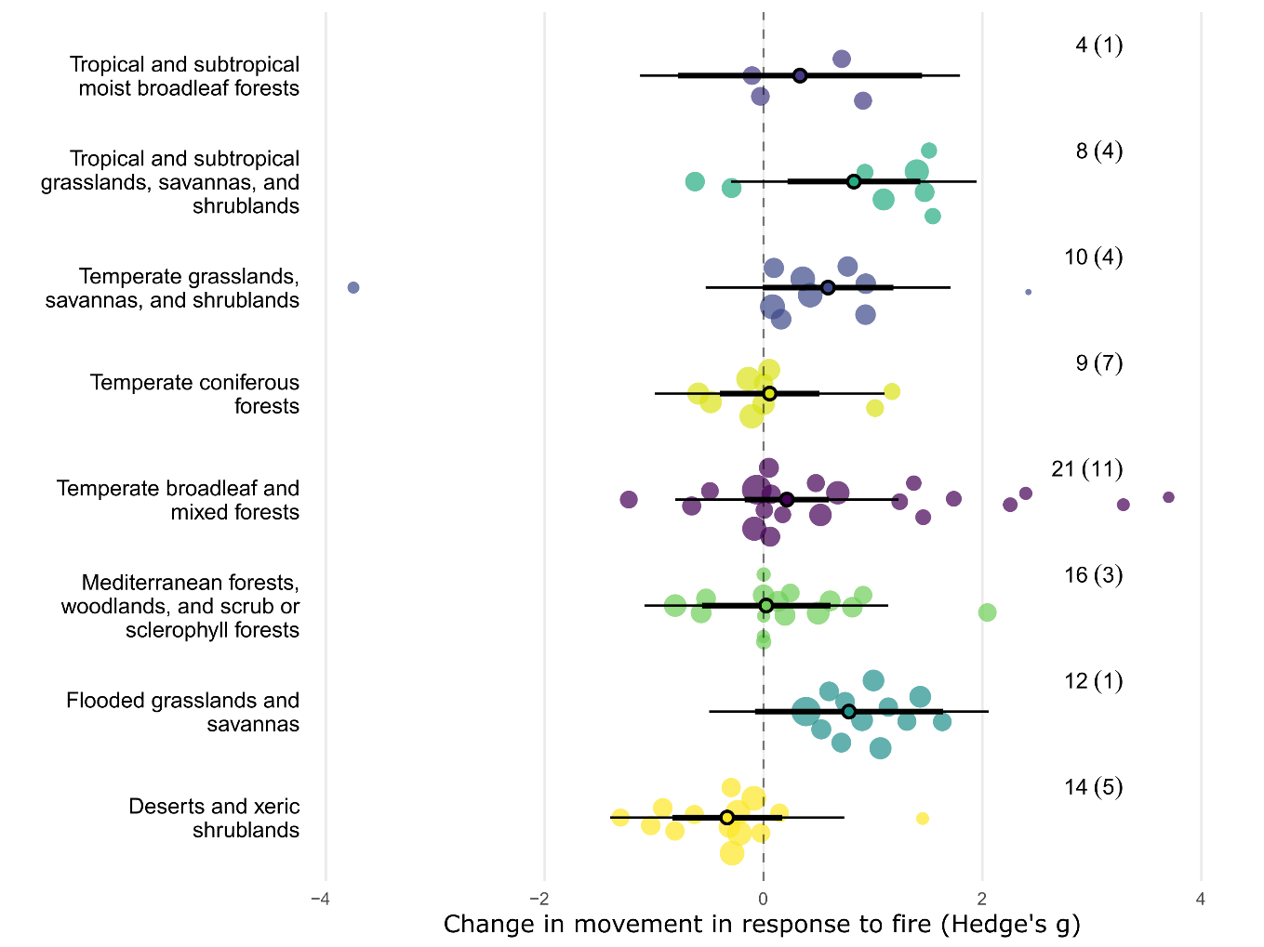
Figure 6: Orchard plot showing the estimated effect of fire on animal movement by biome. The meta-analytic mean is represented by the outlined point, with the thick horizontal bars showing 95% confidence interval and the whiskers the 95% prediction intervals. Each shaded point represents an effect size (Hedge’s g, n = 113), with the size of the point scaled to show precision within the model (1/SE) and larger points having a greater influence on the model. Effect size is shown on the x axis, and points are jittered on the y axis to improve readability.

Climate and Vegetation Structure
When comparing the effect of broad climate zone, and broad climate zone combined with vegetation, we found large, significant effects in the tropical climate zone (0.915, [0.147-1.684]) and open tropical grouping ([0.901, [0.223-1.579]) (Supp mat).
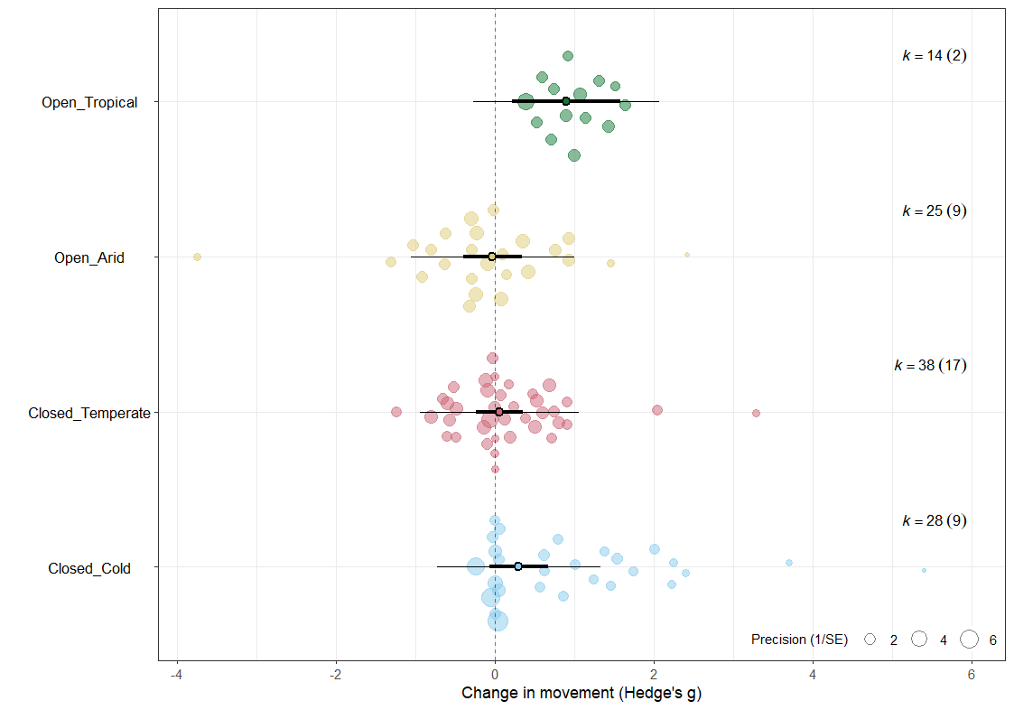
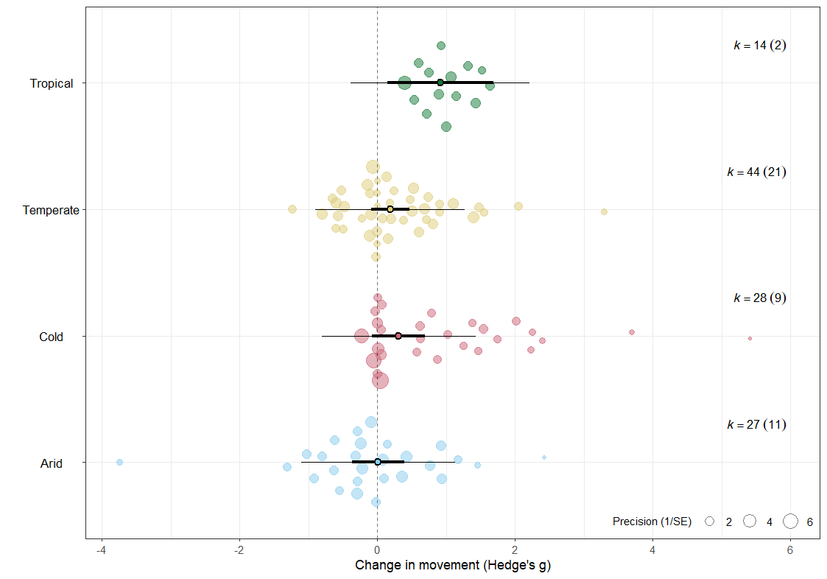

Body Mass
Across the full dataset, body mass was not correlated with animal movement responses to fire (β = 0.02, [ –0.04–0.08]; Supplementary Information 4, Table S4.1). When modelled separately for each taxonomic class, no significant relationship between body mass and movement response was detected in any group (Supplementary Information 4, Table S4.1).

Study heterogeneity, publication bias and sensitivity
For overall effect of fire on animal movement, total heterogeneity was 61.59% (I²_{[total]}=61.59), with 33.26% of variation remaining unexplained (I²_{[residuals]}=33.26), indicating a moderate to high level of true heterogeneity in the full dataset. Across study variation accounted for 28.32% of the estimated heterogeneity (I2_{[study_ID]}=28.32). Neither phylogenetic relatedness or species identity accounted for any additional heterogeneity in the random effects only model, suggesting both residual variation unexplained by the random effects, and limited evolutionary or intraspecific structuring in effect sizes.
The results of the multilevel version of Egger’s regression indicated there was no evidence of publication bias or small-study effects on the dataset. We found no statistical asymmetry in the distribution of effect sizes (β = -0.078 [-0.220, 0.065]). We found a significant decline effect in the dataset (β = -0.023, [-0.043, -0.002]), with the magnitude of effect sizes declining over time (Figure 7). Results of the leave-one-out sensitivity analysis indicated minimal evidence of outlier influence, with confidence intervals of all leave-one-out models within the confidence intervals of the full model (Supplementary Information 2, Figure S2.3)
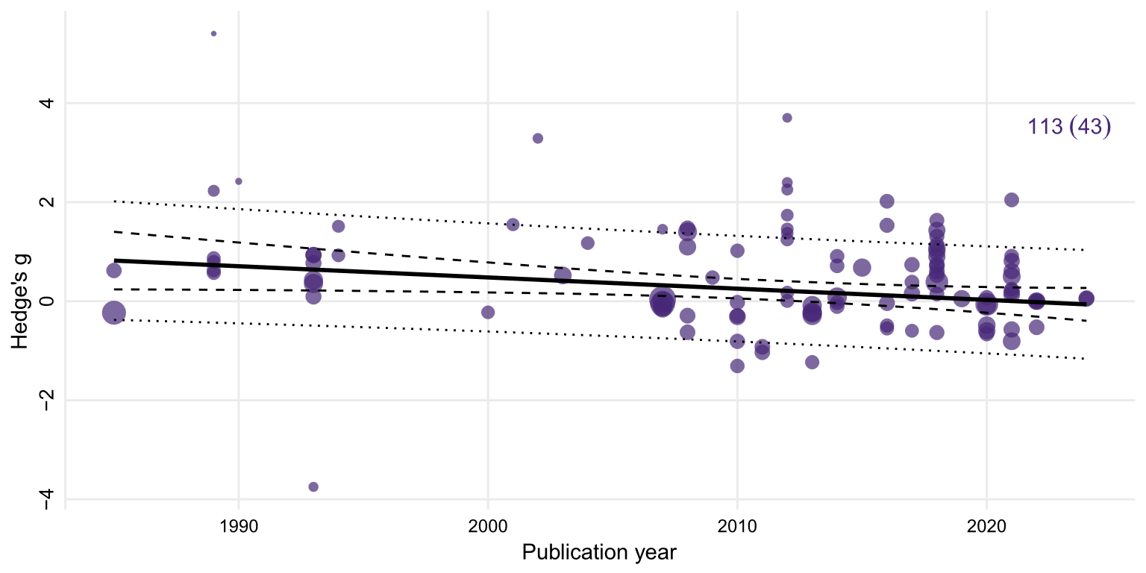
Figure 7: Meta-regression of effect sizes against publication year. Each point represents an individual effect size (Hedge’s g, n = 113), with the point size scaled by precision. The solid line indicates the estimated regression slope, with the 95% confidence interval shown by the dashed lines. The dotted lines show 95% prediction intervals. We found a significant decline effect in our dataset, with the magnitude of effect sizes declining over time.

Discussion
p C
Para 1: Main finding, remind the reader what the study is and why it’s cool, remind the reader why it’s important (150 words)
Animal movement responses represent behavioural strategies and adaptative traits that are central to survival in fire-prone landscapes (Nimmo et al., 2021; Pausas & Parr, 2018; Stevens et al., 2025). Our analysis is the first global scale meta-analysis investigating the influence of fire on the movement of terrestrial vertebrates. Our results revealed a small, positive effect of fire on overall animal movement, indicating that animal movements generally increase following fire. Within our models, movement category, taxonomy, fire type and biome (or veg/climate) were identified as drivers of movement responses. Of these drivers, three biomes demonstrated moderate to large positive effects. Small, positive responses were found for linear distance, mammals and planned burns when compared to other groups within each model. Movement responses are highly heterogeneous and often context dependent (Doherty et al., 2022; Ganz et al., 2022; Geary et al., 2020), and this is reflected by the results of our analysis. As such, understanding movement responses, and the drivers of these responses, is fundamental to informing fire management and predicting how animals will respond to changing fire regimes.
Para 2: Explain the main finding. Explore potential mechanmisms for the overall result, avoid going into specifics about taxa or biomes. Focus on the main metric that drove the response (linear distance). Use the case studies and their interpretations to help explain them, as well as general theory and findings about how disturbance affects movement (recognising fire is not like urbanisation or land clearing, but that previous meta analsysis on those topics might provide some insights) (150-200 words)
When comparing responses between movement categories, linear distance was the only category to demonstrate a positive effect, suggesting that increases in animal movement were largely driven by movement distance responses. Positive effects were observed across several species of mammals, reptiles and birds. This finding follows a similar trend identified in mammals and reptiles by Doherty et al. (2021) in their analysis of the impacts of anthropogenic disturbance on animal movement. Like other forms of disturbance, post-fire increases are likely to be driven by resource redistribution, and subsequent effects on resource acquisition, predation risk, and movement capacity (Doherty et al., 2022; Gomez et al., 2025; Nathan et al., 2008). Kreling et al. (2021) found daily distances travelled of female black-tailed deer (Odocoileus hemionus columbianus) in California increased by more than 40% post-fire. The authors attributed this increase to reduced forage availability within home ranges and also noted that reduced vegetation cover likely facilitated more direct movements (Kreling et al., 2021). Following burns in Northern Australia, the mean distance of fixes from the home range centroid of male frilled-neck lizards (Chlamydosaurus kingii) increased by over 130% compared to lizards unaffected by fire, with lizards likely taking advantage of open habitats to visually forage for invertebrate prey (Griffiths, 1994). Daily distances travelled of male Merriam’s turkeys (Meleagris gallopavo merriami) in southeastern Montana increased in burned habitat (Thompson, 1993). In this case, the authors inferred that decreased habitat quality post-fire affected hen density, increasing the distances males turkeys needed to travel to breed (Thompson, 1993).
Loss of vegetation cover post-fire can alter perceived or actual predation risk, depending on the hunting strategy of predator (Geary et al., 2020). In their study of white-tailed deer (Odocoileus virginianus) in Florida, Cherry et al. (2018) found male and female deer significantly increased movement rates in the month following a wildfire. The authors suggested this increase was the result of reduced perceived predation risk from the Florida panther (Puma concolor coryi), a stalk-and-ambush predator that relies on vegetation cover for concealment (Cherry et al., 2018). Such mechanisms may be acting concurrently and interactively, and disentangling these mechanisms is inherently difficult (Doherty et al., 2021; Gomez et al., 2025).
prey Could
Para 3. Explore taxonomic and body mass results, and explain them. (200 words)
Our taxonomic model found that mammals were the only class to significantly increase movement following fire, suggesting mammal responses are potentially influencing the overall result. While birds also demonstrated a small increase in movement, this result was non-significant. Reptiles demonstrated a neutral result. The results of this model can likely be attributed to morphological differences between taxa and fitness trade-offs between moving or remaining in place. Both movement (Jetz et al., 2004) and energy requirements (Nagy, 2005) scale with body mass. Larger animals, such as mammals, typically have greater energy requirements (Brown et al., 2004; Nagy, 2005). However, they are also capable of moving greater distances to meet these requirements (Jetz et al., 2004; Tamburello et al., 2015). A single fire extent may encompass a mosaic of burnt and unburnt vegetation, with or without heterogeneity in severity (Berry et al., 2016; Crabb et al., 2022; Lacki et al., 2009). The scale at which fire redistributes resources in relation to movement capacity and perception of an individual is an important consideration (Doherty et al., 2019; Nathan et al., 2008; Nimmo et al., 2019). Larger, more mobile animals have the capacity to traverse greater distances and across matrixes in response to environmental heterogeneity within and outside burn extents (Doherty et al., 2019; Nimmo et al., 2019). Many species of large herbivores are attracted to patches of highly palatable post-fire vegetation growth (Klop et al., 2007). Cherry et al. (2018) found white-tailed deer increased home range sizes to incorporate recently burnt patches of forage. Mobile species can also increase movements in response to reduced resources or productivity (Stobo‐Wilson et al., 2021). For example, following a wildfire in Arizona, home ranges of male black bears (Ursus americanus) increased approximately threefold, likely in response to reduced resource availability (Cunningham & Ballard, 2004). For smaller animals, such as reptiles and birds, fire may result in movement barriers (Nimmo et al., 2019).
The distribution of effect sizes across classes reflects taxonomic biases in the movement ecology literature (Joo et al., 2022), and this may also be contributing to the results of our taxonomic model. Mammals made up over 67% of effect sizes in our analysis, and the taxonomic model demonstrated greater certainty in the meta-analytical mean of mammals relative to birds and reptiles. As our analysis focused on movement metrics, it is unsurprising that mammals predominate, given body mass influences tracking device sizes and the quality of the tracking dataset (Kays et al., 2015). As technology continues to advance, our ability to capture robust, high resolution tracking data from smaller species will improve, enhancing our understanding of movement responses of smaller species post-fire (Nathan et al., 2022).
%Para 4: Explore biome results
Biome type was a significant predictor of effect size. (EXPAND - types of movement, is space use contributing to results (ie are animals spending less time in post fire habitats?). Savanna results make sense – less productive ecosystems, individuals need to move greater distances to find resources. See references in intro of (Ganz et al., 2022) for discussion of peak foraging abundance in xeric landscapes)
Discuss temporal scaling of resources post fire/veg succession and seral stages. Discuss differences between biomes/veg types in the weather/climate drivers of productivity (eg. Unpredictability/boom and bust in arid or xeric habitats), as well as veg composition
Para 5. Explore fire attributes; why did planned fire influence movement more than wildfire? Unexpected result. (150-200 words)
WILDFIRE TYPE NOT SIGNIFICANT PREDICTOR – But planned burns demonstrated significant positive effect. Why? What could explain this? Attributes of planned burns? Management approaches (ie are planned burns similar/different to burns of historic regimes)? Again, look at species here – are grazers that are attracted to burned areas post fire contributing to this (eg space use metric)? Less precision in Wildfire results?
Unexpectedly, we found no clear relationship between fire size, maximum burn age, and fire activity, and movement responses to fire. We expected the strength of effect sizes to decrease with maximum treatment age, however found no such relationship. In contrast to site specific, localised factors, the resolution of the extrinsic predictor variables we investigated are much coarser, and do not incorporate spatial or temporal environmental heterogeneity. This may aid in explaining why variables we expected to be influential, such fire size and fire type, were not. Within the studies we reviewed, we extracted qualitative descriptors of burn severity and patchiness when provided or inferred severity from post-fire descriptions of vegetation condition. Generally, burn severity was variable, resulting in a mosaic of differing burn severities and unburnt patches within a single fire extent (eg. Cherry et al., 2018; Crabb et al., 2022; Lacki et al., 2009). Burn heterogeneity, rather than total fire extent, is likely a stronger mediator of resource distribution and availability within the landscape, and therefore a stronger predictor of animal movement responses.
Para 5. Intraspecific variation. Good to discuss. Reflects intraspecific differences in traits, including resource requirements, behaviour strategies available to the species (e.g., torpor), and mobility. (150 words)
The detection of moderate levels of within-individual variation suggests individual movement responses are not necessarily consistent across the movement categories. For example, an increase in home range size may not correlate with an increase in daily distance travelled and vice versa. EXPAND, EXPLAINATION FOR THIS? Notably, phylogenetic relatedness and non-phylogenetic species identity accounted for negligible variance in any of the model. EXPAND, EXPLAINATION FOR THIS?
In addition to site specific factors, variation in species traits, hunting behaviour, and foraging strategies may also be contributing to heterogeneity in movement responses between studies (Ganz et al., 2022; Geary et al., 2020; Pocknee et al., 2023). Our meta-analysis dataset included effect sizes from 13 orders across three classes, representing a broad range of life history strategies, hunting behaviours and foraging strategies. Our results found phylogenetic relatedness did not explain heterogeneity in effect sizes. Therefore, any variability in traits, life histories and behaviours that do contribute to movement responses occur likely at lower taxonomic ranks and are not consistent across higher levels such as order. EXPAND. Hunting behaviours vary across predators, as to does preferred habitat to hunt in (Doherty et al., 2022; Kauffman et al., 2007). SEE ALSO (Moran et al., 2021) for discussion RE condition and risky behaviour.

Significant residual heterogeneity remained among effect sizes for most models, with between-study and within-individual heterogeneity generally accounting for some variance in most models. Between-study heterogeneity suggests either (i) the presence of meaningful differences in animal movement responses between studies, or (ii) differences in the capability of the studies to capture and quantify movement responses. In the first instance, site specific factors such as fire patchiness (Shaw et al., 2021) and fire severity (Crabb et al., 2022) may be driving animal movement responses. Fire is a spatiotemporally dynamic process; within a single fire extent, burn severity may range from complete canopy combustion through to incomplete combustion of the ground layer, leaving mid layers intact (Cherry et al., 2018; Yarnell et al., 2008). Similarly, a single fire extent may encompass a mosaic of burnt and unburnt vegetation, with or without heterogeneity in severity (Berry et al., 2016; Crabb et al., 2022; Lacki et al., 2009). The scale at which these fire characteristics and environmental conditions vary in relation to individual movement capacity is also an important consideration (Berry et al., 2016; Nathan et al., 2008; Nimmo et al., 2019) If post-fire conditions are unfavoured, highly mobile animals may shift the home range to adjacent, preferred habitats, as demonstrated by quokkas Setonix brachyurus following prescribed burns (Povh et al., 2023). In other cases, variation in burn severities across the fire extent may mediate habitat selection, yet have minimal effect on home range size, as seen in American black bears Ursus americanus following the extensive 2011 Wallow Wildfire in Arizona (Crabb et al., 2022). The authors propose heterogeneity in burn severity retained adequate foraging cover from established vegetation, and may have increased the productivity and foraging quality of grasses and herbs growing in areas affected by low severity fire (Crabb et al., 2022). With adequate resources available within the home range, there was no need to increase movement post fire (Crabb et al., 2022). SEE ALSO (Cohen et al., 2019)
Within a single fire extent, burn severity may range from complete canopy combustion through to incomplete combustion of the ground layer, leaving mid layers intact (Cherry et al., 2018; Yarnell et al., 2008). Similarly

SEE ALSO (Driscoll et al., 2021). EXAPND – Other processes that may interact with fire to influence movement. Unfortunately, our sample size precluded a robust evaluation of interactive effects.
SECOND CASE - differences in the capability of the studies to capture and quantify movement responses “(i) confounding factors that are inconsistently measured or accounted for across studies, (ii) problems with statistical inference (e.g., differing statistical power or accuracy), or (iii) methodological differences across studies (e.g., differing times since fire) (Catford et al. 2022)” from Doherty et al. (2023). Furthermore, previous research indicates that interactive and synergistic effects are also likely to exert strong influence on animal responses to fire, and this may also be contributing to the high level of between study heterogeneity we found (Culhane et al., 2022; Doherty et al., 2022; Ganz et al., 2022)
BODY MASS NOT SIGNIFICANT PREDICTOR. Despite correlation between body mass and movement/allometric scaling SEE (Doherty et al., 2019; Jetz et al., 2004; Tamburello et al., 2015).
LIMITATIONS – Cases not included due to small sizes/inadequate data to calculate effect sizes, quantitative fire attributes, no interactive effects modelled. Decline effect in dataset
IMPLICATIONS – Importance of results, future directions, please report more about fire treatments = disentangle effect of fire attributes from other site variables. Context dependency – importance of considering interactive effects, fine scale environmental variables and species traits

Conclusion

References
Abatzoglou, J. T., Kolden, C. A., Cullen, A. C., Sadegh, M., Williams, E. L., Turco, M., & Jones, M. W. (2025). Climate change has increased the odds of extreme regional forest fire years globally. Nature Communications, 16(1), 6390. https://doi.org/10.1038/s41467-025-61608-1
Ankit, R. (2025). WebPlotDigitizer Version 5.2. https://automeris.io
Berry, L. E., Lindenmayer, D. B., Dennis, T. E., Driscoll, D. A., & Banks, S. C. (2016). Fire severity alters spatio–temporal movements and habitat utilisation by an arboreal marsupial, the mountain brushtail possum (Trichosurus cunninghami). International Journal of Wildland Fire, 25(12), 1291-1302.
Blakey, R. V., Sikich, J. A., Blumstein, D. T., & Riley, S. P. D. (2022). Mountain lions avoid burned areas and increase risky behavior after wildfire in a fragmented urban landscape. Current Biology, 32(21), 4762-4768.e4765. https://doi.org/10.1016/j.cub.2022.08.082
Bowman, D. M. J. S., Balch, J. K., Artaxo, P., Bond, W. J., Carlson, J. M., Cochrane, M. A., D’Antonio, C. M., DeFries, R. S., Doyle, J. C., Harrison, S. P., Johnston, F. H., Keeley, J. E., Krawchuk, M. A., Kull, C. A., Marston, J. B., Moritz, M. A., Prentice, I. C., Roos, C. I., Scott, A. C., . . . Pyne, S. J. (2009). Fire in the Earth system. Science, 324(5926), 481-484. https://doi.org/10.1126/science.1163886
Bowman, D. M. J. S., Kolden, C. A., Abatzoglou, J. T., Johnston, F. H., van der Werf, G. R., & Flannigan, M. (2020). Vegetation fires in the Anthropocene. Nature Reviews Earth & Environment, 1(10), 500-515. https://doi.org/10.1038/s43017-020-0085-3
Brown, J. H., Gillooly, J. F., Allen, A. P., Savage, V. M., & West, G. B. (2004). Toward a metabolic theory of ecology. Ecology, 85(7), 1771-1789. https://doi.org/https://doi.org/10.1890/03-9000
Burton, C., Lampe, S., Kelley, D. I., Thiery, W., Hantson, S., Christidis, N., Gudmundsson, L., Forrest, M., Burke, E., Chang, J., Huang, H., Ito, A., Kou-Giesbrecht, S., Lasslop, G., Li, W., Nieradzik, L., Li, F., Chen, Y., Randerson, J., . . . Mengel, M. (2024). Global burned area increasingly explained by climate change. Nature Climate Change, 14(11), 1186-1192. https://doi.org/10.1038/s41558-024-02140-w
Chamberlain, S., & Szöcs, E. (2013). Taxize: taxonomic search and retrieval in R [version 2; peer review: 3 approved]. F1000Research, 2(191). https://doi.org/10.12688/f1000research.2-191.v2
Cherry, M. J., Chandler, R. B., Garrison, E. P., Crawford, D. A., Kelly, B. D., Shindle, D. B., Godsea, K. G., Miller, K. V., & Conner, L. M. (2018). Wildfire affects space use and movement of white-tailed deer in a tropical pyric landscape. Forest Ecology and Management, 409, 161-169. https://doi.org/10.1016/j.foreco.2017.11.007
Clapp, J. G., & Beck, J. L. (2016). Short-term impacts of fire-mediated habitat alterations on an isolated bighorn sheep population. Fire Ecology, 12(3), 80-98. https://doi.org/10.4996/fireecology.1203080
Cohen, B. S., Prebyl, T. J., Collier, B. A., & Chamberlain, M. J. (2019). Spatiotemporal variability of fire characteristics affect animal responses in pyric landscapes. Fire Ecology, 15(1), 41. https://doi.org/10.1186/s42408-019-0058-4
Cosgrove, A. J., McWhorter, T. J., & Maron, M. (2018). Consequences of impediments to animal movements at different scales: A conceptual framework and review. Diversity and Distributions, 24(4), 448-459. https://doi.org/10.1111/ddi.12699
Crabb, M. L., Clement, M. J., Jones, A. S., Bristow, K. D., & Harding, L. E. (2022). Black bear spatial responses to the Wallow Wildfire in Arizona. The Journal of Wildlife Management, 86(3), 1-20. https://doi.org/10.1002/jwmg.22182
Culhane, K., Sollmann, R., White, A. M., Tarbill, G. L., Cooper, S. D., & Young, H. S. (2022). Small mammal responses to fire severity mediated by vegetation characteristics and species traits. Ecology and Evolution, 12(5), e8918. https://doi.org/10.1002/ece3.8918
Cunningham, C. X., Williamson, G. J., & Bowman, D. M. J. S. (2024). Increasing frequency and intensity of the most extreme wildfires on Earth. Nature Ecology & Evolution, 8(8), 1420-1425. https://doi.org/s41559-024-02452-2
Cunningham, S. C., & Ballard, W. B. (2004). Effects of wildfire on black bear demographics in central Arizona. Wildlife Society Bulletin, 32(3), 928-937. https://doi.org/10.2193/0091-7648(2004)032[0928:EOWOBB]2.0.CO;2
Doherty, T. S., Fist, C. N., & Driscoll, D. A. (2019). Animal movement varies with resource availability, landscape configuration and body size: A conceptual model and empirical example. Landscape Ecology, 34(3), 603-614. https://doi.org/10.1007/s10980-019-00795-x
Doherty, T. S., Hays, G. C., & Driscoll, D. A. (2021). Human disturbance causes widespread disruption of animal movement. Nature Ecology & Evolution, 5(4), 513-519. https://doi.org/10.1038/s41559-020-01380-1
Doherty, T. S., Geary, W. L., Jolly, C. J., Macdonald, K. J., Miritis, V., Watchorn, D. J., Cherry, M. J., Conner, L. M., González, T. M., Legge, S. M., Ritchie, E. G., Stawski, C., & Dickman, C. R. (2022). Fire as a driver and mediator of predator–prey interactions. Biological Reviews, 97(4), 1539-1558. https://doi.org/10.1111/brv.12853
Doherty, T. S., Watchorn, D. J., Miritis, V., Pestell, A. J. L., & Geary, W. L. (2023). Cats, foxes and fire: Quantitative review reveals that invasive predator activity is most likely to increase shortly after fire. Fire Ecology, 19(1), 22. https://doi.org/10.1186/s42408-023-00183-6
Driscoll, D. A., Armenteras, D., Bennett, A. F., Brotons, L., Clarke, M. F., Doherty, T. S., Haslem, A., Kelly, L. T., Sato, C. F., Sitters, H., Aquilué, N., Bell, K., Chadid, M., Duane, A., Meza-Elizalde, M. C., Giljohann, K. M., González, T. M., Jambhekar, R., Lazzari, J., . . . Wevill, T. (2021). How fire interacts with habitat loss and fragmentation. Biological Reviews, 96(3), 976-998. https://doi.org/10.1111/brv.12687
Dudley, I. F., Coates, P. S., Prochazka, B. G., Davis, D. M., Gardner, S. C., & Delehanty, D. J. (2022). Maladaptive nest-site selection and reduced nest survival in female sage-grouse following wildfire. Ecosphere, 13(12), e4282. https://doi.org/10.1002/ecs2.4282
Ezzy, L. (2022). Breaking the wildfire cycle: Progressive fire management can shift fire regimes and improve ecosystem condition. A case study from a large conservation reserve in northern Australia. The Rangeland Journal, 44(6), 279-288. https://doi.org/10.1071/RJ22021
Fahrig, L. (2007). Non-optimal animal movement in human-altered landscapes. Functional Ecology, 21(6), 1003-1015. https://doi.org/10.1111/j.1365-2435.2007.01326.x
Faurby, S., Davis, M., Pedersen, R. Ø., Schowanek, S. D., Antonelli, A., & Svenning, J.-C. (2018). PHYLACINE 1.2: The phylogenetic atlas of mammal macroecology. Ecology, 99(11), 2626-2626. https://doi.org/10.1002/ecy.2443
Ganz, T. R., DeVivo, M. T., Kertson, B. N., Roussin, T., Satterfield, L., Wirsing, A. J., & Prugh, L. R. (2022). Interactive effects of wildfires, season and predator activity shape mule deer movements. Journal of Animal Ecology, 91(11), 2273-2288. https://doi.org/10.1111/1365-2656.13810
Gasaway, W. C., Dubois, S. D., Boertje, R. D., Reed, D. J., & Simpson, D. T. (1989). Response of radio-collared moose to a large burn in central Alaska. Canadian Journal of Zoology, 67(2), 325-329. https://doi.org/10.1139/z89-047
Geary, W. L., Doherty, T. S., Nimmo, D. G., Tulloch, A. I. T., & Ritchie, E. G. (2020). Predator responses to fire: A global systematic review and meta-analysis. Journal of Animal Ecology, 89(4), 955-971. https://doi.org/10.1111/1365-2656.13153
Gomez, S., English, H. M., Bejarano Alegre, V., Blackwell, P. G., Bracken, A. M., Bray, E., Evans, L. C., Gan, J. L., Grecian, W. J., Gutmann Roberts, C., Harju, S. M., Hejcmanová, P., Lelotte, L., Marshall, B. M., Matthiopoulos, J., Mnenge, A. J., Niebuhr, B. B., Ortega, Z., Pollock, C. J., . . . Börger, L. (2025). Understanding and predicting animal movements and distributions in the Anthropocene. Journal of Animal Ecology, 94(6), 1146-1164. https://doi.org/10.1111/1365-2656.70040
Greenwood, L., Bliege Bird, R., & Nimmo, D. (2022). Indigenous burning shapes the structure of visible and invisible fire mosaics. Landscape Ecology, 37(3), 811-827. https://doi.org/10.1007/s10980-021-01373-w
Griffiths, A. D. (1994). The effect of seasonal environment and fire on the ecology of frillneck lizards, Chlamydosaurus kingii, in the wet-dry tropics of northern Australia [Master's, Charles Darwin University]. Australia. https://www.proquest.com/dissertations-theses/effect-seasonal-environment-fire-on-ecology/docview/2606878779/se-2?accountid=10344
Harrison, M. E., Deere, N. J., Imron, M. A., Nasir, D., Asti, H. A., Aragay Soler, J., Boyd, N. C., Cheyne, S. M., Collins, S. A., D’Arcy, L. J., Erb, W. M., Green, H., Healy, W., Holly, B., Houlihan, P. R., Husson, S. J., Jeffers, K. A., Kulu, I. P., Kusin, K., . . . Struebig, M. J. (2024). Impacts of fire and prospects for recovery in a tropical peat forest ecosystem. Proceedings of the National Academy of Sciences, 121(17), e2307216121. https://doi.org/10.1073/pnas.2307216121
He, T., Lamont, B. B., & Pausas, J. G. (2019). Fire as a key driver of Earth's biodiversity. Biological Reviews, 94(6), 1983-2010. https://doi.org/10.1111/brv.12544
Hijmans, R. J., Barbosa, M., Ghos, A., & Mandel, A. (2025). geodata. In (Version 0.6-2) https://github.com/rspatial/geodata
Hinam, H., & St. Clair, C. (2008). High levels of habitat loss and fragmentation limit reproductive success by reducing home range size and provisioning rates of northern saw-whet owls. Biological Conservation, 141, 524-535. https://doi.org/10.1016/j.biocon.2007.11.011
Hovick, T. J., McGranahan, D. A., Elmore, R. D., Weir, J. R., & Fuhlendorf, S. D. (2017). Pyric-carnivory: Raptor use of prescribed fires. Ecology and Evolution, 7(21), 9144-9150. https://doi.org/10.1002/ece3.3401
Jetz, W., Carbone, C., Fulford, J., & Brown, J. H. (2004). The scaling of animal space use. Science, 306(5694), 266-268. https://doi.org/10.1126/science.1102138
Joo, R., Picardi, S., Boone, M. E., Clay, T. A., Patrick, S. C., Romero-Romero, V. S., & Basille, M. (2022). Recent trends in movement ecology of animals and human mobility. Movement Ecology, 10(1), 26. https://doi.org/10.1186/s40462-022-00322-9
Kauffman, M. J., Varley, N., Smith, D. W., Stahler, D. R., MacNulty, D. R., & Boyce, M. S. (2007). Landscape heterogeneity shapes predation in a newly restored predator–prey system. Ecology Letters, 10(8), 690-700. https://doi.org/10.1111/j.1461-0248.2007.01059.x
Kays, R., Crofoot, M. C., Jetz, W., & Wikelski, M. (2015). Terrestrial animal tracking as an eye on life and planet. Science, 348(6240), aaa2478. https://doi.org/10.1126/science.aaa2478
Klop, E., van Goethem, J., & de Iongh, H. H. (2007). Resource selection by grazing herbivores on post-fire regrowth in a West African woodland savanna. Wildlife Research, 34(2), 77-83. https://doi.org/10.1071/WR06052
Kreider, M. R., Higuera, P. E., Parks, S. A., Rice, W. L., White, N., & Larson, A. J. (2024). Fire suppression makes wildfires more severe and accentuates impacts of climate change and fuel accumulation. Nature Communications, 15(1), 2412. https://doi.org/10.1038/s41467-024-46702-0
Kreling, S. E. S., Gaynor, K. M., McInturff, A., Calhoun, K. L., & Brashares, J. S. (2021). Site fidelity and behavioral plasticity regulate an ungulate's response to extreme disturbance. Ecology and Evolution, 11(22), 15683-15694. https://doi.org/10.1002/ece3.8221
Lacki, M. J., Cox, D. R., Dodd, L. E., & Dickinson, M. B. (2009). Response of northern bats (Myotis septentrionalis) to prescribed fires in eastern Kentucky forests. Journal of Mammalogy, 90(5), 1165-1175. https://doi.org/10.1644/08-MAMM-A-349.1
McGinn, K., Zulla, C., Wright, M., Wilkinson, Z., Dotters, B., Roberts, K., Keane, J., Peery, M. Z., & Jones, G. M. (2024). Energetics explain predator occurrence and movement in pyrodiverse landscapes. Landscape Ecology, 39(10), 182. https://doi.org/10.1007/s10980-024-01970-5
McGregor, H. W., Legge, S., Jones, M. E., & Johnson, C. N. (2016). Extraterritorial hunting expeditions to intense fire scars by feral cats. Scientific Reports, 6(1), 22559. https://doi.org/10.1038/srep22559
Michonneau, F., Brown, J. W., & Winter, D. J. (2016). rotl: An R package to interact with the Open Tree of Life data. Methods in Ecology and Evolution, 7(12), 1476-1481. https://doi.org/10.1111/2041-210X.12593
Moran, N. P., Sánchez-Tójar, A., Schielzeth, H., & Reinhold, K. (2021). Poor nutritional condition promotes high-risk behaviours: A systematic review and meta-analysis. Biological Reviews, 96(1), 269-288. https://doi.org/10.1111/brv.12655
Morollón, S., Pausas, J. G., Urios, V., & López-López, P. (2022). Wildfire response of GPS-tracked Bonelli's eagles in eastern Spain. International Journal of Wildland Fire, 31(9), 901-908. https://doi.org/10.1071/WF22018
Morris, S. B. (2008). Estimating Effect Sizes From Pretest-Posttest-Control Group Designs. Organizational Research Methods, 11(2), 364-386. https://doi.org/10.1177/1094428106291059
Nagy, K. A. (2005). Field metabolic rate and body size. Journal of Experimental Biology, 208(9), 1621-1625. https://doi.org/10.1242/jeb.01553
Nakagawa, S., & Cuthill, I. C. (2007). Effect size, confidence interval and statistical significance: A practical guide for biologists. Biological Reviews, 82(4), 591-605. https://doi.org/10.1111/j.1469-185X.2007.00027.x
Nakagawa, S., & Santos, E. S. A. (2012). Methodological issues and advances in biological meta-analysis. Evolutionary Ecology, 26(5), 1253-1274. https://doi.org/10.1007/s10682-012-9555-5
Nakagawa, S., Lagisz, M., Jennions, M. D., Koricheva, J., Noble, D. W. A., Parker, T. H., Sánchez-Tójar, A., Yang, Y., & O'Dea, R. E. (2022). Methods for testing publication bias in ecological and evolutionary meta-analyses. Methods in Ecology and Evolution, 13(1), 4-21. https://doi.org/https://doi.org/10.1111/2041-210X.13724
Nakagawa, S., Lagisz, M., O'Dea, R. E., Pottier, P., Rutkowska, J., Senior, A. M., Yang, Y., & Noble, D. W. A. (2023). orchaRd 2.0: An R package for visualising meta-analyses with orchard plots. Methods in Ecology and Evolution, 14(8), 2003-2010. https://doi.org/10.1111/2041-210X.14152
Nathan, R., Getz, W. M., Revilla, E., Holyoak, M., Kadmon, R., Saltz, D., & Smouse, P. E. (2008). A movement ecology paradigm for unifying organismal movement research. Proceedings of the National Academy of Sciences, 105(49), 19052-19059. https://doi.org/10.1073/pnas.0800375105
Nathan, R., Monk, C. T., Arlinghaus, R., Adam, T., Alós, J., Assaf, M., Baktoft, H., Beardsworth, C. E., Bertram, M. G., Bijleveld, A. I., Brodin, T., Brooks, J. L., Campos-Candela, A., Cooke, S. J., Gjelland, K. Ø., Gupte, P. R., Harel, R., Hellström, G., Jeltsch, F., . . . Jarić, I. (2022). Big-data approaches lead to an increased understanding of the ecology of animal movement. Science, 375(6582), eabg1780. https://doi.org/10.1126/science.abg1780
Nimmo, D. G., Avitabile, S., Banks, S. C., Bliege Bird, R., Callister, K., Clarke, M. F., Dickman, C. R., Doherty, T. S., Driscoll, D. A., Greenville, A. C., Haslem, A., Kelly, L. T., Kenny, S. A., Lahoz‐Monfort, J. J., Lee, C., Leonard, S., Moore, H., Newsome, T. M., Parr, C. L., . . . Bennett, A. F. (2019). Animal movements in fire‐prone landscapes. Biological Reviews of the Cambridge Philosophical Society, 94(3), 981-998. https://doi.org/10.1111/brv.12486
Nimmo, D. G., Carthey, A. J. R., Jolly, C. J., & Blumstein, D. T. (2021). Welcome to the Pyrocene: Animal survival in the age of megafire. Global Change Biology, 27(22), 5684-5693. https://doi.org/10.1111/gcb.15834
Nowack, J., Cooper, C. E., & Geiser, F. (2016). Cool echidnas survive the fire. Proceedings of The Royal Society B-Biological Sciences, 283(1828). https://doi.org/10.1098/rspb.2016.0382
Oskyrko, O. M., Chunrong; Meiri, Shai; Du, Weiguo. (2024). ReptTraits: A comprehensive dataset of ecological traits in reptiles.
Pausas, J. G., & Parr, C. L. (2018). Towards an understanding of the evolutionary role of fire in animals. Evolutionary Ecology, 32(2), 113-125. https://doi.org/10.1007/s10682-018-9927-6
Pellegrini Adam, F. A., Tyler, R., Averill, C., Terrer, C., Carla, S. A., Brockway, D. G., Caprio, A., Clatterbuck, W., Coetsee, C., Haywood, J. D., Hobbie, S. E., Hoffmann, W. A., Kush, J., Lewis, T., Keith, M. W., Overby, S. T., Patterson, W. A., III, Peay, K. G., Reich, P. B., . . . Jackson, R. B. (2021). Decadal changes in fire frequencies shift tree communities and functional traits. Nature Ecology & Evolution, 5(4), 504-512. https://doi.org/10.1038/s41559-021-01401-7
Pettett, C. E., Johnson, P. J., Moorhouse, T. P., Hambly, C., Speakman, J. R., & Macdonald, D. W. (2017). Daily energy expenditure in the face of predation: Hedgehog energetics in rural landscapes. Journal of Experimental Biology, 220(3), 460-468. https://doi.org/10.1242/jeb.150359
Pocknee, C. A., Legge, S. M., McDonald, J., & Fisher, D. O. (2023). Modeling mammal response to fire based on species’ traits. Conservation Biology, 37(4), e14062. https://doi.org/10.1111/cobi.14062
Posit team. (2025). RStudio: Integrated Development Environment for R. In (Version 2025.5.0.496) Posit Software, PBC. http://www.posit.co/
Povh, L. F., Willers, N., Shephard, J. M., & Fleming, P. A. (2023). A conservation-significant threatened mammal uses fire exclusions and shifts ranges in the presence of prescribed burning. International Journal of Wildland Fire, 32(9), 1291-1303. https://doi.org/10.1071/WF22196
R Core Team. (2024). R: A Language and Environment for Statistical Computing. In R Foundation for Statistical Computing. https://www.R-project.org/
Rossi, R. C., & Leiner, N. O. (2022). Weather, fire, and density drive population dynamics of small mammals in the Brazilian Cerrado. Journal of Mammalogy, 103(5), 1127-1140. https://doi.org/10.1093/jmammal/gyac053
Shaw, R. E., James, A. I., Tuft, K., Legge, S., Cary, G. J., Peakall, R., & Banks, S. C. (2021). Unburnt habitat patches are critical for survival and in situ population recovery in a small mammal after fire. Journal of Applied Ecology, 58(6), 1325-1335. https://doi.org/10.1111/1365-2664.13846
Stawski, C., Körtner, G., Nowack, J., & Geiser, F. (2015). The importance of mammalian torpor for survival in a post-fire landscape. Biology Letters, 11(6). https://doi.org/10.1098/rsbl.2015.0134
Stevens, B. S., Conway, C. J., Roberts, S. B., & Englestead, D. K. (2025). Fitness consequences of catastrophic wildfire are mitigated by behavioral responses of an iconic bird. Fire Ecology, 21(1), 54. https://doi.org/10.1186/s42408-025-00391-2
Stobo‐Wilson, A. M., Cremona, T., Murphy, B. P., & Carthew, S. M. (2021). Resource availability drives variation in a marsupial glider’s home‐range size. Journal of Zoology, 315(3), 199-212. https://doi.org/10.1111/jzo.12906
Straus, S., Forbes, C., Little, C. J., Germain, R. M., Main, D. A., O'Connor, M. I., Thompson, P. L., Ford, A. T., Gravel, D., & Guzman, L. M. (2024). Macroecological constraints on species' ‘movement profiles’: Body mass does not explain it all. Global Ecology and Biogeography, 33(2), 227-243. https://doi.org/10.1111/geb.13786
Tamburello, N., Isabelle M. Côté, & Dulvy, N. K. (2015). Energy and the scaling of animal space use. The American Naturalist, 186(2), 196-211. https://doi.org/10.1086/682070
Templeton, A. R., Neuwald, J. L., Brazeal, H., & Robertson, R. J. (2007). Restoring demographic processes in translocated populations: The case of collared lizards in the Missouri Ozarks using prescribed forest fires. Israel Journal of Ecology & Evolution, 53(2), 179-196. https://doi.org/10.1560/IJEE.53.2.179
Templeton, A. R., Brazeal, H., & Neuwald, J. L. (2011). The transition from isolated patches to a metapopulation in the eastern collared lizard in response to prescribed fires. Ecology, 92(9), 1736-1747. https://doi.org/10.1890/10-1994.1
Thompson, W. L. (1993). Ecology of Merriam's turkeys in relation to burned and logged areas in southeastern Montana [Ph.D., Montana State University]. United States of America. https://www.proquest.com/dissertations-theses/ecology-merriams-turkeys-relation-burned-logged/docview/304050414/se-2?accountid=10344
Tobias, J. A., Sheard, C., Pigot, A. L., Devenish, A. J. M., Yang, J., Sayol, F., Neate-Clegg, M. H. C., Alioravainen, N., Weeks, T. L., Barber, R. A., Walkden, P. A., MacGregor, H. E. A., Jones, S. E. I., Vincent, C., Phillips, A. G., Marples, N. M., Montaño-Centellas, F. A., Leandro-Silva, V., Claramunt, S., . . . Schleuning, M. (2022). AVONET: morphological, ecological and geographical data for all birds. Ecology Letters, 25(3), 581-597. https://doi.org/https://doi.org/10.1111/ele.13898
Tucker, M. A., Böhning-Gaese, K., Fagan, W. F., Fryxell, J. M., Van Moorter, B., Alberts, S. C., Ali, A. H., Allen, A. M., Attias, N., Avgar, T., Bartlam-Brooks, H., Bayarbaatar, B., Belant, J. L., Bertassoni, A., Beyer, D., Bidner, L., van Beest, F. M., Blake, S., Blaum, N., . . . Mueller, T. (2018). Moving in the Anthropocene: Global reductions in terrestrial mammalian movements. Science, 359(6374), 466-469. https://doi.org/10.1126/science.aam9712
van Wagtendonk, J. W., & Lutz, J. A. (2007). Fire regime attributes of wildland fires in Yosemite National Park, USA. Fire Ecology, 3(2), 34-52. https://doi.org/10.4996/fireecology.0302034
Venter, J. A., Nabe-Nielsen, J., Prins, H. H. T., & Slotow, R. (2014). Forage patch use by grazing herbivores in a South African grazing ecosystem. Acta Theriologica, 59(3), 457-466. https://doi.org/10.1007/s13364-014-0184-y
Viechtbauer, W., & Cheung, M. W. L. (2010). Outlier and influence diagnostics for meta-analysis. Research Synthesis Methods, 1(2), 112-125. https://doi.org/10.1002/jrsm.11
Viechtbauer, W. (2010). Conducting Meta-Analyses in R with the metafor Package. Journal of Statistical Software, 36(3), 1 - 48. https://doi.org/10.18637/jss.v036.i03
Volkmann, L. A., Hutchen, J., & Hodges, K. E. (2020). Trends in carnivore and ungulate fire ecology research in North American conifer forests. Forest Ecology and Management, 458, 117691. https://doi.org/10.1016/j.foreco.2019.117691
Wooster, E. I. F., Gaynor, K. M., Carthey, A. J. R., Wallach, A. D., Stanton, L. A., Ramp, D., & Lundgren, E. J. (2024). Animal cognition and culture mediate predator–prey interactions. Trends in Ecology & Evolution, 39(1), 52-64. https://doi.org/10.1016/j.tree.2023.09.012
Yarnell, R. W., Metcalfe, D. J., Dunstone, N., Burnside, N., & Scott, D. M. (2008). The impact of fire on habitat use by the short-snouted elephant shrew (Elephantulus brachyrhynchus) in North West Province, South Africa. African Zoology, 43(1), 45-52. https://doi.org/10.1080/15627020.2008.11407405

