MOVEMENT IN THE PYROCENE: A GLOBAL META-ANALYSIS OF ANIMAL MOVEMENT RESPONSES TO FIRE

CHLOE L. MCAULEY^{1*}, EAMONN I.F. WOOSTER¹, TIM S. DOHERTY^{2,} MITCH A. COWAN^{1,3}, CHRIS J. JOLLY⁴, GRANT D. LINLEY¹, AMY SIMPSON¹, DYLAN WESTAWAY¹, BEN WILSON¹, DALE G. NIMMO¹
Affiliations:
1 Gulbali Institute, School of Agricultural, Environmental and Veterinary Sciences, Charles
Sturt University, Albury, NSW, Australia
2 Fire Science Program, Biodiversity and Conservation Science, Department of Biodiversity, Conservation and Attractions, Kings Park, Western Australia, Australia
3 School of Agricultural and Environmental Sciences, University of Western Australia,
Crawley, WA, Australia
4 School of Natural Sciences, Macquarie University, Macquarie Park, New South Wales, Australia

* Corresponding author
cmcauley@csu.edu.au

Target Journal – Global Change Biology
Key words
Fire, disturbance, meta-analysis, movement ecology, systematic review

Abstract

Main
Fire is a dynamic disturbance process that has operated across the globe for hundreds of millions of years (Bowman et al., 2009; He et al., 2019). Fire transforms landscapes, initiating ecological changes that shape biotic communities and ecosystem function over varying spatial and temporal scales (Greenwood et al., 2022; Pellegrini Adam et al., 2021). For animals, these dynamics manifest as changes in the availability of food, shelter and breeding resources, and shifts in competition and predation pressure, with flow-on effects for animal fitness and survival (Doherty et al., 2022; Rossi & Leiner, 2022). In response, animals can alter their behaviour to minimise risk, maximise access to resources, and improve survival (McGinn et al., 2024; Stevens et al., 2025).
Movement plays a central role in shaping how animals respond to fire and other disturbances. Movement decisions emerge from interactions between an animal’s internal state, mobility and navigation capacity, as well as external drivers (Nathan et al., 2008). The competing demands of nutrition, reproduction, and predator avoidance influence how, where, and when animals move (Nathan et al., 2008; Wooster et al., 2024). By shaping the external environment, disturbance exerts a major influence on movement decisions (Doherty et al., 2021; Gomez et al., 2025; Tucker et al., 2018). This can have profound consequences for animals by influencing competition (Blakey et al., 2022), energy expenditure (Pettett et al., 2017), foraging success (Hinam & St. Clair, 2008) and ultimately survival (Dudley et al., 2022). These effects can scale up through space and time to drive population dynamics (Cosgrove et al., 2018; Gomez et al., 2025; Templeton et al., 2007).
Fire triggers a variety of animal movements (Nimmo et al., 2019). In the short term, ranging from the hours during a fire to the days immediately after, animals may move to escape fire and leave the burnt area (Morollón et al., 2022; Nimmo et al., 2021), or instead move towards burnt areas to quickly exploit new opportunities in the wake of a fire (Hovick et al., 2017; McGregor et al., 2016a). For instance, following ignition of a wildfire within its usual territory in eastern Spain, a GPS-tracked male Bonelli’s eagle (Aquila fasciata) was observed flying 6 km away from the fire in the 2 hours immediately after ignition, before returning to the fire perimeter and core territory within 5 days (Morollón et al., 2022). In northern Australian savannahs, feral cats (Felis catus) make long distance, extraterritorial movements up to 12.5 km from their usual home ranges to hunt within areas recently burnt by intense fires (McGregor et al., 2016a). When the availability of resources is reduced after fire, animals may move further to meet their ecological requirements (Blakey et al., 2022). In Wyoming (USA), bighorn sheep (Ovis canadensis) expanded home range size by over 200% following wildfire and prescribed burns (Clapp & Beck, 2016). Other species may move less to reduce their energetic requirements and avoid traversing risky post-fire landscapes (Nowack et al., 2016). For example, in the months following a prescribed fire in eastern Australia, torpor frequency and duration in female brown antechinus (Antechinus stuartii) increased two-fold compared to pre-fire and control groups, and daily activity decreased (Stawski et al., 2015). Over longer periods, from months to years and even decades, individuals adjust their movements in response to changing habitat suitability as vegetation recovers (Cherry et al., 2018; Gasaway et al., 1989; Volkmann & Hodges, 2021) The ability of animals to exploit optimal habitat can be the difference between local persistence and extinction (Templeton et al., 2011). Therefore, movement represents an adaptive trait and behavioural strategy that facilitates animal survival and persistence in fire-prone landscapes (He et al., 2019; Nimmo et al., 2021; Pausas & Parr, 2018).
Fire regimes are changing across the globe (Bowman et al., 2020; Cunningham et al., 2024). Anthropogenic climate and land use changes are major drivers of increased fire severity and extent in multiple biogeographic regions (Abatzoglou et al., 2025; Burton et al., 2024; Kreider et al., 2024). Sound understanding of animal movement is fundamental to predicting how animals will respond to shifting fire regimes (Nimmo et al., 2019). While numerous studies have explored the effects of fire on animal movement, these are largely taxon- or context-specific, and no quantitative synthesis has yet evaluated whether general patterns emerge across taxa and ecosystems.
Here, we conduct the first global systematic review and meta-analysis of the influence of fire on movement by terrestrial vertebrates. We calculated 111 effect sizes derived from 40 taxa, 42 studies and six continents to assess how fire attributes, taxonomy, and biogeography influence animal responses to fire. We hypothesised that, overall, fire would increase animal movement as individuals make more long-ranging, tortuous movements in search of resources, leading to larger home ranges after fire. Further, we predicted: (i) movement would increase with spatial extent of burnt area, because of the greater area of altered resources (Bowman et al., 2009); (ii) movement responses would be greater in response to wildfire compared to planned burns, due to differential seasonality, severity and extent (Ezzy, 2022; van Wagtendonk & Lutz, 2007); and (iii) effect sizes would increase with species-level body mass, given that space use increases with body size, and larger animals are likely to have greater resource requirements (Jetz et al., 2004; Straus et al., 2024; Tamburello et al., 2015).

Materials and Methods

Systematic review
We aimed to capture literature investigating four categories of animal movement, namely home range size, linear distance moved, tortuosity, and other measures of space use. Following Doherty et al. (2021), home range responses included area-based measurements of space use, such as home range size and nest area size. Linear distance metrics were those that measured straight-line distances between relocations, such as daily distance travelled, as well as distance travelled per unit of time. Tortuosity provides a measure of how a movement path deviates from a straight-line and was captured by straightness indices and turning angles. Relevant space use metrics not captured by the previous categories, such as mean residency time, time to return, and proportion of fixes within burnt and unburnt habitats, were pooled as ‘other space use metrics’.
We conducted a systematic review to identify studies investigating the influence of fire on animal movement. Database searches were undertaken in Scopus, Web of Science and ProQuest Dissertation and Theses Global between 15th May 2024 and 29th August 2024. Search terms relating to animal movement were combined with terms relating to fire and terrestrial vertebrates to identity suitable studies (Supplementary Information 1). To be considered for inclusion in the systematic review studies needed to meet the following criteria: (i) published in either a peer reviewed article, Master’s thesis, or PhD thesis; (ii) field studies with before–after fire, burnt–unburnt, or before–after control–impact designs (BACI); and (iii) provided an evaluation of movement responses to fire in free-ranging terrestrial vertebrates. We considered terrestrial vertebrates as animals primarily distributed in terrestrial biomes, or animals that used terrestrial habitat features for key life stages, such as reproduction or hibernation. All returned results were filtered to include only articles or theses published in English, and filters were applied in the databases to limit the results to relevant disciplines (Supplementary Information 1). Additional studies were identified by snowball searches of reference lists from two review articles returned in database searches (Nimmo et al., 2019; Nimmo et al., 2021), and one additional review paper known to the authors (Volkmann et al., 2020). Database searches, snowball searches, and title and abstract screening were done by C.L.M. Full text screening was performed by C.L.M, B.W, D.W, C.J.J, M.A.C, E.I.F.W and G.D.L.

Data extraction
From each study, we extracted metadata on fire type (wildfire or planned fire), fire size (hectares), maximum burn age (days), study design (before–after, control–impact, or before–after control–impact), geographic coordinates (latitude and longitude), country, and movement response (home range, linear distance, tortuosity, or other space use metrics) (Supplementary Information 1, Table S1.1). We defined planned fires as those intentionally ignited by people, and wildfires as those ignited by natural causes or unintentionally by anthropogenic sources. Fire type was recorded according to the authors’ description of the event. Maximum burn age was defined as the maximum period (days) between the fire event and the end of data collection, as stated by authors or calculated by reviewers using information provided within the article. To account for variability in sampling duration across the dataset, we chose to extract maximum burn age over other measures of time since fire. This approach provides a more representative measure of post-fire conditions experienced by study animals tracked over longer periods of time. Fire size (area burned, ha) was obtained directly from source studies where available. Not all studies reported all of the fire characteristics listed above.
Sample sizes, means, and measures of variation were extracted from tables, text, supplementary materials, or figures. Where necessary, data in figures were digitised using WebPlotDigitizer (Ankit, 2025). The sampling unit was typically the number of tracked individuals or independent movement paths. To minimise potential confounding from seasonal effects in before–after designs, we recorded the timing of data collection and noted any additional management activities that could interact with fire (e.g. logging, mechanical thinning, or livestock grazing).
Classification of burned and unburned animal populations followed the authors’ definitions. As such, movement data extracted from burned populations were not necessarily constrained to fire scars and included data from animals the study authors categorised as impacted by fire (e.g. a defined portion of the home range overlapped with the burn extent). In the case of chronosequence studies, we extracted data for the fire age closest to the fire event, or, in before–after studies, for the combination of time periods that minimised seasonal confounding. When demographic subgroups (e.g. males and females, adults and juveniles) were presented, each subgroup was treated as a separate case unless the sample size fell below inclusion thresholds; in such cases, subgroups were pooled if responses were similar in magnitude and direction.
We also extracted or derived several additional covariates to use as moderators in the meta-analysis. Biome was determined for each study location using the coordinates provided by authors or estimated from site descriptions, overlaid with the terrestrial biome classification of Olson et al. (2001) via the geodata package (Hijmans et al., 2025) implemented in R version 4.4.2 (R Core Team, 2024). Body mass data (mean or maximum adult body mass, depending on the taxonomic class) were obtained for each species from published databases including AvoNet (Tobias et al., 2022), ReptTraits (Oskyrko, 2024), and Phylacine (Faurby et al., 2018). Body mass data were supplemented with literature values where necessary. Species identity were recorded for all effect sizes based on the original publications, and updated where necessary using the rotl package (Michonneau et al., 2016). Taxonomic class was extracted from the National Center for Biotechnology Information database using the tax_name function within the taxize R package (Chamberlain & Szöcs, 2013). Data extraction was conducted by C.L.M and E.I.F.W.

Meta-analysis
To qualify for data inclusion in the meta-analysis, studies were required to meet the following criteria: (i) they provided sufficient information to calculate sample sizes, means, and measures of variation (standard deviations, standard errors, or confidence intervals) for each treatment group; (ii) each treatment group had a sample size of at least five; (iii) methods were standardised across treatment groups; and (iv) the potential confounding effects of other environmental variables were considered minimal. To minimise seasonal confounding in before–after designs, only studies in which data were collected during the same or adjacent seasons were included in subsequent analyses.
We used the following formula from Morris (2008) to convert before–after control–impact studies to control–impact studies to calculate effect sizes.
$d_{ppc1}= c(\frac{Mₚₒₛₜ,ₜ - Mₚᵣₑ,ₜ}{ SDₚᵣₑ,ₜ} ) - c꜀(\frac{Mₚₒₛₜ,꜀ - Mₚᵣₑ,꜀}{SDₚᵣₑ,꜀})$
Following Morris (2008), we used the pretest (before) SD values for the control and treatment groups. All analyses were performed in using R version 4.4.2 (R Core Team, 2024) in RStudio (Posit team, 2025). Hedge’s g, using the unbiased estimate of sampling variances, was calculated for each study using the escalc function in the metafor package (Viechtbauer, 2010). Hedge’s G is a standardized mean difference method that includes a bias corrector for small sample sizes (Viechtbauer, 2010). By providing a standardised measure between control and treatment groups, Hedge’s g allows for aggregation and comparison of multiple movement responses. A negative effect size indicates a decrease in animal movement, and a positive value an increase in animal movement. We used the effect size benchmarks outlined in Nakagawa and Cuthill (2007), as g > 0.2 for a small effect, >0.5 as moderate and >0.8 as large, and considered an effect to be significant when 95% confidence intervals did not overlap zero. Effect size calculation was done by C.M and E.I.F.W.
To quantify the effect of fire on animal movement, we constructed phylogenetic multi-level meta-analytic models using the rma.mv function in the metafor package (Viechtbauer, 2010). These models weigh each effect size by the inverse of the sampling variance, allowing the models to account for uncertainty in effect sizes. This results in effects with smaller sampling variances having higher weight in the models. To account for nonindependence amongst effect sizes, we included study ID (a unique identifier assigned to each article or thesis), observation ID (a unique identifier assigned to each effect size), species phylogeny, and species identity (non-phylogenetic species identification) as random effects (Nakagawa & Santos, 2012). We included observation ID to account for within study heterogeneity and nonindependence arising from multiple movement metrics being measured from a single individual or related population, for instance home range size and linear distance (Nakagawa & Santos, 2012). Phylogenies were obtained from the Open Tree of Life, using the tnrs_match_names function in the rotl package (Michonneau et al., 2016). Phylogenetic random effect values are a correlation matrix of branch lengths representing the phylogenetic relatedness between species. This is important as we would expect closely related species to respond similarly to fire, while species identity accounts for the effects sizes of the same species instead of relatedness to another species. We included a variance–covariance matrix in our models to account for non-independence resulting from individuals and populations contributing to multiple effect sizes (Nakagawa & Santos, 2012). We assumed a correlation of r = 0.5 for the same species within the same studies (Mathot et al., 2024; Noble et al., 2017).
We first modelled the overall effect of fire on animal movement by fitting a null model (with random effects). We then asked in subsequent models whether movement responses varied according to movement category, fire type, fire size, maximum burn age, biome, body mass, and taxonomic class. The biome analysis was restricted to biomes with a minimum of 10 effect sizes. Models were plotted using the orchaRd package (Nakagawa et al., 2023). Meta-analysis was performed by C.L.M and E.I.F.W.

Study heterogeneity, publication bias and sensitivity analysis
To quantify study heterogeneity, and the proportion of variance attributable to the random effects, we calculated I² using the i2_ml function in the orchaRd package (Nakagawa et al., 2023; Nakagawa & Santos, 2012). To test for publication bias, we visually assessed funnel plot asymmetry and ran a multilevel version of Egger’s regressions with an approximation of observation precision as a predictor (Nakagawa et al., 2022). We tested for a time lag effect by regressing effect sizes against study year. Finally, we performed a leave-a-study-out test to evaluate the sensitity of the overall model results to influential studies (Viechtbauer & Cheung, 2010). Publication bias testing was done by C.L.M and E.I.F.W.

Results

Systematic review
Our database searches yielded 5,231 records after duplicate removal. Following screening, 84 studies met the eligibility criteria for the systematic review. These studies were conducted across 12 countries and six continents (Figure 1). Most research was conducted in North America (60.7%), followed by Oceania (20.2%). All Oceania studies were from Australia, while 90.2% of North American studies were from the United States, with the remainder from Canada. In Africa, 71.4% of studies originated from South Africa, with single studies from Kenya and Uganda. South America was represented by a single study from Paraguay. In Asia, 60% of studies were conducted in Indonesia, while Europe was represented by three studies, two from Spain and one from Portugal. Research effort has increased markedly over time. Only nine of the 84 studies were published before 2000, whereas nearly half (48.8%) were published between 2010 and 2019 (Supplementary Information 3, Figure S3.1).
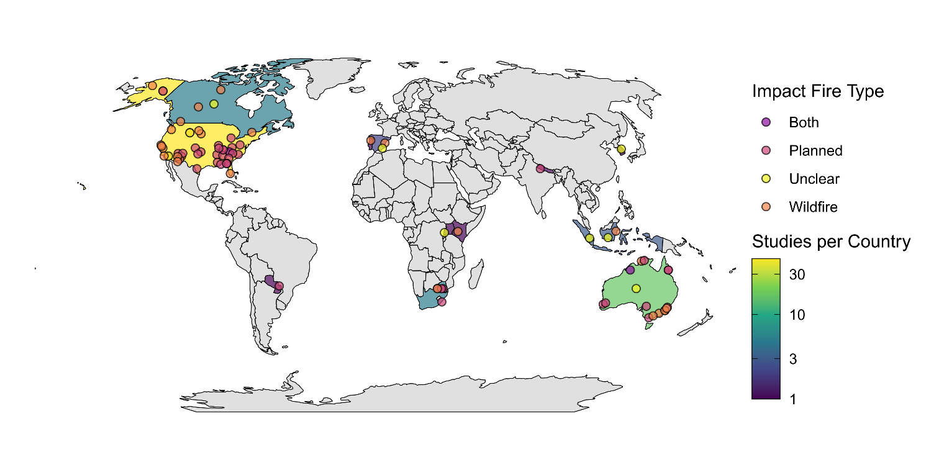
Figure 1: Map illustrating the number of studies per country and locations of the 84 studies included in the systematic review. The color scale shows the number of studies per country, with darker colours indicating fewer studies, and lighter colours indicating more studies. The colour of the study points indicate the type of fire the study investigated.
From the 84 studies, we extracted 185 cases investigating the influence of fire on animal movement for inclusion in the review. Only a single study investigated movement responses to both planned and wildfire fire separately (Clapp & Beck, 2016), although other studies investigated the combined effect of wildfire and planned burns. Similarly, all but one study investigated movement responses in a single species (Venter et al., 2014). Over half (n = 102, 55.1%) of all cases investigated movement responses using a control–impact (burnt–unburnt) study design. A before–after design was used in 34.6% of cases and BACI designs accounted for the remaining 10.3%. Investigations of home range metrics accounted for 45.6% of cases, followed by linear distance (35.1%) other space use (14.1%) and tortuosity (3.8%).
Twelve biomes were represented among the 185 cases included in the review (Supplementary Information 3, Figure S3.2). Most research occurred in temperate biomes, with 20% of cases in ‘Temperate broadleaf and mixed forests’ (n = 37), 26% in ‘Mediterranean forests, woodlands and scrub’ (including sclerophyll forests, n = 26), and 25% in ‘Temperate coniferous forests’ (n =25). Approximately half of all cases (49.7%) examined the effects of wildfire, while 34.1% investigated planned burns. Fire type was not clearly specified for 9.2% of observations, and 7% assessed the combined effects of wildfire and planned burns. Within ‘Temperate broadleaf and mixed forests,’ more than half of the cases examined planned fires, whereas in ‘Mediterranean forests, woodlands and scrub’ (or sclerophyll forests), most studies focused on wildfire effects. Across the remaining biomes, planned burns and wildfires were investigated at similar frequencies.
The dataset encompassed 73 taxa spanning 23 orders and four vertebrate classes. Most taxa belonged to Mammalia (65.9%), followed by Aves (18.9%), Reptilia (13.0%), and Amphibia (2.2%). Among orders, Artiodactyla (even-toed ungulates; 23.8%) and Rodentia (14.1%) were the most frequently represented (Supplementary Information 3, Figure S3.3). Several orders, Accipitriformes, Caprimulgiformes, Piciformes, and Dasyuromorphia, were each represented by a single case. Within Aves, Galliformes was the most frequently studied order, while within Reptilia, Testudines predominated. At the species level, white-tailed deer (Odocoileus virginianus) was the most commonly studied species (12 cases), followed by moose (Alces alces) with 10 cases.

Meta-analysis
From the 185 cases included in the systematic review, we calculated 111 effect sizes from 42 studies. The remaining 76 cases were not included in the meta-analysis, largely due to insufficient sample sizes and inadequate data to calculate effect sizes. The phylogenetic multilevel meta-analytic model revealed a significant positive overall effect of fire on animal movement (Hedge’s g = 0.2, 95% CI [0.02–0.40]; Figure 2). On average, animals occupying fire-affected habitats moved more than those in unburnt areas. However, responses varied substantially among species, indicating high interspecific heterogeneity (Supplementary Information 4, Figure S4.1).

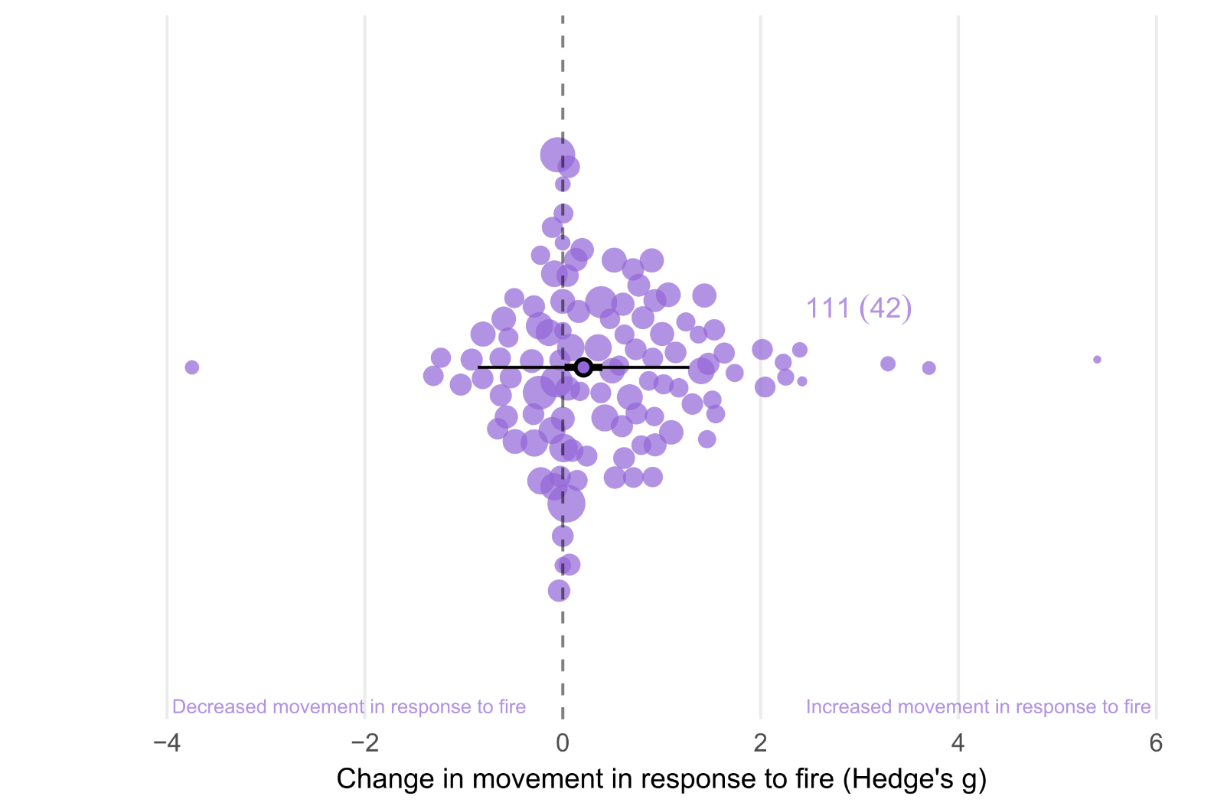
Figure 2: Orchard plot showing the overall estimated effect of fire on animal movement. The outlined point is the meta-analytic mean, the thick horizontal bars are 95% confidence intervals, and the whiskers are 95% prediction intervals. Shaded points are effect sizes (Hedge’s g, n = 111), with point size scaled to show precision (1/SE; i.e., larger points had greater influence). Points are jittered on the y axis to improve readability. The annotation next to the point cloud represents number of effect sizes followed by number of studies in parentheses.

Movement Category
When testing movement category as a moderator, fire had a small but significant positive effect on linear distance movements (0.30, [0.04–0.56]; Figure 3). The effect of fire was also positive but non-significant for both other space use (0.28, [-0.11–0.68]) and home-range size (0.15, [-0.08–0.38]). There was no clear effect for tortuosity (0.13, [-0.56–0.83]).
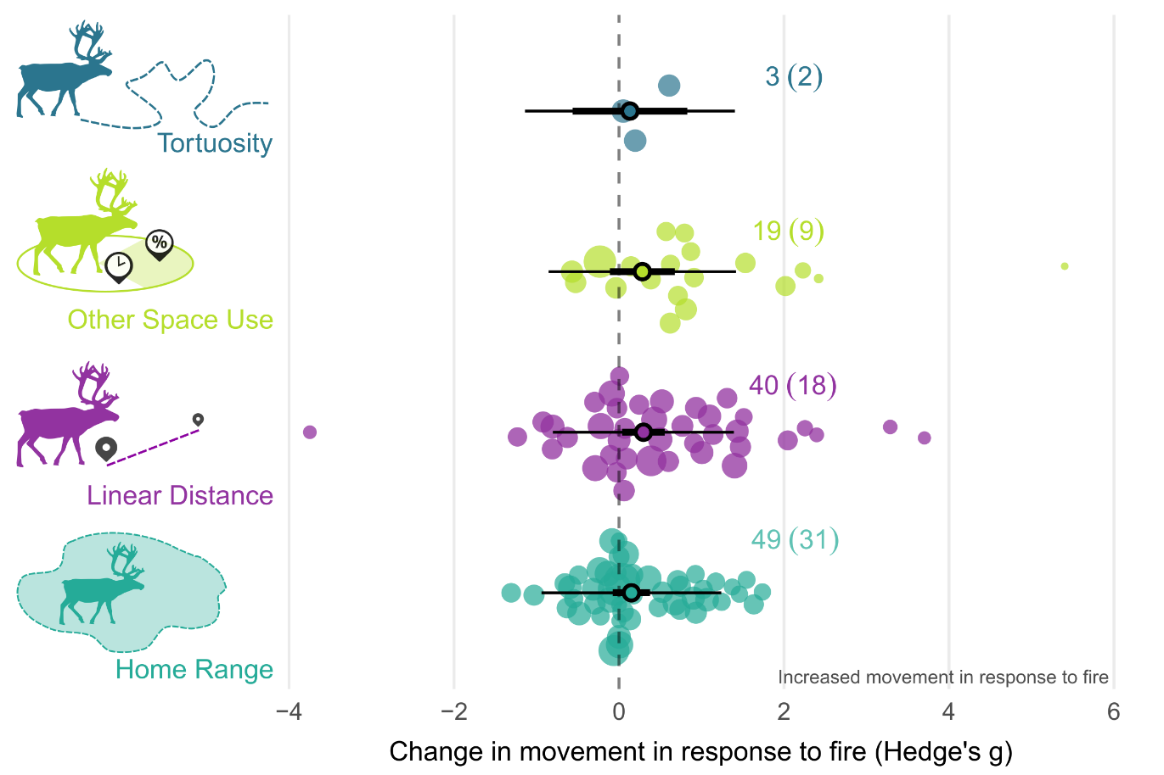
Figure 3: Orchard plot showing the estimated effect of fire on each of the four movement response categories. The outlined point is the meta-analytic mean, the thick horizontal bars are 95% confidence intervals, and the whiskers are 95% prediction intervals. Shaded points are effect sizes (Hedge’s g, n = 111), with point size scaled to show precision (1/SE; i.e., larger points had greater influence). Points are jittered on the y axis to improve readability. The annotation next to the point cloud represents number of effect sizes followed by number of studies in parentheses. Silhouettes are from Phylopic.

Taxonomy
When modelling taxonomic class as a moderator, fire had a small, marginally significant positive effect on movement in mammals (0.25, [0.00–0.51]) and birds (0.38, [-0.01–0.77]; Figure 4). In contrast, no effect of fire was detected on movement in reptiles (0.00, [-0.42–0.42]).
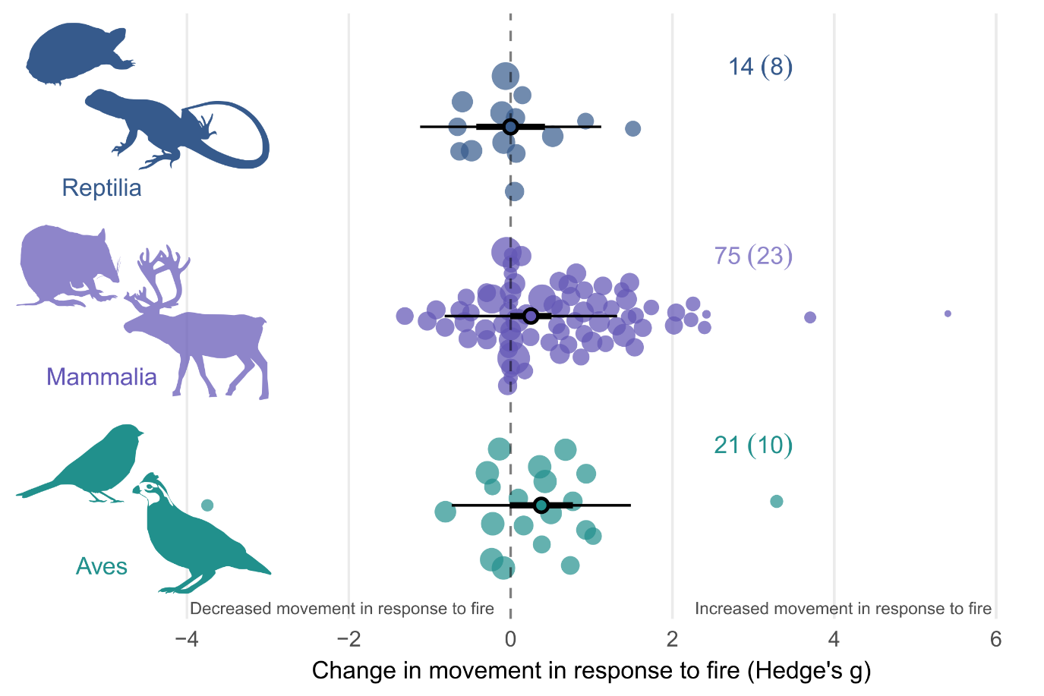
Figure 4: Orchard plot showing the estimated effect of fire on animal movement by taxonomic class. The outlined point is the meta-analytic mean, the thick horizontal bars are 95% confidence intervals, and the whiskers are 95% prediction intervals. Shaded points are effect sizes (Hedge’s g, n = 110), with point size scaled to show precision (1/SE; i.e., larger points had greater influence). Points are jittered on the y axis to improve readability. The annotation next to the point cloud represents number of effect sizes followed by number of studies in parentheses Silhouettes are from Phylopic.

Fire Type, Fire Size, & Maximum Burn Age
When comparing the effect of fire type on animal movement (96 effect sizes), we found that planned burns had a small significant positive effect on movement (0.33, [0.02–0.64]), whereas there was no clear effect for wildfire (-0.19, [-0.6–0.22]; Figure 5). When modelling the effect of maximum burn age (106 effect sizes), we found no effect on movement responses (-0.04, [-0.16–0.07]; Supplementary Information 4, Table S4.1). Similarly, we found no relationship between fire size and movement responses from 65 effect sizes (-0.01, [-0.12–0.11]; Supplementary Information 4, Table S4.1).

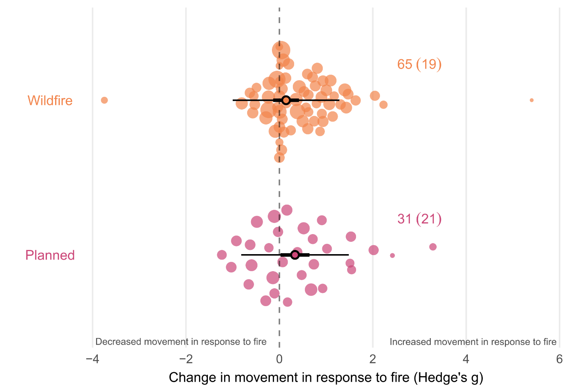
Figure 5: Orchard plot showing the estimated effect of fire on animal movement by fire type. The outlined point is the meta-analytic mean, the thick horizontal bars are 95% confidence intervals, and the whiskers are 95% prediction intervals. Shaded points are effect sizes (Hedge’s g, n = 111), with point size scaled to show precision (1/SE; i.e., larger points had greater influence). Points are jittered on the y axis to improve readability. The annotation next to the point cloud represents number of effect sizes followed by number of studies in parentheses.

Biome
Seven biomes had sufficient sample sizes to be included in the biome model. This model indicated that biome had little influence on animal movement responses to fire, with confidence levels overlapping zero for all biomes (Figure 6; Supplementary Information 4, Table S4.1). ‘Deserts and xeric shrublands’ and ‘Mediterranean forests, woodlands, and scrub or sclerophyll forests’ exhibited non-significant moderate and small negative effects, respectively (Figure 6). A non-significant, moderate positive effect was detected for ‘Temperate grasslands, savannas, and shrublands.’ ‘Flooded grasslands and savannas’ exhibited a small, non-significant positive effect; however, all effect sizes were drawn from a single study.
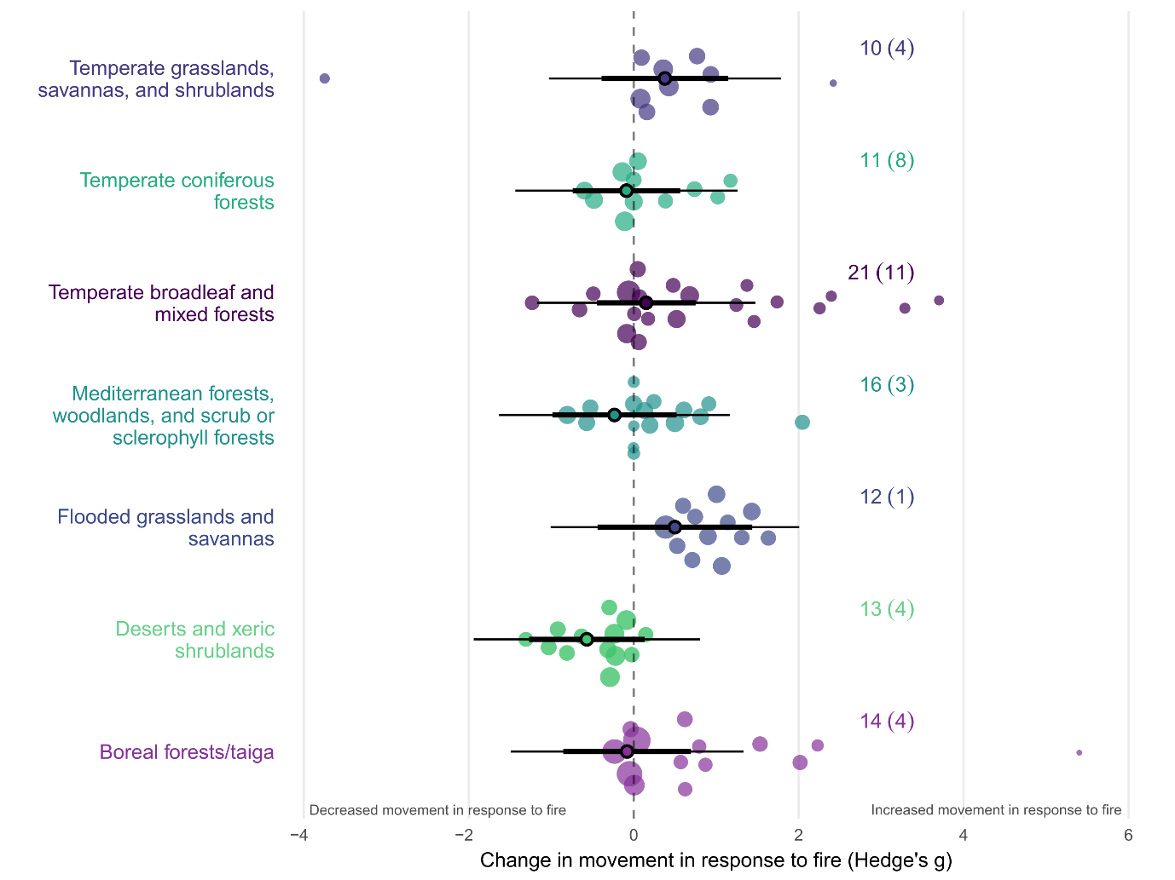
Figure 6: Orchard plot showing the estimated effect of fire on animal movement by biome. The outlined point is the meta-analytic mean, the thick horizontal bars are 95% confidence intervals, and the whiskers are 95% prediction intervals. Shaded points are effect sizes (Hedge’s g, n = 97), with point size scaled to show precision (1/SE; i.e., larger points had greater influence). Points are jittered on the y axis to improve readability. Silhouettes are from Phylopic.

Body Mass
Across the full dataset, body mass was not correlated with animal movement responses to fire (0.02, [-0.04–0.08]; Supplementary Information 4, Table S4.1). When modelled separately for each taxonomic class, no significant relationship between body mass and movement response was detected in any group (Supplementary Information 4, Table S4.1).

Study heterogeneity, publication bias and sensitivity
For the overall effect of fire on animal movement, total heterogeneity was 61.53% (I²_{[total]}=61.53), with 33.26% of variation remaining unexplained (I²_{[residuals]}=31.75), indicating a moderate to high level of true heterogeneity in the full dataset. Between-study variation accounted for 29.78% of the estimated heterogeneity (I2_{[study_ID]} =29.78). Neither phylogenetic relatedness nor species identity explained additional heterogeneity in the random-effects–only model. This indicates that much of the residual variation remains unrelated to taxonomic structure, and that effect sizes show little evidence of evolutionary or intraspecific clustering.
The results of the multilevel version of Egger’s regression indicated there was no evidence of publication bias or small-study effects on the dataset. We found no statistical asymmetry in the distribution of effect sizes (-0.08, [-0.22–0.06]). We found a significant decline effect in the dataset (-0.02, [-0.04–0.00]), with the magnitude of effect sizes declining over time (Figure 7). Results of the leave-one-out sensitivity analysis indicated minimal evidence of outlier influence, with confidence intervals of all leave-one-out models within the confidence intervals of the full model (Supplementary Information 2, Figure S2.3)
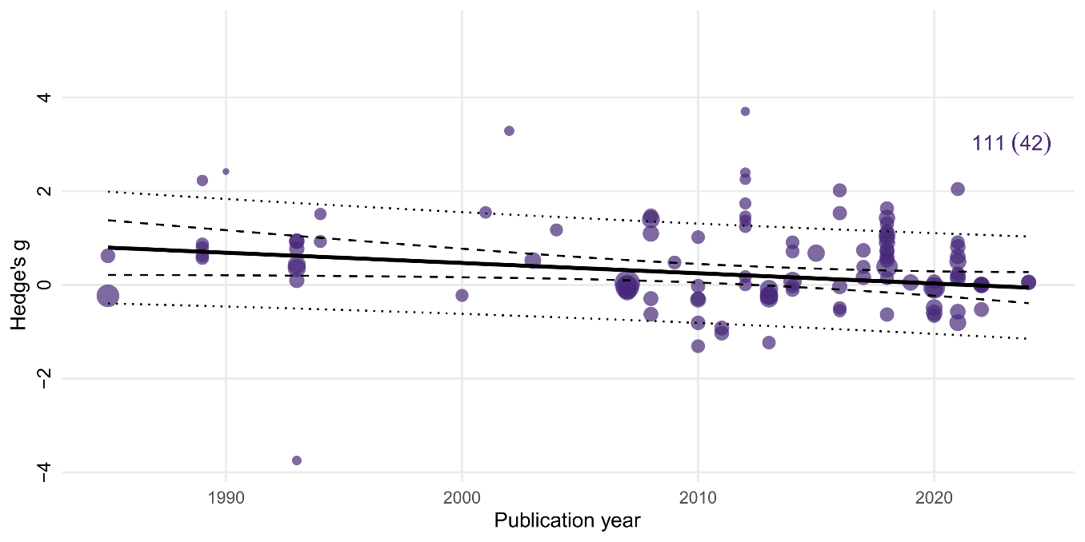
Figure 7: Meta-regression of effect sizes against publication year. Each point represents an individual effect size (Hedge’s g, n = 111), with the point size scaled by precision. The solid line indicates the estimated regression slope, with the 95% confidence interval shown by the dashed lines. The dotted lines show 95% prediction intervals. We found a significant decline effect in our dataset, with the magnitude of effect sizes declining over time.

Discussion
Animal movement is vital to persistence in fire-prone landscapes (Nimmo et al., 2019). Here, we provide the first global meta-analysis of the influence of fire on animal movements. Consistent with our predictions, we found that animal movements generally increase following fire, although a wide range of both increases and decreases were recorded. Increases in animal movement in response to fire were most frequent for linear distance movements, in mammals and birds, and following planned burns. Our study suggests that increased movement is a relatively widespread form of phenotypic plasticity that enables animals to persist in fire-prone landscapes.

Movement Category
We found that linear distance alone increased after fire, and increases were seen across all taxonomic classes. Like other forms of disturbance, post-fire increases in movement distances and rates are likely to be driven by resource redistribution and (Gomez et al., 2025; Moran et al., 2021), predation risk (Doherty et al., 2022), and navigation capacity (Nathan et al., 2008). Within the studies we reviewed, reduced forage availability within home ranges (Kreling et al., 2021; Roe et al., 2020) and changes in mate density due to decreased habitat quality (Thompson, 1993) were posited as drivers of increased movement distances following fire. In tropical northern Australia, male frilled-neck lizards (Chlamydosaurus kingii) at burnt sites travelled further from home range centroids relative to unburnt sites, with the species likely taking advantage of reduced ground cover to visually forage for invertebrate prey (Griffiths, 1994). Fire-induced changes to vegetation cover can reduce concealment for stalk and ambush predators (Doherty et al., 2022; Hopcraft et al., 2005), while improving visibility for prey species (Jaffe & Isbell, 2009). As such, changes in vegetation cover and visibility can reduce perceived perception risk, prompting prey species to travel further in some contexts (Cherry et al., 2018; Jaffe & Isbell, 2009). We hypothesize site fidelity further influences these patterns. Numerous taxa maintain moderate to high site fidelity following fire and other disturbances, including spotted owls (Strix occidentalis) (Bond et al., 2002), long-nosed potoroos (Potorous tridactylus) (Pla et al., 2024), black-tailed deer (Odocoileus hemionus columbianus) (Kreling et al., 2021), Bachman's Sparrows (Peucaea aestivalis) (Cox & Jones, 2007), and mule deer (Odocoileus hemionus) (Brown et al., 2020; Forrester et al., 2024). For such species, increasing movement within known areas likely represents fitness trade-off between the risks and rewards of moving beyond familiar areas.

Taxonomy
We found mammals and birds demonstrated small, marginally significant increases in movement after fire. This is likely explained by the relatively greater motion capacity and mobility of these taxa (Nathan et al., 2008) and fitness trade-offs between moving or remaining in place. Birds and mammals are highly mobile (Straus et al., 2024), employing locomotion strategies such as running, flying and gliding that enable rapid and energetically efficient movement over longer durations (Hillman et al., 2014). Contrasting modes of thermoregulation also likely aid in explaining these results, with ectothermic reptiles having lower energetic requirements (Nagy, 2005). Our results align with the findings of Doherty et al. (2021), who found that birds and mammals showed stronger increases in movement in response to anthropogenic disturbance than reptiles did. Higher energetic requirements, combined with greater mobility, likely mean that for mammals and birds, the benefits of increasing movement to access resources outweigh the potential costs (Brown & Kotler, 2004). Thus, relative to birds and mammals, reptiles may be less motivated to increase movement in response to fire, instead responding in ways that reduce activity and predation risk (Fenner & Bull, 2007; Lillywhite et al., 1977).
The distribution of effect sizes across classes reflects widely recognised taxonomic biases in the movement ecology literature (Cagnacci et al., 2010; Crane et al., 2021; Joo et al., 2022). Animal body mass constrains the size and battery capacity of tracking devices that can be fitted, limiting the scope of telemetry research on smaller-bodied species (Kays et al., 2015). In addition to their relatively smaller body mass, telemetry studies of reptiles are further impacted by complications associated with transmitter attachment and retention (Simbula et al., 2025). As such, large mammals have historically been overrepresented in movement ecology research (Kays et al., 2015). Our dataset reflects this bias, with mammals making up over 67% of effect sizes in our analysis. Currently, this bias limits our ability to quantify post-fire movement responses of small-bodied taxa, and to elucidate the mechanisms underpinning those responses. As technology continues to advance, our ability to capture robust, high-resolution tracking data from smaller species will improve, enhancing our understanding of these processes (Crane et al., 2021; Nathan et al., 2022).
We found no relationship between body mass and movement responses to fire. This is surprising because animal movements scale with body mass (Jetz et al., 2004), and a previous study found that larger birds and mammals, but not reptiles, moved further in response to disturbance (Doherty et al., 2021). The lack of relationship we found for fire may be the result of the available data not spanning a sufficient body mass gradient within taxonomic groups to detect an effect, reflecting the previously discussed study bias towards larger species. It is also possible that fire-related variables not incorporated in this model (e.g. fire type or severity) moderate the influence of body mass on movement responses, thus obscuring potential relationships. As the fire movement ecology literature grows, it will become more feasible to test how interactions between species traits and fire characteristics shape animal movement.

Fire Attributes
We found no clear relationship between fire size or maximum burn age and any of our movement metrics. We interpret this result with caution and suggest that it may be due to the coarse nature of our fire variables. For instance, we were not able to obtain data on several fire attributes that are likely to affect movement, such fire severity, season, extent, or pyrodiversity, each of which are likely to influence animal movements (Nimmo et al., 2019). Burn heterogeneity, rather than total fire extent, is likely a stronger mediator of resource distribution and availability within the landscape, and therefore may be a stronger predictor of animal movement responses. By contrast, fire type did influence movement: animals exposed to planned burns moved more than those experiencing wildfire, which itself may be related to the variables mentioned above. Planned fires typically occur in cooler months than wildfires (Morgan et al., 2020; Penman et al., 2011; Ryan et al., 2013), and are generally less intense and severe (Price et al., 2022). Thus, planned fires may result in greater landscape heterogeneity as they are typically conducted under more mild conditions, which reduces the risk of high severity fires (Donovan et al., 2024; Knapp & Keeley, 2006). This heterogeneity may facilitate animal movement by providing complementary resources across space (Leonard & Koprowski, 2010), including refugia that mitigates predation risk during movement bouts (Cohen et al., 2019; Leahy et al., 2016). Conversely, larger, more uniform wildfires increase the risks and costs of moving, thereby reducing movements distances (Brown & Kotler, 2004).

Implications
Collectively, these findings emphasise that movement functions as a phenotypically plastic movement response for many taxa occurring in fire-prone landscapes. Our results demonstrate a high degree of variation in animal movement responses to fire, with both increases and decreases detected. The strongest signal was an increase in movement distances and rates, particularly among birds and mammals, and in landscapes affected by planned burns. The mechanisms underlying these patterns likely reflect both independent and interactive effects of resource redistribution, altered predation risk, changes in navigation capacity, and site fidelity. Taxonomic patterns in our results suggest that highly mobile, endothermic taxa are better able to offset the costs of increased movement, while less mobile reptiles instead adopt risk-avoidance strategies. Fire attributes further mediate movement responses, with planned burns potentially facilitating movement by providing complementary resources and refugia that reduce the costs associated with moving.

Limitations and Future Directions
Most heterogeneity in our dataset remained unexplained, which may reflect either (i) true mechanistic context dependency, where contextual factors are interacting to influence movement responses to fire; or (ii) apparent context dependency, due to differences in the capability of the studies to capture and quantify movement responses (Catford et al., 2022). In the first instance, fine scale, site-specific characteristics such as burn heterogeneity (Shaw et al., 2021), fire severity (Crabb et al., 2022), and fire history (McGregor et al., 2016b), may be interacting with species traits (Franklin et al., 2025; Pocknee et al., 2023), sex (Thompson, 1993), life history stages (Ganz et al., 2022) and predation risk (Leahy et al., 2016) to modulate movement responses. This aligns with previous work indicating that interactive and synergistic effects are likely to exert strong influence on animal responses to fire (Culhane et al., 2022; Doherty et al., 2022; Ganz et al., 2022). The detection of moderate levels of within-individual variation also suggests species movement responses are not necessarily consistent across movement types (Flaherty & Gienger, 2020) and sex (Thompson, 1993). In the case of apparent context dependency, a combination of confounding factors, differing statistical power, and methodological differences between studies could also explain the moderate levels of between-study heterogeneity we observed (Catford et al., 2022).
The generalisability of our results is hampered by taxonomic and biogeographical biases evident in the original studies. As previously mentioned, over half the effect sizes in our dataset were drawn from mammals. All reptile effect sizes in our dataset originated from the United States, Canada or Australia, despite high reptile diversity in tropical regions, a bias also noted by Crane et al. (2021). Similarly, the United States, Canada and Australia were overrepresented in the full dataset, a widely recognised trend in fire ecology research (Geary et al., 2020; Gordon et al., 2025). However, we were limited to reviewing studies published in English, and this may be contributing to these trends. Nevertheless, substantial knowledge gaps remain for smaller, cryptic taxa including reptiles, and tropical fire-prone regions. We recommend expanding research effort to address these biases, particularly as technological and methodological advances improve our ability to disentangle the mechanistic drivers of movement responses (Gomez et al., 2025; Joo et al., 2022).
The stronger movement response to planned fire raises important questions about whether contemporary fire management replicates the historical regimes animals evolved with (Jones et al., 2023). If prescribed burns differ from historical regimes, or do not consider the importance of patch size for fire sensitive taxa (Cohen et al., 2019), these burns may elicit novel or maladaptive movement responses that impact body condition, survival and abundance (Fordyce et al., 2016; Pla et al., 2024; Radford et al., 2020). At the same time, large-scale, high severity wildfire events may create barriers to movement, with potential for individual through to population level consequences (Dudley et al., 2022; Kelly et al., 2020; Plumanns-Pouton et al., 2025). Future research should endeavour to report fine-scale fire attributes, including burn severity, heterogeneity and seasonality, to evaluate how these attributes influence movement responses to wildfires and planned burns. Gaps in reporting fire attributes, coupled with taxonomic and geographic biases, currently limit our ability to predict responses and guide management under shifting fire regimes and increasing megafire frequency.

Conclusion

References
Abatzoglou, J. T., Kolden, C. A., Cullen, A. C., Sadegh, M., Williams, E. L., Turco, M., & Jones, M. W. (2025). Climate change has increased the odds of extreme regional forest fire years globally. Nature Communications, 16(1), 6390. https://doi.org/10.1038/s41467-025-61608-1
Ankit, R. (2025). WebPlotDigitizer Version 5.2. https://automeris.io
Blakey, R. V., Sikich, J. A., Blumstein, D. T., & Riley, S. P. D. (2022). Mountain lions avoid burned areas and increase risky behavior after wildfire in a fragmented urban landscape. Current Biology, 32(21), 4762-4768.e4765. https://doi.org/10.1016/j.cub.2022.08.082
Bond, M. L., Gutiérrez, R. J., Franklin, A. B., Lallaye, W. S., May, C. S., & Seamans, M. E. (2002). Short-term effects of wildfires on spotted owl survival, site fidelity, mate fidelity, and reproductive success. Wildlife Society Bulletin, 30(4), 1022-1028.
Bowman, D. M. J. S., Balch, J. K., Artaxo, P., Bond, W. J., Carlson, J. M., Cochrane, M. A., D’Antonio, C. M., DeFries, R. S., Doyle, J. C., Harrison, S. P., Johnston, F. H., Keeley, J. E., Krawchuk, M. A., Kull, C. A., Marston, J. B., Moritz, M. A., Prentice, I. C., Roos, C. I., Scott, A. C., . . . Pyne, S. J. (2009). Fire in the Earth system. Science, 324(5926), 481-484. https://doi.org/10.1126/science.1163886
Bowman, D. M. J. S., Kolden, C. A., Abatzoglou, J. T., Johnston, F. H., van der Werf, G. R., & Flannigan, M. (2020). Vegetation fires in the Anthropocene. Nature Reviews Earth & Environment, 1(10), 500-515. https://doi.org/10.1038/s43017-020-0085-3
Brown, C. L., Smith, J. B., Wisdom, M. J., Rowland, M. M., Spitz, D. B., & Clark, D. A. (2020). Evaluating indirect effects of hunting on mule deer spatial behavior. The Journal of Wildlife Management, 84(7), 1246-1255. https://doi.org/10.1002/jwmg.21916
Brown, J. S., & Kotler, B. P. (2004). Hazardous duty pay and the foraging cost of predation. Ecology Letters, 7(10), 999-1014. https://doi.org/10.1111/j.1461-0248.2004.00661.x
Burton, C., Lampe, S., Kelley, D. I., Thiery, W., Hantson, S., Christidis, N., Gudmundsson, L., Forrest, M., Burke, E., Chang, J., Huang, H., Ito, A., Kou-Giesbrecht, S., Lasslop, G., Li, W., Nieradzik, L., Li, F., Chen, Y., Randerson, J., . . . Mengel, M. (2024). Global burned area increasingly explained by climate change. Nature Climate Change, 14(11), 1186-1192. https://doi.org/10.1038/s41558-024-02140-w
Cagnacci, F., Boitani, L., Powell, R. A., & Boyce, M. S. (2010). Animal ecology meets GPS-based radiotelemetry: a perfect storm of opportunities and challenges. Philosophical Transactions of the Royal Society B: Biological Sciences, 365(1550), 2157-2162. https://doi.org/10.1098/rstb.2010.0107
Catford, J. A., Wilson, J. R. U., Pyšek, P., Hulme, P. E., & Duncan, R. P. (2022). Addressing context dependence in ecology. Trends in Ecology & Evolution, 37(2), 158-170. https://doi.org/10.1016/j.tree.2021.09.007
Chamberlain, S., & Szöcs, E. (2013). Taxize: taxonomic search and retrieval in R [version 2; peer review: 3 approved]. F1000Research, 2(191). https://doi.org/10.12688/f1000research.2-191.v2
Cherry, M. J., Chandler, R. B., Garrison, E. P., Crawford, D. A., Kelly, B. D., Shindle, D. B., Godsea, K. G., Miller, K. V., & Conner, L. M. (2018). Wildfire affects space use and movement of white-tailed deer in a tropical pyric landscape. Forest Ecology and Management, 409, 161-169. https://doi.org/10.1016/j.foreco.2017.11.007
Clapp, J. G., & Beck, J. L. (2016). Short-term impacts of fire-mediated habitat alterations on an isolated bighorn sheep population. Fire Ecology, 12(3), 80-98. https://doi.org/10.4996/fireecology.1203080
Cohen, B. S., Prebyl, T. J., Collier, B. A., & Chamberlain, M. J. (2019). Spatiotemporal variability of fire characteristics affect animal responses in pyric landscapes. Fire Ecology, 15(1), 41. https://doi.org/10.1186/s42408-019-0058-4
Cosgrove, A. J., McWhorter, T. J., & Maron, M. (2018). Consequences of impediments to animal movements at different scales: A conceptual framework and review. Diversity and Distributions, 24(4), 448-459. https://doi.org/10.1111/ddi.12699
Cox, J. A., & Jones, C. D. (2007). Home range and survival characteristics of male Bachman's Sparrows in an old-growth forest managed with breeding season burns. Journal of Field Ornithology, 78(3), 263-269. https://doi.org/10.1111/j.1557-9263.2007.00113.x
Crabb, M. L., Clement, M. J., Jones, A. S., Bristow, K. D., & Harding, L. E. (2022). Black bear spatial responses to the Wallow Wildfire in Arizona. The Journal of Wildlife Management, 86(3), 1-20. https://doi.org/10.1002/jwmg.22182
Crane, M., Silva, I., Marshall, B. M., & Strine, C. T. (2021). Lots of movement, little progress: A review of reptile home range literature. PeerJ, 9, e11742. https://doi.org/10.7717/peerj.11742
Culhane, K., Sollmann, R., White, A. M., Tarbill, G. L., Cooper, S. D., & Young, H. S. (2022). Small mammal responses to fire severity mediated by vegetation characteristics and species traits. Ecology and Evolution, 12(5), e8918. https://doi.org/10.1002/ece3.8918
Cunningham, C. X., Williamson, G. J., & Bowman, D. M. J. S. (2024). Increasing frequency and intensity of the most extreme wildfires on Earth. Nature Ecology & Evolution, 8(8), 1420-1425. https://doi.org/s41559-024-02452-2
Doherty, T. S., Hays, G. C., & Driscoll, D. A. (2021). Human disturbance causes widespread disruption of animal movement. Nature Ecology & Evolution, 5(4), 513-519. https://doi.org/10.1038/s41559-020-01380-1
Doherty, T. S., Geary, W. L., Jolly, C. J., Macdonald, K. J., Miritis, V., Watchorn, D. J., Cherry, M. J., Conner, L. M., González, T. M., Legge, S. M., Ritchie, E. G., Stawski, C., & Dickman, C. R. (2022). Fire as a driver and mediator of predator–prey interactions. Biological Reviews, 97(4), 1539-1558. https://doi.org/10.1111/brv.12853
Donovan, V. M., Scholtz, R., & Wonkka, C. L. (2024). Fire refugia patch dynamics differ between prescribed fires and wildfires in longleaf pine savanna. Forest Ecology and Management, 569, 122179. https://doi.org/10.1016/j.foreco.2024.122179
Dudley, I. F., Coates, P. S., Prochazka, B. G., Davis, D. M., Gardner, S. C., & Delehanty, D. J. (2022). Maladaptive nest-site selection and reduced nest survival in female sage-grouse following wildfire. Ecosphere, 13(12), e4282. https://doi.org/10.1002/ecs2.4282
Ezzy, L. (2022). Breaking the wildfire cycle: Progressive fire management can shift fire regimes and improve ecosystem condition. A case study from a large conservation reserve in northern Australia. The Rangeland Journal, 44(6), 279-288. https://doi.org/10.1071/RJ22021
Faurby, S., Davis, M., Pedersen, R. Ø., Schowanek, S. D., Antonelli, A., & Svenning, J.-C. (2018). PHYLACINE 1.2: The phylogenetic atlas of mammal macroecology. Ecology, 99(11), 2626-2626. https://doi.org/10.1002/ecy.2443
Fenner, A. L., & Bull, C. M. (2007). Short-term impact of grassland fire on the endangered pygmy bluetongue lizard. Journal of Zoology, 272(4), 444-450. https://doi.org/10.1111/j.1469-7998.2007.00287.x
Flaherty, J. P., & Gienger, C. M. (2020). Habitat selection and movement patterns of copperheads (Agkistrodon contortrix) in fire-altered landscapes. Herpetological Conservation and Biology, 15(1), 150-159.
Fordyce, A., Hradsky, B. A., Ritchie, E. G., & Di Stefano, J. (2016). Fire affects microhabitat selection, movement patterns, and body condition of an Australian rodent (Rattus fuscipes). Journal of Mammalogy, 97(1), 102-111. https://doi.org/10.1093/jmammal/gyv159
Forrester, T. D., Spitz, D. B., Merems, J. L., Wisdom, M. J., Rowland, M. M., Johnson, B. K., Smith, J. B., Levi, T., Long, R. A., & Clark, D. A. (2024). Mule deer selection of fuel reductions is restricted by site fidelity and structured by circadian and seasonal patterns. Forest Ecology and Management, 569. 122005. https://doi.org/10.1016/j.foreco.2024.122005
Franklin, M. J. M., Bradstock, R. A., & Major, R. E. (2025). Relative species mobility is a key determinant of avian diversity in post-megafire recovery. Austral Ecology, 50(11), e70139. https://doi.org/10.1111/aec.70139
Ganz, T. R., DeVivo, M. T., Kertson, B. N., Roussin, T., Satterfield, L., Wirsing, A. J., & Prugh, L. R. (2022). Interactive effects of wildfires, season and predator activity shape mule deer movements. Journal of Animal Ecology, 91(11), 2273-2288. https://doi.org/10.1111/1365-2656.13810
Gasaway, W. C., Dubois, S. D., Boertje, R. D., Reed, D. J., & Simpson, D. T. (1989). Response of radio-collared moose to a large burn in central Alaska. Canadian Journal of Zoology, 67(2), 325-329. https://doi.org/10.1139/z89-047
Geary, W. L., Doherty, T. S., Nimmo, D. G., Tulloch, A. I. T., & Ritchie, E. G. (2020). Predator responses to fire: A global systematic review and meta-analysis. Journal of Animal Ecology, 89(4), 955-971. https://doi.org/10.1111/1365-2656.13153
Gomez, S., English, H. M., Bejarano Alegre, V., Blackwell, P. G., Bracken, A. M., Bray, E., Evans, L. C., Gan, J. L., Grecian, W. J., Gutmann Roberts, C., Harju, S. M., Hejcmanová, P., Lelotte, L., Marshall, B. M., Matthiopoulos, J., Mnenge, A. J., Niebuhr, B. B., Ortega, Z., Pollock, C. J., . . . Börger, L. (2025). Understanding and predicting animal movements and distributions in the Anthropocene. Journal of Animal Ecology, 94(6), 1146-1164. https://doi.org/10.1111/1365-2656.70040
Gordon, L., Evans, M. J., Zylstra, P., & Lindenmayer, D. B. (2025). Trends and gaps in prescribed burning research. Environmental Management, 75(4), 746-760. https://doi.org/10.1007/s00267-025-02119-z
Greenwood, L., Bliege Bird, R., & Nimmo, D. (2022). Indigenous burning shapes the structure of visible and invisible fire mosaics. Landscape Ecology, 37(3), 811-827. https://doi.org/10.1007/s10980-021-01373-w
Griffiths, A. D. (1994). The effect of seasonal environment and fire on the ecology of frillneck lizards, Chlamydosaurus kingii, in the wet-dry tropics of northern Australia [Master's, Charles Darwin University]. Australia. https://www.proquest.com/dissertations-theses/effect-seasonal-environment-fire-on-ecology/docview/2606878779/se-2?accountid=10344
He, T., Lamont, B. B., & Pausas, J. G. (2019). Fire as a key driver of Earth's biodiversity. Biological Reviews, 94(6), 1983-2010. https://doi.org/10.1111/brv.12544
Hijmans, R. J., Barbosa, M., Ghos, A., & Mandel, A. (2025). geodata. In (Version 0.6-2) https://github.com/rspatial/geodata
Hillman, S. S., Drewes, R. C., Hedrick, M. S., & Hancock, T. V. (2014). Physiological vagility and its relationship to dispersal and neutral genetic heterogeneity in vertebrates. Journal of Experimental Biology, 217(18), 3356-3364. https://doi.org/10.1242/jeb.105908
Hinam, H., & St. Clair, C. (2008). High levels of habitat loss and fragmentation limit reproductive success by reducing home range size and provisioning rates of northern saw-whet owls. Biological Conservation, 141, 524-535. https://doi.org/10.1016/j.biocon.2007.11.011
Hopcraft, J. G. C., Sinclair, A. R. E., & Packer, C. (2005). Planning for success: Serengeti lions seek prey accessibility rather than abundance. Journal of Animal Ecology, 74(3), 559-566. https://doi.org/10.1111/j.1365-2656.2005.00955.x
Hovick, T. J., McGranahan, D. A., Elmore, R. D., Weir, J. R., & Fuhlendorf, S. D. (2017). Pyric-carnivory: Raptor use of prescribed fires. Ecology and Evolution, 7(21), 9144-9150. https://doi.org/10.1002/ece3.3401
Jaffe, K. E., & Isbell, L. A. (2009). After the fire: Benefits of reduced ground cover for vervet monkeys (Cercopithecus aethiops). American Journal of Primatology, 71(3), 252-260. https://doi.org/10.1002/ajp.20644
Jetz, W., Carbone, C., Fulford, J., & Brown, J. H. (2004). The scaling of animal space use. Science, 306(5694), 266-268. https://doi.org/10.1126/science.1102138
Jones, G. M., Goldberg, J. F., Wilcox, T. M., Buckley, L. B., Parr, C. L., Linck, E. B., Fountain, E. D., & Schwartz, M. K. (2023). Fire-driven animal evolution in the Pyrocene. Trends in Ecology & Evolution, 38(11), 1072-1084. https://doi.org/10.1016/j.tree.2023.06.003
Joo, R., Picardi, S., Boone, M. E., Clay, T. A., Patrick, S. C., Romero-Romero, V. S., & Basille, M. (2022). Recent trends in movement ecology of animals and human mobility. Movement Ecology, 10(1), 26. https://doi.org/10.1186/s40462-022-00322-9
Kays, R., Crofoot, M. C., Jetz, W., & Wikelski, M. (2015). Terrestrial animal tracking as an eye on life and planet. Science, 348(6240), aaa2478. https://doi.org/10.1126/science.aaa2478
Kelly, L. T., Giljohann, K. M., Duane, A., Aquilué, N., Archibald, S., Batllori, E., Bennett, A. F., Buckland, S. T., Canelles, Q., Clarke, M. F., Fortin, M.-J., Hermoso, V., Herrando, S., Keane, R. E., Lake, F. K., McCarthy, M. A., Morán-Ordóñez, A., Parr, C. L., Pausas, J. G., . . . Brotons, L. (2020). Fire and biodiversity in the Anthropocene. Science, 370(6519), eabb0355. https://doi.org/10.1126/science.abb0355
Knapp, E. E., & Keeley, J. E. (2006). Heterogeneity in fire severity within early season and late season prescribed burns in a mixed-conifer forest. International Journal of Wildland Fire, 15(1), 37-45. https://doi.org/10.1071/WF04068
Kreider, M. R., Higuera, P. E., Parks, S. A., Rice, W. L., White, N., & Larson, A. J. (2024). Fire suppression makes wildfires more severe and accentuates impacts of climate change and fuel accumulation. Nature Communications, 15(1), 2412. https://doi.org/10.1038/s41467-024-46702-0
Kreling, S. E. S., Gaynor, K. M., McInturff, A., Calhoun, K. L., & Brashares, J. S. (2021). Site fidelity and behavioral plasticity regulate an ungulate's response to extreme disturbance. Ecology and Evolution, 11(22), 15683-15694. https://doi.org/10.1002/ece3.8221
Leahy, L., Legge, S. M., Tuft, K., McGregor, H. W., Barmuta, L. A., Jones, M. E., & Johnson, C. N. (2016). Amplified predation after fire suppresses rodent populations in Australia’s tropical savannas. Wildlife Research, 42(8), 705-716.
Leonard, K. M., & Koprowski, J. L. (2010). Effects of fire on endangered mount graham red squirrels (Tamiasciurus hudsonicus grahamensis): Responses of individuals with known fates. Southwestern Naturalist, 55(2), 217-224. https://doi.org/10.1894/MRD-01.1
Lillywhite, H. B., Friedman, G., & Ford, N. (1977). Color matching and perch selection by lizards in recently burned chaparral. Copeia, 1977(1), 115-121. https://doi.org/10.2307/1443512
Mathot, K. J., Arteaga-Torres, J. D., Besson, A., Hawkshaw, D. M., Klappstein, N., McKinnon, R. A., Sridharan, S., & Nakagawa, S. (2024). A systematic review and meta-analysis of unimodal and multimodal predation risk assessment in birds. Nature Communications, 15(1), 4240. https://doi.org/10.1038/s41467-024-48702-6
McGinn, K., Zulla, C., Wright, M., Wilkinson, Z., Dotters, B., Roberts, K., Keane, J., Peery, M. Z., & Jones, G. M. (2024). Energetics explain predator occurrence and movement in pyrodiverse landscapes. Landscape Ecology, 39(10), 182. https://doi.org/10.1007/s10980-024-01970-5
McGregor, H. W., Legge, S., Jones, M. E., & Johnson, C. N. (2016a). Extraterritorial hunting expeditions to intense fire scars by feral cats. Scientific Reports, 6(1), 22559. https://doi.org/10.1038/srep22559
McGregor, H. W., Cliff, H. B., & Kanowski, J. (2016b). Habitat preference for fire scars by feral cats in Cape York Peninsula, Australia. WILDLIFE RESEARCH, 43(8), 623-633. https://doi.org/10.1071/WR16058
Michonneau, F., Brown, J. W., & Winter, D. J. (2016). rotl: An R package to interact with the Open Tree of Life data. Methods in Ecology and Evolution, 7(12), 1476-1481. https://doi.org/10.1111/2041-210X.12593
Moran, N. P., Sánchez-Tójar, A., Schielzeth, H., & Reinhold, K. (2021). Poor nutritional condition promotes high-risk behaviours: A systematic review and meta-analysis. Biological Reviews, 96(1), 269-288. https://doi.org/10.1111/brv.12655
Morgan, G. W., Tolhurst, K. G., Poynter, M. W., Cooper, N., McGuffog, T., Ryan, R., Wouters, M. A., Stephens, N., Black, P., Sheehan, D., Leeson, P., Whight, S., & Davey, S. M. (2020). Prescribed burning in south-eastern Australia: History and future directions. Australian Forestry, 83(1), 4-28. https://doi.org/10.1080/00049158.2020.1739883
Morollón, S., Pausas, J. G., Urios, V., & López-López, P. (2022). Wildfire response of GPS-tracked Bonelli's eagles in eastern Spain. International Journal of Wildland Fire, 31(9), 901-908. https://doi.org/10.1071/WF22018
Morris, S. B. (2008). Estimating Effect Sizes From Pretest-Posttest-Control Group Designs. Organizational Research Methods, 11(2), 364-386. https://doi.org/10.1177/1094428106291059
Nagy, K. A. (2005). Field metabolic rate and body size. Journal of Experimental Biology, 208(9), 1621-1625. https://doi.org/10.1242/jeb.01553
Nakagawa, S., & Cuthill, I. C. (2007). Effect size, confidence interval and statistical significance: A practical guide for biologists. Biological Reviews, 82(4), 591-605. https://doi.org/10.1111/j.1469-185X.2007.00027.x
Nakagawa, S., & Santos, E. S. A. (2012). Methodological issues and advances in biological meta-analysis. Evolutionary Ecology, 26(5), 1253-1274. https://doi.org/10.1007/s10682-012-9555-5
Nakagawa, S., Lagisz, M., Jennions, M. D., Koricheva, J., Noble, D. W. A., Parker, T. H., Sánchez-Tójar, A., Yang, Y., & O'Dea, R. E. (2022). Methods for testing publication bias in ecological and evolutionary meta-analyses. Methods in Ecology and Evolution, 13(1), 4-21. https://doi.org/https://doi.org/10.1111/2041-210X.13724
Nakagawa, S., Lagisz, M., O'Dea, R. E., Pottier, P., Rutkowska, J., Senior, A. M., Yang, Y., & Noble, D. W. A. (2023). orchaRd 2.0: An R package for visualising meta-analyses with orchard plots. Methods in Ecology and Evolution, 14(8), 2003-2010. https://doi.org/10.1111/2041-210X.14152
Nathan, R., Getz, W. M., Revilla, E., Holyoak, M., Kadmon, R., Saltz, D., & Smouse, P. E. (2008). A movement ecology paradigm for unifying organismal movement research. Proceedings of the National Academy of Sciences, 105(49), 19052-19059. https://doi.org/10.1073/pnas.0800375105
Nathan, R., Monk, C. T., Arlinghaus, R., Adam, T., Alós, J., Assaf, M., Baktoft, H., Beardsworth, C. E., Bertram, M. G., Bijleveld, A. I., Brodin, T., Brooks, J. L., Campos-Candela, A., Cooke, S. J., Gjelland, K. Ø., Gupte, P. R., Harel, R., Hellström, G., Jeltsch, F., . . . Jarić, I. (2022). Big-data approaches lead to an increased understanding of the ecology of animal movement. Science, 375(6582), eabg1780. https://doi.org/10.1126/science.abg1780
Nimmo, D. G., Avitabile, S., Banks, S. C., Bliege Bird, R., Callister, K., Clarke, M. F., Dickman, C. R., Doherty, T. S., Driscoll, D. A., Greenville, A. C., Haslem, A., Kelly, L. T., Kenny, S. A., Lahoz‐Monfort, J. J., Lee, C., Leonard, S., Moore, H., Newsome, T. M., Parr, C. L., . . . Bennett, A. F. (2019). Animal movements in fire‐prone landscapes. Biological Reviews of the Cambridge Philosophical Society, 94(3), 981-998. https://doi.org/10.1111/brv.12486
Nimmo, D. G., Carthey, A. J. R., Jolly, C. J., & Blumstein, D. T. (2021). Welcome to the Pyrocene: Animal survival in the age of megafire. Global Change Biology, 27(22), 5684-5693. https://doi.org/10.1111/gcb.15834
Noble, D. W. A., Lagisz, M., O'Dea, R. E., & Nakagawa, S. (2017). Nonindependence and sensitivity analyses in ecological and evolutionary meta-analyses. Molecular Ecology, 26(9), 2410-2425. https://doi.org/10.1111/mec.14031
Nowack, J., Cooper, C. E., & Geiser, F. (2016). Cool echidnas survive the fire. Proceedings of The Royal Society B-Biological Sciences, 283(1828). https://doi.org/10.1098/rspb.2016.0382
Oskyrko, O. M., Chunrong; Meiri, Shai; Du, Weiguo. (2024). ReptTraits: A comprehensive dataset of ecological traits in reptiles.
Pausas, J. G., & Parr, C. L. (2018). Towards an understanding of the evolutionary role of fire in animals. Evolutionary Ecology, 32(2), 113-125. https://doi.org/10.1007/s10682-018-9927-6
Pellegrini Adam, F. A., Tyler, R., Averill, C., Terrer, C., Carla, S. A., Brockway, D. G., Caprio, A., Clatterbuck, W., Coetsee, C., Haywood, J. D., Hobbie, S. E., Hoffmann, W. A., Kush, J., Lewis, T., Keith, M. W., Overby, S. T., Patterson, W. A., III, Peay, K. G., Reich, P. B., . . . Jackson, R. B. (2021). Decadal changes in fire frequencies shift tree communities and functional traits. Nature Ecology & Evolution, 5(4), 504-512. https://doi.org/10.1038/s41559-021-01401-7
Penman, T. D., Christie, F. J., Andersen, A. N., Bradstock, R. A., Cary, G. J., Henderson, M. K., Price, O., Tran, C., Wardle, G. M., Williams, R. J., & York, A. (2011). Prescribed burning: How can it work to conserve the things we value? International Journal of Wildland Fire, 20(6), 721-733. https://doi.org/10.1071/WF09131
Pettett, C. E., Johnson, P. J., Moorhouse, T. P., Hambly, C., Speakman, J. R., & Macdonald, D. W. (2017). Daily energy expenditure in the face of predation: Hedgehog energetics in rural landscapes. Journal of Experimental Biology, 220(3), 460-468. https://doi.org/10.1242/jeb.150359
Pla, M. L., Hradsky, B. A., Di Stefano, J., Farley-Lehmer, T. C., Birnbaum, E. K., & Pascoe, J. H. (2024). High site fidelity and reduced survival of a mycophagous mammal after prescribed fire. Biodiversity and Conservation, 33(13), 3799-3820. https://doi.org/10.1007/s10531-024-02927-5
Plumanns-Pouton, E., Santos, J. L., Aponte, C., Brotons, L., Kelly, L. T., Mason Jr, S. C., Parris, K., Ponisio, L., & Keith, D. A. (2025). The mechanisms through which fire drives population change in terrestrial biota. Global Change Biology, 31(9), e70479. https://doi.org/10.1111/gcb.70479
Pocknee, C. A., Legge, S. M., McDonald, J., & Fisher, D. O. (2023). Modeling mammal response to fire based on species’ traits. Conservation Biology, 37(4), e14062. https://doi.org/10.1111/cobi.14062
Posit team. (2025). RStudio: Integrated Development Environment for R. In (Version 2025.5.0.496) Posit Software, PBC. http://www.posit.co/
Price, O. H., Nolan, R. H., & Samson, S. A. (2022). Fuel consumption rates in resprouting eucalypt forest during hazard reduction burns, cultural burns and wildfires. Forest Ecology and Management, 505, 119894. https://doi.org/10.1016/j.foreco.2021.119894
R Core Team. (2024). R: A Language and Environment for Statistical Computing. In R Foundation for Statistical Computing. https://www.R-project.org/
Radford, I. J., Woolley, L.-A., Corey, B., Vigilante, T., Hatherley, E., Fairman, R., Carnes, K., Start, A. N., & Wunambal Gaambera Aboriginal, C. (2020). Prescribed burning benefits threatened mammals in northern Australia. Biodiversity and Conservation, 29(9), 2985-3007. https://doi.org/10.1007/s10531-020-02010-9
Roe, J. H., Kish, A. L., & Nacy, J. P. (2020). Variation and repeatability of home range in a forest-dwelling terrestrial turtle: Implications for prescribed fire in forest management. Journal of Zoology, 310(1), 71-82. https://doi.org/10.1111/jzo.12732
Rossi, R. C., & Leiner, N. O. (2022). Weather, fire, and density drive population dynamics of small mammals in the Brazilian Cerrado. Journal of Mammalogy, 103(5), 1127-1140. https://doi.org/10.1093/jmammal/gyac053
Ryan, K. C., Knapp, E. E., & Varner, J. M. (2013). Prescribed fire in North American forests and woodlands: History, current practice, and challenges. Frontiers in Ecology and the Environment, 11(s1), e15-e24. https://doi.org/10.1890/120329
Shaw, R. E., James, A. I., Tuft, K., Legge, S., Cary, G. J., Peakall, R., & Banks, S. C. (2021). Unburnt habitat patches are critical for survival and in situ population recovery in a small mammal after fire. Journal of Applied Ecology, 58(6), 1325-1335. https://doi.org/10.1111/1365-2664.13846
Simbula, G., Montinaro, G., Grimm, T., & Ludwigs, J.-D. (2025). Lizards unplugged: A methodology study on radiotelemetry equipment for monitoring small–medium reptilian species. The Herpetological Journal, 35, 266-277. https://doi.org/10.33256/35.4.266277
Stawski, C., Körtner, G., Nowack, J., & Geiser, F. (2015). The importance of mammalian torpor for survival in a post-fire landscape. Biology Letters, 11(6). https://doi.org/10.1098/rsbl.2015.0134
Stevens, B. S., Conway, C. J., Roberts, S. B., & Englestead, D. K. (2025). Fitness consequences of catastrophic wildfire are mitigated by behavioral responses of an iconic bird. Fire Ecology, 21(1), 54. https://doi.org/10.1186/s42408-025-00391-2
Straus, S., Forbes, C., Little, C. J., Germain, R. M., Main, D. A., O'Connor, M. I., Thompson, P. L., Ford, A. T., Gravel, D., & Guzman, L. M. (2024). Macroecological constraints on species' ‘movement profiles’: Body mass does not explain it all. Global Ecology and Biogeography, 33(2), 227-243. https://doi.org/10.1111/geb.13786
Tamburello, N., Isabelle M. Côté, & Dulvy, N. K. (2015). Energy and the scaling of animal space use. The American Naturalist, 186(2), 196-211. https://doi.org/10.1086/682070
Templeton, A. R., Neuwald, J. L., Brazeal, H., & Robertson, R. J. (2007). Restoring demographic processes in translocated populations: The case of collared lizards in the Missouri Ozarks using prescribed forest fires. Israel Journal of Ecology & Evolution, 53(2), 179-196. https://doi.org/10.1560/IJEE.53.2.179
Templeton, A. R., Brazeal, H., & Neuwald, J. L. (2011). The transition from isolated patches to a metapopulation in the eastern collared lizard in response to prescribed fires. Ecology, 92(9), 1736-1747. https://doi.org/10.1890/10-1994.1
Thompson, W. L. (1993). Ecology of Merriam's turkeys in relation to burned and logged areas in southeastern Montana [Ph.D., Montana State University]. United States of America. https://www.proquest.com/dissertations-theses/ecology-merriams-turkeys-relation-burned-logged/docview/304050414/se-2?accountid=10344
Tobias, J. A., Sheard, C., Pigot, A. L., Devenish, A. J. M., Yang, J., Sayol, F., Neate-Clegg, M. H. C., Alioravainen, N., Weeks, T. L., Barber, R. A., Walkden, P. A., MacGregor, H. E. A., Jones, S. E. I., Vincent, C., Phillips, A. G., Marples, N. M., Montaño-Centellas, F. A., Leandro-Silva, V., Claramunt, S., . . . Schleuning, M. (2022). AVONET: morphological, ecological and geographical data for all birds. Ecology Letters, 25(3), 581-597. https://doi.org/https://doi.org/10.1111/ele.13898
Tucker, M. A., Böhning-Gaese, K., Fagan, W. F., Fryxell, J. M., Van Moorter, B., Alberts, S. C., Ali, A. H., Allen, A. M., Attias, N., Avgar, T., Bartlam-Brooks, H., Bayarbaatar, B., Belant, J. L., Bertassoni, A., Beyer, D., Bidner, L., van Beest, F. M., Blake, S., Blaum, N., . . . Mueller, T. (2018). Moving in the Anthropocene: Global reductions in terrestrial mammalian movements. Science, 359(6374), 466-469. https://doi.org/10.1126/science.aam9712
van Wagtendonk, J. W., & Lutz, J. A. (2007). Fire regime attributes of wildland fires in Yosemite National Park, USA. Fire Ecology, 3(2), 34-52. https://doi.org/10.4996/fireecology.0302034
Venter, J. A., Nabe-Nielsen, J., Prins, H. H. T., & Slotow, R. (2014). Forage patch use by grazing herbivores in a South African grazing ecosystem. Acta Theriologica, 59(3), 457-466. https://doi.org/10.1007/s13364-014-0184-y
Viechtbauer, W., & Cheung, M. W. L. (2010). Outlier and influence diagnostics for meta-analysis. Research Synthesis Methods, 1(2), 112-125. https://doi.org/10.1002/jrsm.11
Viechtbauer, W. (2010). Conducting Meta-Analyses in R with the metafor Package. Journal of Statistical Software, 36(3), 1 - 48. https://doi.org/10.18637/jss.v036.i03
Volkmann, L. A., Hutchen, J., & Hodges, K. E. (2020). Trends in carnivore and ungulate fire ecology research in North American conifer forests. Forest Ecology and Management, 458, 117691. https://doi.org/10.1016/j.foreco.2019.117691
Volkmann, L. A., & Hodges, K. E. (2021). Post-fire movements of Pacific marten (Martes caurina) depend on the severity of landscape change. Movement Ecology, 9(1), 49. https://doi.org/10.1186/s40462-021-00286-2
Wooster, E. I. F., Gaynor, K. M., Carthey, A. J. R., Wallach, A. D., Stanton, L. A., Ramp, D., & Lundgren, E. J. (2024). Animal cognition and culture mediate predator–prey interactions. Trends in Ecology & Evolution, 39(1), 52-64. https://doi.org/10.1016/j.tree.2023.09.012

