MOVEMENT IN THE PYROCENE: A GLOBAL META-ANALYSIS OF ANIMAL MOVEMENT RESPONSES TO FIRE

CHLOE L. MCAULEY^{1*}, EAMONN I.F. WOOSTER¹, MITCH A. COWAN^{1,2}, CHRIS J. JOLLY⁴, GRANT D. LINLEY¹, AMY SIMPSON¹, DYLAN WESTAWAY¹, BEN WILSON¹, TIM S. DOHERTY⁵, DALE G. NIMMO¹
Affiliations:
1 Gulbali Institute, School of Agricultural, Environmental and Veterinary Sciences, Charles
Sturt University, Albury, NSW, Australia
3 School of Agricultural and Environmental Sciences, University of Western Australia,
Crawley, WA, Australia
4 School of Natural Sciences, Macquarie University, Macquarie Park, New South Wales, Australia
5 Biodiversity and Conservation Science, WA Department of Biodiversity, Conservation and Attractions, Woodvale, Western Australia, Australia

* Corresponding author
Chloes email here
Key words
Fire, disturbance, meta-analysis, movement ecology, systematic review

Abstract

Main
Fire is a spatiotemporally dynamic disturbance process that has operated across the globe for hundreds of millions of years (Bowman et al., 2009; He et al., 2019). Fire transforms landscapes, initiating ecological succession processes that shape landscape structure over space and time (Greenwood et al., 2022). As such, fire alters the spatiotemporal distribution and availability of a wide range of resources for fauna, including food, breeding sites, and shelter (Doherty et al., 2022; Fordyce et al., 2016; He et al., 2019). In response to changing resource landscapes, animals may modify alter their behaviour, such as movement, to minimise risk and maximise access to resources (Nimmo et al., 2019). The way they do this depends on a complex interaction between animal traits (e.g., mobility), the spatial and temporal characteristics of fire regimes, and the consequent effects on key resources (Blakey et al., 2022; Cherry et al., 2017; Pasch & Koprowski, 2011).
Fire triggers a variety of animal movements across different spatial and temporal scales (Nimmo et al., 2019). In the short term—ranging from the hours during a fire to the days immediately after—animals may move to escape an ongoing fire (Nimmo et al., 2021) or to quickly exploit new opportunities in the wake of a fire (Hovick et al., 2017; McGregor et al., 2016b). When the availability of resources is reduced after fire, movements (e.g., distance travelled, home range size) can increase, as animals traverse further to meet their requirements (Blakey et al., 2022; Cherry et al., 2018). Over longer periods, from months to decades, individuals adjust their movements to track resources that emerge as vegetation passes through successive stages of recovery (Gasaway et al., 1989; McGregor et al., 2016a). In cases where fire results in the direct mortality of animals (Jolly et al., 2022), post-fire population recovery may dependent on dispersal and recruitment (Shaw et al., 2021). If post-fire seral stages create dispersal barriers, unfavoured habitat or increase predation pressure, populations may become extirpated (Templeton et al., 2011). These movement responses are central among a suite of adaptive traits and behavioural strategies that facilitate animal survival and persistence in fire-prone landscapes (He et al., 2019; Nimmo et al., 2021; Pausas & Parr, 2018).
Movement decisions can have significant implications for animal fitness and population persistence (Cosgrove et al., 2018; Hinam & St. Clair, 2008; Templeton et al., 2011). These decisions emerge from complex and dynamic interactions between internal processes and external environmental conditions (Nathan et al., 2008; Nathan et al., 2022). The competing demands of nutrition, reproduction and predator avoidance influence how, where and when animals move (Brown & Kotler, 2004; Doherty et al., 2019; Nathan et al., 2008). Likewise, external factors, including inherent environmental heterogeneity (Nathan et al., 2008), and fragmentation or disturbance (Doherty et al., 2021; Gomez et al., 2025; Tucker et al., 2018), exert dramatic influence on movement behaviours, and modulate intrinsic factors (Nathan et al., 2008). Movement can have profound consequences for competition (Blakey et al., 2022), energy expenditure (Pettett et al., 2017) and foraging intake (Hinam & St. Clair, 2008). The consequences of movement decisions on these physiological and ecological processes impact individual fitness (Cosgrove et al., 2018). Unmet nutritional or energetic needs can impact reproductive success (Hinam & St. Clair, 2008), predation risk (Leahy et al., 2016), and increase likelihood of undertaking risky behaviours (Blakey et al., 2022; Moran et al., 2021). Individual level and localised effects of movement on fitness and survival can scale up through space and time, ultimately affecting multiple generations and species-level distributions (Cosgrove et al., 2018; Gomez et al., 2025; Templeton et al., 2007).
Fire regimes are changing across the globe (Bowman et al., 2020; Cunningham et al., 2024). Driven by land use changes, disruption of Indigenous fire regimes, anthropogenic climate change, and decades of fire suppression, fire severity and extent has increased across multiple biogeographic regions (Abatzoglou et al., 2025; Burton et al., 2024; Kreider et al., 2024). Fire has and continues to be fundamental driver of ecological and evolutionary processes, and biodiversity (He et al., 2019; Kelly et al., 2020; McLauchlan et al., 2020). Whilst fire can promote biodiversity (McLauchlan et al., 2020), rapidly changing and novel fire regimes adversely affect many species (Doherty et al., 2024; Driscoll et al., 2024; Kelly et al., 2020). Altered fire regimes threaten entire ecosystems (Kelly et al., 2020) and contribute to long-term shifts in the composition and structure of vegetation communities (Harrison et al., 2024). A recent study found that modified fire regimes were identified as a threat to 15% of all threatened terrestrial and freshwater species (Kelly et al., 2020). Movement is a fundamental component of biodiversity, contributing to demographic processes, community interactions, ecosystem functioning, as well as animal responses to environmental change (Jeltsch et al., 2013; Nathan et al., 2008).
Despite the ecological and evolutionary significance of movement responses to fire, a global, cross-taxa quantitative synthesis is yet to be conducted. Numerous studies have been published exploring the effects of fire on animal movement at the individual or population scale (e.g. Cherry et al., 2018; Crabb et al., 2022; McGregor et al., 2016b). However, we lack knowledge of whether there is generality in animal movement responses to fire, and the distal and proximate factors driving these responses. Understanding how fire alters animal movement is essential for informing conservation efforts and land management in the face of novel fire regimes, climate change and synergistic threats to biodiversity (Doherty et al., 2024; Nimmo et al., 2021; Pausas & Parr, 2018).
Here, we conduct a global systematic review and meta-analysis of the influence of fire on the movement of those most effected by it, terrestrial vertebrates. Our objectives are to: (i) provide the first meta-analytic synthesis exploring the generality of animal movement responses to fire , and (ii) analyse the importance of fire attributes, taxonomy, and biogeography in explaining movement responses to fire. We hypothesised that overall, fire would increase animal movement, as animals respond to changes in resource availability and distribution post-fire (Doherty et al., 2021; Nimmo et al., 2019). We expect positive effects for both home range size and linear distances in burnt habitats, with animals increasing these types of movement responses to fulfil energetic or other demands (Nathan et al., 2008; Nimmo et al., 2019; Stobo‐Wilson et al., 2021). Further, we predicted a positive relationship between the spatial extent of burnt area and movement responses, as a result of the increased spatial extent of resource alteration (Doherty et al., 2021; Nimmo et al., 2019). Furthermore, we expect that relative to planned burns, wildfire will a greater positive effect on animal movement, due to differential seasonality, severity and extent (Ezzy, 2022; van Wagtendonk & Lutz, 2007). We further predict a positive relationship between effect size and body mass, given that space use increases with body size, and these larger animals are likely to have greater movement capacity (Jetz et al., 2004; Straus et al., 2024; Tamburello et al., 2015).

Materials and Methods

Systematic review
We aimed to capture literature investigating four categories of quantitative movement responses, home range, linear distance, tortuosity, and other measures of space use. Following Doherty et al. (2021) home range responses included mean area-based measurements, such as home range size and nest area size. Linear distance responses included metrics that measured mean straight-line distances between relocations, such as daily distance travelled, as well as movement rates measured as distance travelled within a given unit of time. Tortuosity provides a measure of how a movement path deviates from a straight-line and was captured by straightness indices and turning angles. Other space use included metrics that quantified other aspects of animal movement decisions and behaviours not captured by the other categories, such as mean residency time, time to return, and proportion of fixes within burnt and unburnt habitats.
We conducted a systematic review to identify studies investigating the influence of fire on animal movement. Database searches were undertaken in Scopus, Web of Science and ProQuest Dissertation and Theses Global between 15th May 2024 and 29th August 2024. Search terms relating to animal movement were combined with terms relating to fire and terrestrial vertebrates to identity suitable studies (Supplementary Information 1). To be considered for inclusion in the systematic review studies needed to meet the following criteria: (i) published in either a peer reviewed article, Master’s thesis, or PhD thesis; (ii) field studies with before-after, burnt-unburnt, or before-after-control-impact designs; and (iii) provided an evaluation of movement responses to fire in free ranging terrestrial vertebrates. We considered terrestrial vertebrates as animals primarily distributed in terrestrial biomes, or animals that used terrestrial habitat features for key life stages, such as reproduction or hibernation. All returned results were filtered to include only articles or theses published in English, and filters were applied in the databases to limit the results to relevant disciplines (Supplementary Information 1). Additional studies were identified by snowball searches of reference lists from 2 review articles returned in database searches (Nimmo et al., 2019; Nimmo et al., 2021), and 1 review paper known to the authors (Volkmann et al., 2020). Database searches, snowball searches, and title and abstract screening were done by CM. Full text screening was performed by CM, BW, DW, CJ, MC, E.I.F.W and GL.

Data extraction
To qualify for data-extraction, studies must have met the following criteria: studies must have provided adequate information to calculate sample sizes, means and standard deviations (SDs) for each treatment group, and sample sizes for each treatment group ≥ 5; studies must have used standardised methods across treatment groups, and the confounding effects of other environmental variables considered to be low. Additionally, to minimise seasonal confounding in before-after studies, only studies where data was collected during the same or adjacent seasons were included in subsequent analyses.
We extracted meta-data from each study on fire type (wildfire or planned), study design (before-after, control-impact, and before-after control-impact), latitude and longitude, country and movement responses (home range, linear distance, tortuosity, and other space use). Fire was defined as either planned, fires intentionally lit from anthropogenic sources, or wildfire, fires ignited by natural sources and accidentally lit from anthropogenic sources. Fire type was recorded based on the authors description of the fire event. Sample sizes, means, and variance (e.g., types of variance you collected SD,SE and 95% CI’s I imagine) values were extracted from text, supplementary materials or figures of articles and theses. Information about what was used as sample size. Data was extracted using WebPlotDigitiser (Ankit, 2025). To minimise the potential of the time of year data was collected confounding before-after studies, the seasonality of data collection was recorded, as were any other potentially confounding aspects of the study (eg. combining fire with logging, mechanical thinning treatments or livestock grazing). Classification of burned or unburned animal populations followed the authors categorisation. Where time series data or multiple treatment and reference groups were provided in a study, we extracted data for groups closest to the fire event, or the in the case of before-after studies, the groups that minimised seasonal confounding of data collection timing. Where the authors provided demographic subgroups of animals (eg. males and females or adults and juveniles), we treated each subgroup as a single case unless the sample size was below the sample size criteria for inclusion. In these cases, we pooled subgroups if the study results indicated movement responses were similar in magnitude and direction. Data extraction was done by C.M.

Meta-analysis
We used the following formula from Morris (2008) to convert before-after-control-impact studies to control-impact studies to calculate effect sizes.
$d_{ppc1}= c(\frac{Mₚₒₛₜ,ₜ - Mₚᵣₑ,ₜ}{ SDₚᵣₑ,ₜ} ) - c꜀(\frac{Mₚₒₛₜ,꜀ - Mₚᵣₑ,꜀}{SDₚᵣₑ,꜀})$
Following Morris (2008) we used the pretest (before) SD values for the control and treatment groups. All analyses were performed in using R version 4.4.2 (R Core Team, 2024) in RStudio (Posit team, 2025). Hedge’s G, using the unbiased estimates of sampling variances, was calculated for each study using the escalc function in the metafor package (Viechtbauer, 2010). Hedge’s G is a standardized mean difference method that includes a bias corrector for small sample sizes (Viechtbauer, 2010). By providing a standardised measure between control and treatment groups, Hedge’s G allows for aggregation and comparison of multiple movement responses. A negative effect size indicates a decrease in animal movement, and a positive value an increase in animal movement. We used the effect size benchmarks outlined in Nakagawa and Cuthill (2007), as g > 0.2 for a small effect, >0.5 as moderate and >0.8 as large, and considered an effect to be significant when 95% confidence intervals did not overlap zero. Effect size calculation was done by C.M, E.I.F.W and T.S.D.
To quantify the effect of fire on animal movement, we constructed phylogenetic multi-level meta analytic models using the rma.mv function in the metafor package (Viechtbauer, 2010). These models weigh each effect size by the inverse of the sampling variance, allowing the models to account for data quality. This results in larger sample sizes having higher weight in the models. To account for non-independence within our effect sizes, we included study ID (a unique identifier assigned to each article or thesis), observation ID (a unique identifier assigned to each effect size), species phylogeny, and species identity (non-phylogenetic species identification) as random effects (Nakagawa & Santos, 2012). Phylogenies were obtained from the Open Tree of Life, using the rotl package (Michonneau et al., 2016). Phylogenetic random effect values are a correlation matrix of branch lengths representing the phylogenetic relatedness between species. This is important as we would expect closely related species to respond similarly to fire, while species identity accounts for the effects sizes of the same species instead of relatedness to another species. We included a variance-covariance matrix in our models to account for non-independence resulting from individuals and populations contributing to multiple effect sizes (Nakagawa & Santos, 2012). We assumed a correlation of r = 0.5 for the same species within the same studies.
First, we modelled the overall effect of fire on animal movement. We then asked in subsequent models how movement response category, fire type, fire size, maximum burn age, biome, body mass, taxonomic class and species. . Models were plotted using the orchaRd package (Nakagawa et al., 2023). Body mass data was extracted from AvoNet (Tobias et al., 2022), ReptTraits (Oskyrko, 2024) and Phylacine (Faurby et al., 2018), and supplemented with values from the literature when body mass values were not available in the databases. Terrestrial biomes (Olson et al., 2001) were extracted using the geodat package (Hijmans et al., 2025). Where exact locations were not provided by authors, coordinates of the approximate study location were estimated using Google Earth and used to extract biomes. Meta-analysis was performed by C.M and E.I.F.W.

Study heterogeneity, publication bias and sensitivity analysis
To quantify study heterogeneity, and the proportion of variance attributable to the random effects, we calculated I² using the i2_ml function in the orchaRd package (Nakagawa et al., 2023; Nakagawa & Santos, 2012). For overall effect of fire on animal movement, total heterogeneity was 61.59% (I²_{[total]}=61.59), with 33.26% of variation remaining unexplained I²_{[residuals]}=33.26), indicating a moderate to high level of true heterogeneity in the full dataset. Across study variation accounted for 28.32% of the estimated heterogeneity (I2_{[study_ID]}=28.32). Neither phylogenetic relatedness or species identity accounted for any additional heterogeneity in the random effects only model, suggesting both residual variation unexplained by the random effects, and limited evolutionary or intraspecific structuring in effect sizes.
To test for publication bias resulting from biases in outcome reporting, we visually assessed funnel plot asymmetry and ran a multilevel version of Egger’s regressions with an approximation of observation precision as a predictor (Nakagawa et al., 2022). We tested for a time lag effect by regressing effect sizes against study year. Finally, we performed a leave-a-study-out-test to evaluate the sensitity of the overall model results to influential studies (Viechtbauer & Cheung, 2010).
The results of the multilevel version of Egger’s regression indicated there was no evidence of publication bias or small-study effects on the dataset. We found no statistical asymmetry in the distribution of effect sizes (β = -0.0778, [-0.2204, 0.0648], p = 0.282). We found a significant decline effect in the dataset (β = -0.0227, [-0.0433, -0.002], p = 0.0317), with the magnitude of effect sizes declining over time (Figure 1). Results of the leave-one-out sensitivity analysis indicated minimal evidence of outlier influence, with confidence intervals of all leave-one-out models within the confidence intervals of the full model (Supplementary Information 2, Figure S2.3). Publication bias testing was done by C.M and E.I.F.W.
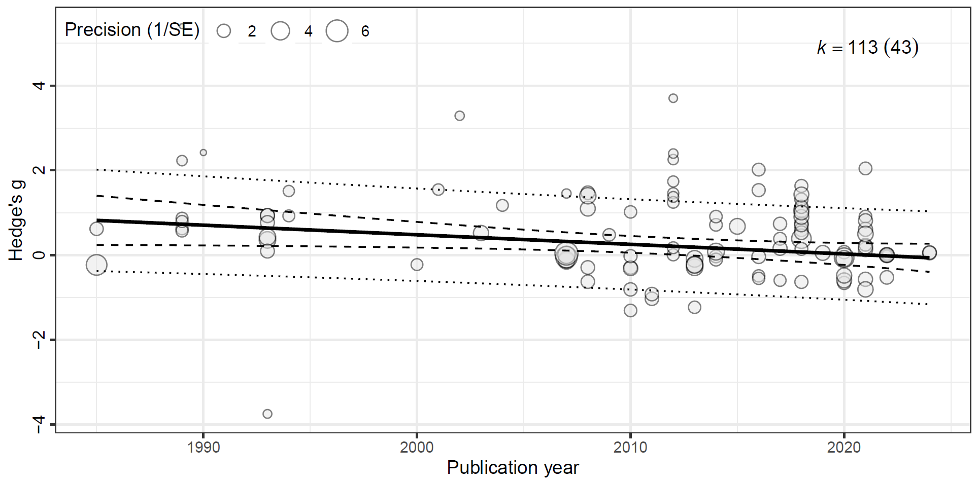
Figure 1: Meta-regression of effect sizes against publication year. Each point represents an induvial effect size (k = 133), with the point size scaled by precision. The solid line indicates the estimated regression slope, with the 95% confidence interval shown by the dashed lines. The dotted lines show 95% prediction intervals. We found a significant decline effect in our dataset, with the magnitude of effect sizes declining over time.

Results

Systematic review
Our systematic review returned 5231 records after duplicate removal. Following screening, 84 studies met the review eligibility criteria. These studies were conducted in 12 countries, across six continents (Figure 2). Most studies occurred in North America (60.7 %), followed by Oceania (20.2%). The United States of America accounted for 90.2% of studies in North America, with the remaining studies from Canada. In Africa, 71.4% of studies were conducted in South Africa, with a single study from each Kenya and Uganda. The South American continent was represented by a single study conducted in Paraguay. Sixty percent of studies in Asia were attributed to studies in Indonesia. Three studies were from Europe, two from Spain and one from Portugal. There was a trend of research effort increasing with time, with only nine of the 84 studies published prior to 2000 (Supplementary Information 3, Figure S3.1). The majority of studies (48.8%) were published between 2010 and 2019.
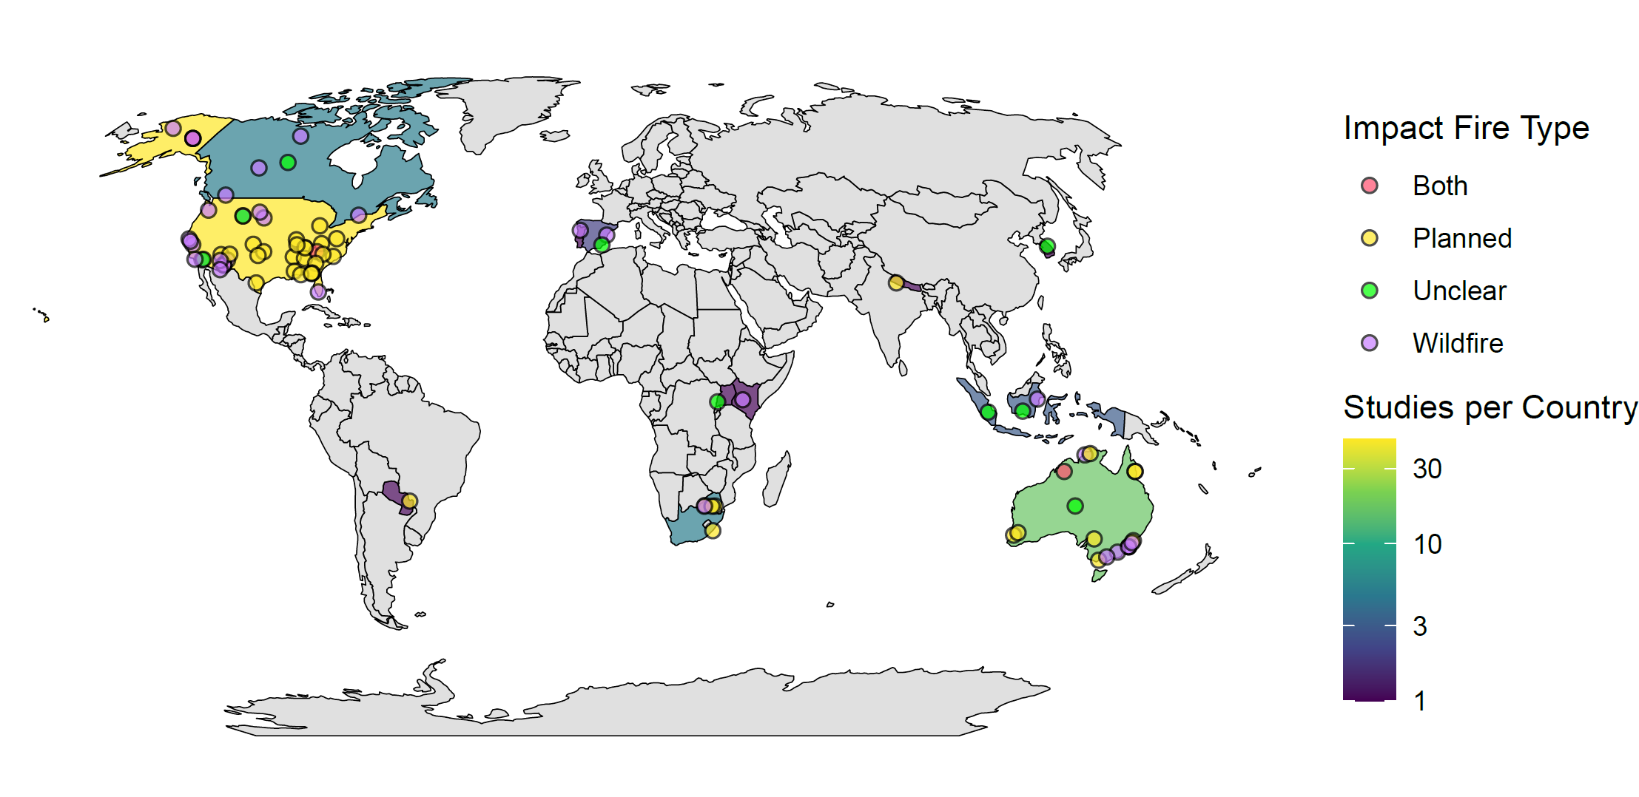
Figure 2: Map illustrating the number of studies per country and locations of the 84 studies included in the review. The color scale shows the number of studies per country, with darker colours indicating fewer studies, and lighter colours indicating more studies. The colour of the study points indicate the type of fire the study investigated.
From the 84 studies, we extracted 185 cases investigating the influence of fire on animal movement for inclusion in the review. Only a single study investigated movement responses to both planned and wildfire fire separately (Clapp & Beck, 2016), although other studies investigate the combined effect of wildfire and planned burns. Similarly, all but one study investigated movement responses in a single species (Venter et al., 2014). Over half (n = 102, 55.1 %) of all cases investigated movement responses using a burnt-unburnt study design. A before-after study design was used in 34.6% of cases and before-after control-impact designs accounted for the remaining 10.3%. Investigations of home range metrics accounted for 45.6% of cases, followed by linear distance (35.1%) and other space use (14.1%).
Twelve biomes were represented in the 185 cases (Supplementary Information 3, Figure S3.2). Most research occurred in temperate biomes, with 20% of cases in Temperate broadleaf and mixed forests, 26% in Mediterranean forests, woodlands, and scrub, or sclerophyll forests, and 25% in Temperate coniferous forests. Approximately half (49.7%) of cases examined the effect of wildfire on movement, while 34.1% assessed the effect of planned burns. The type of fire evaluated was unclear for 9.2% of observations, and 7% considered the combined effect of wildfire and planned burns. Within the Temperate broadleaf and mixed forests biome, over half of cases examined the effect of planned fire. Conversely, over half of all cases in Mediterranean forests, woodlands, and scrub or sclerophyll forests investigated how wildfire affected movement.
The movement response of 73 taxa across 23 orders and four classes were examined. Most taxa were within the Mammalia class (65.9%), followed by Aves (18.9%), Reptilia (13%) and Amphibia (2.2%). When considering cases by order, Artiodactyla (even toed undulates, 23.8%) and Rodentia (14.1%) were the most frequently studied (Supplementary Information 3, Figure S3.3). The orders Accipitriformes, Caprimulgiformes, Piciformes and Dasyuromorphia were all represented by a single case. Within Aves, Galliformes was the most frequently studied order. Testudines was the most frequently studied order within Reptilia. The most frequently studied species was white-tailed deer (Odocoileus virginianus), with 12 cases, followed by moose (Alces alces) with 10.

Meta-analysis
The phylogenetic multilevel meta-analytic model found fire had an overall significant positive effect on animal movement (Hedge’s g = 0.2147 [95% CI = 0.0244, 0.4051], p = 0.0244; Figure 3). Put simply, we found that compared to animals occupying unburnt habitat, animals increased their movement in fire-affected habitats. However, when looking at the species level we found highly variable responses (Supplementary Information 4, Figure S4.1).
We modelled mean effect sizes for 22 species with at least two effect sizes, however for most species effect sizes were drawn from a single study (Supplementary Information 4,). A single species demonstrated a significant positive mean effect size. All other mean effect sizes were non-significant. Individual effect sizes for all but one species were also non-significant, indicating intraspecific variability as well as uncertainty in the effects of fire on animal movement on individual species.
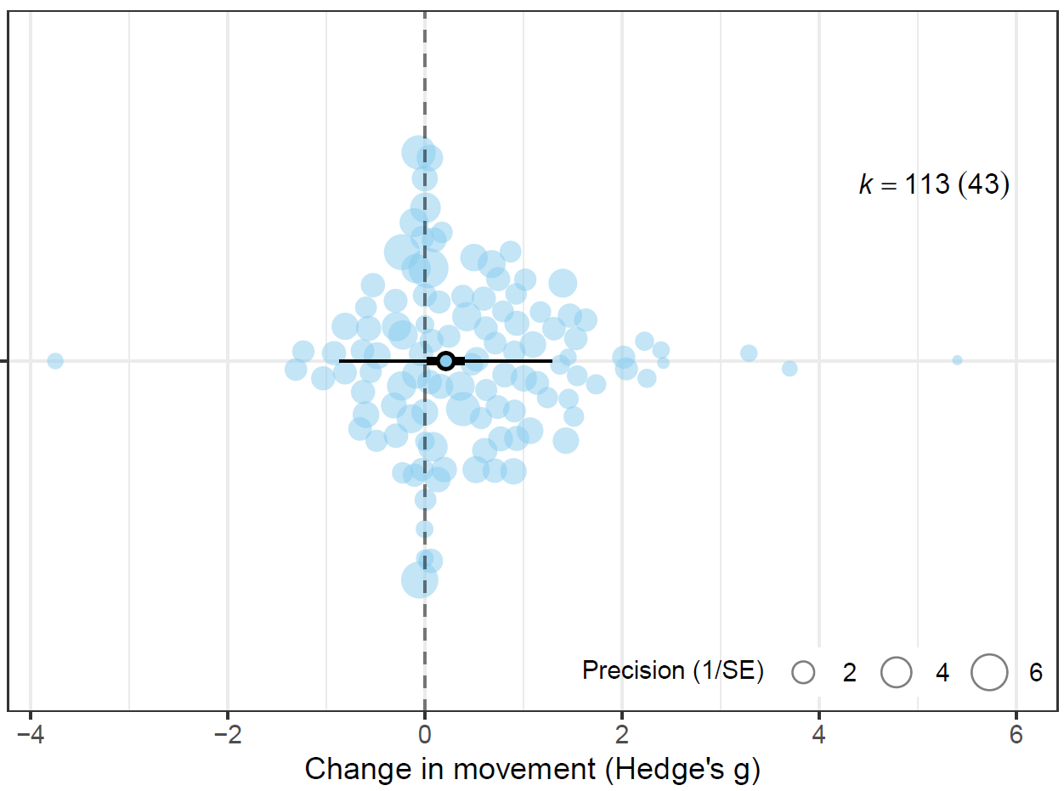
Figure 3: Orchard plot showing the overall estimated effect of fire on animal movement. The meta-analytic mean of the random effects model is represented by the outlined point, with the thick horizontal bars showing 95% confidence interval and the whiskers the 95% prediction intervals. Each shaded point represents an effect size (n = 113), with the size of the point scaled to show precision within the model (1/SE) and larger points having a greater influence on the model. Effect size is shown on the x axis, and points are jittered on the y axis to improve readability.

Movement Category
When modelling movement category as a moderator, we found fire had a significant yet small positive effect on linear distance movements (Hedge’s g = 0.3027 [95% CI =0.0432, 0.5621], p = 0.0227; Figure 4). The effect of fire on other space use was also small, but non-significant (Hedge’s g = 0.323377 [95% CI = -0.07733, 0.724081], p = 0.112607). Effects on home range size (Hedge’s g = 0.1534 [95% CI =-0.0722, 0.3789], p = 0.1805) and tortuosity (Hedge’s g = 0.1428 [95% CI = -0.5606, 0.8463], p = 0.6882) were also non-significant.
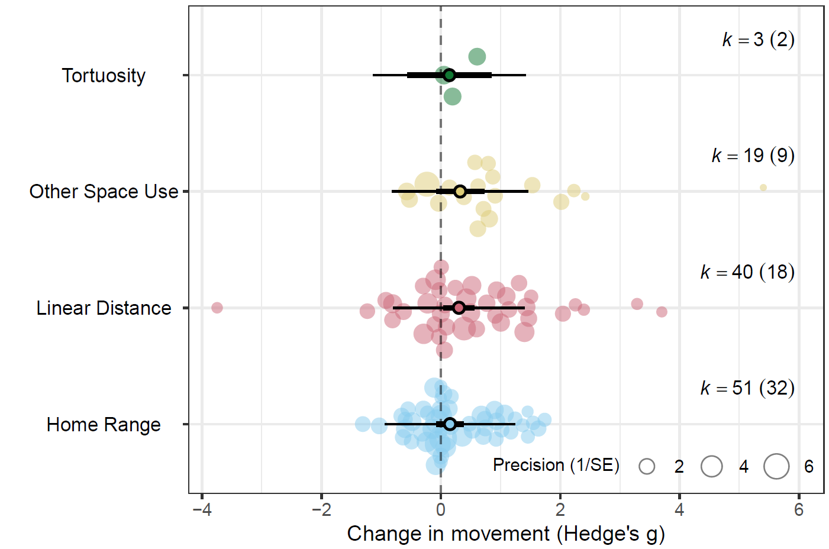
Figure 4: Orchard plot showing the estimated effect of fire on each of the four movement response categories. The meta-analytic mean is represented by the outlined point, with the thick horizontal bars showing 95% confidence interval and the whiskers the 95% prediction intervals. Each shaded point represents an effect size (Hedge’s g, n = 113), with the size of the point scaled to show precision within the model (1/SE) and larger points having a greater influence on the model. Effect size is shown on the x axis, and points are jittered on the y axis to improve readability.

Taxonomy
When modelling class as a moderator, we found a small, yet significant effect in mammals (Hedge’s g = 0.271 [95% CI = 0.018, 0.524], p = 0.036) (Figure 5). A small, marginally significant but positive effect was observed in birds (Hedge’s g = 0.350 [95% CI = -0.039, 0.739], p = 0.077). No effect was found in reptiles (Hedge’s g = -0.0004 [95% CI = -0.4248, 0.4240], p = 0.9985).
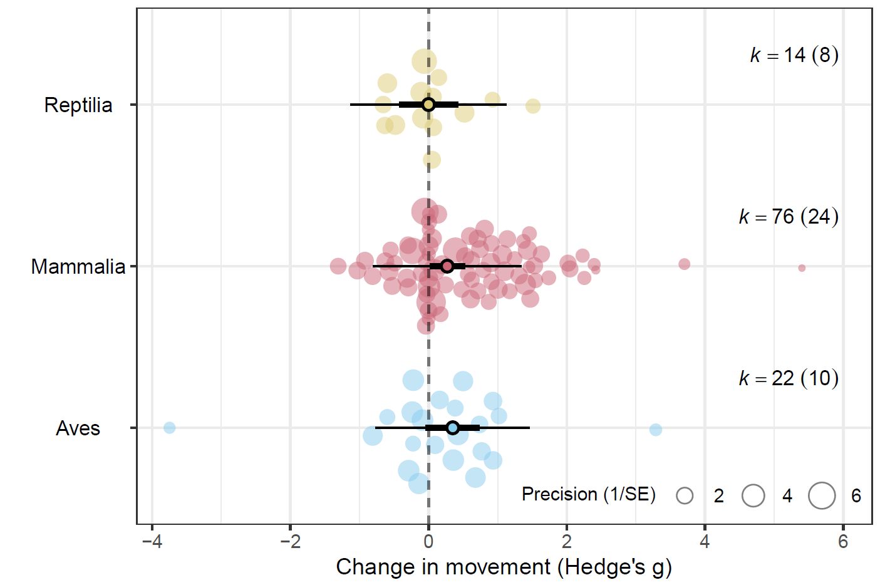
Figure 5: Orchard plot showing the estimated effect of fire on animal movement by class. The meta-analytic mean is represented by the outlined point, with the thick horizontal bars showing 95% confidence interval and the whiskers the 95% prediction intervals. Each shaded point represents an effect size (Hedge’s g, n = 109), with the size of the point scaled to show precision within the model (1/SE) and larger points having a greater influence on the model. Effect size is shown on the x axis, and points are jittered on the y axis to improve readability.

Biome
The phylogenetic multilevel meta-analytic model revealed biome influenced animal movement following fire, although the magnitude and direction of effects varied between biomes (Figure 6). We found a large significant effect in tropical and subtropical grasslands, savannas, and shrublands (Hedge’s g = 0.8256 [95% CI = 0.2189, 1.4323], p = 0.0082). Moderate, yet marginally significant, positive effects were observed in flooded grasslands and savannas (Hedge’s g = 0.7803 [95% CI = -0.0785, 1.6392], p = 0.0744) and temperate grasslands, savannas, and shrublands (Hedge’s g = 0.5893 [95% CI = -0.0076 - 1.186], p = 0.0529). Deserts and xeric shrublands was the only biome to have a negative, although non-significant, effect size. Effect sizes in the remaining biomes were non-significant (Supplementary Information 4, Table S4.1).
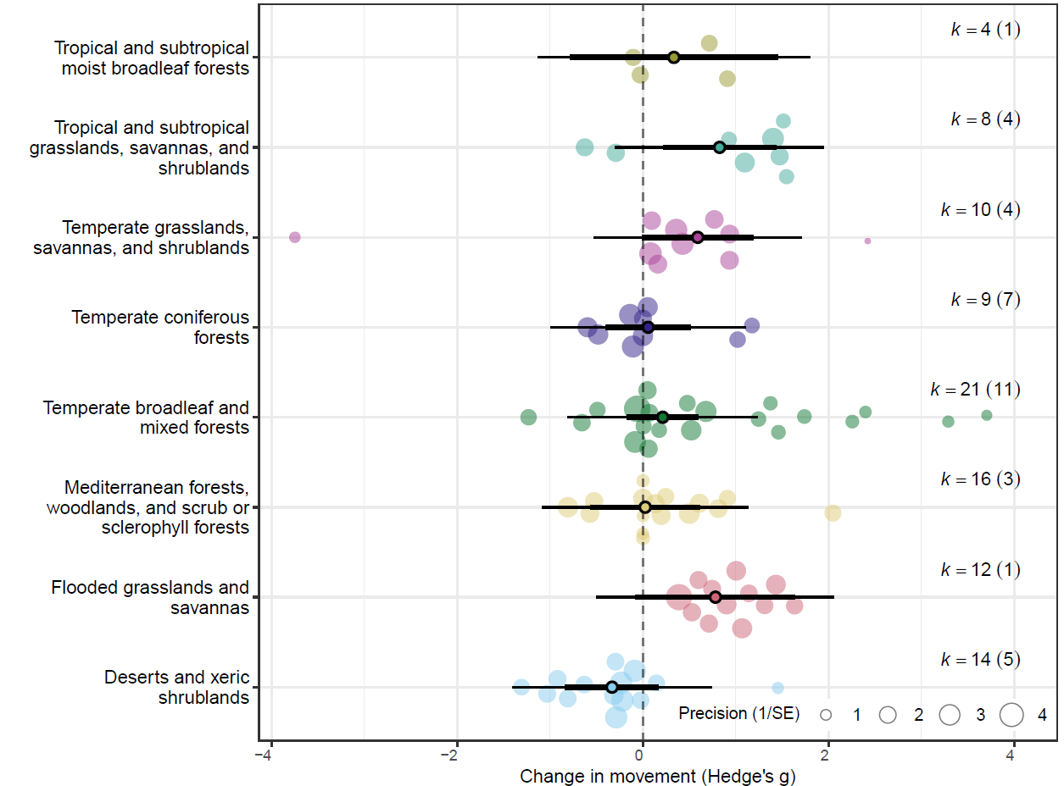
Figure 6: Orchard plot showing the estimated effect of fire on animal movement by biome. The meta-analytic mean is represented by the outlined point, with the thick horizontal bars showing 95% confidence interval and the whiskers the 95% prediction intervals. Each shaded point represents an effect size (n = 113), with the size of the point scaled to show precision within the model (1/SE) and larger points having a greater influence on the model. Effect size is shown on the x axis, and points are jittered on the y axis to improve readability.

Fire Type, Fire Size & Maximum Burn Age
When comparing the effect of fire type, either planned or wildfire, on animal movement, we found that planned burns had a significant small, positive effect on movement (Hedge’s g = 0.3131 [95% CI = 0.0048, 0.6215], p = 0.0466; Figure 7). When modelling the effect of maximum burn age on movement responses we found no correlation between maximum burn age and movement responses (β = –0.047 [95% CI = –0.163, 0.070], p = 0.43; Supplementary Information 4, Table S4.1). Similarly, we found no relationship between fire size and movement responses (β = 0.0021 [95% CI = -0.1125, 0.1167], p = 0.97; Supplementary Information 4, Table S4.1).

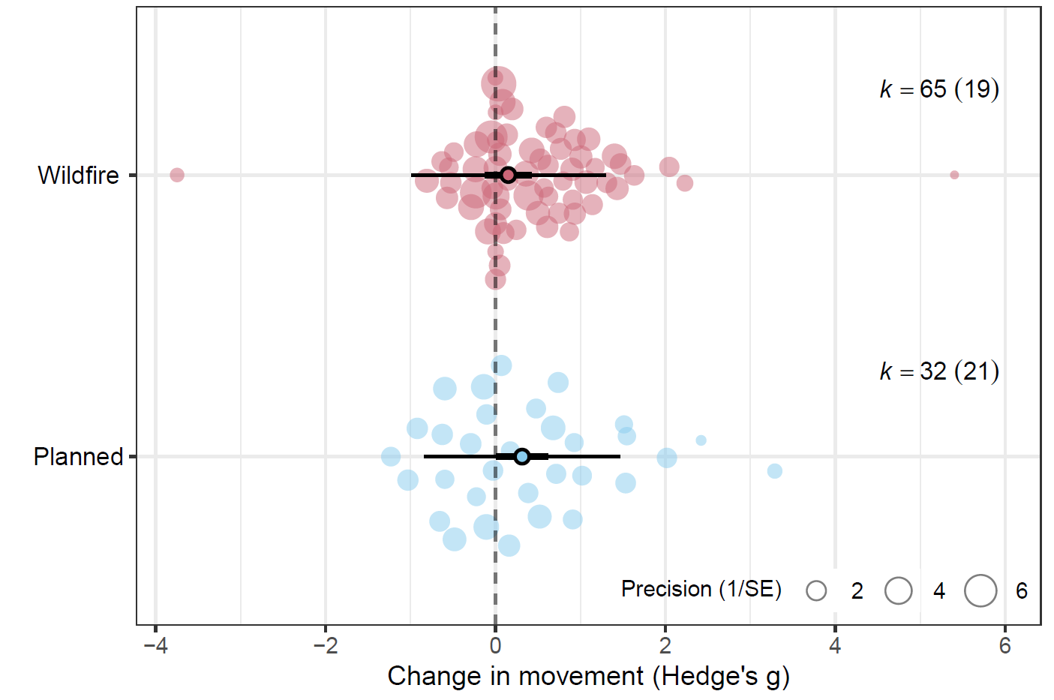
Figure 7: Orchard plot showing the estimated effect of fire on animal movement by fire type. The meta-analytic mean is represented by the outlined point, with the thick horizontal bars showing 95% confidence interval and the whiskers the 95% prediction intervals. Each shaded point represents an effect size (Hedge’s g, n = 97), with the size of the point scaled to show precision within the model (1/SE) and larger points having a greater influence on the model. Effect size is shown on the x axis, and points are jittered on the y axis to improve readability.

Body Mass
We modelled the effect of body mass on the overall data set and found no correlation between body mass and animal movement responses to fire (β = 0.0199 [–0.0414, 0.0812], p = 0.5211) Supplementary Information 4, Table S4.1). We then modelled the effect of body mass for each taxonomic class. No effect of body mass was observed for any taxonomic class (Supplementary Information 4, Table S4.1).

Discussion
Animal movement responses to fire are highly heterogeneous and often context dependent (Doherty et al., 2022; Doherty et al., 2023; Ganz et al., 2022; Geary et al., 2020), and this is reflected in the results of our meta-analysis. The results of our overall model reveal a small, yet positive effect of fire on animal movement, indicating that animal movements generally increase following fire. When comparing the strength of this effect between the movement categories, the linear distance category demonstrated small, yet significant positive effect, although movement category was not a strong predictor of effect size. HOW AND WHY FIRE MAY AFFECT LINEAR MOVEMENTS AND OTHER MOVEMENTS? what species are showing increases? Are these prey species? Could this be attributed to predation risk or perceived risk in open habitats? Could this be attributed to changes in predator behaviour? Altered perception? Stobo‐Wilson et al. (2021) for discussion of expectation that home range increases as resource availability decreases (also relevant for biome discussion).
TOPIC SENTENCE RE VARIANCE MODERATORS. The detection of moderate levels of within-individual variation suggests individual movement responses are not necessarily consistent across the movement categories. For example, an increase in home range size may not correlate with an increase in daily distance travelled and vice versa. EXPAND, EXPLAINATION FOR THIS? Notably, phylogenetic relatedness and non-phylogenetic species identity accounted for negligible variance in any of the model. EXPAND, EXPLAINATION FOR THIS?
Significant residual heterogeneity remained among effect sizes for most models, with between-study and within-individual heterogeneity generally accounting for some variance in most models. Between-study heterogeneity suggests either (i) the presence of meaningful differences in animal movement responses between studies, or (ii) differences in the capability of the studies to capture and quantify movement responses. In the first instance, site specific factors such as fire patchiness (Shaw et al., 2021) and fire severity (Crabb et al., 2022) may be driving animal movement responses. Fire is a spatiotemporally dynamic process; within a single fire extent, burn severity may range from complete canopy combustion through to incomplete combustion of the ground layer, leaving mid layers intact (Cherry et al., 2018; Yarnell et al., 2008). Similarly, a single fire extent may encompass a mosaic of burnt and unburnt vegetation, with or without heterogeneity in severity (Berry et al., 2016; Crabb et al., 2022; Lacki et al., 2009). The scale at which these fire characteristics and environmental conditions vary in relation to individual movement capacity is also an important consideration (Berry et al., 2016; Nathan et al., 2008; Nimmo et al., 2019) If post-fire conditions are unfavoured, highly mobile animals may shift the home range to adjacent, preferred habitats, as demonstrated by quokkas Setonix brachyurus following prescribed burns (Povh et al., 2023). In other cases, variation in burn severities across the fire extent may mediate habitat selection, yet have minimal effect on home range size, as seen in American black bears Ursus americanus following the extensive 2011 Wallow Wildfire in Arizona (Crabb et al., 2022). The authors propose heterogeneity in burn severity retained adequate foraging cover from established vegetation, and may have increased the productivity and foraging quality of grasses and herbs growing in areas affected by low severity fire (Crabb et al., 2022). With adequate resources available within the home range, there was no need to increase movement post fire (Crabb et al., 2022). SEE ALSO (Cohen et al., 2019)
In addition to site specific factors, variation in species traits, hunting behaviour, and foraging strategies may also be contributing to heterogeneity in movement responses between studies (Ganz et al., 2022; Geary et al., 2020; Pocknee et al., 2023). Our meta-analysis dataset included effect sizes from 13 orders across three classes, representing a broad range of life history strategies, hunting behaviours and foraging strategies. Our results found phylogenetic relatedness did not explain heterogeneity in effect sizes. Therefore, any variability in traits, life histories and behaviours that do contribute to movement responses occur likely at lower taxonomic ranks and are not consistent across higher levels such as order. EXPAND. Hunting behaviours vary across predators, as to does preferred habitat to hunt in (Doherty et al., 2022; Kauffman et al., 2007). SEE ALSO (Moran et al., 2021) for discussion RE condition and risky behaviour.
SEE ALSO (Driscoll et al., 2021). EXAPND – Other processes that may interact with fire to influence movement. Unfortunately, our sample size precluded a robust evaluation of interactive effects.
SECOND CASE - differences in the capability of the studies to capture and quantify movement responses “(i) confounding factors that are inconsistently measured or accounted for across studies, (ii) problems with statistical inference (e.g., differing statistical power or accuracy), or (iii) methodological differences across studies (e.g., differing times since fire) (Catford et al. 2022)” from Doherty et al. (2023). Furthermore, previous research indicates that interactive and synergistic effects are also likely to exert strong influence on animal responses to fire, and this may also be contributing to the high level of between study heterogeneity we found (Culhane et al., 2022; Doherty et al., 2022; Ganz et al., 2022)
Apart from biome, we found no clear relationship between our predictor variables and movement responses to fire. In contrast to site specific, localised factors, the resolution of the extrinsic predictor variables we investigated are much coarser, and do not incorporate spatial or temporal environmental heterogeneity. This may aid in explaining why variables we expected to be influential, such fire size and fire type, were not. Within the studies we reviewed, we extracted qualitative descriptors of burn severity and patchiness when provided or inferred severity from post-fire descriptions of vegetation condition. Generally, burn severity was variable, resulting in a mosaic of differing burn severities and unburnt patches within a single fire extent (eg. Cherry et al., 2018; Crabb et al., 2022; Lacki et al., 2009). Burn heterogeneity, rather than total fire extent, is likely a stronger mediator of resource distribution and availability within the landscape, and therefore a stronger predictor of animal movement responses. We expected the strength of effect sizes to decrease with maximum treatment age, however found no relationship. Discuss temporal scaling of resources post fire/veg succession and seral stages. Discuss differences between biomes/veg types in the weather/climate drivers of productivity (eg. Unpredictability/boom and bust in arid or xeric habitats), as well as veg composition.
Biome type was a significant predictor of effect size. (EXPAND - types of movement, is space use contributing to results (ie are animals spending less time in post fire habitats?). Savanna results make sense – less productive ecosystems, individuals need to move greater distances to find resources. See references in intro of (Ganz et al., 2022) for discussion of peak foraging abundance in xeric landscapes)
WILDFIRE TYPE NOT SIGNIFICANT PREDICTOR – But planned burns demonstrated significant positive effect. Why? What could explain this? Attributes of planned burns? Management approaches (ie are planned burns similar/different to burns of historic regimes)? Again, look at species here – are grazers that are attracted to burned areas post fire contributing to this (eg space use metric)? Less precision in Wildfire results?
BODY MASS NOT SIGNIFICANT PREDICTOR. Despite correlation between body mass and movement/allometric scaling SEE (Doherty et al., 2019; Jetz et al., 2004; Tamburello et al., 2015).
LIMITATIONS – Cases not included due to small sizes/inadequate data to calculate effect sizes, quantitative fire attributes, no interactive effects modelled
IMPLICATIONS – Importance of results, future directions, please report more about fire treatments = disentangle effect of fire attributes from other site variables. Context dependency – importance of considering interactive effects, fine scale environmental variables and species traits

Conclusion

References
Abatzoglou, J. T., Kolden, C. A., Cullen, A. C., Sadegh, M., Williams, E. L., Turco, M., & Jones, M. W. (2025). Climate change has increased the odds of extreme regional forest fire years globally. Nature Communications, 16(1), 6390. https://doi.org/10.1038/s41467-025-61608-1
Ankit, R. (2025). WebPlotDigitizer Version 5.2. https://automeris.io
Berry, L. E., Lindenmayer, D. B., Dennis, T. E., Driscoll, D. A., & Banks, S. C. (2016). Fire severity alters spatio–temporal movements and habitat utilisation by an arboreal marsupial, the mountain brushtail possum (Trichosurus cunninghami). International Journal of Wildland Fire, 25(12), 1291-1302.
Blakey, R. V., Sikich, J. A., Blumstein, D. T., & Riley, S. P. D. (2022). Mountain lions avoid burned areas and increase risky behavior after wildfire in a fragmented urban landscape. Current Biology, 32(21), 4762-4768.e4765. https://doi.org/10.1016/j.cub.2022.08.082
Bowman, D. M. J. S., Balch, J. K., Artaxo, P., Bond, W. J., Carlson, J. M., Cochrane, M. A., D’Antonio, C. M., DeFries, R. S., Doyle, J. C., Harrison, S. P., Johnston, F. H., Keeley, J. E., Krawchuk, M. A., Kull, C. A., Marston, J. B., Moritz, M. A., Prentice, I. C., Roos, C. I., Scott, A. C., . . . Pyne, S. J. (2009). Fire in the Earth System. Science, 324(5926), 481-484. https://doi.org/10.1126/science.1163886
Bowman, D. M. J. S., Kolden, C. A., Abatzoglou, J. T., Johnston, F. H., van der Werf, G. R., & Flannigan, M. (2020). Vegetation fires in the Anthropocene. Nature Reviews Earth & Environment, 1(10), 500-515. https://doi.org/10.1038/s43017-020-0085-3
Brown, J. S., & Kotler, B. P. (2004). Hazardous duty pay and the foraging cost of predation. Ecology Letters, 7(10), 999-1014. https://doi.org/10.1111/j.1461-0248.2004.00661.x
Burton, C., Lampe, S., Kelley, D. I., Thiery, W., Hantson, S., Christidis, N., Gudmundsson, L., Forrest, M., Burke, E., Chang, J., Huang, H., Ito, A., Kou-Giesbrecht, S., Lasslop, G., Li, W., Nieradzik, L., Li, F., Chen, Y., Randerson, J., . . . Mengel, M. (2024). Global burned area increasingly explained by climate change. Nature Climate Change, 14(11), 1186-1192. https://doi.org/10.1038/s41558-024-02140-w
Cherry, M. J., Warren, R. J., & Conner, L. M. (2017). Fire-mediated foraging tradeoffs in white-tailed deer. ECOSPHERE, 8(4). https://doi.org/10.1002/ecs2.1784
Cherry, M. J., Chandler, R. B., Garrison, E. P., Crawford, D. A., Kelly, B. D., Shindle, D. B., Godsea, K. G., Miller, K. V., & Conner, L. M. (2018). Wildfire affects space use and movement of white-tailed deer in a tropical pyric landscape. Forest Ecology and Management, 409, 161-169. https://doi.org/10.1016/j.foreco.2017.11.007
Clapp, J. G., & Beck, J. L. (2016). Short-term impacts of fire-mediated habitat alterations on an isolated bighorn sheep population. Fire Ecology, 12(3), 80-98. https://doi.org/10.4996/fireecology.1203080
Cohen, B. S., Prebyl, T. J., Collier, B. A., & Chamberlain, M. J. (2019). Spatiotemporal variability of fire characteristics affect animal responses in pyric landscapes. Fire Ecology, 15(1), 41. https://doi.org/10.1186/s42408-019-0058-4
Cosgrove, A. J., McWhorter, T. J., & Maron, M. (2018). Consequences of impediments to animal movements at different scales: A conceptual framework and review. DIVERSITY AND DISTRIBUTIONS, 24(4), 448-459. https://doi.org/10.1111/ddi.12699
Crabb, M. L., Clement, M. J., Jones, A. S., Bristow, K. D., & Harding, L. E. (2022). Black bear spatial responses to the Wallow Wildfire in Arizona. The Journal of Wildlife Management, 86(3), 1-20. https://doi.org/10.1002/jwmg.22182
Culhane, K., Sollmann, R., White, A. M., Tarbill, G. L., Cooper, S. D., & Young, H. S. (2022). Small mammal responses to fire severity mediated by vegetation characteristics and species traits. Ecology and Evolution, 12(5), e8918. https://doi.org/10.1002/ece3.8918
Cunningham, C. X., Williamson, G. J., & Bowman, D. M. J. S. (2024). Increasing frequency and intensity of the most extreme wildfires on Earth. Nature Ecology & Evolution, 8(8), 1420-1425. https://doi.org/s41559-024-02452-2
Doherty, T. S., Fist, C. N., & Driscoll, D. A. (2019). Animal movement varies with resource availability, landscape configuration and body size: a conceptual model and empirical example. Landscape Ecology, 34(3), 603-614. https://doi.org/10.1007/s10980-019-00795-x
Doherty, T. S., Hays, G. C., & Driscoll, D. A. (2021). Human disturbance causes widespread disruption of animal movement. Nature Ecology & Evolution, 5(4), 513-519. https://doi.org/10.1038/s41559-020-01380-1
Doherty, T. S., Geary, W. L., Jolly, C. J., Macdonald, K. J., Miritis, V., Watchorn, D. J., Cherry, M. J., Conner, L. M., González, T. M., Legge, S. M., Ritchie, E. G., Stawski, C., & Dickman, C. R. (2022). Fire as a driver and mediator of predator–prey interactions. Biological Reviews, 97(4), 1539-1558. https://doi.org/10.1111/brv.12853
Doherty, T. S., Watchorn, D. J., Miritis, V., Pestell, A. J. L., & Geary, W. L. (2023). Cats, foxes and fire: Quantitative review reveals that invasive predator activity is most likely to increase shortly after fire. Fire Ecology, 19(1), 22. https://doi.org/10.1186/s42408-023-00183-6
Doherty, T. S., Macdonald, K. J., Nimmo, D. G., Santos, J. L., & Geary, W. L. (2024). Shifting fire regimes cause continent-wide transformation of threatened species habitat. Proceedings of the National Academy of Sciences, 121(18), e2316417121. https://doi.org/10.1073/pnas.2316417121
Driscoll, D. A., Armenteras, D., Bennett, A. F., Brotons, L., Clarke, M. F., Doherty, T. S., Haslem, A., Kelly, L. T., Sato, C. F., Sitters, H., Aquilué, N., Bell, K., Chadid, M., Duane, A., Meza-Elizalde, M. C., Giljohann, K. M., González, T. M., Jambhekar, R., Lazzari, J., . . . Wevill, T. (2021). How fire interacts with habitat loss and fragmentation. Biological Reviews, 96(3), 976-998. https://doi.org/10.1111/brv.12687
Driscoll, D. A., Macdonald, K. J., Gibson, R. K., Doherty, T. S., Nimmo, D. G., Nolan, R. H., Ritchie, E. G., Williamson, G. J., Heard, G. W., Tasker, E. M., Bilney, R., Porch, N., Collett, R. A., Crates, R. A., Hewitt, A. C., Pendall, E., Boer, M. M., Gates, J., Boulton, R. L., . . . Phillips, R. D. (2024). Biodiversity impacts of the 2019–2020 Australian megafires. Nature, 635(8040), 898-905. https://doi.org/10.1038/s41586-024-08174-6
Ezzy, L. (2022). Breaking the wildfire cycle: Progressive fire management can shift fire regimes and improve ecosystem condition. A case study from a large conservation reserve in northern Australia. The Rangeland journal, 44(6), 279-288. https://doi.org/10.1071/RJ22021
Faurby, S., Davis, M., Pedersen, R. Ø., Schowanek, S. D., Antonelli, A., & Svenning, J.-C. (2018). PHYLACINE 1.2: The Phylogenetic Atlas of Mammal Macroecology. Ecology, 99(11), 2626-2626. https://doi.org/10.1002/ecy.2443
Fordyce, A., Hradsky, B. A., Ritchie, E. G., & Di Stefano, J. (2016). Fire affects microhabitat selection, movement patterns, and body condition of an Australian rodent (Rattus fuscipes). Journal of Mammalogy, 97(1), 102-111. https://doi.org/10.1093/jmammal/gyv159
Ganz, T. R., DeVivo, M. T., Kertson, B. N., Roussin, T., Satterfield, L., Wirsing, A. J., & Prugh, L. R. (2022). Interactive effects of wildfires, season and predator activity shape mule deer movements. Journal of Animal Ecology, 91(11), 2273-2288. https://doi.org/10.1111/1365-2656.13810
Gasaway, W. C., Dubois, S. D., Boertje, R. D., Reed, D. J., & Simpson, D. T. (1989). Response of radio-collared moose to a large burn in central Alaska. Canadian Journal of Zoology, 67(2), 325-329. https://doi.org/10.1139/z89-047
Geary, W. L., Doherty, T. S., Nimmo, D. G., Tulloch, A. I. T., & Ritchie, E. G. (2020). Predator responses to fire: A global systematic review and meta-analysis. Journal of Animal Ecology, 89(4), 955-971. https://doi.org/10.1111/1365-2656.13153
Gomez, S., English, H. M., Bejarano Alegre, V., Blackwell, P. G., Bracken, A. M., Bray, E., Evans, L. C., Gan, J. L., Grecian, W. J., Gutmann Roberts, C., Harju, S. M., Hejcmanová, P., Lelotte, L., Marshall, B. M., Matthiopoulos, J., Mnenge, A. J., Niebuhr, B. B., Ortega, Z., Pollock, C. J., . . . Börger, L. (2025). Understanding and predicting animal movements and distributions in the Anthropocene. Journal of Animal Ecology, 94(6), 1146-1164. https://doi.org/10.1111/1365-2656.70040
Greenwood, L., Bliege Bird, R., & Nimmo, D. (2022). Indigenous burning shapes the structure of visible and invisible fire mosaics. Landscape Ecology, 37(3), 811-827. https://doi.org/10.1007/s10980-021-01373-w
Harrison, M. E., Deere, N. J., Imron, M. A., Nasir, D., Asti, H. A., Aragay Soler, J., Boyd, N. C., Cheyne, S. M., Collins, S. A., D’Arcy, L. J., Erb, W. M., Green, H., Healy, W., Holly, B., Houlihan, P. R., Husson, S. J., Jeffers, K. A., Kulu, I. P., Kusin, K., . . . Struebig, M. J. (2024). Impacts of fire and prospects for recovery in a tropical peat forest ecosystem. Proceedings of the National Academy of Sciences, 121(17), e2307216121. https://doi.org/10.1073/pnas.2307216121
He, T., Lamont, B. B., & Pausas, J. G. (2019). Fire as a key driver of Earth's biodiversity. Biological Reviews, 94(6), 1983-2010. https://doi.org/10.1111/brv.12544
Hijmans, R. J., Barbosa, M., Ghos, A., & Mandel, A. (2025). geodata. In (Version 0.6-2) https://github.com/rspatial/geodata
Hinam, H., & St. Clair, C. (2008). High levels of habitat loss and fragmentation limit reproductive success by reducing home range size and provisioning rates of northern saw-whet owls. Biological Conservation, 141, 524-535. https://doi.org/10.1016/j.biocon.2007.11.011
Hovick, T. J., McGranahan, D. A., Elmore, R. D., Weir, J. R., & Fuhlendorf, S. D. (2017). Pyric-carnivory: Raptor use of prescribed fires. Ecology and Evolution, 7(21), 9144-9150. https://doi.org/10.1002/ece3.3401
Jeltsch, F., Bonte, D., Pe'er, G., Reineking, B., Leimgruber, P., Balkenhol, N., Schröder, B., Buchmann, C. M., Mueller, T., Blaum, N., Zurell, D., Böhning-Gaese, K., Wiegand, T., Eccard, J. A., Hofer, H., Reeg, J., Eggers, U., & Bauer, S. (2013). Integrating movement ecology with biodiversity research - exploring new avenues to address spatiotemporal biodiversity dynamics. Movement Ecology, 1(1), 6. https://doi.org/10.1186/2051-3933-1-6
Jetz, W., Carbone, C., Fulford, J., & Brown, J. H. (2004). The scaling of animal space use. Science, 306(5694), 266-268. https://doi.org/10.1126/science.1102138
Jolly, C. J., Dickman, C. R., Doherty, T. S., van Eeden, L. M., Geary, W. L., Legge, S. M., Woinarski, J. C. Z., & Nimmo, D. G. (2022). Animal mortality during fire. Global Change Biology, 28(6), 2053-2065. https://doi.org/10.1111/gcb.16044
Kauffman, M. J., Varley, N., Smith, D. W., Stahler, D. R., MacNulty, D. R., & Boyce, M. S. (2007). Landscape heterogeneity shapes predation in a newly restored predator–prey system. Ecology Letters, 10(8), 690-700. https://doi.org/10.1111/j.1461-0248.2007.01059.x
Kelly, L. T., Giljohann, K. M., Duane, A., Aquilué, N., Archibald, S., Batllori, E., Bennett, A. F., Buckland, S. T., Canelles, Q., Clarke, M. F., Fortin, M.-J., Hermoso, V., Herrando, S., Keane, R. E., Lake, F. K., McCarthy, M. A., Morán-Ordóñez, A., Parr, C. L., Pausas, J. G., . . . Brotons, L. (2020). Fire and biodiversity in the Anthropocene. Science, 370(6519), eabb0355. https://doi.org/10.1126/science.abb0355
Kreider, M. R., Higuera, P. E., Parks, S. A., Rice, W. L., White, N., & Larson, A. J. (2024). Fire suppression makes wildfires more severe and accentuates impacts of climate change and fuel accumulation. Nature Communications, 15(1), 2412. https://doi.org/10.1038/s41467-024-46702-0
Lacki, M. J., Cox, D. R., Dodd, L. E., & Dickinson, M. B. (2009). Response of northern bats (Myotis septentrionalis) to prescribed fires in eastern Kentucky forests. Journal of Mammalogy, 90(5), 1165-1175. https://doi.org/10.1644/08-MAMM-A-349.1
Leahy, L., Legge, S. M., Tuft, K., McGregor, H. W., Barmuta, L. A., Jones, M. E., & Johnson, C. N. (2016). Amplified predation after fire suppresses rodent populations in Australia’s tropical savannas. Wildlife Research, 42(8), 705-716.
McGregor, H., Cliff, H., B. , & Kanowski, J. (2016a). Habitat preference for fire scars by feral cats in Cape York Peninsula, Australia. Wildlife Research, 43(8), 623-633. https://doi.org/10.1071/WR16058
McGregor, H. W., Legge, S., Jones, M. E., & Johnson, C. N. (2016b). Extraterritorial hunting expeditions to intense fire scars by feral cats. SCIENTIFIC REPORTS, 6(1), 22559. https://doi.org/10.1038/srep22559
McLauchlan, K. K., Higuera, P. E., Miesel, J., Rogers, B. M., Schweitzer, J., Shuman, J. K., Tepley, A. J., Varner, J. M., Veblen, T. T., Adalsteinsson, S. A., Balch, J. K., Baker, P., Batllori, E., Bigio, E., Brando, P., Cattau, M., Chipman, M. L., Coen, J., Crandall, R., . . . Watts, A. C. (2020). Fire as a fundamental ecological process: Research advances and frontiers. Journal of Ecology, 108(5), 2047-2069. https://doi.org/10.1111/1365-2745.13403
Michonneau, F., Brown, J. W., & Winter, D. J. (2016). rotl: An R package to interact with the Open Tree of Life data. Methods in Ecology and Evolution, 7(12), 1476-1481. https://doi.org/10.1111/2041-210X.12593
Moran, N. P., Sánchez-Tójar, A., Schielzeth, H., & Reinhold, K. (2021). Poor nutritional condition promotes high-risk behaviours: A systematic review and meta-analysis. Biological Reviews, 96(1), 269-288. https://doi.org/10.1111/brv.12655
Morris, S. B. (2008). Estimating Effect Sizes From Pretest-Posttest-Control Group Designs. Organizational Research Methods, 11(2), 364-386. https://doi.org/10.1177/1094428106291059
Nakagawa, S., & Cuthill, I. C. (2007). Effect size, confidence interval and statistical significance: A practical guide for biologists. Biological Reviews, 82(4), 591-605. https://doi.org/10.1111/j.1469-185X.2007.00027.x
Nakagawa, S., & Santos, E. S. A. (2012). Methodological issues and advances in biological meta-analysis. Evolutionary Ecology, 26(5), 1253-1274. https://doi.org/10.1007/s10682-012-9555-5
Nakagawa, S., Lagisz, M., Jennions, M. D., Koricheva, J., Noble, D. W. A., Parker, T. H., Sánchez-Tójar, A., Yang, Y., & O'Dea, R. E. (2022). Methods for testing publication bias in ecological and evolutionary meta-analyses. Methods in Ecology and Evolution, 13(1), 4-21. https://doi.org/https://doi.org/10.1111/2041-210X.13724
Nakagawa, S., Lagisz, M., O'Dea, R. E., Pottier, P., Rutkowska, J., Senior, A. M., Yang, Y., & Noble, D. W. A. (2023). orchaRd 2.0: An R package for visualising meta-analyses with orchard plots. Methods in Ecology and Evolution, 14(8), 2003-2010. https://doi.org/10.1111/2041-210X.14152
Nathan, R., Getz, W. M., Revilla, E., Holyoak, M., Kadmon, R., Saltz, D., & Smouse, P. E. (2008). A movement ecology paradigm for unifying organismal movement research. Proceedings of the National Academy of Sciences, 105(49), 19052-19059. https://doi.org/10.1073/pnas.0800375105
Nathan, R., Monk, C. T., Arlinghaus, R., Adam, T., Alós, J., Assaf, M., Baktoft, H., Beardsworth, C. E., Bertram, M. G., Bijleveld, A. I., Brodin, T., Brooks, J. L., Campos-Candela, A., Cooke, S. J., Gjelland, K. Ø., Gupte, P. R., Harel, R., Hellström, G., Jeltsch, F., . . . Jarić, I. (2022). Big-data approaches lead to an increased understanding of the ecology of animal movement. Science, 375(6582), eabg1780. https://doi.org/10.1126/science.abg1780
Nimmo, D. G., Avitabile, S., Banks, S. C., Bliege Bird, R., Callister, K., Clarke, M. F., Dickman, C. R., Doherty, T. S., Driscoll, D. A., Greenville, A. C., Haslem, A., Kelly, L. T., Kenny, S. A., Lahoz‐Monfort, J. J., Lee, C., Leonard, S., Moore, H., Newsome, T. M., Parr, C. L., . . . Bennett, A. F. (2019). Animal movements in fire‐prone landscapes. Biological Reviews of the Cambridge Philosophical Society, 94(3), 981-998. https://doi.org/10.1111/brv.12486
Nimmo, D. G., Carthey, A. J. R., Jolly, C. J., & Blumstein, D. T. (2021). Welcome to the Pyrocene: Animal survival in the age of megafire. Global Change Biology, 27(22), 5684-5693. https://doi.org/10.1111/gcb.15834
Olson, D. M., Dinerstein, E., Wikramanayake, E. D., Burgess, N. D., Powell, G. V. N., Underwood, E. C., D'Amico, J. A., Itoua, I., Strand, H. E., Morrison, J. C., Loucks, C. J., Allnutt, T. F., Ricketts, T. H., Kura, Y., Lamoreux, J. F., Wettengel, W. W., Hedao, P., & Kassem, K. R. (2001). Terrestrial Ecoregions of the World: A New Map of Life on Earth: A new global map of terrestrial ecoregions provides an innovative tool for conserving biodiversity. BioScience, 51(11), 933-938. https://doi.org/10.1641/0006-3568(2001)051[0933:TEOTWA]2.0.CO;2
Oskyrko, O. M., Chunrong; Meiri, Shai; Du, Weiguo. (2024). ReptTraits: A comprehensive dataset of ecological traits in reptiles.
Pasch, B., & Koprowski, J. L. (2011). Impacts of fire suppression on space use by Mexican fox squirrels. Journal of Mammalogy, 92(1), 227-234. https://doi.org/10.1644/10-MAMM-A-133.1
Pausas, J. G., & Parr, C. L. (2018). Towards an understanding of the evolutionary role of fire in animals. Evolutionary Ecology, 32(2), 113-125. https://doi.org/10.1007/s10682-018-9927-6
Pettett, C. E., Johnson, P. J., Moorhouse, T. P., Hambly, C., Speakman, J. R., & Macdonald, D. W. (2017). Daily energy expenditure in the face of predation: Hedgehog energetics in rural landscapes. Journal of Experimental Biology, 220(3), 460-468. https://doi.org/10.1242/jeb.150359
Pocknee, C. A., Legge, S. M., McDonald, J., & Fisher, D. O. (2023). Modeling mammal response to fire based on species’ traits. Conservation Biology, 37(4), e14062. https://doi.org/10.1111/cobi.14062
Posit team. (2025). RStudio: Integrated Development Environment for R. In (Version 2025.5.0.496) Posit Software, PBC. http://www.posit.co/
Povh, L. F., Willers, N., Shephard, J. M., & Fleming, P. A. (2023). A conservation-significant threatened mammal uses fire exclusions and shifts ranges in the presence of prescribed burning. International Journal of Wildland Fire, 32(9), 1291-1303. https://doi.org/10.1071/WF22196
R Core Team. (2024). R: A Language and Environment for Statistical Computing. In R Foundation for Statistical Computing. https://www.R-project.org/
Shaw, R. E., James, A. I., Tuft, K., Legge, S., Cary, G. J., Peakall, R., & Banks, S. C. (2021). Unburnt habitat patches are critical for survival and in situ population recovery in a small mammal after fire. JOURNAL OF APPLIED ECOLOGY, 58(6), 1325-1335. https://doi.org/10.1111/1365-2664.13846
Stobo‐Wilson, A. M., Cremona, T., Murphy, B. P., & Carthew, S. M. (2021). Resource availability drives variation in a marsupial glider’s home‐range size. Journal of Zoology, 315(3), 199-212. https://doi.org/10.1111/jzo.12906
Straus, S., Forbes, C., Little, C. J., Germain, R. M., Main, D. A., O'Connor, M. I., Thompson, P. L., Ford, A. T., Gravel, D., & Guzman, L. M. (2024). Macroecological constraints on species' ‘movement profiles’: Body mass does not explain it all. Global Ecology and Biogeography, 33(2), 227-243. https://doi.org/10.1111/geb.13786
Tamburello, N., Isabelle M. Côté, & Dulvy, N. K. (2015). Energy and the scaling of animal space use. The American Naturalist, 186(2), 196-211. https://doi.org/10.1086/682070
Templeton, A. R., Neuwald, J. L., Brazeal, H., & Robertson, R. J. (2007). Restoring demographic processes in translocated populations: The case of collared lizards in the Missouri Ozarks using prescribed forest fires. ISRAEL JOURNAL OF ECOLOGY & EVOLUTION, 53(2), 179-196. https://doi.org/10.1560/IJEE.53.2.179
Templeton, A. R., Brazeal, H., & Neuwald, J. L. (2011). The transition from isolated patches to a metapopulation in the eastern collared lizard in response to prescribed fires. Ecology, 92(9), 1736-1747. https://doi.org/10.1890/10-1994.1
Tobias, J. A., Sheard, C., Pigot, A. L., Devenish, A. J. M., Yang, J., Sayol, F., Neate-Clegg, M. H. C., Alioravainen, N., Weeks, T. L., Barber, R. A., Walkden, P. A., MacGregor, H. E. A., Jones, S. E. I., Vincent, C., Phillips, A. G., Marples, N. M., Montaño-Centellas, F. A., Leandro-Silva, V., Claramunt, S., . . . Schleuning, M. (2022). AVONET: morphological, ecological and geographical data for all birds. Ecology Letters, 25(3), 581-597. https://doi.org/https://doi.org/10.1111/ele.13898
Tucker, M. A., Böhning-Gaese, K., Fagan, W. F., Fryxell, J. M., Van Moorter, B., Alberts, S. C., Ali, A. H., Allen, A. M., Attias, N., Avgar, T., Bartlam-Brooks, H., Bayarbaatar, B., Belant, J. L., Bertassoni, A., Beyer, D., Bidner, L., van Beest, F. M., Blake, S., Blaum, N., . . . Mueller, T. (2018). Moving in the Anthropocene: Global reductions in terrestrial mammalian movements. Science, 359(6374), 466-469. https://doi.org/10.1126/science.aam9712
van Wagtendonk, J. W., & Lutz, J. A. (2007). Fire regime attributes of wildland fires in Yosemite National Park, USA. Fire Ecology, 3(2), 34-52. https://doi.org/10.4996/fireecology.0302034
Venter, J. A., Nabe-Nielsen, J., Prins, H. H. T., & Slotow, R. (2014). Forage patch use by grazing herbivores in a South African grazing ecosystem. Acta Theriologica, 59(3), 457-466. https://doi.org/10.1007/s13364-014-0184-y
Viechtbauer, W. (2010). Conducting Meta-Analyses in R with the metafor Package. Journal of Statistical Software, 36(3), 1 - 48. https://doi.org/10.18637/jss.v036.i03
Viechtbauer, W., & Cheung, M. W. L. (2010). Outlier and influence diagnostics for meta-analysis. Research Synthesis Methods, 1(2), 112-125. https://doi.org/10.1002/jrsm.11
Volkmann, L. A., Hutchen, J., & Hodges, K. E. (2020). Trends in carnivore and ungulate fire ecology research in North American conifer forests. Forest Ecology and Management, 458, 117691. https://doi.org/10.1016/j.foreco.2019.117691
Yarnell, R. W., Metcalfe, D. J., Dunstone, N., Burnside, N., & Scott, D. M. (2008). The impact of fire on habitat use by the short-snouted elephant shrew (Elephantulus brachyrhynchus) in North West Province, South Africa. African Zoology, 43(1), 45-52. https://doi.org/10.1080/15627020.2008.11407405

