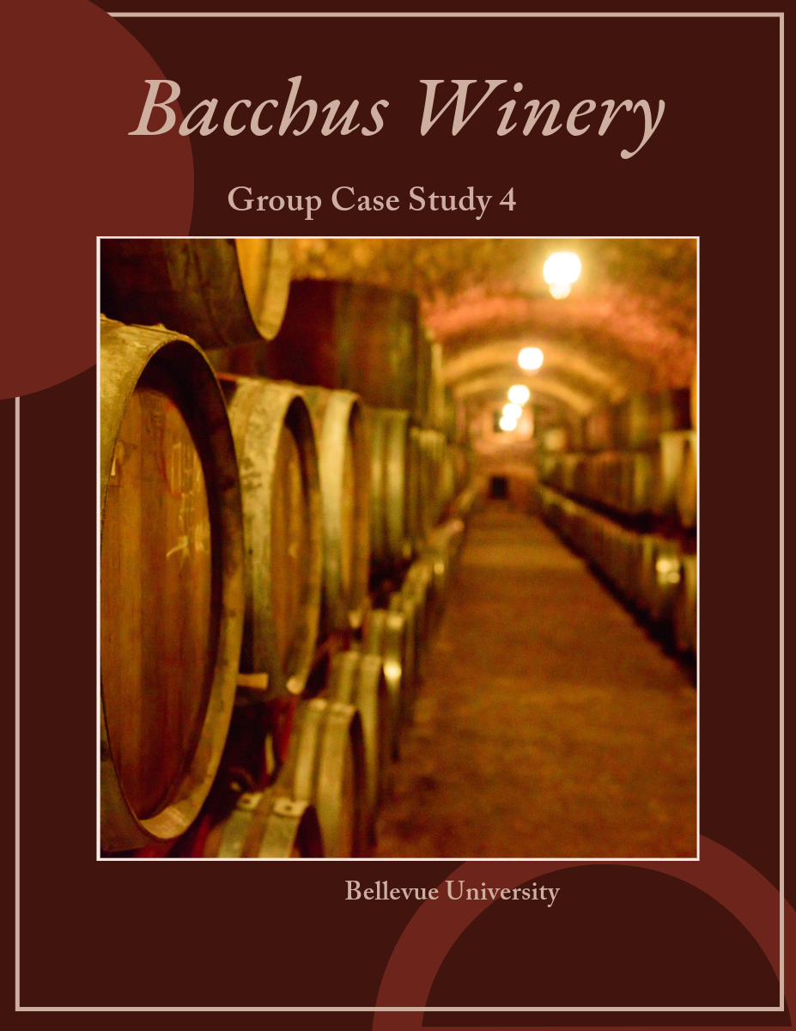

Milestone

Bacchus Winery

Kyle Marlia-Conner  
Steve Stylin  
Ean Masoner  
Cuitlahuac Hernandez  
Mirajo Tesora

| Database Development and Use | 12/07/2024

# CASE STUDY

This case study explores the operational framework of Bacchus Winery, emphasizing the essential business rules and practices that govern various facets of its operations. The winery is celebrated for its exceptional wine production, efficient employee management, strong supplier relationships, and effective distribution strategies. By identifying the unique identifiers for employees, wines, and suppliers and by detailing the structured inventory management and sales tracking processes, this document aims to offer a comprehensive overview of Bacchus Winery's business operations. Additionally, it includes an initial Entity-Relationship Diagram (ERD) that illustrates the interconnections among these components and the assumptions that underpin the analysis. This structured approach is designed to enhance the understanding of the winery's business model.

## Business Rules

**Employee Management**:

Each employee has a unique Employee ID.

Employees are categorized by their roles: Finance, Marketing, Production, and Distribution.

Each department has a head, and employees report to their respective department heads.

Employee work hours are tracked on a quarterly basis.

**Wine Production**:

Bacchus Winery produces four types of wine: Merlot, Cabernet, Chablis, and Chardonnay.

Each type of wine has a unique Wine ID and is associated with specific grape varieties grown on-site.

**Supplier Management**:

There are three suppliers, each providing different components necessary for wine production and packaging.

Each supplier has a unique Supplier ID.

Suppliers are evaluated based on their delivery performance, precisely on-time delivery rates.

Monthly reports are generated to assess supplier performance.

**Inventory Management**:

Inventory includes raw materials (grapes, bottles, corks, labels, boxes, vats, tubing) and finished products (wines).

Inventory levels are tracked in real-time to facilitate efficient ordering and supply management.

Stan and Davis are responsible for monitoring inventory levels and placing orders as needed.

**Distribution Management**:

Distributors have unique Distributor IDs and can place orders online.

Each distributor is associated with specific wines they carry.

Shipment tracking is available for all orders placed by distributors.

**Sales Tracking**:

Sales data is collected for each type of wine sold through various distributors.

Monthly sales reports are generated to analyze the performance of each wine type.

A wine is considered underperforming if it does not meet a predefined sales threshold.

## Assumptions

* The winery operates on a monthly reporting cycle for inventory and sales.
* All employees are full-time and work a standard number of hours each week.
* The winery uses a centralized database to manage all information related to employees, suppliers, inventory, and sales.
* Online ordering and tracking systems are implemented for both suppliers and distributors.

## Entity Relationship Diagram

To construct an ERD in 3NF for Bacchus Winery, we must first identify the entities, their attributes, and the relationships among them based on the business rules. The following entities will be included in the ERD:

1. ***Employee***
2. ***Department***
3. ***Wine***
4. ***Grape Variety***
5. ***Supplier***
6. ***Inventory***
7. ***Distributor***
8. ***Sales***

### Entity Definitions and Attributes

1. **Employee**

**EmployeeID** (Primary Key)

FirstName

LastName

Role (Finance, Marketing, Production, Distribution)

DepartmentID (Foreign Key)

WorkHours (Quarterly)

1. **Department**

**DepartmentID** (Primary Key)

DepartmentName

HeadEmployeeID (Foreign Key referencing EmployeeID)

1. **Wine**

**WineID** (Primary Key)

WineType (Merlot, Cabernet, Chablis, Chardonnay)

GrapeVarietyID (Foreign Key)

1. **Grape Variety**

**GrapeVarietyID** (Primary Key)

VarietyName

1. **Supplier**

**SupplierID** (Primary Key)

SupplierName

DeliveryPerformance (On-time delivery rates)

1. **Inventory**

**InventoryID** (Primary Key)

ItemType (Raw Material or Finished Product)

ItemName (Grapes, Bottles, Corks, Labels, Boxes, Vats, Tubing, Wines)

Quantity

ResponsibleEmployeeID (Foreign Key referencing EmployeeID)

1. **Distributor**

**DistributorID** (Primary Key)

DistributorName

ContactInformation

1. **Sales**

**SalesID** (Primary Key)

WineID (Foreign Key)

DistributorID (Foreign Key)

SaleDate

QuantitySold

SaleAmount

#### Relationships

* **Employee** to **Department**: One-to-Many (One department can have multiple employees, but each employee belongs to one department).
* **Department** to **Employee**: One-to-One (Each department has one head).
* **Wine** to **Grape Variety**: Many-to-One (Each wine is associated with one grape variety, but a grape variety can be used for multiple wines).
* **Supplier** to **Inventory**: One-to-Many (Each supplier can provide multiple inventory items).
* **Inventory** to **Employee**: Many-to-One (One employee monitors each inventory item).
* **Distributor** to **Sales**: One-to-Many (Each distributor can have multiple sales records).
* **Wine** to **Sales**: One-to-Many (Each wine can have multiple sales records).

## Conclusion

The operational analysis of Bacchus Winery reveals a well-organized structure that effectively manages employee roles, wine production, supplier partnerships, inventory control, and sales tracking. The established business rules not only provide clarity and efficiency in day-to-day operations but also facilitate strategic insights through consistent reporting and performance evaluations. The assumptions made further reinforce the reliability of the ERD presented in this case study, highlighting the winery's commitment to leveraging a centralized database and modernized systems for order and inventory management. Through this detailed exploration, Bacchus Winery can be positioned to optimize its processes, ensure quality in production, and enhance profitability in a competitive market.